Create a Pricing Rule:

1) Create Pricing Rule: Step 1 of 4

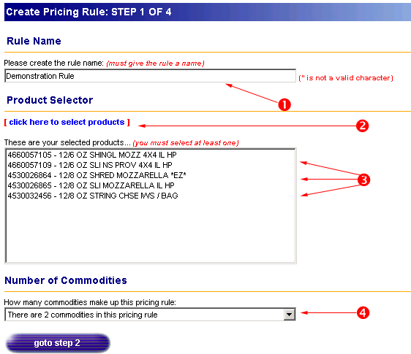

① Rule Name: Enter the name for your rule here. This name is how you can refer to the rule in order to change, modify or delete it.
② Product Selector – click here to select products: Clicking on this link will open a new page (see #2 below).
③ The products you selected using the pop up window in step two will be displayed here. Double check that these are the products you want to be used in your pricing rule.
④ Number of Commodities: Select the number of commodities that will play a role in your pricing rule. You can choose between 0 and 4 commodities.

2) Select Product

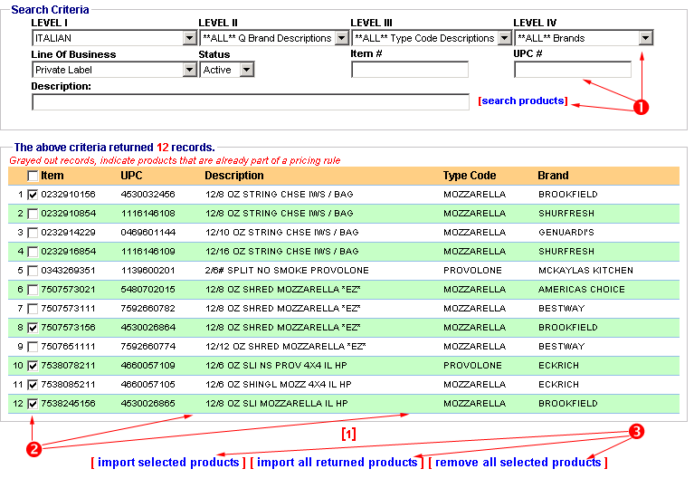
① Search Criteria: There are 9 ways to search for a product or products. You can search by: Type Group Descriptions, Q Brand Descriptions, Type Code Descriptions, Brands, Line of Business, Status, Item Number, UPC Number, and Description. If you do not select anything, you will see all products. If you search by more than one criteria, then you will only see products that match both selections. For example, the twelve records returned above are what is shown when “Italian” is selected for the Type Group Description and “Private Label” is selected as the Line of Business. There are 120 records shown when just “Italian” is selected. If only “Private Label” is selected 287 records are displayed. Click on [search products] to see the results of your search once you have made your selections.
② Returned Records: Once you have identified the records you are interested in, you need to select them in order to change whether or not they are in your pricing rule. Click on the check box on the left hand side of the screen to select a product. The Item Number, UPC, Description, Type Code and Brand are all displayed to help you make your selection.
③ Once you are satisfied, with your selections, you can do three things. The first is to include all the products you have checked in your pricing rule by clicking on [import selected products]. The second is to import all of the products that are returned by your search by clicking on [import all returned products] (for example, in this case clicking on [import all returned products] would make all 12 returned products part of the pricing solution). Finally, you can remove products from your pricing rule by checking them and clicking [remove all selected products].

NOTE: If a product is grayed out, you cannot select it to be added to your pricing rule. It is already a part of another pricing rule.

3) Select Commodities
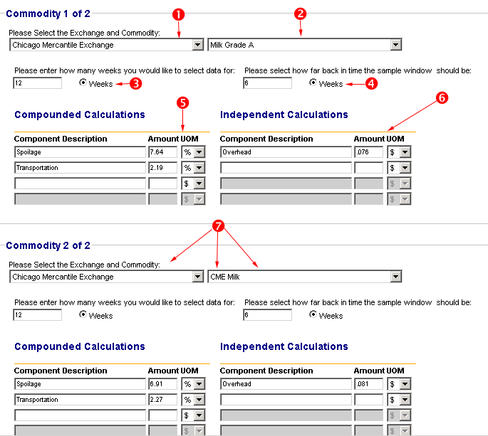

① Please Select the Exchange and Commodity: Select the exchange which deals with the commodity you are interested in adding to the pricing rule. What you select for an exchange will change what will be available for you to select in the commodity list. For example, selecting the Chicago Mercantile Exchange will provide a commodity list including Milk Grade A, Butter, and Feeding Cattle. If you select the Minneapolis Grain Exchange, commodity options include white wheat, cottonseed, and durum wheat.
② Once you have selected the appropriate exchange on the left, you can choose the commodity you are selecting from the pull-down menu on the right.
③ Please enter how many weeks you would like to select data for: This allows you to choose the sample size you wish to have analyzed to create the price rule. If you would like a 12 week period analyzed, enter 12 here.
④ Please select how far back in time the sample window should be: The number of weeks entered here indicates how many weeks ago the sample should be taken. If you were to enter 6 weeks for this, then the data that would be used in evaluating the pricing rule would be 12 weeks worth of data, starting 18 weeks ago and ending 6 weeks ago.

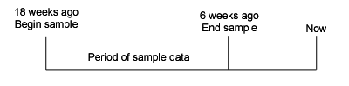

- Compounded Calculations: Compound calculations are dependent upon each other. For example, if a commodity price is $10, and the first component of the calculation is 10%, then the price for that component is $1. The second component might have a calculation of 10% as well, but the price for it is $1.10 – it is 10% of the commodity $1 and 10% of the $1 that the first calculation added. The total price for these two components would be $2.10.

Compounded Calculation #1:
$10 x 10% = $1
Compounded Calculation #2:
($10 + $1) x 10% = $1.10
Total Additional Cost from Compounded Calculations:
$1 + $1.10 = $2.10

⑥ Independent Calculations: Independent calculations are separate from each other. If the commodity price being modified is $10 and the first component of the calculation is 10%, then the cost for that component is $1. If the second component is also 10% the cost for the component is $1. The total price for these two components would be $2.

Independent Calculation #1:
$10 x 10% = $1
Independent Calculation #2:
$10 x 10% = $1
Total Additional Cost from Independent Calculations:
$1 + $1 = $2

⑦ Steps 1-6 are repeated for each commodity you selected.
4) Final Adjustments
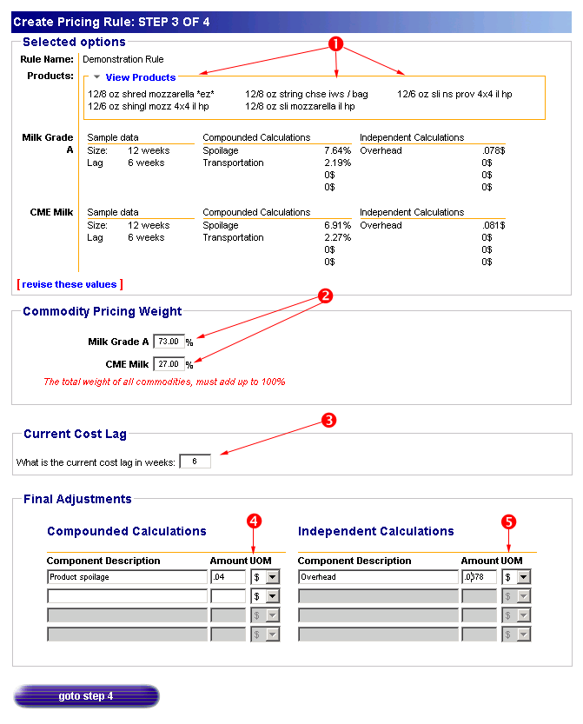
① Selected Options: The selected options pane shows you the entries you have made to date. You can see the name of your rule. Clicking on the “View/Hide Products” link will show the products if they are not visible, and hide the products you selected if they are shown. You can change the values shown by clicking on [revise these values].
② Commodity Pricing Weight: Here you can enter the percentage of the pricing rule the commodity comprises. For example, your price rule might use 70% Milk Grade and 27% CME Milk. The total of all the percentages for the commodities you are creating the price rule around must equal 100%.
③ Current Cost Lag: This indicates the number of weeks in the past you want information generated for. If you were to enter 6 here, then it would begin calculations from 6 weeks back. In our example, we already have a 6 week lag, and a 12 week period specified. Entering 6 for the current cost lag would produce information about a 12 week period that occurred beginning 24 weeks ago and ending 12 weeks ago (6 weeks for the current cost lag and 6 weeks for the lag entered in 3.4).

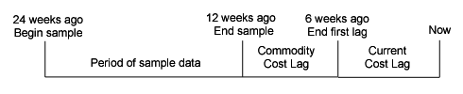

④ Final Adjustments – Compounded Calculations: The compounded calculations used here work in exactly the same manner they did on the previous page. The difference is that at this point you can run the same calculation on the final cost – not just on the different commodities. Please note that these calculations are on top of the calculations already made on a commodity basis. So if you take the previous example where the commodity price was $10, the cost of compounded calculations was $2.10 and the cost of independent calculations was $2, then the beginning cost used in these calculations will be $14.10.

Compounded Calculation #1:
$14.10 x 10% = $1.41
Compounded Calculation #2:
($14.10 + $1.41) x 10% = $1.551
Total Additional Cost from Compounded Calculations:
$1.41 + $1.551 = $2.961

⑤ Final Adjustments – Independent Calculations: These calculations work the same as on the earlier screen, except with beginning price difference noted above.
- Select Commodities
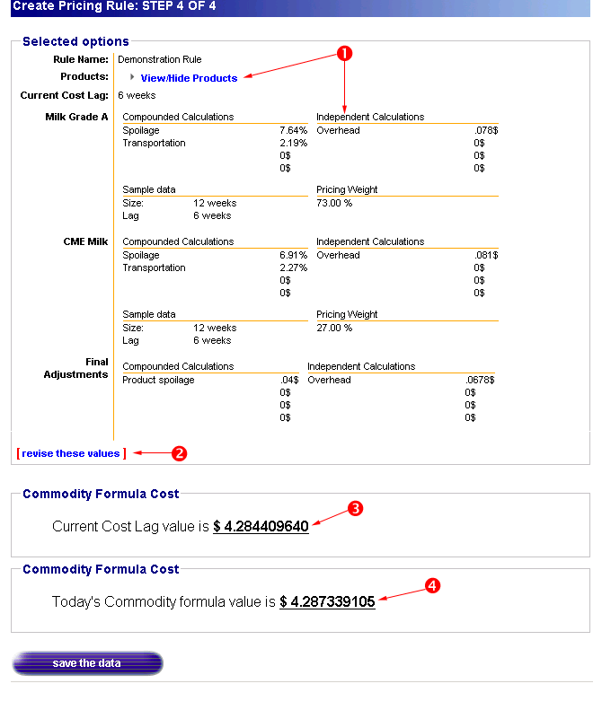
① Selected Options: Review the information you entered here. Clicking on “View/Hide Products” will display your product list if it is currently not shown, and hide it if it is currently shown.
② You can change any of the information displayed here by clicking on [revise these values].
③ Commodity Formula Cost (including lag): This shows the commodity formula cost including the lag you indicated on the previous page.
④ Commodity Formula Cost (as of today): This shows the commodity formula cost calculated from today. This number is the result of all the information you have entered, and will be used to calculate the margin for a program. To save this formula and make it available to others to use in creating programs, click on “save the data”. You will now be able to see your pricing rule when creating a new program.

