Maintenance Page Display Steps

- Take down the web server.
- Rename the file <WEBROOT>/index2.cfm to index2_bkp.cfm
- Rename the file <WEBROOT>/ index2_Maintenance.cfm to index2.cfm
- Bring the web server back up.
- Go to the application login page and verify that the maintenance page is displaying.

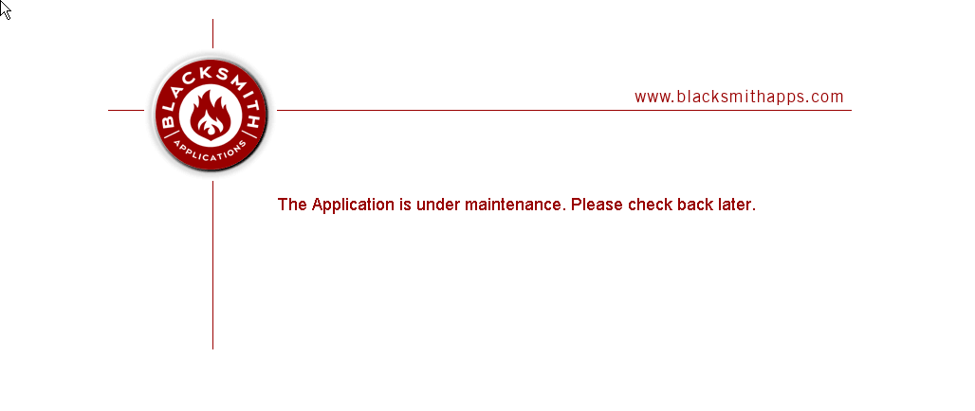
Log all of the users out:

select * from session_tracker

/*

Update session_tracker set session_id = null

*/

OR For No DB and CF

Update IIS to use Index_Maint.htm as the default page. It is a good idea to turn CF off at this point as well:

