Business Performance and Industry Analysis Dashboard
Prepared By: S.M.Abirami

Project Overview:
This project focuses on analyzing business performance and industry trends using Power BI. The provided Excel dataset was cleaned, transformed, and visualized to develop an interactive dashboard. Various analytical techniques and visualizations were used to monitor key performance indicators, identify trends, compare business segments, and generate actionable insights. The dashboard supports data-driven decision-making by presenting complex business information in a clear and user-friendly format.

Objectives:
- Analyze overall business performance using key metrics and KPIs.
- Identify revenue, profit, and growth trends across business segments.
- Compare performance across regions, categories, and industry sectors.
- Monitor business performance through interactive visualizations.
- Discover patterns and insights from the dataset.
- Support data-driven decision-making through business intelligence reporting.

Dataset Description:
The dataset consists of company and contact information collected from various industries and geographic locations. It includes details such as company name, annual revenue, industry type, location information, contact details, email engagement metrics, technology usage, and lead qualification indicators. The data was imported from Excel, cleaned, transformed, and analyzed using Power BI to generate meaningful business insights and support data-driven decision-making.
Data Cleaning and Preprocessing:
The dataset was reviewed and processed to ensure data accuracy, consistency, and reliability before analysis. Data cleaning techniques were applied to identify and resolve data quality issues that could affect the analytical results. After the cleaning process, the dataset was stored and validated in phpMyAdmin before being
imported into Power BI for visualization and reporting.
Data Cleaning Activities Performed:
- Imported the raw dataset for initial review and assessment.
- Identified and removed duplicate records.
- Handled missing and incomplete data values.
- Standardized data formats and naming conventions.
- Validated company, contact, and location-related information.
- Loaded the cleaned dataset into phpMyAdmin for storage and verification.
- Imported the validated dataset into Power BI for further analysis and dashboard development.
Key Performance Indicators (KPIs):
- Contact Reachability – Evaluates the volume of available business contacts for outreach and engagement activities.
- Revenue Potential Analysis – Assesses the annual revenue distribution of companies to identify high-value business opportunities.
- Industry Representation – Analyzes the distribution of companies across various industry sectors.
- Geographical Presence – Measures the business footprint across countries, states, and cities.
- Email Engagement Rate – Tracks email open and interaction levels to evaluate communication effectiveness.
- Email Deliverability Rate – Monitors successful email delivery and identifies bounce-related issues.
- Lead Response Rate – Measures the proportion of contacts that responded to outreach efforts.
- Lead Quality Assessment – Evaluates the quality and qualification status of business leads.
- Technology Adoption Insights – Identifies commonly used technologies across organizations for market analysis.
- Decision-Maker Distribution – Analyzes contacts based on roles, departments, and seniority levels.
- Business Intelligence Metrics – Provides actionable insights to support strategic planning and data-driven decision-making.

Analytical Questions :
- Which industry sectors demonstrate the highest concentration of organizations, and what does this indicate about market representation within the dataset?
- How are companies geographically distributed across countries, states, and cities, and which regions present the greatest business opportunities?
- What patterns can be observed between company annual revenue and industry classification, and how do these patterns influence business potential?
- To what extent do email engagement metrics, including open rates and response rates, reflect the effectiveness of business outreach activities?
- How does the adoption of different technologies vary across industries, and what insights can be derived regarding digital transformation trends among organizations?

Exploratory Data Analysis (EDA) Summary:
Exploratory Data Analysis (EDA) was performed to understand the structure, quality, and distribution of the dataset. The analysis focused on examining company information, industry classifications, geographical distribution, annual revenue, contact details, email engagement metrics, and technology adoption patterns. Various visualizations and summary statistics were used to identify trends, detect inconsistencies, and uncover meaningful business insights. The EDA process provided a foundation for developing interactive Power BI dashboards and supporting data-driven decision-making.
Key Insights:

- Certain industries contain a higher concentration of companies compared to others.
- Business presence is distributed across multiple countries, states, and cities, indicating diverse market coverage.
- Annual revenue varies significantly across industry segments and organizations.
- Email engagement metrics reveal differences in communication effectiveness among contacts.
- Technology adoption patterns vary across companies, reflecting different levels of digital maturity.
- Seniority and role distributions help identify key decision-makers within organizations.

Recommendations:

Short-Term Recommendations:
- Focus outreach efforts on industries with the highest concentration of companies.
- Prioritize regions with strong business presence and immediate growth opportunities.
- Improve email engagement strategies to increase open and response rates.
- Regularly validate and update contact information to improve communication effectiveness.
- Track campaign performance and optimize marketing efforts based on results.

Long-Term Recommendations:
- Develop targeted business strategies using industry-specific trends and revenue insights.
- Monitor technology adoption across organizations to identify emerging opportunities.
- Establish a strong data governance framework to maintain data quality and consistency.
- Utilize advanced analytics and predictive models to support future business decisions.
- Build long-term customer engagement strategies to improve retention and business growth.

Visualizations:
- Bar Chart – Industry Distribution Analysis
This bar chart shows the distribution of companies across different industries. Information Technology & Services has the highest company count, followed by Construction, Real Estate, and Financial Services, indicating stronger business concentration in these sectors.
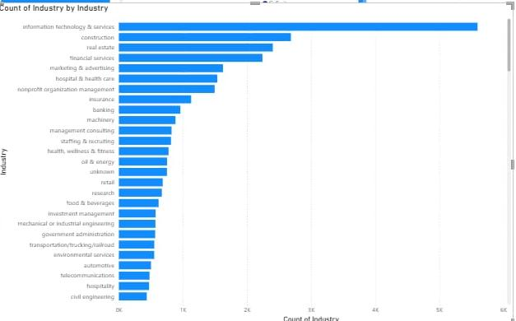
Relationship / Insight:
The chart shows that Information Technology & Services has the highest concentration of companies compared to other industries, followed by sectors such as Construction, Real Estate, and Financial Services. This indicates stronger business activity and organizational presence in technology-related industries, while several other sectors contribute smaller portions to the overall distribution.

2.Pie Chart – Company Distribution by State
This pie chart illustrates the percentage distribution of companies across different states. Each segment represents the proportion of companies located in a specific geographical region.

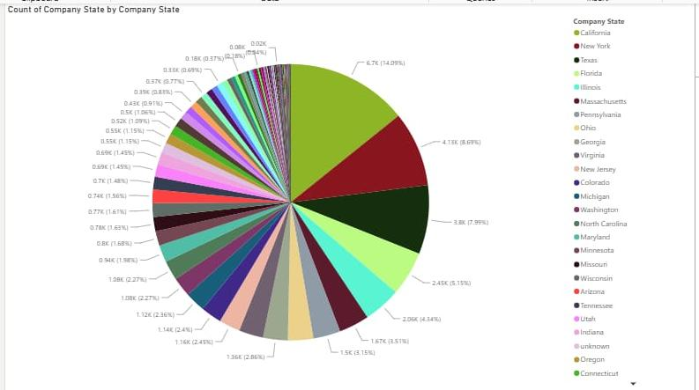

Relationship / Insight:
The visualization indicates that company presence is concentrated in a few major states while the remaining states contribute smaller shares. States with larger portions represent stronger business concentration and regional market influence,

3.Donut Chart – Employee Distribution by Departments:
This donut chart displays the total number of employees across different departments. The circular structure provides a representation of department-wise contribution to the overall workforce.

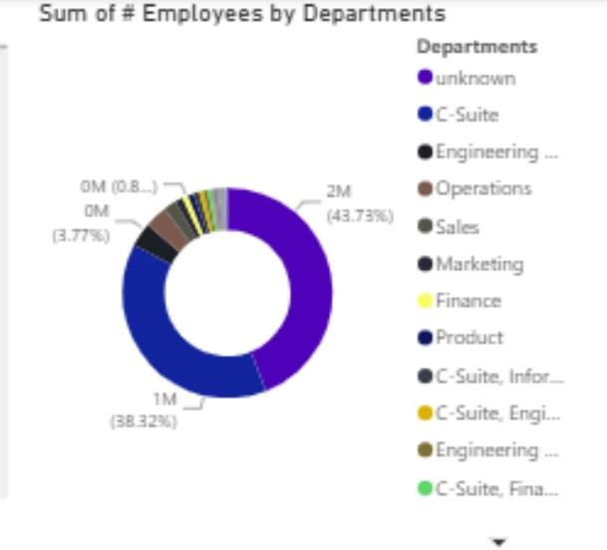

Relationship / Insight:
The chart shows that employee concentration is significantly higher in selected departments, particularly categories with larger segments, while the remaining departments account for smaller portions of total employees. This helps understand workforce
allocation and identify departments with higher organizational dependency.
4. Column Chart – City Count by Seniority Level
This visualization presents the relationship between employee seniority levels and company locations by comparing city counts across multiple seniority categories
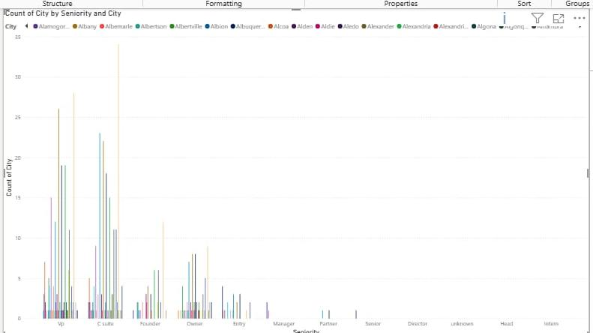
Relationship / Insight:
The chart reveals that senior positions and employee distribution vary across different cities. Certain seniority levels show higher concentration in specific locations, indicating differences in workforce structure and organizational hierarchy across regions. This analysis supports better understanding of employee distribution and location-based management decisions.

Conclusion:
The Power BI dashboard effectively visualizes and analyzes business-related data through multiple interactive charts and visual elements. The analysis provides valuable insights into industry distribution, company presence across states, employee allocation by departments, and workforce distribution based on seniority levels. The visualizations help identify patterns, compare performance across categories, and understand business concentration in different areas. By integrating interactive filtering and graphical representation, the dashboard supports efficient data exploration and enables better decision-making through clear and meaningful insights.

