Devops

Name: Abirami S A

Email: [abiramisree1@gmail.com](mailto:abiramisree1@gmail.com)

Topic: Linux Basic Commands Assignment

Assignment Part-3

Playing with files

# Create a file like **nano file1.txt**

o Edit some data and then save the file

command : nano file1.txt

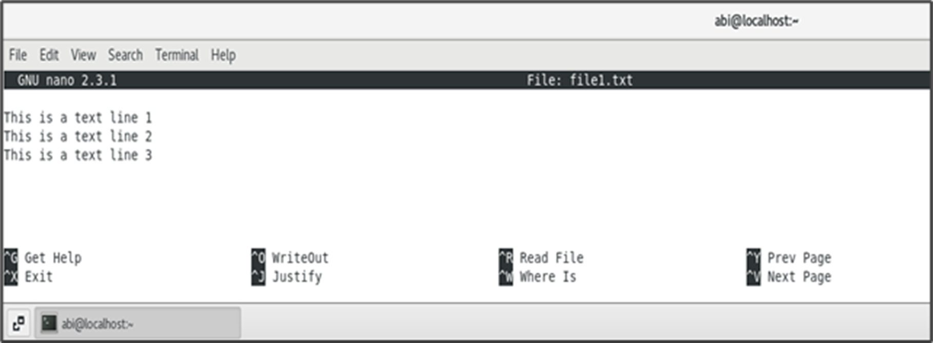

# Now we will copy date from file1 to new file2

o **cp file1.txt file2.txt**

o Then see the output of file2.txt, **cat file2.txt**

o Give screenshot

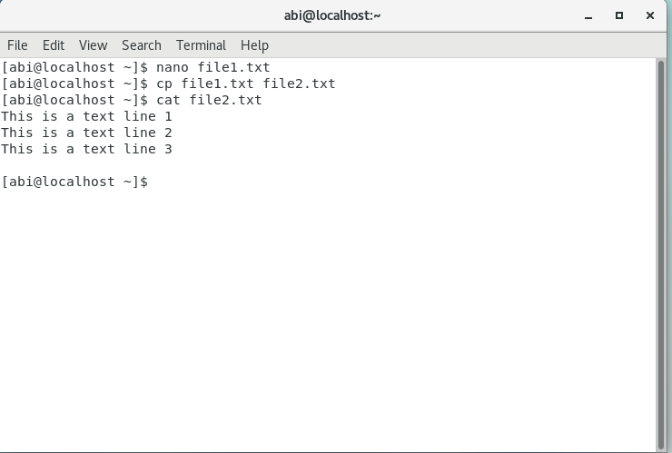

# Now we will move the file2.txt to new folder /home

o mv file2.txt /home

o Then go to home directory and check ls, file exits or not?

o Given screenshot

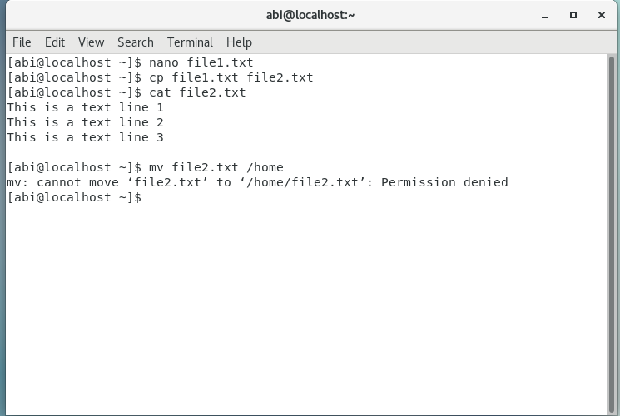

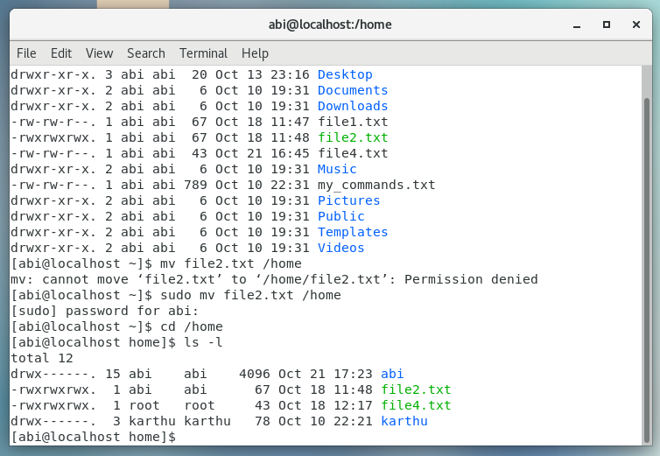

# Then we create a new file3.txt and file4.txt in home directory and add content in it.

o Now do echo “Hello I am newline” > file3.txt and provide the output of file3.txt

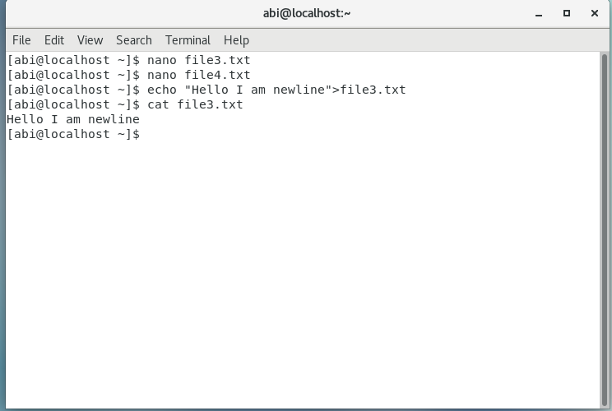

o Now do echo “Hello I am newline” >> file4.txt and provide the output of file4.txt

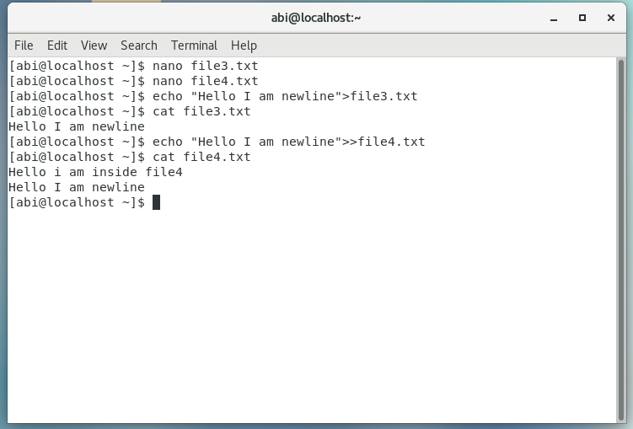

o Tell the different between both step you follow and the reason behind it

Reason: When using the “>” replaces the old content with new text whereas “>>” appends the new text with the existing content.

# For remove a file or directory you can use the below two commands

* To delete a file – **rm <any_filename>**

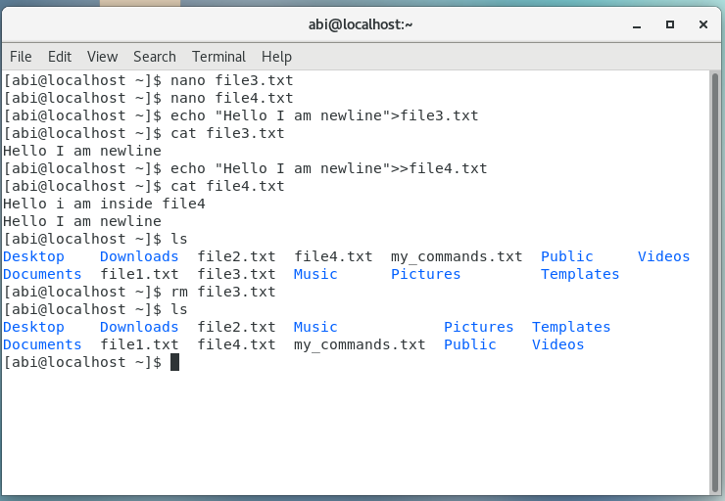

* To delete a directory **– rmdir<any_directoryname>**

