Assignment Name: Computer Networking commands

Assignment No: 2

Date: 09-02-2022

**1) ipconfig (windows) and ifconfig(linux)**

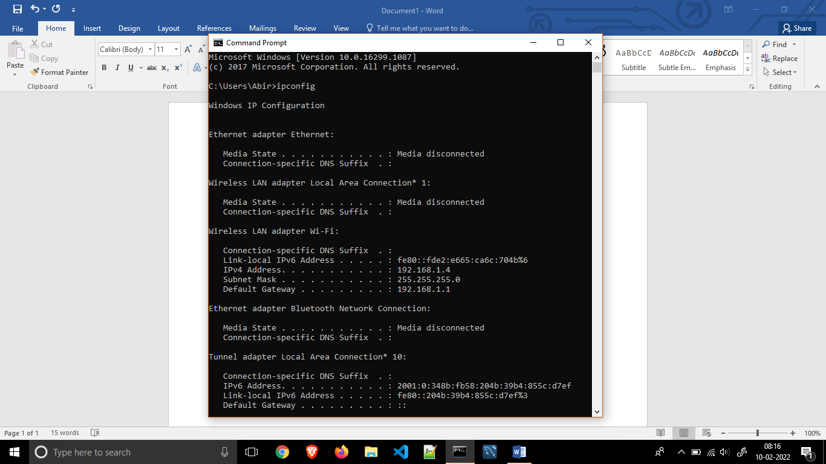

Ipconfig displays all current TCP/IP network configuration values and refreshes Dynamic Host Configuration Protocol (DHCP) and Domain Name System (DNS) settings. Used without parameters, ipconfig displays Internet Protocol version 4 (IPv4) and IPv6 addresses, subnet mask, and default gateway for all adapters.

**2) ping <ip address>**

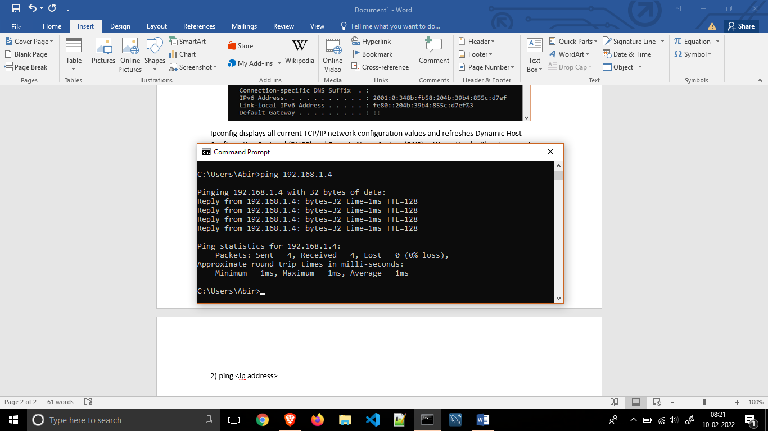

Ping is a computer network administration command used to test the reachability of a host on an Internet Protocol (IP) network. It is available for virtually all operating systems that have networking capability, including most embedded network administration software.

**3) nslookup <website address>**

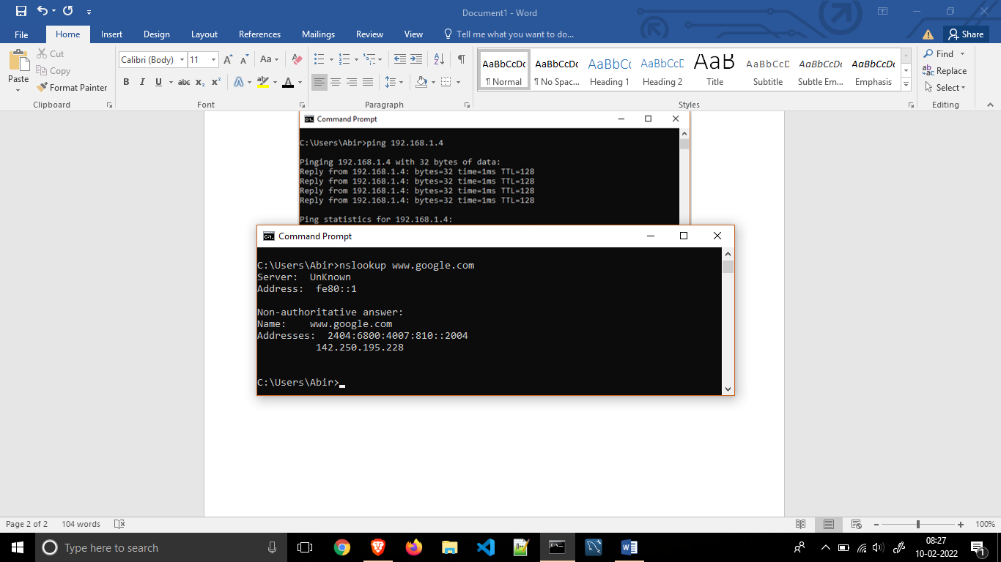

nslookup is a network administration command-line tool for querying the Domain Name System to obtain the mapping between domain name and IP address, or other DNS records.

**4) tracert <website address>**

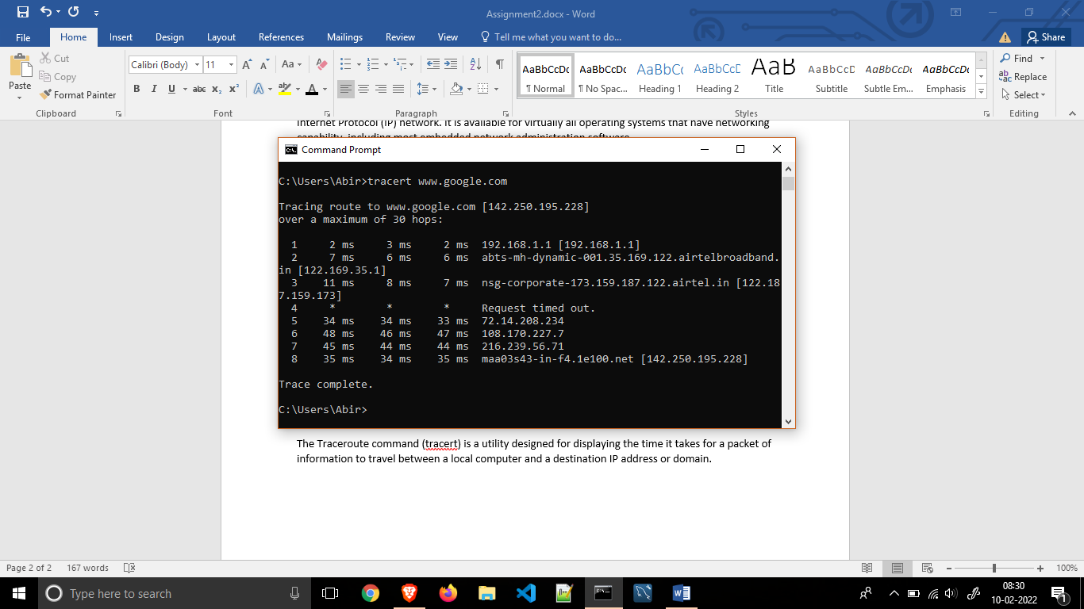

The Traceroute command (tracert) is a utility designed for displaying the time it takes for a packet of information to travel between a local computer and a destination IP address or domain.