Q) Write two Java program to detect Error in Data Link Layer using CRC.

**Algorithm:**

|  |  |
| --- | --- |
| **Client:**  **Step 1:** A message is taken as input from the User in Binary Form.  **Step 2:** For a n length parity checker (n-1) number of zeroes are appended in the end of the Input and sent in the **checksum()** function to find out the crc.  **Step 3:** The crc is appended with the User input and sent to the Server. | **Server:**  **Step 4:** The received data is sent to the **checksum()** function to calculate the crc.  **Step 5:** If the crc is zero then send “No Error” as acknowledgement to the client else send “Error”. |

**Algorithm for checksum()**

**Step 1:** Store the data in an m sized integer array(a[]) where m=size of the string received by checksum()

**Step 2:** for a parity of 1011 do the following steps for m-n times

**Step 3:** a[i]=0 if a[i]==1 else a[i]=1

**Step 4:** a[i+1]=1 if a[i+1]==1 else a[i+1]=0

**Step 5:** a[i+2]=1 if a[i+2]==0 else a[i+2]=1

**Step 6:** a[i+3]=1 if a[i+3]==0 else a[i+3]=1

**Step 7:** Go back to Step 2

**Step 8:** Return last (n-1) value of the array in concatenated string form

**Code:**

*Server:*

import java.io.*;

import java.net.*;

public class Crc_server {

public static String checksum(String str) {

int a[] = new int[20];

int n = str.length();

for (int i = 0; i < n; i++) {

a[i] = Integer.parseInt("" + str.charAt(i));

}

for (int i = 0; i <= n - 4; i++) {

if (a[i] == 1) {

a[i] = (a[i] == 1) ? 0 : 1;

a[i + 1] = (a[i + 1] == 1) ? 1 : 0;

a[i + 2] = (a[i + 2] == 1) ? 0 : 1;

a[i + 3] = (a[i + 3] == 1) ? 0 : 1;

}

}

String r = "";

for (int i = n - 3; i < n; i++) {

r = r + ("" + a[i]);

}

return r;

}

public static void main(String[] args) throws IOException {

System.out.println("Waiting for connection\n ");

ServerSocket ss = new ServerSocket(8000);

while (true) {

Socket s = ss.accept();

BufferedReader br = new BufferedReader(new InputStreamReader(s.getInputStream()));

String Clientsent = br.readLine();

System.out.println("Message from Client=> "+Clientsent);

String str3 = "";

if (checksum(Clientsent).equalsIgnoreCase("000"))

str3 = "No Error";

else

str3 = "Error";

System.out.println("CRC=> "+checksum(Clientsent));

DataOutputStream ds = new DataOutputStream(s.getOutputStream());

ds.writeBytes(str3 + "\n");

s.close();

}

}

}

*Client:*

import java.io.*;

import java.net.*;

public class Crc_client {

public static String checksum(String str) {

int a[] = new int[20];

int n = str.length();

for (int i = 0; i < n; i++) {

a[i] = Integer.parseInt("" + str.charAt(i));

}

for (int i = 0; i <= n - 4; i++) {

if (a[i] == 1) {

a[i] = (a[i] == 1) ? 0 : 1;

a[i + 1] = (a[i + 1] == 1) ? 1 : 0;

a[i + 2] = (a[i + 2] == 1) ? 0 : 1;

a[i + 3] = (a[i + 3] == 1) ? 0 : 1;

}

}

String r = "";

for (int i = n - 3; i < n; i++) {

r = r + ("" + a[i]);

}

return r;

}

public static void main(String[] args) throws IOException {

BufferedReader br = new BufferedReader(new InputStreamReader(System.in));

String msg = br.readLine();

String crc = checksum(msg.concat("000"));

System.out.println("CRC=> "+crc);

String sendData = msg + crc;

Socket s = new Socket("LocalHost", 8000);

DataOutputStream ds = new DataOutputStream(s.getOutputStream());

ds.writeBytes(sendData + "\n");

BufferedReader br1 = new BufferedReader(new InputStreamReader(s.getInputStream()));

String str2 = br1.readLine();

System.out.println("Acknowledgement from Server=> " + str2);

s.close();

}

}

**Output:**

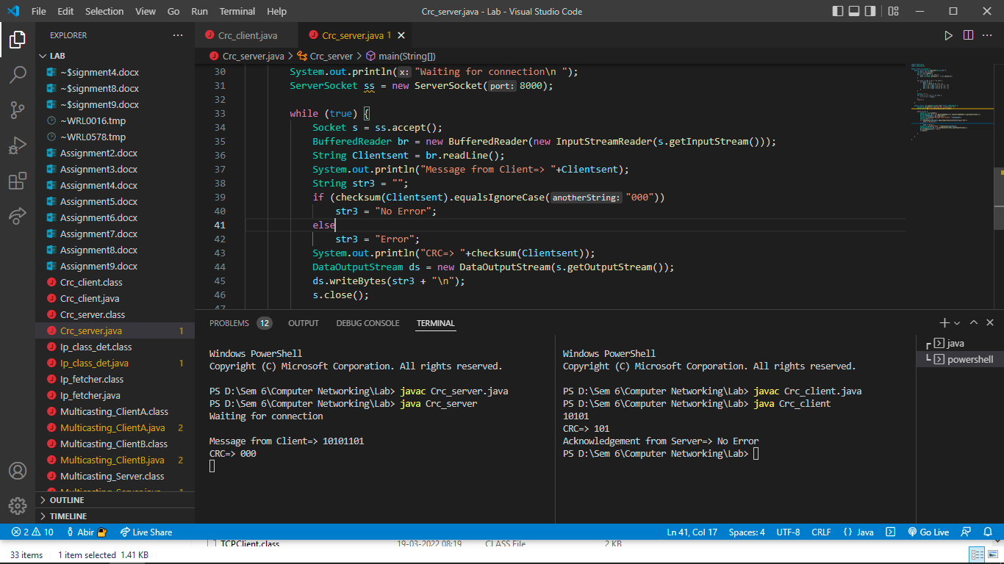

{

DatagramPacket dp=new DatagramPacket(receiveData,receiveData.length);

ms.receive(dp);

String msg=new String(dp.getData());

System.out.println("Client 2 receives this message => "+msg);

}

}

}

**Output:**

