

**CSE302 (Section 02)**

**[Summer 2022]**

**Lab Assignment Submission Report**

**Assignment Title:** Introduction to Oracle Database XE and SQLPlus Tool for writing SQL queries

**Submitted by:**

**Md. Abir Hasan khan**

**2019-1-60-013**

**Screenshots**

**Lab Task # 01 (Creating a table):**

**1.(a).**

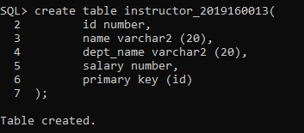

**1.(b).**

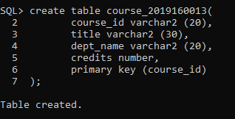

**Lab Task # 02 (Inserting data into a table):**

**2.(a).**

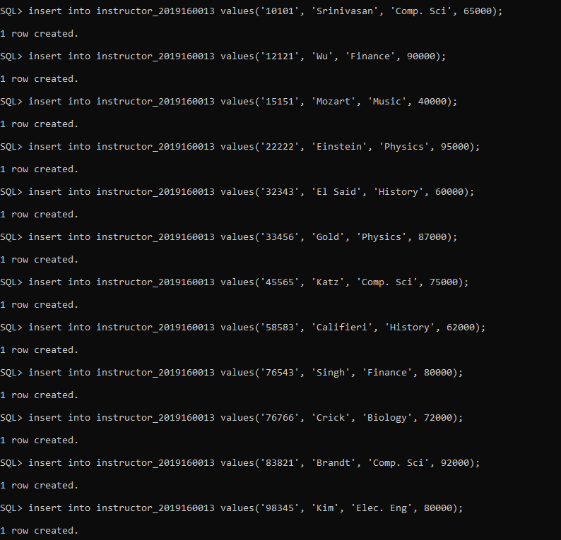

**2.(b).**

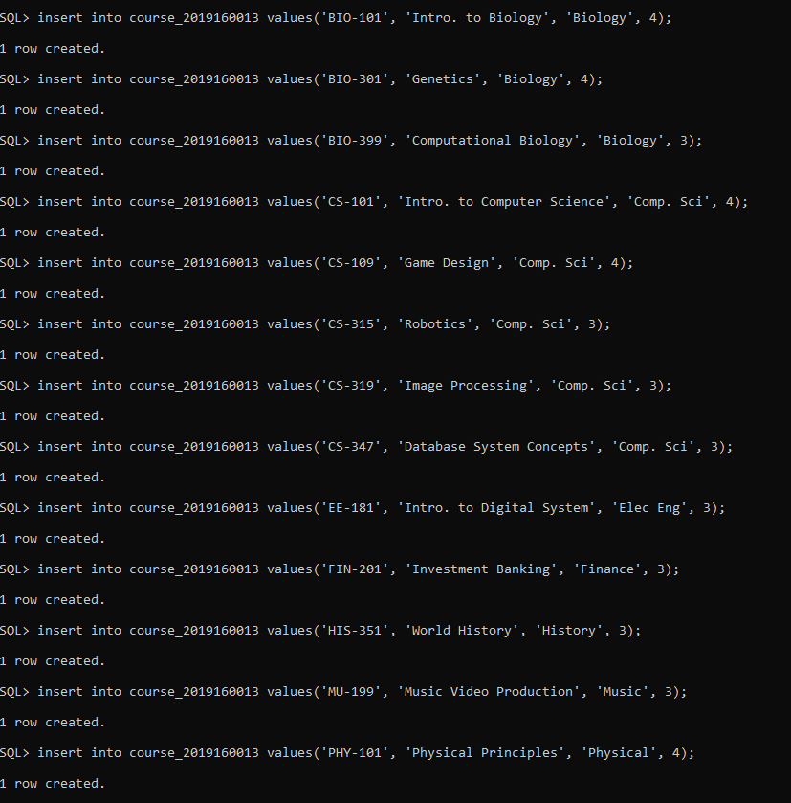

**Lab Task # 03 (Writing Queries):**

**1.**

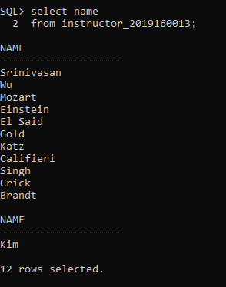

**2.**

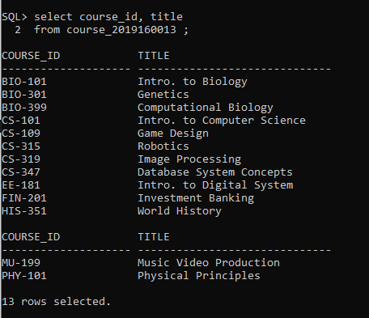

**3.**

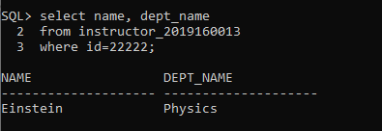

**4.**

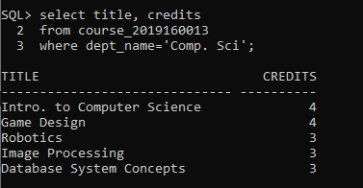

**5.**

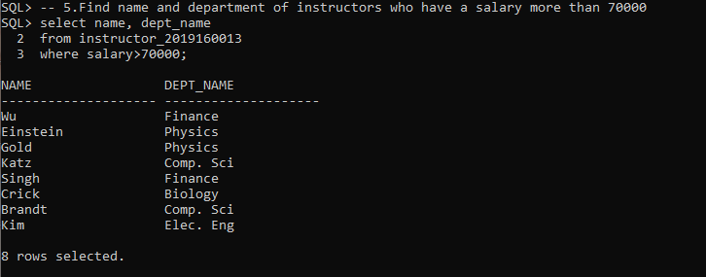

**6.**

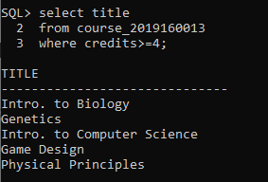

**7.**

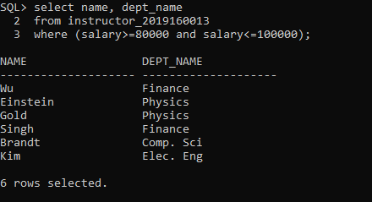

**8.**

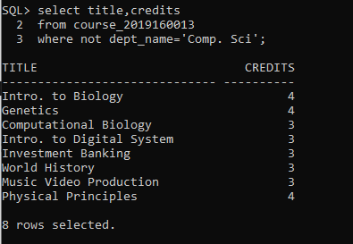

**9.**

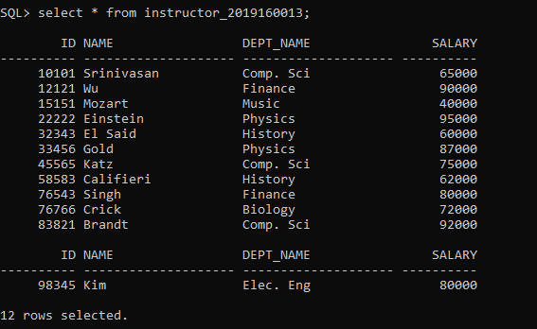

**10.**

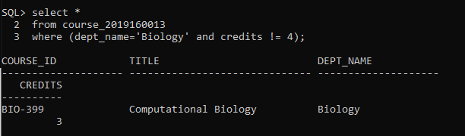

**2. Learning Outcomes**

Through this assignment, I learn installing Oracle database and write SQL commands.

For example - Creating a common database user. Creating a table, drop table. And learn their different data types. Insert values into the table and delete a record from a table. SQL query, conditional statement. Retrieving data from a table and updating the existing record.

That's all I learn from this assignment.