

**CSE302 (Section 02)**

**[Summer 2022]**

**Lab Assignment Submission Report**

**Assignment Title: Lab 02**

**Submitted by:**

**Md. Abir Hasan khan**

**2019-1-60-013**

**1. Screenshots**

**-- Lab Task # 01 (Schema Definition):**

**1.**

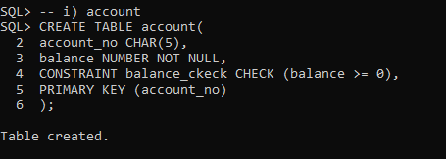

**2.**

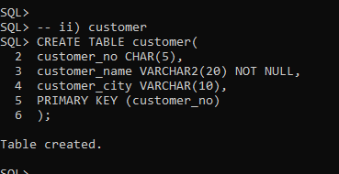

**3.**

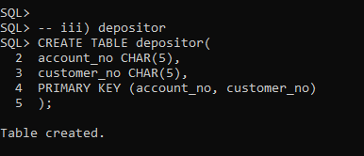

**-- Lab Task # 02 (Schema Modification):**

**1.**

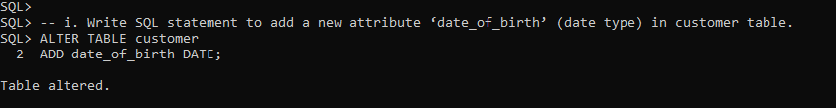

**2.**

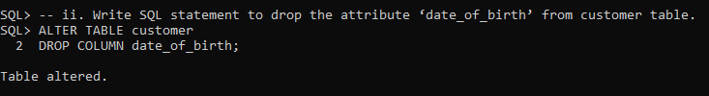

**3.**

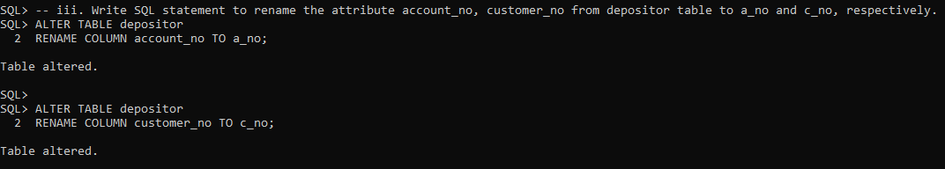

**4.**

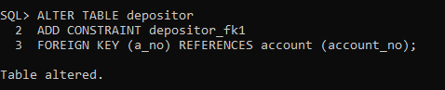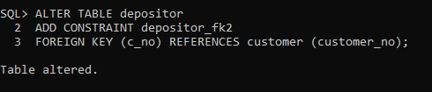

**-- Lab Task # 03 (Inserting Records into Tables):**

**1.**

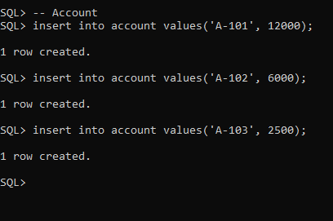

**2.**

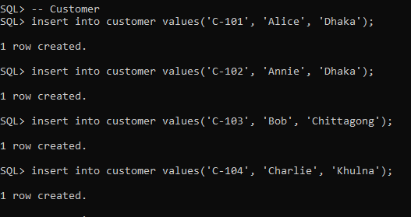

**3.**

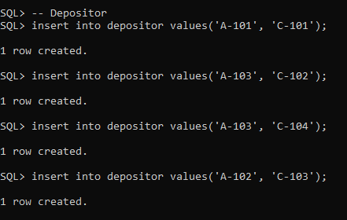

**-- Lab Task # 04 (Queries):**

**1.**

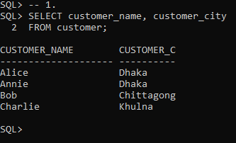

**2.**

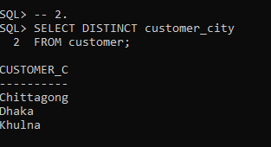

**3.**

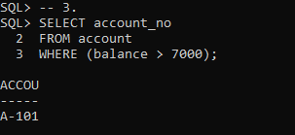

**4.**

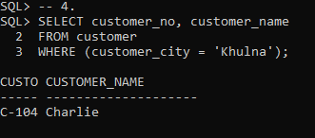

**5.**

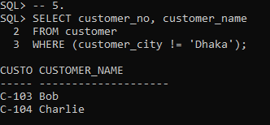

**6.**

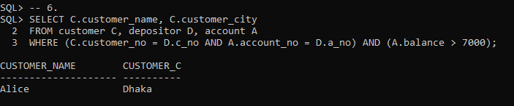

**7.**

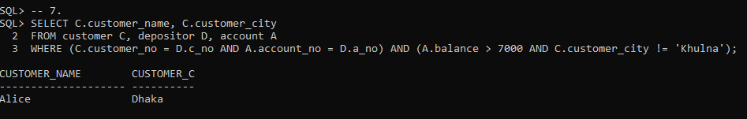

**8.**

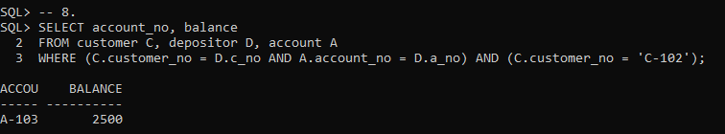

**9.**

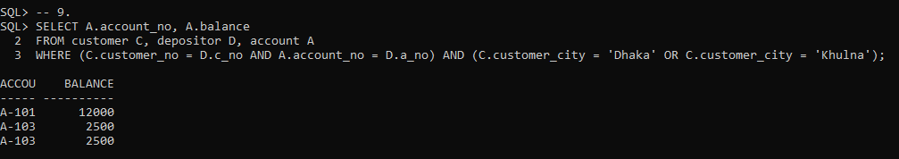

**10.**



**2. Learning Outcomes**

Through this assignment, I learn about adding, dropping, modifying data type, renaming a attribute. How to rename table and adding a constraint into a table (primary key constraint, foreign key constraint). Deleting a constraint from a table. And also lean multi-table queries. That's all I learn from this assignment.