

**CSE302 (Section 02)**

**[Summer 2022]**

**Lab Assignment Submission Report**

**Assignment Title: Lab 04**

**Submitted by:**

**Md. Abir Hasan khan**

**2019-1-60-013**

**1. Screenshots**

**-- Lab Task**

**1**

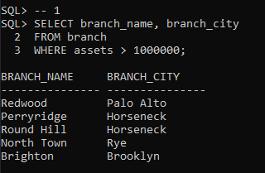

**2**

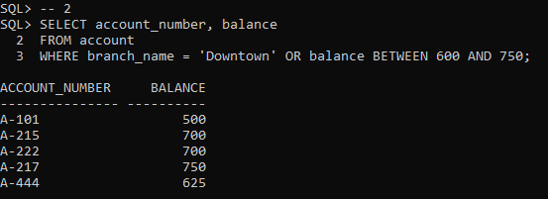

**3**

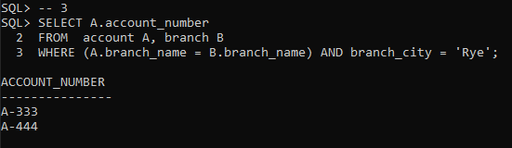

**4**

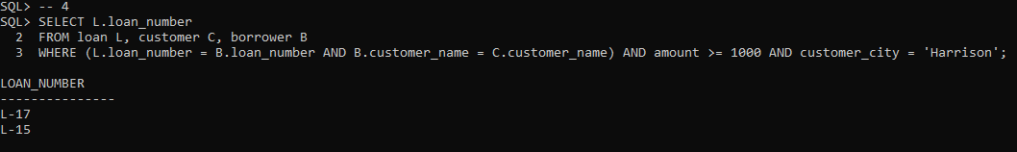

**5**

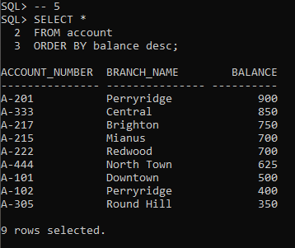

**6**

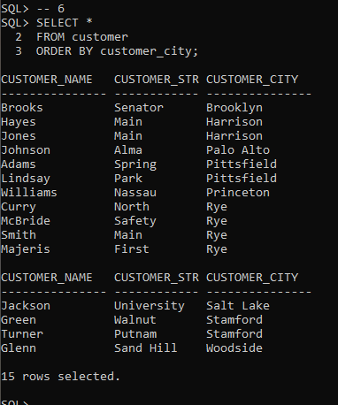

**7**

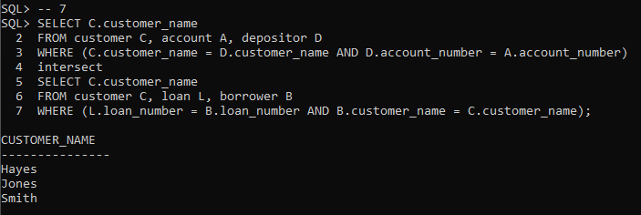

**8**

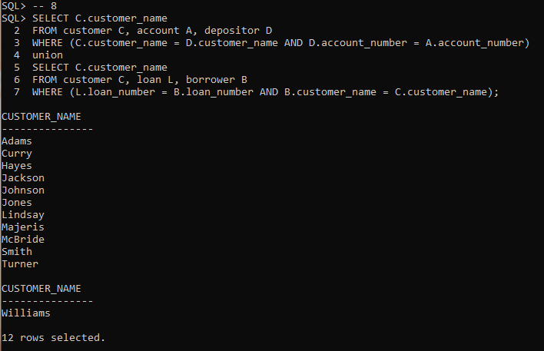

**9**

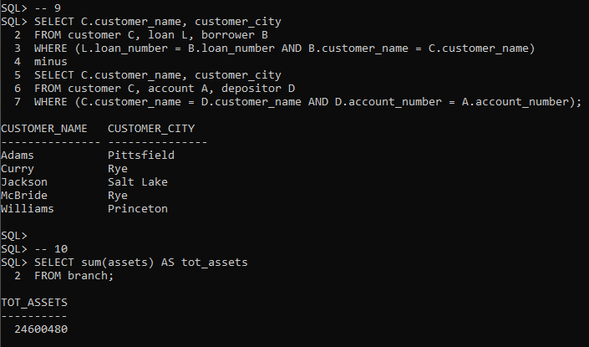

**10**

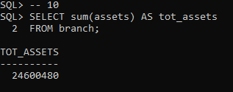

**11**

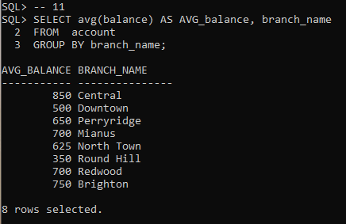

**12**

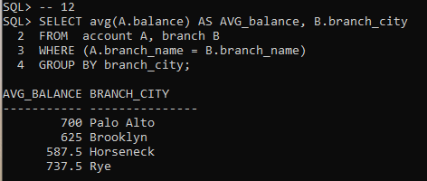

**13**

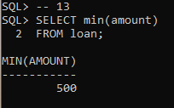

**14**

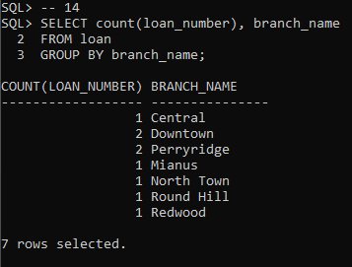

**15**

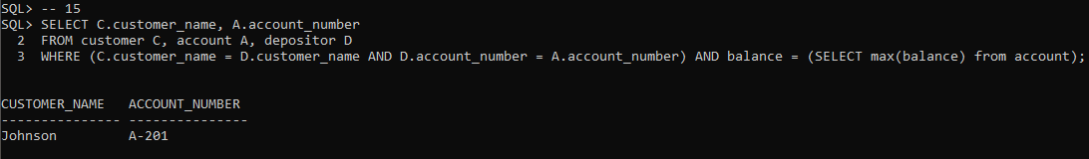

**2. Learning Outcomes**

Through this assignment, I learn about relational algebra, Cartesian, join operation, set operation, aggregate functions etc.