

**CSE302 (Section 02)**

**[Summer 2022]**

**Lab Assignment Submission Report**

**Assignment Title: Lab 05**

**Submitted by:**

**Md. Abir Hasan khan**

**2019-1-60-013**

**1. Screenshots**

* 01

**A**

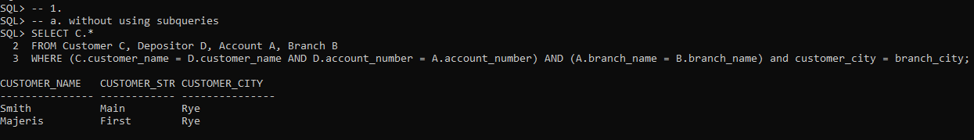

**B**

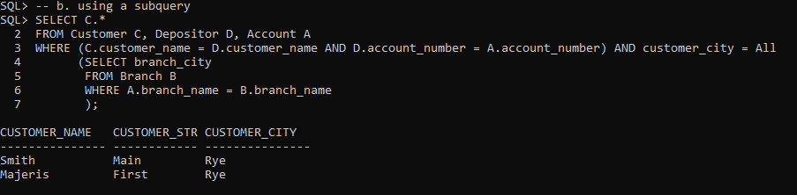

* 02

**A**

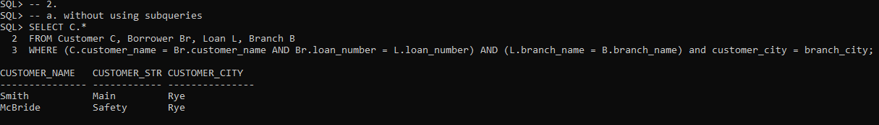

**B**

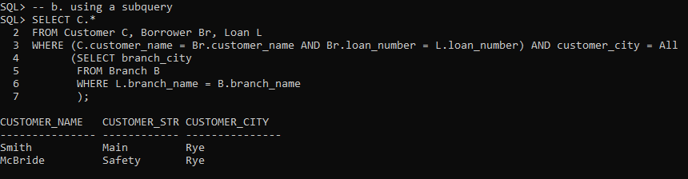

* 03

**A**

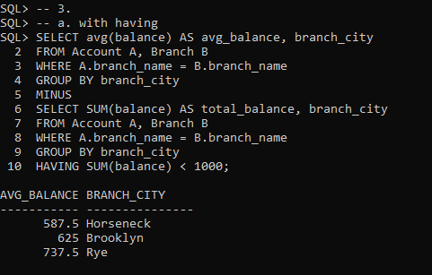

**B**

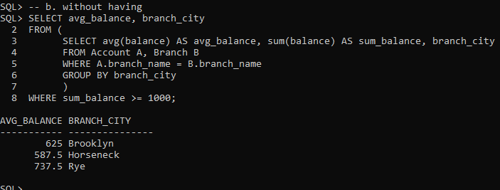

* 04

**A**

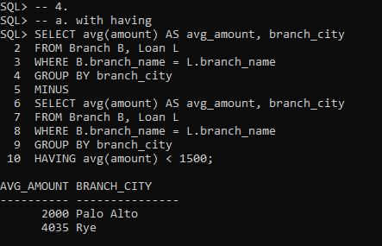

**B**

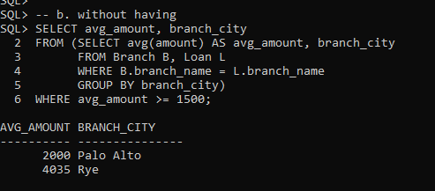

* 05

**A**

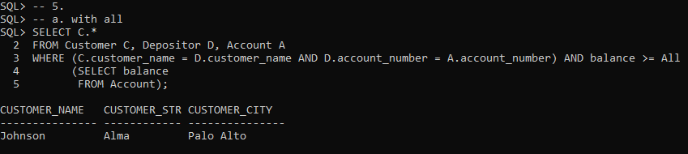

**B**

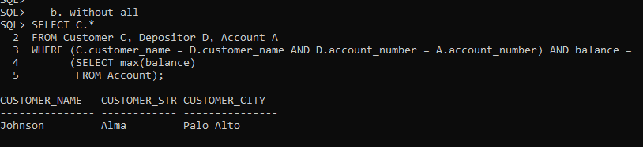

* 06

**A**

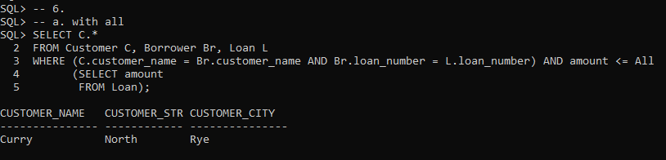

**B**

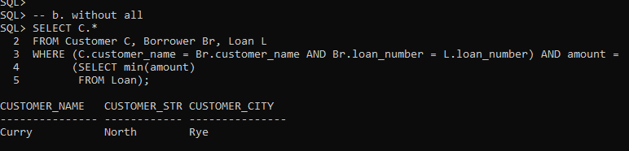

* 07

**A**

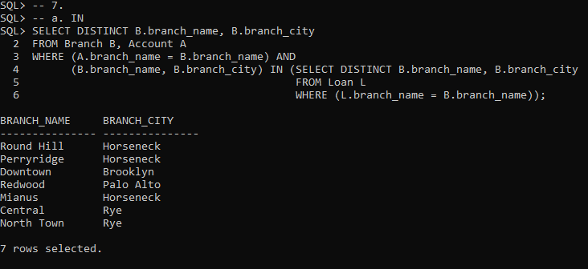

**B**

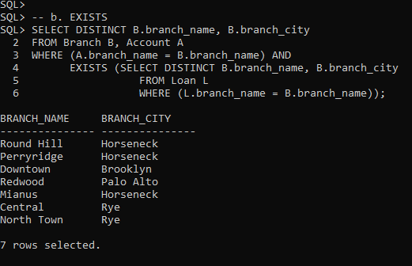

* 08

**A**

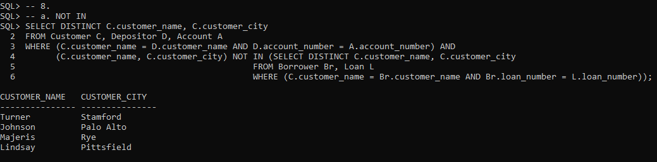

**B**

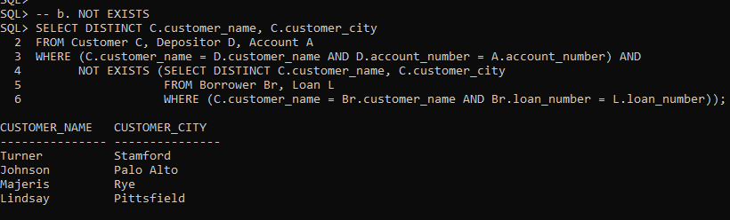

* 09

**A**

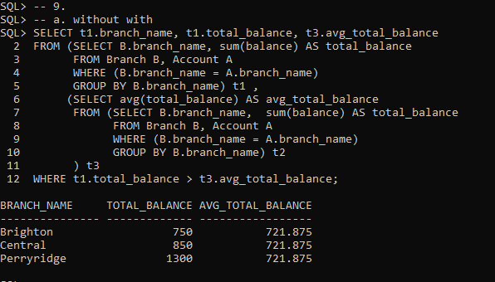

**B**

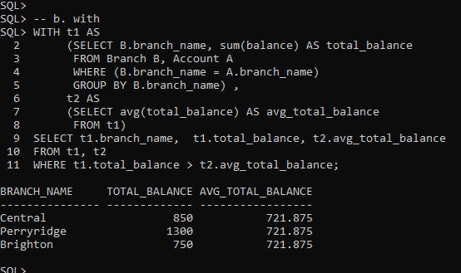

* 10

**A**

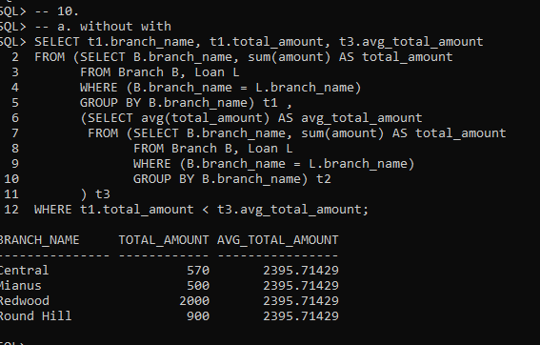

**B**

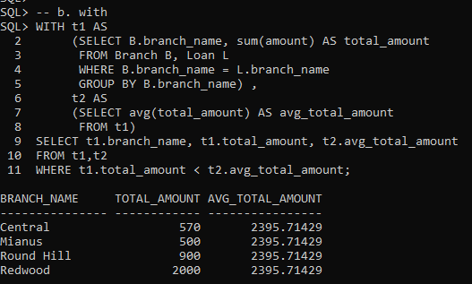

**2. Learning Outcomes**

Through this assignment, I learn about subqueries in the WHERE clause, subqueries in the FROM clause and Natural Join, IN / NOT IN, SOME / ALL, EXISTS/NOT EXISTS. And also learn complex queries using WITH clause.