Extracting a three-dimensional apple-tree skeleton from RGB-D images
MMA3001 Numerical Methods and Machine Learning – Individual Project: Written Project Documentation
Student: Arthur Birkbeck | Dataset: Dataset 1 – Monash TreeID apple-tree RGB-D observations | Repository: https://github.com/abirkbexk/tree-skeleton-3d (package treeskel, branch main)

1. Engineering problem
Context. Modern orchard automation (robotic pruning, blossom/fruit thinning and harvesting) needs a machine-readable model of tree structure. In trained, Y-shaped apple trees the skeleton – the trunk and primary branches – tells a robot where to cut, where fruit can be reached and how the canopy is organised. Cameras give only a view of the canopy: leaves and fruit hide much of the branch structure, and lighting varies between seasons.
Problem. Given one RGB image and an aligned depth image of an apple tree, estimate the tree skeleton including branch sections that are partly hidden by foliage, and lift it to three dimensions as a polyline in metres from which branch lengths can be computed. The work uses supervised learning: RGB-D images are paired with ground-truth skeleton annotations, so the model learns to hallucinate occluded structure from context.
Why it matters / intended use. A fast, cheap skeleton estimate from a single RGB-D frame is a perception step for pruning and harvesting robots and for phenotyping (branch lengths, branching height). The solution is a research prototype; it is not a certified measurement tool.
Scope and limitations. (i) Only the trunk and the two primary branches of a Y-shaped tree are modelled, as one x-position per branch per image row. Near-horizontal branches and trees with more than two leaders cannot be represented. (ii) The ground truth is a 2D annotation, so the 3D skeleton is validated only through its 2D projection; no independent 3D measurement exists. (iii) Only the labelled Summer images were used for training (Section 2).

2. Inputs, outputs and data
 | Specification | Meaning / handling
RGB input | PNG, 8-bit, 3 channels (native 480×640) | Centre-cropped to a square and resized to 256×256 (IMG_SIZE).
Depth input (optional) | PNG aligned to the RGB image. 16-bit: millimetres. 8-bit (this dataset): 0 = no reading, brighter = nearer | Normalised to [0,1] for the model. 8-bit depth has no stored scale, so it is mapped linearly to 0–4 m (inverted); metric 3D results are therefore approximate.
Training target | PNG skeleton annotation, 256×256 binary line (centre crop) | Converted to left/right branch x-position per row (2×256 values).
Output 1 – 2D skeleton | rows_px: x-position of each branch for each image row, plus top/bottom extent and junction row | Where the branches run, including occluded parts; the junction row marks where the Y splits.
Output 2 – 3D skeleton | points_3d: (X, Y, Z) per branch in metres (X right, Y down, Z forward); CSV and PLY export | Skeleton lifted with a pinhole camera model (nominal RealSense D435 intrinsics, f = 615 px).
Output 3 – branch lengths | length_m per branch (Simpson quadrature of the 3D polyline) | Approximate; limited by depth scale and occlusion bias.
Table 1. Top-level inputs and outputs (function-level inputs/outputs are in the pdoc documentation in the repository).
Invalid or missing input. A missing file raises FileNotFoundError; a non-PNG raises ValueError; an unreadable annotation or one with fewer than 10 skeleton rows is rejected and reported during training (0 of 400 were rejected); missing or mostly empty depth (<20 % valid pixels) gives a 2D result only, with a warning, because the model was trained with a depth channel; holes in depth are filled by interpolation before use.
Data. The labelled Monash TreeID Summer set contains 400 trees, each with an RGB, a depth and a ground-truth skeleton PNG (1200 files, ~250 MB, filenames R{row}N{tree}_Summer_{RGB|D|GT}-{h}-{m}-{s}.png). It is bundled in the repository (data/TreeID) so the workflow is reproducible from a clone. Winter and ‘U’ trees have no skeleton annotation and were not used. The annotations were checked visually against the images on sample trees (Figure 1): they follow the visible trunk and branches and are drawn through occluded regions.

3. Computational approach
Representation. Skeletons of Y-shaped trees are well described by the horizontal position of the left and right branch at each image row, so skeleton extraction becomes a regression from an image to 2×256 numbers. This avoids per-pixel segmentation, which is ill-posed where branches are hidden, and gives smooth, ordered outputs that can be integrated and lifted to 3D directly.
Pipeline.
- Features: RGB and depth (hole-filled, median-centred per image and scaled to ±3 half-metres, i.e. relative depth) are down-sampled to 32×32 (FEAT_SIZE) and flattened (4096 values); a PCA keeps 100 components.
- Targets: the 512-value target vectors are compressed by SVD/PCA to 16 components. The rank-16 reconstruction error is 1.05 px, which matches the Eckart–Young prediction from the discarded singular values and bounds the error added by compression.
- Models compared: mean-skeleton baseline, ridge regression, decision tree, k-nearest neighbours, support vector regression (SVR) and a multilayer perceptron (MLP); an optional small PyTorch CNN is implemented but was not run for the results here. Hyper-parameters are tuned by 5-fold cross-validation grouped by tree on the training set only.
- Post-processing: candidate smoothers (global polynomial of degree 2–15, smoothing spline with several smoothing factors, or none) are compared on validation data.
- 3D lifting and length: each predicted row position is combined with a robust, foreground-biased depth estimate in a small window and back-projected with a pinhole model, X = (u−c_x)Z/f, Y = (v−c_y)Z/f. Branch length is the arc length of the 3D polyline by Simpson quadrature.
Why this approach. It uses the unit methods directly and each can be verified against known solutions, it trains in seconds on a CPU, and it gives a baseline-versus-learned comparison. Table 2 maps the unit topics to the code.
Unit topic (weeks) | Method used | Module
Linear algebra, SVD (2) | Target/feature PCA by SVD; ridge by normal equations versus SVD; conditioning | models, experiments
Interpolation, curve fitting (3) | Newton polynomial, cubic spline, PCHIP; depth-hole filling; smoothing spline | numerics, postprocess, data
Machine learning (5) | Ridge, tree, kNN, SVR, MLP, CNN; grouped cross-validation; metrics | models, cnn, metrics
Differentiation, ODEs (6) | Finite differences; Euler/Heun/RK4 integration of predicted slopes (alternative method) | numerics, ode_recon
Quadrature (7) | Trapezoid, Simpson, Romberg, Gauss–Legendre; arc length of the 3D skeleton | numerics, geometry
Table 2. Mapping of unit methods to the implementation.
Assumptions and parameters. Branches are single-valued in the image row; the camera is a pinhole with nominal intrinsics; depth is linear in the 8-bit value (bright = near, 0 m–4 m full scale); a tree’s frames never occur in more than one data split. Key settings: IMG_SIZE=256, FEAT_SIZE=32, 100 feature and 16 target components, SEED=42. All are in one configuration dictionary (config.py).

4. Validation method and results
Design. The 400 trees were split by tree (group) into 279 training, 61 validation and 60 test trees. Hyper-parameters were tuned on the training set by grouped cross-validation, the model and post-processing were selected using validation data only, and the test set was used once for the final table. Grouping matters because images of the same tree are near-duplicates; a random image split would leak information and inflate accuracy.
Metrics. Position RMSE (px) between predicted and annotated branch x-position over annotated rows, on the 256-px working image (256 px ≈ one 480-px image height). Also the symmetric Chamfer distance between predicted and true skeleton points (px) and the absolute error of the junction row (px). The correlation coefficient is reported by the code but is not informative here: even the mean skeleton scores 0.977 because all trees share the same overall Y shape.
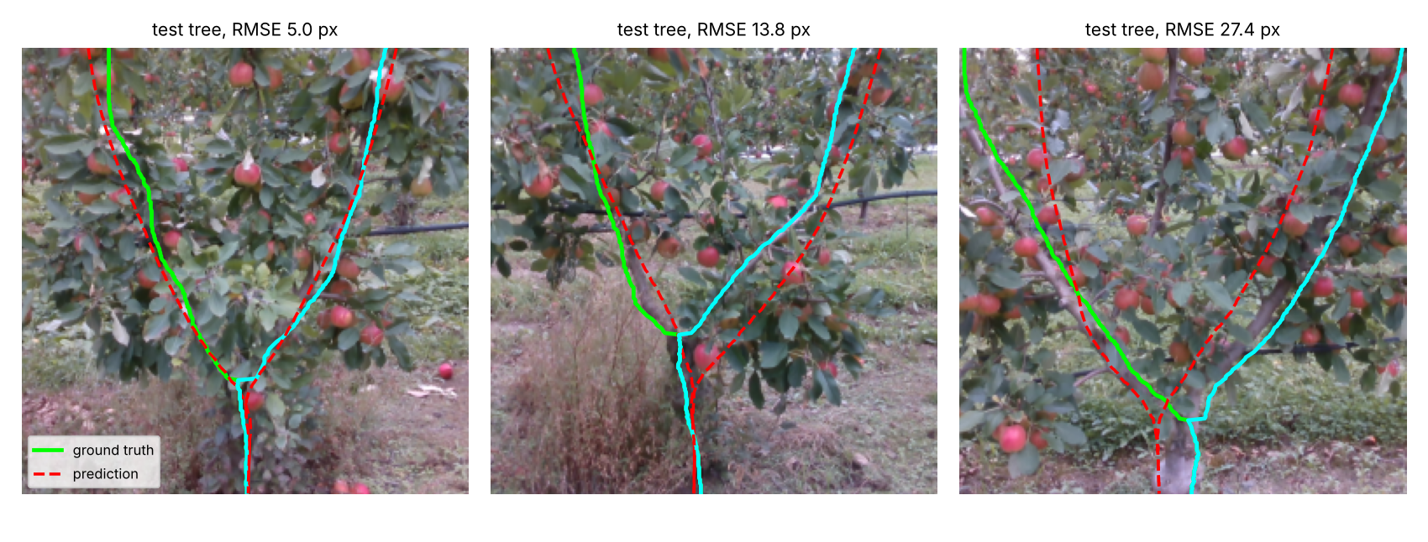
Figure 1. Test trees at the 10th percentile (best), median and 90th percentile (worst) of Ridge error. Green/cyan: ground-truth left/right branch; red dashed: prediction.
Model | Val RMSE (px) | Test RMSE (px) | Test Chamfer (px) | Test junction error (px) | Predict (ms/img)
Mean-skeleton baseline | 15.76 | 16.04 | 12.23 | 24.1 | 0.01
Ridge (selected on validation) | 13.35 | 14.15 | 10.53 | 22.1 | 0.07
SVR | 13.54 | 13.58 | 10.05 | 19.9 | 0.62
kNN (k = 15) | 14.60 | 14.65 | 10.91 | 18.8 | 0.09
Decision tree | 15.71 | 14.76 | 10.96 | 21.1 | 0.08
MLP | 18.47 | 18.07 | 13.12 | 29.7 | 0.07
Table 3. Model comparison on the 61 validation and 60 test trees (single split, seed 42).
Results. Ridge had the lowest validation RMSE and was selected; on the test set it scored 14.1 px against 16.0 px for the mean-skeleton baseline (12 % lower), with SVR slightly better (13.6 px) but not selected, because selection must not use test data. The per-tree Ridge test RMSE has median 13.8 px and 10th/90th percentiles of 7.9 and 21.4 px, so accuracy varies strongly between trees (Figure 1). Post-processing made no practical difference: the best smoothing spline (s = 0.2) improved validation RMSE by 0.0002 px over unsmoothed predictions, while low-degree polynomials and heavy smoothing were worse (up to 14.3 px). The tuned models are not much better than the baseline, which means most of the achieved accuracy comes from the shared Y shape rather than tree-specific image evidence (Section 6).
Verification of the numerical building blocks (known-answer tests in tests/, 52 tests, 78 % line coverage; HTML report in docs/test_report.html):
Check | Result | Expected
Finite differences on sin x (observed order) | forward 0.996, central 1.998 | 1 and 2
Euler / Heun / RK4 on x′ = −2x + t | 0.94 / 2.12 / 4.11 | 1 / 2 / 4
Quadrature of the arc length of sin 3t, n = 257 (abs. error) | trapezoid 1.2e−5, Simpson 6.0e−10, Romberg 2.1e−10, Gauss 2.8e−14 | spectral/high order beats trapezoid
Ridge solved in float32 normal equations vs float64 SVD (rel. error; cond(A) = 101) | 6.7e−5 (normal eq.), 6.9e−7 (SVD) | SVD more accurate; normal equations still adequate when well conditioned
Newton interpolation of one annotated branch, 24 equispaced nodes (RMSE) | 1663 px (Runge oscillation) versus 1.3 px for a cubic spline | splines stable, high-degree polynomials not
Table 4. Verification of numerical methods against known solutions (`scripts/run_experiments.py`).
What the validation cannot establish. The test set is 60 trees from one season and one orchard, so confidence intervals on the RMSE are wide and a single split cannot separate SVR from Ridge. The ground truth is a 2D hand annotation that is itself uncertain where branches are occluded. There is no independent 3D truth, so the 3D coordinates and lengths are checked only for self-consistency; depth is a monotone map of the true depth with an assumed scale.

5. Comparison and optimisation
Alternative solutions. Table 3 compares one baseline and five learned models. Ridge is the most interpretable and fastest to train (3.9 s including the search) and predict (0.07 ms per image); SVR is ten times slower to predict for a 0.6 px lower test error that is within split noise; the MLP is the least accurate model on 279 trees. A second, alternative formulation regresses branch slopes and integrates them with Euler, Heun or RK4. With true slopes (an oracle) the integration error is 0.48, 0.25 and 0.21 px, ordered as the solver orders predict, but with predicted slopes all three give about 14.4 px: the error is dominated by learning, not by integration, so the extra complexity is not justified and the direct position regression was kept.
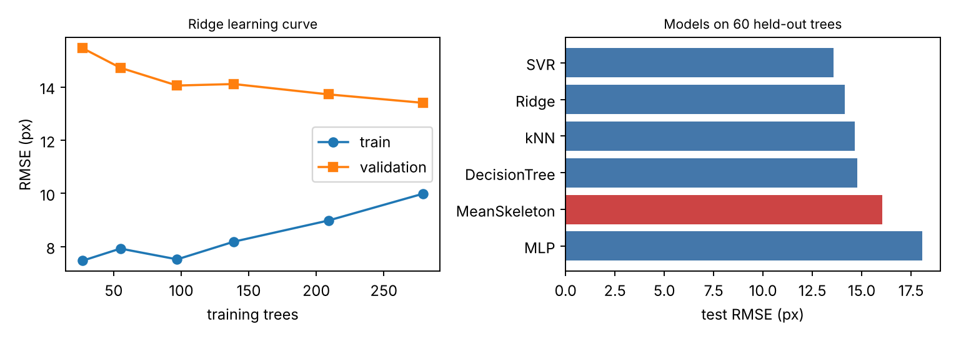
Figure 2. Left: Ridge learning curve (validation error still falling at 279 trees). Right: test RMSE of all models; red = baseline.
Data requirements. The learning curve (Figure 2) shows the validation RMSE falling from 15.5 px with 27 trees to 13.4 px with 279, while the training error rises from 7.5 to 10.0 px: the models are limited by the amount and variety of data, not by model capacity, and more annotated trees would help.
Input resolution. Feature resolution was varied from 12×12 to 64×64 pixels (Ridge). Validation RMSE was flat within about 0.2 px (13.26 px at 24×24, 13.35 px at 32×32, 13.49 px at 64×64) while the feature matrix grew from 0.9 MB to 26 MB and fitting time doubled, so 32×32 was kept as a safe compromise; 24×24 is slightly cheaper and not measurably worse.
Computational performance. Ridge inference costs about 0.85 MFLOP and 3.4 MB of weight traffic per image, an arithmetic intensity of 0.25 FLOP/byte, which is memory-bound; the measured 0.044 ms per image corresponds to about 19 GFLOP/s on a 2-core 2.8 GHz CPU. Peak extra memory for predicting the 60 test images is 2.0 MB, and the profiler shows time dominated by scikit-learn input validation and the PCA transform rather than the arithmetic. Everything runs on a CPU in seconds, so no GPU is required; the whole 400-tree training run, including data loading (~13 s) and the search, takes under a minute.
Baseline versus selected solution. Mean skeleton 16.0 px → Ridge with light spline smoothing 14.1 px test RMSE (Chamfer 12.2 → 10.5 px, junction error 24.1 → 22.1 px). The selection is justified by validation data and by cost; the remaining gain from more complex models is not demonstrated on this split.

6. Limitations and lessons learned
- Weak gain over the baseline. An image-to-rows regression on 32×32 features learns little beyond the shared Y shape (Figure 1, right: the model gets branch lean wrong when the canopy is asymmetric). Higher-capacity image models (the CNN, pre-trained features) and more training trees are the obvious next step; the CNN has been implemented but not evaluated here.
- Single-valued representation. One x-value per branch per row cannot describe horizontal branches or more than two leaders, and the junction error (≈ 22 px) is large because the junction location is poorly determined by the features.
- Depth. The dataset’s 8-bit depth has no stored scale, so 3D lengths are only approximate; depth on a hidden branch is that of the leaf in front of it, so a mis-predicted branch picks up background depth. An example 3D run on a test tree gave branch lengths of about 2.0 m and 2.1 m, but these cannot be validated without independent measurements and the 3D curve of one branch is visibly noisy.
- Validation. One season, one orchard, one split. The summer-only restriction means the occluded-season generalisation named in the dataset outline was not tested. Repeated or nested cross-validation and confidence intervals would strengthen the conclusions.
- Lessons. Grouped splitting is essential; a strong baseline is the right yardstick (it shows that correlation-type metrics are misleading); known-answer tests caught real defects (Section 7); and an optimisation that is not measurably better (ODE integration, heavy post-processing, higher resolution) should not be adopted.

7. AI-use reflection
Tool. Claude (Anthropic, Claude Sonnet 5.5) through claude.ai and Claude Code; no other AI tools. Level of contribution. Roughly 60 %.
What it was used for. Main uses: (1) base coding of the numerical methods and principles that I selected from the unit pre-reading (weeks 1, 2, 3, 5, 6, 7); and (2) establishing the general structure of the repository (package layout, tests, docs, scripts, notebook, CI). Smaller uses: assisting with tests and test debugging, the pdoc/pytest documentation tooling, importing the dataset into the repository, and drafting README and report text from my instructions and results.
Why. To speed up routine implementation and scaffolding so that more of my time went on choosing and justifying methods, checking results and learning the methods.
How AI output was checked. Numerical methods were tested against known answers (Table 4). After restructuring the notebook into a package, a synthetic run reproduced identical metrics. The tests and report are in the repository (52 tests, 78 % coverage). On the real data I inspected the file-pairing summary (400 complete trees), checked the depth encoding by eye (brighter = nearer), and compared predictions with ground truth visually (Figure 1) and numerically using a grouped split with selection on validation data only.
Decisions that were mine. The project and dataset; which unit methods to apply; the validation protocol (grouped split, selection on validation only); which results and limitations to report.
Errors and unhelpful output. The first depth sampling read background depth next to thin branches and inflated 3D lengths; it was improved but a branch mis-predicted by about 10 px can still pick up background depth. Some AI-written tests asserted behaviour the code did not have (a depth-window assumption, a too-tight tolerance) and failed until corrected. The dataset’s depth scale is not stored, so an assumed scale is used.
Effect on my understanding and workflow. It sped up building the pipeline and exposed me to many methods at once. The depth-sampling bug showed that code can look right and still be wrong, so verification against known answers and ground truth was necessary rather than optional. I remain responsible for all code, results and claims.

References
- Chen, Z., Granland, K., Newbury, R., Chen, C. (2022). HOB-CNN: Hallucination of Occluded Branches with a Convolutional Neural Network for 2D Fruit Trees. arXiv:2208.00002.
- Monash University, Laboratory for Mechatronics and Intelligent Systems (LMGA). Y-shaped Tree Dataset for Tree Branch Prediction (TreeID, Dataset 1 of this unit). https://www.monash.edu/engineering/lmga/news/y-shaped-tree-dataset-for-tree-branch-prediction
- Pedregosa, F. et al. (2011). Scikit-learn: Machine Learning in Python. Journal of Machine Learning Research 12, 2825–2830.
- Virtanen, P. et al. (2020). SciPy 1.0: fundamental algorithms for scientific computing in Python. Nature Methods 17, 261–272.
- Eckart, C., Young, G. (1936). The approximation of one matrix by another of lower rank. Psychometrika 1, 211–218.
- Hartley, R., Zisserman, A. (2004). Multiple View Geometry in Computer Vision, 2nd ed. Cambridge University Press (pinhole camera model).
- MMA3001 unit pre-reading and notebooks, weeks 1, 2, 3, 5, 6, 7 (Monash University).

Appendix A. Reproducing the results
Clone the repository and run (Python 3.10+):
pip install -e ".[dev]"
treeskel-train --no-cnn --out-dir outputs # Table 3
python scripts/run_experiments.py --data-mode repo --no-cnn --out-dir outputs # Table 4, learning curve
treeskel-predict tree_RGB.png --depth tree_D.png --model outputs/skeleton_model.joblib
pytest --cov=treeskel --html=docs/test_report.html --self-contained-html
pdoc treeskel -o docs/api
Repository layout: src/treeskel (package), tests/, scripts/, notebooks/ (Colab), data/TreeID (training data), docs/ (API HTML, test report, results tables), LICENSE (MIT).

