4. Results
This section reports experimental findings in the order established in Section 3.9. E1 first establishes that Adam-NV performs competitively against existing first-order adaptive optimizers under unperturbed training, prior to any claim regarding its adaptive mechanism. E2 then isolates the mechanism itself, first confirming that Adam-NV's controller responds to injected gradient noise as designed (H2a), and second testing whether that response translates into improved final accuracy relative to standard Adam (H2b). E7-A and E7-C examine the role of time-varying adaptation directly, through a fixed-versus-adaptive ablation and a continuous sweep of adaptation strength. E9 quantifies the computational cost of the mechanism. E11 and E12 test whether the same mechanism generalizes to two further, structurally distinct sources of training-time noise: label corruption and batch-size-intrinsic gradient noise. Findings are reported here without interpretation; their implications are discussed jointly in Section 5.

4.1 E1 — Baseline Convergence Benchmarking
Question. Is Adam-NV's behavior on unperturbed CIFAR-10 training competitive with established first-order adaptive optimizers?
Figure 4 shows final validation accuracy (mean ± standard deviation, n = 4 seeds) for all four optimizers.

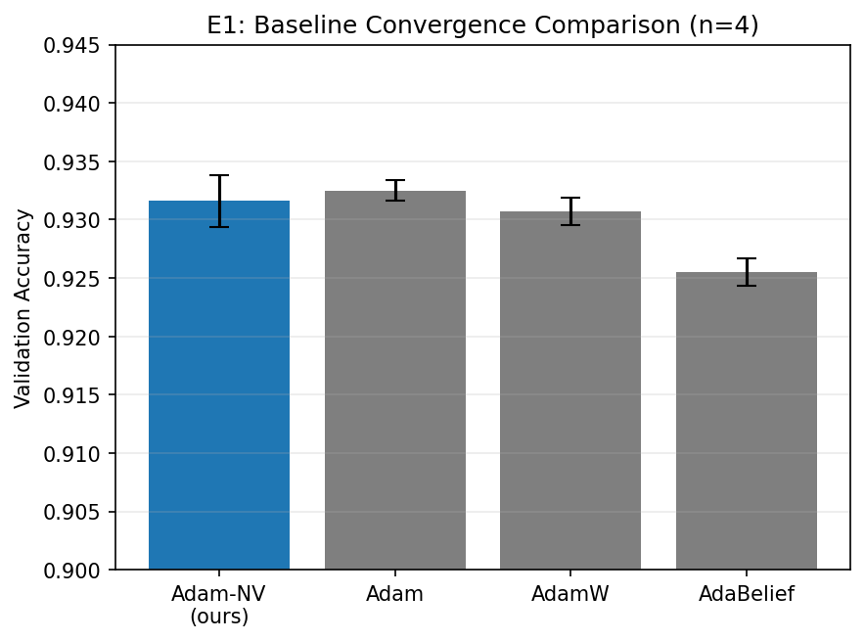
Figure 4. E1 baseline convergence comparison (n = 4 seeds).
Table 2. E1 baseline comparison (n = 4 seeds).
Optimizer | Val. Acc. (mean ± std) | Epochs to 90% | Significant vs. Adam-NV (Holm-corrected)
Adam-NV (ours) | 0.9316 ± 0.0022 | 19 | —
Adam | 0.9325 ± 0.0009 | 21 | No
AdamW | 0.9307 ± 0.0012 | 19 | No
AdaBelief | 0.9255 ± 0.0012 | 26 | Yes (p < 0.0167)

Findings. Figure 4 and Table 2 show Adam-NV within the range of Adam and AdamW at n = 4 seeds, with no resolvable difference from either. A resolvable difference was observed only against AdaBelief, surviving Holm-Bonferroni correction across the three pre-specified comparisons; extending this comparison to n = 8 seeds (Δacc = 0.0066, p = 0.000001) reproduced the same direction and magnitude. These results establish Adam-NV as a viable first-order optimizer under unperturbed training, providing the baseline against which the noise-response experiments that follow are interpreted.
E7-A directly tests whether time-varying adaptation, specifically, contributes to any behavioral or performance difference of the kind observed here.

4.2 E2 (H2a) — Mechanism Validation Under Gradient Noise
Question. Does Adam-NV's adaptive controller respond to injected gradient noise, and if so, at what noise magnitude?
Figure 5 shows mean β₁ trajectories across all four tested noise levels over 60 epochs of training; mean σ² followed a qualitatively similar pattern across the same conditions (Table 5).

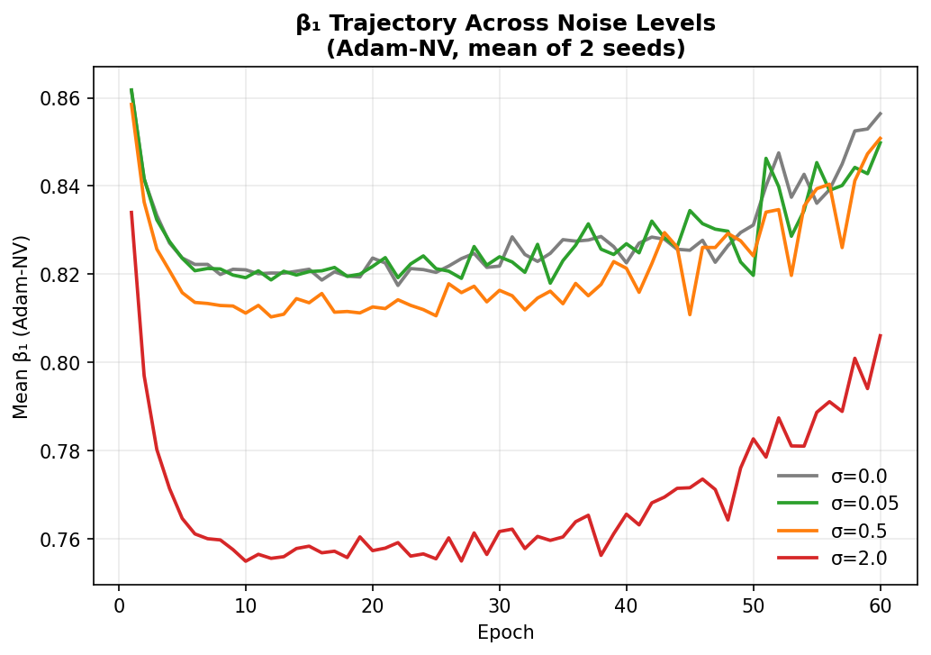
Figure 5. Mean β₁ trajectories across all four tested noise levels over 60 epochs of training (Adam-NV, mean of 2 seeds).
Table 5. Final-epoch mechanism state by noise level.
σ | Final β₁ (approx.) | β₁ / σ² response relative to σ = 0.0
0.0 | ~0.86 | —
0.05 | ~0.85 | Not distinguishable
0.5 | ~0.81–0.84 | Modest separation
2.0 | ~0.72–0.80 | Pronounced, sustained separation

Findings. Figure 5 shows β₁ separating by noise level only above a threshold near σ = 0.5; trajectories at σ = 0.0 and σ = 0.05 remain indistinguishable throughout training, while σ = 2.0 produces a pronounced, sustained separation (Table 5). Mean σ² followed the same pattern. Per-step diagnostics confirmed injected noise reached the optimizer at the calibrated magnitude at every tested σ.
E2 (H2b) reports whether this mechanism-level response corresponds to a difference in final accuracy between Adam-NV and Adam.

4.3 E2 (H2b) — Performance Robustness Under Gradient Noise
Question. Does Adam-NV's final accuracy degrade less than Adam's under injected gradient noise?
Figure 6 shows validation accuracy curves for Adam and Adam-NV across all four noise levels; Figure 6b shows the corresponding training-loss curves for the same conditions.

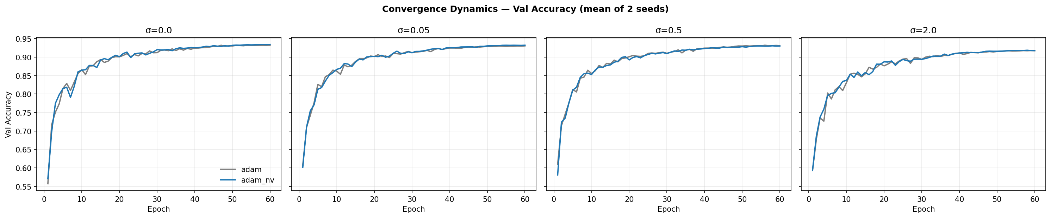
Figure 6. Validation accuracy curves for Adam and Adam-NV across all four noise levels (mean of 2 seeds).
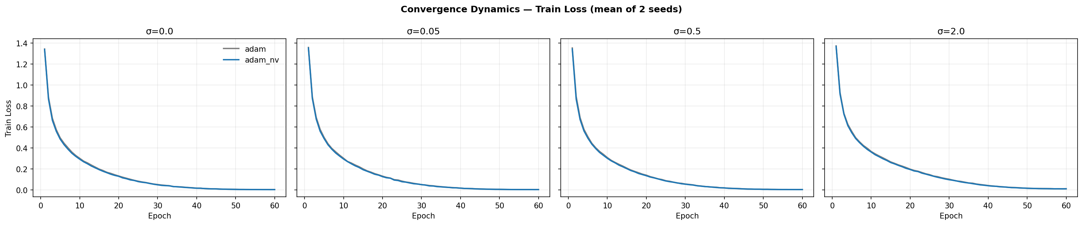
Figure 6b. Training loss curves for Adam and Adam-NV across all four noise levels (mean of 2 seeds), corresponding to the same σ sweep as Figure 6.
Table 6. Δacc comparison, Adam vs. Adam-NV.
σ | Adam val. acc. | Adam-NV val. acc. | Δacc (Adam) | Δacc (Adam-NV)
0.0 | 0.9324 | 0.9344 | — | —
0.05 | 0.9306 | 0.9324 | 0.0018 | 0.0017
0.5 | 0.9313 | 0.9302 | 0.0003 | 0.0038
2.0 | 0.9174 | 0.9177 | 0.0145 | 0.0158

Findings. Table 6 shows Adam-NV's Δacc was not smaller than Adam's at any tested noise level, including σ = 2.0, where the mechanism response is most pronounced (Figure 5). A power analysis at σ = 2.0 (pooled std ≈ 0.0025) indicates approximately 100 seeds per condition would be needed to resolve a difference of the observed magnitude.
E7-A and E7-C examine whether adaptation strength, specifically, affects outcomes under conditions where the mechanism is confirmed active (σ = 2.0).

4.4 E7-A — Adaptive vs. Fixed β₁ Ablation
Question. Is any behavior of Adam-NV attributable to time-varying adaptation of β₁, as distinct from Adam-NV converging on an effective constant value?
Figure 7 compares final validation accuracy between full adaptive Adam-NV and a fixed-β₁ variant, obtained by setting γ = 0 so that β₁ remains at its configured constant for the duration of training (Section 3.9), at both tested noise levels.

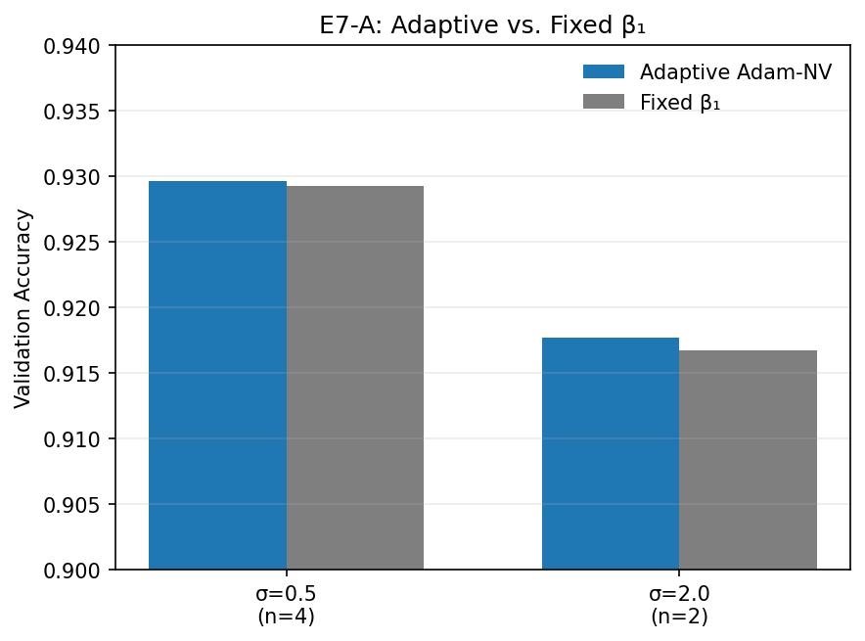
Figure 7. Final validation accuracy, adaptive Adam-NV vs. a fixed-β₁ variant, at both tested noise levels.
Table 7. Adaptive vs. fixed-β₁ comparison.
σ | Fixed β₁ | Δacc (adaptive − fixed) | Epochs to 90% (adaptive / fixed) | Cross-seed std (adaptive / fixed)
0.5 | 0.8366 | 0.0004 | 18, 19, 20, 23 / 18, 18, 22, 22 | 0.0021 / 0.0017
2.0 | 0.79 | 0.0009 | 32, 33 / 32, 33 | 0.0025 / 0.0017

Findings. Figure 7 and Table 7 show no resolvable advantage for the adaptive configuration over the fixed-β₁ configuration in final accuracy, convergence speed, or cross-seed stability at either noise level. Per-step logging confirmed the fixed variant held β₁ at the configured constant throughout training.
E7-C extends this comparison across a continuous range of adaptation strength (γ) rather than a single on/off contrast.

4.5 E7-C — Adaptation-Strength (γ) Sweep
Question. How do mechanism state and accuracy vary with adaptation strength γ?
Figure 8a and Figure 8b show mean β₁ and mean σ² trajectories for γ ∈ {0, 0.5, 1, 2}; Figure 8c and Figure 8d show the corresponding accuracy trend.

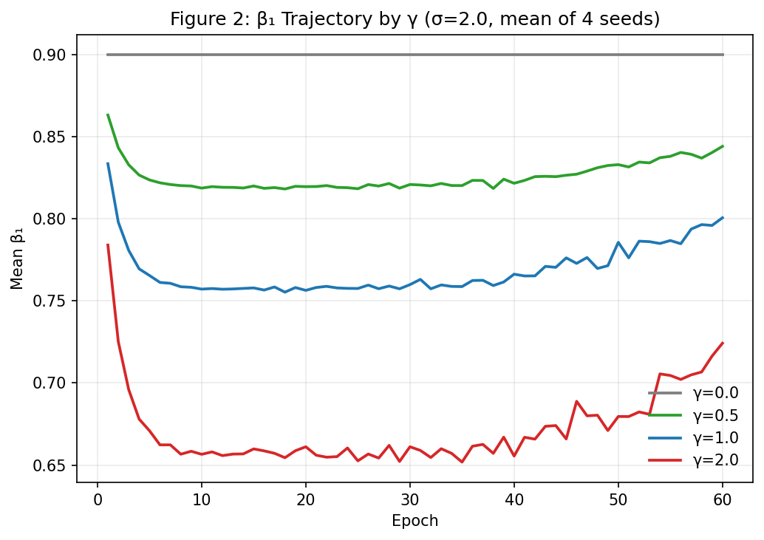
Figure 8a. Mean β₁ trajectory by γ (σ = 2.0, mean of 4 seeds).
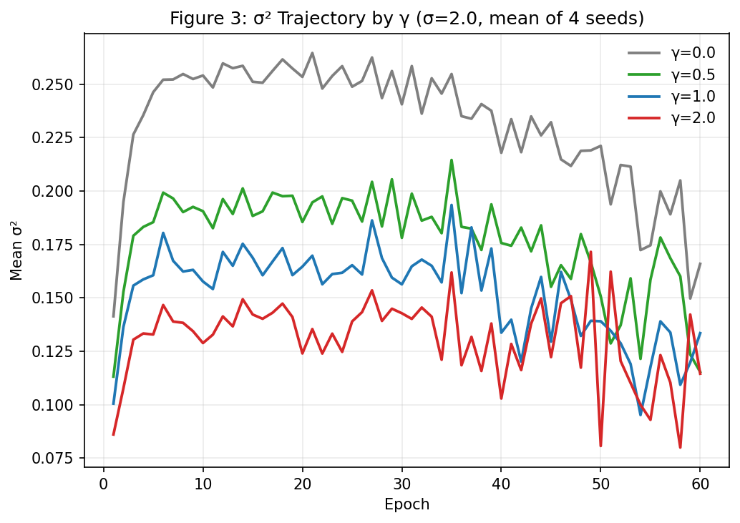
Figure 8b. Mean σ² trajectory by γ (σ = 2.0, mean of 4 seeds).
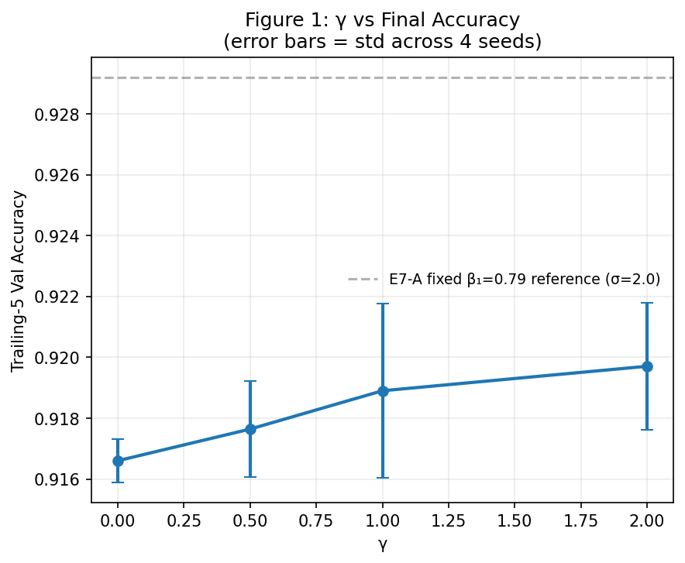
Figure 8c. Trailing-5 validation accuracy as a function of γ (error bars: standard deviation across 4 seeds; dashed line: E7-A fixed-β₁ reference at σ = 2.0).
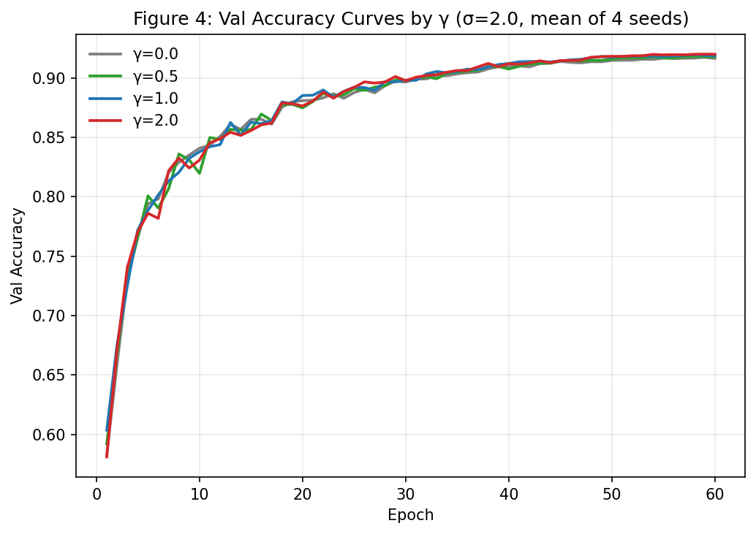
Figure 8d. Validation accuracy curves by γ (σ = 2.0, mean of 4 seeds).
Table 9. E7-C mechanism and accuracy by γ (n = 4).
γ | Final β₁ | Final σ² | Trailing-5 val. acc.
0.0 | 0.9000 | 0.1660 | 0.9166
0.5 | 0.8442 | 0.1154 | 0.9176
1.0 | 0.8007 | 0.1335 | 0.9189
2.0 | 0.7242 | 0.1145 | 0.9197

Findings. Figure 8a and Figure 8b show mean β₁ and mean σ² varying with γ — monotonically for β₁, non-monotonically for σ² (Table 9). Figure 8c and Figure 8d show final accuracy trending upward with γ. The pre-specified comparison (γ = 0 vs. γ = 1) showed no resolvable difference (t = 1.558, p = 0.207). A post-hoc comparison at γ = 2.0, the empirically highest-accuracy value, was likewise not resolvable at n = 4 or n = 8 (p = 0.0535 and p = 0.0865, respectively).
E9 reports the computational cost associated with Adam-NV's mechanism, independent of its effect on accuracy.

4.6 E9 — Computational Overhead
Question. What is Adam-NV's per-epoch computational overhead relative to Adam, and is it constant across training conditions?
Figure 9 shows the overhead ratio (Adam-NV time / Adam time) as a function of batch size, with a horizontal reference line at 1× indicating no overhead.

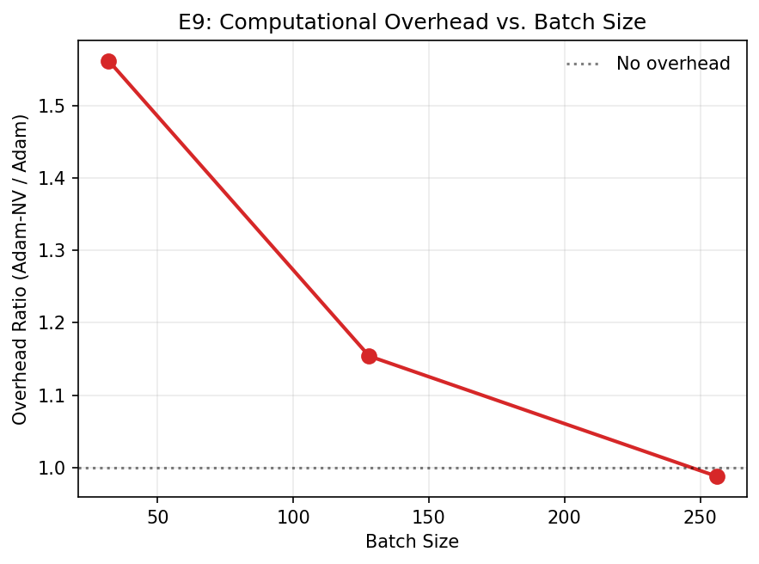
Figure 9. Overhead ratio (Adam-NV time / Adam time) as a function of batch size, with a 1× reference line indicating no overhead.
Table 11. Overhead ratio (Adam-NV / Adam) across tested conditions.
Condition | Adam (s/epoch) | Adam-NV (s/epoch) | Ratio
Batch size 32 | 50.19 | 78.38 | 1.562×
Batch size 128 | 42.21 | 48.70 | 1.154×
Batch size 256 | 46.48 | 45.92 | 0.988×
σ sweep (E2, mean across 4 levels, bs = 128) | — | — | 1.21×
Label noise, clean (E11, bs = 128) | — | — | 1.18×
Label noise, 20% corrupted (E11, bs = 128) | — | — | 1.14×

Findings. Figure 9 and Table 11 show overhead ratio ranging from 1.562× at batch size 32 to 0.988× at batch size 256, indicating overhead is configuration-dependent rather than an intrinsic, fixed cost of the optimizer. Ratio was consistent (1.13×–1.28×) across all tested gradient-noise and label-noise conditions at fixed batch size 128.
E11 and E12 report mechanism and accuracy behavior under label corruption and batch-size variation respectively, the two remaining perturbation types examined in this study.

4.7 E11 — Label-Noise Evaluation
Question. Does Adam-NV's mechanism respond to label corruption, a structurally different perturbation from injected Gaussian gradient noise, and does any such response correspond to improved robustness?
Figure 10 shows mean β₁ and mean σ² trajectories for clean vs. 20%-label-corrupted training over 60 epochs; the two trajectories cross near epoch 26, as annotated in the figure.

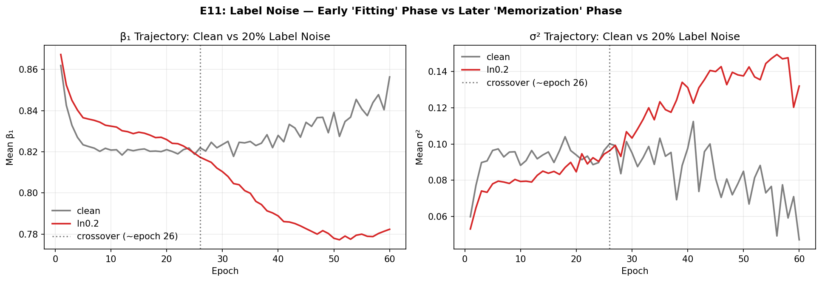
Figure 10. Mean β₁ and mean σ² trajectories, clean vs. 20%-label-corrupted training, over 60 epochs.
Table 12. E11 accuracy and mechanism state, clean vs. 20% label-corrupted training.
Metric | Clean | 20% Label Noise | Statistic
Adam val. acc. | 0.9329 ± 0.0014 | 0.7863 ± 0.0024 | Degradation = 0.1466
Adam-NV val. acc. | 0.9323 ± 0.0031 | 0.7871 ± 0.0064 | Degradation = 0.1453
Mean β₁ (final) | 0.8452 | 0.7803 | t = 28.18, p = 0.00008
Mean σ² (final) | 0.0609 | 0.1391 | t = −12.50, p = 0.00002

Findings. Figure 10 and Table 12 show mean β₁ and mean σ² diverging between clean and label-corrupted training by epoch 60, crossing near epoch 26. The interaction effect — whether Adam-NV's degradation was smaller than Adam's — showed no resolvable difference (Δ = 0.0013, p = 0.79). Overhead ratio under label noise (1.18× clean, 1.14× at 20%) was consistent with the batch-size-128 figure reported in E9 (Table 11).
E12 examines whether the same mechanism responds to gradient noise arising intrinsically from minibatch sampling, rather than from an explicit perturbation (gradient noise, in E2; label corruption, here).

4.8 E12 — Batch-Size Sensitivity
Question. Does Adam-NV's controller respond to gradient noise that arises intrinsically from minibatch sampling, and does batch size affect accuracy or computational overhead?
Figure 11 shows mean β₁ and mean σ² as a function of batch size.

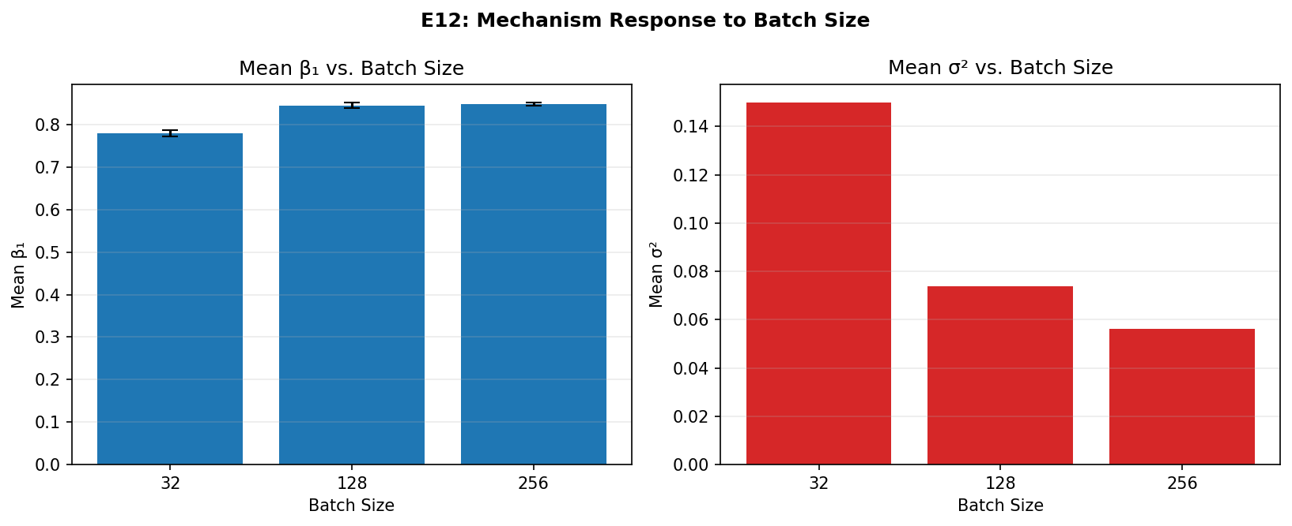
Figure 11. Mean β₁ and mean σ² as a function of batch size.
Table 13. Mechanism and accuracy by batch size (n = 4).
Batch size | Mean β₁ (± std) | Mean σ² | Δacc (Adam-NV − Adam) | p (Δacc)
32 | 0.7802 ± 0.0073 | 0.1499 | 0.0004 | 0.65
128 | 0.8454 ± 0.0057 | 0.0738 | 0.0005 | 0.72
256 | 0.8482 ± 0.0039 | 0.0563 | 0.0006 | 0.50

Findings. Figure 11 and Table 13 show mean β₁ differing between batch size 32 and batch sizes 128 and 256 (p ≤ 0.00003 for both comparisons), consistent with a possible threshold effect rather than a continuously graded response. β₁ did not differ resolvably between batch sizes 128 and 256 (p = 0.45), despite a twofold difference in per-epoch step count. No resolvable Δacc between Adam and Adam-NV was observed at any batch size tested.
This concludes the experimental results. Table 14 summarizes mechanism-validation and performance outcomes across the noise-response experiments reported above; Section 5 discusses these findings jointly, including their cross-experiment consistency and the limitations of the present study.

Table 14. Summary of mechanism validation and performance outcomes across noise-response experiments.
Experiment | Mechanism Response Confirmed | Resolvable Accuracy Improvement over Adam
E2 | ✓ | ✗
E7-A | ✓ | ✗
E7-C | ✓ | ✗
E11 | ✓ | ✗
E12 | ✓ | ✗

5. Discussion
5.1 Synthesis of Findings
Across every noise-response experiment in this study — injected gradient noise (E2), the adaptive-vs-fixed ablation (E7-A), the adaptation-strength sweep (E7-C), label corruption (E11), and batch-size-intrinsic noise (E12) — Adam-NV's controller responded as designed: β₁ and σ² tracked the presence and structure of training-time perturbation (Table 14). In no case, however, did this response translate into a resolvable improvement in final validation accuracy over standard Adam. E1 separately established that Adam-NV is competitive with existing first-order adaptive optimizers under unperturbed training. Taken together, these results indicate that Adam-NV's mechanism operates correctly without yet demonstrating a performance benefit.
5.2 Practical Implications
These results suggest that Adam-NV is not yet a general drop-in replacement for Adam when the goal is improved accuracy under noisy training conditions. Its overhead (1.15×–1.56×, Table 11) is not offset by a resolvable accuracy gain in any condition tested here. Adam-NV may currently be best suited to settings where the mechanism's behavior — rather than its effect on final accuracy — is itself of interest: for example, as a diagnostic for the reliability of the gradient signal during training, or as a component within a broader controller that couples β₁ adaptation with other hyperparameters (Section 5.4).
5.3 Why Mechanism Does Not Imply Performance
A plausible explanation is that Adam's existing per-parameter second-moment normalization already absorbs much of the effect that β₁ adaptation targets. If the denominator term already down-weights unreliable directions, an additional, first-moment-level noise response may be largely redundant rather than additive. This is consistent with the absence of a resolvable accuracy difference even at σ = 2.0, where the mechanism response is most pronounced (E2, E7-A).
5.4 Why β₁ Adaptation Alone May Be Insufficient
Noise robustness in adaptive optimizers is typically distributed across several interacting terms — the first-moment decay rate, the second-moment decay rate, the effective learning rate, and any gradient clipping applied. Adapting only β₁ leaves these other terms fixed, which may limit the mechanism's ability to influence final accuracy on its own. A controller that jointly adapts β₁ and β₂, or that couples β₁ adaptation to the learning-rate schedule, may be a necessary extension rather than an incremental one.
5.5 Why Optimizer Competitiveness Does Not Imply Mechanism Benefit
E1 shows Adam-NV performs comparably to Adam and AdamW under unperturbed training. This competitiveness establishes that the mechanism does not harm performance, but it should not be read as evidence that the mechanism helps performance; the noise-response experiments (E2, E7-A, E7-C, E11, E12) test that question directly, and none show a resolvable benefit.
5.6 Future Controller Designs
Extensions worth testing directly from these results include a joint β₁–β₂ controller, per-layer rather than per-tensor adaptation strength, and a controller tuned specifically to respond to label corruption rather than to zero-mean gradient noise, given the qualitatively different trajectory shape observed in E11. Coupling the noise estimate to an adaptive learning-rate reduction, rather than to β₁ alone, is also a natural next step given the discussion in Section 5.4.
5.7 Threats to Validity
Several factors limit the generality of these conclusions:
- Architecture. All experiments use a single CIFAR-adapted ResNet-18; results may not transfer to other architectures (e.g., transformers, wider or deeper networks).
- Dataset. CIFAR-10 is the sole primary dataset; label noise and gradient noise were studied on this dataset alone.
- Batch-size / step-count coupling. E12's batch-size conditions co-vary with per-epoch step count at a fixed epoch budget (Section 3.9), so batch-size and step-count effects cannot be fully separated.
- Optimizer family. Comparisons are limited to Adam-family optimizers (Adam, AdamW, AdaBelief); no comparison was made to non-adaptive methods (e.g., SGD with momentum).
- Epoch budget. All experiments use a fixed 60-epoch budget; mechanism or performance differences that emerge only over longer training schedules would not be captured here.

6. Conclusion
This study introduced Adam-NV, a first-order adaptive optimizer that varies β₁ per parameter and per step as a function of a locally estimated noise-to-signal ratio σ². The mechanism lowers β₁ when σ² is high and raises it toward its nominal value when σ² is low, with the goal of reducing reliance on historical momentum when the instantaneous gradient signal is less reliable.
Across explicit gradient-noise injection (E2), an adaptive-vs-fixed ablation (E7-A), a continuous adaptation-strength sweep (E7-C), label corruption (E11), and batch-size-intrinsic noise (E12), the experiments in this study established that Adam-NV's controller responds to training-time perturbation in the direction predicted by its design. E1 further established that Adam-NV is competitive with existing first-order adaptive optimizers under unperturbed training.
These experiments did not establish a resolvable improvement in final validation accuracy over standard Adam, in any tested condition, at the seed counts used here. This holds whether noise is injected explicitly, arises from label corruption, or arises intrinsically from minibatch sampling.
Future work should test whether jointly adapting β₁ and β₂, coupling the noise estimate to the learning-rate schedule, or applying adaptation at finer (e.g., per-layer) granularity yields the performance benefit that per-parameter β₁ adaptation alone does not, and should extend this evaluation beyond a single architecture, dataset family, and epoch budget.

