4. Results
This section reports the available findings in the order established in the methodology. E1 is provisional because baseline seed counts are unequal. E2, E7-A, and E7-C test controller response and adaptation; E9 reports exploratory timing; E11 and E12 test label and batch-size perturbations. E13–E15 are reanalyzed with paired statistics, while E16 and corrected protocol-v2 response-lag reruns remain pending. Findings are separated from interpretation, which is discussed in Section 5.

4.1 E1 — Baseline Convergence Benchmarking
Question. Is Adam-NV's behavior on unperturbed CIFAR-10 training competitive with established first-order adaptive optimizers?
Figure 4 shows provisional trailing-five-epoch validation accuracy. The repository contains four Adam-NV runs but only two complete runs for Adam, AdamW, and AdaBelief; inferential E1 comparisons are therefore withheld pending completion of baseline seeds 2 and 3.

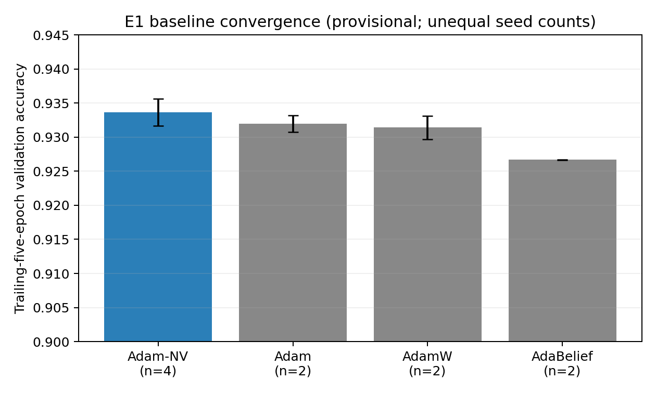
Figure 4. Provisional E1 comparison using available runs; unequal seed counts preclude confirmatory optimizer comparisons.
Table 2. Provisional E1 baseline summary using available repository logs.
Optimizer | Trailing-5 val. acc. | Available n | Confirmatory comparison
Adam-NV (ours) | 0.9337 ± 0.0020 | 4 | Withheld - incomplete baselines
Adam | 0.9319 ± 0.0012 | 2 | Withheld - incomplete baselines
AdamW | 0.9314 ± 0.0017 | 2 | Withheld - incomplete baselines
AdaBelief | 0.9267 ± 0.0000 | 2 | Withheld - incomplete baselines

Findings. Adam-NV has four complete runs; Adam, AdamW, and AdaBelief each have two. The previously reported n=4 baseline table and significance claims are unsupported by the repository snapshot and are withdrawn. No E1 optimizer-superiority or equivalence claim should be made until seeds 2 and 3 are completed for every baseline and paired analysis is rerun.
E7-A directly tests whether time-varying adaptation, specifically, contributes to any behavioral or performance difference of the kind observed here.

4.2 E2 (H2a) — Mechanism Validation Under Gradient Noise
Question. Does Adam-NV's adaptive controller respond to injected gradient noise, and if so, at what noise magnitude?
Figure 5 shows mean β₁ trajectories across all four tested noise levels over 60 epochs of training; mean σ² followed a qualitatively similar pattern across the same conditions (Table 5).

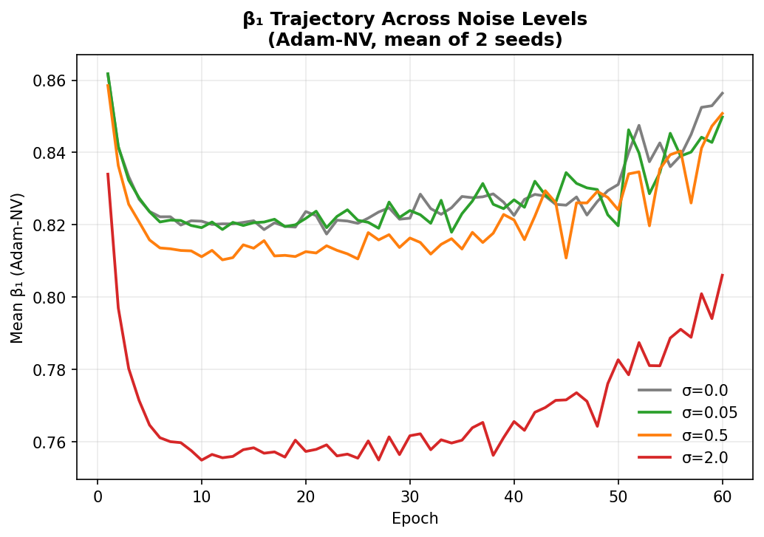
Figure 5. Mean β₁ trajectories across all four tested noise levels over 60 epochs of training (Adam-NV, mean of 2 seeds).
Table 5. Final-epoch mechanism state by noise level.
σ | Final β₁ (approx.) | β₁ / σ² response relative to σ = 0.0
0.0 | ~0.86 | —
0.05 | ~0.85 | Not distinguishable
0.5 | ~0.81–0.84 | Modest separation
2.0 | ~0.72–0.80 | Pronounced, sustained separation

Findings. Figure 5 shows β₁ separating by noise level only above a threshold near σ = 0.5; trajectories at σ = 0.0 and σ = 0.05 remain indistinguishable throughout training, while σ = 2.0 produces a pronounced, sustained separation (Table 5). Mean σ² followed the same pattern. Per-step diagnostics confirmed injected noise reached the optimizer at the calibrated magnitude at every tested σ.
E2 (H2b) reports whether this mechanism-level response corresponds to a difference in final accuracy between Adam-NV and Adam.

4.3 E2 (H2b) — Performance Robustness Under Gradient Noise
Question. Does Adam-NV's final accuracy degrade less than Adam's under injected gradient noise?
Figure 6 shows validation accuracy curves for Adam and Adam-NV across all four noise levels; Figure 6b shows the corresponding training-loss curves for the same conditions.

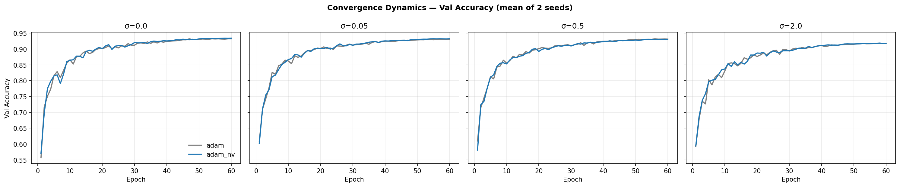
Figure 6. Validation accuracy curves for Adam and Adam-NV across all four noise levels (mean of 2 seeds).
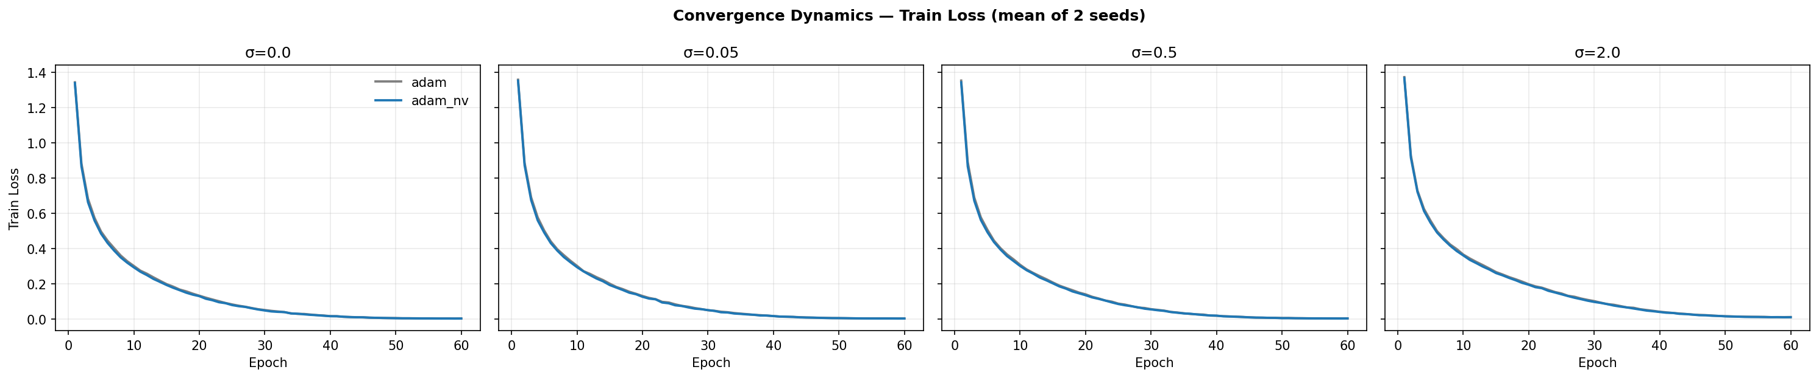
Figure 6b. Training loss curves for Adam and Adam-NV across all four noise levels (mean of 2 seeds), corresponding to the same σ sweep as Figure 6.
Table 6. Δacc comparison, Adam vs. Adam-NV.
σ | Adam val. acc. | Adam-NV val. acc. | Δacc (Adam) | Δacc (Adam-NV)
0.0 | 0.9324 | 0.9344 | — | —
0.05 | 0.9306 | 0.9324 | 0.0018 | 0.0017
0.5 | 0.9313 | 0.9302 | 0.0003 | 0.0038
2.0 | 0.9174 | 0.9177 | 0.0145 | 0.0158

Findings. Table 6 shows Adam-NV's Δacc was not smaller than Adam's at any tested noise level, including σ = 2.0, where the mechanism response is most pronounced (Figure 5). A power analysis at σ = 2.0 (pooled std ≈ 0.0025) indicates approximately 100 seeds per condition would be needed to resolve a difference of the observed magnitude.
E7-A and E7-C examine whether adaptation strength, specifically, affects outcomes under conditions where the mechanism is confirmed active (σ = 2.0).

4.4 E7-A — Adaptive vs. Fixed β₁ Ablation
Question. Is any behavior of Adam-NV attributable to time-varying adaptation of β₁, as distinct from Adam-NV converging on an effective constant value?
Figure 7 compares final validation accuracy between full adaptive Adam-NV and a fixed-β₁ variant, obtained by setting γ = 0 so that β₁ remains at its configured constant for the duration of training (Section 3.9), at both tested noise levels.

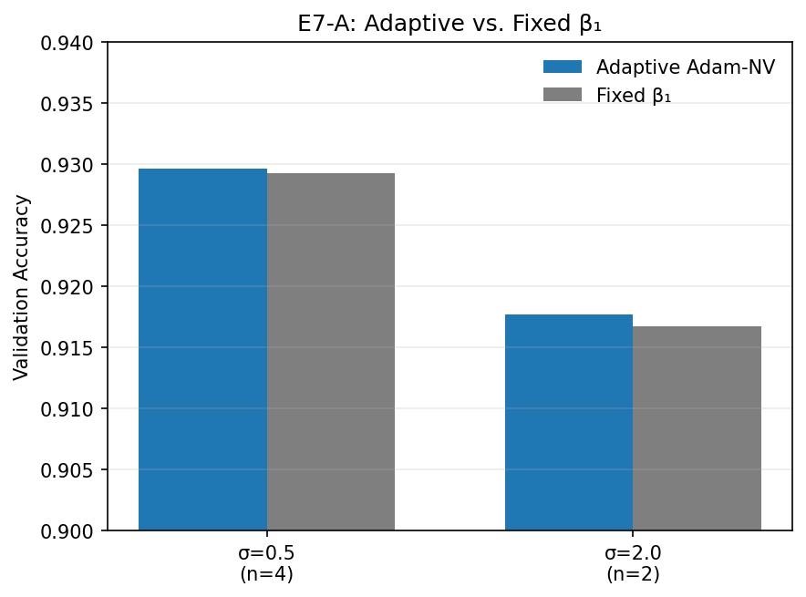
Figure 7. Final validation accuracy, adaptive Adam-NV vs. a fixed-β₁ variant, at both tested noise levels.
Table 7. Adaptive vs. fixed-β₁ comparison.
σ | Fixed β₁ | Δacc (adaptive − fixed) | Epochs to 90% (adaptive / fixed) | Cross-seed std (adaptive / fixed)
0.5 | 0.8366 | 0.0004 | 18, 19, 20, 23 / 18, 18, 22, 22 | 0.0021 / 0.0017
2.0 | 0.79 | 0.0009 | 32, 33 / 32, 33 | 0.0025 / 0.0017

Findings. Figure 7 and Table 7 show no resolvable advantage for the adaptive configuration over the fixed-β₁ configuration in final accuracy, convergence speed, or cross-seed stability at either noise level. Per-step logging confirmed the fixed variant held β₁ at the configured constant throughout training.
E7-C extends this comparison across a continuous range of adaptation strength (γ) rather than a single on/off contrast.

4.5 E7-C — Adaptation-Strength (γ) Sweep
Question. How do mechanism state and accuracy vary with adaptation strength γ?
Figure 8a and Figure 8b show mean β₁ and mean σ² trajectories for γ ∈ {0, 0.5, 1, 2}; Figure 8c and Figure 8d show the corresponding accuracy trend.

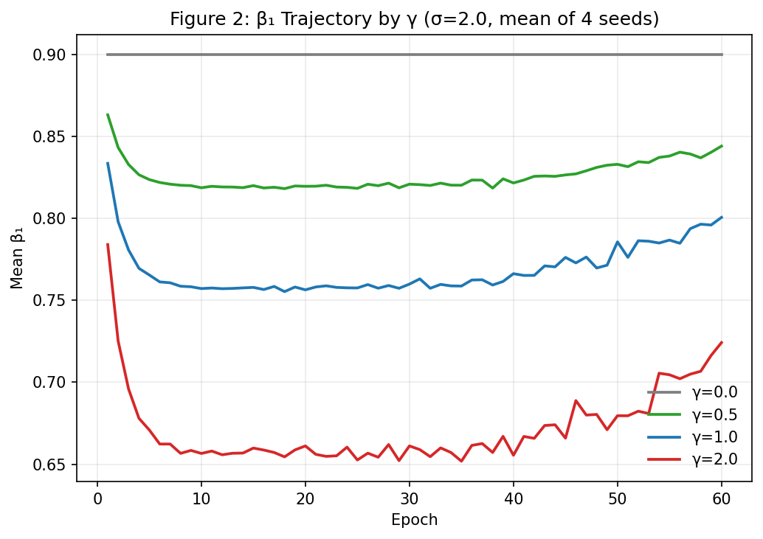
Figure 8a. Mean β₁ trajectory by γ (σ = 2.0, mean of 4 seeds).
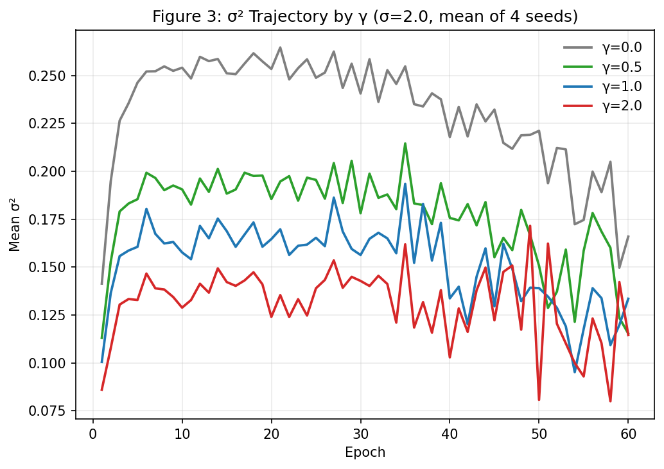
Figure 8b. Mean σ² trajectory by γ (σ = 2.0, mean of 4 seeds).
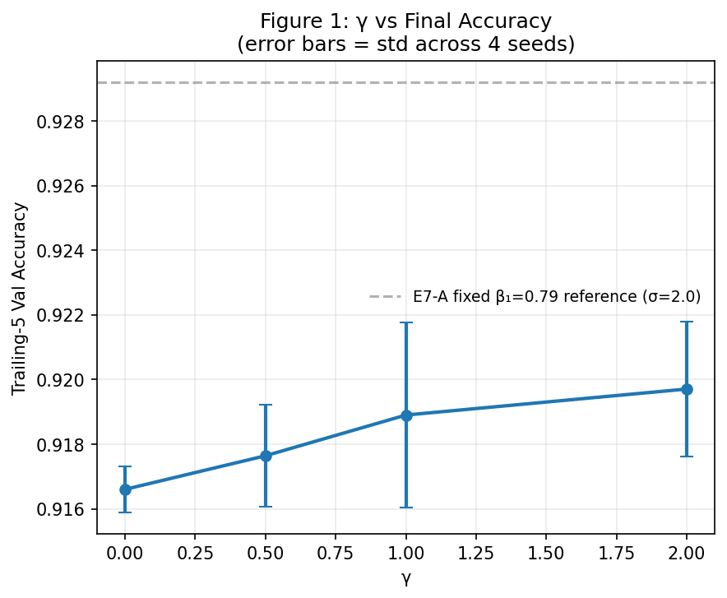
Figure 8c. Trailing-5 validation accuracy as a function of γ (error bars: standard deviation across 4 seeds; dashed line: E7-A fixed-β₁ reference at σ = 2.0).
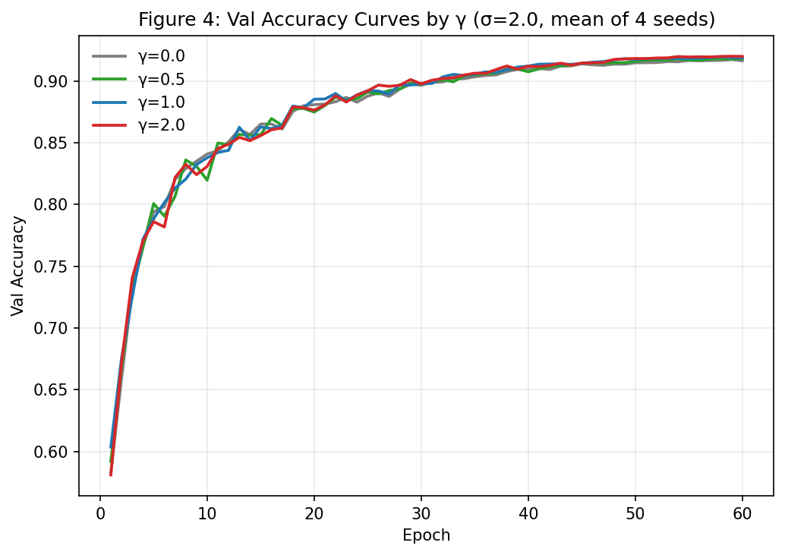
Figure 8d. Validation accuracy curves by γ (σ = 2.0, mean of 4 seeds).
Table 9. E7-C mechanism and accuracy by γ (n = 4).
γ | Final β₁ | Final σ² | Trailing-5 val. acc.
0.0 | 0.9000 | 0.1660 | 0.9166
0.5 | 0.8442 | 0.1154 | 0.9176
1.0 | 0.8007 | 0.1335 | 0.9189
2.0 | 0.7242 | 0.1145 | 0.9197

Findings. Figure 8a and Figure 8b show mean β₁ and mean σ² varying with γ — monotonically for β₁, non-monotonically for σ² (Table 9). Figure 8c and Figure 8d show final accuracy trending upward with γ. The pre-specified comparison (γ = 0 vs. γ = 1) showed no resolvable difference (t = 1.558, p = 0.207). A post-hoc comparison at γ = 2.0, the empirically highest-accuracy value, was likewise not resolvable at n = 4 or n = 8 (p = 0.0535 and p = 0.0865, respectively).
E9 reports the computational cost associated with Adam-NV's mechanism, independent of its effect on accuracy.

4.6 E9 — Computational Overhead
Question. What is Adam-NV's per-epoch computational overhead relative to Adam, and is it constant across training conditions?
Figure 9 shows the overhead ratio (Adam-NV time / Adam time) as a function of batch size, with a horizontal reference line at 1× indicating no overhead.

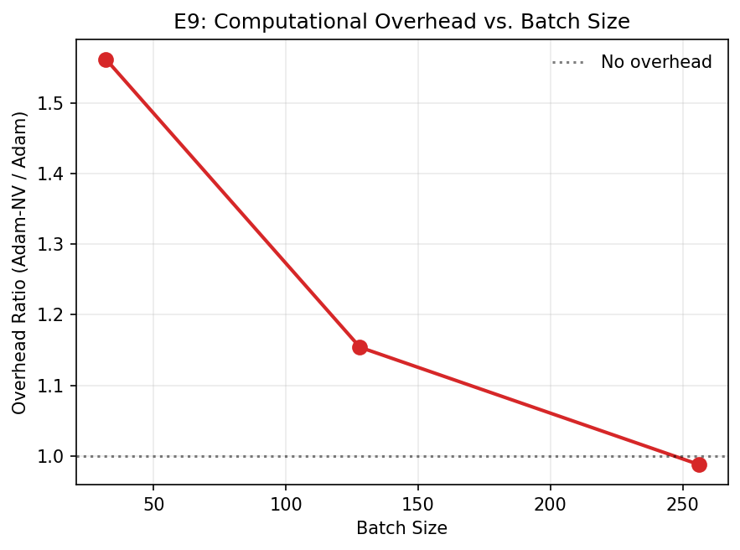
Figure 9. Overhead ratio (Adam-NV time / Adam time) as a function of batch size, with a 1× reference line indicating no overhead.
Table 11. Overhead ratio (Adam-NV / Adam) across tested conditions.
Condition | Adam (s/epoch) | Adam-NV (s/epoch) | Ratio
Batch size 32 | 50.19 | 78.38 | 1.562×
Batch size 128 | 42.21 | 48.70 | 1.154×
Batch size 256 | 46.48 | 45.92 | 0.988×
σ sweep (E2, mean across 4 levels, bs = 128) | — | — | 1.21×
Label noise, clean (E11, bs = 128) | — | — | 1.18×
Label noise, 20% corrupted (E11, bs = 128) | — | — | 1.14×

Findings. The displayed epoch-time ratios are exploratory and vary from 0.988x to 1.562x across batch sizes. Because they were not obtained from repeated synchronized benchmark runs and lack uncertainty estimates, they do not support a stable-overhead claim. Confirmatory timing remains pending under the repeated warm-up and profiling protocol in Section 3.9.
E11 and E12 report mechanism and accuracy behavior under label corruption and batch-size variation respectively, the two remaining perturbation types examined in this study.

4.7 E11 — Label-Noise Evaluation
Question. Does Adam-NV's mechanism respond to label corruption, a structurally different perturbation from injected Gaussian gradient noise, and does any such response correspond to improved robustness?
Figure 10 shows mean β₁ and heuristic-score trajectories for clean and 20%-label-corrupted training. The curves cross near epoch 26, but these controller trajectories alone cannot identify a memorization transition.

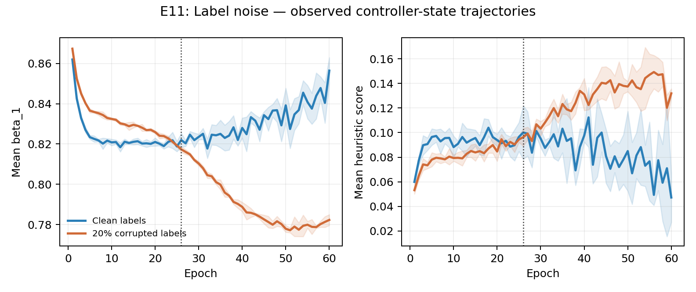
Figure 10. Mean β₁ and mean σ² trajectories, clean vs. 20%-label-corrupted training, over 60 epochs.
Table 12. E11 accuracy and mechanism state, clean vs. 20% label-corrupted training.
Metric | Clean | 20% Label Noise | Statistic
Adam val. acc. | 0.9329 ± 0.0014 | 0.7863 ± 0.0024 | Degradation = 0.1466
Adam-NV val. acc. | 0.9323 ± 0.0031 | 0.7871 ± 0.0064 | Degradation = 0.1453
Mean β₁ (final) | 0.8452 | 0.7803 | t = 28.18, p = 0.00008
Mean σ² (final) | 0.0609 | 0.1391 | t = −12.50, p = 0.00002

Findings. Mean β₁ and the heuristic score diverge between clean and label-corrupted training by epoch 60. The crossover near epoch 26 is a mechanism-state observation, not direct evidence of memorization. The claim remains provisional until training accuracy is measured separately on uncorrupted examples and corrupted examples against both clean and reassigned labels. No detectable robustness advantage was found in the reported interaction analysis.
E12 examines whether the same mechanism responds to gradient noise arising intrinsically from minibatch sampling, rather than from an explicit perturbation (gradient noise, in E2; label corruption, here).

4.8 E12 — Batch-Size Sensitivity
Question. Does Adam-NV's controller respond to gradient noise that arises intrinsically from minibatch sampling, and does batch size affect accuracy or computational overhead?
Figure 11 shows mean β₁ and mean σ² as a function of batch size.

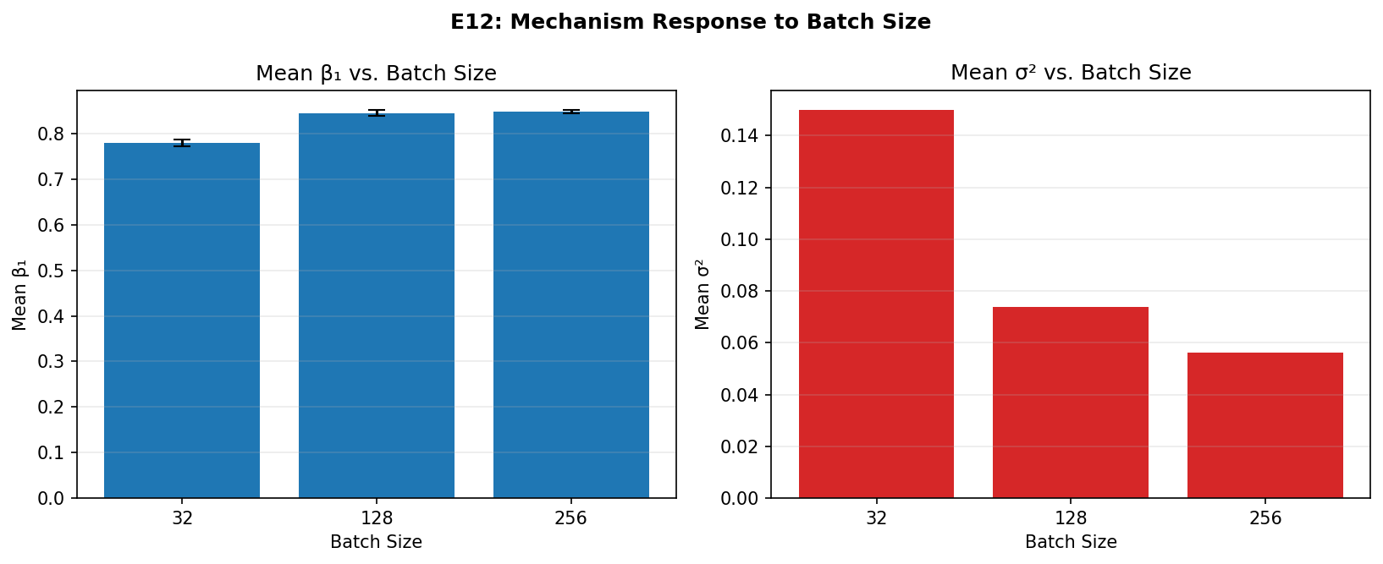
Figure 11. Mean β₁ and mean σ² as a function of batch size.
Table 13. Mechanism and accuracy by batch size (n = 4).
Batch size | Mean β₁ (± std) | Mean σ² | Δacc (Adam-NV − Adam) | p (Δacc)
32 | 0.7802 ± 0.0073 | 0.1499 | 0.0004 | 0.65
128 | 0.8454 ± 0.0057 | 0.0738 | 0.0005 | 0.72
256 | 0.8482 ± 0.0039 | 0.0563 | 0.0006 | 0.50

Findings. Figure 11 and Table 13 show mean β₁ differing between batch size 32 and batch sizes 128 and 256 (p ≤ 0.00003 for both comparisons), consistent with a possible threshold effect rather than a continuously graded response. β₁ did not differ resolvably between batch sizes 128 and 256 (p = 0.45), despite a twofold difference in per-epoch step count. No resolvable Δacc between Adam and Adam-NV was observed at any batch size tested.
Table 14 summarizes observed controller responses and performance outcomes for E2, E7-A, E7-C, E11, and E12. Section 4.9 then records the completion status of E13–E16 before Section 5 discusses the findings jointly.

Table 14. Summary of observed controller responses and performance outcomes.
Experiment | Logged controller response observed | Resolvable Accuracy Improvement over Adam
E2 | ✓ | ✗
E7-A | ✓ | ✗
E7-C | ✓ | ✗
E11 | ✓ | ✗
E12 | ✓ | ✗

4.9 E13–E16 — Extended Study Status
E13 non-stationary schedules, E14 coupled β₂ sensitivity, and E15 decoupled noise memory are present in the repository and have been reanalyzed with paired seed matching. In the current exploratory table, no E13 Adam-NV-versus-Adam contrast and no E15 decoupled-versus-coupled contrast survives Holm correction. E14 suggests a ramp-up degradation at β₂=0.95 in the adjusted paired t-test, but the exact four-seed sign-flip p-value is 0.125. One intermittent E14 run ends at epoch 32, so the analysis correctly refuses publication-mode output. E16 CIFAR-100 and all protocol-v2 lag reruns remain pending. These extended results must replace, not be combined with, the invalid legacy 1,317-to-47-step lag claim.
5. Discussion
5.1 Synthesis of Findings
Across E2, E7-A, E7-C, E11, and E12, Adam-NV's logged controller state changed with the tested perturbations. These results validate activation of the implemented mechanism, not calibration of σ² as variance or optimality of lowering β₁ under noise. No tested condition established a detectable validation-accuracy advantage over Adam.
5.2 Practical Implications
The current evidence does not support Adam-NV as a general drop-in replacement for Adam for improved noisy-training accuracy. Earlier overhead values are exploratory; formal synchronized benchmarking is pending. Adam-NV is best viewed at present as a mechanism probe whose controller direction, generality, and runtime cost still require validation.
5.3 Why Mechanism Does Not Imply Performance
A plausible explanation is that Adam's existing per-parameter second-moment normalization already absorbs much of the effect that β₁ adaptation targets. If the denominator term already down-weights unreliable directions, an additional, first-moment-level noise response may be largely redundant rather than additive. This is consistent with the absence of a resolvable accuracy difference even at σ = 2.0, where the mechanism response is most pronounced (E2, E7-A).
5.4 Why β₁ Adaptation Alone May Be Insufficient
Noise robustness in adaptive optimizers is typically distributed across several interacting terms — the first-moment decay rate, the second-moment decay rate, the effective learning rate, and any gradient clipping applied. Adapting only β₁ leaves these other terms fixed, which may limit the mechanism's ability to influence final accuracy on its own. A controller that jointly adapts β₁ and β₂, or that couples β₁ adaptation to the learning-rate schedule, may be a necessary extension rather than an incremental one.
5.5 Why Optimizer Competitiveness Does Not Imply Mechanism Benefit
The available E1 repository logs are incomplete for the baseline optimizers, so competitiveness claims are provisional. Across the completed noise-response experiments, no detectable accuracy advantage was found under the tested conditions.
5.6 Future Controller Designs
Extensions worth testing directly from these results include a joint β₁–β₂ controller, per-layer rather than per-tensor adaptation strength, and a controller tuned specifically to respond to label corruption rather than to zero-mean gradient noise, given the qualitatively different trajectory shape observed in E11. Coupling the noise estimate to an adaptive learning-rate reduction, rather than to β₁ alone, is also a natural next step given the discussion in Section 5.4.
5.7 Threats to Validity
Several factors limit the generality of these conclusions:
- Architecture. All experiments use a single CIFAR-adapted ResNet-18; results may not transfer to other architectures (e.g., transformers, wider or deeper networks).
- Dataset. CIFAR-10 is the sole primary dataset; label noise and gradient noise were studied on this dataset alone.
- Batch-size / step-count coupling. E12's batch-size conditions co-vary with per-epoch step count at a fixed epoch budget (Section 3.9), so batch-size and step-count effects cannot be fully separated.
- Optimizer family. Comparisons are limited to Adam-family optimizers (Adam, AdamW, AdaBelief); no comparison was made to non-adaptive methods (e.g., SGD with momentum).
- Epoch budget. All experiments use a fixed 60-epoch budget; mechanism or performance differences that emerge only over longer training schedules would not be captured here.

6. Conclusion
This study introduced Adam-NV, which varies β₁ per parameter element and step using a bounded heuristic noise score. The original rule lowers β₁ as the score rises. The score is not a calibrated variance or noise-to-signal estimator, and the optimal direction of the controller remains an empirical question.
The reported CIFAR-10 experiments show that the controller state responds to several perturbation types. They do not establish optimizer superiority. E1 baseline comparisons remain provisional because only Adam-NV has four complete runs in the repository snapshot.
No detectable improvement in final validation accuracy over Adam was found under the tested conditions and available seed counts. This wording does not imply equivalence or rule out smaller effects.
Priority follow-up work is to complete missing baseline and E14 runs, rerun the corrected protocol-v2 response diagnostic across seeds, test the reverse controller direction, collect direct label-memorization metrics, benchmark overhead formally, and complete CIFAR-100 evaluation. E13-E15 statistical conclusions must use paired confidence intervals, direct contrasts, and Holm-adjusted p-values.

