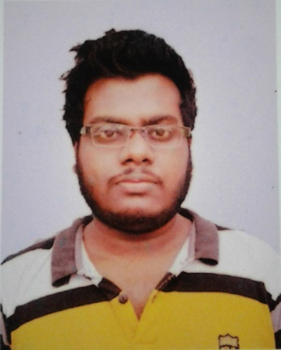**CURRICULUM-VITAE**

*Of*

Md.Abir Husain.

Bhagyakul, Munshigonj, Bangladesh

Phone: +88 01760711791

**CAREER SUMMARY:**

To achieve a very responsible position in a reputed or renowned multinational or group of companies or private organization, where innovative environment will ensure ingenious career development allowing showing the result of knowledge, effort, capabilities.

**Educational Qualification:**

|  |  |  |  |  |  |
| --- | --- | --- | --- | --- | --- |
| **Name of Exam** | **Group** | **Name Of Institute** | **Division/GPA** | **Year** | **Board** |
| S.S.C | Business | Bhagyakul H.L High School. | 3.94 | 2009 | Dhaka |
| Diploma in Engineering | Computer Technology | Bangladesh Computer Management Institute. | 3.36 | 2014 | Dhaka |
| B.S.C | CSE | Bangladesh University. | Completed | 2018 | Dhaka |

**COMPUTER SKILLS:**

1. Typing (35+ WPM) in English. (22+ WPM) in Bangla.
2. Web design (HTML, CSS, Bootstrap, Java Script, J-Query).
3. Have good understanding regarding of computer applications such as,

* Microsoft Word, Excel and Power Point.
* Programming C, C++, Java and Android.

**LANGUAGES:**

I was born in Bangladesh, Dhaka and continue to talk and write in Bengali. I am good in writing and spoken in English.

**KEY OUALITIES:**

* Ability to take responsibility.
* Aspiration to build up a career showing superior performance.
* Hard working, sincere and eager to learn.
* Strong desire to achieve results.
* Strong desire of leading an honest life with dignity.

**INTERESTS:**

My interests include information technology, travelling and getting to know other cultures and seeing interesting and historic places, materials that have a similar effect and anything that is beautiful, interesting and different.

**PERSONAL DIRECTORY:**

|  |  |
| --- | --- |
| Name | Md.Abir Husain. |
| Father’s Name | Habibur Rahman. |
| Mother’s Name | Kharun nessa. |
| Permanent Address | Vill: - Bhagyakul, Thana: - Sreenagar, P.O:-Bhagyakul, District: - Munshigonj. |
| Date of Birth | 12/10/1993. |
| Nationality | Bangladesh. |
| Religion | Islam. |
| Mailing Address | Bhagyakul. |
| E-Mail | abir.rugal@gmail.com |
| Blood Group | A+ |
| Marital Status | Unmarried. |
| Height | 5 Fit 5 Inches |
| Contact Number | 01760711791 |

Date: Signature: