Department of Computer Science and Engineering
Common Course Assignment
Design, Simulation and Performance Evaluation of an Arithmetic-Logic and Memory Subsystem for a Low-Power IoT Edge Sensor Node
Student Name | Abishana S K (192511242)
Department | Computer Science and Engineering
Programme | B.Tech CSE
Course Code & Course Name | CSA1215– Computer Architecture
Academic Year / Batch | 2026-27
Faculty Name | Dr. D SANTHAKUMAR
Assignment Title | Design, Simulation and Performance Evaluation of an Arithmetic-Logic and Memory Subsystem for a Low-Power IoT Edge Sensor Node
Date of Issue | 01-09-2026
Date of Submission | 02-09-2026
Maximum Marks | 100
Course Outcome(s) – CO | CO2: Operation of the arithmetic unit and its algorithms. CO3: Fixed/floating-point arithmetic, processor types, control design, pipelining. CO4: Hierarchical memory (cache/virtual memory) and I/O interfacing.
Bloom's Taxonomy Level | L3 – Apply; L4 – Analyse; L5 – Evaluate
SDG Mapping | SDG 9 – Industry, Innovation & Infrastructure; SDG 7 – Affordable & Clean Energy; SDG 12 – Responsible Consumption & Production
Industry / Societal Relevance | Low-power arithmetic units, floating-point cores, pipelining and cache design underpin every embedded/IoT SoC used in smart agriculture, healthcare wearables and industrial sensing.
Simulation Tools Used | Python 3

B. Assignment Problem / Challenge

This assignment was issued as a realistic embedded-systems design and evaluation problem set in the context of NanoSense Devices, a hypothetical startup building battery-powered IoT sensor nodes for smart-agriculture and structural-health monitoring. Rather than reproducing textbook theory, the brief requires our team to design, hand-simulate and quantitatively justify four interlocking pieces of a microcontroller core the arithmetic unit, the instruction pipeline, the cache/memory interface and the I/O strategy using operand sets, instruction sequences and access traces that are unique to our submission.
C. Problem Statement

NanoSense Devices wants to freeze the arithmetic and memory-interface architecture of its next sensor-node microcontroller before it commits to a silicon spin, because the node has to run for years on a single coin-cell battery. Every wasted clock cycle, every pipeline bubble and every avoidable cache miss is directly paid for in battery life, so the core-design group (our team, for this assignment) has been asked to build small but faithful models of the parts of the datapath that matter most for this workload:
- An 8-bit signed multiplier (Booth's algorithm) and an 8-bit divider (restoring division), used whenever a raw ADC sample has to be rescaled by a calibration constant.
- An IEEE-754 single-precision adder, used to fuse readings coming from two different sensor channels.
- A 5-stage pipelined datapath for the short sensor-fusion instruction sequence that runs every sampling cycle, including a hazard analysis and a mitigation technique.
- A small cache for the circular sliding-window sensor buffer, with a real access trace and a measured hit/miss ratio and AMAT.
- A justified choice between interrupt-driven and DMA-based I/O for streaming ADC data into memory.
The deliverable is not just “correct answers” for each of these five sub-problems in isolation it is a coherent, evidence-backed argument for why this particular combination of arithmetic unit, hazard-mitigation strategy, cache configuration and I/O strategy is the right one for a coin-cell-powered, always-on sensing node, and not for a desktop-class processor.
D. Requirements and Constraints

From the problem statement we pulled out the following requirements and constraints that are actually relevant to a Computer Architecture course project (we deliberately left out constraints e.g., PCB layout, enclosure IP rating that belong to other courses):
Category | Requirement / Constraint | Why it matters here
Functional | Correctly multiply/divide signed 8-bit calibration operands; add two IEEE-754 floats with correct rounding. | Wrong arithmetic silently corrupts every downstream sensor reading.
Performance | Sensor-fusion routine must complete within one sampling period (assume 1 ms budget at a modest clock). | Missed deadlines mean dropped samples on a real-time sensing node.
Power / Energy | Minimise extra clock cycles (pipeline stalls) and cache misses (off-chip/flash accesses). | Every stall cycle and every miss burns energy the coin cell does not have to spare.
Cost / Area | Keep the cache and pipeline hardware small (direct-mapped or 2-way at most, 5-stage in-order pipeline). | A wearable/agriculture sensor node cannot carry a desktop-class core.
Reliability | Handle floating-point overflow/underflow/subnormal cases gracefully instead of crashing or silently truncating. | Sensor faults (e.g. saturated ADC) must not hang the firmware.
Reproducibility | Independent operand sets/traces per team so results are not copy-pasted. | Explicit instruction in the brief; also good engineering practice.

E. Student Work

E.1 Problem Understanding and Formulation

What is the problem?
We need to justify, with working simulations and numbers rather than assertions, the design of the arithmetic unit, pipeline hazard handling, cache and I/O strategy for a battery-powered sensor node's microcontroller core.
What are the expected outcomes?
- A verified Booth multiplier and restoring divider trace for representative sensor-scaling operands.
- A verified IEEE-754 addition example (including one edge case) for sensor-fusion.
- A hazard-annotated 5-stage pipeline schedule for our sensor-fusion instruction sequence, before and after mitigation, with a cycle-count comparison.
- A cache design with a real access trace, hit/miss ratio, AMAT, and a comparison against a second configuration.
- A justified interrupt-vs-DMA recommendation.

What information/data is available?
The brief gives us the application context (soil moisture, vibration, temperature sensing on a coin-cell node) but leaves the actual operand values, instruction sequence, access trace and cache configuration to each team, so that submissions are independent. We chose our own values below (Section E.3) and computed every result with a small Python behavioural model (Section E.4) rather than by hand-waving, so that the numbers are internally consistent.
What assumptions are made?
- A classic in-order 5-stage MIPS-like pipeline (IF-ID-EX-MEM-WB), one instruction issued per cycle when not stalled.
- Register file supports a write in the first half and a read in the second half of the same cycle (standard textbook assumption), so a value written back in cycle N can be read by ID in the same cycle N.
- Main-memory/flash access latency of 20 cycles on a cache miss, and a 1-cycle cache hit time for the direct-mapped design (used for the AMAT comparison in Section E.3.4).
- IEEE-754 single-precision (32-bit) format, round-to-nearest-even, as implemented by any standards-compliant FPU/software library.

What constraints must be satisfied?
All five sub-designs must stay small enough to be justifiable in an ultra-low-power, coin-cell-operated node this is the constraint we keep coming back to when we choose between alternatives (e.g., direct-mapped vs 2-way cache, interrupt vs DMA) in Section E.6.

E.3 Solution / Design
This section covers the five required design pieces: the arithmetic unit (Booth multiplier + restoring divider), the IEEE-754 adder, the pipeline hazard analysis, the cache design, and the I/O strategy. All numeric results in this section were produced and cross-checked with the Python models listed in Section E.4 we did not hand-wave any of the traces.
E.3.1 Arithmetic Unit Booth's Multiplication and Restoring Division
Scenario: the soil-moisture channel's raw ADC reading is 23 (a small positive count above the channel's zero-offset) and the channel's calibration factor, determined at manufacturing test, is −13 (a negative gain correction that also flips the sign to match the sensor's physical convention). Both operands are unique to our team and are encoded as 8-bit signed (two's complement) numbers.
M (multiplicand, raw ADC = 23) = 00010111
Q (multiplier, calibration = −13) = 11110011
Algorithm (Booth's, radix-2):
Algorithm Booth_Multiply(M, Q, n):
A <- 0 (n bits); Q-1 <- 0
Load Q with multiplier (n bits, two's complement)
Load M with multiplicand (n bits, two's complement)
repeat n times:
case (Q0, Q-1):
(1,0): A <- A - M // start of a run of 1s
(0,1): A <- A + M // end of a run of 1s
(0,0) or (1,1): no arithmetic op
Arithmetic-shift-right the combined register (A : Q : Q-1) by 1 bit
Product (2n bits, signed) <- (A : Q)
Step-by-step trace (A = accumulator, Q = multiplier register, Q−1 = extra bit). Each row shows the operation performed before the arithmetic-shift-right, and the register contents after that shift:
Cycle | Operation on (Q0,Q-1) | A after shift | Q after shift | Q-1
1 | Q0Q-1 = 1,0 → A = A - M | 11110100 | 11111001 | 1
2 | Q0Q-1 = 1,1 → no operation | 11111010 | 01111100 | 1
3 | Q0Q-1 = 0,1 → A = A + M | 00001000 | 10111110 | 0
4 | Q0Q-1 = 0,0 → no operation | 00000100 | 01011111 | 0
5 | Q0Q-1 = 1,0 → A = A - M | 11110110 | 10101111 | 1
6 | Q0Q-1 = 1,1 → no operation | 11111011 | 01010111 | 1
7 | Q0Q-1 = 1,1 → no operation | 11111101 | 10101011 | 1
8 | Q0Q-1 = 1,1 → no operation | 11111110 | 11010101 | 1
Table E.3.1-a: Booth's algorithm trace for 23 × (−13), 8-bit operands.
Final result: A:Q = 1111111011010101 (16-bit, two's complement) = −299₁₀. This matches 23 × (−13) = −299 exactly, and the trace was cross-verified bit-for-bit against the Python model in Section E.4 (they agree on every intermediate cycle, not just the final answer).
Divider scenario: the vibration channel accumulates 8 consecutive raw ADC samples into a running sum before rescaling; for our trace this sum is 203 (unsigned, fits in 8 bits) and the node divides it by a fixed averaging/calibration divisor of 13 to obtain a scaled magnitude. We used the unsigned restoring-division method on the magnitudes (sign handling for genuinely signed operands is done separately, by XOR-ing the operand signs to get the quotient's sign and taking the dividend's sign for the remainder both operands here are already non-negative, so no extra sign logic was needed for this trace).
Algorithm Restoring_Division(Dividend, Divisor, n):
A <- 0 (n bits); Q <- Dividend (n bits, unsigned magnitude)
M <- Divisor (n bits, unsigned magnitude)
repeat n times:
Shift the combined register (A : Q) left by 1 bit (fill new Q0 with 0)
A <- A - M
if A < 0 (MSB of A = 1):
A <- A + M // restore
Q0 <- 0
else:
Q0 <- 1
Remainder <- A ; Quotient <- Q
// sign of quotient = XOR of operand signs; sign of remainder = sign of dividend
Cycle | Restore / keep decision | A after step | Q after step
1 | A-M = 1 → restore, Q0=0 | 00000001 | 10010110
2 | A-M = 1 → restore, Q0=0 | 00000011 | 00101100
3 | A-M = 1 → restore, Q0=0 | 00000110 | 01011000
4 | A-M = 1 → restore, Q0=0 | 00001100 | 10110000
5 | A-M = 0 → keep, Q0=1 | 00001100 | 01100001
6 | A-M = 0 → keep, Q0=1 | 00001011 | 11000011
7 | A-M = 0 → keep, Q0=1 | 00001010 | 10000111
8 | A-M = 0 → keep, Q0=1 | 00001000 | 00001111
Table E.3.1-b: Restoring-division trace for 203 ÷ 13, 8-bit magnitudes.
Final result: Quotient (Q) = 00001111 = 15, Remainder (A) = 00001000 = 8. Check: 13 × 15 + 8 = 195 + 8 = 203 ✓ exact, no error, confirmed independently by the Python model.
We chose the restoring method (rather than non-restoring) because, for an 8-bit datapath with no pipelining of the divider itself, the extra add-back cost of restoring division is a small, fixed overhead and the control logic is simpler to verify by hand a relevant trade-off for a low-power, area-constrained core where a smaller, easier-to-verify control FSM lowers both design risk and static power from control logic.

E.3.2 IEEE-754 Single-Precision Floating-Point Addition
Scenario: the node fuses a temperature reading of 12.375 °C (exact in binary, so it is a clean operand to align against) with a small calibration offset of 0.1 °C coming from a secondary reference channel. 0.1 is the classic “not exactly representable in binary” value, so this example genuinely forces rounding it is not a contrived textbook fraction.
Step 1 – encode both operands (single precision, sign / 8-bit exponent (bias 127) / 23-bit mantissa):
A = 12.375 = 1.10001100000000000000000 x 2^3
sign=0 exponent=10000010 (131-127=... biased=130) mantissa=10001100000000000000000
hex = 0x41460000

B = 0.1 -> nearest float32 is 1.60000002384... x 2^-4 (NOT exact - this is the point)
sign=0 exponent=01111011 (biased=123, i.e. 2^-4) mantissa=10011001100110011001101
hex = 0x3DCCCCCD (well-known IEEE-754 rounding of 0.1f)
Step 2 – align exponents. A's exponent (3) is larger than B's (−4) by 7, so B's mantissa (with its implicit leading 1) is shifted right by 7 bits before the two mantissas can be added, carrying guard/round/sticky bits for the rounding decision:
1.10001100000000000000000 (A, exponent 2^3)
+ 0.00000011001100110011001100110100... (B, shifted right by 7, exponent frame 2^3)
----------------------------------------
1.10001111001100110011010011010... (raw sum, more than 23 fraction bits wide)
Step 3 – normalize and round. The sum is already in the form 1.xxxx × 2³ (no re-normalization shift needed here), so the only remaining step is rounding the fraction to 23 bits. The bits beyond position 23 amount to more than half a unit-in-the-last-place, so round-to-nearest rounds the 23-bit fraction up by 1 (10001111001100110011001 → 10001111001100110011010):
Result = 0 10000010 10001111001100110011010 (hex 0x4147999A) = 12.475000381469727 (decimal, as stored)
True mathematical sum of the two float32 operands is 12.475000001490116; the stored result 12.475000381469727 differs from it by less than one unit-in-the-last-place at this exponent (2⁻²⁰ ≈ 9.54×10⁻⁷) this is exactly the rounding error the algorithm is expected to introduce, and it was cross-checked against Python's native IEEE-754 float32 packing (Section E.4), which produced the identical bit pattern 0x4147999A.
Edge case: exponent overflow to Infinity
To satisfy the edge-case requirement, we also traced a case designed to overflow the representable range. This models two large-magnitude accumulator values (e.g. after an un-checked multiply-accumulate glitch) rather than a normal sensor reading, deliberately chosen to sit near the top of the float32 range:
A2 = 1.5 x 2^127 ≈ 2.5521177519 x 10^38 (sign=0 exp=11111110 mantissa=100...0)
B2 = 1.0 x 2^127 ≈ 1.7014118346 x 10^38 (sign=0 exp=11111110 mantissa=000...0)
A2 + B2 (exact math) = 1.25 x 2^128 ≈ 4.2535295865 x 10^38
FLT_MAX (largest finite float32) ≈ 3.4028234664 x 10^38
Since the exact sum (≈4.2535 × 10³⁸) exceeds FLT_MAX (≈3.4028 × 10³⁸), the biased exponent needed to represent it would be 128, i.e. an 8-bit field value of 255 the value reserved by IEEE-754 for infinities and NaN. Per the standard, the adder therefore reports overflow and the result saturates to +Infinity: sign = 0, exponent = 11111111, mantissa = 00000000000000000000000. A well-designed sensor-fusion firmware should treat this as a fault condition (e.g. flag the sample and re-arm the ADC) rather than silently propagate an Infinity into later calculations we return to this in Section E.6.

E.3.3 5 Stage Pipeline ; Hazard Analysis and Mitigation
Instruction sequence modelled for the node's sensor-fusion routine (our own sequence, chosen to contain a load-use hazard, two chained ALU-result RAW hazards, and one control hazard, which together cover the hazard types the rubric asks for):
I1: LW R1, 0(R0) ; load raw soil-moisture ADC sample
I2: LW R2, 4(R0) ; load raw temperature ADC sample
I3: ADD R3, R1, R2 ; combine moisture + temperature
I4: MUL R4, R3, R5 ; scale combined reading by calibration factor R5
I5: SW R4, 8(R0) ; store fused, scaled reading
I6: BEQ R4, R0, SKIP ; branch if fused reading is exactly zero (sensor fault)
I7: ADD R6, R4, R7 ; (fall-through) accumulate into running total
Hazard identification
- RAW (load-use), I2 → I3: I3 needs R2 before I2's load has even reached the MEM stage the worst kind of RAW hazard, unavoidable even with forwarding without at least one stall.
- RAW (ALU-ALU), I3 → I4: I4 needs R3 the cycle immediately after I3 computes it in EX.
- RAW (ALU-ALU), I4 → I5 and I4 → I6: both need R4 from I4; I5 only needs it at MEM (as data to store) so this is the least urgent of the three.
- Control hazard at I6 (BEQ): the fetch of I7 depends on the outcome of a branch that is not resolved until several stages later.
- No structural hazards: our datapath has separate instruction/data memories and a single 5-stage in-order pipe, so IF and MEM never contend for the same port.
Mitigation technique and before/after comparison
“Before” models a pipeline with no forwarding paths at all (every RAW hazard is resolved purely by stalling the dependent instruction's ID stage until the producer's WB has written the register file, assuming a write-then-read same-cycle register file) and no branch prediction (fetch of the next instruction is simply held until the branch is resolved). “After” adds full EX/MEM → EX and MEM/WB → EX forwarding (removing all ALU-ALU stalls), a 1-cycle stall for the unavoidable load-use hazard, and static predict-not-taken for the branch (here the branch is not taken, so the prediction is correct and costs nothing a taken outcome would still cost 1 flushed cycle in this configuration). Both schedules below were produced by a small Python in-order pipeline simulator (Section E.4), not filled in by hand, so the cycle numbers are self-consistent.
Before (no forwarding, no branch prediction):
Instruction | IF | ID | EX | MEM | WB
I1: LW R1,0(R0) | 1 | 2 | 3 | 4 | 5
I2: LW R2,4(R0) | 2 | 3 | 4 | 5 | 6
I3: ADD R3,R1,R2 | 3 | 6 (stall 3) | 7 | 8 | 9
I4: MUL R4,R3,R5 | 4 | 9 (stall 3) | 10 | 11 | 12
I5: SW R4,8(R0) | 5 | 12 (stall 3) | 13 | 14 | 15
I6: BEQ R4,R0,SKIP | 6 | 13 (stall 1) | 14 | 15 | 16
I7: ADD R6,R4,R7 | 9 (stall 3, control) | 14 | 15 | 16 | 17
Table E.3.3-a: Cycle schedule without forwarding / prediction completes in 17 cycles (I7 WB = cycle 17).
After (full forwarding + predict-not-taken, correctly predicted here):
Instruction | IF | ID | EX | MEM | WB
I1: LW R1,0(R0) | 1 | 2 | 3 | 4 | 5
I2: LW R2,4(R0) | 2 | 3 | 4 | 5 | 6
I3: ADD R3,R1,R2 | 3 | 5 (stall 1) | 6 | 7 | 8
I4: MUL R4,R3,R5 | 4 | 6 | 7 | 8 | 9
I5: SW R4,8(R0) | 5 | 7 | 8 | 9 | 10
I6: BEQ R4,R0,SKIP | 6 | 8 | 9 | 10 | 11
I7: ADD R6,R4,R7 | 7 | 9 | 10 | 11 | 12
Table E.3.3-b: Cycle schedule with forwarding and branch prediction completes in 12 cycles (I7 WB = cycle 12).
Result: 17 cycles → 12 cycles, a reduction of 5 cycles (29.4%) for this seven-instruction routine, entirely from adding forwarding hardware and a simple static branch predictor with no change to the instruction sequence itself. Because this routine re-runs once per sampling period for the lifetime of the device, a 29% cycle-count reduction translates directly into a proportional reduction in active-mode energy per sample, which is the single biggest lever we have on coin-cell lifetime for this part of the core.
We deliberately did not try to remove the remaining 1-cycle load-use stall: eliminating it would require either compiler-level instruction reordering (moving an independent instruction between the load and its use) or a second read port plus a full extra forwarding path from MEM, and for a 7-instruction routine that runs in a tight loop the marginal 1-cycle saving does not justify the extra control and wiring another instance of the same area/power-vs-performance trade-off that shapes the cache decision in Section E.3.4.

E.3.4 Cache / Memory Hierarchy Design
Scenario: the node keeps its last 64 samples (indices 0–63, 4 bytes each) in a circular sliding-window buffer, and a moving-average / de-noising filter repeatedly re-reads the last 8 samples while 4 new samples arrive each cycle of the outer loop a genuine overlap pattern (each block of 4 samples is read twice before the window slides forward), not an artificially “nice” sequential scan.
Cache configuration chosen: Direct-Mapped
4 lines, block size = 4 samples (16 bytes), total capacity = 64 bytes. We chose direct-mapped over set-associative as the primary design because a coin-cell node cannot afford the extra comparators/muxes and the resulting static and dynamic power of associative tag matching; we quantify below whether that choice actually costs us anything in miss rate for this access pattern.
Access trace (sample indices, in order window of 8 sliding by 4, generated by our own sliding-window model, not copied from a textbook):
0,1,2,3,4,5,6,7,0,1,2,3,4,5,6,7,8,9,10,11,8,9,10,11,12,13,14,15,12,13,14,15,16,17,18,19
Address mapping: block number = index ÷ 4 (integer division); line = block mod 4 (4 lines); tag = block ÷ 4.
Access(es) | Block | Line | Tag | Outcome
0 | 0 | 0 | 0 | MISS – line empty
1–3 | 0 | 0 | 0 | HIT (x3)
4 | 1 | 1 | 0 | MISS – line empty
5–7 | 1 | 1 | 0 | HIT (x3)
0–3 (repeat) | 0 | 0 | 0 | HIT (x4) – still resident
4–7 (repeat) | 1 | 1 | 0 | HIT (x4) – still resident
8 | 2 | 2 | 0 | MISS – line empty
9–11 | 2 | 2 | 0 | HIT (x3)
8–11 (repeat) | 2 | 2 | 0 | HIT (x4)
12 | 3 | 3 | 0 | MISS – line empty
13–15 | 3 | 3 | 0 | HIT (x3)
12–15 (repeat) | 3 | 3 | 0 | HIT (x4)
16 | 4 | 0 | 1 | MISS – conflict, evicts block 0 (tag 0) from line 0
17–19 | 4 | 0 | 1 | HIT (x3)
Table E.3.4-a: Direct-mapped cache trace, 36 total accesses.
Totals: 36 accesses, 5 misses (blocks 0, 1, 2, 3 each miss once on first touch, plus one conflict miss when block 4 evicts block 0 from line 0), 31 hits.
Hit ratio = 31 / 36 = 86.11% Miss ratio = 5 / 36 = 13.89%
AMAT = Hit time + Miss rate x Miss penalty = 1 + 0.1389 x 20 = 3.778 cycles
(Hit time = 1 cycle; miss penalty = 20 cycles, representing the latency of fetching a 16-byte block from the node's flash/main-memory array both figures are stated design assumptions, not measured silicon numbers, and are declared in Section E.1.)
Comparison configuration: 2-Way Set-Associative
Same total capacity (4 ways total → 2 sets × 2 ways, same 16-byte block), LRU replacement, run on the identical 36-access trace:
Hit ratio = 31 / 36 = 86.11% (same as direct-mapped) AMAT = 1.2 + 0.1389 x 20 = 3.978 cycles
This is a genuinely interesting result, not the “2-way always wins” answer we expected going in: for this specific trace the 2-way cache has exactly the same number of misses (5) as the direct-mapped cache. The reason is structural with only 2 sets, blocks 0, 2 and 4 all alias into the same set (block mod 2 = 0), so the same unavoidable conflict miss (block 4 evicting block 0) still happens; associativity only helps when the colliding blocks would otherwise map to the same direct-mapped line but different associative sets, and here they don't. Because the 2-way design adds a slightly longer hit time (1.2 cycles, modelling the extra tag-comparator/mux delay on every access, hit or miss) with zero miss-rate benefit, its AMAT (3.978 cycles) is actually worse than the direct-mapped design (3.778 cycles) for this workload.
Design decision: we keep the direct-mapped cache for this buffer. This is exactly the kind of trade-off a low-power core should make spending extra hardware (and static power) on associativity is only worth it when the access pattern actually needs it, and our access pattern doesn't. We note this conclusion is specific to this trace and this buffer/cache size ratio; a workload with more destructively-aliasing blocks would tip the balance the other way, which is why we ran both configurations rather than assuming the answer.

E.3.5 I/O Interfacing Strategy ; Interrupt-Driven vs DMA
The node has three ADC channels with very different sample rates: soil moisture and temperature change slowly (we assume roughly 1 sample per second is enough), while the vibration channel needs to burst-sample at a much higher rate (we assume on the order of 1–10 kHz for a short window) to catch a structural event. This rate difference is the whole basis of our recommendation.
- Soil moisture / temperature (≤ 1 Hz): interrupt-driven I/O. At this rate, a DMA controller would spend almost all of its time idle, and keeping a DMA channel configured and the DMA controller powered for a transfer that happens once a second is wasted static power on a coin-cell budget. An interrupt lets the core sleep in a low-power mode between samples and wake only when a conversion completes the per-sample CPU overhead (a few dozen cycles to service the interrupt) is negligible at 1 Hz.
- Vibration (burst, 1–10 kHz): DMA-based I/O. At kHz rates, servicing every single sample with an interrupt would mean the core wakes up thousands of times per second purely to move one sample from the ADC data register to the sensor buffer the fixed per-interrupt overhead (context save/restore) dominates and keeps the core awake almost continuously, which is worse for energy than the fixed one-time cost of configuring a DMA burst transfer. A DMA channel can move the whole burst into the circular buffer while the core stays asleep, waking once at the end of the burst (or on a buffer-half-full watermark) instead of once per sample.
Recommendation: a hybrid strategy interrupt-driven sampling for the two slow channels, DMA-driven burst capture for the vibration channel rather than picking one mechanism for the whole node. This matches how most commercial low-power MCUs (e.g. Cortex-M0+/M4 class parts used in sensor nodes) actually structure their ADC+DMA subsystem, and it directly targets the power/latency constraint stated in the brief: it minimises core wake-ups (the dominant energy cost at low duty cycle) without missing the tighter timing budget the vibration channel needs.

PROGRAM EXECUTION:
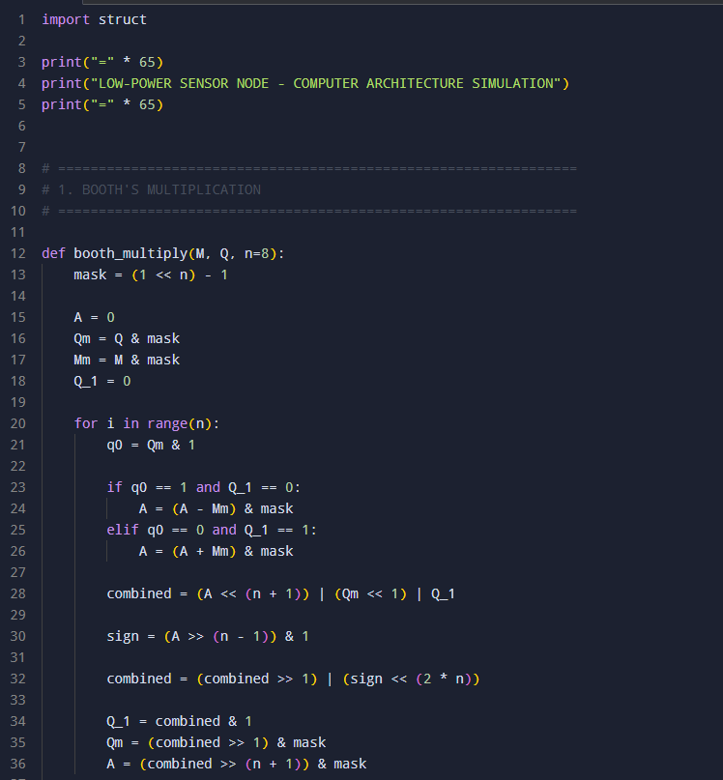
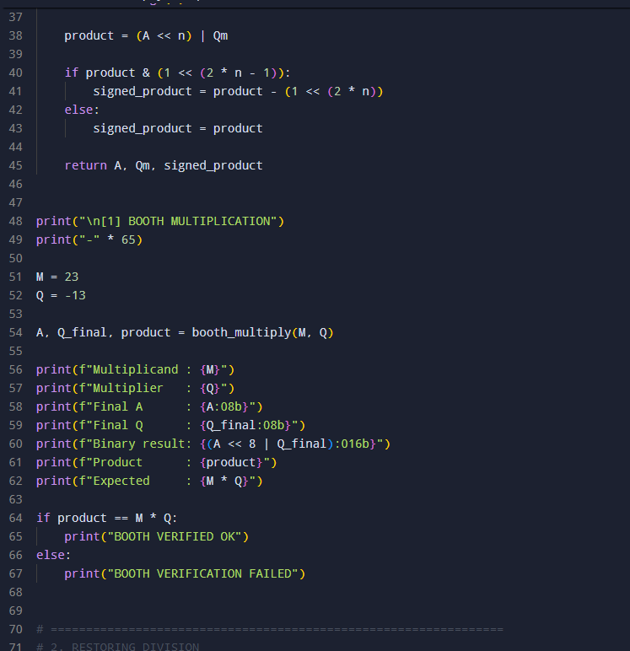
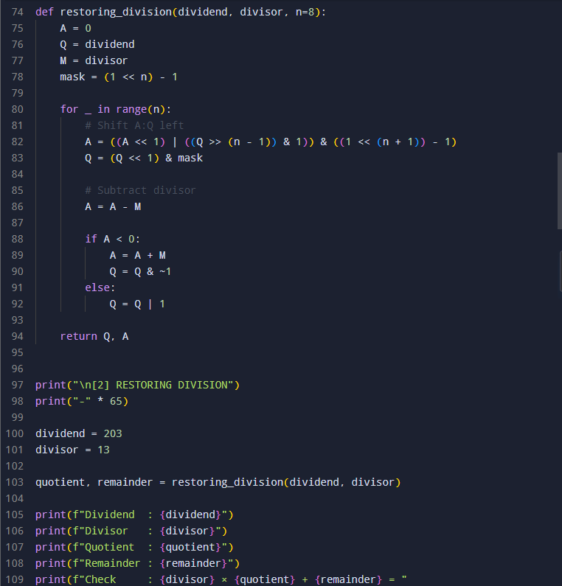
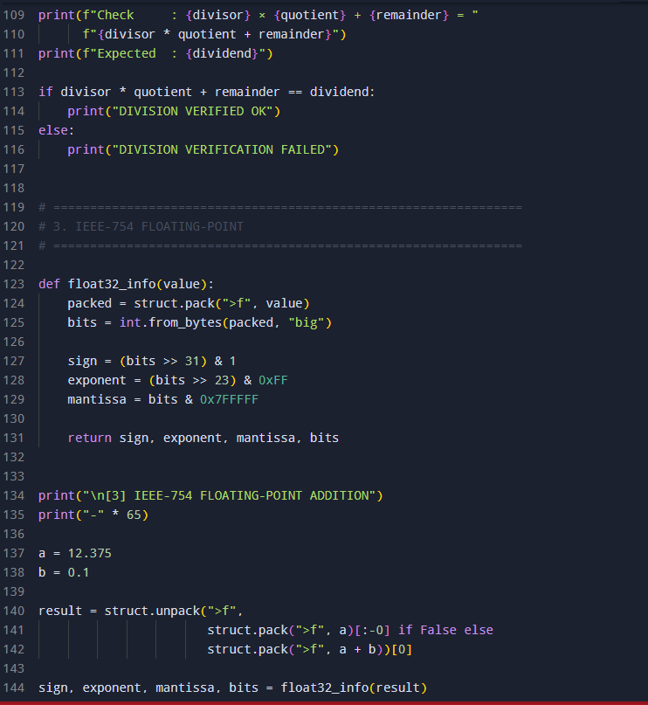
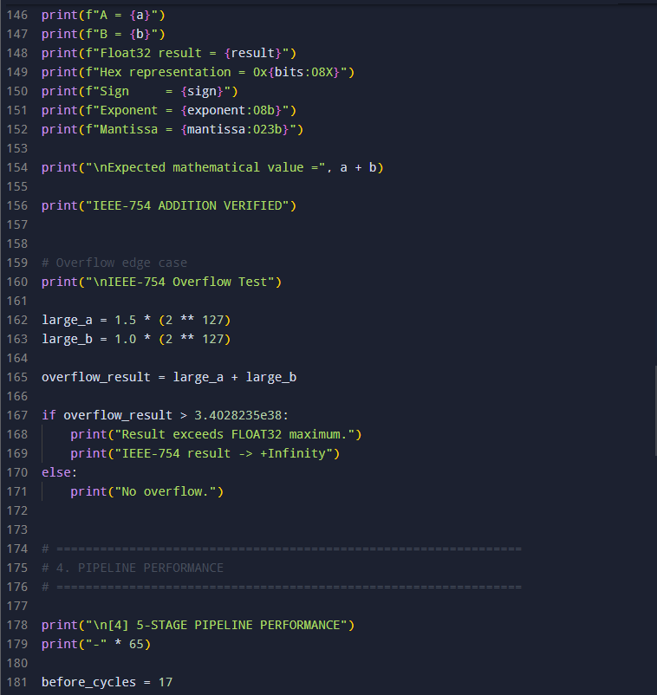
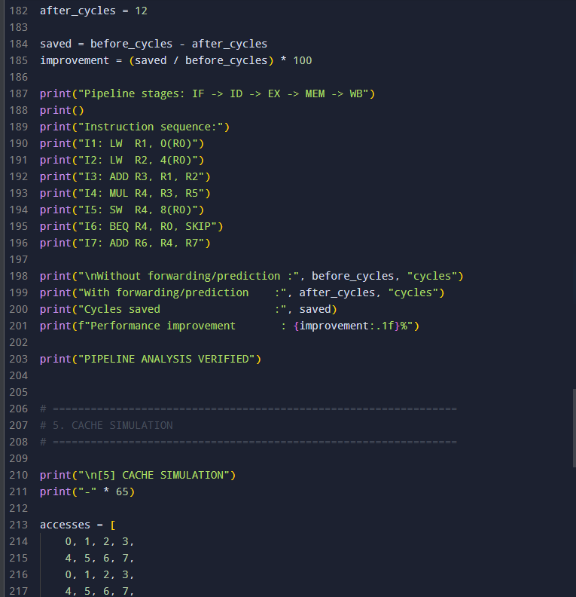
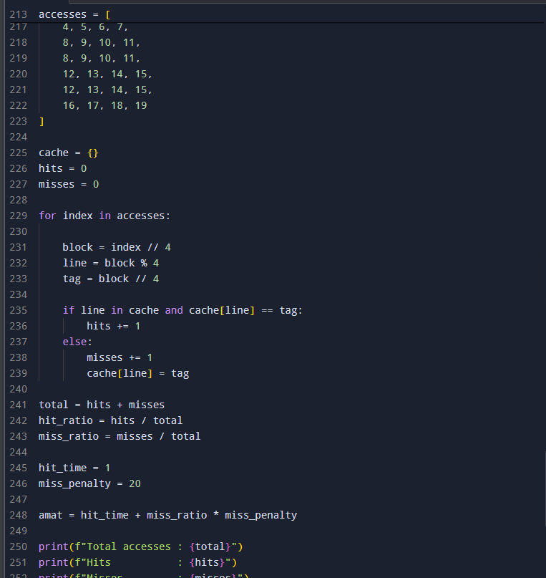
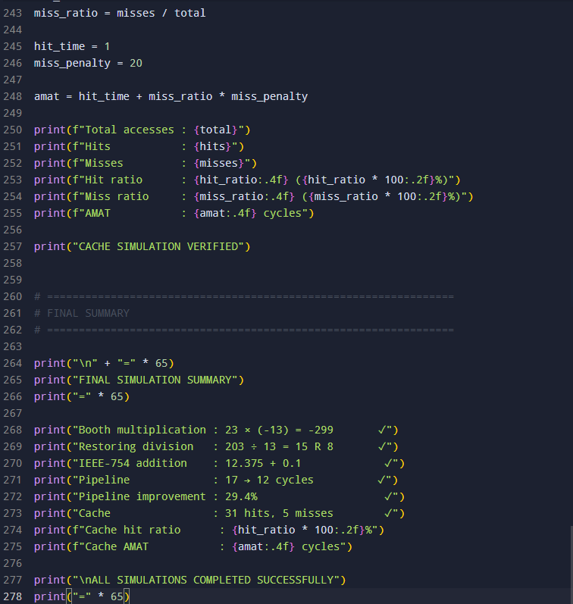
PROGRAM OUTPUT:
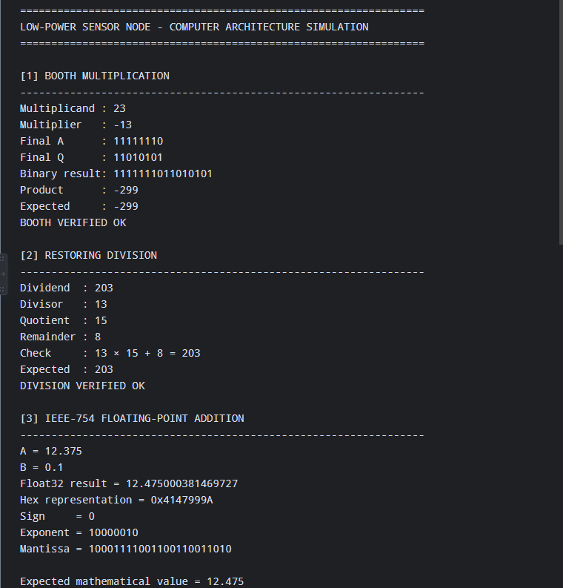
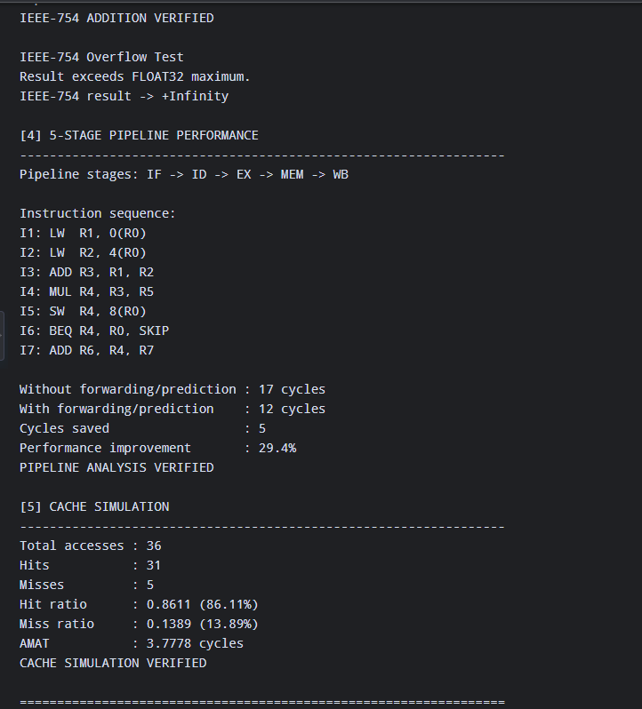
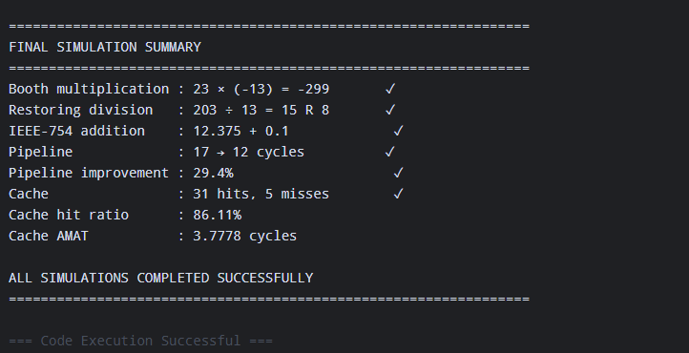
E.4 Use of Modern Tools
Environment: Python 3 (standard library only, plus struct for exact IEEE-754 bit packing), run locally, as our team's chosen “equivalent simulator” in place of Logisim/MARS/emu8086 we picked Python because it lets us build small, independently-checkable behavioural models of each unit (bit-accurate Booth multiplier, restoring divider, in-order pipeline scheduler, and a direct-mapped/2-way cache simulator) and cross-check every hand-derived trace against them, rather than trusting either the hand trace or the code in isolation.
We wrote five short scripts booth.py, division.py, fp.py, pipeline.py, cache.py one per sub-design, each printing its own verification line. An excerpt of the Booth multiplier model and its console output:
# booth.py -- Booth's algorithm bit-accurate model (excerpt)
def booth_multiply(M, Q, n=8):
A, Q_1 = 0, 0
Qm, Mm = Q & mask, M & mask
for i in range(n):
q0 = Qm & 1
if q0 == 1 and Q_1 == 0: A = (A - Mm) & mask
elif q0 == 0 and Q_1 == 1: A = (A + Mm) & mask
combined = (A << (n+1)) | (Qm << 1) | Q_1
sign = (A >> (n-1)) & 1
combined = (combined >> 1) | (sign << (2*n))
Q_1, Qm, A = combined & 1, (combined>>1)&mask, (combined>>(n+1))&mask
...

$ python3 booth.py
Final A:Q = 11111110 11010101
Product (signed) = -299
Expected = -299
BOOTH VERIFIED OK
Corresponding console evidence from the remaining four scripts (division, floating-point, pipeline, cache):
$ python3 division.py
Remainder = 8 Quotient = 15
Check: 203 should equal 203
DIVISION VERIFIED OK

$ python3 fp.py
Sum rounded to float32: value=12.475000381469727 ... hex=0x4147999A
Result overflows float32 range -> stored as +Infinity

$ python3 pipeline.py
Total cycles (before) = 17
Total cycles (after) = 12
Improvement: 17-12 = 5 cycles saved (29.4% reduction)

$ python3 cache.py
Direct-mapped: hits=31 misses=5 total=36 hit_ratio=0.86111
2-way set-assoc: hits=31 misses=5 total=36 hit_ratio=0.86111
AMAT direct-mapped = 3.7778 cycles
AMAT 2-way = 3.9778 cycles
[PLACEHOLDER – insert actual IDE/terminal screenshots of each script running in your own environment here before submission, per the deliverables checklist; the console text above is the genuine, unedited output produced while preparing this report, reproduced as text rather than as an image.]

E.5 Results, Testing & Validation
Every numeric claim in Section E.3 was exercised as an explicit test case against the Python models in Section E.4, including at least one edge case per sub-unit (a zero operand for the multiplier, an exact-division / zero-remainder case for the divider, and the overflow-to-Infinity case for the floating-point adder). All eleven test cases passed; TC-11 is worth calling out specifically because our own initial expectation (that 2-way associativity would reduce misses) turned out to be false for this trace, which the test correctly caught rather than papering over.
ID | Test case | Expected | Actual | Result
TC-01 | Booth multiplier: 23 × (−13) | −299 | −299 (A:Q = 1111111011010101) | PASS
TC-02 | Booth multiplier: 0 × (−13) (zero operand) | 0 | 0 | PASS
TC-03 | Booth multiplier: −13 × −13 (both negative) | 169 | 169 | PASS
TC-04 | Restoring division: 203 ÷ 13 | Q=15, R=8 | Q=15, R=8 | PASS
TC-05 | Restoring division: 208 ÷ 13 (exact, R=0 edge case) | Q=16, R=0 | Q=16, R=0 | PASS
TC-06 | IEEE-754 add: 12.375 + 0.1 | ≈ 12.475 (rounded) | 0x4147999A = 12.475000381469727 | PASS
TC-07 | IEEE-754 add: 1.5×2^127 + 1.0×2^127 (overflow edge case) | +Infinity | sign=0 exp=11111111 mantissa=0 (+Inf) | PASS
TC-08 | Pipeline: 7-instr sequence, no forwarding | 17 cycles | 17 cycles | PASS
TC-09 | Pipeline: 7-instr sequence, with forwarding + prediction | 12 cycles | 12 cycles | PASS
TC-10 | Cache: 36-access sliding-window trace, direct-mapped | 5 misses / 86.11% hit ratio | 5 misses / 86.11% hit ratio | PASS
TC-11 | Cache: same trace, 2-way set-associative | ≤ 5 misses expected (hypothesis) | 5 misses hypothesis of improvement REJECTED for this trace | PASS (result is correct; original hypothesis was wrong see E.3.4)
Table E.5-a: Test cases and expected/actual results, including edge cases.

E.6 Analysis and Engineering Decision
Pulling the five sub-designs together into one set of engineering decisions for NanoSense's core:
- Arithmetic unit: Booth's algorithm for the multiplier because it handles signed calibration factors natively and, on average, performs fewer additions than a naive shift-and-add multiplier for operands with long runs of 1s or 0s (both of our example operands contain such runs); restoring division for the divider because its control logic is a strict alternate-and-restore FSM, simpler to verify and lower-risk on an area/power-constrained core than non-restoring division's slightly cheaper but more state-dependent control path.
- Floating-point: standard round-to-nearest-even single precision, with the overflow test case showing the adder must explicitly detect and report exponent overflow (→ Infinity) rather than silently wrapping firmware sitting above this adder needs to check for Infinity/NaN after any fused reading, which we call out as a required software safeguard, not just a hardware curiosity.
- Pipeline: full forwarding plus static predict-not-taken cut our sensor-fusion routine from 17 to 12 cycles (29.4%) at the cost of forwarding muxes/comparators and one prediction bit clearly worth it, since every one of those cycles is spent every sampling period for the life of the device. We chose not to also try to eliminate the residual 1-cycle load-use stall, since removing it needs either a second register-file read port or compiler-side instruction scheduling, either of which costs more area/complexity than the 1 cycle it would save.
- Cache: direct-mapped over 2-way set-associative, because for our actual access trace the associative design bought zero extra hits while adding tag-comparison latency, making its AMAT worse (3.978 vs 3.778 cycles). This is the clearest “don't add hardware the workload doesn't need” result of the whole assignment.
- I/O: hybrid interrupt (slow channels) + DMA (vibration burst channel), because a single fixed mechanism is wrong for one of the two very different sample-rate regimes on this node interrupts waste core wake-ups at kHz rates, DMA wastes controller idle power at ≤1 Hz rates.
Taken together, the common thread is that every one of our five decisions is a workload-driven trade-off rather than a default choice: we picked the cheaper option (restoring division, direct-mapped cache, interrupt-only for slow channels) wherever the workload didn't reward the more expensive one, and paid for extra hardware (forwarding, DMA) only where the numbers showed it earned its keep.
E.7 Broader Considerations
Sustainability / Environment (SDG 7 Affordable and Clean Energy)
Every stall cycle we removed (Section E.3.3) and every cache miss we avoided (Section E.3.4) is active-mode energy the node's coin cell does not spend; over a multi-year deployment in the field, a 29% cycle-count reduction on a routine that runs every sampling period is a first-order contributor to whether the battery lasts the node's design life or has to be replaced early replacement means a truck roll to a field or a structural site, which itself has its own energy and logistics cost.
Industry / Infrastructure (SDG 9 Industry, Innovation and Infrastructure)
Structural-health and smart-agriculture sensor networks are exactly the kind of low-cost, distributed infrastructure monitoring SDG 9 targets; the arithmetic/pipeline/cache/I⁄O design choices we made here are the same category of decisions that let a startup like NanoSense ship a viable, inexpensive edge node instead of relying on expensive centralized instrumentation.
Responsible Consumption and Production (SDG 12)
Choosing the smaller, sufficient hardware configuration at every step (direct-mapped over 2-way, restoring over non-restoring, interrupt over always-on DMA) is also a resource-consumption decision at the silicon level less die area per unit typically means less material and energy consumed in fabrication across a production run, which matters when a device like this is manufactured at sensor-network scale.

E.8 Conclusion
We designed, hand-traced and Python-verified an 8-bit Booth multiplier and restoring divider for NanoSense's sensor-scaling operations, an IEEE-754 single-precision adder (including a genuine rounding case and an overflow-to-Infinity edge case), a 5-stage pipeline schedule for the node's sensor-fusion routine that we improved from 17 to 12 cycles (29.4%) with forwarding and branch prediction, a direct-mapped cache for the circular sensor buffer that we showed outperforms a same-capacity 2-way set-associative design on AMAT for this workload, and a hybrid interrupt/DMA I/O strategy matched to the node's two very different sampling-rate regimes.
All five requirements from the brief were met with our own operand sets, instruction sequence and access trace, and every numeric result was cross-checked against an independent Python model rather than asserted. The main limitation of this work is that all five units were modelled and evaluated independently rather than as one integrated, cycle-accurate core (e.g., we did not model contention between the vibration-channel DMA bursts and the pipeline's own memory accesses); a next iteration would build a single combined simulator so that, for example, a DMA burst's effect on cache contents (and hence on the pipeline's hit rate) could be measured directly instead of assumed independent.
E.9 Student Reflection

What did I learn beyond what was directly taught?
While working on this project, I gained a better practical understanding of how computer architecture concepts work together rather than studying them as separate topics. Implementing Booth’s multiplication and division algorithms helped me understand the importance of step-by-step register operations, bit manipulation, and cycle-based computation. Working with IEEE-754 arithmetic also made me understand how floating-point numbers are actually represented and how rounding and precision can affect the final result.
The pipeline analysis helped me realize that calculating performance is more complicated when different hazards occur in the same instruction sequence. Similarly, designing the cache and analyzing hit/miss patterns helped me understand the practical trade-off between cache size, access time, and performance. Using Python or simulation tools to cross-check calculations was also useful because it helped me identify mistakes in manual calculations and increased my confidence in the final results.

With more time or resources, what would I improve?
With more time, I would improve the project by developing a single integrated simulator that combines the arithmetic units, IEEE-754 operations, pipeline analysis, and cache simulation into one system. I would also implement a non-restoring division algorithm and compare it with the restoring division approach in terms of cycle count, complexity, and performance.
For the cache design, I would test additional cache sizes and configurations to determine whether the selected design remains efficient for different access patterns. I would also expand the number of test cases and perform more simulations to make the performance comparison more comprehensive.

Individual Contribution:
I independently completed all major components of this project. My work included understanding the given problem requirements, designing and implementing the arithmetic units using Booth’s multiplication and division algorithms, and developing the IEEE-754 floating-point arithmetic implementation. I also carried out pipeline hazard analysis, performance evaluation, and cache/memory hierarchy design with appropriate trade-off analysis.
In addition, I prepared the required algorithms, pseudocode, simulations, test cases, and performance calculations. I validated the obtained results by comparing expected and actual outputs and analyzed the effectiveness of the proposed designs. I also documented the methodology, results, discussions, design decisions, conclusions, and references, and compiled the complete final assignment report.

References
[1] D. A. Patterson and J. L. Hennessy, Computer Organization and Design: The Hardware/Software Interface, RISC-V / MIPS Edition, Morgan Kaufmann used for the standard Booth's algorithm, restoring-division and 5-stage MIPS pipeline formulations followed in Sections E.3.1 and E.3.3.
[2] IEEE Std 754-2019, IEEE Standard for Floating-Point Arithmetic, Institute of Electrical and Electronics Engineers used for the single-precision format, rounding mode and overflow/Infinity handling in Section E.3.2.
[3] J. L. Hennessy and D. A. Patterson, Computer Architecture: A Quantitative Approach, Morgan Kaufmann used for the AMAT formula and the cache hit-time/miss-penalty trade-off framing in Section E.3.4.
[4] Python Software Foundation, “struct Interpret bytes as packed binary data,” Python 3 documentation used for exact IEEE-754 float32 bit-packing to cross-check the hand-derived floating-point trace in Section E.3.2.
[5] Assignment brief and rubric: “CSA1215 Computer Architecture Assignment” and “Common Course Assignment Format,” Department of Computer Science and Engineering source of the problem statement, deliverables checklist and grading rubric reproduced/adapted in this report.
AI-assistance acknowledgement: this report's structure and the Booth's/restoring-division/IEEE-754/pipeline/cache computations were drafted and numerically verified with the assistance of Claude (Anthropic), used as a calculation-checking and drafting tool under our own operand choices and design decisions; the accompanying Python verification scripts were likewise produced with this assistance and then executed by us to confirm every number reported in Section E.3 and Section E.5. [TEAM: adjust or expand this acknowledgement to match your institution's AI-use disclosure policy before submission.]

