ENHANCING LOAN ACCESSIBILITY FOR RETAIL CUSTOMERS: A STUDY OF FINJET CORPORATE ADVISORS' FINANCIAL ADVISORY ROLE
Internship report submitted in partial fulfilment of the requirements for the award of the Degree of

MASTER OF BUSINESS ADMINISTRATION

of



By

RACHEL ROSHAN
Under the guidance of
Ms. Hemalatha Yadav J
Assistant Professor
T. JOHN COLLEGE
Autonomous, Affiliated to Bangalore University

2025-2026

COMPANY CERTIFICATE

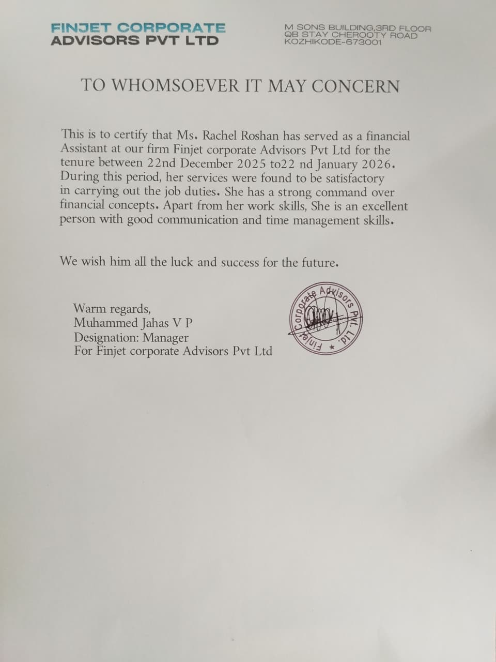

GUIDE CERTIFICATE

This is to certify that the Internship report “ENHANCING LOAN ACCESSIBILITY FOR RETAIL CUSTOMERS: A STUDY OF FINJET CORPORATE ADVISORS' FINANCIAL ADVISORY ROLE” submitted by Rachel Roshan P03ZJ24M015001 in partial fulfilment of the requirements for the award of the degree of Master of Business Administration (MBA) of T. John College Autonomous, Affiliated to Bangalore University, is a record of the original and independent work carried out by the student during the internship program at Finjet Corporate Advisors PVT LTD. To the best of my knowledge, the work embodied in this report has not been submitted, either in part or full, for any other degree or diploma in this or any other institution.
The Internship was conducted under my guidance and supervision.

Place: Bangalore Name of Guide: Ms. Hemalatha Yadav J
Date: Signature:

DECLARATION BY THE STUDENT

I hereby declare that “ENHANCING LOAN ACCESSIBILITY FOR RETAIL CUSTOMERS: A STUDY OF FINJET CORPORATE ADVISORS' FINANCIAL ADVISORY ROLE” is the result of the Internship work carried out by me under the guidance of Ms. Hemalatha Yadav J, Assistant Professor in partial fulfilment for the award of MASTER OF BUSINESS ADMINISTRATION by T. John College Autonomous, Affiliated to Bangalore University.
This report has not been submitted by me or anyone else for any other degree or diploma, to any other university or institution. All the information in this report has been obtained and presented as per academic rules and ethical conduct. Wherever contributions of others are involved, every effort is made to indicate this clearly, with due reference.
This Internship was carried out at Finjet Corporate Advisors PVT LTD under the supervision of Muhammed Jahas VP during the period from 22nd December to 22nd January.

Place: Bangalore Name: Rachel Roshan
Date: Register Number: P03ZJ24M015001
ACKNOWLEDGEMENT

First and foremost, I praise and thank God almighty from the depth of my heart that has been the source of strength in the completion of this Internship. I have greatly enjoyed the Internship and I take the opportunity to express my sincere thanks to all who supported me in completing my work.
With great respect, I am thankful to Dr. SHAILESH G (Principal, T. JOHN COLLEGE AUTONOMOUS, BANGALORE) for generating permission to conduct the study. A special thanks to Dr. LALITHA P (Head of the Department of Management Studies). I utilize the opportunity to express my heart thanks for the sincere guidance of Ms. Hemalatha Yadav J, Assistant Professor faculty of the Department of Management Studies for his kind cooperation, valuable guidance, and constant encouragement in getting this work completed.
I am also expressing my sincere gratitude to all faculty members in the Department of Management and Studies and all my beloved and dearest friends who helped me with valuable suggestions for the completion of this work.
I express my heartfelt thanks to all authorities for their helpful advice and direction in completing my Internship in spite of their busy schedule.

Place: Bangalore Name: Rachel Roshan
Date: Register Number: P03ZJ24M015001




Estd. 1993, AUTONOMOUS Institute, Affiliated to Bangalore University
Accredited by NAAC with ‘A’ Grade | Recognized under section 2(f) and 12(B) of UGC | Approved by AICTE & Government of Karnataka
#88/1, Gottigere Post, Bannergatta Road, Bengaluru – 560083 Ph: +91–80–40250520 Email: tjcprincipal@tjohngroup.com

DEPARTMENT OF MANAGEMENT STUDIES

CERTIFICATE OF ORIGINALITY

This is to certify that the Internship titled Enhancing Loan Accessibility for Retail Customers: A Study of Finjet Corporate Advisors' Financial Advisory Role” is an original work of Ms. Rachel Roshan Bearing University registration number P03ZJ24M015001and is being submitted in partial fulfilment for the award of the Master’s degree in Business Administration of T. John College Autonomous, Affiliated to Bangalore University. The report has not been submitted earlier either to this University or any other institution for the fulfilment of the requirement of a course of study.
Ms. Rachel Roshan is guided by Dr. Hemalatha Yadav J who is the Faculty Guide as per the regulations of T. John College Autonomous, Affiliated to Bangalore University.

Internship Guide Head of the Department Principal
Date:

TABLE OF CONTENTS

Chapter No. | Title | Page No.
1 | INTRODUCTION | 4
1 | CONCEPTUAL BACKGROUND OF THE STUDY | 5
1 | INDUSTRY PROFILE /OBJECTIVES OF THE STUDY/NEED OF THE STUDY/SCOPE OF THE STUDY/RESEARCH STUDY | 6
2 | INTRODUCTION TO FINJET CORPORATE ADVISORS PVT LTD | 11
2 | COMPANY HISTORY | 12
2 | VISION, MISSION AND OBJECTIVES | 13
2 | MILESTONES AND ACHIEVEMENTS | 14
2 | PRODUCTS AND SERVICE PROFILE | 15
2 | COMPETITOR PROFILE AND ANALYSIS | 16
2 | ORGANIZATIONAL HIERARCHY AND VISUAL | 19
2 | DEPARTMENTAL HIERARCHY | 22
3 | DEPARTMENTS ASSIGNED | 25
3 | ROLES AND RESPONSIBILITIES | 25
3 | WEEKLY SUMMARY | 25
3 | TOOLS, TECHNIQUES AND SOFTWARE USED | 26
4 | TITLE OF THE PROJECT | 28
4 | OBJECTIVES OF THE STUDY | 29
4 | RESEARCH DESIGN | 30
4 | DATA COLLECTION METHODS | 30
4 | DATA ANALYSIS AND INTERPRETATION | 32
5 | LEARNING OUTCOMES | 43
6 | FINDINGS, SUGGESTIONS AND CONCLUSION | 44
7 | BIBLIOGRAPHY | 56
 | ANNEXURE | 58

LIST OF TABLES

Table No. | Tables | Page No.
1 | AGE DISTRIBUTION PARTICULARS | 33
2 | GENDER DISTRIBUTION | 34
3 | AWARENESS OF ADVISORY SERVICES | 35
4 | PURPOSE CLEARLY EXPLAINED | 36
5 | ADVISOR ASSESED FINANCIAL NEEDS | 37
6 | SUITABLE LOAN OPTION SUGGESTED | 38
7 | LOAN DETAILS | 39
8 | DOCUMENTATION PROCESS | 40
9 | REDUCED DOCUMENTATION ERRORS AND DELAYS | 41
10 | REGULAR UPDATES ON LOAN APPLICATION STATUS | 42
11 | IMPROVED LOAN ACCESSIBILITY | 43
12 | OVERALL SATISFACTION | 44

TABLE OF FIGURES
Figure No. | Figures | Page No.
1 | AGE DISTRIBUTION PARTICULARS | 33
2 | GENDER DISTRIBUTION | 34
3 | AWARENESS OF ADVISORY SERVICES | 35
4 | PURPOSE CLEARLY EXPLAINED | 36
5 | ADVISOR ASSESED FINANCIAL NEEDS | 37
6 | SUITABLE LOAN OPTION SUGGESTED | 38
7 | LOAN DETAILS | 39
8 | DOCUMENTATION PROCESS | 40
9 | REDUCED DOCUMENTATION ERRORS AND DELAYS | 41
10 | REGULAR UPDATES ON LOAN APPLICATION STATUS | 42
11 | IMPROVED LOAN ACCESSIBILITY | 43
12 | OVERALL SATISFACTION | 44

