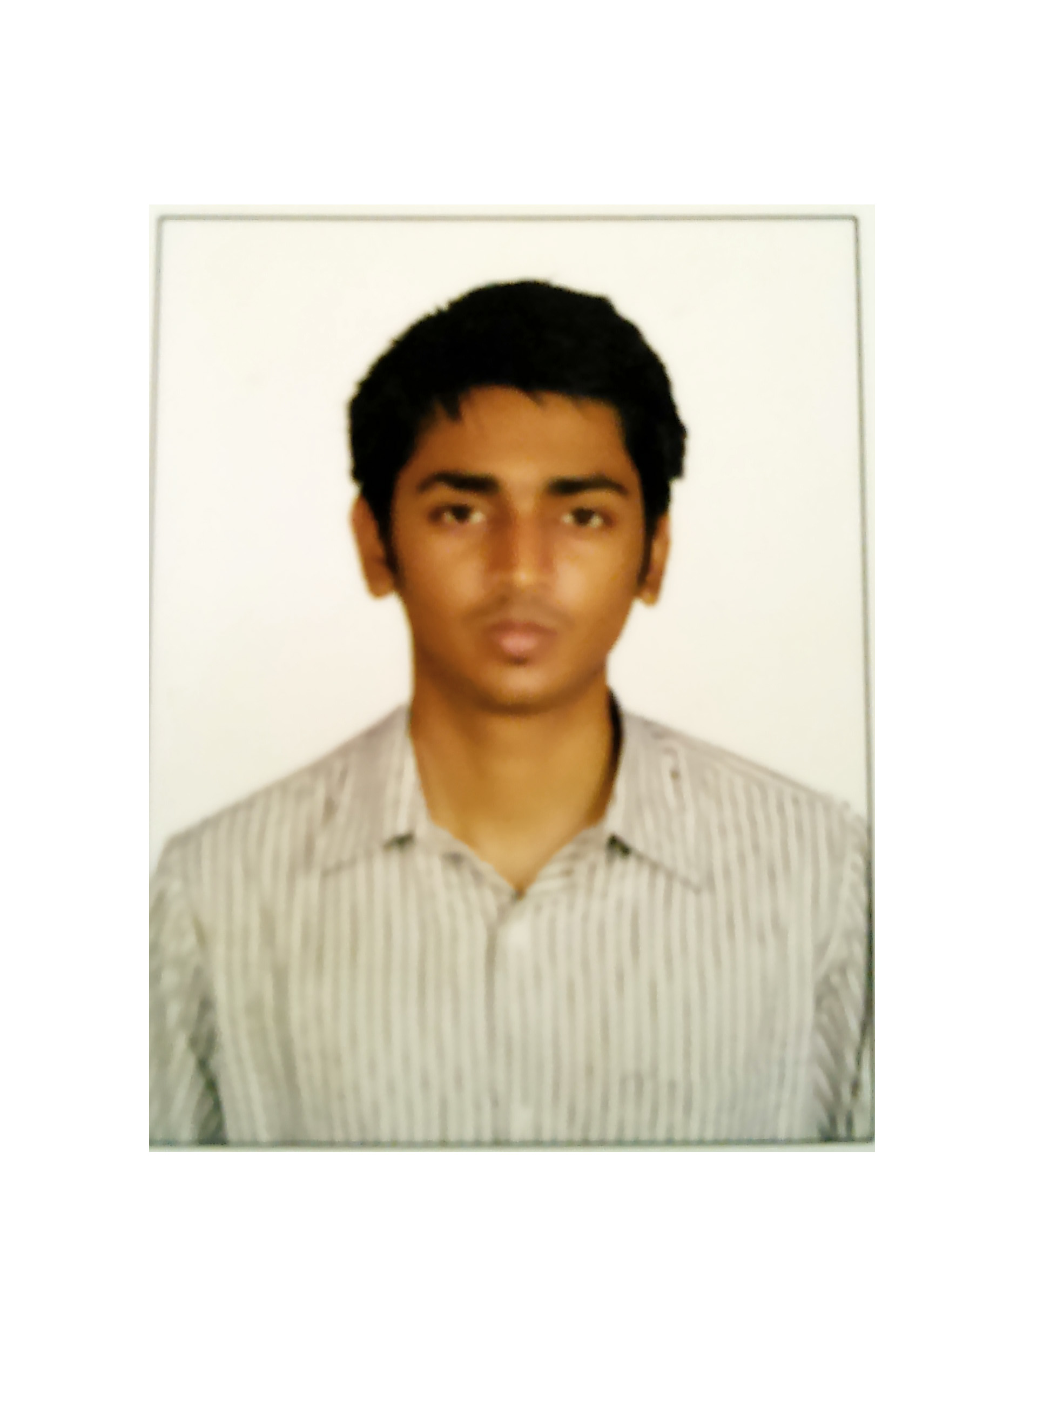**S.BALAJI**

Plot no.150,7th cross extn.,

Sudarshan nagar,

Madambakkam,

Chennai-600126

Email-id:usa.powernet@gmail.com

Contact No:+91-9843010995

**Academic Background:**

* Pursuing undergraduate degree at Sathyabama University,Chennai in Computer Science and Engineering.

**Computer Skills:**

* Programming languages:C,C++,Java,Ruby on Rails,Javascript,MySQL
* Web Designing:HTML4.01 and CSS3
* Good at: Ruby on Rails,C++

**Achievements:**

* Successfully completed two online courses on:
  1. Android Programming
  2. Introduction to Logic
* Attended a 2-day workshop on Arduino microcontroller conducted by IEEE
* Presented seminars on Artificial Intelligence at CS Club meeting.

**Programming Experience:**

* Worked in Technosummit2013 symposium during backend development.
* Created a blog using Ruby on Rails.( https://github.com/abisheak/examplecode)

**Areas Interested:**

* Web development
* Cloud Computing
* Artificial Intelligence
* Machine Learning

**Grades:**

|  |  |  |  |
| --- | --- | --- | --- |
| **Qualification** | **Year of passing** | **Institution** | **Percentage/CGPA** |
| **SSLC** | **2009** | **Zion Matriculation Higher secondary school** | **84%** |
| **HSC** | **2011** | **Zion Matriculation Higher secondary school** | **82%** |
| **Undergraduate**  **(B.E-C.S.E)** | **2015** | **Sathyabama University** | **6.75** |

**About Me:**

* Quick learner,
* Friendly,
* I believe in working smart rather than working hard.
* Interested in Machine learning and Artificial intelligence
* Interested in Developing new products and learning new technologies

**Hobbies:**

* + Football and Martial Arts.
  + Learning programming languages.

**Skill Sets:**

* + Ability to lead a team.
  + Ability to motivate people.
  + Complete dedication

**Certifications:**

* Won a programming contest at the technosummit 2013 symposium.

**References:**

|  |
| --- |
| **Mr.Pio Sajin**  Professor at Sathyabama University  Contact No:9629255630 |

**Declaration**: I hereby declare that all the details furnished above are true to the best of my knowledge and belief.

**Place: Chennai Signature**

**Date: 30.04.2015 (S.BALAJI)**