Program :

import matplotlib.pyplot as plt
import seaborn as sns
import pandas as pd
import numpy as np

# Step 2: Simulate sample Big Data summary (e.g., sales per month)
months = ['Jan', 'Feb', 'Mar', 'Apr', 'May', 'Jun']
sales = [1500, 1800, 2200, 2400, 2000, 2700]

df = pd.DataFrame({'Month': months, 'Sales': sales})

# Line Chart - Sales trend
plt.figure(figsize=(6, 4))
plt.plot(df['Month'], df['Sales'], marker='o', linestyle='-', color='green')
plt.title("Monthly Sales Trend (Big Data Sample)")
plt.xlabel("Month")
plt.ylabel("Sales")
plt.grid(True)
plt.show()

# Bar Chart - Sales per month
plt.figure(figsize=(6, 4))
sns.barplot(x='Month', y='Sales', data=df, palette='crest')
plt.title("Bar Chart of Sales per Month")
plt.show()

# Pie Chart - Sales proportion per month
plt.figure(figsize=(5, 5))
plt.pie(df['Sales'], labels=df['Month'], autopct='%1.1f%%', startangle=90, colors=sns.color_palette("pastel"))
plt.title("Sales Distribution")
plt.axis('equal')
plt.show()

OUTPUT :
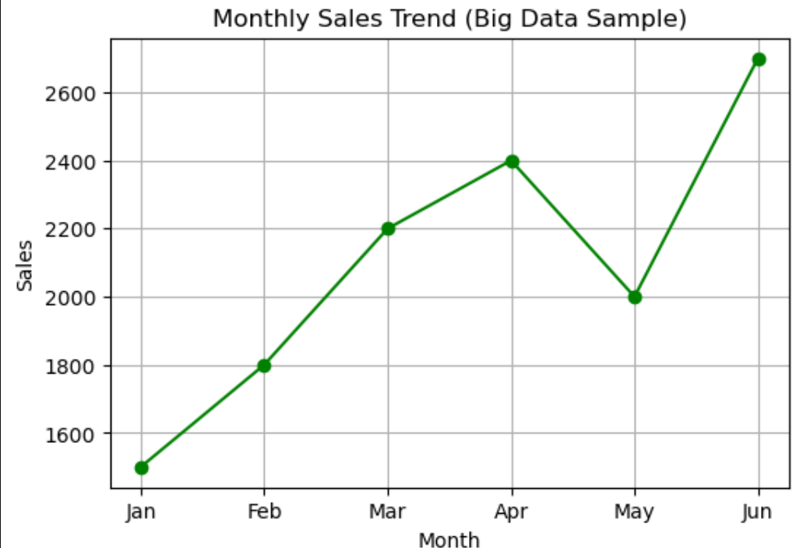
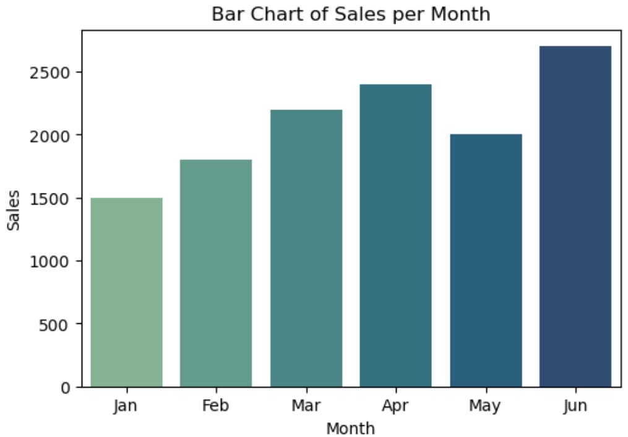

Employee Attrition Prediction — Logistic Regression
# 1. Import libraries
import pandas as pd

from sklearn.model_selection import train_test_split
from sklearn.preprocessing import LabelEncoder, StandardScaler
from sklearn.linear_model import LogisticRegression
from sklearn.metrics import accuracy_score, classification_report, confusion_matrix

# 2. Load dataset
df = pd.read_csv("WA_Fn-UseC_-HR-Employee-Attrition.csv")

# 3. Display dataset
print(df.head())
print(df.info())

# 4. Remove unnecessary columns
df.drop(["EmployeeNumber", "EmployeeCount", "Over18", "StandardHours"],
axis=1, inplace=True)

# 5. Separate features and target
X = df.drop("Attrition", axis=1)
y = df["Attrition"]

# 6. Convert categorical columns into numbers
X = pd.get_dummies(X, drop_first=True)

# 7. Convert target: Yes = 1, No = 0
y = y.map({"Yes": 1, "No": 0})

# 8. Split dataset
X_train, X_test, y_train, y_test = train_test_split(
X,
y,
test_size=0.2,
random_state=42,
stratify=y
)

# 9. Scale features
scaler = StandardScaler()

X_train = scaler.fit_transform(X_train)
X_test = scaler.transform(X_test)

# 10. Create Logistic Regression model
model = LogisticRegression(max_iter=1000)

# 11. Train the model
model.fit(X_train, y_train)

# 12. Predict employee attrition
y_pred = model.predict(X_test)

# 13. Evaluate model
accuracy = accuracy_score(y_test, y_pred)

print("\nAccuracy:", accuracy)

print("\nClassification Report:")
print(classification_report(y_test, y_pred))

print("\nConfusion Matrix:")
print(confusion_matrix(y_test, y_pred))

# 14. Predict one employee
prediction = model.predict(X_test[:1])

if prediction[0] == 1:
print("\nPrediction: Employee is likely to LEAVE")
else:
print("\nPrediction: Employee is likely to STAY")

OUTPUT:
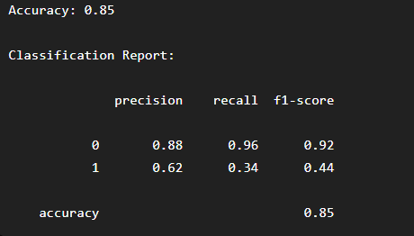

Crop Recommendation — Naïve Bayes
# 1. Import libraries
import pandas as pd

from sklearn.model_selection import train_test_split
from sklearn.preprocessing import LabelEncoder
from sklearn.naive_bayes import GaussianNB
from sklearn.metrics import accuracy_score, classification_report, confusion_matrix

# 2. Load dataset
df = pd.read_csv("Crop_recommendation.csv")

# 3. Display dataset
print(df.head())
print(df.info())

# 4. Separate features and target
X = df.drop("label", axis=1)
y = df["label"]

# 5. Encode target labels
le = LabelEncoder()
y = le.fit_transform(y)

# 6. Split dataset into training and testing
X_train, X_test, y_train, y_test = train_test_split(
X,
y,
test_size=0.2,
random_state=42,
stratify=y
)

# 7. Create Naïve Bayes model
model = GaussianNB()

# 8. Train the model
model.fit(X_train, y_train)

# 9. Make predictions
y_pred = model.predict(X_test)

# 10. Evaluate the model
accuracy = accuracy_score(y_test, y_pred)

print("Accuracy:", accuracy)

print("\nClassification Report:")
print(classification_report(y_test, y_pred))

print("\nConfusion Matrix:")
print(confusion_matrix(y_test, y_pred))

# 11. Recommend a crop for new conditions
# N, P, K, temperature, humidity, pH, rainfall

new_data = [[90, 42, 43, 20.8, 82.0, 6.5, 202.9]]

prediction = model.predict(new_data)

recommended_crop = le.inverse_transform(prediction)

print("\nRecommended Crop:", recommended_crop[0])

OUTPUT:
