FORMS
Ex no: 4
Project: Inventory Manager using Low-Code in Zoho Creator
FORM 1: SUPPLIERS
Field | Type | Settings
Supplier_Name | Single Line | Mandatory
Phone | Phone | Default country code +91
Email | Email | Valid email format

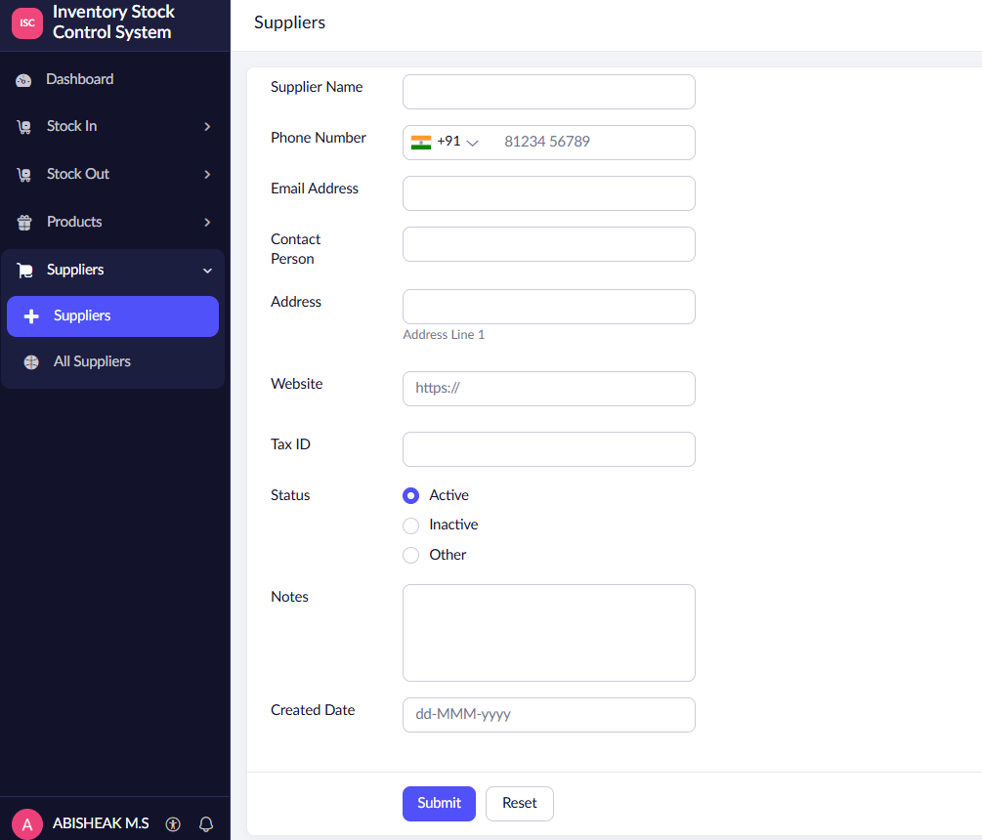
Figure 4.1: Suppliers form
FORM 2: PRODUCTS
Field | Type | Settings
Product_Name | Single Line | Mandatory
SKU | Single Line | No duplicate values
Category | Dropdown | Electronics, Stationery, Furniture
Unit | Dropdown | Pcs, Box, Kg
Supplier | Lookup | Lookup to Suppliers form
Reorder_Level | Number | Minimum stock before a low-stock alert
Current_Stock | Number | Default 0; admin only, updated by workflow

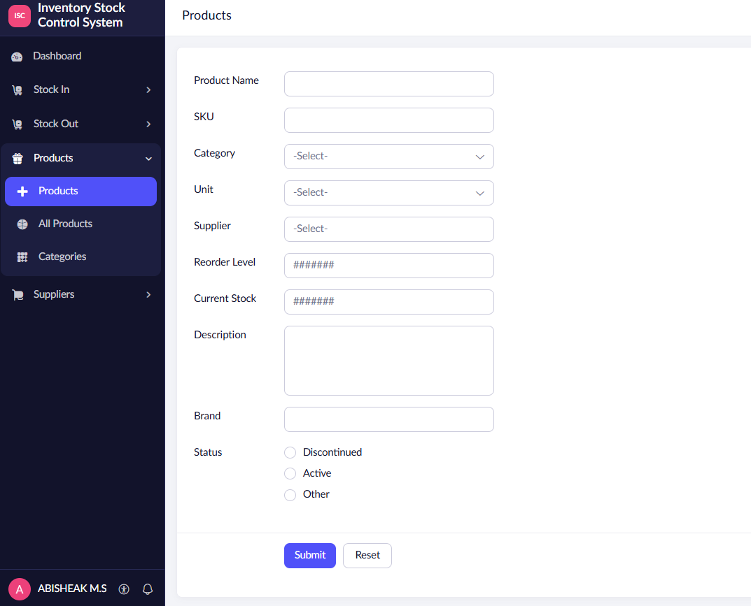

FORM 3: STOCK_IN (STOCK RECEIVED)
Field | Type | Settings
Product | Lookup | Lookup to Products form
Quantity | Number | Mandatory; minimum 1
Received_Date | Date | Default value: today
Invoice_No | Single Line | Supplier invoice reference

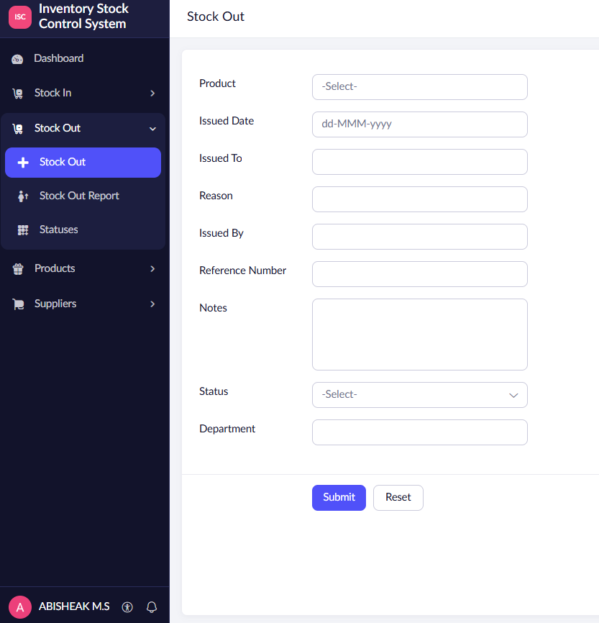
FORM 4: STOCK_OUT (STOCK ISSUED)
Field | Type | Settings
Product | Lookup | Lookup to Products form
Quantity | Number | Mandatory; minimum 1
Issued_Date | Date | Default value: today
Issued_To | Single Line | Person or department receiving the stock



