REPORTS
Ex no: 5
Project: Inventory Manager using Low-Code in Zoho Creator
REPORT 1: LOW STOCK REPORT
Property | Value
Source form | Products
Filter criteria | Current_Stock <= Reorder_Level
Columns shown | Product_Name, SKU, Category, Current_Stock, Reorder_Level, Supplier
Purpose | Shows items that must be reordered

REPORT 2: STOCK IN HISTORY
Property | Value
Source form | Stock_In
Grouping | Product
Columns shown | Product, Quantity, Received_Date, Invoice_No
Purpose | Shows every stock receipt, grouped by product
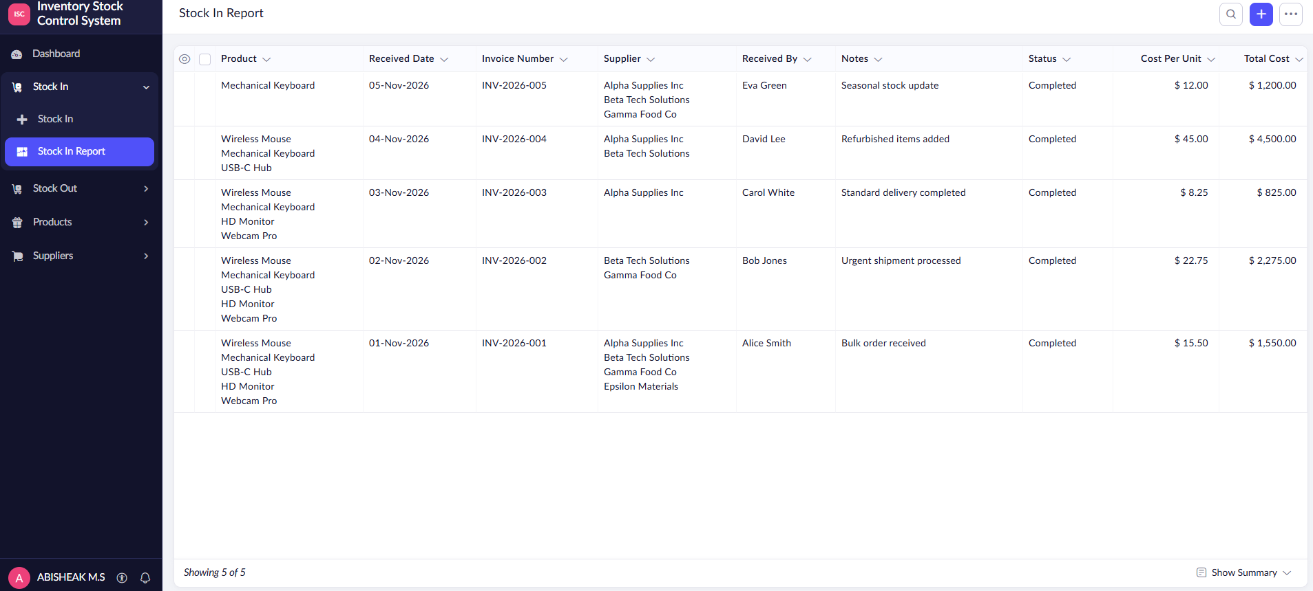REPORT 3: STOCK OUT HISTORY
Property | Value
Source form | Stock_Out
Grouping | Issued_Date (by month) and Issued_To
Columns shown | Product, Quantity, Issued_Date, Issued_To
Purpose | Shows stock issued, grouped by month and receiver



