WORKFLOW
Ex no: 6
Project: Inventory Manager using Low-Code in Zoho Creator
FORM WORKFLOWS
Form | Event | Action
Stock_In | On Success of Add, Edit, Delete | Call recalcStock(Product) to refresh Current_Stock
Stock_Out | On Validate of Add, Edit | Block the entry if Quantity exceeds available stock
Stock_Out | On Success of Add, Edit, Delete | Call recalcStock(Product) and send low-stock email if required
Stock_In, Stock_Out | On Load of Edit | Disable the Product field

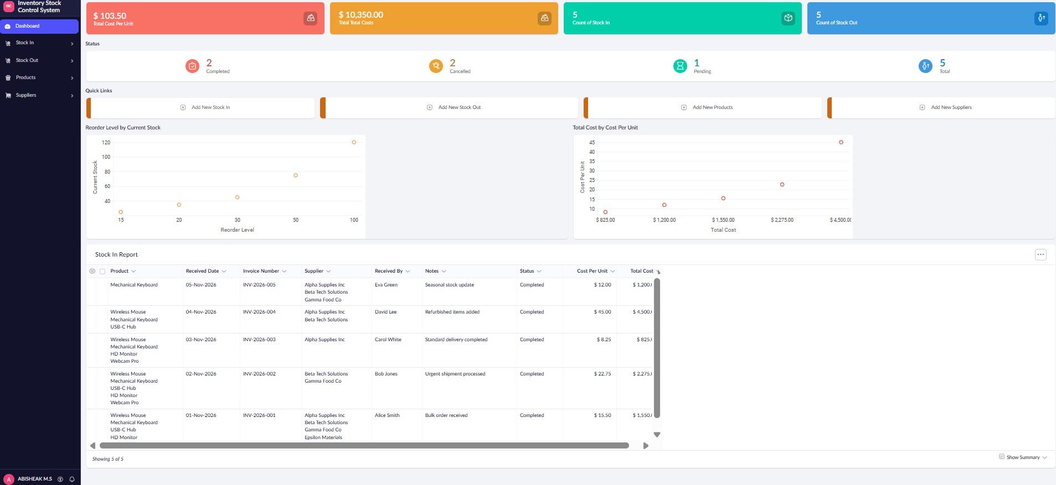SCHEDULE WORKFLOW: DAILY LOW STOCK DIGEST
Runs once a day and emails the administrator a list of all products at or below their reorder level.
lowItems = Products[Current_Stock <= Reorder_Level];
body = "";
for each p in lowItems
{
body = body + p.Product_Name + " - " + p.Current_Stock + " left<br>";
}
if(body != "")
{
sendmail
[
from: zoho.adminuserid
to: zoho.adminuserid
subject: "Daily low stock report"
message: body
]
}

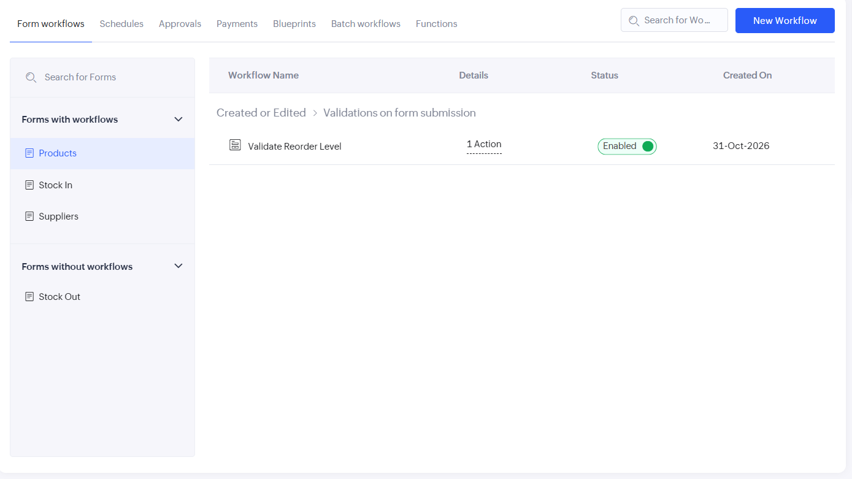STOCK_OUT: ON VALIDATE OF ADD
prod = Products[ID == input.Product];
if(input.Quantity > prod.Current_Stock)
{
alert "Only " + prod.Current_Stock + " units available in stock.";
cancel submit;
}

