**What are whycon markers and how do they work?**

WhyCon is a version of a vision-based localization system that can be used with low-cost web cameras, and achieves millimeter precision with very high performance. The system is capable of efficient real-time detection and precise position estimation of several circular markers in a video stream. WhyCon is meant as an alternative to widely used and expensive localization systems. It is fully open-source.

At stage 1 the algorithm perform flood fill technique and search for continuous black segments and then it The ratio of each segment’s pixels to its bounding box area is then compared to a value calculated from dimensions of the whycon marker. After that it searches for the white pixels to get the centroid and calculates the 3D position .then the other whycon markers are detected and the distance between each markers are calculated and using those data the localisation of the robot is done.

**What are AruCo markers and how do they work?**

Aruco markers are markers which are placed on objects and scenes for uniquely identifying based on the pattern on the marker. Each marker represents different objects which makes robot easier to identify the particular object associated with the pattern

**Open Loop Control System**

It is system in which the output of the system does not affect the action of the control system .Basically , the system that totally depends on the input and provides output based on the input .So it does not require a feedback .Since it does not check the output it is prone to have errors at the output. And the advantage of the open loop system is that it is quick to react as the control actions are based on the input

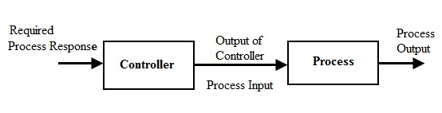

### Closed-Loop Control System

In this system the action of the control systems is based on the error, which is the difference in input and output signal. As the control system requires output signal to calculate the error, this system requires a feedback node. This control system is not as fast as open loop control system as the output is based on previous cycle(refers that the true output is produced at second cycle) .The advantage is that the errors caused due to some external factors can be reduced.

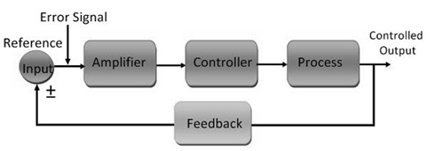

**PID controllers**

PID (proportional integral derivative) controllers acts based on the errors between set point and measured value. Each part in PID controller contributes for minimising the error. Each part of the PID controller has constants or multiplier and it has to be tuned properly to get desired output.

The proportional part just multiplies the error with the multiplier.

The integral part integrates over the error.

The derivative part tries to reduce the slope in order to reduce overshoot.

**Optimal way of tuning PID controller**

|  |  |
| --- | --- |
| **Rule Name** | **Tuning Parameters** |
| Classic Ziegler-Nichols | Kp = 0.6 Ku     Ti = 0.5 Tu     Td = 0.125 Tu |
| Pessen Integral Rule | Kp = 0.7 Ku     Ti = 0.4 Tu     Td = 0.15 Tu |
| Some Overshoot | Kp = 0.33 Ku    Ti = 0.5 Tu     Td = 0.33 Tu |
| No Overshoot | Kp = 0.2 Ku     Ti = 0.5 Tu     Td = 0.33 Tu |

the period Tu of the oscillation frequency at the stability limit

the gain margin Ku for loop stability

**Flowchart for working of PID controller**

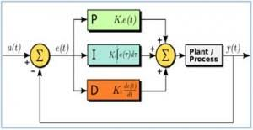

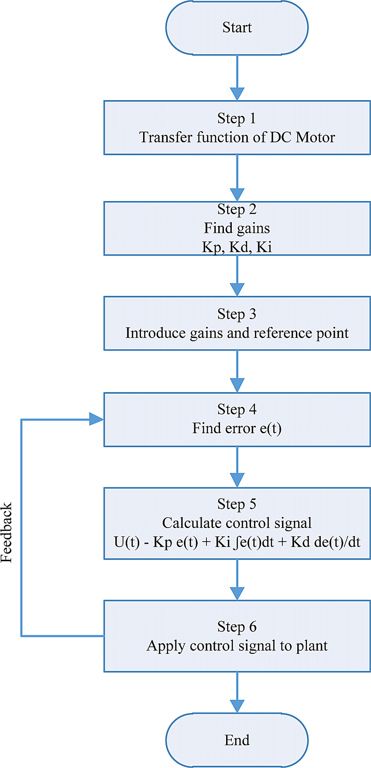

task_2: implementation and tuning of PID controller

In this week we had to build a PID controller for the drone given to us and the objective of this week is to make the drone fly and stay in the given position.The controller used for the task is a PID controller.The most important part in this task is to tune the PID controller. The implementation of the PID controller code was refered from <http://brettbeauregard.com/blog/2011/04/improving-the-beginners-pid-introduction/> a blog which explains how to develop aPID controller for beginers . Then the tuning is done with the help of plotjuggler, which is a graph visualisation tool and PID tune, which is a python script .The python script displays 4 dialog boxes with control bars for setting the value of KP,KI,KD for throttle pitch and roll

Then KP,KI,KD for each of the parameters(throttle pitch and roll) have to be tuned and the output can be viewed on the graph (plotjuggler) .You have to tune for one axis at a tine (eg. First tune the throttle then the pitch and then the roll).All shouldn’t be done together. After tuning substitute the values of KP,KI,KD in the PID controller script .

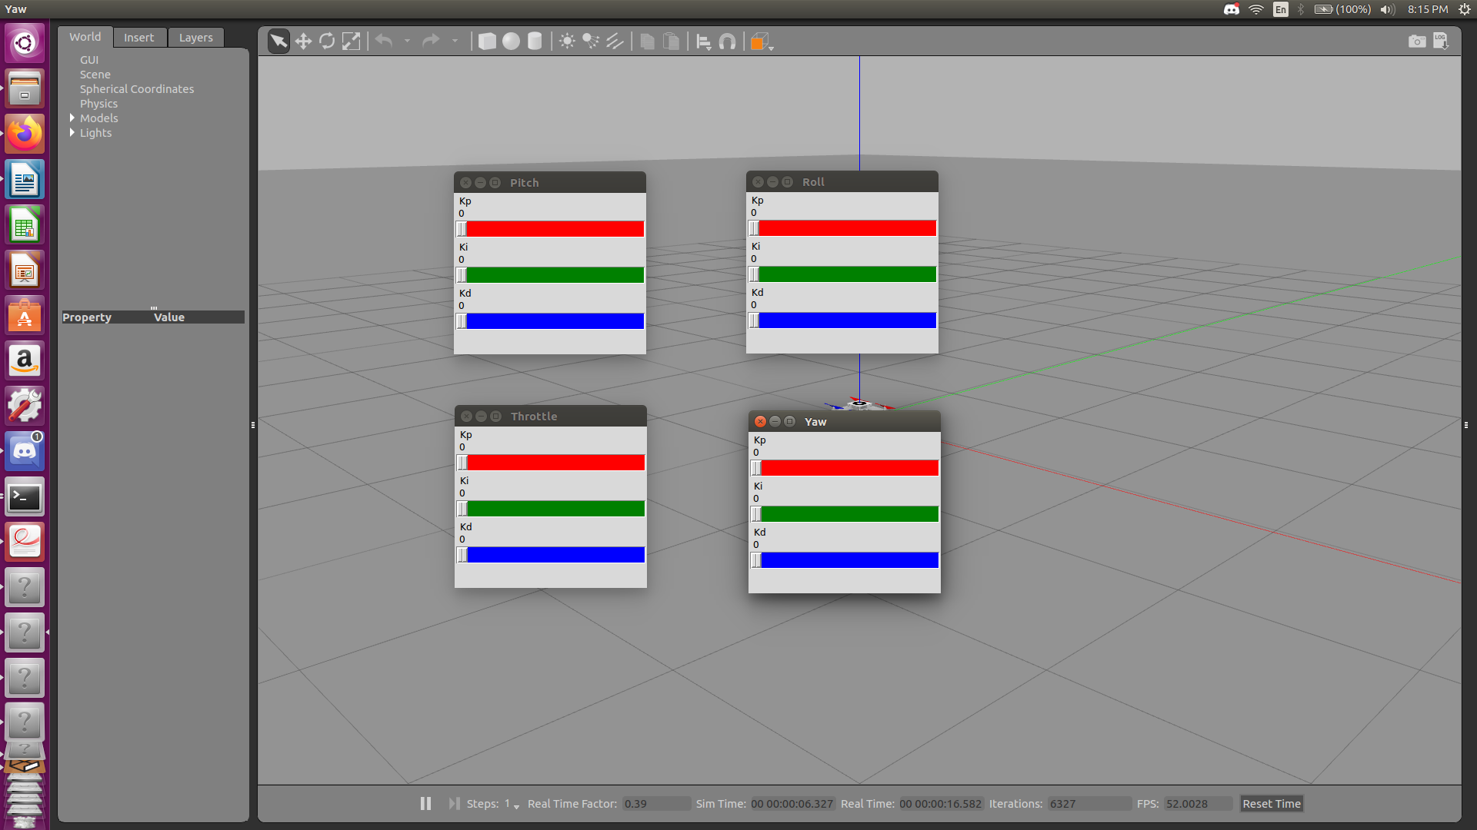

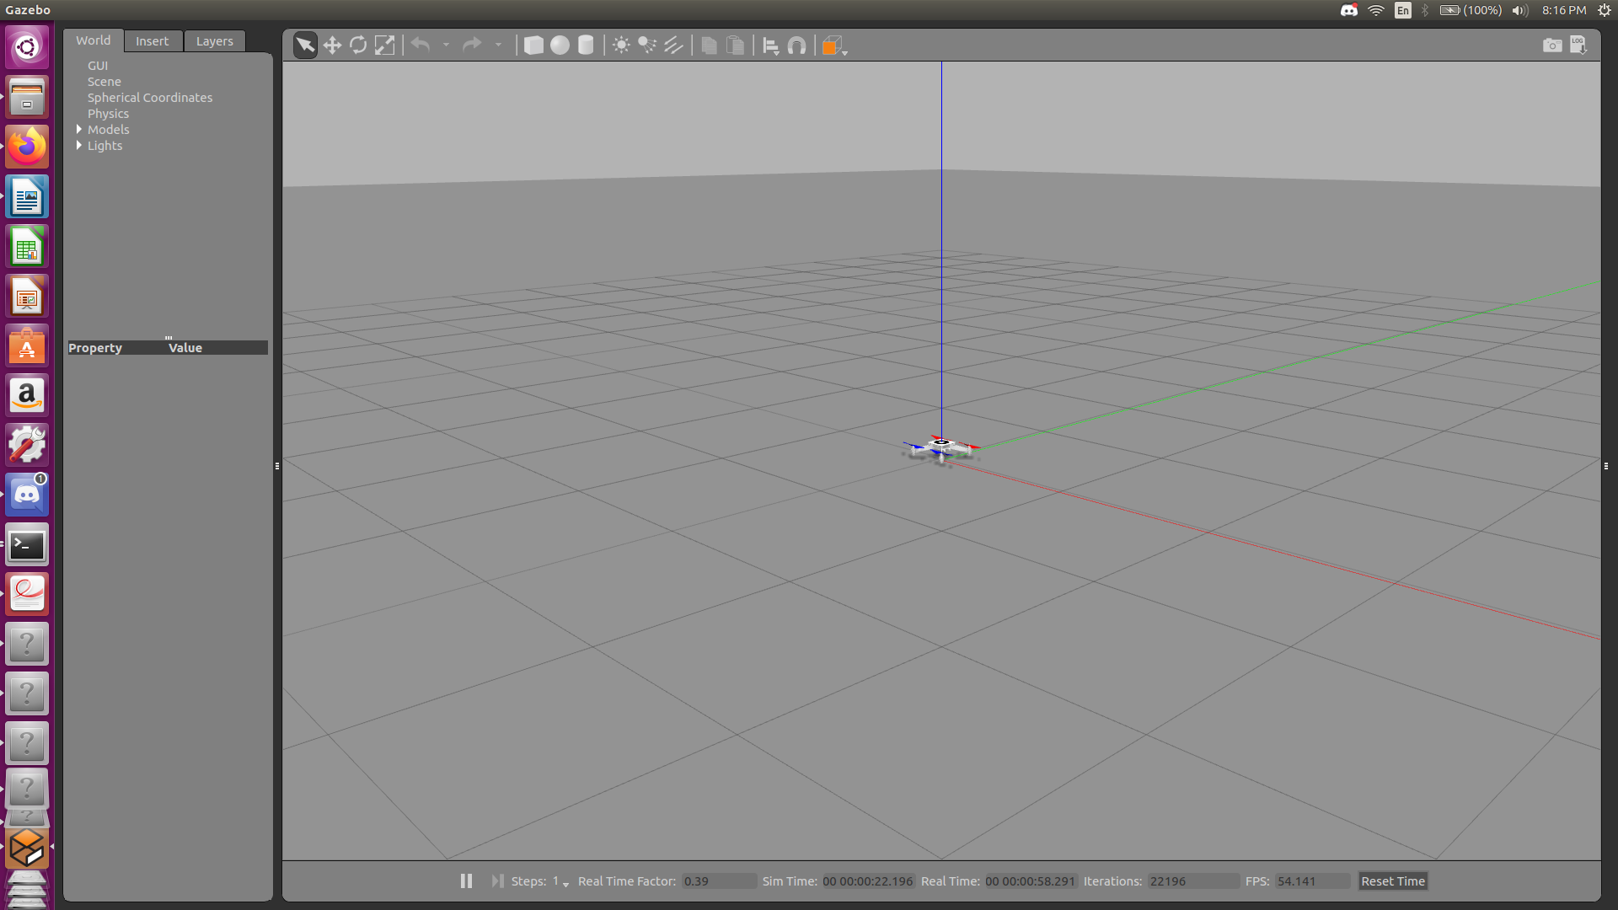

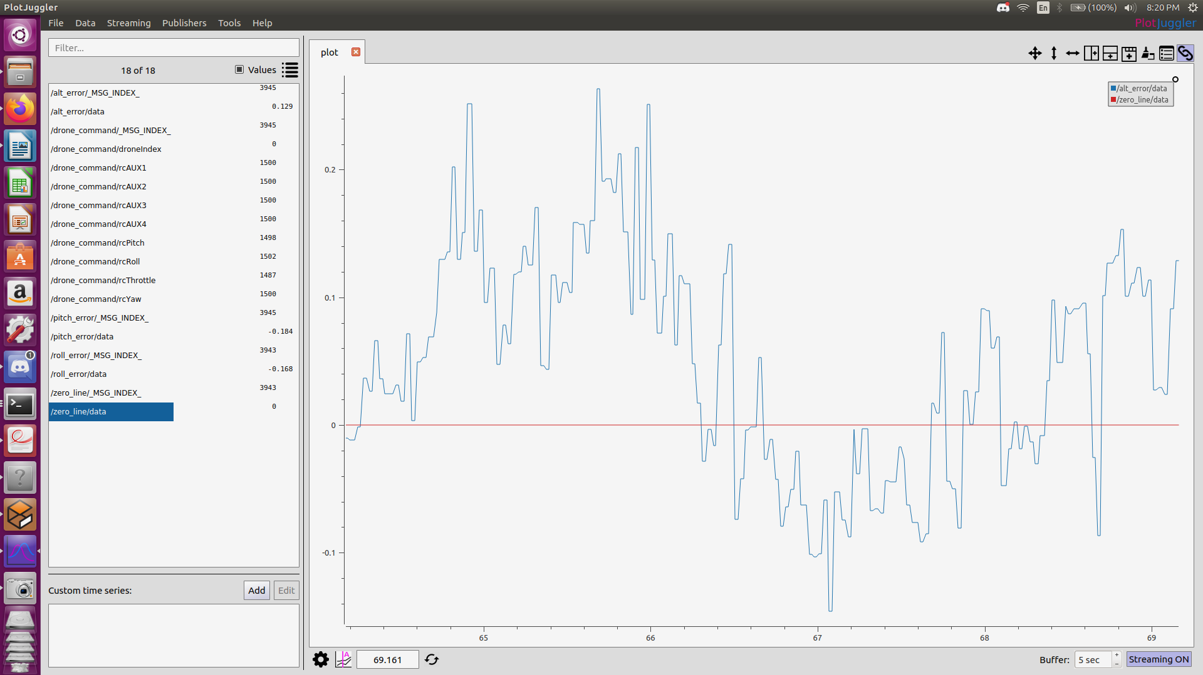

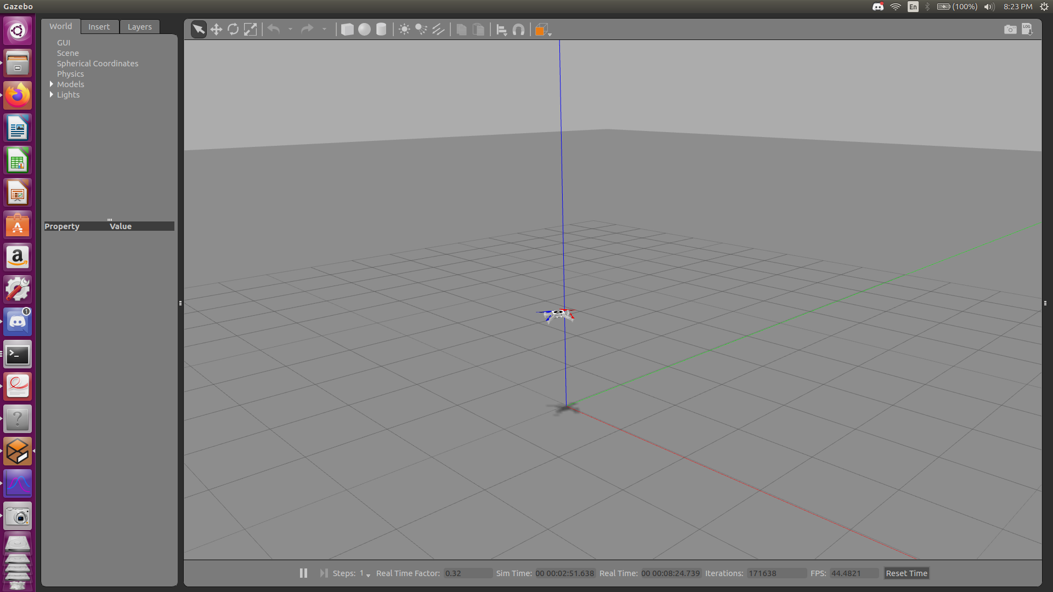

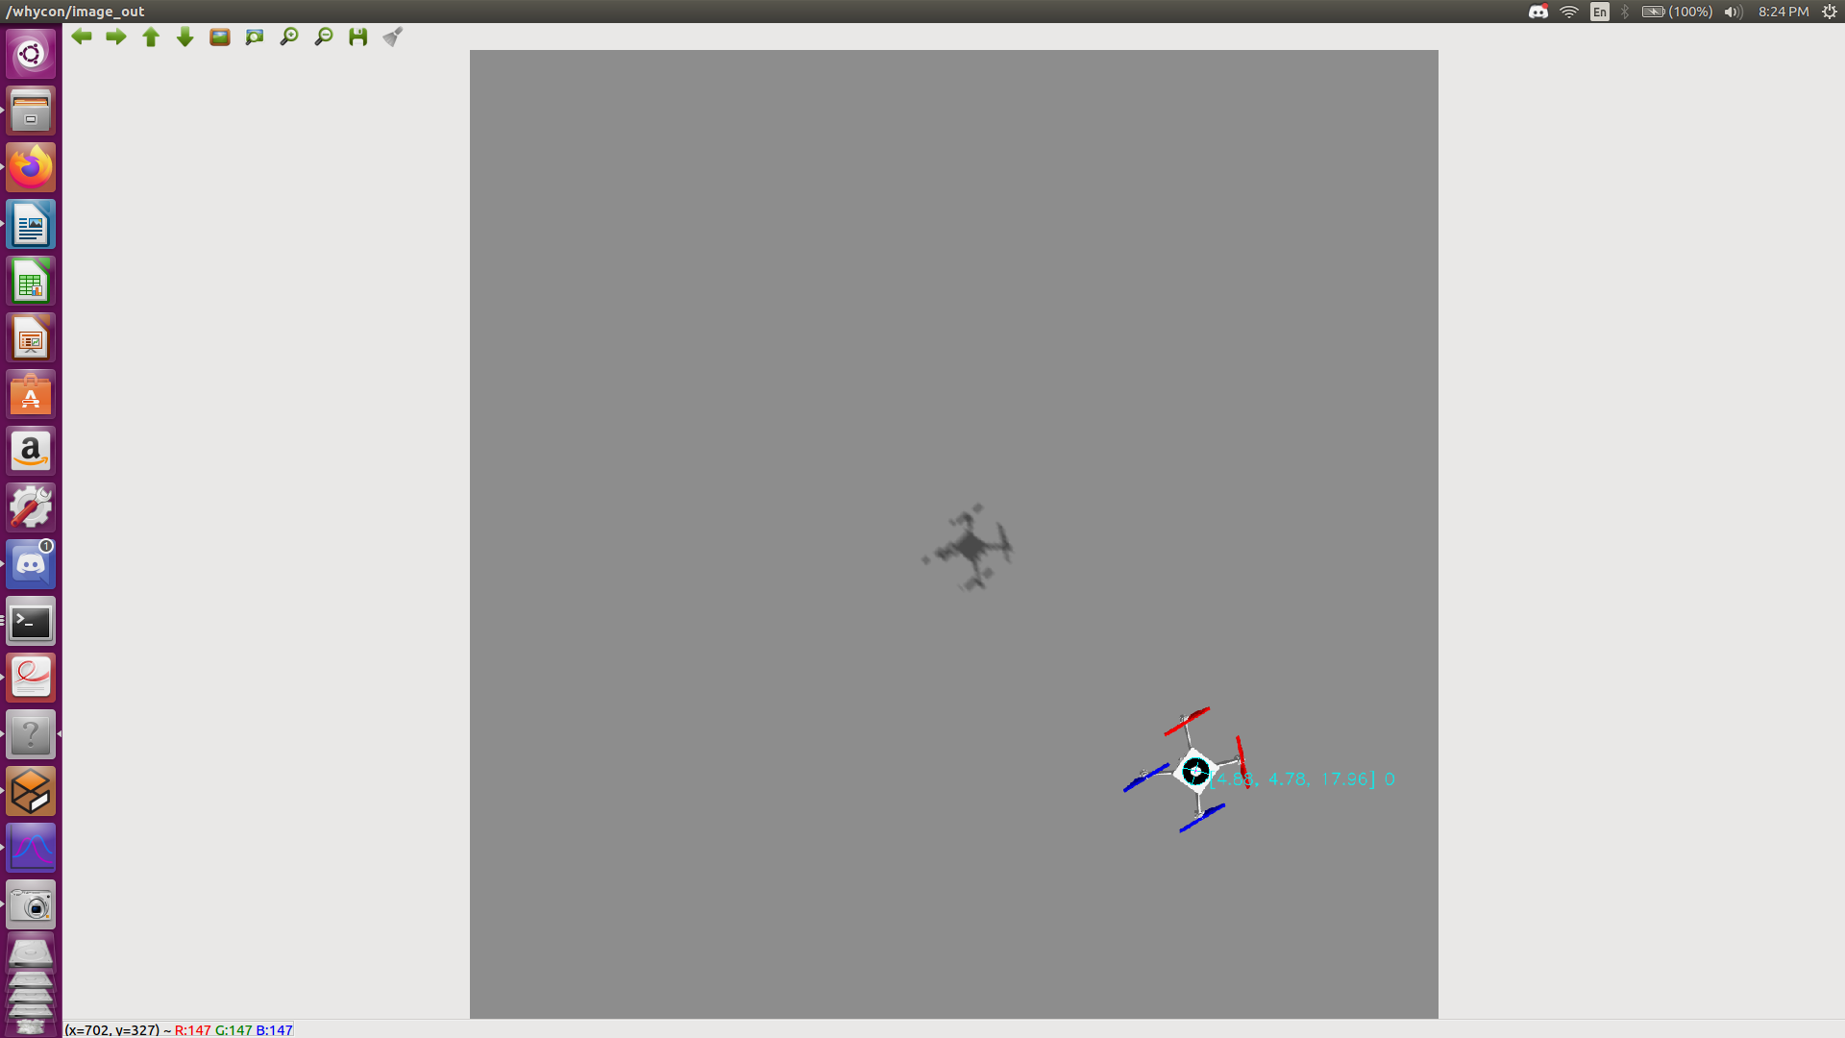

**References**

Open and Closed loop control system - [https://www.elprocus.com/difference-between-open-loop-closed-loop-control-system/#:~:text=The%20main%20difference%20between%20open,depends%20on%20the%20controlled%20act](https://www.elprocus.com/difference-between-open-loop-closed-loop-control-system/" \l ":~:text=The main difference between open,depends on the controlled act).

PID controller - <https://en.wikipedia.org/wiki/PID_controller>

Optimal way of tuning PID controller - [http://www.mstarlabs.com/control/znrule.html#Ref4](http://www.mstarlabs.com/control/znrule.html" \l "Ref4)

Whycon marker - <https://core.ac.uk/download/pdf/42583963.pdf>

<http://brettbeauregard.com/blog/2011/04/improving-the-beginners-pid-introduction/>

AruCo markers - [https://www.learnopencv.com/augmented-reality-using-aruco-markers-in-opencv-c-python/#:~:text=An%20aruco%20marker%20is%20a,in%20a%20variety%20of%20sizes](https://www.learnopencv.com/augmented-reality-using-aruco-markers-in-opencv-c-python/" \l ":~:text=An aruco marker is a,in a variety of sizes).

PID flowchart1 – <https://upload.wikimedia.org/wikipedia/commons/thumb/4/43/PID_en.svg/400px-PID_en.svg.png>

PID flowchart2 - <https://www.researchgate.net/profile/Sohaib_Aslam2/publication/307092705/figure/fig3/AS:400324838871042@1472456287510/Flow-Chart-of-PID-Implementation.png>

Task_2

Implementation of PID controller: <http://brettbeauregard.com/blog/2011/04/improving-the-beginners-pid-introduction/>

eyantra_drone documentation: <http://wiki.ros.org/eyantra_drone>

plotjuggler cheatsheet: <https://www.plotjuggler.io/cheatsheet>

Videos regarding PID controller :

1. <https://www.youtube.com/watch?v=wkfEZmsQqiA&list=PLn8PRpmsu08pQBgjxYFXSsODEF3Jqmm-y>

2. <https://www.youtube.com/watch?v=UR0hOmjaHp0>