Experiment 1
Title:
Implement a solution using DVC and MLflow to track data, code, model versions, and experiment metrics, ensuring full reproducibility of the ML pipeline.
By the end of this experiment, students should be able to
✅ Create a reproducible ML project
✅ Track datasets using DVC
✅ Track experiments using MLflow
✅ Compare multiple experiments
✅ Version control using Git
Dataset
Use any dataset
Software Required
Python 3.10+
VS Code
Git
GitHub
DVC
MLflow
scikit-learn
pandas
numpy
joblib

Project Structure:
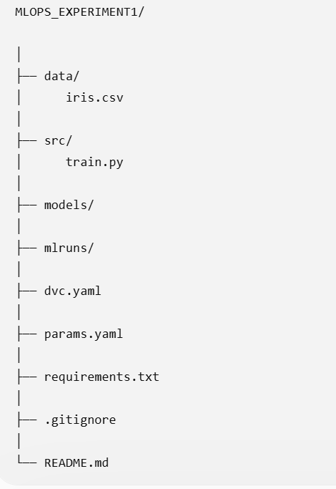
Step 1
Create Virtual Environment
python -m venv venv
Activate:
venv\Scripts\activate
Install packages:
pip install pandas
pip install numpy
pip install scikit-learn
pip install mlflow
pip install dvc
pip install joblib

Save Dependencies:
pip freeze > requirements.txt

Step 2
Initialize Git
git init
Step 3
Initialize DVC
dvc init
Commit
git add .
git commit -m "Initialize DVC"
Step 4
Create Dataset:
create_dataset.py
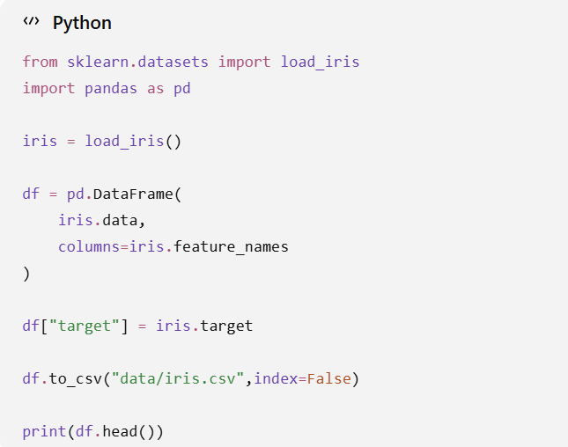
Run:
python create_dataset.py
Step 5
Track Dataset
dvc add data/iris.csv
DVC creates “iris.csv.dvc”
Commit:
git add .
git commit -m "Track dataset using DVC"
Step 6
Training Script
src/train.py
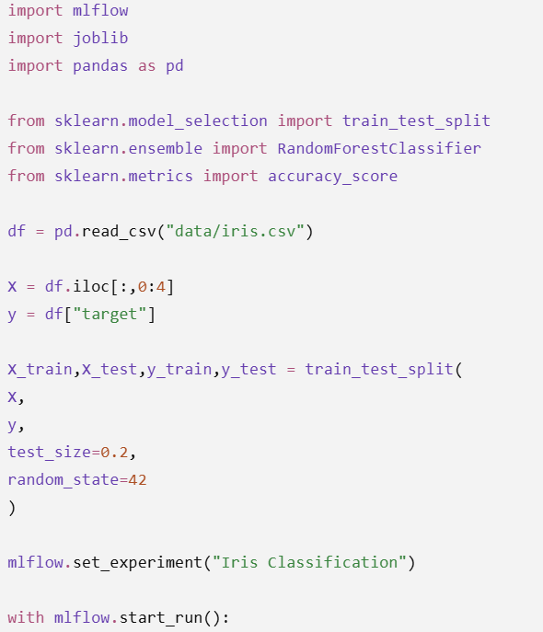

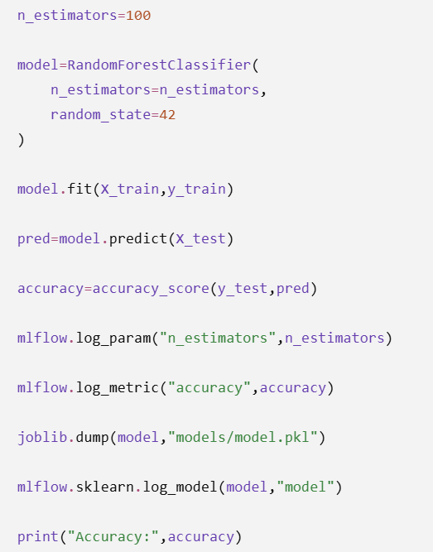

Step 7
Run Training
src/train.py
Output:
Accuracy : 1
Step 8
Open MLflow UI
mlflow ui
Open
http://127.0.0.1:5000
Step 9
Change Hyperparameter
n_estimators=50
n_estimators=100
n_estimators=200
n_estimators=10
Step 10
Track Model
git add .
git commit -m "Added trained model"
Step 11
DVC Pipeline
dvc.yaml
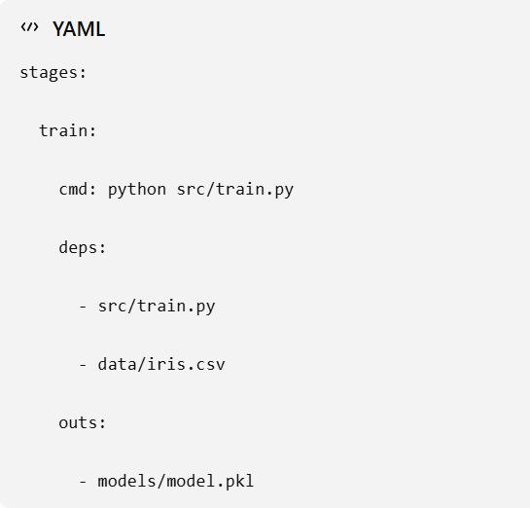
Run
dvc repro
Step 12
Push to GitHub
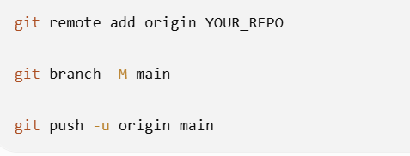
Expected Output:
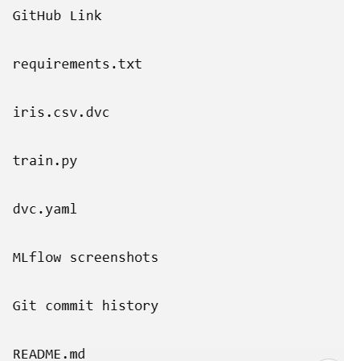

Optional:
- Change Datasets
- Change Training Models
- Change Hyper parameters

