**Program 1**

**Exercise 1:** Program to implement simple programs based on operators, Loop and decision making statements

**Aim:** To Write a program to perform the student marksheet processing using operators,loop and decision making statments

**Procedure**

1. Import the header files
2. Create the main class ex1
3. Declare the variable sname as string, m1,m2,m3,tot,ch as int, avr as float, gr as char.
4. Repeat the loop,until the argument value is false
   1. Create the object d for DataInputStream class
   2. Read the sname,m1,m2,m3
   3. Set tot=m1+m2+m3;
   4. Set avr=tot/3
   5. Check if avr >=80

Set gr=’A’;

gr='A';

else if (avr >= 70 && avr<=79)

gr='B';

else if (avr>=60 && avr<=69)

gr='C';

else

gr='D';

* 1. Read ch
  2. If (ch ==0) break the loop

1. Stop the execution

**Program**

import java.io.*;

class ex1

{

public static void main(String args[]) throws IOException

{

String sname;

int m1,m2,m3,tot;

int ch;

float avr;

char gr;

while(true)

{

DataInputStream d=new DataInputStream(System.in);

System.out.println("Enter sname,m1,m2,m3");

sname=d.readLine();

m1=Integer.parseInt(d.readLine());

m2=Integer.parseInt(d.readLine());

m3=Integer.parseInt(d.readLine());

tot=m1+m2+m3;

avr=tot/3;

if ( avr >= 80)

gr='A';

else if (avr >= 70 && avr<=79)

gr='B';

else if (avr>=60 && avr<=69)

gr='C';

else

gr='D';

System.out.println("Student Name="+sname);

System.out.println("Total="+tot);

System.out.println("Grade="+gr);

System.out.println("Do You want to continue Press 1- year 0 - no");

ch=Integer.parseInt(d.readLine());

if (ch == 0)

break;

}

}

}

**Ouput:**

D:\java\lab>java ex1

Enter sname,m1,m2,m3

Jai

67

69

45

Student Name=Jai

Total=181

Grade=C

Do You want to continue Press 1- year 0 - no

1

Enter sname,m1,m2,m3

krishna

34

56

67

Student Name=krishna

Total=157

Grade=D

Do You want to continue Press 1- year 0 - no

0

**Result**

Thus the Program has been executed successfully.

**Exercise 2b: Program to implement array**

**Aim: To Write a program to print the two dimensional array**

**Procedure**

1. Import the header files
2. Create the main class ex2b
3. Declare the array a with size 4,4, n,I,j as int
4. Read n
5. Repeat the loop I = 0 to n and j=0 to n
   1. Read a[i][j]
6. Repeat the loop i=0 to n and j=0 to n
   1. Print a[i][j]
7. Stop the execution

**Program**

import java.io.*;

class ex2b

{

public static void main(String args[]) throws IOException

{

int a[][]=new int[4][4];

int n,i,j;

DataInputStream d=new DataInputStream(System.in);

System.out.println("Enter the number of elements");

n=Integer.parseInt(d.readLine());

System.out.println("Enter the Array Values");

for(i=0;i<n;i++)

{

for(j=0;j<n;j++)

{

a[i][j]=Integer.parseInt(d.readLine());

}

}

for(i=0;i<n;i++)

{

for(j=0;j<n;j++)

{

System.out.print(" "+a[i][j]);

}

System.out.println();

} } }

**Output**

D:\java\lab>java ex2b

Enter the number of elements

2  
Enter the Array Values

2

3

4

5

2 3

4 5

**Result**

Thus the Program has been executed successfully.

**Program 3**

**Exercise 3** : Program to demonstrate the use of interfaces

**Aim : To Write a program to perform the telephone connection using an interfaces**

**Procedure**

1. Import the header files
2. Create the interface with the inter and have a member function connect()
3. Create the class tele which implements inter
   1. Declare the variable cno,ph_no as int and cname and status as string
   2. Define the member function get()

Set cno=112;

Set cname="Vandana";

Set ph_no=234533;

* 1. Define the member function connect with public scope

Set status="Socket connected with telephone";

* 1. Define the member function dis()

Print cno,cname,ph_no and status

1. Create the main class named with ex4
   1. Create the object t for the class tele
   2. Call the function t.get(),t.connect(),t.dis()

**Program**

import java.io.*;

interface inter

{

void connect();

}

class tele implements inter

{

int cno;

String cname,status;

int ph_no;

void get()

{

cno=112;

cname="Vandana";

ph_no=234533;

}

public void connect()

{

status="Socket connected with telephone";

}

void dis()

{

System.out.println("Customer No"+cno);

System.out.println("Customer Name"+cname);

System.out.println("Phone No."+ph_no);

System.out.println("Status"+status);

}

}

class ex4

{

public static void main(String args[])

{

tele t=new tele();

t.get();

t.connect();

t.dis();

}

}

**Output**

D:\java\lab>java ex4

Customer No112

Customer NameVandana

Phone No.234533

StatusSocket connected with telephone

**Result**

Thus the Program has been executed successfully.

**Exercise 4 Program to implement user-defined and pre-defined packages**

**Aim : To write a program to create a package for vacancy in companies**

**Algorithm:**

**Wipro.java**

1. Declare the package with the name pack;
2. Create the class named with wipro
   1. Declare the variable cname,desig as string, pos as int,sal as float
   2. Define the member function wiproget()
      1. Cname = “wipro” desig-“Assembler” pos=20 and sal = 40000
   3. Define the member function wiproput()
      1. Print the cname,desig,pos and sal

**Hcl.java**

1. Declare the package with the name pack;
2. Create the class named with hcl
   1. Declare the variable cname,desig as string, pos as int,sal as float
   2. Define the member function hclget()
      1. Cname = “HCL” desig-“Developer” pos=10 and sal = 30000
   3. Define the member function hclput()
      1. Print the cname,desig,pos and sal

**Ex5.java**

1. Import the package pack.*;
2. Create the class named with ex5
   1. Create the object wipro w=new wipro();
   2. Create the object hcl h=new hcl();
   3. Call the method w.wiproget(),w.wiproput(), h.hclget(), h.hclput();

**Program**

**Package Creation**

**wipro.java**

package pack;

public class wipro

{

public String cname, desig;

public int pos;

public float sal;

public void wiproget()

{

cname="Wipro";

desig="Assembler";

pos=20;

sal=40000;

}

public void wiproput()

{

System.out.println("Company Name"+cname);

System.out.println(" Designation "+desig);

System.out.println("Vacancy"+pos);

System.out.println("Salary"+sal);

}

}

**hcl.java**

package pack;

public class hcl

{

public String cname, desig;

public int pos;

public float sal;

public void hclget()

{

cname="HCL";

desig="Developer";

pos=10;

sal=30000;

}

public void hclput()

{

System.out.println("Company Name"+cname);

System.out.println(" Designation "+desig);

System.out.println("Vacancy"+pos);

System.out.println("Salary"+sal);

}

}

**Package imports**

import java.io.*;

import pack.*;

class ex5

{

public static void main(String args[])

{

wipro w=new wipro();

hcl h=new hcl();

w.wiproget();

w.wiproput();

h.hclget();

h.hclput();

}

}

**Output**

D:\java\lab\pack> javac hcl.java

D:\java\lab\pack> javac wipro.java

D:\java\lab>java ex5

Company Name Wipro

Designation Assembler

Vacancy 20

Salary 40000

Company Name HCL

Designation Developer

Vacancy 10

Salary 30000

**Result**

Thus the Program has been executed successfully.

**Exercise 5: Program to implement an applet using graphics class**

**Aim : To write a program to implement an applet using graphics class**

**Algorithm:**

1. define the <applet> tab with code=”ex12.calss” ,width and height
2. import the header fiels
3. create the class ex12 extends applet
   1. define the method paint(Graphics g)
      1. g.setColor(Color.red);
      2. g.drawRect(100,100,200,200);
      3. g.drawLine(100,100,150,150);
      4. g.drawString("Welcome",50,50);

**Program:**

/*<applet code="ex12.class" width=200 height=200>

</applet>*/

import java.awt.*;

import java.applet.*;

public class ex12 extends Applet

{

public void paint(Graphics g)

{

g.setColor(Color.red);

g.drawRect(100,100,200,200);

g.drawLine(100,100,150,150);

g.drawString("Welcome",50,50);

}

}

**Output**

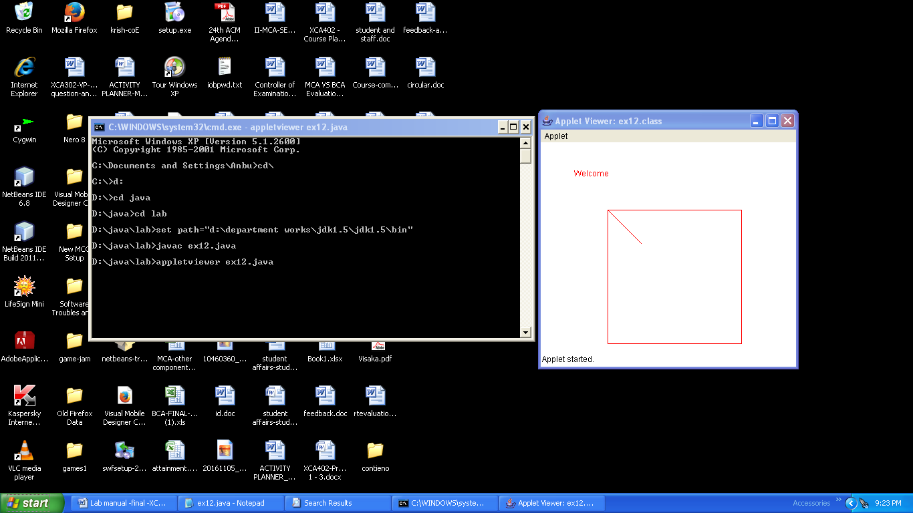

**Result:**

Thus the Program has been executed successfully.

**Exercise 5: To Develop a Frame using AWT implement various events.**

**Aim: To write a programe to implement develop a frame using AWT implement various events.**

**Programe:**

1. **import** java.awt.*;
2. **import** java.awt.event.*;
3. **class** AEvent **extends** Frame **implements** ActionListener{
4. TextField tf;
5. AEvent(){
7. tf=**new** TextField();
8. tf.setBounds(60,50,170,20);
9. Button b=**new** Button("click me");
10. b.setBounds(100,120,80,30);
12. b.addActionListener(**this**);//passing current instance
13. add(b);add(tf);
14. setSize(300,300);
15. setLayout(**null**);
16. setVisible(**true**);
17. }
18. **public** **void** actionPerformed(ActionEvent e){
19. tf.setText("Welcome");
20. }
21. **public** **static** **void** main(String args[]){
22. **new** AEvent();
23. }
24. }

Output:

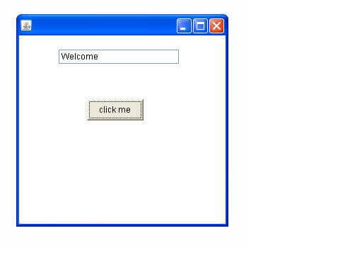

**Result:**

Thus the Program has been executed successfully.

**Exercise7 : To develop a programe to execute select Query using JDCB**

**Aim : To write a program to implement develop a programe to execute select Query using JDCB**

**Programe:**

1. **import** java.sql.*;
2. **class** MysqlCon{
3. **public** **static** **void** main(String args[]){
4. **try**{
5. Class.forName("com.mysql.jdbc.Driver");
6. Connection con=DriverManager.getConnection(
7. "jdbc:mysql://localhost:3306/sonoo","root","root");
8. password
9. Statement stmt=con.createStatement();
10. ResultSet rs=stmt.executeQuery("select * from emp");
11. **while**(rs.next())
12. System.out.println(rs.getInt(1)+"  "+rs.getString(2)+"  "+rs.getString(3));
13. con.close();
14. }**catch**(Exception e){ System.out.println(e);}
15. }
16. }

**Output:**

ID Name city

01 Raja panruti

02 Ramu Thanjavur

03 Somu vellore

**Result:**

Thus the Program has been executed successfully.

**Exercise8 : Program to implement data Insert /Delete/Update Records Using JDBC**

**Aim : To write a program to implement Insert /Delete/Update Records Using JDBC**

**Programe:**

import java.sql.*;  
class EmployeeRecord  
{  
     public static final String DBURL = "jdbc:oracle:thin:@localhost:1521:XE";  
     public static final String DBUSER = "local";  
     public static final String DBPASS = "test";  
     public static void main(String args[])  
     {  
          try  
          {  
               //Loading the driver  
               Class.forName("oracle.jdbc.driver.OracleDriver");  
               //Cretae the connection object  
               Connection con = DriverManager.getConnection(DBURL, DBUSER, DBPASS);  
               //Insert the record  
               String sql = "INSERT INTO emp (emp_id, empname, email, city) VALUES (?, ?, ?, ?)";  
               PreparedStatement statement = con.prepareStatement(sql);  
               statement.setInt(1, 100);  
               statement.setString(2, "Prashant");  
               statement.setString(3, "prasant@saxena.com");  
               statement.setString(4, "Pune");  
  
               int rowsInserted = statement.executeUpdate();  
               if (rowsInserted > 0)  
               {  
                    System.out.println("A new employee was inserted successfully!\n");  
               }  
               // Display the record  
               String sql1 = "SELECT * FROM Emp";  
               Statement stmt = con.createStatement();  
               ResultSet result = stmt.executeQuery(sql1);  
  
               while (result.next())  
               {  
                    System.out.println (result.getInt(1)+" "+  
                    result.getString(2)+" "+  
                    result.getString(3)+" "+  
                    result.getString(4));  
               }  
  
               //Update the record  
               String sql2 = "Update Emp set email = ? where empname = ?";  
               PreparedStatement pstmt = con.prepareStatement(sql2);  
               pstmt.setString(1, "Jaya@gmail.com");  
               pstmt.setString(2, "Jaya");  
               int rowUpdate = pstmt.executeUpdate();  
               if (rowUpdate > 0)  
               {  
                    System.out.println("\nRecord updated successfully!!\n");  
               }  
  
               //Delete the record  
               String sql3 = "DELETE FROM Emp WHERE empname=?";  
               PreparedStatement statement1 = con.prepareStatement(sql3);  
               statement1.setString(1, "Prashant");  
  
               int rowsDeleted = statement1.executeUpdate();  
               if (rowsDeleted > 0)  
               {  
                    System.out.println("A Employee was deleted successfully!\n");  
               }  
          }  
          catch(Exception ex)  
          {  
               ex.printStackTrace();  
          }  
     }  
}

**Output:**

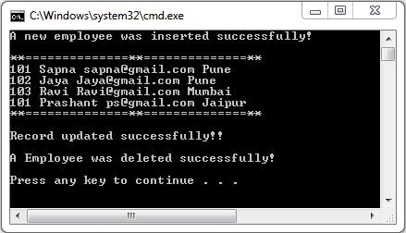

**Result:**

Thus the Program has been executed successfully.

**Exercise9 : To Execute Java Scripts frontend Validation**

**Aim : To write a program to implement Java Scripts frontend Validation**

**Programe:**

<html>

<head>

<title>Form Validation</title>

<script type = "text/javascript">

// Form validation code will come here.

function validate() {

if( document.myForm.Name.value == "" ) {

alert( "Please provide your name!" );

document.myForm.Name.focus() ;

return false;

}

if( document.myForm.EMail.value == "" ) {

alert( "Please provide your Email!" );

document.myForm.EMail.focus() ;

return false;

}

if( document.myForm.Zip.value == "" || isNaN( document.myForm.Zip.value ) ||

document.myForm.Zip.value.length != 5 ) {

alert( "Please provide a zip in the format #####." );

document.myForm.Zip.focus() ;

return false;

}

if( document.myForm.Country.value == "-1" ) {

alert( "Please provide your country!" );

return false;

}

return( true );

}

</script>

</head>

<body>

<form action = "/cgi-bin/test.cgi" name = "myForm" onsubmit = "return(validate());">

<table cellspacing = "2" cellpadding = "2" border = "1">

<tr>

<td align = "right">Name</td>

<td><input type = "text" name = "Name" /></td>

</tr>

<tr>

<td align = "right">EMail</td>

<td><input type = "text" name = "EMail" /></td>

</tr>

<tr>

<td align = "right">Zip Code</td>

<td><input type = "text" name = "Zip" /></td>

</tr>

<tr>

<td align = "right">Country</td>

<td>

<select name = "Country">

<option value = "-1" selected>[choose yours]</option>

<option value = "1">USA</option>

<option value = "2">UK</option>

<option value = "3">INDIA</option>

</select>

</td>

</tr>

<tr>

<td align = "right"></td>

<td><input type = "submit" value = "Submit" /></td>

</tr>

</table>

</form>

</body>

</html>

Output:

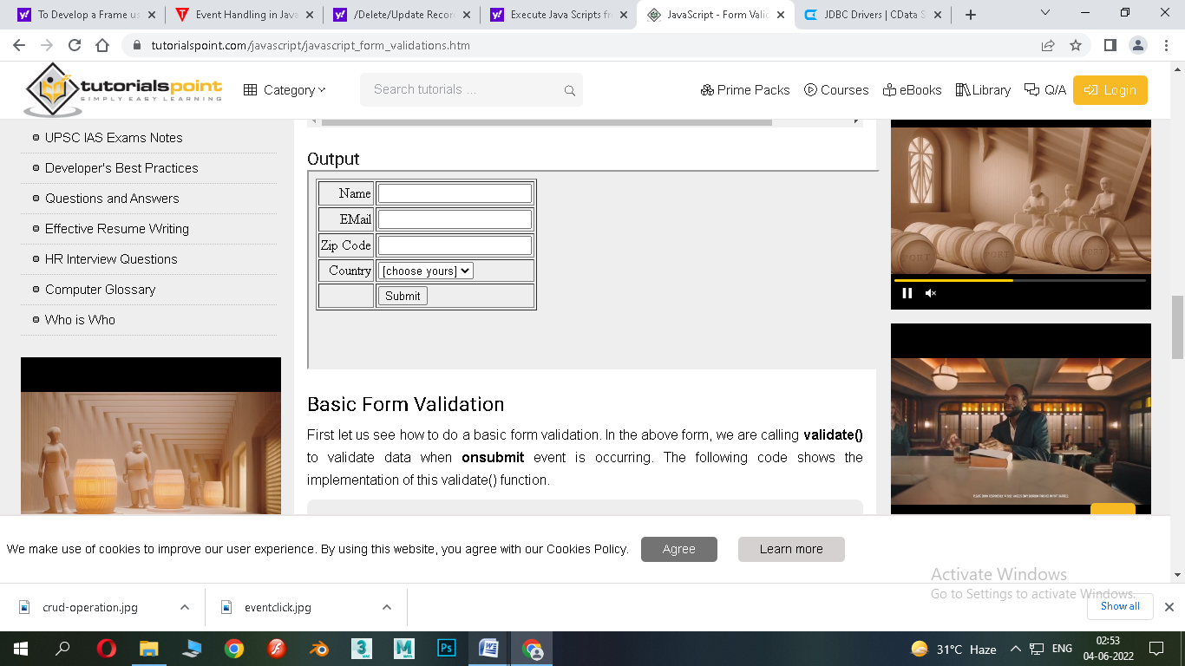

**Result:**

Thus the Program has been executed successfully.

**Exercise10: Programe to implement check validate using java script**

**Aim : To write a program to implement Java check validate using java script**

**Programe:**

**<!DOCTYPE html>**

**<html>**

**<head>**

**<script>**

**function validateForm() {**

**let x = document.forms["myForm"]["fname"].value;**

**if (x == "") {**

**alert("Name must be filled out");**

**return false;**

**}**

**}**

**</script>**

**</head>**

**<body>**

**<h2>JavaScript Validation</h2>**

**<form name="myForm" action="/action_page.php" onsubmit="return validateForm()" method="post">**

**Name: <input type="text" name="fname">**

**<input type="submit" value="Submit">**

**</form>**

**</body>**

**</html>**

**Output:**

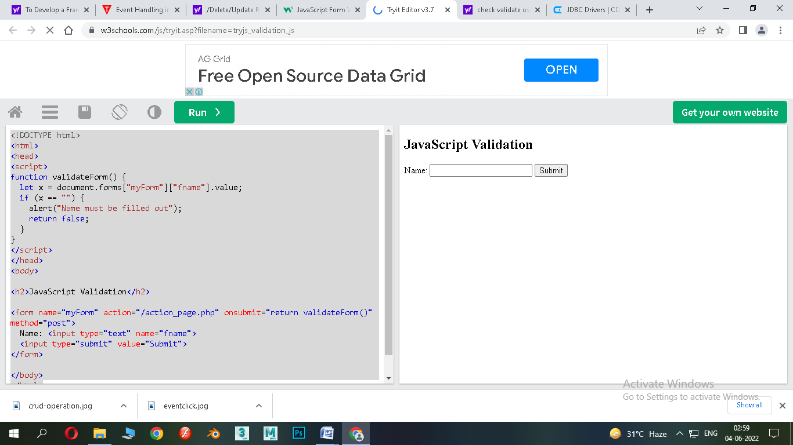

**Result:**

Thus the Program has been executed successfully.