**Department of Software Engineering**

Periyar Nagar, Vallam Thanjavur - 613 403, Tamil Nadu, India.

Email:headmsc@pmu.edu Web: www. pmu.edu

Phone: +91 – 4362 – 264600, Fax: +91 – 4362 - 264660

**M.Sc COMPUTER SCIENCE**

REAL TIME EVALUATION REPORT

Course : M.Sc Computer Science

Year : I

Semester : I

Year of Admission : 2021

Course Code :

**COURSE CODE:** YCS102 **COURSE NAME:** INTERNET OF THINGS

SUBMITTED BY

XYZ

(Reg.No: 123456789)

|  |  |  |  |  |  |  |
| --- | --- | --- | --- | --- | --- | --- |
| Examines | Content organization  (5) | Presentation  (5) | Depth of content  (5) | Communication & Language  (5) | Responsive to audience  (5) | Marks  (25) |
| Internal |  |  |  |  |  |  |
| External |  |  |  |  |  |  |
| Total (50) | | | | | |  |
| Total (100) | | | | | |  |

Internal Examiner External Examiner



**Department of Software Engineering**

Periyar Nagar, Vallam Thanjavur - 613 403, Tamil Nadu, India.

Email:headmsc@pmu.edu Web: www. pmu.edu

Phone: +91 – 4362 – 264600, Fax: +91 – 4362 - 264660

**BONAFIDE CERTIFICATE**

CERTIFIED TO BE BONAFIDE RECORD OF WORK DONE BY Mr.XXXXXXXXXXX REG.NO.123456789 OF M.Sc COMPUTER SCIENCE DEGREE I SEMESTER ODD SEMESTER REAL TIME EVALUATION IN THE **“YCS102 INTERNET OF THINGS”** DURING THE YEAR 2021 - 2022.

# Course Teacher Head of the Department

**TOPIC : Smart Vehicle and Anti-Theft System Using IoT**

**Abstract :**

|  |  |  |
| --- | --- | --- |
| **S.NO** | **CONTENT** | **PAGE.NO** |
| **1** | **Introduction** | **3** |
| **2** | **Definitions** | **4** |
| **3** | **Real life application** | **5** |
| **4** |  | **7** |
| **5** |  | **10** |
| **6** | **Discuss and future directions** | **14** |
| **7** | **Conclusion** | **16** |
| **8.** | **Reference** | **17** |

**INTRODUCTION**

**1.1 INTRODUCTION**

The Internet of things describes physical objects that are embedded with sensors, processing ability, software, and other technologies that connect and exchange data with other devices and systems over the Internet or other communications networks.

Internet of Things (IoT) is a new revolution that uses Internet services to connect to the entire world anywhere, anytime without restricting geographic location. It provides a platform for interconnecting things, self-organizing, identifying themselves using radio frequency identification (RFID), ZigBee network, wireless network, etc. for effective communication. The unique characteristics of this technology provide the dynamic nature, connectivity, large size, heterogeneity, sensed energy, etc., which have the ability to promote various innovative applications and services such as smart supply chain, smart city, industrial internet, cars and smart connected health networks, smart home, agriculture Smart, smart retail, etc., which are more suitable for today's needs. Internet of Things provides a ­­­three-tiered architecture - perception, network, and layer application.

In the perception layer, Internet of Things is deployed with different types of sensors - RFID, temperature sensor, proximity sensor, etc. Each sensor is an information source that captures the contents. The second is the network layer, which is the core of the Internet of Things that integrates various wireless and wired networks for accurate. Transmission of information that is collected regularly from the sensor nodes. Another layer is the application layer that collects, processes and analyzes the necessary data. However, the structure of the Internet of Things provides a complex environment that contains many difficult problems like connectivity, energy, energy and security, which need to be solved. The success of IoT depends on a security issue that protects personal user data from real-time threats. However, the different security mechanism already used in the traditional network is no longer sufficient to protect the next generation of Internet of Things. This paper reviews several security attacks and countermeasures at the three levels of the Internet of Things

­­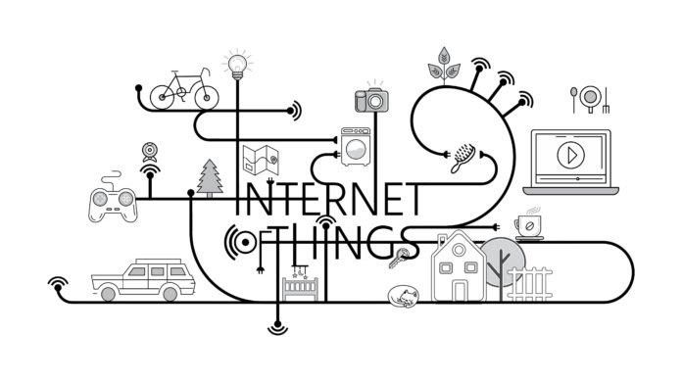

***Figure 1.1: Example of*** *Internet of Things*

**1.2 Application of IoT**

IoT applications run on IoT devices and can be created to be specific to almost every industry and vertical, including healthcare, industrial automation, smart homes and buildings, automotive, and wearable technology. Increasingly, IoT applications are using AI and machine learning to add intelligence to devices.

* Application Areas
  + Smart Cities
  + Smart Environment
  + Smart Energy
  + Smart Agriculture
  + E-Health
  + Retail
  + Logistics
  + Industrial Control

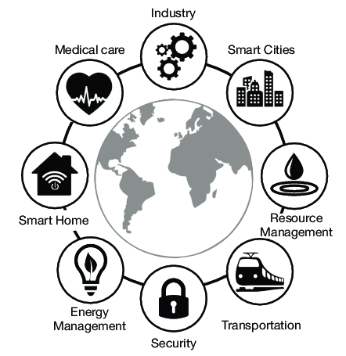

***Figure 1.2:***Application of IoT

**1.4 Layers of IoT**

**Layer Architecture**

It proposes three layers: Perception, Network, and Application. This is the physical layer of the architecture. This is where the sensors and connected devices come into play as they gather various amounts of data as per the need of the project

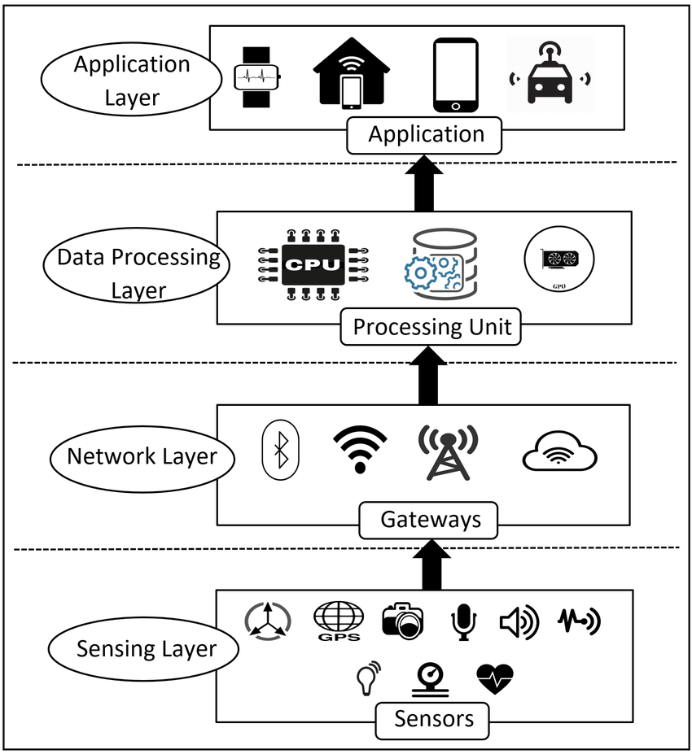

***Figure 1.3:*** Layer of IoT

**3-Phase Architecture**

It proposes three layers: Perception, Network, and Application. This is the physical layer of the architecture. This is where the sensors and connected devices come into play as they gather various amounts of data as per the need of the project



**Fig IV:** 3-Layer Architecture

**Real life application of IoT**

**Smart Vehicle and Anti-Theft System Using IoT**