**PORTABLE ANGLE WOOD & METAL CUTTING FIXTURE**

## MEA1713– DESIGN OF JIGS, FIXTURES AND PRESS TOOLS FOR AUTOMOBILE INDUSTRY

***Submitted to***

**SAVEETHA INSTITUTE OF MEDICAL AND TECHNICAL SCIENCES**

***In partial fulfilment for the award of the degree of***

**BACHELOR OF MECHANICAL ENGINEERING**

**By**

B.V.P.PRANEETH

**(Reg. No. 192014009)**

***Supervisor***

**Dr. BHARTHIRAJA G**



**SIMATS SCHOOL OF ENGINEERING**

**SAVEETHA INSTITUTE OF MEDICAL AND TECHNICAL SCIENCES**

**CHENNAI – 602 105**

**JUNE 2024**

**BONAFIDE CERTIFICATE**

Certified that this project report “**PORTABLE ANGLE WOOD & METAL CUTTING FIXTUR**” is the Bonafide work of B.V.P.PRANEETH GUPTA(192014009) who carried out the project work under my supervision.

|  |  |
| --- | --- |
| **Signature**  **Dr.N.SENTHIL KUMAR**  Head of Department Department of Thermal Engineering  Saveetha School of  Engineering, SIMATS  Chennai-602105 | **Signature**  **Dr.BHARATHIRAJA G**  Supervisor Associate Professor  Dept of Thermal Engineering Saveetha School of Engineering,  SIMATS  Chennai-602105 |

## Internal examiner External examiner

**DECLARATION BY THE CANDIDATE**

I declare that the report entitled “**PORATABLE ANGLE WOOD & METAL CUTTING FIXTURE**” submitted by me for the degree of Bachelor of Engineering is the record of the project work carried out by me under the guidance of “**Dr. BHARATHIRAJA G**” Further this work has not found the basis for the award of any degree or diploma in this or any other University or other similar institution of higher learning.

**B.V.P.PRANEETH GUPTA**

**192014009**

# ABSTRACT:

In this fabrication of project, we will mainly be focusing on problems facing by the many operators is that they have to use larger machine to manufacture a

small wood work piece, which consume more electricity and expensive. Which in turn increase the cost of work piece, due to it size less space remain vacant and annually worldwide 30,000 incidents take places injury related mainly include hand and fingers. To overcome all this problem, mention above we have discussed and fabricating the portable table saw which can almost solve all the problem mention earlier. Asit will be smaller in size so it will not take large space so it can be adjusted at many shelves, this project will use a dc motor of 24 v which consume less electricity which will solve the problem of high

electricity consumption. The operators will afford this table saw as it supporting frame will made from wood and will sustain considerable amount of weight and we will make as compact as possible. This machine will increase the productivity as it is easy to operate. This machine is beneficial and will be affordable to all who will perform wood operation. This machine will also reduce the risk factor as it will be much safer if use properly.

# INTRODUCTION:

1. A table saw is a wood cutting tool consisting of a circular saw blade mounted on an arbor that is driven by an electric motor (either directly or by belt or by gear).
2. The blade propagates through the top of the table, which provide a support for the work piece being cut. It also known as saw bench. The table saw mainly used for cutting wooden work piece, but sometime metal sheet is also cut by using it.
3. The first table saw was invented in 18th century. It was invented by Samuel Miller from South Hampton in England in 1777. The wood tool has a fixed arbor and table.
4. You have to move the table in up and down movement to cut the work piece at different height. To cut the work piece you had two options either to clamp it in the wise or hold the part you need to cut on the blade and start the motor for the blade to rotate in a circular motion and cut it. The main disadvantage of Miller
5. Medal was that it was having no option to controlled the depth and direction of cut and it was too bulky model. The table saw is typically thought of as the workhorse of the wood shop, as it is likely the most versatile and productive of all wood working machines.
6. In a cutting-edge table saw, depth of the cut is shifted by moving the sharp edge all over: the higher the edge juts over the table, the deeper is the cut made. The point of cut is controlled by altering the sharp edge.
7. A table saw is a wood working tool, consisting of a circular saw blade, mounted on an arbor, that is driven by an electric motor. Motor and arbor are connected with the help of timing pulley and belt. This table saw tool can be used for cross-cut, mitercut, square, dado, rabbet, and even apply shapes to edges of wood stock.

# PROJECT BACKGROUND

The main reason behind choosing the design and fabrication of portable table saw machine is to provide a machine that will be affordable to people who can’t afford expensive table saw machine this will give them an opportunity to work on their project or operation at low cost. Due to low weight of the machine and minimum size will be carried out at any working sites without any difficulties.

Portable table saw machine will be much cheaper than larger machine in much aspect such as,

1. It will consume low electricity compared to large machine.
2. As it will be light in weight which reduces the price of machine. This portable machine will be works with the same efficiency as that of large table saw machine.
3. It will be much more compact machine so you don’t have to think about the space requirement for this machine. You can keep it anywhere you want.
4. One of the important reasons behind the project is that the machine will be increase the productivity and save time. While using such a large table saw you have risk of injury and that can be fatal, but due to its small size here injury can’t be fatal and will avoid injury if use properly.

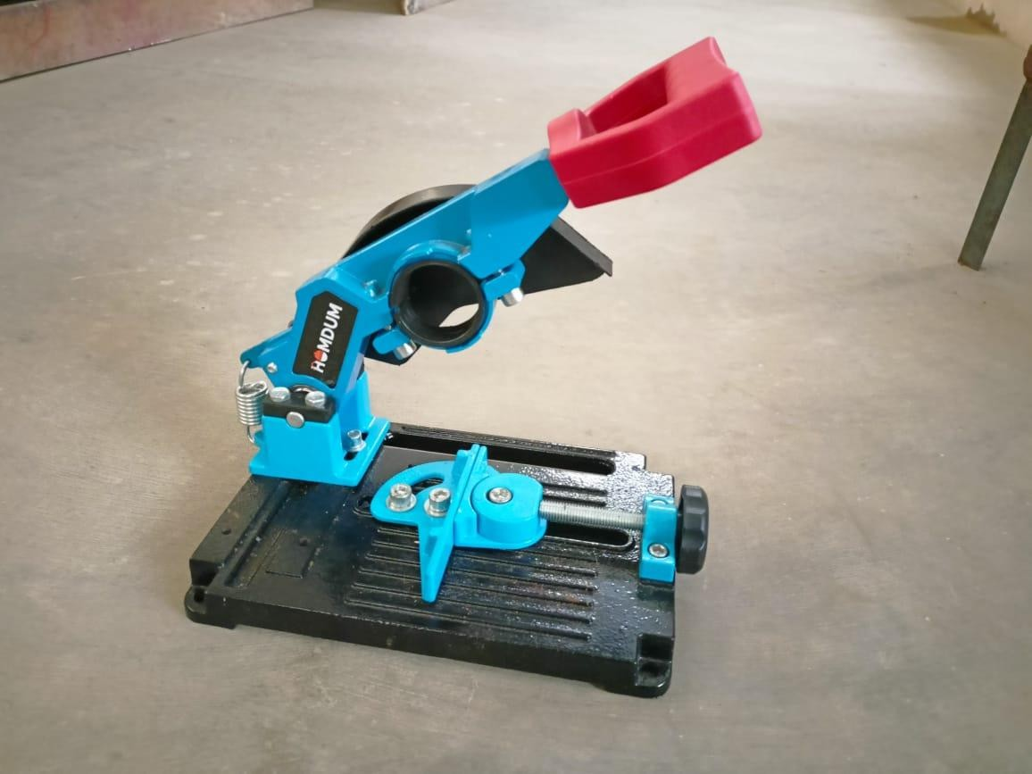

# PROBLEM DIFINITION:

The current problem facing by many small workshop owner and local carpenter

Is that in order to cut single piece of wood they have to use bigger expensive table saw. Which in turn consume more electricity and acquired more space.

In order to tackle those problem, we will fabricating a small portable table saw which will require less space and consume low electricity and provide same

efficiency as those of large table saw to cut small piece of wooden work piece. The Objective of this paper is to

1. To perform essential cut quickly, safely, efficiently
2. To cut work piece precisely in required dimension
3. To reduce the power consumption of electricity

# MATERIALS NEEDED:

* + Metal frame (aluminum or steel) for structural support and stability.
  + Wood cutting blade (circular saw blade or jigsaw blade) for cutting wood.
  + Metal cutting blade (metal-cutting circular saw blade or metal chop saw blade) for cutting metal.
  + Clamping mechanism to secure the material being cut.
  + Adjustable guides for precise cuts.
  + Portable power source (battery-powered or corded) depending on the intended use.

# DESIGN CONSIDERATION:

* + - Versatility: Ensure the fixture can accommodate various sizes and types of wood and metal.
    - Portability: Make it lightweight and easy to transport. Consider incorporating handles or a foldable design.
    - Stability: The fixture must be stable during operation to ensure accurate cuts and user safety.
    - Safety Features: Implement guards and safety switches to prevent accidents.
    - Adjustability: Allow for adjustments to accommodate different angles and depths of cuts.
    - Durability: Choose durable materials that can withstand the rigors of cutting tasks.

# USAGE:

* + Setup: Place the fixture on a stable surface and secure it in place if necessary.
  + Material Preparation: Prepare the wood or metal material to be cut, ensuring it fits securely within the clamping mechanism.
  + Cutting: Turn on the power source and carefully guide the material through the blade, following the designated cutting path.
  + Monitoring: Keep an eye on the cutting process to ensure accuracy and safety.
  + Cleanup: After cutting, turn off the power source and clean any debris from the fixture to maintain its performance.

KEY COMPONENTS:

* + Metal Frame: Provides stability and support for the cutting operation.
  + Wood Cutting Blade: Circular saw blade or jigsaw blade for cutting wood.
  + Metal Cutting Blade: Metal-cutting circular saw blade or metal chop saw blade for cutting metal.
  + Clamping Mechanism: Secures the material being cut in place.
  + Adjustable Guides: Ensures precise and accurate cuts.
  + Safety Features: Incorporates guards and safety switches to prevent accidents during operation.

ADVANTAGES:

* + Versatility: Capable of cutting both wood and metal materials, making it suitable for a wide range of applications.
  + Portability: Lightweight and easy to transport, allowing for on-site cutting tasks and mobility between job sites.
  + Precision: Adjustable guides and clamping mechanism ensure precise and accurate cuts, reducing material wastage.
  + Safety: Incorporates safety features such as blade guards and emergency stop switches to prioritize user safety during operation.
  + Efficiency: Streamlines cutting processes, increasing productivity and workflow efficiency.

APPLICATIONS:

* + Construction: Ideal for on-site cutting tasks in construction projects, including framing, decking, and metal fabrication.
  + Carpentry: Suited for woodworking projects such as furniture making, cabinetry, and trim work.
  + Metalworking: Enables precise cutting of metal materials for fabrication, welding, and metal sculpture.
  + DIY Projects: Useful for hobbyists and DIY enthusiasts undertaking various projects at home or in workshops.

STUDY:

A table saw (also known as a saw bench or bench saw) is a woodworking tool, consisting of a circular saw blade, mounted on an arbor, that is driven by an

electric motor (either directly, by belt, or by gears). The blade protrudes through the top of a table, which provides support for the material, usually wood, being cut. In most modern table saws, the depth of the cut is varied by moving the blade up and down: the higher the blade protrudes above the table, the deeper the cut that is made in the material. In some early table saws, the blade and arbor were fixed, and the table was moved up and down to expose more or less of the blade. The angle of cut is controlled by adjusting the angle of blade.

Some earlier saws angled the table to control the cut angle.

# ASSEMBLY:

In this paper a design for a machine here we will take a long wooden board of dimension 16x20x0.5 inches. At the right center of board, we will cut 5x0.3 inches small block shape for passing the cutter blade. Then we will fix the motor holder on to the wooden block. Using screw, we will be attaching the motor with motor holder. After fixing the motor, will add external shaft to the motor to hold saw blade tightly. As we will using a 24-volt DC motor will require a power supply of 24-volt 10A. Then we will mount the power supplier at the corner of wooden block and doing the necessary connection. Later we

will add a switch button to supplier to control it from single point. Now we will make a lid with the wooden board of dimension (30x20x05) inches and close it from the top of the box. The blade will protrude up 2cm upward while operating by cutting the board. At end we will adding a measuring scale and fences (if required) to guide the work piece accordingly.

CAUTION:

Always be sure that the tool is switched off and unplugged before carrying out any work on the tool. The tool is shipped from the factory with the saw blade and blade guard not in the installed condition. Always be sure that the tool is switched off and unplugged before installing or removing the blade. • Use only the Makita hex wrench provided to install or remove the blade. Failure to do so may result in overtightening or insufficient tightening of the hex bolt. This could cause an injury. Use the following saw blade. Do not use saw blades which do not comply with the characteristics specified in these instructions.

# OPERATION:

1. Making a cut with incorrect blade depth
2. Sawing into knots or nails in the workpiece
3. Twisting the wood while making a cut
4. Failing to support work
5. Forcing a cut
6. Cutting warped or wet lumber
7. Using the wrong blade for the type of cut

# COMPLETION:

The traditional method for cutting wood using a table saw involves a stationary saw motor in which the wood is fed through the saw by hand. This approach entails serious safety hazards. On the other hand, aluminum cutting requires extra precaution and careful craftsmanship to ensure an accurate cut, and the cutting can be dangerous if not executed properly. Given the inherent risks of conventional sawing practice, limitations of cutting both materials, benefits of automation and to support panelized construction, in this paper Axiomatic design theory is applied for investigating the problems of the present table saws

and for designing an uncoupled new one. As a result of mapping from

functional domain to physical domain, the feed speed and RPM for wood and

aluminum cutting found to be coupled. A complete control system strategy from defining the process flow to its full implementation was crafted to meet the design objectives and based on the analysis an uncoupled design of saw cutting machine is introduced. Discrete event modelling is employed to estimate the performance of the machine and implication of different sizes of profiles. The simulation results provide valuable insight into machine’s key performance indicators, for instance, cycle time and operator’s utilization.

# CONCLUSION:

In conclusion, the portable metal and wood cutting device is an essential and adaptable tool for a variety of DIY projects and enterprises. Because of its sturdy design and capacity to cut both metal and wood, it is an invaluable tool for both hobbyists and professionals. Because of the fixture's portability, cutting jobs can be effectively completed in a variety of settings and offers flexibility in use. When relocating between work spaces is required for DIY projects, workshops, and building sites, this mobility is especially helpful. In addition, the precision and accuracy of the fixture, made possible by movable guides and a safe clamping system, guarantee excellent cuts and save material waste. In addition to prioritizing user protection while in use, its safety measures also

help create a secure working environment. As a whole, the portable wood.