BOAT HOUSE BOOKING APPLICATION

APP DEVELOPMENT REPORT

Submitted by

ABISHEAK MARUDHU S (727722EUAI002)

HARIHARAN M (727722EUAI021)

MANIBHARATHI N (727722EUAI034)

In partial fulfillment for the award of the degree of

BACHELOR OF TECHNOLOGY
IN

ARTIFICIAL INTELLIGENCE AND DATA SCIENCE

SRI KRISHNA COLLEGE OF ENGINEERING AND TECHNOLOGY
An Autonomous Institution | Approved by AICTE | Affiliated to Anna University | Accredited by NAAC with A++ Grade
Kuniamuthur, Coimbatore – 641008.

NOVEMBER 2024



SUSTAINABLE DEVELOPMENT GOALS

The Sustainable Development Goals are a collection of 17 global goals designed to blue print to achieve a better and more sustainable future for all. The SDGs, set in 2015 by the United Nations General Assembly and intended to be achieved by the year 2030, In 2015, 195 nations agreed as a blue print that they can change the world for the better. The project is based on one of the 17 goals.

SDG | IMPLEMENTATION
SDG 9: Industry, Innovation, and Infrastructure | Implemented through a digital platform that streamlines booking, scheduling, and communication, enhancing operational efficiency and supporting sustainable growth in the boat rental industry.
SDG 11: Sustainable Cities and Communities | Facilitates efficient use of shared resources, reducing overbooking and supporting responsible, sustainable tourism in local water based activities.



BONAFIDE CERTIFICATE

Certified that this app development project report “BOAT HOUSE BOOKING APPLICATION” is the Bonafide work of “ABISHEAK MARUDHU S (727722EUAI002),
HARIHARAN M (727722EUAI021) , MANIBHARATHI N (727722EUAI062)”who carried out the app development project work under my supervision.

SIGNATURE SIGNATURE

Dr. S. VENKATA LAKSHMI M.TECH., Ph.D Mr.K.BALAJI ME.,(PhD)

HEAD OF THE DEPARTMENT SUPERVISOR

Professor Assistant Professor

Department of Artificial Intelligence And Department of Artificial Intelligence
Data Science And Data Science

Sri Krishna College Of Engineering And Sri Krishna College Of Engineering

Technology, Coimbatore-641008. And Technology, Coimbatore-641008.

Submitted for the Project viva-voce examination held on______________________

INTERNAL EXAMINER EXTERNAL EXAMINER

ACKNOWLEDGEMENT

We express our sincere thanks to the management and Dr. K. PORKUMARAN, ME., Ph.D., PEng., CEng Principal, Sri Krishna College of Engineering and Technology, Coimbatore for providing us the facilities to carry out this App Development project.

We are thankful to Dr. S. VENKATA LAKSHMI MTECH., Ph.D., Professor and Head, Department of Artificial Intelligence and Data Science, for her continuous evaluation and comments given during the course of the App Development project.

We express our deep sense of gratitude to our supervisor Mr. K.BALAJI M.E.,(PhD) Assistant Professor, Department of Artificial Intelligence and Data Science, for his valuable advice, guidance and support during the course of our App Development project.

We would also like to thank our App Development coordinator Mr. S. SENTHIL KUMAR M.E.,(PhD) Assistant Professor, Department of Artificial Intelligence and Data Science for helping us in completing our App Development project.

We express our heartfelt sense of gratitude and thanks to our beloved parents, family and friends who have helped during the App Development project course.

ABSTRACT

The Boat House Booking Application is an advanced digital platform designed to revolutionize how customers book boats and boathouses, as well as how owners and administrators manage reservations, availability, and customer engagement. By providing a seamless, user-friendly interface, this application simplifies essential booking tasks, allowing users to effortlessly browse options, schedule reservations, and enjoy a hassle-free booking experience tailored to their needs. With powerful booking and scheduling tools, the application empowers users to reserve boats and boathouses with ease. They can view availability in real-time, ensuring they only book what is accessible at their desired time and location. Moreover, users can filter options based on criteria such as location, capacity, type of boat, and available amenities, creating a personalized experience that meets their specific requirements. This level of customization helps ensure that customers find exactly what they are looking for, whether it's a small boat for a quiet day on the water or a large boathouse for a family gathering. For boat and boathouse owners, the application provides a robust set of administrative features that streamline management and improve day-to-day operations. Administrators can monitor the status of each boat or boathouse, track reservations, and engage directly with users to address inquiries or special requests. These tools enhance operational efficiency, reduce booking conflicts, and create a positive experience for both customers and staff. Additionally, the Boat House Booking Application integrates real-time notifications and reminders, ensuring that users and administrators stay informed of upcoming bookings and any necessary preparation or maintenance requirements. With built-in customer support features, administrators can quickly respond to user inquiries, facilitating smooth and responsive communication channels that enhance customer satisfaction. In conclusion, the Boat House Booking Application represents a significant advancement in the booking industry by offering a comprehensive, modern solution that addresses the needs of users, boat owners, and administrators alike. By streamlining reservation management, providing real-time availability tracking, and enabling seamless customer support, the application supports the growth and success of boat house operations. Its user-centric design and modern technology foster a more efficient, enjoyable, and satisfying booking experience for all parties involved, ensuring that both customers and operators benefit from the platform’s capabilities.

TABLE OF CONTENTS

CHAPTER NO TITLE PAGE NO

ACKNOWLEDGEMENT IV
ABSTRACT V
LIST OF ABBREVIATIONS VII
- INTODUCTION 1
1.1 Overview 1
1.1.1 Features 1
1.1.2 Technical Overview 2
1.2 Goals and Objectives 3
- INSTALLATION AND SETUP 6
2.1 System Requirements 6
2.2 Configurations Steps 7
- USER MANAGEMENT 8
3.1 Overview of User Management 8
- CURRICULUM 12
4.1 Boat Search Page 12
4.2 Boat Booking Page 13
4.3 Endpoints 13
- ADMINISTRATION 14
5.1 Admin Dashboard 14
5.2 User Management 15
- CONCLUSION AND FUTURE WORKS 17
6.1 Conclusion 17
6.2 Future Developments 17
- REFERENCES 20
- APPENDIX-I 21
- APPENDIX-II 55

LIST OF ABBREVIATIONS

ACRONYM ABBREVIATIONS

URL UNIFORM RESOURCE LOCATOR
HREF HYPERTEXT REFERENCE
UI USER ITERFACE
UX USER EXPERIENCE
DB DATABASE
CRUD CREATE, READ, UPDATE, DELETE
JSON JAASCRIPT OBJECT NOTATION
SQL STRUCTURED QUERY LANGUAGE
DOM DOCUMENT OBJECT MODEL
JS JAVASCRIPT
HTTP HYPERTEXT TRANSFER PROTOCOL
PK PRIMARY KEY
FK FOREIGN KEY
JWT JSON WEB TOKEN

CHAPTER 1

INTRODUCTION

  - OVERVIEW OF BOAT HOUSE BOOKING APPLICATION
The Boat House Booking Application is an online platform designed to simplify the booking and management of boats and boathouses by efficiently handling reservations, availability, and customer interactions. It provides a comprehensive, modern solution to address the specific needs of boat rental services, enhancing day-to-day operations and the customer booking experience.
1.1.1 FEATURES
- Booking Alerts and Notifications
- Admins receive real-time notifications on upcoming bookings and cancellations for better planning and availability management.
- Users are notified of booking confirmations and reminders, enhancing the customer experience by keeping them informed.
- Reservation and Availability Tracking System
- Admins can view the status of current and upcoming reservations, monitor boat availability, and track maintenance schedules.
- Boat owners receive notifications on booking requests, streamlining the rental process.
- User and Supplier Relationship Management
- Admins can access pre-built templates to communicate efficiently with suppliers, schedule maintenance, and update contracts, saving time and enhancing accuracy.
- Advanced Search Capabilities
- Users can filter available boats by location, capacity, amenities, or boat type, making it easier to find the ideal boat for their needs.

- Boat Details and Availability Management
- Boat owners can create detailed profiles for each boat, displaying specifications, rental hours, and availability.
- Scheduling tools allow admins to manage boat availability, assign bookings, and monitor usage seamlessly.
- Booking Analytics and Reporting Tools
- Admins can access real-time booking analytics, view daily and monthly booking trends, and generate reports to support strategic decision-making.
- Visual dashboards provide quick overviews of popular boat types, customer preferences, and revenue growth.

1.1.2 TECHNICAL OVERVIEW
- Frontend:
The frontend is developed using React.js to create a responsive and engaging user interface. Built with a component-based structure, it efficiently organizes features like booking forms, availability filters, and boat details, allowing for easy updates and scalability.
- Backend:
The backend, implemented with Python and Django, focuses on simplicity and scalability. Using the Model-View-Template (MVT) architecture, it separates business logic, data handling, and UI, simplifying maintenance. Django’s ORM facilitates database interactions, while its built-in security features protect user and booking data.
- Software Development Cycle:
The Software Development Life Cycle (SDLC) phases guide the project, covering Planning, Requirements Gathering, Design, Development, Testing, Deployment, and Maintenance.

This structured approach ensures the project meets objectives, operates smoothly, and offers continuous support.
- Hardware and Software Requirements:
The platform requires both infrastructure and specific development tools for optimal functionality.
- Hardware Requirements include server and client machine specifications to ensure high performance and reliability.
- Software Requirements detail the operating system, database, development frameworks, and middleware essential for the application.
- User Authentication: Ensures secure registration and login.
- Booking Search Functionality: Allows users to search available boats using various filters, like location, capacity, and amenities.

The Boat House Booking Application streamlines essential booking processes, supporting operational efficiency and improved customer satisfaction through its integrated and user-centric design.

GOALS AND OBJECTIVES
- Provide Comprehensive Boat House Booking Resources
- Goal: To establish the Boat House Booking Application as a central platform for managing boat rental operations, offering a suite of tools to optimize booking management, boat availability, and customer engagement.
- Objectives: Develop an advanced booking management system with filters based on location, boat type, capacity, and availability, enabling users to locate and reserve boats efficiently.

Create detailed boat profiles to track specifications, availability, and maintenance schedules, allowing for optimized boat allocation and management. Offer a comprehensive admin dashboard that allows administrators to monitor booking statuses and boat availability.

- Enhance Community and Supplier Engagement
- Goal: To foster a collaborative and supportive environment among boat house managers, owners, and suppliers, encouraging streamlined operations and communication.
- Objectives: Implement communication channels and feedback mechanisms to gather user input on system functionality and overall experience.Facilitate regular supplier engagement events and training sessions to improve boat maintenance knowledge and availability management skills . Organize mentorship programs where experienced boat managers can provide insights to new employees, enhancing workforce skills and engagement.
- Promote Learning and Skill Development for Employees
- Goal: To empower boat house employees to enhance their skills, leading to improved job performance and operational efficiency.
- Objectives: Provide access to training resources covering topics such as boat handling, customer service, and booking management. Offer instructional content, including videos and tutorials, focused on developing both soft and technical skills relevant to boat house operations. Collaborate with training providers to feature certifications that add value to employees' skill sets and align with industry standards.
- Ensure Accessibility and Inclusivity in Application Design
- Goal: To make the Boat House Booking Application accessible and easy-to-use for a including boat house managers, customers, and staff with different levels of experience and technical abilities.
- Objectives: Design a responsive interface with intuitive navigation suitable for users of all skill levels, promoting efficient usage across various devices. Implement multilingual support to accommodate users from different linguistic backgrounds within the boat house’s customer and employee base. Adhere to accessibility standards, providing features that support users with disabilities to ensure inclusivity and compliance.

- Support Skill Recognition and Achievement in the Workplace
- Goal: To acknowledge and celebrate employee achievements and milestones within the application’s community.
- Objectives: Develop a system to track and display employee accomplishments, such as training completion, booking management milestones, and customer satisfaction scores.Create recognition programs and awards to highlight high-performing employees, fostering motivation and a positive work culture.Partner with training providers to offer certifications and incentives to employees who demonstrate excellence and dedication in their roles.

- Prioritize Security and Privacy of Data
- Goal: To ensure the security and confidentiality of user and organizational data, adhering to legal and industry standards.
- Objectives: Implement robust authentication and authorization protocols to secure user accounts and sensitive data. Employ encryption and data protection techniques to maintain the confidentiality of user and operational information. Conduct regular security audits and assessments to identify and mitigate potential risks, safeguarding the platform’s integrity

CHAPTER 2

INSTALLATION AND SETUP

2.1 SYSTEM REQUIREMENTS
- Operating System: Compatible with Windows, macOS, or Linux distributions.
- Node.js and npm: Latest stable versions installed for React development.
- Java Development Kit (JDK): Installed for Spring Boot backend development.
- PostgreSQL: Installed and configured with appropriate permissions for database management.
Frontend (React ):
- Clone the frontend repository or obtain the source code package from the designated repository.
- Navigate to the frontend directory in the terminal
- Install dependencies by running
- Start the development server with Vite.
- Access the frontend application in your web browser at:http://localhost:4000.
Backend (Django):
- Clone the backend repository or obtain the source code package from the designated repository. Navigate to the backend directory in the terminal
- Ensure that the appropriate JDK version is installed and configured properly on your system.
- Build the Spring Boot application using Maven or Gradle by executing.
- Run the application using the generated JAR file

CONFIGURATION STEPS

Frontend (React)

Update API endpoint URLs in the configuration files (such as config.js or environment variables) to point to the Spring Boot backend server address and port.

Ensure that environment-specific variables, such as API keys or backend server URLs, are properly configured for different deployment environments (development, staging, production).

Backend (Django)

Configure the database connection details (URL, username, password) in the application.properties or application.yml file according to your PostgreSQL setup.

Implement JWT security for authentication and authorization. Configure JWT-related properties, such as secret key and token expiration time, in the application configuration file.

Configure Swagger UI for API documentation by adding relevant annotations to your Spring Boot REST controllers and enabling the Swagger dependencies in the project's build configuration.

Ensure that CORS (Cross-Origin Resource Sharing) is configured appropriately to allow frontend requests from different origins, if applicable.

These installation and configuration instructions provide a comprehensive guide for setting up both the frontend and backend components of the job searching portal. Ensure that all steps are followed accurately to ensure smooth deployment and operation of the application.

CHAPTER 3

USER MANAGEMENT
3.1 OVERVIEW OF USER MANAGEMENT
User management is a critical component of any web application, including the boat house booking application. It involves the registration, login, and profile management functionalities that allow users to interact with the platform securely and personalize their experience. Effective user management enhances security, facilitates personalization, and ensures a seamless user experience.

1.Registration:
Registration enables new users to create accounts on the boat house booking application. During registration, users are typically required to provide basic information such as username, email address, and password. The registration process may also include additional steps such as email verification or captcha verification to prevent spam registrations. Implementing strong validation rules for user inputs helps maintain data integrity and security.
Example of registration process:
    - User fills out registration form with required information.
    - Backend validates user inputs and checks for duplicate usernames or email addresses.
    - If validation passes, the user account is created, and a confirmation email may be sent for account activation.

2.Login:
The login functionality allows registered users to access their accounts securely. Users are required to provide their credentials (e.g., username/email and password) to authenticate themselves.

It's crucial to implement security measures such as password hashing and salting to protect user credentials from unauthorized access. Session management techniques ensure that users remain authenticated across multiple requests during their session.
Key points about login:
    - Passwords should be hashed and stored securely in the database to prevent exposure in case of a data breach.
    - Brute-force protection mechanisms should be implemented to mitigate the risk of password guessing attacks.
    - Sessions can be managed using server-side techniques (e.g., sessions stored in memory or databases) or client-side techniques (e.g., JSON Web Tokens).

3.Profile Management:
Profile management allows users to customize their profiles, update personal information, and manage preferences. Advanced features may include profile picture uploads, bio sections, privacy settings, and notification preferences. It's essential to provide users with granular control over their profile privacy settings to respect their preferences regarding data visibility.
Example of profile management features:
  - User can upload a profile picture and update personal details such as name, bio, and contact information.
  - Privacy settings allow users to control who can view their profile, posts, and activity on the platform.
  - Notification preferences enable users to choose how they want to receive notifications (e.g., email, in-app notifications).

4.Token Generation and Expiry:
Token-based authentication, specifically JSON Web Tokens (JWTs), is commonly used to manage user sessions securely. JWTs are encoded tokens containing user claims (e.g., user ID, roles) that are signed by the server to ensure integrity. Tokens have expiration times to limit their validity period and mitigate the risk of session hijacking or replay attacks.
Best practices for token generation and expiry:
  - Use strong cryptographic algorithms (e.g., HMAC SHA-256) to sign tokens and verify their integrity.
  - Include expiration timestamps in tokens to enforce session timeouts and token rotation policies.
  - Implement mechanisms to handle token expiration gracefully, such as refreshing tokens or requiring reauthentication after expiration.

5.Token Security:
Token security is paramount to prevent unauthorized access to user accounts and sensitive data. Tokens should be protected against various attacks, including token leakage, tampering, and interception. Security measures such as HTTPS encryption, token revocation, and token blacklisting help mitigate token-related vulnerabilities.
Key considerations for token security:
    - Transmit tokens over secure channels (e.g., HTTPS) to prevent interception by attackers.
    - Store tokens securely on the client-side using techniques like HttpOnly cookies or secure storage mechanisms (e.g., localStorage).
    - Implement token revocation mechanisms to invalidate tokens if they are compromised or no longer needed.

6.Cross-Verifying with Database:
During token authentication, it's essential to cross-verify token claims with user data stored in the database to ensure the token's authenticity and integrity. This involves retrieving user information based on the token claims (e.g., user ID) and validating them against the token payload. Cross-verification helps detect and prevent token tampering or unauthorized access attempts.
Steps for cross-verifying tokens with the database:
    - Extract token claims (e.g., user ID) from the token payload.
    - Retrieve user data from the database based on the extracted claims.
    - Compare the retrieved user data with the token claims to verify their authenticity.
    - Grant access or deny the request based on the verification results.
    - Educate users about security best practices, such as avoiding password reuse and phishing awareness.

Effective user management and token handling are essential for ensuring the security and usability of the boat house booking application. By implementing robust registration, login, and profile management functionalities, developers can create a secure and user-friendly experience for application users. Additionally, employing token-based authentication with proper security measures helps protect user sessions and sensitive data from unauthorized access. By following best practices and staying vigilant against emerging threats, developers can build a trusted and reliable platform for boat house booking enthusiasts to learn and engage.

CHAPTER 4

CURRICULUM
4.1 BOATSEARCH PAGE
The Boat Search Page provides users with a primary interface to explore available boats, with options for searching and filtering based on different criteria. It is designed to be intuitive, helping users to quickly find the specific type of boat they are interested in.
Features
- Search Functionality: Allows users to search for boats by entering keywords related to the boat’s name, type, or location.
- Filtering Options: Enables users to filter boats based on various criteria, such as availability, size, and price range.
- Boat Listings: Displays a list of boats that match the search query, showing details like boat name, description, capacity, and pricing.
The search results are displayed as a list of boats that match the search criteria and selected filters. Each boat listing typically includes the following information:
- Boat Name: The name of the boat, often with a thumbnail image, provides an immediate visual and name recognition for users.
- Description: A brief description summarizes key details, such as the boat type, features, and any unique aspects (e.g., "spacious luxury yacht" or "perfect for fishing trips").
- Capacity: The maximum number of passengers the boat can accommodate, helping users assess whether the boat meets their group size requirements.
- Pricing: The price per hour, day, or trip duration is shown clearly, allowing users to make informed decisions based on budget considerations.
- Location and Availability: Listings also display the location and availability status of each boat, so users can make decisions based on proximity and scheduling.

4.2 BOAT BOOKING PAGE
The BOAT BOOKING PAGE is the critical component of the platform where users can finalize their selection and secure a booking for their chosen boat. This page is designed to provide a straightforward and reassuring booking process, guiding users step-by-step through essential details, dates, and payment options. The goal of the BOAT BOOKING PAGE is to ensure a smooth, efficient, and transparent booking experience for users, thereby increasing user satisfaction and reducing booking abandonment rates.
1. Booking Details Summary
At the top of the page, the booking summary displays the essential details of the selected boat and allows users to verify their choices before proceeding further. This section includes:
- Boat Name and Image: A thumbnail image and the boat's name are displayed to reassure the user that they’re booking the correct boat.
- Description and Key Features: Highlights of the boat's key features (e.g., size, capacity, amenities) to reaffirm the boat’s suitability for the user's needs.
- Date and Time Selection: Interactive calendar or date picker options allow users to select their preferred rental dates and, if applicable, specific time slots. This tool includes real-time availability checks, ensuring users can only select dates when the boat is available.

4.3 ENDPOINTS
- The Boat Booking Application uses various API endpoints that allow interaction between the frontend and backend, enabling features like searching, viewing boat details, and booking boats.
Authentication: The endpoints require user authentication for creating and managing bookings.

Authorization: Access control ensures users can only view and manage their own bookings, protecting user data and enhancing security.

CHAPTER 5

ADMINISTRATION

The Administration Section of the Boat House Booking Application is dedicated to streamlining administrative tasks and managing various aspects of the platform. It provides administrators with tools to oversee user accounts, monitor platform activity, and manage booking content efficiently.

5.1 ADMIN DASHBOARD

In the Boat House Booking Application, the admin has comprehensive access to manage the entire platform. Their primary roles include adding, updating, and deleting boat listings, as well as managing booking requests and monitoring user activity. The admin can also track the number of bookings for each boat listing, providing valuable insights into popular boat choices and booking trends. Additionally, the admin has authority to grant access to boat owners, enabling them to manage their boat listings and view booking inquiries. This functionality ensures a streamlined and efficient booking process, allowing admins to maintain control over listings and facilitate smooth operations.

Key Features of the Admin Dashboard:

User Statistics: Displays essential statistics related to user demographics, registration trends, and engagement metrics. Administrators can track user growth, active users, and other relevant metrics to assess platform popularity and performance.

Content Management: Offers tools for managing boat listings and descriptions, as well as uploading boat images and updating pricing. Administrators can keep boat information accurate and up-to-date, ensuring users have access to the latest details.

Booking Insights: Provides real-time data on bookings, including booking frequency by season, most popular boat types, and cancellation statistics. This helps admins make informed decisions about availability and pricing.

System Alerts: Monitors system health and generates alerts for any detected issues, such as server downtime or database errors. Administrators receive real-time notifications, allowing them to take prompt action to resolve problems and minimize service interruptions.

5.2 USER MANAGEMENT
The User Management section allows administrators to efficiently manage user registrations, roles, and access permissions tailored to different responsibilities on the platform. This includes roles such as Admin, Boat Owner, and User. The user management system enhances operational transparency, allowing administrators to oversee roles and access levels, manage account issues, and communicate directly with users.
Key User Management Tasks:
- User Registration and Role Assignment
Manages user registration, including account creation, verification, and role assignment. Administrators can assign roles such as Admin, Boat Owner, or User, reviewing new registrations and verifying details to ensure secure, authorized access.
- Role-Based Permissions
Assigns specific permissions to users based on their roles. Admins have full access to all sections, Boat Owners can manage their own listings, and Users have access to browsing and booking features. This control ensures secure, role-specific access across the platform.
- User Profiles
Maintains comprehensive user profiles, including personal details, contact information, and role-specific preferences.

Administrators can assist users with account-related issues by updating profiles, resetting passwords, and providing user support.
- User Communication
Facilitates communication with users through notifications or direct messages within the platform. Administrators can send updates, reminders, or alerts related to booking statuses, policy changes, or system updates, ensuring users stay informed in real time.

This user management system allows administrators to handle registration, assign roles with tailored permissions, and provide role-specific access to features. Comprehensive profiles support personalized user management, while real-time communication capabilities keep users updated on important platform information. The Boat House Booking Application administration tools enable effective platform management, creating a secure, well-organized experience for both users and administrators.

The Administration Section of the Boat House Booking Application provides essential tools for managing users, boat listings, and bookings. Administrators can oversee platform activity, update boat details, and track booking trends. The Admin Dashboard displays key metrics, such as user engagement and booking frequency, helping admins optimize the platform. With role-based permissions, admins can control access for Boat Owners and Users, ensuring secure, customized experiences. Real-time alerts and notifications keep the admin informed of system health and user activity, promoting smooth operations and timely responses. Comprehensive user management and content control streamline platform oversight for a seamless booking experience.

CHAPTER 6

CONCLUSION AND FUTURE WORKS
  - CONCLUSION
- The Boat House Booking Application is designed to streamline and modernize the boat rental experience, providing an all-in-one platform that connects administrators, boat owners, and users. With dedicated features for managing boat listings, reservations, and user profiles, this application aims to simplify booking operations and improve service delivery.
- Throughout this documentation, we have outlined the application’s essential features, user roles, and overall benefits. From boat listing management and user feedback collection to booking insights, the platform offers extensive tools to monitor, manage, and enhance the boat rental experience.
- As we continue to develop and refine this application, our commitment remains to deliver a smooth, valuable experience for all users. We aim to gather ongoing user feedback, enhance platform functionality, and introduce new features to meet the evolving needs of the boat rental industry.

  - FUTURE DEVELOPMENTS
Looking ahead, we have identified several key areas for potential enhancement and future development:
- Advanced Booking and Availability Insights
  - Plans include integrating advanced tools for real-time availability tracking, providing administrators and boat owners with insights into booking patterns, demand forecasting, and scheduling conflicts.
- Enhanced Boat Owner Profile Management
  - Additional features will allow boat owners to create comprehensive profiles with boat maintenance records, insurance details, and pricing options, helping users make informed booking choices and improving transparency.
- Direct User-Owner Communication Channels
  - Strengthening the user experience, we aim to introduce messaging features, allowing users and boat owners to communicate directly to address inquiries or provide rental instructions, ensuring a smoother booking process.
- Mobile Application Development
  - Recognizing the need for mobility, we plan to develop a mobile app version of the platform, allowing administrators, boat owners, and users to manage listings, bookings, and inquiries from anywhere.
- Analytics and Reporting Tools
  - Enhanced analytics will offer administrators valuable insights into booking trends, user demographics, and boat popularity, enabling data-driven decision-making to boost operational efficiency.
- Localization and Regional Customization
  - To broaden the application’s reach, we will focus on localization, making the platform adaptable for various regional markets with language options and culturally relevant features.
- Strategic Partnerships and Integrations
  - We will explore partnerships with tourism providers, payment gateways, and other travel-related services to expand offerings, enhance convenience, and provide a more integrated user experience.

The Boat House Booking Application is a comprehensive solution designed to streamline operations and enhance the boat rental process by addressing the needs of administrators, boat owners, and users. By enabling efficient booking, management, and communication, the platform fosters a user-friendly, service-oriented community that meets the high standards of the boat rental industry.

The platform’s messaging system isn’t only beneficial for notifications and alerts; it also serves as a secure communication channel where users can ask questions, owners can provide guidance, and administrators can clarify policies or respond to specific inquiries. By centralizing this interaction within the application, the Boat House Booking Application ensures that all communication is consistent, accessible, and relevant to the booking context, which minimizes misunderstandings and improves overall transparency. This integrated communication system ultimately fosters stronger relationships between customers and service providers by enhancing the level of support, convenience, and reliability that each party can expect from the platform. In today’s fast-paced rental market, the ability to respond swiftly to changing conditions is essential. The Boat House Booking Application’s messaging and notifications system addresses this need by providing a reliable way for users, owners, and administrators to stay informed and respond instantly to changes. Whether it’s a last-minute availability update, a booking confirmation, or a reminder of upcoming reservations, the real-time alerts support better decision-making and efficient management. This functionality not only simplifies the booking process but also elevates the level of professionalism and trust within the rental market.In conclusion, the integrated messaging and notification system of the Boat House Booking Application is an invaluable tool for the evolving rental market. It ensures that users, owners, and administrators are fully informed and capable of responding to the dynamic nature of boat and boathouse rentals. By supporting seamless communication and real-time coordination, the application is transforming the rental experience, making it more efficient, reliable, and responsive to the needs of all stakeholders. The Boat House Booking Application thus stands as a modern, indispensable solution that meets the growing demands of a connected, real-time marketplace, offering enhanced support and fostering better customer and provider relationships through its innovative, user-centric approach.

REFERENCES

- Smith, J., and L. Watson. The Future of Boat Rental: Technology and Service Management. Routledge, 2019. ProQuest Ebook Central.
- Chen, M., and Y. Li. "Reservation Optimization in Boat Rentals Using Machine Learning." International Journal of Tourism Management, vol. 31, no. 3, pp. 512-527, 2020.
- Gupta, R., and D. Sharma. "Digital Transformation in the Leisure Industry: A Case Study on Boat Rentals." International Conference on Tourism and Leisure Systems, pp. 75-81, 2021.
- Tan, C. K., and H. L. Nguyen. "Enhancing Customer Experience in Boat Rentals Through AI and Big Data." Journal of Leisure and Consumer Services, vol. 48, pp. 172-181, 2019.
- Davis, A. E-Commerce and the Rise of Online Boat Bookings. McGraw-Hill, 2021.
- Martinez, L., and T. Kim. "Booking Fulfillment in Boat Rental Platforms: Challenges and Solutions." IEEE Transactions on Engineering Management, vol. 68, no. 4, pp. 1068-1079, 2021.
- Jones, P., and S. Mitchell. "Reservation Control and Demand Forecasting in Boat Rentals." Journal of Operations Research, vol. 56, no. 5, pp. 897-906, 2020.
- Yu, Z., and J. Lee. "Service Chain Management for Boat Rentals." International Conference on Service Chain and Logistics, pp. 213-220, 2018.
- "Boat Rental Industry Trends and Insights." https://www.marketwatch.com

APPENDICES
APPENDIX – I
FRONTEND:
authActions.jsx :-

import axios from 'axios';

export const registerUser = (userData) => async (dispatch) => {
try {
const response = await axios.post('http://127.0.0.1:8000/api/create_user/', userData);
dispatch({ type: 'REGISTER_SUCCESS', payload: response.data });
} catch (error) {
dispatch({ type: 'REGISTER_FAIL', payload: error.message });
}
};

export const loginUser = (loginData) => async (dispatch) => {
try {
const response = await axios.get('http://127.0.0.1:8000/api/read_users/');
const users = response.data;
const foundUser = users.find(user => user.email === loginData.email);

if (!foundUser) {
throw new Error('User not found');
}

if (foundUser.password !== loginData.password) {
throw new Error('Incorrect password');
}

// Store user data in local storage
localStorage.setItem('user', JSON.stringify(foundUser));

console.log('Login successful');
dispatch({ type: 'LOGIN_SUCCESS', payload: foundUser });
} catch (error) {
console.error('Login failed:', error.message);
dispatch({ type: 'LOGIN_FAIL', payload: error.message });
}
};

export const logoutUser = () => (dispatch) => {
localStorage.removeItem('user');
dispatch({ type: 'LOGOUT' });
};

export const UPDATE_USER = 'UPDATE_USER';

export const updateUser = (user) => ({
type: UPDATE_USER,
payload: user,
});

AdminDashboard.js

import React, { useState } from 'react';
import BoatList from './BoatList';
import UserList from './UserList';
import BookingList from './BookingList';
import './AdminDashboard.css';

const AdminDashboard = () => {
const [view, setView] = useState('boats');

const renderContent = () => {
switch (view) {
case 'boats':
return <BoatList />;
case 'users':
return <UserList />;
case 'bookings':
return <BookingList />;
default:
return <BoatList />;
}
};

return (
<div className="admin-dashboard">
<h1>Admin Dashboard</h1>
<div className="button-group" id='grp'>
<button onClick={() => setView('boats')}>Manage Boats</button>
<button onClick={() => setView('users')}>Manage Users</button>
<button onClick={() => setView('bookings')}>Manage Bookings</button>
</div>
{renderContent()}
</div>
);
};

export default AdminDashboard;

BoatForm.js
import React, { useState } from 'react';
import axios from 'axios';

const BoatForm = ({ token, boat, onSave }) => {
const [name, setName] = useState(boat ? boat.name : '');
const [description, setDescription] = useState(boat ? boat.description : '');
const [price, setPrice] = useState(boat ? boat.price : '');
const [location, setLocation] = useState(boat ? boat.location : '');
const [type, setType] = useState(boat ? boat.type : '');
const [capacity, setCapacity] = useState(boat ? boat.capacity : '');
const [features, setFeatures] = useState(boat ? boat.features.join(', ') : '');

const handleSubmit = async (e) => {
e.preventDefault();
const boatData = {
name,
description,
price,
location,
type,
capacity,
features: features.split(',').map(feature => feature.trim())
};
if (boat) {
await axios.put(`http://127.0.0.1:8000/api/update_boat/${boat.id}/`, boatData, {
headers: { Authorization: `Bearer ${token}` }
});
} else {
await axios.post('http://127.0.0.1:8000/api/create_boat/', boatData, {
headers: { Authorization: `Bearer ${token}` }
});
}
onSave();
};

return (
<form onSubmit={handleSubmit} className="boat-form">
<input type="text" value={name} onChange={(e) => setName(e.target.value)} placeholder="Name" required />
<input type="text" value={description} onChange={(e) => setDescription(e.target.value)} placeholder="Description" required />
<input type="number" value={price} onChange={(e) => setPrice(e.target.value)} placeholder="Price" required />
<input type="text" value={location} onChange={(e) => setLocation(e.target.value)} placeholder="Location" required />
<input type="text" value={type} onChange={(e) => setType(e.target.value)} placeholder="Type" required />
<input type="number" value={capacity} onChange={(e) => setCapacity(e.target.value)} placeholder="Capacity" required />
<input type="text" value={features} onChange={(e) => setFeatures(e.target.value)} placeholder="Features (comma separated)" required />
<button type="submit">Save</button>
</form>
);
};

export default BoatForm;

BoatDeatils.jsx

import React, { useEffect, useState } from 'react';
import { useParams, useNavigate } from 'react-router-dom';
import { useSelector } from 'react-redux';
import DatePicker from 'react-datepicker';
import 'react-datepicker/dist/react-datepicker.css';
import './BoatDetail.css';

const BoatDetail = () => {
const { id } = useParams();
const [boat, setBoat] = useState(null);
const [loading, setLoading] = useState(true);
const [error, setError] = useState(null);
const [selectedDate, setSelectedDate] = useState(null);
const [showDatePicker, setShowDatePicker] = useState(false);
const navigate = useNavigate();
const isLogged = useSelector(state => state.auth.isLogged);

useEffect(() => {
fetch(`http://127.0.0.1:8000/api/read_boats/`)
.then(response => {
if (!response.ok) {
throw new Error('Network response was not ok');
}
return response.json();
})
.then(data => {
const selectedBoat = data.find(boat => boat.id === parseInt(id));
if (selectedBoat) {
setBoat(selectedBoat);
} else {
setError('Boat not found');
}
setLoading(false);
})
.catch(error => {
console.error('Fetch error:', error);
setError('Failed to fetch boat data');
setLoading(false);
});
}, [id]);

const handleBookClick = () => {
if (isLogged) {
setShowDatePicker(true);
} else {
if (window.confirm("You need to be logged in to book a boat. Do you want to go to the login page?")) {
navigate('/login');
}
}
};

const handleDateConfirm = () => {
if (!selectedDate) {
alert("Please select a date to book the boat.");
return;
}
setShowDatePicker(false);
navigate(`/payment`, { state: { boat, selectedDate } });
};

if (loading) {
return <div>Loading...</div>;
}

if (error) {
return <div>{error}</div>;
}

if (!boat) {
return <div>Boat not found</div>;
}

return (
<div className="boat-detail-container">
<div className="boat-detail-main">
<img src={boat.image} alt={boat.name} className="boat-detail-image" />
<div className="boat-detail-info">
<h1>{boat.name}</h1>
<p>{boat.description}</p>
<p className="boat-detail-price">{boat.price} <span style={{ color: 'black', fontSize: 'small' }}> per day</span></p>
<button className="book-button" onClick={handleBookClick}>Book</button>
{showDatePicker && (
<div className="date-picker-container">
<DatePicker
selected={selectedDate}
onChange={date => setSelectedDate(date)}
dateFormat="yyyy/MM/dd"
placeholderText="Select a date"
className="date-picker"
/>
<button className="confirm-button" onClick={handleDateConfirm}>Confirm Date</button>
</div>
)}
</div>
</div>
<div className="boat-detail-extra">
<h2>Images</h2>
<div className="boat-images">
{boat.extra_images.map((img, index) => (
<img key={index} src={img} alt={`${boat.name} ${index + 1}`} className="boat-extra-image" />
))}
</div>
<hr></hr>
<h2>Details</h2>
<ul className="boat-extra-details">
<li><strong>Type:</strong> {boat.type}</li>
<li><strong>Location:</strong> {boat.location}</li>
<li><strong>Capacity:</strong> {boat.capacity} people</li>
<li><strong>Features:</strong> {boat.features.join(', ')}</li>
</ul>
</div>
</div>
);
};

export default BoatDetail;

Bookings.js
import React, { useEffect, useState } from 'react';
import './Bookings.css';

const Bookings = () => {
const [bookings, setBookings] = useState([]);
const [loading, setLoading] = useState(true);

useEffect(() => {
fetch('http://localhost:3001/bookings')
.then(response => response.json())
.then(data => {
setBookings(data);
setLoading(false);
})
.catch(error => {
console.error('Error fetching bookings:', error);
setLoading(false);
});
}, []);

if (loading) return <div>Loading...</div>;

if (!bookings || bookings.length === 0) return <div>No bookings available</div>;

return (
<div className="bookings-container">
{bookings.map(booking => (
<div key={booking.id} className="booking-card">
<h3>{booking.boatName}</h3>
<img src={booking.boatImage || '/default-image.jpg'} alt={booking.boatName} className="booking-image" />
<p>{booking.description}</p>
<p>Days: {booking.days}</p>
<p>Total Price: {booking.totalPrice} Rs</p>
<p>Booking Date: {new Date(booking.bookingDate).toLocaleDateString()}</p>
</div>
))}
</div>
);
};

export default Bookings;

Home.jsx
import React, { useEffect, useState } from 'react';
import { useNavigate } from 'react-router-dom';
import './Home.css';

const Home = () => {
const [boats, setBoats] = useState([]);
const [filteredBoats, setFilteredBoats] = useState([]);
const [searchTerm, setSearchTerm] = useState('');
const navigate = useNavigate();

useEffect(() => {
fetch('http://127.0.0.1:8000/api/read_boats/')
.then(response => response.json())
.then(data => {
setBoats(data);
setFilteredBoats(data);
});
}, []);

useEffect(() => {
const filtered = boats.filter(boat =>
boat.location.toLowerCase().includes(searchTerm.toLowerCase())
);
setFilteredBoats(filtered);
}, [searchTerm, boats]);

const handleCardClick = (id) => {
navigate(`/boat/${id}`);
};

return (
<div className="home-container">
<h1>Boats</h1>
<div className="search-container">
<input
type="text"
placeholder="Search by location..."
value={searchTerm}
onChange={(e) => setSearchTerm(e.target.value)}
className="search-input"
/>
</div>
<div className="boat-grid">
{filteredBoats.map(boat => (
<div key={boat.id} className="boat-card" onClick={() => handleCardClick(boat.id)}>
<img src={boat.image} alt={boat.name} className="boat-image" />
<h2>{boat.name}</h2>
<p>{boat.description}</p>
<p className="boat-price">{boat.price}</p>
</div>
))}
</div>
</div>
);
};

export default Home;

Login.jsx
import React, { useState, useEffect } from 'react';
import { useDispatch, useSelector } from 'react-redux';
import { useNavigate, Link } from 'react-router-dom';
import { loginUser } from '../../actions/authActions';

const Login = () => {
const [loginData, setLoginData] = useState({ email: '', password: '' });
const dispatch = useDispatch();
const navigate = useNavigate();
const error = useSelector(state => state.auth.error);
const isLogged = useSelector(state => state.auth.isLogged);

console.log('Component isLogged:', isLogged); // Add this line

const handleChange = (e) => {
setLoginData({ ...loginData, [e.target.name]: e.target.value });
};
const handleLogin = (e) => {
e.preventDefault();
dispatch(loginUser(loginData));
};

useEffect(() => {
if (isLogged) {
navigate('/');
}
}, [isLogged, navigate]);

return (
<div style={styles.container}>
<center>
<form style={styles.form} onSubmit={handleLogin}>
<center>
<h1 style={{ fontFamily: 'sans-serif' }}>Login</h1>
</center>
<label style={styles.label}>
<input
type="email"
name="email"
value={loginData.email}
onChange={handleChange}
style={{ ...styles.input, textAlign: 'center' }}
placeholder="Email"
/>
</label>
<br />
<label style={styles.label}>
<input
type="password"
name="password"
value={loginData.password}
onChange={handleChange}
style={{ ...styles.input, textAlign: 'center' }}
placeholder="Password"
/>
</label>
<br />
<button type="submit" style={styles.button}>
Login
</button>
<br />
{error && <span style={styles.error}>{error}</span>}
<p style={styles.registerLink}>
Don't have an account? <Link to="/register" style={styles.link}>Register</Link>
</p>
</form>
</center>
</div>
);
};

const styles = {
container: {
paddingTop: '130px',
justifyContent: 'center',
alignItems: 'center',
height: '100vh',
backgroundColor: 'backgroundColor: #rgba(255, 255, 255, 0.347)', // Light blue background
fontFamily: 'Arial, sans-serif',
},
form: {
display: 'flex',
flexDirection: 'column',
maxWidth: '350px',
padding: '20px',
border: '1px solid #00796b', // Teal border
borderRadius: '8px',
backgroundColor: '#ffffff',
boxShadow:
'rgba(0, 0, 0, 0.3) 0px 8px 16px 0px, rgba(0, 0, 0, 0.1) 0px 4px 8px 0px',
},
label: {
marginBottom: '12px',
fontSize: '16px',
fontWeight: 'bold',
color: '#00796b', // Teal color
},
input: {
padding: '10px',
marginBottom: '20px',
border: '1px solid #00796b', // Teal border
borderRadius: '5px',
fontSize: '16px',
width: '100%',
boxSizing: 'border-box',
},
button: {
padding: '12px',
border: 'none',
borderRadius: '5px',
backgroundColor: '#00796b', // Teal background
color: '#ffffff',
fontSize: '18px',
cursor: 'pointer',
transition: 'background-color 0.3s ease',
},
buttonHover: {
backgroundColor: '#004d40', // Darker teal for hover
},
error: {
color: '#d32f2f', // Red color for error
fontSize: '14px',
marginTop: '10px',
},
registerLink: {
marginTop: '20px',
fontSize: '16px',
},
link: {
color: '#00796b', // Teal color
textDecoration: 'underline',
cursor: 'pointer',
},
};

export default Login;

App.js
import React from 'react';
import { Routes, Route } from 'react-router-dom';
import Home from './Components/Home/Home';
import Register from './Components/Register/Register';
import Login from './Components/Login/Login';
import Navbar from './Components/Navbar/Navbar';
import Profile from './Components/Profile';
import BoatDetail from './Components/BoatDetail/BoatDetail';
import Payment from './Components/Payment/Payment';
import Bookings from './Components/Bookings/Bookings';
import AdminDashboard from './Components/Admin/AdminDashboard';
import PrivateRoute from './Components/PrivateRoute';

const App = () => {
return (
<div>
<Navbar />
<Routes>
<Route path="/" element={<Home />} />
<Route path="/login" element={<Login />} />
<Route path="/boat/:id" element={<BoatDetail />} />
<Route path="/profile" element={<Profile />} />
<Route path="/register" element={<Register />} />
<Route path="/payment" element={<Payment />} />
<Route path="/bookings" element={<Bookings />} />
<Route
path="/dashboard"
element={
<PrivateRoute>
<AdminDashboard />
</PrivateRoute>
}
/>
</Routes>
</div>
);
};

export default App;

Django (Backend) Code

Models.py

from django.db import models

class User(models.Model):
name = models.CharField(max_length=100)
email = models.EmailField(unique=True)
password = models.CharField(max_length=100)

def __str__(self):
return self.name

class Admin(models.Model):
email = models.EmailField(unique=True)
password = models.CharField(max_length=100)

def __str__(self):
return self.email

class BoatData(models.Model):
name = models.CharField(max_length=100)
description = models.TextField()
image = models.CharField(max_length=200) # Changed to CharField
price = models.CharField(max_length=20)
location = models.CharField(max_length=100)
type = models.CharField(max_length=50)
capacity = models.IntegerField()
features = models.JSONField() # Stores list of features
extra_images = models.JSONField() # Stores list of URLs for extra images

def __str__(self):
return self.name

class Boat(models.Model):
id = models.CharField(max_length=20,primary_key=True)
name = models.CharField(max_length=100)
price = models.CharField(max_length=20)
location = models.CharField(max_length=100)
user_email = models.EmailField()

def __str__(self):
return self.name

class Booking(models.Model):
name = models.CharField(max_length=100)
email = models.EmailField()
age = models.IntegerField()
date = models.DateField()
persons = models.IntegerField()
rooms = models.IntegerField()
food = models.CharField(max_length=20)
days = models.IntegerField()
boat_id = models.CharField(max_length=10)
boat_name = models.CharField(max_length=100)

def __str__(self):
return f"Booking by {self.name} on {self.date}
Serializers.py
from rest_framework import serializers
from .models import User, Admin, Boat, Booking, BoatData
class UserSerializer(serializers.ModelSerializer):
class Meta:
model = User
fields = '__all__'
class AdminSerializer(serializers.ModelSerializer):
class Meta:
model = Admin
fields = '__all__'
class BoatSerializer(serializers.ModelSerializer):
class Meta:
model = Boat
fields = '__all__'
class BookingSerializer(serializers.ModelSerializer):
class Meta:
model = Booking
fields = '__all__'
class BoatDataSerializer(serializers.ModelSerializer):
class Meta:
model = BoatData
fields = '__all__'

Views.py

from rest_framework.decorators import api_view
from rest_framework.response import Response
from rest_framework import status
from .models import User, Admin, Boat, Booking, BoatData
from .serializers import UserSerializer, AdminSerializer, BoatSerializer, BookingSerializer, BoatDataSerializer
from django.http import HttpResponse

def home(request):
return HttpResponse("Welcome to the Boat Booking API!")
@api_view(['GET', 'POST'])
def user_list(request):
if request.method == 'GET':
users = User.objects.all()
serializer = UserSerializer(users, many=True)
return Response(serializer.data)
elif request.method == 'POST':
serializer = UserSerializer(data=request.data)
if serializer.is_valid():
serializer.save()
return Response(serializer.data, status=status.HTTP_201_CREATED)
return Response(serializer.errors, status=status.HTTP_400_BAD_REQUEST)

@api_view(['GET', 'PUT', 'DELETE'])
def user_detail(request, pk):
try:
user = User.objects.get(pk=pk)
except User.DoesNotExist:
return Response(status=status.HTTP_404_NOT_FOUND)

if request.method == 'GET':
serializer = UserSerializer(user)
return Response(serializer.data)
elif request.method == 'PUT':
serializer = UserSerializer(user, data=request.data)
if serializer.is_valid():
serializer.save()
return Response(serializer.data)
return Response(serializer.errors, status=status.HTTP_400_BAD_REQUEST)
elif request.method == 'DELETE':
user.delete()
return Response(status=status.HTTP_204_NO_CONTENT)

# Admin Views

@api_view(['GET', 'POST'])
def admin_list(request):
if request.method == 'GET':
admins = Admin.objects.all()
serializer = AdminSerializer(admins, many=True)
return Response(serializer.data)
elif request.method == 'POST':
serializer = AdminSerializer(data=request.data)
if serializer.is_valid():
serializer.save()
return Response(serializer.data, status=status.HTTP_201_CREATED)
return Response(serializer.errors, status=status.HTTP_400_BAD_REQUEST)

@api_view(['GET', 'PUT', 'DELETE'])
def admin_detail(request, pk):
try:
admin = Admin.objects.get(pk=pk)
except Admin.DoesNotExist:
return Response(status=status.HTTP_404_NOT_FOUND)

if request.method == 'GET':
serializer = AdminSerializer(admin)
return Response(serializer.data)
elif request.method == 'PUT':
serializer = AdminSerializer(admin, data=request.data)
if serializer.is_valid():
serializer.save()
return Response(serializer.data)
return Response(serializer.errors, status=status.HTTP_400_BAD_REQUEST)
elif request.method == 'DELETE':
admin.delete()
return Response(status=status.HTTP_204_NO_CONTENT)

# Boat Views

@api_view(['GET', 'POST'])
def boat_list(request):
if request.method == 'GET':
boats = Boat.objects.all()
serializer = BoatSerializer(boats, many=True)
return Response(serializer.data)
elif request.method == 'POST':
serializer = BoatSerializer(data=request.data)
if serializer.is_valid():
serializer.save()
return Response(serializer.data, status=status.HTTP_201_CREATED)
return Response(serializer.errors, status=status.HTTP_400_BAD_REQUEST)

@api_view(['GET', 'PUT', 'DELETE'])
def boat_detail(request, pk):
try:
boat = Boat.objects.get(pk=pk)
except Boat.DoesNotExist:
return Response(status=status.HTTP_404_NOT_FOUND)

if request.method == 'GET':
serializer = BoatSerializer(boat)
return Response(serializer.data)
elif request.method == 'PUT':
serializer = BoatSerializer(boat, data=request.data)
if serializer.is_valid():
serializer.save()
return Response(serializer.data)
return Response(serializer.errors, status=status.HTTP_400_BAD_REQUEST)
elif request.method == 'DELETE':
boat.delete()
return Response(status=status.HTTP_204_NO_CONTENT)

# Booking Views

@api_view(['GET', 'POST'])
def booking_list(request):
if request.method == 'GET':
bookings = Booking.objects.all()
serializer = BookingSerializer(bookings, many=True)
return Response(serializer.data)
elif request.method == 'POST':
serializer = BookingSerializer(data=request.data)
if serializer.is_valid():
serializer.save()
return Response(serializer.data, status=status.HTTP_201_CREATED)
return Response(serializer.errors, status=status.HTTP_400_BAD_REQUEST)

@api_view(['GET', 'PUT', 'DELETE'])
def booking_detail(request, pk):
try:
booking = Booking.objects.get(pk=pk)
except Booking.DoesNotExist:
return Response(status=status.HTTP_404_NOT_FOUND)

if request.method == 'GET':
serializer = BookingSerializer(booking)
return Response(serializer.data)
elif request.method == 'PUT':
serializer = BookingSerializer(booking, data=request.data)
if serializer.is_valid():
serializer.save()
return Response(serializer.data)
return Response(serializer.errors, status=status.HTTP_400_BAD_REQUEST)
elif request.method == 'DELETE':
booking.delete()
return Response(status=status.HTTP_204_NO_CONTENT)

# BoatData Views

@api_view(['GET', 'POST'])
def boat_data_list(request):
if request.method == 'GET':
boat_data = BoatData.objects.all()
serializer = BoatDataSerializer(boat_data, many=True)
return Response(serializer.data)
elif request.method == 'POST':
serializer = BoatDataSerializer(data=request.data)
if serializer.is_valid():
serializer.save()
return Response(serializer.data, status=status.HTTP_201_CREATED)
return Response(serializer.errors, status=status.HTTP_400_BAD_REQUEST)

@api_view(['GET', 'PUT', 'DELETE'])
def boat_data_detail(request, pk):
try:
boat_data = BoatData.objects.get(pk=pk)
except BoatData.DoesNotExist:
return Response(status=status.HTTP_404_NOT_FOUND)

if request.method == 'GET':
serializer = BoatDataSerializer(boat_data)
return Response(serializer.data)
elif request.method == 'PUT':
serializer = BoatDataSerializer(boat_data, data=request.data)
if serializer.is_valid():
serializer.save()
return Response(serializer.data)
return Response(serializer.errors, status=status.HTTP_400_BAD_REQUEST)
elif request.method == 'DELETE':
boat_data.delete()
return Response(status=status.HTTP_204_NO_CONTENT)

Urls.py
from django.urls import path
from . import views

urlpatterns = [
# User URLs
path('users/', views.user_list, name='user-list'),
path('users/<int:pk>/', views.user_detail, name='user-detail'),

# Admin URLs
path('admins/', views.admin_list, name='admin-list'),
path('admins/<int:pk>/', views.admin_detail, name='admin-detail'),

# Boat URLs
path('boats/', views.boat_list, name='boat-list'),
path('boats/<int:pk>/', views.boat_detail, name='boat-detail'),

# Booking URLs
path('bookings/', views.booking_list, name='booking-list'),
path('bookings/<int:pk>/', views.booking_detail, name='booking-detail'),
# BoatData URLs
path('boatdata/', views.boat_data_list, name='boatdata-list'),
path('boatdata/<int:pk>/', views.boat_data_detail, name='boatdata-detail')
APPENDIX – II
LOGIN PAGE:
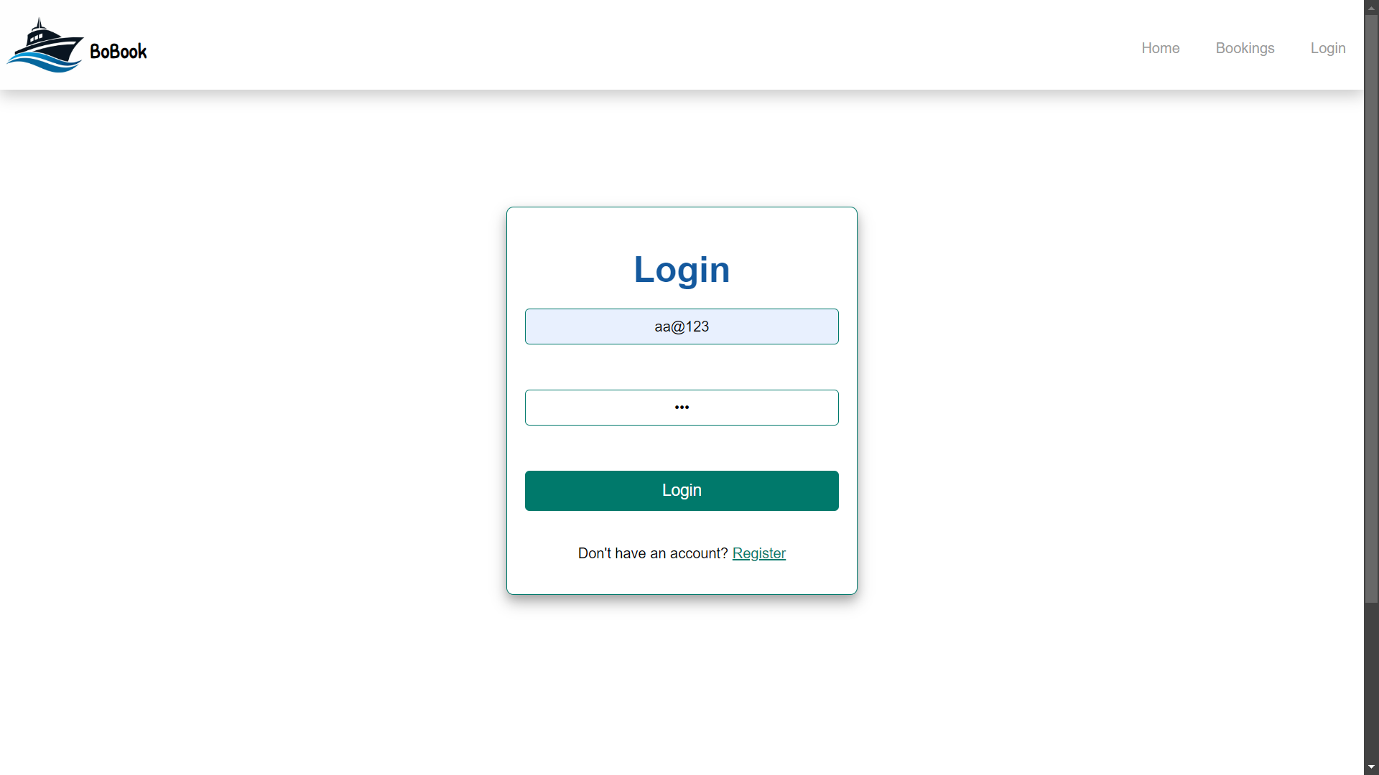

HOME PAGE:

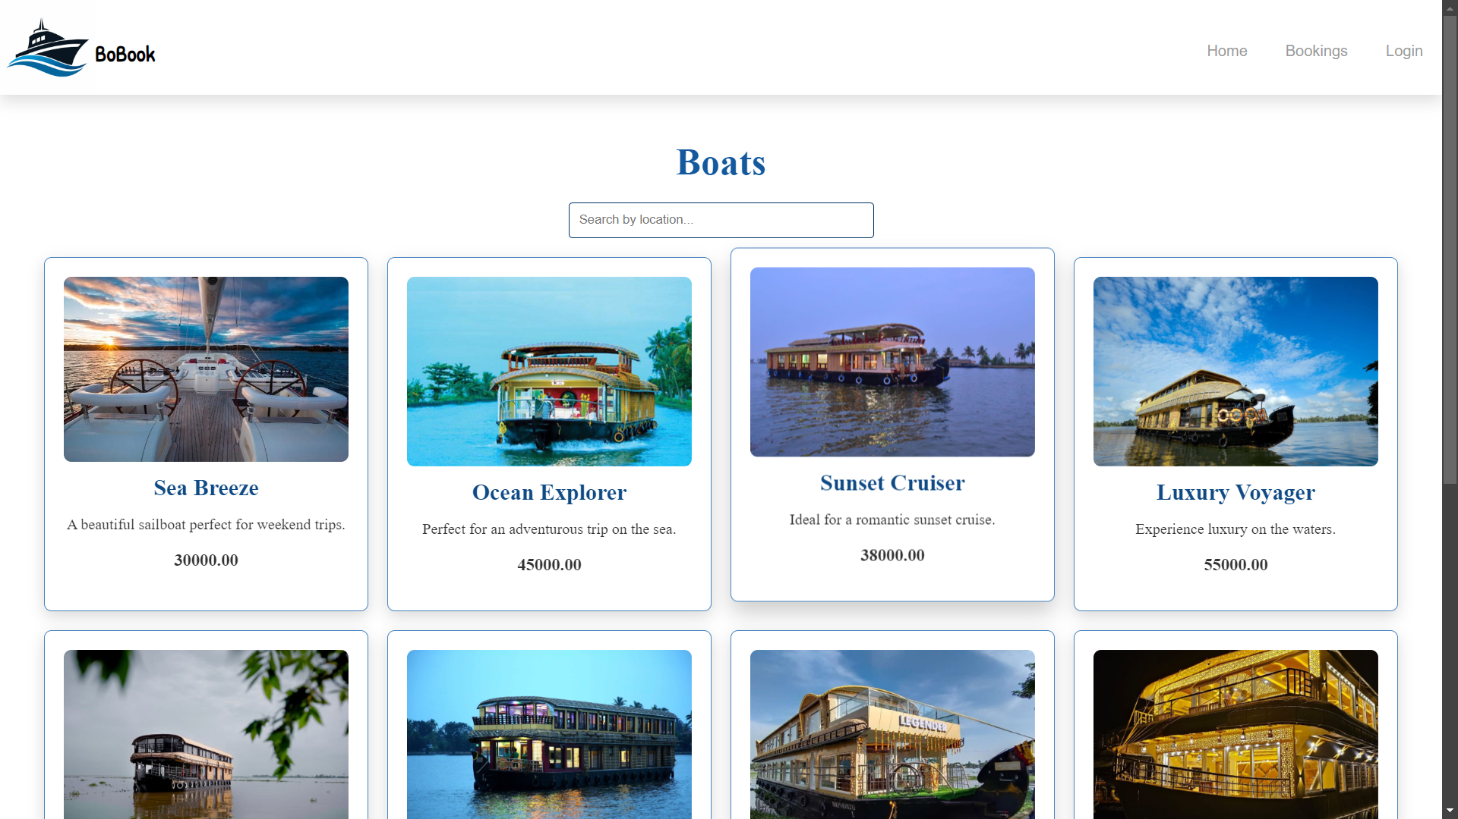

BOOKINGS PAGE:

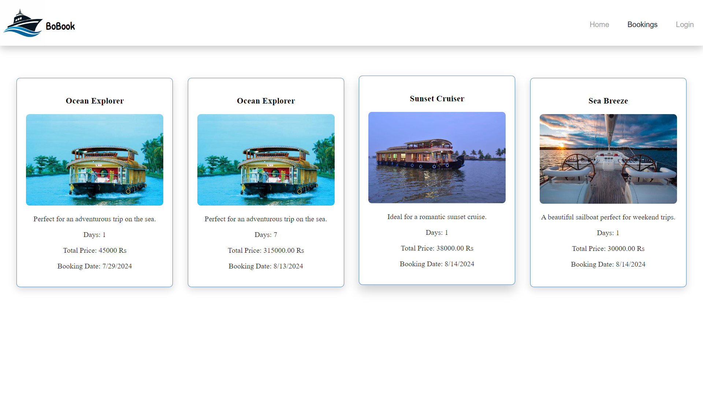

ADMIN DASHBOARD:

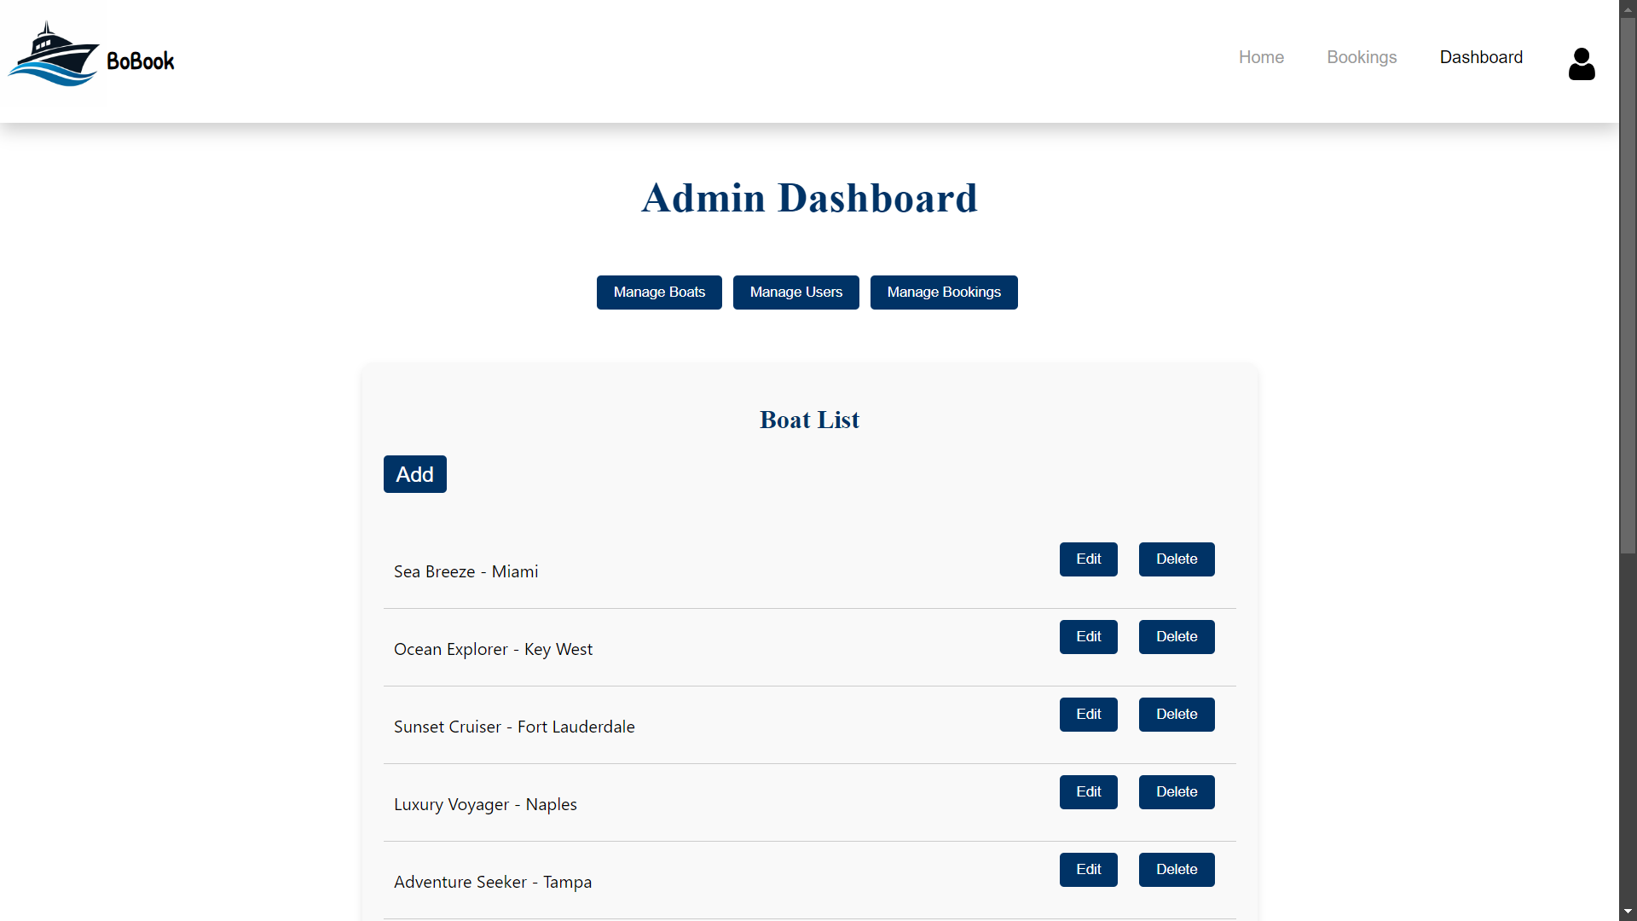

CUSTOMER LIST PAGE:

