# SOUTHWESTERN STATE COLLEGE

TRIBHUVAN UNIVERSITY

FACULTY OF HUMANITIES AND SOCIAL SCIENCE



A

Project Report On

# BLOOD GROUP INFO SYSTEM

### Submitted to Department of Computer Application

Southwestern State College, Basundhara, Kathmandu

*In partial fulfillment of the requirements for the Bachelor in Computer Application*

*Submitted By*

Name: Min Raj Gurung

TU Reg. No: 6-2-530-64-2018

Name: Abishek Das Darjee

TU Reg. No: 6-2-530-25-2018

# SOUTHWESTERN STATE COLLEGE

TRIBHUVAN UNIVERSITY

FACULTY OF HUMANITIES AND SOCIAL SCIENCE



# SUPERVISOR’S RECOMMENDATION

We hereby recommend that this project is prepared by Abishek Das Darjee and Min Raj Gurung under supervision by Mr. Bijay Babu Regmi entitled “BLOOD GROUP INFO SYSTEM” in partial fulfillment of the requirements for the degree of Bachelor of Computer Application be processed for the evaluation.

Bijay Babu Regmi Project Supervisor

# LETTER OF APPROVAL

This is to certify that this project is prepared by Abishek Das Darjee (6-2-530-25-2018)

and Min Raj Gurung (6-2-530-64-2018) entitled “BLOOD GROUP INFO SYSTEM”

in partial fulfillment of the requirements for the degree of Bachelor in Computer

Application has been evaluated. In our opinion it is satisfactory in the scope and quality as

a project for the required degree.

#### Mr. Bijay Babu Regmi Mr. Kiran Ghimire

Project Supervisor Head of Department

BCA Department BCA Department

SWSC SWSC

#### Mr. Durba Timalsina

#### Academic Head

#### External Examiner

Tribhuvan University   
 BCA Department

# ACKNOWLEDGMENT

Before we get into the thick of things, we would like to add few words of appreciation for the people who have been a part of this project right from its inception. The writing of this project has been of the significant academic challenges we have faced and without the support, patience and guidance of the people involved, this task wouldn’t have been completed. It is to them we own our deepest gratitude.

It gives us immense pleasure in presenting this project report on “BLOOD GROUP INFO SYSTEM”. It has been our privilege to have a team of project guides who have hasted us from the commencement of this project. The success of this project is a result of the hard work and determination put in by us with the help of my project guide. We hereby take this opportunity to add a special note of thanks to Mr. Bijay Babu Regmi, who undertook to act as our mentor despite his many other academic commitments. His wisdom, knowledge, and commitment to the highest standards inspired and motivated us. Without his insight support and energy wouldn’t have started and neither has reached fruitfulness.

Also, our deepest appreciation especially to our other teachers for their utmost support and encouragement without them all these would not be possible. Last but not the least, many thanks and appreciation to all our colleagues for helping us with a lot of ideas, motivations and encouragements.

Name: Min Raj Gurung

TU Reg No: 6-2-530-64-2018

Name: Abishek Das Darjee

TU Reg No: 6-2-530-25-2018

# ABSTRACT

A BLOOD DONOR MANAGEMENT SYSTEM is system that provides the information about the blood’s donor and its details. The purpose of Blood donor management system is to simplify and automate the process of searching for blood in the case of an emergency and maintain the records of the donors, recipients, blood groups, donor contact numbers. When the blood receiver wants the blood, the blood donors might be out of the area or the Donor has already given the blood. In this system, we can see that the users can see the notice about the campaign such as the blood donor campaign and which hospitals need the emergency blood. There is an announcement method as well. In Blood Donor management system, there is a representation of Pie-Chart which shows how much blood information is according to the Blood Group. Besides this, we can create, edit view and delete the donors information details, announcements and campaigns and blood collection Details.

*Keywords: Blood; Donors; Blood Info System; User; Customer;*

# TABLE OF CONTENTS

SUPERVISOR’S RECOMMENDATION ii

LETTER OF APPROVAL iii

ACKNOWLEDGMENT iv

ABSTRACT v

TABLE OF CONTENTS vi

LIST OF FIGURES viii

LIST OF TABLES ix

LIST OF ABBREVATIONS x

CHAPTER 1: INTRODUCTION 1

* 1. Overview 1
  2. Background 2
  3. Problem Statement 3
  4. Objective 3
  5. Scope 4
  6. Report Organization 4

CHAPTER 2: REQUIREMENTS ANALYSIS AND FEASIBILITY STUDY 5

* 1. Software Requirement Specification 5
     1. Existing System 5
     2. Comparisons 6

CHAPTER 3: SYSTEM ANALYSIS AND DESIGN 7

* 1. Requirement Specification 7
     1. Functional Requirement 7
     2. Non-Functional Requirements 8
  2. Feasibility Analysis 9
     1. Technical feasibility 9
     2. Operational feasibility 9
     3. Economic feasibility 10
     4. Schedule feasibility 10
  3. Requirements Collection Method 10
     1. Brainstorming 11
     2. Document Analysis 11
     3. Focus Group 11
     4. Interface Analysis 12
     5. Observation 12
  4. ER Diagram 12
  5. Sequence Diagram 14
  6. Data Flow Diagram 15
  7. Database Schema 16

CHAPTER 4: IMPLEMENTATION AND TESTING 17

* 1. SDLC Model 17
  2. System Architecture 18
  3. Tools and Technologies 18
  4. System Testing 20
     1. Unit Testing 20
        1. Test for the admin module 20
     2. Integration Testing 21
        1. Test Plan 21

CHAPTER 5: CONCLUSION 23

REFERENCES 24

APPENDIX 25

# LIST OF FIGURES

Figure 1: Use case diagram 8

Figure 2: ER Diagram 13

Figure 3: Sequence Diagram 14

Figure 4: Level 0 DFD 15

Figure 5: Level 1 DFD 15

Figure 6: Database Schema 16

Figure 7: Waterfall Model 17

Figure 8: System Architecture 18

# LIST OF TABLES

Table 1: Gantt chart 10

Table 2: Test Case 1 21

Table 3: Test Case 2 21

Table 4: Test Case 3 22

# LIST OF ABBREVATIONS

|  |  |
| --- | --- |
| CSS: | Cascading Style Sheet |
| DFD: | Data Flow Diagram |
| ER: | Entity Relation |
| GUI: | Graphical User Interface |
| HTML: | Hypertext Markup Language |
| ID: | Identity Document |
| ILS: | Integrated Library System |
| JS: | JavaScript |
| MYSQL: | Structured Query Language |
| SRS: | Software Requirement Specification |

# CHAPTER 1: INTRODUCTION

### Overview

The BLOOD DONOR MANAGEMENT SYSTEM is a system that provides information about the blood donor and its details. The purpose of the Blood group Info is to simplify and automate the process of searching for blood in the case of an emergency and maintain the records of the donors, recipients, blood groups, and donor’s contact numbers.

The BLOOD DONOR MANAGEMENT SYSTEM shows where the person has accepted or declined the request and after the request is accepted and donation of blood is done, the personal account will be done to donate blood for the next 6 months. At present, the public can only know about the blood donors’ hospitals or people and get blood from a blood bank. There is no information regarding the availability of blood donors that are available in the blood banks. There is a current system that only allows information about the availability of blood types or not. The records of the donor might not be kept safely and there might be a high chance of missing donors' records due to human error or disasters. There is also a centralized database used to keep the donor’s records. Each bank (Blood bank) is having its records of donors. If a donor brings along the donation certificate.

There are some criteria for the donors and receivers to get the blood. In this system, the receiver can’t get access the blood donors’ for getting the blood. Those people who want blood must send the photo that is requested by the doctor and the photo will be verified by this system. After it, it will give access to the blood donors.

Some of the reasons to select this project are as follows:

1. It can save the money and precious time of the donors and blood receivers.
2. Find blood donors' conditions and health issues
3. Received the blood by the verification document

### Background

For hospital, a blood group management system known as blood collection center, also an area in collected blood bags are stores and presents there are many organizations that keep the records about the blood.

Blood Donor Management system (BDMS) known as an automated Blood system is a software that is developed to handle the basic records of blood, that provide the information regarding the Blood, it Donors and the users.

According to Kampala International University Dar es Salaam Campus website [www.kiu.ac.tz,](http://www.kiu.ac.tz/) Kampala International University Dar es Salaam Campus began operations in January 2009 at Quality Plaza along Pugu road. Currently, the university center is situated on a 100-acre piece of land, at Gongo la Mboto area in Ilala. The spacious campus offers an ideal university learning atmosphere and plenty of room for further expansion. The first phase of development is almost complete. It is a constituent college of Kampala International University found in Uganda. The University envisions becoming a prominent International in the great lake’s region and beyond, nurturing talents in multicultural learning environment and advancing market-driven courses. Currently, Kampala International University Dar salaam Campus uses a manual library management system. This wastes a lot of time for students and librarians especially when students are borrowing or returning books. Currently when a student wants to borrow a book, he/she goes to the counter of the reference section and asks the librarian for the book he/she wants. If the book is in the stock, the librarian gets the book, register the details of the book and the student and then give the book to the student. This process, especially during busy hours of the day 11-5, delays students [2].

### Problem Statement

Most people faced the problem of not getting the blood at the right time due to a lack of information about donors. Blood is a very sensitive thing. When people contact the donor’, the donors might reject for many reasons. Some of the reasons are: the donor's phone number is not correct like the donor is already giving the blood and not able to give blood.

Donors might be out of the area and couldn’t be available when the patient need it. Some time, the receiver not needed the blood, but he lies to the donors for getting the blood and the donor’s valuable time is being lost.

### Objective

The main objective of the system is to provide the right information and condition of the donors to the receiver.; it also keep the record information about the donors like as blood donate, health issue, geographical area, up-to-date phone number and both donors and receiver must login/sign in their account.

1. To find the blood in proper time.
2. To find the condition of donors whether donor can donate the blood or not.
3. To find the blood according to the group wise
4. To verify the document of the receiver.
5. To check the heath issue of both donors and receiver.
   1. Scope

The system function and feature of system will include the following: [1]

1. Registration

This function allows the donor and administrator to register as a user to interact with

the system.

1. View and edit information online

Donors are allowed to view their blood donation records online by their given

account. They can also edit their personal information through the system.

1. Recording donation records

The system is able to record data of whole blood which is sent from the hospital or

by the user/receiver.

1. Blood request

User can request the blood vie email and calling to the blood bank.

1. Notify by Email

The donor’s account and generated password will be sent via E-mail, following by

their blood result of the previous donation sent in a separated E-mail.

### 1.6 Report Organization

BLOOD DONOR MANAGEMENT SYSTEM is a project designed to provide a system which can manage all the record of blood donors and receiver information. This application is mainly introduced for the blood donors and receiver where receiver can easily view the blood and the condition of donors. A receiver has to signed their document by the doctors and send that document by the user report photo. From the admin side, all the system is control. Admin can insert, update and delete the donor’s details in this application and all information is store in admin database. The project is based on HTML and CSS.

Chapter 2 contains the information about data collection, specification and analysis done for the project.

Chapter 3 contains the information about the overall architecture of the system along with the diagrams.

Chapter 4 contains detail information about the implementation and testing of the system done. Last but not the least, contains the conclusion of the project in chapter 5.

# CHAPTER 2: REQUIREMENTS ANALYSIS AND

# FEASIBILITY STUDY

In this chapter, analyzation about the developing process of Blood Donor Management System that including software requirement specification (SRS) has been done. Besides that, existing

vs proposed provides a view of how the proposed system will be more efficient than the

existing one.

### Software Requirement Specification

BLOOD DONOR MANAGEMENT SYSTEM is a computerized system which helps admin to manage the donors and blood receiver daily activity in an electronic format. It reduces the manual work.

#### Existing System

* 1. There is already a BLOOD DONOR MANAGEMENT SYSTEM such as “Nepal Blood” [2]. There are many features in this system such as Search Blood donors and finding the Blood Group accordingly. Users can get blood by accessing this site.
  2. Another site of getting blood is “Nepal Red Cross Society” (NRCS) [3]. On this site, there is no searching option but there is a facility like membership of that company by applying the membership application form, location of their Company, Hotline offer, and people can directly denote blood, their works and events are mentioned manually.
  3. “Hamro Doctor” is the next site to find the blood [4]. There are also some features. At the initial point, we can find the two options that are Request for blood & Register for Blood Donors Donation. The major feature of this site is Find Blood in need. This page is designed in Nepali fonts so many peoples can understand and can get the facilities from there.

#### Comparisons

**.**

A Blood Banking system was developed in 2500 BCE-Egyptians Use Bleeding[5]. This system has many features. In this Blood Donor Management system , firstly we have to Login through the “Admin Login” by login. After Login the system, we can see the “Admin DashBoard”. In this section, we can see the Total Donors, Available Blood, Announcement and Adding Blood Details and the Pie-Chart. This system can be categories into the two Sides. One is Admin side and another is User side.

Admin Login enable the admin to monitor the whole system. The User side can be Login by providing the user and the password. In this side, again, we can see the Dashboard of Donor’s. There we can see the blood collection or about the details of Donors that include the Blood Group, Gender, Date of Birth, weight, Address, Quantity of Blood and the collection date of Blood.

Through the admin panel , admin can insert the announcement while the user can see the announcement. Same this, Campaigns are also seen.

# CHAPTER 3: SYSTEM ANALYSIS AND DESIGN

### Requirement Specification

* + 1. Direct Observation

Direct Observation is mostly used for collecting the data. For this project, our   
 environment, society, and people are included for observing.

* + 1. Interview

For this project, some people are asked face to face. People share about the   
 problem and also their view. Accordingly, this project might help people for   
 getting the info about the blood and contact to the people.

#### Functional Requirement

The e-library system developed in this work from which some of the interfaces are being shown offers a lot of functionalities. The system is designed to support three level of user: Admin, students and staff. The functionalities of the admin in the system is to register new users, add hard copy materials to the library based on categories and send the outdated materials to the archive section of the library. The software shall have the following features:

* A new donor /receiver shall able to create an account
* An admin shall able to update the information in the application see the
* An admin shall able to see the donor and receiver information
* A receiver can able to request blood by sending the doctor/hospital report photo.

The use case diagram for the system is given below:

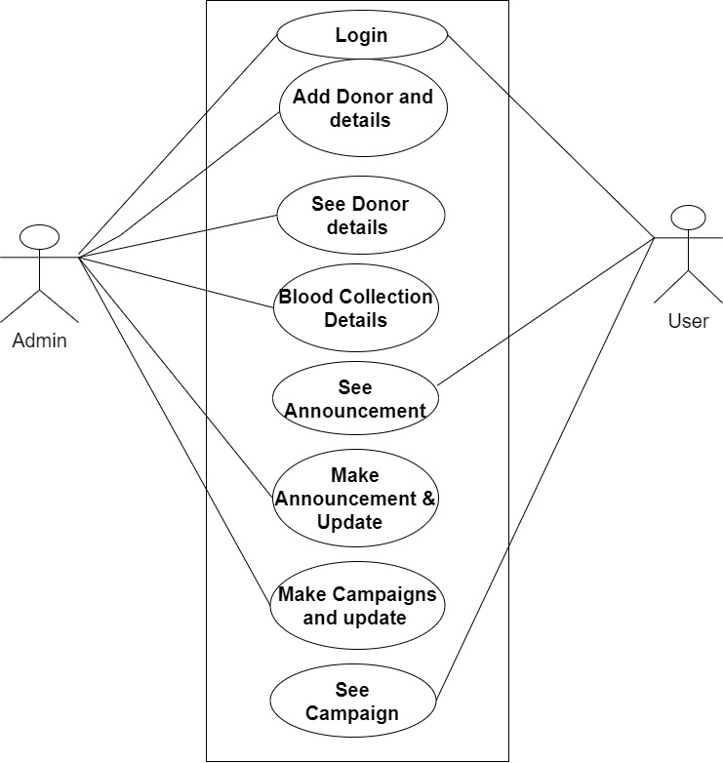

*Figure 1: Use case diagram*

#### Non-Functional Requirements

Non- functional requirement are not actual user requirements but the conditions to be used to judge the operations of the system. The simple user interface ease of use is some non-functional requirement.

Some of the non- functional requirements are:

* The system must be friendly.
* The system must be easy to maintain
* The system must be easy to upgrade.

### Feasibility Analysis

As we are building a system we must know if the system is feasible or not. There are different factors that might affect the development of the system. There are many concerns done before building a system. The feasibility analysis done in our project are:

#### Technical feasibility

This system required a minimum of 4GB memory requirement window 7-32 bit. For Designing this

system, Sublime Text and MySQL are used as software.

#### Operational feasibility

This system is user friendly and reliable system. There is response time, accuracy and it provide services. The minimum requirement is Human Resources to operate. There is no high cost to operate this system.

#### Economic feasibility

For this system, additional hardware is not use. The system support window 7-32bits. This system

can be operated in normal space.

3.2.4. Schedule feasibility

Whether the project will be completed on the given deadline or not? The team was divided, and all the activity were scheduled. The project is scheduled and can complete with in the deadline. Gantt chart was used for scheduling the time for this project.

*Table 1: Gantt chart*

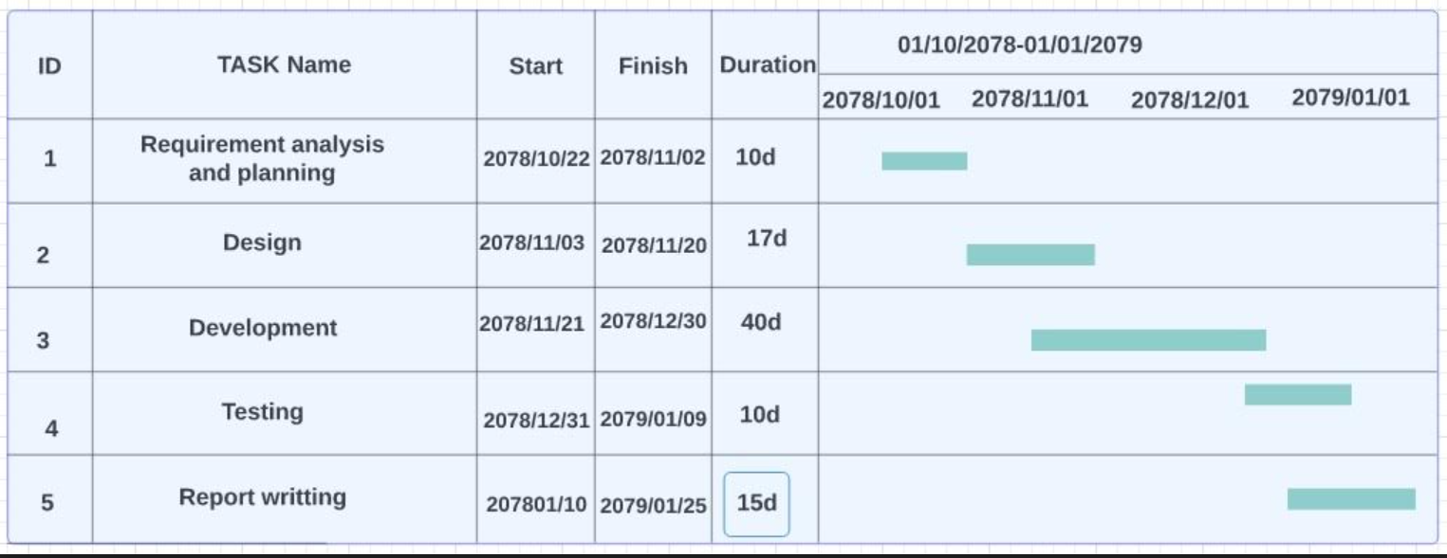

[*https://www.sciencedirect.com/topics/immunology-and-microbiology/blood-management*](https://www.sciencedirect.com/topics/immunology-and-microbiology/blood-management)

### Requirements Collection Method

The purpose of this paper is to examine the different methods in gathering requirements. Requirements are one of the most vital pieces to ensuring the success of a system or project. To ensure the optimal requirements are received, the methods in which those requirements are obtained are equally important. Through this paper, we will look at what requirements are, as well as the different methods in gathering them.

#### Brainstorming

During the brainstorming session we analyzed the problems faced in our current library system.

* Firstly, we noted down all the flaws persisting in current Blood
* All flaws were sorted and issues requiring immediate attention were considered for in next.

#### Document Analysis

In this project we are reviewing the documentation of an existing system like:

Koha Online Library management system, Online Library Project [5], Library management system [6], E- library Management system [7]. Bits of information are often hidden in existing documents that help us ask questions as part of validating requirement completeness and it helped when creating AS–IS process document, as well as driving gap analysis for scoping of migration projects. Reviewing the requirements of existing system was starting point for documenting current requirements.

#### Focus Group

Discussion session was organized with the staff members who are currently involved in library management for identifying the needs or for improvising the flaws existing in the current system. After system was developed, another discussion session was organized to validate if the requirement identified in earlier phase was meet or not. Outcome from the feedbacks is the current library management system.

#### Interface Analysis

Interfaces for a software product can be human or machine. Integration with external systems and devices is just another interface. User centric design approaches are very effective at making sure that we create usable software. Interface analysis – reviewing the touch points with other external systems is important to make sure we don’t overlook requirements that aren’t immediately visible to users.

#### Observation

By observing users (students) and Librarian, we identify a process flow, steps, points and opportunities for improvement. Observations has been done in ways passive or active (asking questions while observing). Passive observation was used for getting feedback on a prototype (to refine requirements), where active observation was useful for understanding of an existing business process.

### ER Diagram

The Entity Relationship (ER) diagram of an online library management system is composed of four entities books, categories, author and admin. The admin is the main user of this system who manages all the categories, displays books and adds authors. The books are grouped into many categories with their book id through which the admin can search them easily and book duplication problem doesn’t occur.

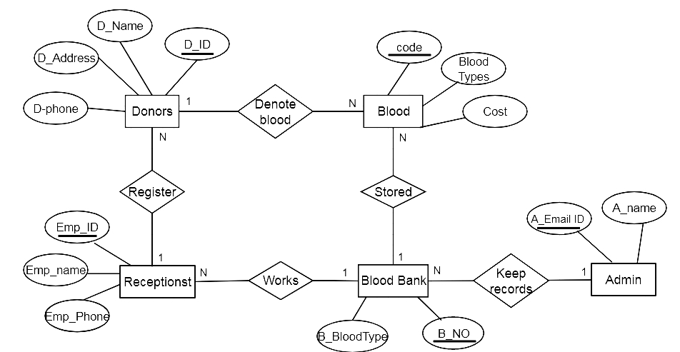

*Figure 2: ER Diagram*

### Sequence Diagram

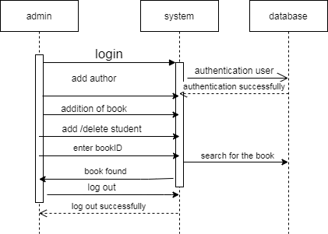

*Figure 3: Sequence Diagram*

### Data Flow Diagram

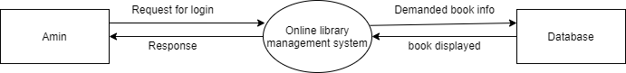

*Figure 4: Level 0 DFD*

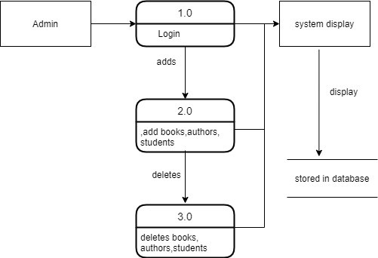

*Figure 5: Level 1 DFD*

### Database Schema

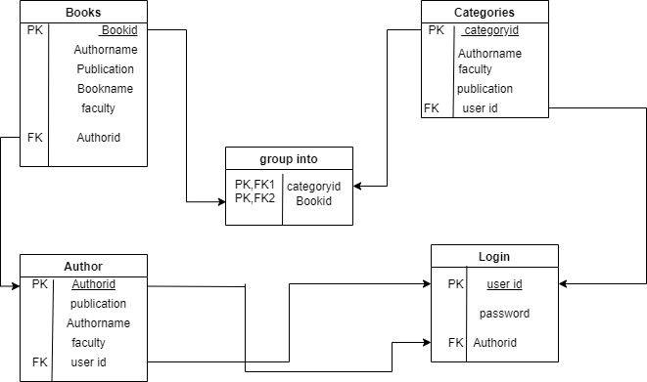

*Figure 6: Database Schema*

# CHAPTER 4: IMPLEMENTATION AND TESTING

This chapter will discuss about the coding of the library management system. Different logic thinking and coding id required at development of the system. A lot research has been done to enhance the efficiency when writing coding.

### SDLC Model

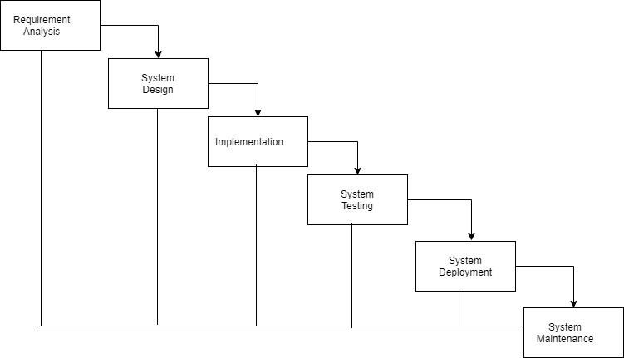

*Figure 7: Waterfall Model*

### System Architecture

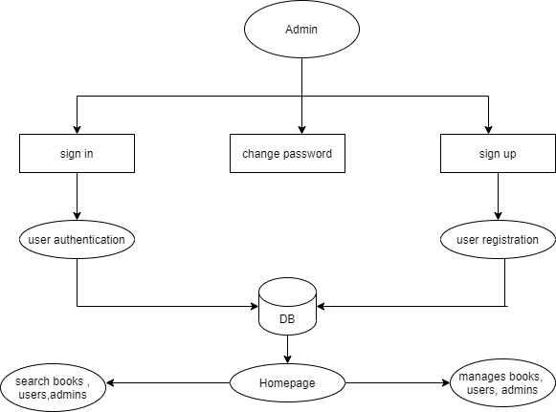

### Tools and Technologies

*Figure 8: System Architecture*

This part describes the software and hardware requirements of the system.

#### Software requirement

The whole system is divided into 2 parts: the frontend and the backend

Frontend (Development tools and programming language): the frontend is designed using: HTML, CSS, JS and PHP

Backend: the backend is designed using MYSQL and PHP.

Other Platforms used: XAMPP, Draw.io

HTML: HTML (Hypertext Markup Language) is used in this system for denoting structural, semantics for text such as headings, paragraphs, lists and other items. Through HTML codes different labels have been implemented such as for registering donors forms such as text, email, password, text area to log in are implemented through HTML.

CSS: CSS (Cascading Style Sheet) is used in this system for designing and styling forms, managing the padding and margin of label and bottom as well as adding background color and images to the system. Also, it’s for designing the navbar, header, footer, and menu of this system.

JavaScript: JS is used in this system to pop up the message using the alter keyword to display the message in the system such as after registering the student (“new donor’s registered!”), and adding the new donor in the system (“New donor added”) is displayed.

PHP: PHP a server-side scripting language has been used to connect HTML files to the database in this system.

XAMPP: XAMPP an abbreviation for cross-platform Apache and PHP is used as a local server in this project.

Draw.io: Through the use of Draw.io, diagrams such as flowcharts, sequence diagrams, and use case diagrams are created for this project.

### System Testing

The aim of the system testing process was to determine all defects in our project. The program was subjected to a set of test inputs and various observations were made and based on these observations it will be decided whether the program behaves as expected or not.

Our Project went through two levels of testing:

1. Unit testing
2. Integration testing

#### Unit Testing

Unit testing is undertaken when a module has been created and successfully reviewed. In order to test a single module, we need to provide a complete environment i.e. besides the module we would require.

* + - * The procedures belonging to other modules that the module under test calls.
      * Non local data structures that module accesses.
      * A procedure to call the functions of the module under test with appropriate parameters.

Unit testing was done on each and every module that is described under module description.

#### 4.4.1.1. Test for the admin module

Testing admin login form-This form is used for log in of administrator of the system. In this we enter the username and password if both are correct administration page will open otherwise if any of data is wrong it will get redirected back to the login page and again ask for username and password.

Student account addition- In this section the admin can verify student details from student academic information and then only add student details to main library database it contains

add and delete buttons if user click add button data will be added to student database and if he clicks delete button the student data will be deleted.

Book Addition- Admin can enter details of book and can add the details to the main book table also he can view the books requests.

#### Integration Testing

In this type of testing, we test various integration of the project module by providing the input. The primary objective is to test the module interfaces in order to ensure that no errors are occurring when one module invokes the other module.

#### 4.4.2.1. Test Plan

Test case description: Student register

*Table 2: Test Case 1*

|  |  |  |  |  |  |
| --- | --- | --- | --- | --- | --- |
| Condition | Input | Steps | Output | Actual  Result | Result |
| Should be in registration page | Full name, email, gender, student id, course | 1. Enter the required and valid information. 2. Click submit button. | User must get new account to application. | User gets new account to the application. | Pass to |

#### Test case description: Admin login

*Table 3: Test Case 2*

|  |  |  |  |  |  |
| --- | --- | --- | --- | --- | --- |
| Condition | Input | Steps | Output | Actual  Result | Result |
| Should be registered to the application. | Username, password | 1. Enter the valid username  and password. | User must login to the application. | User gets logged into the application. | Pass to Label 3 Dashboard |

|  |  |  |  |  |  |
| --- | --- | --- | --- | --- | --- |
|  |  | 2. Click log  in button. |  |  |  |

#### Test case description: Add Book

*Table 4: Test Case 3*

|  |  |  |  |  |  |
| --- | --- | --- | --- | --- | --- |
| Condition | Input | Steps | Output | Actual  Result | Result |
| Admin should be logged in. | Book name, Book id, Book’s author, publication, faculty | 1. Enter valid and required information. 2. Click add book button. | Book must be inserted in the application and displayed in home  page. | Book is inserted and displayed in the application. | Pass to Label 5 Add Book, registered book. |

# CHAPTER 5: CONCLUSION

The adaptation of e-library system has been able to address the problems of the traditional library system. This website provides a computerized version of library which will be beneficial for the Library staff’s as well as students. “Class fox” is a book management software application that runs on Microsoft Windows Platform which uses relational database to store the book information. The data contained in the database can be easily used by other applications to manage the books categories.

The e-library system is a tremendous improvement on the traditional library system that is prevalent in schools today because it improves educational activities and minimizes the workload and time spent in storing, accessing and retrieving materials from the traditional library. The use of this e-library system will successfully bring about ease and efficiency to existing system, which is characterized by manual, time consuming and rigorous processes. The e-library system, an electronic and a web-based system has been able to address the problems of the traditional library system by offering features like round the clock availability, removal of physical bounding, multiple accesses, easy information retrieval, provision of unlimited storage space, networking of operations and low cost of maintenance. The extension of this work is going to be in the embedding of the other library activities that are not captured by the system for a complete library software solution.

# REFERENCES

|  |  |
| --- | --- |
| [ 1  ] | A. Richard, "Grin (Electronic library management system (ELMS))," Grin, Alikira Richard  , 2012. [Online]. Available: https:/[/www.grin.](http://www.grin.com/document/205391)c[om/document/205391.](http://www.grin.com/document/205391) [Accessed 24 April 2021]. |
| [ 2  ] | Leaonardo Candela, Donatella Castelli, Pasquale Pagano, "Histroy , Evolution and impact of Digital Libries," researchgate, 2010. [Online]. Available: https:/[/www.rese](http://www.researchgate.net/publication/229422428_History_Evolution_and_Impact_of)a[rchgate.net/publication/229422428_History_Evolution_and_Impact_of](http://www.researchgate.net/publication/229422428_History_Evolution_and_Impact_of)  _Digital_Libraries/link/09e415110d91b1c40f000000/download. [Accessed 24 April 2021]. |
| [ 3  ] | Rickey Richard, "KOHA LIBRARY MANAGEMENT SYSTEM," *Management Process,*  vol. 1, no. 1, pp. 100-105, 2020. |
| [ 4  ] | Ayodeji Iwayemi(Department of Computer Engineering), Sulaimon Oyeniyi Adebayo(Department of Computer Engineering), "Development of a Robust Library Management System," International Journal of Computer Applications (0975 – 8887), Nigeria, International Journal of Computer Applications (0975 – 8887). |
| [ 5  ] | Surya Teja Muthyala(Governors State University), Sai Krishna Raparthi(Governors State University), Satyanarayana Asundi, ""Online Library Project" (2016)," Governors State University, 2016. [Online]. [Accessed 2021]. |
| [ 6  ] | T. C. Chuan, "LMS," Tan Chaur Chuan , 2010/11. [Online]. [Accessed 24 April 2021]. |
| [ 7  ] | Abir Roy, Anindita Mridha,Dibyajyoti Paul,Jewel Dutta , Subhojyoti Mondal , Susmita Giri, "Gr.-06library-project-report," E-LIBRARY MANAGEMENT SYSTEM by Abir Roy , Anindita Mridha,Dibyajyoti Paul,Jewel Dutta , Subhojyoti Mondal , Susmita Giri,  2018. [Online]. [Accessed 24 April 2021]. |

# APPENDIX

## HOME PAGE



*Label 1: Home Page*

## ADMIN LOGIN

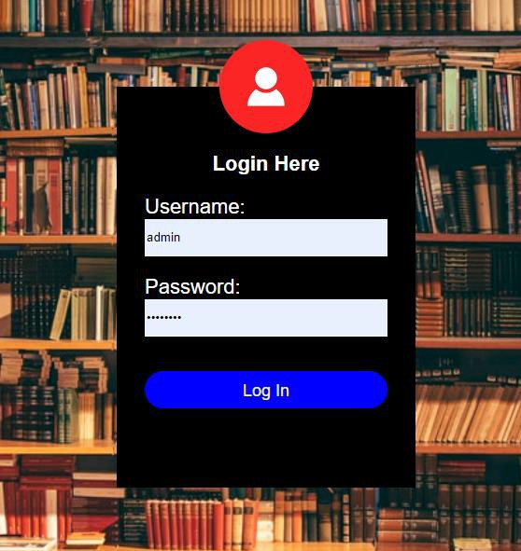

*Label 2: Admin login*

## ADMIN DASHBOARD

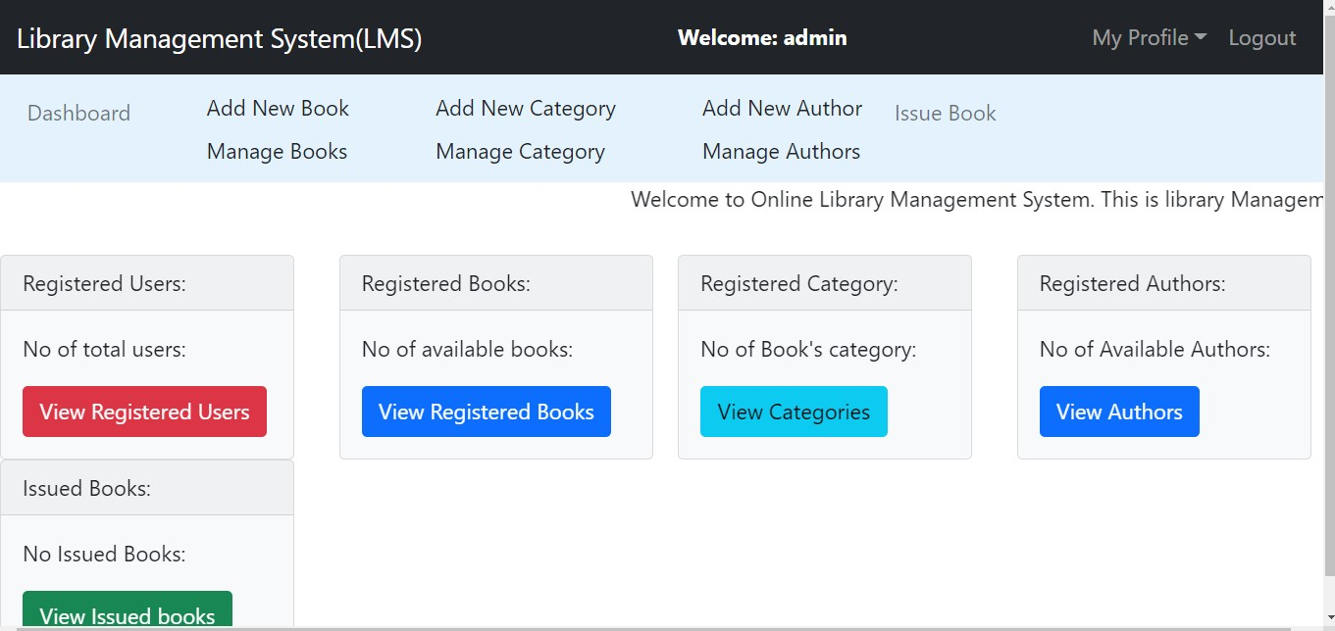

*Label 3: Admin dashboard*

## MANAGE AUTHOR

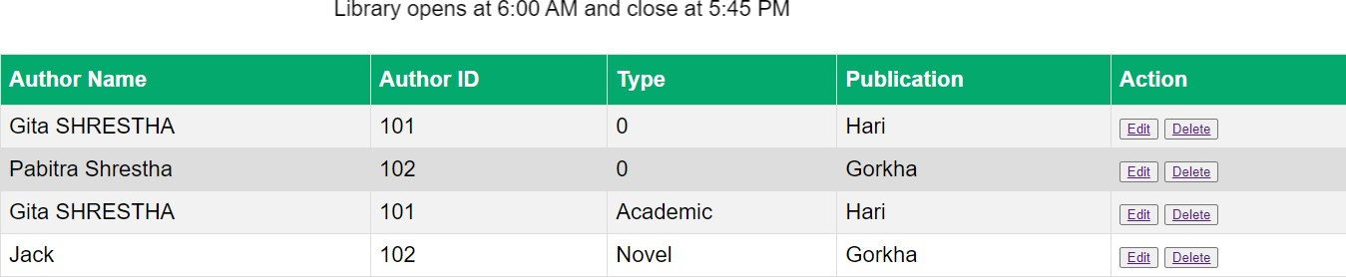

*Label 4: Manage Author*

## ADD BOOK

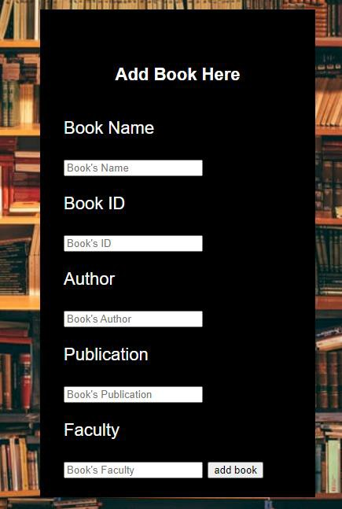

*Label 5: Add Book*

## REGISTER STUDENT

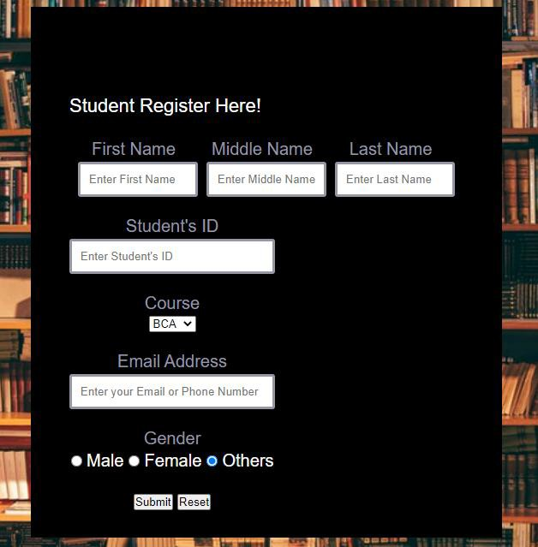

*Label 6: Register Student*

## MANAGE BOOKS

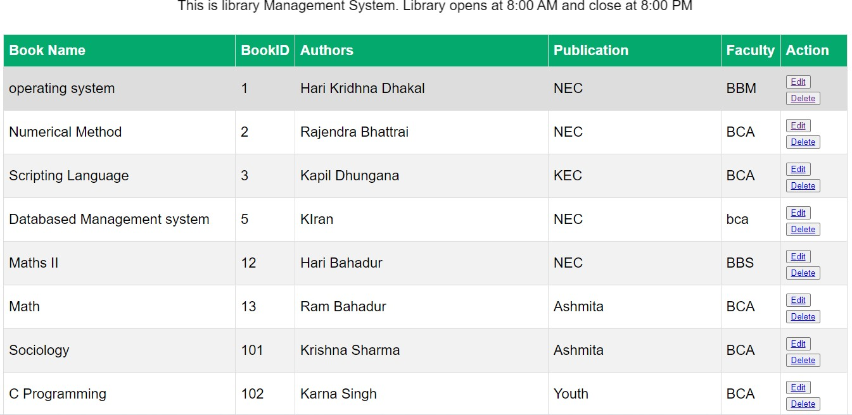

*Label 7: Manage Books*

## ISSUED BOOKS

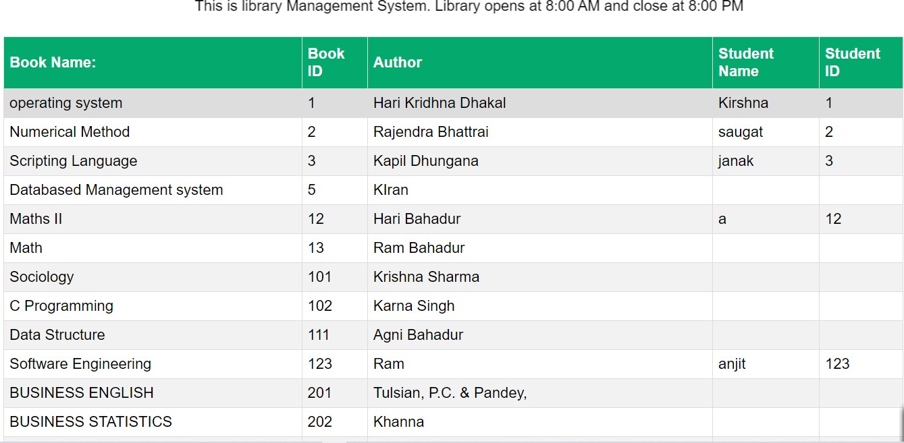

*Label 8: Manage Books*

## MANAGE CATEGORY

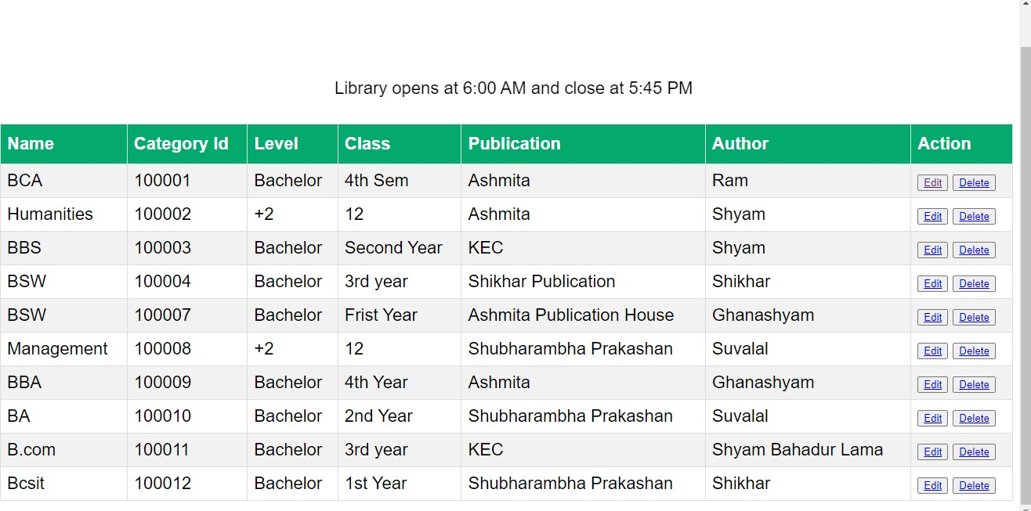

*Label 9: Manage Category*

## DATABASE

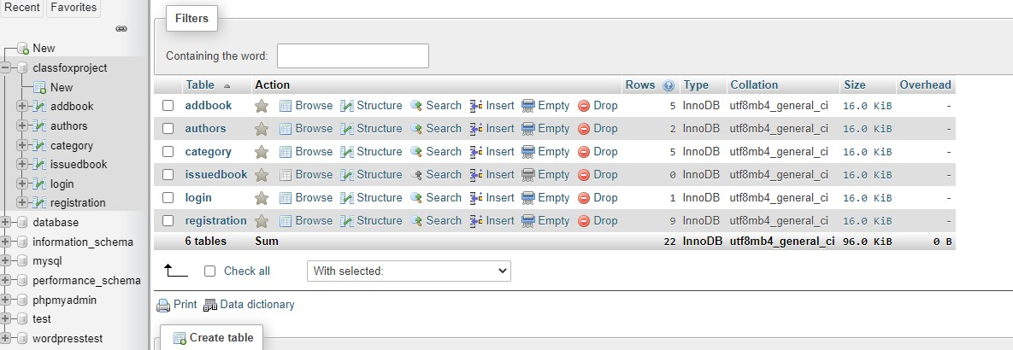

*Label 10: Database*

## ADD BOOK DATABASE

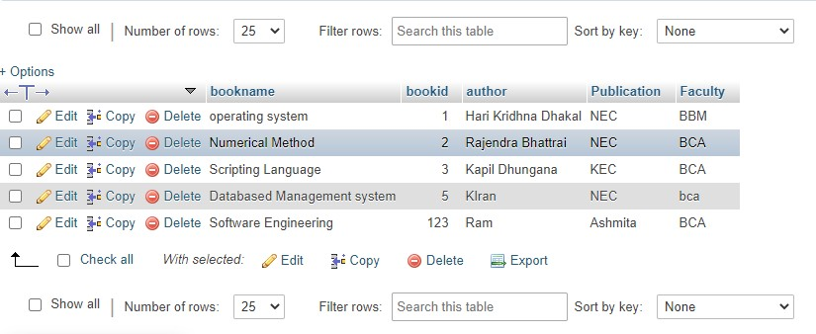

*Label 11: Add book database*

## ADMIN LOGIN DATABASE

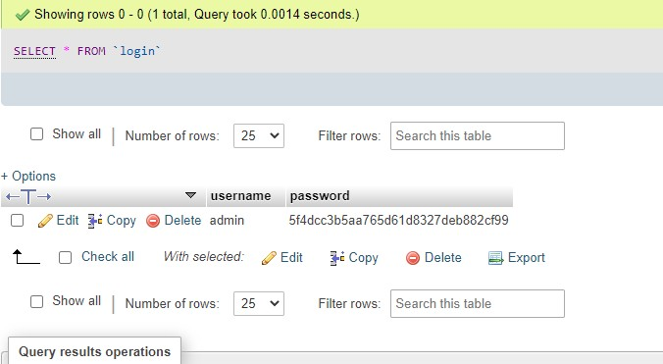

*Label 12: Admin Login Database*