1. **Stack using Structure.**

#include <stdio.h>

#include <stdlib.h>

typedef struct STACK{

int *data;

int top;

int stack_length;

}Stack;

Stack* init(int size){

Stack *sp = (Stack*)malloc(sizeof(Stack));

if(sp == NULL){

printf("Error unable to allocate memory !!");

exit(1);

}

sp->top = -1;

sp->stack_length = size;

sp->data = (int*) malloc(sizeof(int) * size);

return sp;

}

void push(Stack *s,int value){

if(s->top != s->stack_length-1){

s->data[++s->top] = value;

}

else{

printf("Overflow condition !!");

}}

void pop(Stack *s){

if(s->top != -1){

printf("Popped element is %d\n",s->data[s->top]);

s->top -= 1;

}

else{

printf("Stack is Empty !!");

}}

void display(Stack *s){

int i;

if (s->top != -1){

printf("Elements in stack are: \n");

for(i = s->top; i >= 0; i --){

printf(" %d \n",s->data[i]);

}}}

void peep(Stack *a){

if(a->top != -1){

printf("Topmost element of stack is: %d\n",a->data[a->top]);

}}

void main(){

Stack *a;

a = init(4);

push(a,43);

push(a,44);

push(a,45);

push(a,46);

display(a);

peep(a);

pop(a);

display(a);

}

**OUTPUT:**

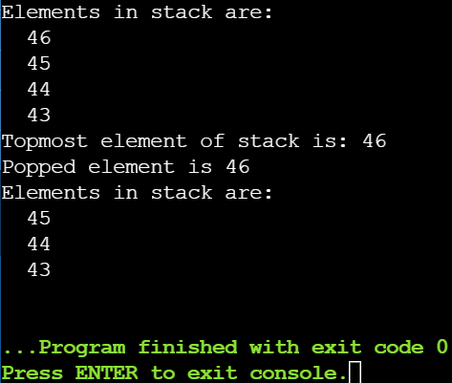

1. **Infix Expression to postfix.**

#include <stdio.h>

#include <math.h>

#include <stdlib.h>

#include <string.h>

typedef struct {

char *data;

int top;

int size;

}Stack;

Stack* initialize(int size){

Stack *s = (Stack*)malloc(sizeof(Stack));

s->data = (char*)malloc(sizeof(char) * size);

s->top = -1;

s->size = size;

return s;

}

char pop(Stack *s){

if(s->top != -1){

char element = s->data[s->top];

s->top --;

return element;

}}

char push(Stack *s,char ele){

if(s->top < s->size-1){

s->data[++s->top] = ele;

}}

void display(Stack *s){

int i;

for(i = 0; i <= s->top; i ++){

printf("%c",s->data[i]);

}}

char peep(Stack *s){

if(s->top != -1){

return s->data[s->top];

}}

int precedence(char a){

switch(a){

case '^':

return 5;

break;

case '/':

return 4;

break;

case '*':

return 3;

break;

case '+':

return 2;

break;

case '-':

return 1;

break;

default:

return 0;

break;

}}

int main(){

Stack *op_stack, *out_stack;

op_stack = initialize(15);

out_stack = initialize(15);

char infix_expression[20];

char character,popped;

int i;

printf("Enter infix expression:");

scanf("%s",infix_expression);

printf("Infix Expression is: %s\n",infix_expression);

while(infix_expression[i] != '\0'){

character = infix_expression[i];

if(character == '('){

push(op_stack,character);

}

else if(character == ')'){

while(peep(op_stack) != '('){

popped = pop(op_stack);

push(out_stack,popped);

}

pop(op_stack);

}

else if(character == '^'||character == '/'||character == '*'||character == '+'||character == '-'){

while(precedence(peep(op_stack)) > precedence(character) && op_stack->top != -1){

popped = pop(op_stack);

push(out_stack,popped);

}

push(op_stack,character);

}

else{

push(out_stack,character);

}

i++;

}

if(op_stack->top != -1){

while(op_stack->top != -1){

popped = pop(op_stack);

push(out_stack,popped);

}}

display(out_stack);

return 0;

}

**OUTPUT:**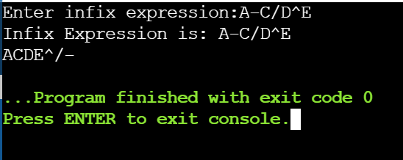

1. **Infix Expression to Prefix Expression.**

#include <stdio.h>

#include <math.h>

#include <stdlib.h>

#include <string.h>

typedef struct {

char *data;

int top;

int size;

}Stack;

Stack* initialize(int size){

Stack *s = (Stack*)malloc(sizeof(Stack));

s->data = (char*)malloc(sizeof(char) * size);

s->top = -1;

s->size = size;

return s;

}

char pop(Stack *s){

if(s->top != -1){

char element = s->data[s->top];

s->top --;

return element;

}}

char push(Stack *s,char ele){

if(s->top < s->size-1){

s->data[++s->top] = ele;

}}

void display(Stack *s, int j){

if(j == 1){

int i;

for(i = 0; i <= s->top; i ++){

printf("%c",s->data[i]);

}}

else if(j == 0){

int i;

for(i = s->top; i >= 0; i --){

printf("%c",s->data[i]);

}}}

char peep(Stack *s){

if(s->top != -1){

return s->data[s->top];

}}

int precedence(char a){

switch(a){

case '^':

return 5;

break;

case '/':

return 4;

break;

case '*':

return 3;

break;

case '+':

return 2;

break;

case '-':

return 1;

break;

default:

return 0;

break;

}}

int main(){

Stack *op_stack, *out_stack;

op_stack = initialize(15);

out_stack = initialize(15);

char infix_expression[20];

char character,popped;

int i;

printf("Enter infix expression:");

scanf("%s",infix_expression);

printf("Infix Expression is: %s\n",infix_expression);

i = strlen(infix_expression);

while(i >= 0){

character = infix_expression[i];

if(character == ')'){

push(op_stack,character);

}

else if(character == '('){

while(peep(op_stack) != ')'){

popped = pop(op_stack);

push(out_stack,popped);

}

pop(op_stack);

}

else if(character == '^'||character == '/'||character == '*'||character == '+'||character == '-'){

while(precedence(peep(op_stack)) > precedence(character) && op_stack->top != -1){

popped = pop(op_stack);

push(out_stack,popped);

}

push(op_stack,character);

}

else{

push(out_stack,character);

}

i--; }

if(op_stack->top != -1){

while(op_stack->top != -1){

popped = pop(op_stack);

push(out_stack,popped);

}

i--; }

printf(“Prefix Expression: “);

display(out_stack,0);

return 0;

}

**OUTPUT:**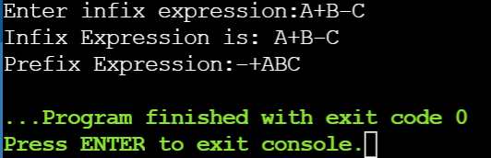

1. **Evaluate prefix expression**

#include <stdio.h>

#include <string.h>

#include <stdlib.h>

#include <math.h>

typedef struct{

int *data;

int top;

int size;

}Stack;

Stack* init(int size){

Stack *s = (Stack*)malloc(sizeof(Stack));

s->data = (int*)malloc(sizeof(int) * size);

s->top = -1;

s->size = size;

return s;

}

void push(Stack *sp,int element){

if(sp->top > sp->size - 1){

printf("Stack is full");

}

else{

sp->top ++;

sp->data[sp->top] = element;

}

}

int pop(Stack *sp){

if(sp->top != -1){

int ele;

ele = sp->data[sp->top];

sp->top --;

return ele;

}

}

void display(Stack *s){

int i;

printf("\nStack is");

for(i = s->top; i >= 0; i --){

printf(" %d \n",s->data[i]);

}}

int main(){

Stack *s;

s = init(10);

char a[10];

printf("Enter prefix expression: ");

scanf("%s",a);

int i = 0,ans,c,b;

char ele;

i = strlen(a) - 1;

while(i >= 0){

ele = a[i];

if(a[i] >= 48 && a[i] < 58){

push(s,ele - '0');

}

else{

b= pop(s);

c = pop(s);

switch(ele){

case '^':

ans = pow(b,c);

break;

case '+':

ans = b + c;

break;

case '-':

ans = b - c; break;

case '*':

ans = b * c;

break;

case '/':

ans = b / c;

break;

default:

break;

}

push(s,ans);

}

display(s);

printf("\n");

i --;

}

printf("Answer is: %d",pop(s));

return 0;

}

**OUTPUT:**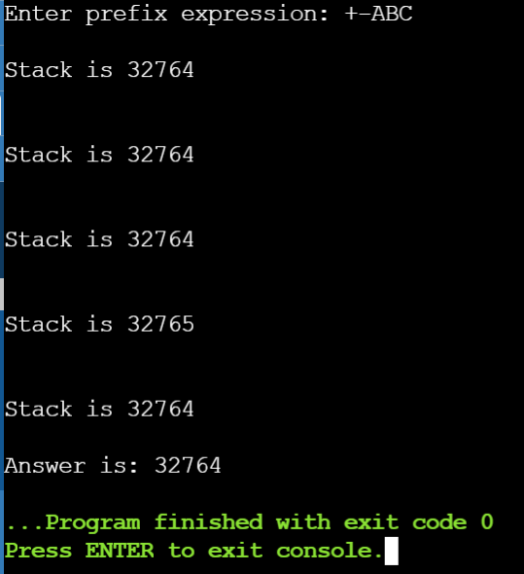

1. **Evaluate postfix expression**

#include <stdio.h>

#include <string.h>

#include <stdlib.h>

#include <math.h>

typedef struct{

int *data;

int top;

int size;

}Stack;

Stack* init(int size){

Stack *s = (Stack*)malloc(sizeof(Stack));

s->data = (int*)malloc(sizeof(int) * size);

s->top = -1;

s->size = size;

return s;

}

void push(Stack *sp,int element){

if(sp->top > sp->size - 1){

printf("Stack is full");

}

else{

sp->top ++;

sp->data[sp->top] = element;

}

}

int pop(Stack *sp){

if(sp->top != -1){

int ele;

ele = sp->data[sp->top];

sp->top --;

return ele;

}

}

void display(Stack *s){

int i;

printf("\nStack is: ");

for(i = s->top; i >= 0; i --){

printf(" %d \n",s->data[i]);

}

}

int main(){

Stack *s;

s = init(10);

char a[10];

printf("Enter postfix expression: ");

scanf("%s",a);

int i = 0,ans,c,b;

char ele;

while(i < strlen(a)){

ele = a[i];

if(a[i] >= 48 && a[i] < 58){

push(s,ele - '0');

}

else{

b= pop(s);

c = pop(s);

switch(ele){

case '^':

ans = pow(b,c);

break;

case '+':

ans = b + c;

break;

case '-':

ans = b - c;

break;

case '*':

ans = b * c;

break;

case '/':

ans = b / c;

break;

default:

break;

}

push(s,ans);

}

display(s);

printf("\n");

i ++;

}

printf("Answer is: %d",pop(s));

return 0;

}

**OUTPUT:**