Machine Learning Operations (AIMLCZG523)
Assignment 1 - End-to-End MLOps Pipeline
Heart Disease Risk Prediction API

Item | Details
Name | Abishek J S
BITS ID | 2025AE05545
Programme | M.Tech AI/ML (WILP), Semester 3
Code repository | https://github.com/<your-github-username>/heart-disease-mlops
Pipeline video | <paste video link (Google Drive / YouTube unlisted)>
Submission date | October 2026

1. Problem and approach
The goal is to predict whether a patient has heart disease from 13 routine clinical attributes (UCI Heart Disease, Cleveland subset) and to run the model as a monitored API, built the way it would be in production: reproducible data steps, tracked experiments, automated tests and builds, a container, a Kubernetes deployment and basic monitoring.
I treated the model as a screening aid. In that setting, a sick patient sent home as healthy (false negative) costs much more than an extra test for a healthy patient, so recall on the disease class mattered more to me than raw accuracy. This choice shows up in model selection, the decision threshold and the monitoring dashboard.
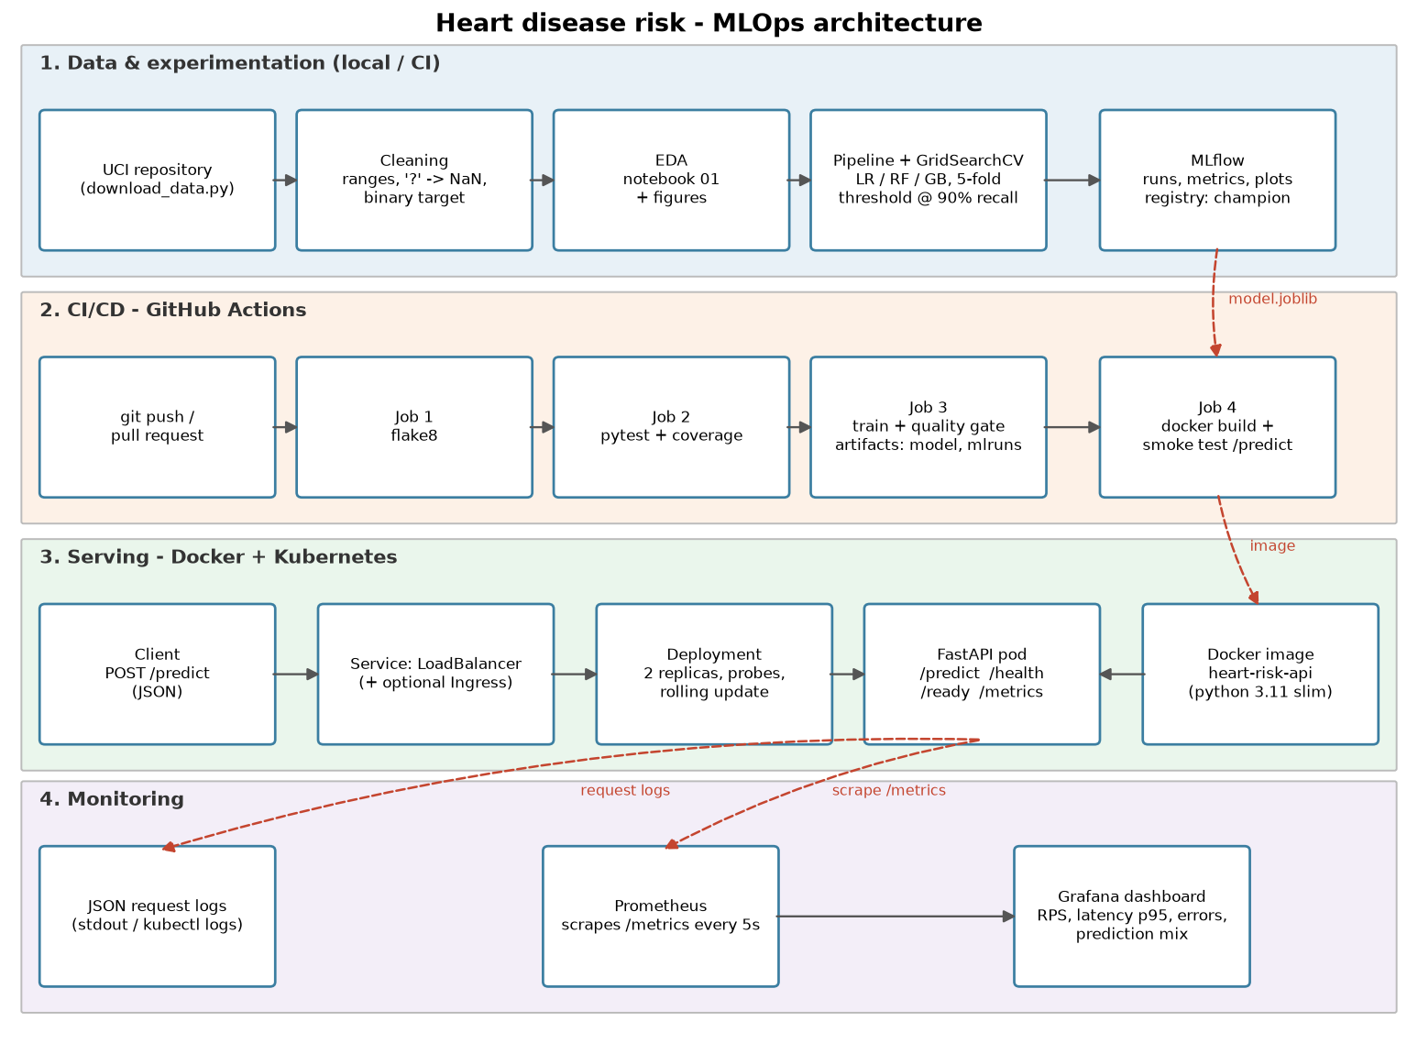
Figure 1: End-to-end architecture

1.1 Repository layout
heart-disease-mlops/
src/heartrisk/ config, data, features, train, predict, api (FastAPI), eda
scripts/ download_data.py, run_eda.py, load_test.py, build_report.py
notebooks/ 01_eda, 02_training, 03_inference (executed)
data/raw|processed/ raw UCI file and cleaned CSV
models/ model.joblib + model_meta.json (champion)
tests/ pytest suite (data, features, model, api, eda)
.github/workflows/ ci.yml (lint -> test -> train -> docker smoke test)
Dockerfile, docker-compose.yml, k8s/, monitoring/ (Prometheus + Grafana)
screenshots/, reports/

1.2 Setup and run instructions
git clone <repo> && cd heart-disease-mlops
python3.11 -m venv .venv && source .venv/bin/activate
pip install -r requirements.txt # also installs the package (-e .)
python scripts/download_data.py # UCI download -> data/raw, data/processed
python scripts/run_eda.py # figures -> reports/figures
python -m heartrisk.train # tuning + MLflow + models/model.joblib
pytest -v # unit tests
mlflow ui --backend-store-uri sqlite:///mlflow.db --port 5000
docker build -t heart-risk-api:1.0.0 . && docker run -p 8000:8000 heart-risk-api:1.0.0
kubectl apply -f k8s/ # Docker Desktop Kubernetes / minikube
docker compose up -d # API + Prometheus :9090 + Grafana :3000

2. Data acquisition and EDA
scripts/download_data.py pulls processed.cleveland.data from the UCI repository. If UCI is unreachable it falls back to a public mirror of the same 303 records and converts it to the UCI coding, so the rest of the pipeline never changes. The raw file is saved untouched in data/raw; cleaning writes data/processed/heart_clean.csv.
- Missing values: {'ca': 4, 'thal': 2} - the raw file uses '?'. They are kept as NaN in the clean file and imputed inside the model pipeline, so the imputer only sees training folds (no leakage) and the API applies the identical step.
- Validation: codes outside the documented sets (e.g. thal not in 3/6/7) and values outside plausible ranges are turned into missing values rather than silently kept.
- Target: num (0-4) is converted to binary - 0 = no disease, 1-4 = disease.
- Class balance: {'No disease': 164, 'Disease': 139} - mildly imbalanced, so accuracy is still meaningful but recall and ROC-AUC are reported alongside it.
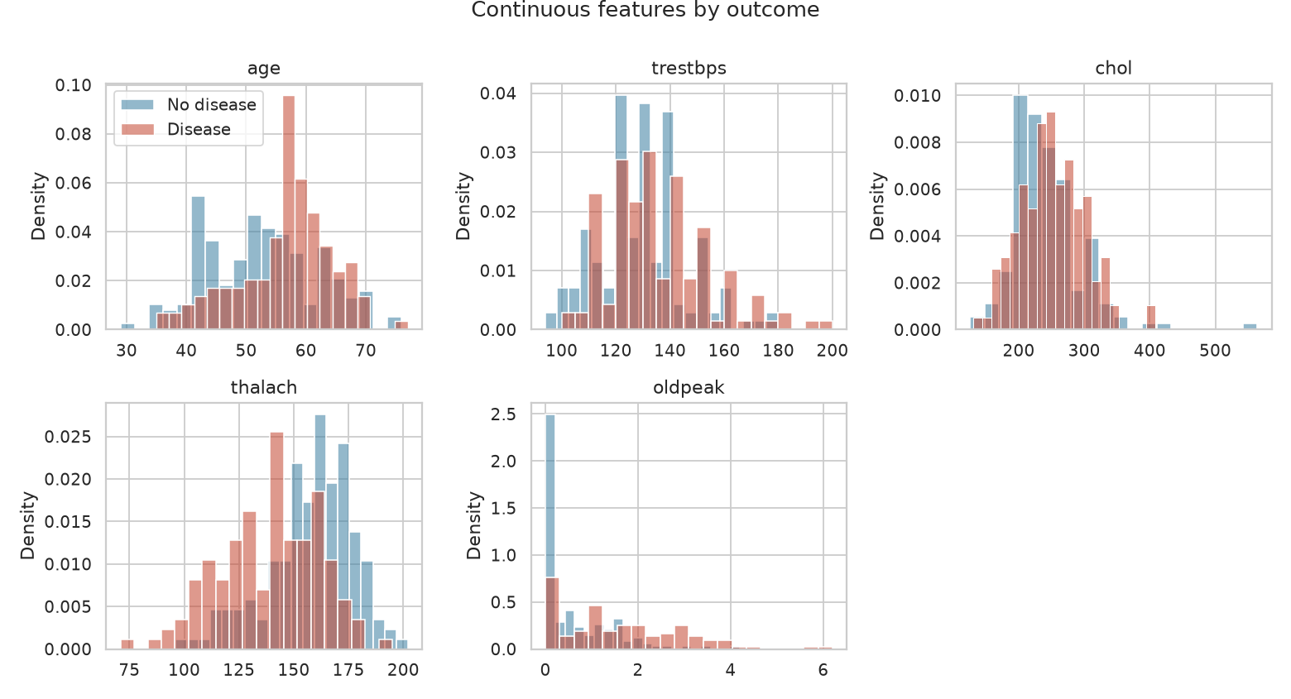
Figure 2: Continuous features by outcome
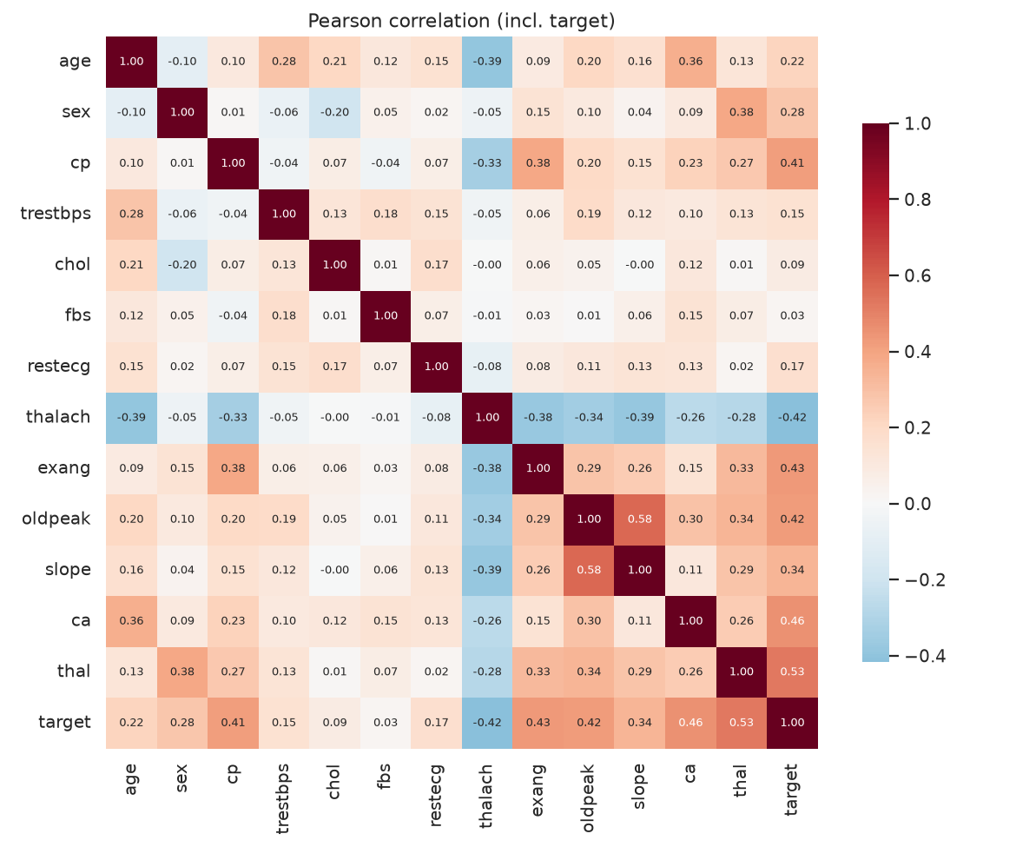
Figure 3: Correlation heatmap
Strongest associations with the target: thal (0.526), ca (0.46), exang (0.432), oldpeak (0.425), thalach (0.417), cp (0.414). Patients with disease reach a lower peak heart rate and show more ST depression. Asymptomatic chest pain (cp = 4) has the highest disease rate (about 73%), which looks odd but is well known for this dataset. restecg = 1 has only 4 patients, which is why the encoder ignores unseen categories instead of failing.
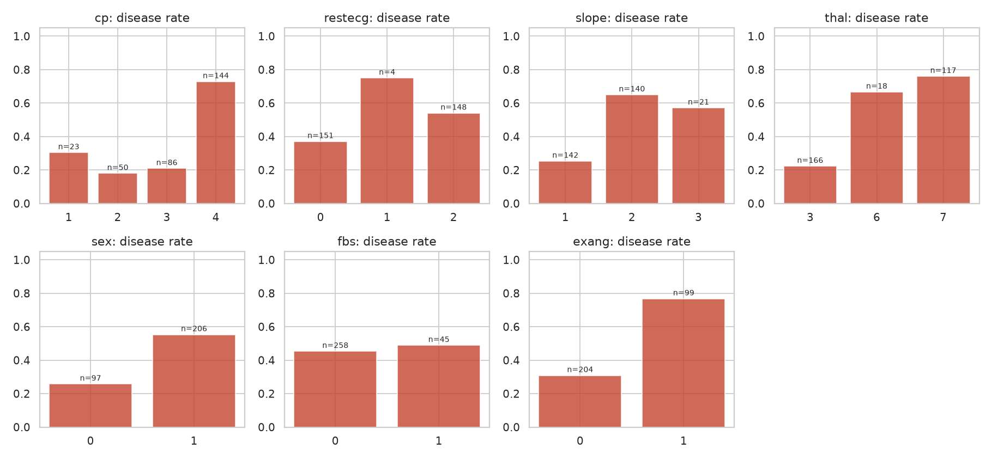
Figure 4: Disease rate per category

3. Feature engineering and model development
All preprocessing lives in one sklearn Pipeline that is saved together with the model:
- Engineered feature: hr_reserve_pct = thalach / (220 - age), the share of the age-predicted maximum heart rate reached in the stress test. It combines two raw columns into one clinically meaningful signal.
- Numeric (age, trestbps, chol, thalach, oldpeak, ca, hr_reserve_pct): median imputation + standard scaling.
- Binary (sex, fbs, exang): most-frequent imputation.
- Categorical (cp, restecg, slope, thal): most-frequent imputation + one-hot encoding (handle_unknown = ignore).
I compared three model families. Data was split 80/20 (stratified, seed 42). Each model was tuned with GridSearchCV on the 80% part using 5-fold stratified CV and ROC-AUC as the score. The champion is the best mean CV ROC-AUC, so the hold-out set is never used for any choice and only gives the final, unbiased numbers.
Model | Tuned hyper-parameters | Combinations
Logistic Regression | C, L1/L2 penalty, class_weight | 20
Random Forest | n_estimators, max_depth, min_samples_leaf, max_features | 36
Gradient Boosting | n_estimators, learning_rate, max_depth, subsample | 16

Model | CV ROC-AUC | CV acc. | CV prec. | CV recall | Test AUC | Test recall* | Threshold
logistic regression | 0.907 +/- 0.020 | 0.855 | 0.882 | 0.801 | 0.961 | 0.964 | 0.30
random forest | 0.900 +/- 0.023 | 0.818 | 0.839 | 0.764 | 0.954 | 0.964 | 0.31
gradient boosting | 0.883 +/- 0.025 | 0.818 | 0.836 | 0.765 | 0.958 | 0.964 | 0.22

The champion is logistic regression (best parameters: {'C': 0.3, 'class_weight': 'balanced', 'penalty': 'l2'}). With only 242 training rows, the simpler linear model generalised as well as or better than the tree ensembles, and it is also the easiest to explain to a clinician. CV metrics use the default 0.5 cut-off. *Test metrics use the tuned threshold.

3.1 Decision threshold
At the default 0.5 cut-off the champion's cross-validated recall was only 0.80. I therefore picked the threshold from out-of-fold training predictions as the highest value that still reaches 90% recall: 0.3. On the untouched hold-out set this gives recall 0.964, precision 0.711 and accuracy 0.803 (ROC-AUC 0.961). The trade-off is more false alarms, which is acceptable for screening. The threshold is stored in model_meta.json and applied by the API, so it is versioned together with the model.
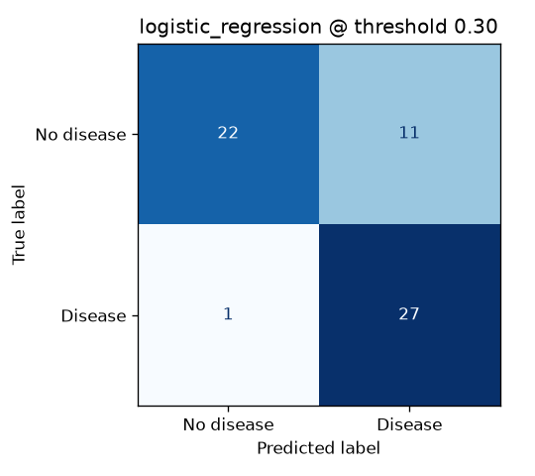
Figure 5: Hold-out confusion matrix at the tuned threshold
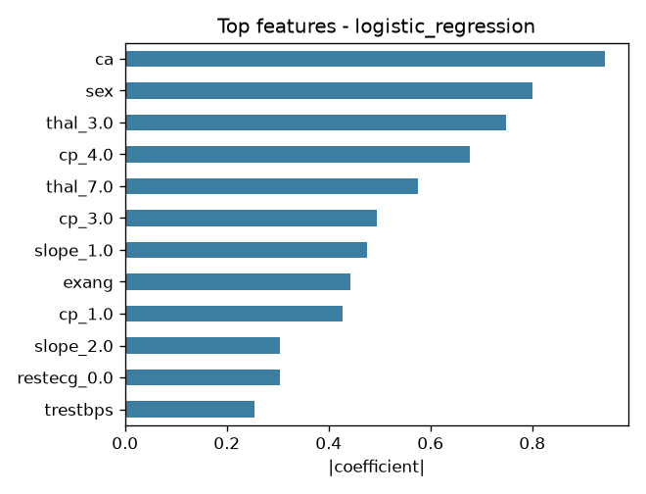
Figure 6: Largest model coefficients / importances

4. Experiment tracking (MLflow)
Each model family is one MLflow run in the experiment heart-disease-risk, backed by a local SQLite store (mlflow.db) with artifacts under mlruns/. Per run I log:
- parameters: best grid values, CV folds, split sizes, grid size, decision threshold
- metrics: CV accuracy / precision / recall / F1 / ROC-AUC (+ std), hold-out metrics at both the tuned threshold and 0.5
- artifacts: confusion matrix, ROC curve, feature importance plot, full grid-search results CSV, and the model itself with input signature and example
- tags: model family, git commit SHA, dataset id, champion flag
The champion is registered as heart-disease-classifier with the alias 'champion', so a deployment can always refer to the approved version instead of a run id.
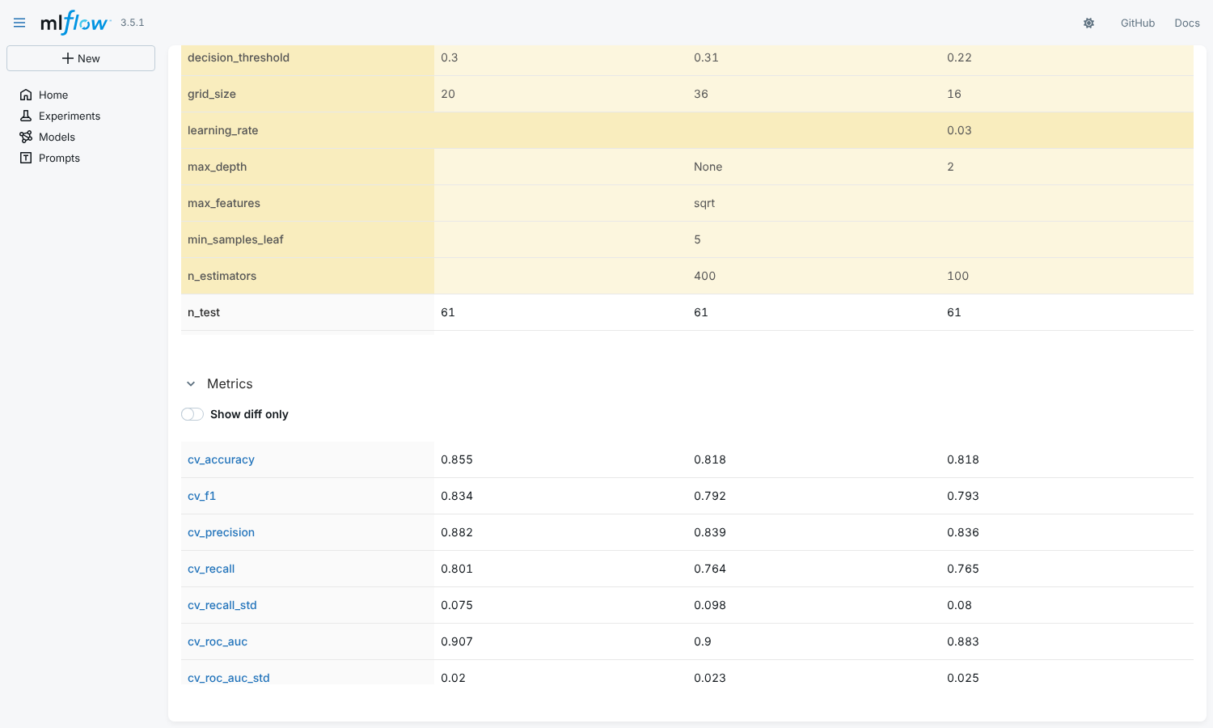
Figure 7: MLflow - comparing the three runs
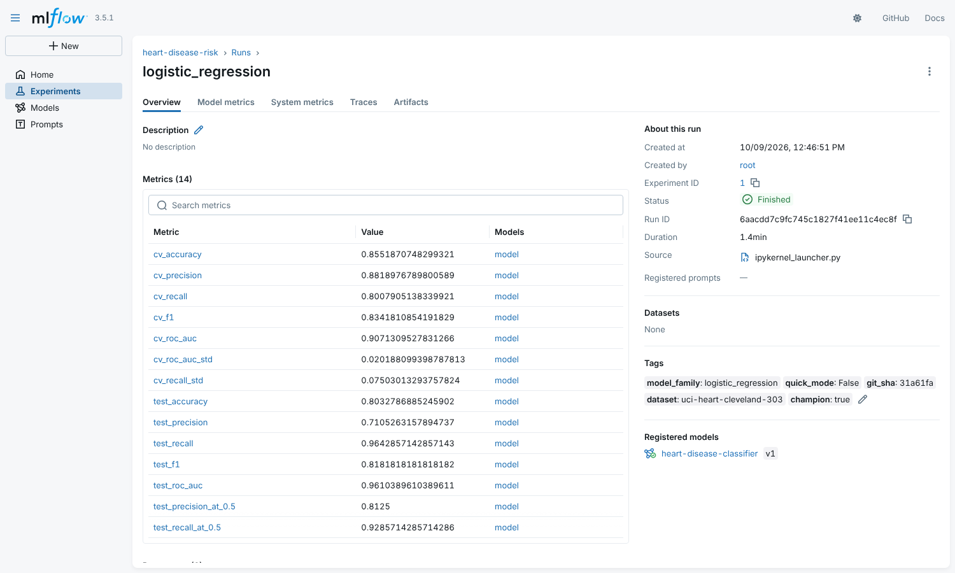
Figure 8: Champion run - metrics and tags
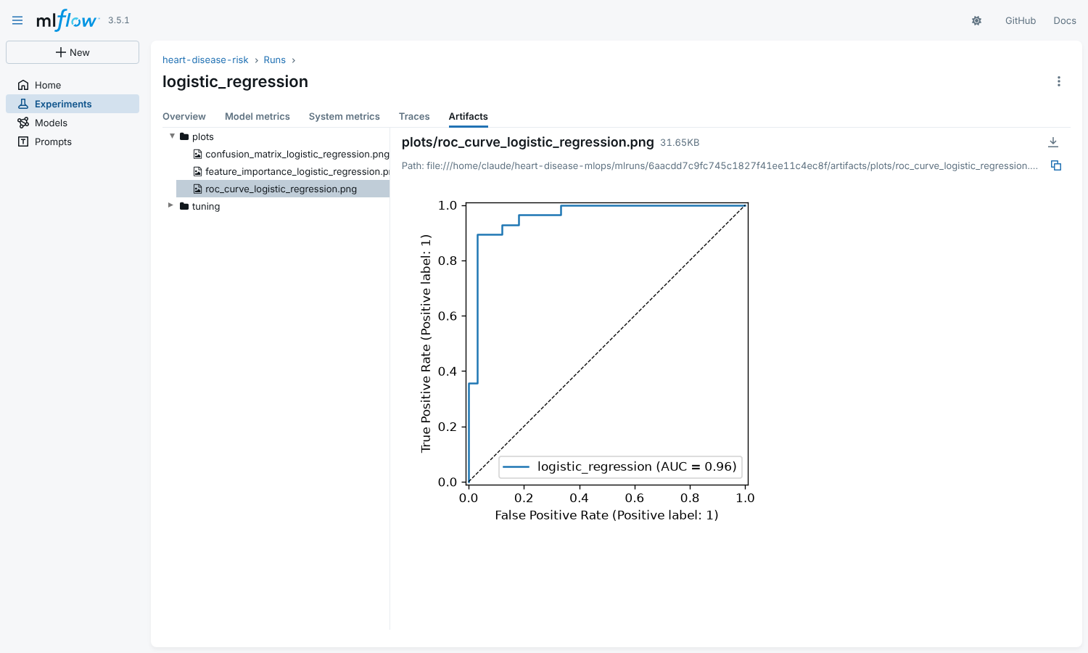
Figure 9: Logged artifacts (ROC curve)

5. Model packaging and reproducibility
- Single artifact: models/model.joblib holds preprocessing + model, so training and serving cannot drift apart. The same model is also saved in MLflow format.
- Metadata: models/model_meta.json records model version (package version + git SHA), MLflow run id, registry version, threshold, metrics, sklearn and Python versions.
- Pinned environment: requirements.txt pins every library (Python 3.11). The serving image uses requirements-serve.txt, a subset with the same versions as training.
- Determinism: fixed seed for the split, CV folds and models; data download is scripted and the cleaned CSV is committed.
{
"model_name": "logistic_regression",
"model_version": "1.0.0+31a61fa",
"decision_threshold": 0.3,
"registry_version": 1,
"sklearn_version": "1.7.2"
}

6. CI/CD pipeline and automated testing
The test suite has 24 pytest tests across five files: parsing of both data sources, cleaning rules (invalid codes, ranges, duplicates, target), the engineered feature, imputation and scaling, unseen categories, threshold selection, a minimum quality bar for the saved model, and API behaviour (valid prediction, 422 on bad input, batch endpoint, metrics endpoint).
GitHub Actions (.github/workflows/ci.yml) runs on every push and pull request to main. Each job needs the previous one, so any lint error, failed test or broken build stops the pipeline with the log of the failing step:
Job | What it does | Artifacts
1. Lint | flake8 on src, tests, scripts | -
2. Unit tests | download data, quick training, pytest with coverage | junit.xml, coverage.xml
3. Train | full training, EDA, quality gate (tests/test_model.py) | model, mlruns, mlflow.db, reports, training.log
4. Docker | build image, run it, wait for /ready, check /predict, 422 and /metrics | container.log

[ADD SCREENSHOT: screenshots/ci_01_workflow_run.png] GitHub repo -> Actions -> latest run (shows the 4 green jobs)
Figure 10: Successful GitHub Actions run
[ADD SCREENSHOT: screenshots/ci_02_artifacts.png] Bottom of the same run page: artifacts list + model comparison summary
Figure 11: Workflow artifacts and job summary

7. Containerisation
The API is a FastAPI app (src/heartrisk/api.py). POST /predict takes one patient as JSON and returns the prediction, a readable label, the disease probability, the confidence in the returned class, a risk band, the threshold and the model version. Input is validated with Pydantic (allowed codes and clinical ranges), so bad requests get HTTP 422 instead of a silent wrong answer. ca and thal may be null and are imputed. Other endpoints: /predict/batch, /health (liveness), /ready (model loaded), /model-info, /metrics and /docs.
The Dockerfile uses python:3.11-slim, installs only the serving requirements in a cached layer, runs as a non-root user and has a HEALTHCHECK. One uvicorn worker runs per container; scaling is done with Kubernetes replicas, which also keeps the Prometheus counters per process simple.
$ curl -X POST localhost:8000/predict -H 'Content-Type: application/json' \
-d @samples/high_risk.json
{"prediction":1,"label":"heart disease risk","probability_disease":0.9932,
"confidence":0.9932,"risk_band":"high","threshold":0.3,"model_version":"1.0.0+..."}
[ADD SCREENSHOT: screenshots/docker_01_build_run.png] Terminal: docker build ... then docker ps
Figure 12: Image built and container running locally
[ADD SCREENSHOT: screenshots/docker_02_predict.png] Terminal: curl /predict with samples/high_risk.json and low_risk.json
Figure 13: /predict on the local container

Figure 14: Interactive API docs (/docs)

8. Production deployment (Kubernetes)
I deployed to Docker Desktop Kubernetes using the manifests in k8s/: a namespace, a Deployment with 2 replicas, and a LoadBalancer Service on port 80. The Deployment uses a readiness probe on /ready (no traffic until the model is loaded), a liveness probe on /health, CPU and memory requests and limits, a non-root security context and a rolling update with maxUnavailable 0, so a new model version rolls out without downtime. An optional nginx Ingress (heart-api.local) is included.
docker build -t heart-risk-api:1.0.0 .
kubectl apply -f k8s/namespace.yaml -f k8s/deployment.yaml -f k8s/service.yaml
kubectl -n heart-risk get pods,svc
curl -X POST http://localhost/predict -H 'Content-Type: application/json' \
-d @samples/high_risk.json
[ADD SCREENSHOT: screenshots/k8s_01_pods_svc.png] Terminal: kubectl -n heart-risk get pods,svc -o wide
Figure 15: Pods running and LoadBalancer service
[ADD SCREENSHOT: screenshots/k8s_02_predict_lb.png] Terminal: curl http://localhost/predict ... and curl http://localhost/ready
Figure 16: Prediction through the LoadBalancer

9. Monitoring and logging
Every request is logged as one JSON line (request id, method, path, status, latency, client) and every prediction logs the outcome and probability. Logs go to stdout, so kubectl logs and any log collector can read them. The API also exposes Prometheus metrics:
- api_requests_total (by endpoint and status) and api_request_latency_seconds histogram
- model_predictions_total by outcome and model_prediction_probability histogram - a shift in these is an early, label-free sign of data drift
- api_invalid_requests_total (validation failures) and model_info (version in service)
docker compose starts the API with Prometheus (scraping every 5 s, both the compose container and the Kubernetes LoadBalancer) and Grafana with a provisioned dashboard: request rate, p50/p95 latency, error rate, prediction mix, share of disease predictions and mean predicted probability. scripts/load_test.py sends realistic traffic, including about 5% invalid requests, to populate it.
[ADD SCREENSHOT: screenshots/grafana_01_dashboard.png] http://localhost:3000 -> Dashboards -> Heart Risk -> Heart Risk API (after load test)
Figure 17: Grafana dashboard under load
[ADD SCREENSHOT: screenshots/prometheus_01_targets.png] http://localhost:9090/targets
Figure 18: Prometheus scrape targets
[ADD SCREENSHOT: screenshots/logs_01_json_requests.png] Terminal: kubectl -n heart-risk logs deploy/heart-api --tail=15
Figure 19: Structured request logs

10. Conclusion and next steps
The final system takes raw UCI data to a monitored API on Kubernetes with every step automated and reproducible. The logistic regression champion reaches ROC-AUC 0.961 and recall 0.964 on unseen patients.
Limitations: 303 patients from one hospital is a small and dated sample, so the hold-out numbers have wide uncertainty (61 test rows) and the model should not be used clinically without validation on local data. Things I would add next: push the image to a registry and deploy from CI to a managed cluster (EKS/GKE), Prometheus alert rules on latency, error rate and prediction-mix drift, a scheduled retraining job, and a proper drift report comparing live inputs with the training data.

Links
- Code repository: https://github.com/<your-github-username>/heart-disease-mlops
- Pipeline video: <paste video link (Google Drive / YouTube unlisted)>
- API access: Local deployment - run `kubectl apply -f k8s/` then call http://localhost/predict (steps in README)

