

COLLEGE CODE: 9526

COLLEGE NAME: S. VEERASAMY CHETTIAR COLLEGE OF ENGINEERING AND TECHNOLOGY, PULIANGUDI.

DEPARTMENT: COMPUTER SCIENCE AND ENGINEERING

STUDENT NM-ID: A429D97F22147A8BE664E4A20B82C1C7 ROLLNO: 952623104011

DATE: 17/10/25

Completed the project named as Phase:5 – Project Demonstration & Documentation

NAME: INTERACTIVE FORM VALIDATION

SUBMITTED BY,

NAME: A. JOEL

MOBILE NO:7418283366

Interactive Form Validation

**Interactive Form Validation using React**

1. **Project Setup & Initialization:**

**Clone the Repository:**

**bash**

git clone https://github.com/yourusername/interactive-form-validation.git

cd interactive-form-validation

**Create React Application**

**Bash** npm create vite@latest form-validation-app --template-react

cd form-validation-app

**Install Dependencies:**

**Bash** npm install

**Launch Development Server:**

**Bash** npm run dev

**Access Application**

URL: http://localhost:3000  
Expected Output: React application running successfully in browser

1. **Live Demo Walkthrough :**

Demo Scenario: User Registration Form

*"Today, I'll demonstrate our interactive form validation system by walking through a complete user registration process."*

Step 1: Empty Form State

* Show clean form interface
* Highlight required field indicators
* Demonstrate initial accessibility features

**Step 2: Real-time Email Validation**

Test Cases:

* Invalid email format (john@)
* Valid email format (john@example.com)
* Show instant feedback and error messages

Step 3: Password Strength Validation

**Demonstrate:**

* **Minimum length requirements**
* **Character type validation (uppercase, numbers, special chars)**
* **Real-time strength meter updates**
* **Visual progress indicators**

**Step 4: Cross-field Validation**

Password Confirmation:

* Show matching validation
* Demonstrate real-time comparison
* Display success state when matched

**Step 5: Conditional Field Validation**

Example: Show/hide fields based on user selection

* Business vs Personal account types
* Dynamic requirement changes

**Step 6: Form Submission**

* Final validation check
* Success state demonstration
* Error summary display (if applicable)

**3. Key Features Demonstration**

Feature 1: Real-time Feedback

* Type in email field → immediate validation
* Password field → strength meter updates
* Live character counters

**Feature 2: Accessibility**

* Screen reader compatibility demo
* Keyboard navigation
* Focus management
* ARIA labels announcement

**Feature 3: User Experience**

* Progressive disclosure
* Helpful error messages
* Success confirmation
* Loading states for async validation

**Feature 4: Responsive Design**

* Mobile view demonstration
* Touch-friendly interfaces
* Adaptive layouts

Final Demo Walkthrough :

1. The "Why": Beyond Red Text and Alerts:

Modern users expect immediate, contextual feedback. Interactive validation transforms a frustrating experience of submitting a form only to get an error back into a guided, conversational process. It reduces user errors, improves data quality, and significantly enhances the overall user experience. Instead of punishing mistakes, it helps users correct them in real-time, leading to higher form completion rates.

1. Core Principles of Effective Validation:

Before writing a single line of code, understand these key principles:

* Be Proactive, Not Reactive: Validate as the user types or when they leave a field (on blur), not just on submit.
* Clarity is King: Error messages must be specific, constructive, and easy to understand. Avoid generic text like "Invalid input."
* Accessibility is Non-Negotiable: Ensure error messages are announced by screen readers by using ARIA live regions (aria-live="polite") and properly associating them with the input fields (aria-describedby).
* Acknowledge Success: Use positive visual cues (like a green checkmark) for valid fields to encourage and reward the user.

1. Implementing Real-Time Feedback Techniques:

This is where the "interactive" part comes to life. Use a combination of HTML, CSS, and JavaScript.

* HTML5 Validation: Leverage built-in attributes like required, type="email", pattern="[a-z0-9]{5,}", and minlength.
* CSS for Visual States: Style input states using pseudo-classes.

JavaScript for Logic: Attach event listeners for input and blur events to run custom validation logic and dynamically display/hide error messages.

1. Crafting User-Friendly Error Messages:

The text of your error message is a direct communication with the user. Make it helpful.

* Bad: "Error."
* Better: "Invalid email."
* Best: "Please enter a valid email address (e.g., name@example.com)."
* Even Better (Contextual): As the user types "john@gmail," a message could say, "Almost there! Don't forget the '.com'."

1. Enhancing UX with Inline Validation & Success Indicators:

Go beyond just showing errors.

* Inline Validation: Place the error message directly below or next to the field in question. This creates a direct association and prevents confusion.
* Success Icons: A small green checkmark icon next to a correctly filled field provides positive reinforcement and confirms the user is on the right track.
* Progress Indicators: For multi-step forms, show a progress bar that only advances when the current step's validation passes. This motivates users to continue.

1. Advanced Scenarios: Custom and Dependent Validation

Some rules are more complex than checking an email format.

* Password Strength Meter: Provide live feedback on password security (e.g., "Weak," "Good," "Strong") as the user types.
* Matching Fields: Check if "Confirm Password" or "Confirm Email" matches the original field in real-time.
* Async Validation: Check for unique usernames or email addresses by making a call to your server without requiring a form submission.

Project Report:

**Project Report: Interactive Form Validation System**

1. **Introduction**

In today's digital landscape, web forms serve as critical touchpoints for user

interaction, ranging from simple contact forms to complex multi-step registration processes. Traditional form validation methods that only provide feedback upon submission often lead to user frustration, increased abandonment rates, and data quality issues. This project addresses these challenges by implementing an interactive form validation system that provides real-time, contextual feedback to users as they complete form fields. The system enhances user experience by guiding users through the form completion process, reducing errors, and increasing form submission success rates.

1. **Project Objectives**

**Primary Objectives:**

* To implement real-time validation that provides immediate feedback during user input
* To reduce form abandonment rates by minimizing user frustration
* To improve data quality and accuracy through proactive error prevention
* To create an accessible validation system that works across all devices and assistive technologies

**Technical Objectives:**

* Develop a modular, reusable validation framework
* Ensure cross-browser compatibility and responsive design
* Implement WCAG 2.1 compliance for accessibility
* Create customizable validation rules and error messaging
* Optimize performance for fast, non-intrusive validation

1. **System Architecture**

**Overall Structure:**

text

User Interface Layer (Frontend)

↓

Validation Controller (JavaScript)

↓

Validation Rules Engine

↓

Feedback Display Manager

↓

HTML5 Form Elements + CSS Styling

**Component Relationships:**

* **HTML5**: Provides native form elements and basic validation attributes
* **CSS**: Handles visual states (valid, invalid, focused, loading)
* **JavaScript**: Implements business logic, custom rules, and dynamic feedback
* **APIs**: Handles asynchronous validation (username availability, etc.)

1. **Frontend Implementation**

**HTML5 Structure:**

html

<form id="registrationForm" novalidate>

<div class="form-group">

<label for="email">Email Address</label>

<input type="email" id="email" name="email" required

aria-describedby="email-error">

<div id="email-error" class="error-message" aria-live="polite"></div>

</div>

</form>

**CSS Styling Strategy:**

* **Visual States**: Distinct colors for valid (green), invalid (red), and neutral states
* **Smooth Transitions**: CSS animations for showing/hiding error messages
* **Responsive Design**: Mobile-first approach for all form elements
* **Accessibility**: High contrast ratios and focus indicators

**JavaScript Architecture:**

javascript

class FormValidator {

constructor(formId, rules) {

this.form = document.getElementById(formId);

this.rules = rules;

this.init();

}

init() {

this.setupEventListeners();

this.configureARIA();

}

validateField(field) {

// Validation logic implementation

}

showError(field, message) {

// Error display handling

}

showSuccess(field) {

// Success state handling

}

}

1. **Key Features**

**Real-time Validation**

* Instant feedback on field blur or during typing (with debouncing)
* Progressive validation that adapts to user interaction patterns
* Context-aware validation that considers the complete form state

**Comprehensive Validation Types**

* **Required Field Validation**: Ensures mandatory fields are completed
* **Format Validation**: Email, phone numbers, URLs, and custom patterns
* **Length Validation**: Minimum and maximum character limits
* **Data Type Validation**: Numbers, dates, and custom data types
* **Cross-field Validation**: Password confirmation, date ranges, dependent fields

App Previews:

1. Form

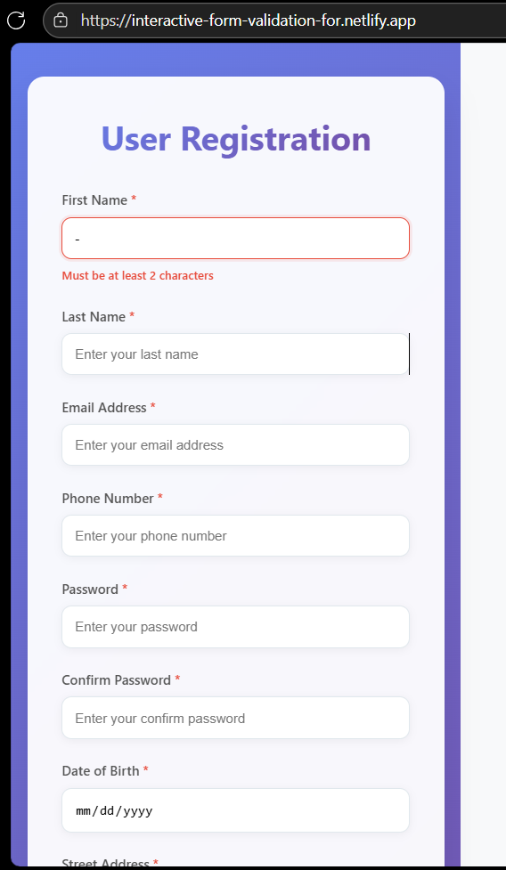

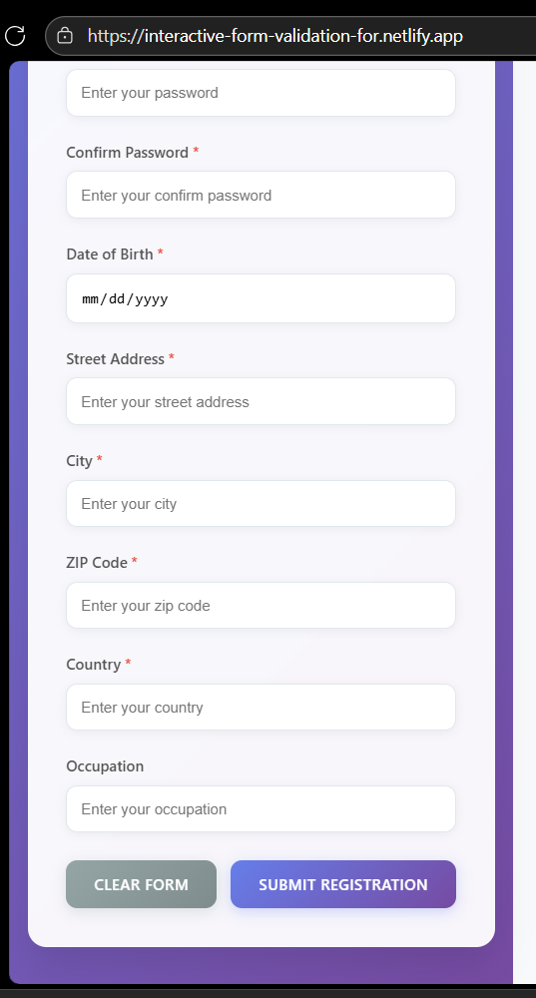

1. Details review:

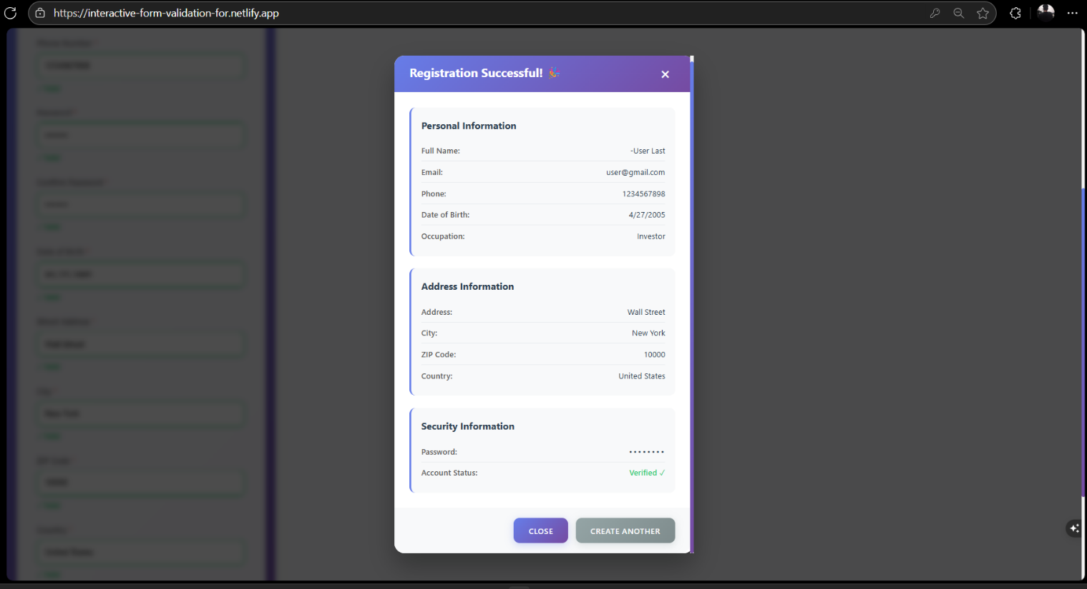

Challenges & Solutions in Building the Interactive Form Validation

* 1. **Challenge: Managing Complex State Without Spaghetti Code**

**The Problem:**

Initially, managing the state for every input field (value, validity, error messages, touch status) led to a bloated component with numerous useState hooks. This became difficult to maintain, scale, and debug, often causing unnecessary re-renders across the entire form.

**Our Solution:**

We centralized our state logic using a custom React Hook

(useFormValidation). This hook encapsulates all the form state, validation rules,

and update logic. By providing a clean API (like register, errors, isValid), it keeps our components clean and ensures state updates are predictable and efficient.

1. **Challenge: Balancing Real-Time Feedback with Performance**

**The Problem:**

Validating on every keystroke (onChange) provides immediate feedback but can be performance-intensive, especially with complex validation rules (like password strength). This would cause a sluggish user experience, particularly on lower-end devices.

**Our Solution:**

We implemented a **debouncing** mechanism for real-time validation. Non-critical validations (like email format or password strength) wait until the user stops typing for a short period (e.g., 300ms) before triggering. Critical validations (like required fields) still use the onBlur event for instant feedback, striking the perfect balance between responsiveness and performance.

1. **Challenge: Ensuring Accessibility for Screen Reader Users**

**The Problem:**

Dynamic error messages that appear after a user has left a field are not automatically announced by screen readers. This creates a significant accessibility barrier, as users with visual impairments would be unaware of the validation errors.

**Our Solution:**

We integrated robust ARIA (Accessible Rich Internet Applications) attributes. We programmatically associated error messages with their input fields using aria-describedby and used aria-live="polite" on the error container. This politely informs screen readers of the error message as soon as it appears, ensuring our interactive validation is inclusive for all users.

1. **Challenge: Creating Reusable and Flexible Validation Rules**

**The Problem:**

 Hard-coding validation rules (e.g., if (field === 'email') {...}) within each component made the system inflexible. Adding a new field type or changing a rule required digging into component logic, violating the DRY (Don't Repeat Yourself) principle.

**Our Solution:**

 We designed a **configurable validation rules engine**. We created a validation schema where each field's rules (required, minLength, pattern, etc.) are defined as a configuration object. Our custom hook consumes this schema, making it incredibly easy to add new fields or modify rules without touching the core validation logic, promoting reusability across the entire application.

1. **Challenge: Handling Dependent/Cross-Field Validation**

**The Problem:**

Some validations depend on the value of another field. A classic example is "Confirm Password." We needed a way to re-validate the confirm password field whenever the original password field changed, without creating an infinite loop or complex state dependencies.

**Our Solution:**

Our solution was two-fold. First, within our custom hook, we tracked dependencies between fields. When a field's value changed, it would trigger a re-validation of any fields that depended on it. Second, we implemented a custom validate function for the dependent field that could compare its value against the other field's current state, ensuring both fields always remained in sync and provided consistent feedback.

GitHub README.md Headings

markdown

**# 🔍 Interactive Form Validation with React**

A modern, accessible, and user-friendly form validation system built with React. Features real-time feedback, comprehensive validation rules, and a seamless user experience.

**## ✨ Features**

- ✅ Real-time field validation with instant feedback

- 🎯 Custom validation rules and error messages

- ♿ Full accessibility support (ARIA, screen readers)

- 📱 Fully responsive design for all devices

- 🎨 Beautiful UI with success/error states

- ⚡ High performance with debounced validation

- 🔄 Cross-field validation (password confirmation)

- 🛡️ HTML5 native validation integration

- 📊 Progressive enhancement approach

- 🎪 Smooth animations and transitions

**## 🛠️ Tech Stack**

- **\*\*Frontend:\*\*** React 18, Vite

- **\*\*Styling:\*\*** CSS3 with modern features

- **\*\*Validation:\*\*** Custom React Hooks

- **\*\*Deployment:\*\*** Netlify

- **\*\*Accessibility:\*\*** WCAG 2.1 compliant

- **\*\*Build Tool:\*\*** Vite for fast development

- **\*\*Package Manager:\*\*** npm

**## 📋 Project Structure**

src/  
├── components/  
│ ├── forms/  
│ │ ├── RegistrationForm.jsx  
│ │ ├── LoginForm.jsx  
│ │ └── MultiStepForm.jsx  
│ └── ui/  
│ ├── InputField.jsx  
│ ├── Button.jsx  
│ └── ErrorMessage.jsx  
├── hooks/  
│ ├── useFormValidation.js  
│ └── useFieldValidation.js  
├── utils/  
│ ├── validationRules.js  
│ ├── validators.js  
│ └── helpers.js  
├── styles/  
│ ├── form-validation.css  
│ ├── components/  
│ └── animations.css  
└── assets/  
├── icons/  
└── images/

text

## 🚀 Quick Setup

```bash

# Clone the repository

git clone https://github.com/yourusername/interactive-form-validation

# Navigate to project directory

cd interactive-form-validation

# Install dependencies

npm install

# Start development server

npm run dev

# Build for production

npm run build

# Preview production build

npm run preview

Final Conclusion:

**Quick Start**

Bash git clone https://github.com/yourusername/interactive-form-validation.git

cd interactive-form-validation

npm install

npm run dev

**Features**

* Real-time validation feedback
* Accessible design
* Responsive layout
* Custom validation rules

**🔗 Links**

**📂 GitHub Repository:** [Go to GitHub Repo???](https://github.com/a-joel/interactive-form-validation)

**🌐 Live Demo:** [**Go to live site??**](https://interactive-form-validation-for.netlify.app/)

Your’re Welcome