Q14. Write the following queries in SQL, using the university schema.

a. Create a new course “INFO-610”, titled “Analysis of Database”,with 3 credits.

INSERT into course VALUES('INFO 610','Analysis of Database','Comp. Sci.',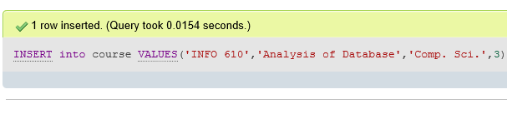

b. Create a section of this course in Spring 2017, with sec id of 5.

INSERT into section(`course_id`,`sec_id`,`semester`,`year`) VALUES('INFO 610', 5, 'Spring',2017)



c. Enroll every student in the Biology department in the above section.

INSERT INTO takes(ID, course_id, sec_id, semester, YEAR)

SELECT ID, 'INFO 610', '5', 'Spring', 2017

FROM student

WHERE dept_name = 'Biology';

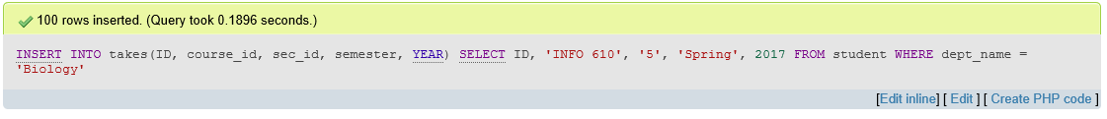

d. Delete enrollments in the above section where the student’s name is John.

delete from takes

where (course_id = 'INFO 610') and (sec_id = '5') and (semester = 'Spring') and (year = 2017)

and (ID in (select ID from student

where name = 'John'))

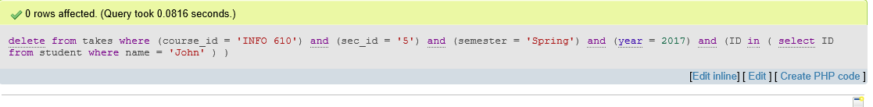

e. Delete the course “INFO-610”. What will happen if you run this delete statement without first deleting offerings (sections) of this course.

DELETE FROM `course` WHERE `course_id` ='INFO 610'



Q15. Write the following queries in SQL, using the university schema.

1. Find all the departments which are residing in “Taylor” building.

SELECT dept_name FROM department WHERE building IN ('Taylor');

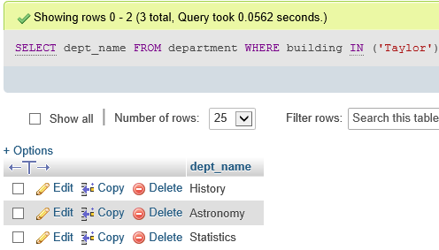

1. Find list of all advisors who are advising students of department whose name starts with A.

SELECT ID,name,dept_name

FROM instructor

WHERE dept_name LIKE 'A%';

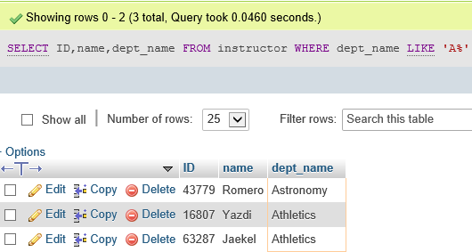

1. Find name of all courses whose pre-requisite course is “Real-Time Database Systems”.

SELECT course.title

FROM prereq

INNER JOIN course ON prereq.course_id=course.course_id

WHERE prereq_id =any(SELECT course_id FROM course WHERE title="Real-Time Database Systems");

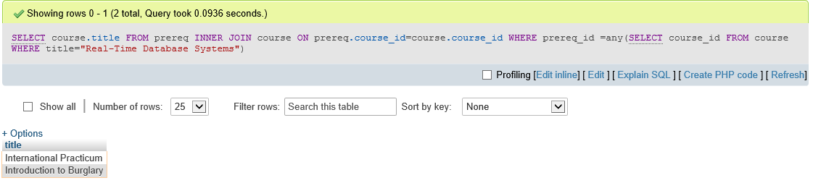

1. Find the maximum capacity of any room

SELECT MAX(capacity)

FROM classroom;

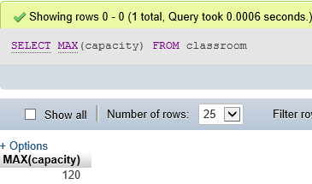

1. Find the average capacity of the rooms

SELECT AVG(capacity)

FROM classroom;

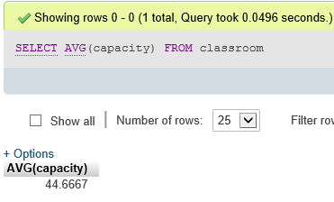

1. List the total capacity of all the buildings. (hint: use group by)

SELECT building,SUM(capacity)

FROM classroom

GROUP BY building

ORDER BY SUM(capacity) DESC;

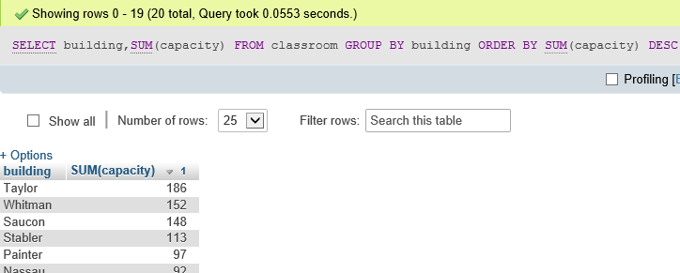

1. Find the maximum capacity of any building

SELECT building,MAX(capacity) as maximum_capacity

FROM classroom

GROUP BY building

ORDER BY MAX(capacity) DESC

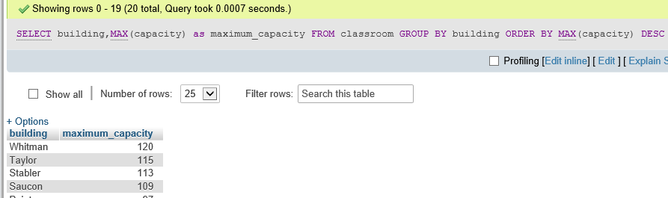

1. Find the average capacity of the buildings

SELECT building,AVG(capacity) as average_capacity

FROM classroom

GROUP BY building

ORDER BY AVG(capacity) DESC;

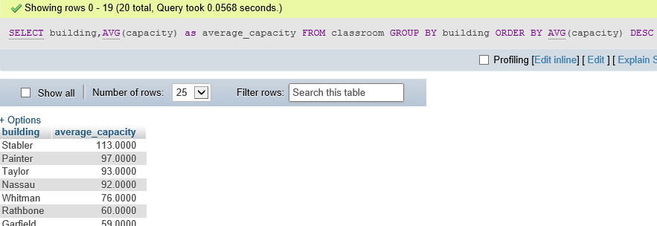

1. Find the department wise average credit of the courses

SELECT dept_name,AVG(credits) as Average_credits ,SUM(credits) as total_credits,MAX(credits) as Maxm_credits

FROM course

GROUP BY dept_name

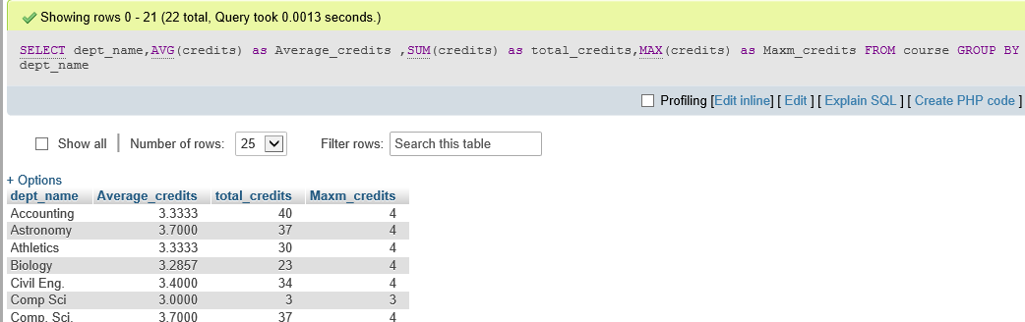

1. Find the name of all the students who have received grades of “A” or “A+” or “A-“ in any of the course offered in 2004 or 2005

SELECT name

FROM student

INNER JOIN takes ON takes.ID=student.ID

WHERE grade IN ('A+','A-','A') AND year IN ('2004','2005');

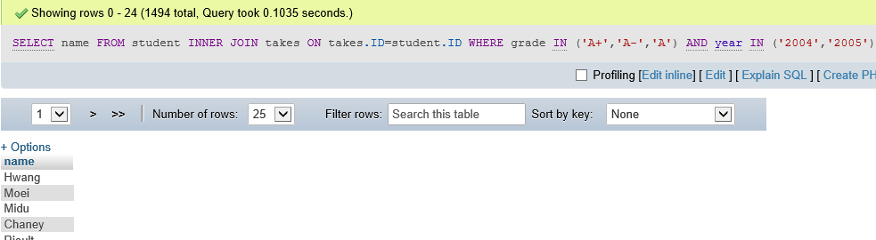

1. Find the maximum salary of the instructor in Comp. Sci.

SELECT MAX(salary) as paisa_paisa

FROM instructor

WHERE dept_name IN('Comp. Sci.');

