**Casino - Prolog**

**TECHNICAL MANUAL**

December 15, 2018

Abish Jha

Ramapo College of New Jersey

**Contents**

1. Bug Report
2. Feature Report
3. Description of data structures/classes
4. How to Run
5. Screen Shots

Bug Report

The give loose cards to player who captured last at the end of round is not working for multi-dimensional lists, so it is commented out of the function execution.

Feature Report

* The only move that can be made, checked or be gotten as hint is trail.

Description of data structures/classes

The only data structure used in the game is the inbuilt prolog list.

How to Run

The program can be run by consulting the Casino.pl file in the prolog terminal. Once the database is loaded, query ‘casino(_).’

Screen Shots

New game ::

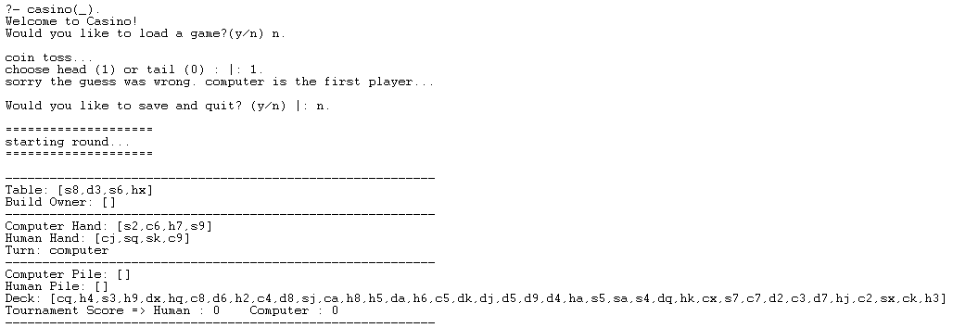

Load Game ::

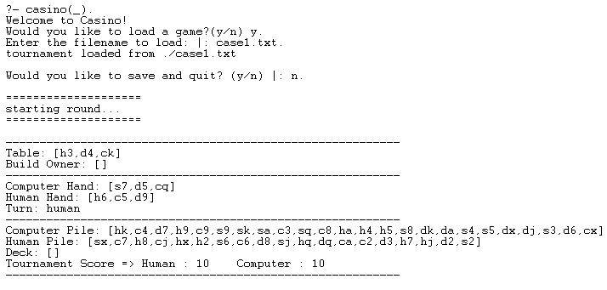

Human Move Menu ::

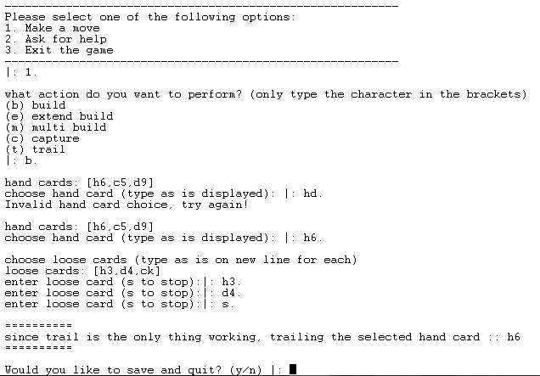

Computer Move ::

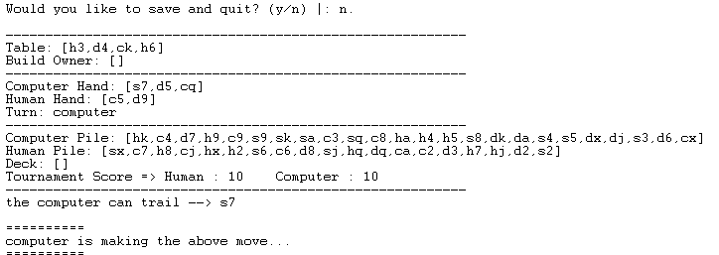

Hint ::

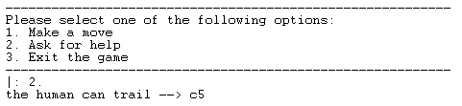

Round and Tournament End Stat ::

