**Trinity International College**

**Dillibazar Height, Kathmandu**

(Affiliated to TU)



**Lab Report**

Data Warehousing and Data Mining

Lab No: 1

**Submitted By: Submitted To:**

Abishkar Koirala Ashok Poudel

Semester: 7th  Lecturer

Roll No: 05

**Theory**

BI tools:  
Business intelligence (BI) tools are types of application software which collect and process large amounts of unstructured data from internal and external systems, including books, journals, documents, health records, images, files, email, video and other business sources.

SeekTable:  
Online pivot tables SeekTable is a self-service BI tool for ad-hoc data analytics, operational & embedded reporting with live tables & charts.

Questions:

1. How many domestic arrests were made in 2020?

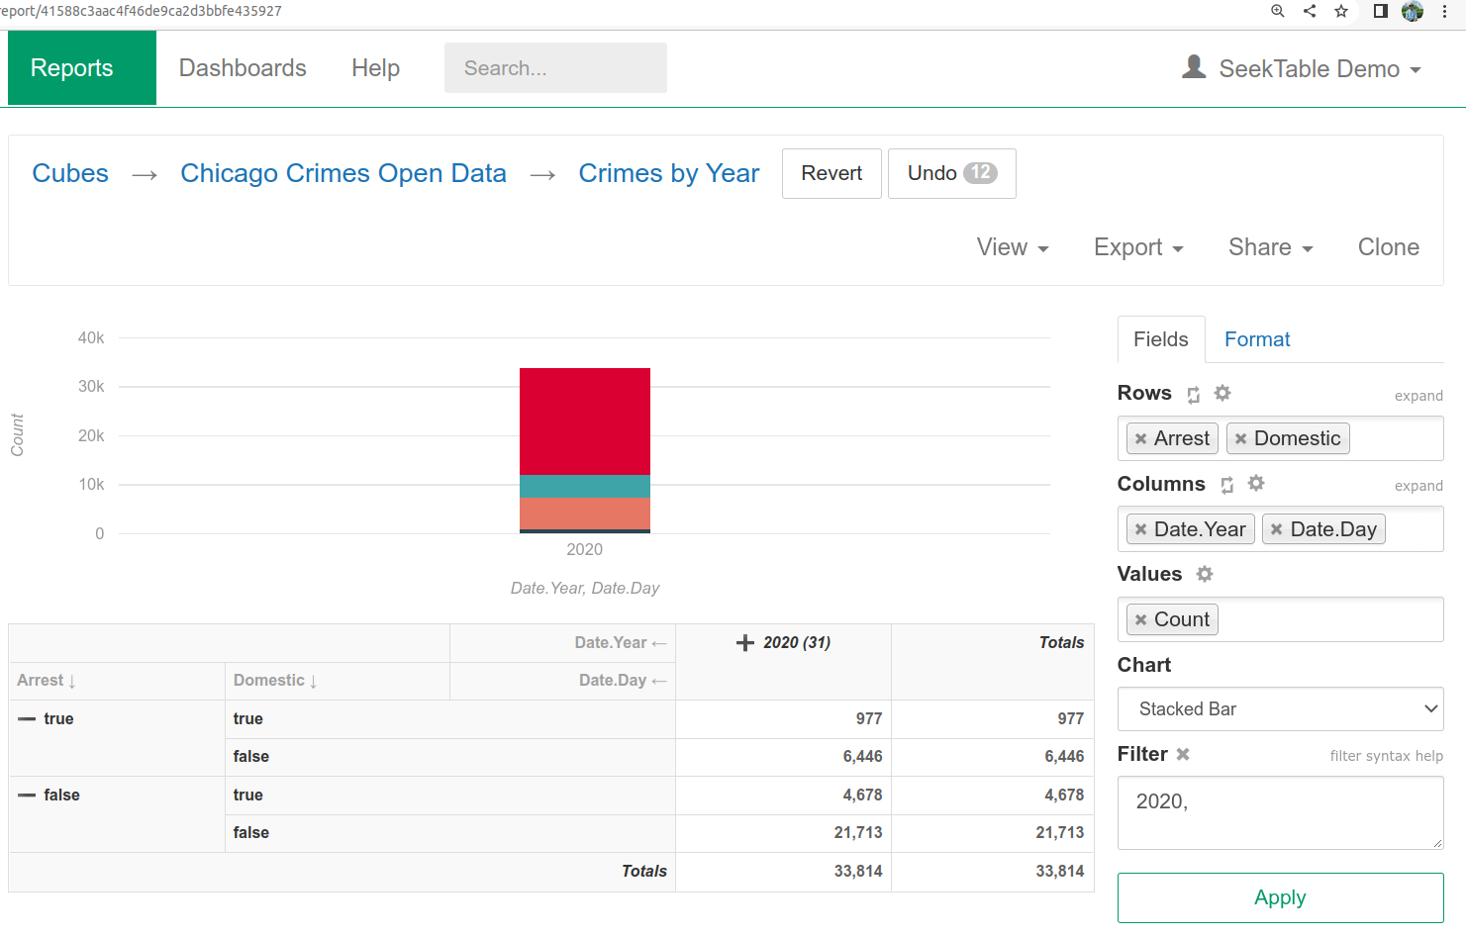

1. Total number of chai (tea) orders in the USA

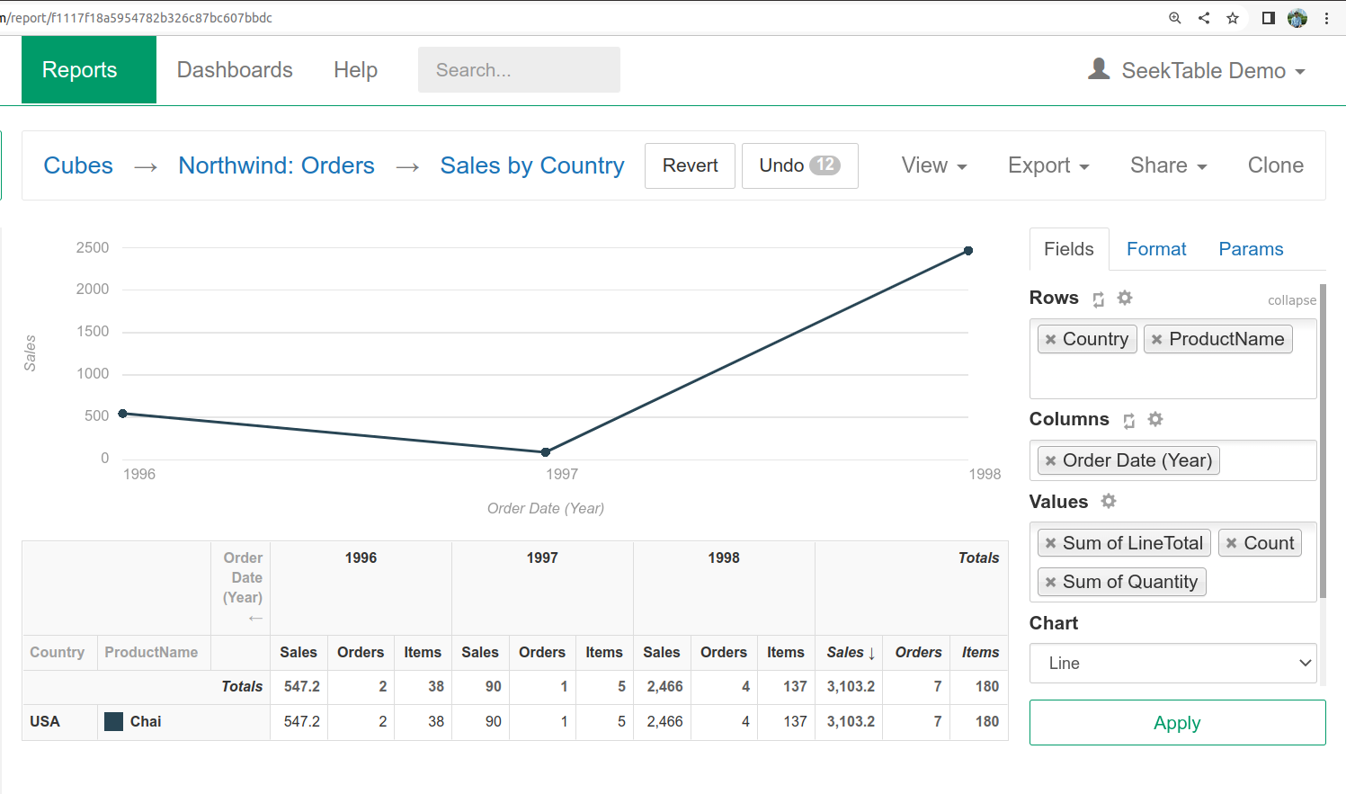

1. Shopping and Earnings in the USA

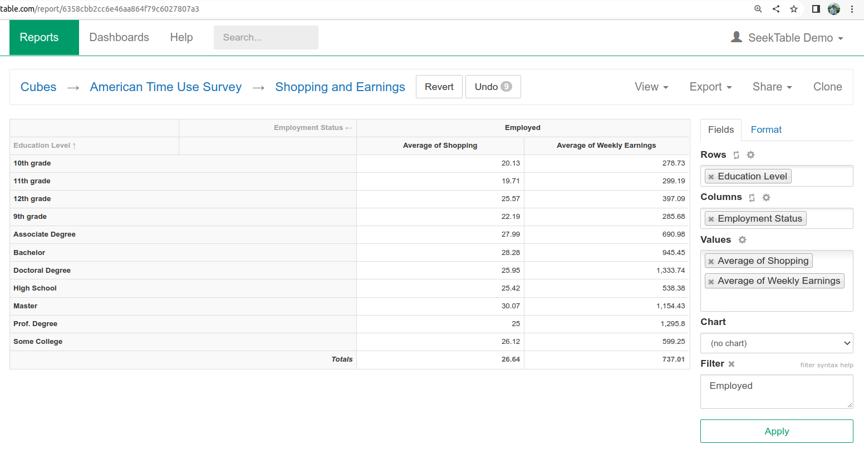

1. Total number of coffee orders in Germany

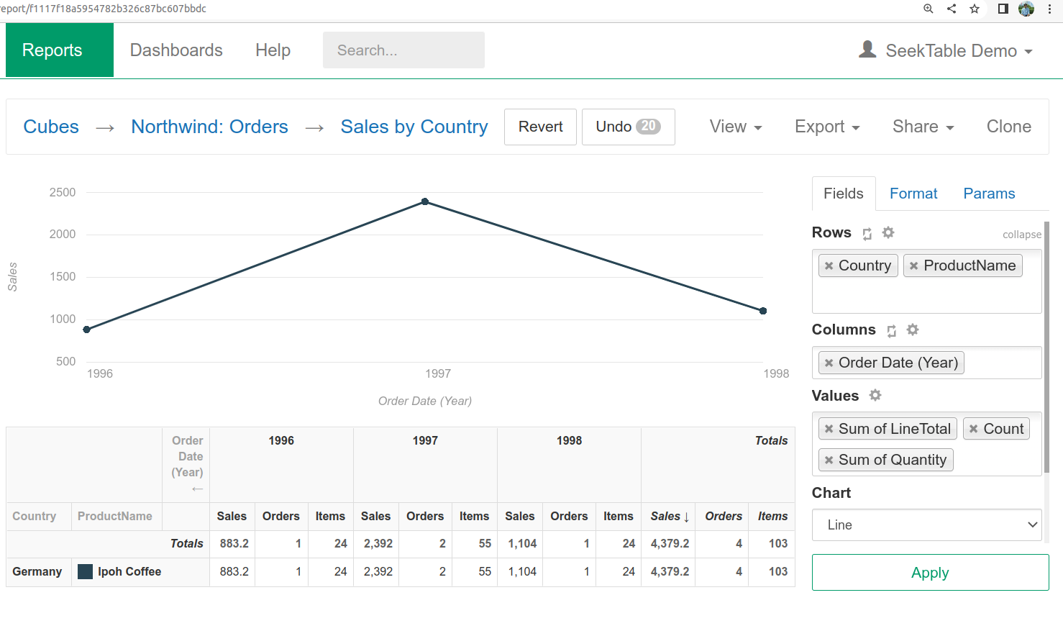

1. Superstores sales by year with discount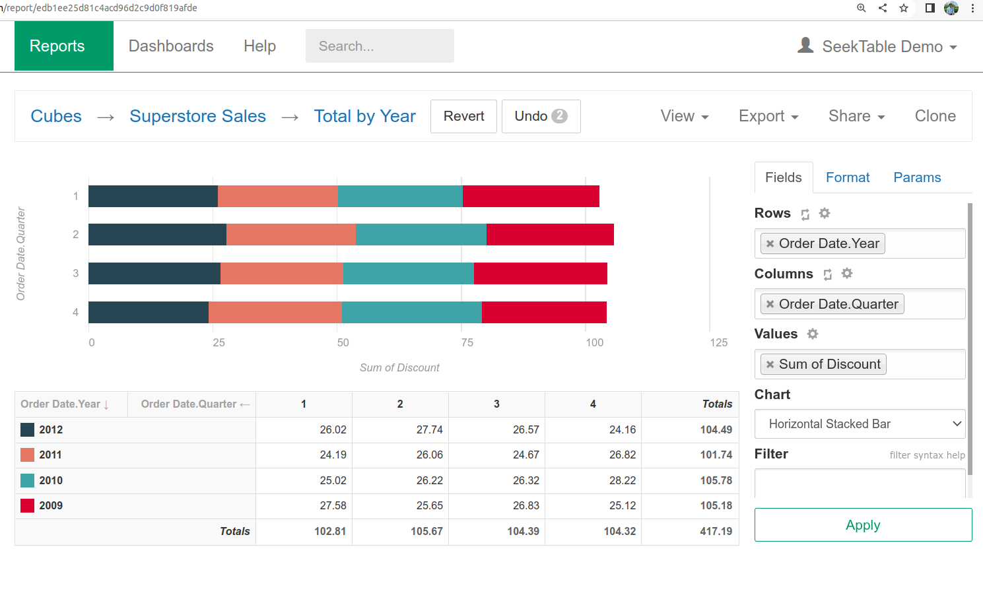

**Conclusion**

We learned to filter the necessary data from the data sets using BI tools.

**Trinity International College**

**Dillibazar Height, Kathmandu**

(Affiliated to TU)



**Lab Report**

Data Warehousing and Data Mining

Lab No: 2

**Submitted By: Submitted To:**

Abishkar Koirala Ashok Poudel

Semester: 7th  Lecturer

Roll No: 05

**Theory**

A pivot table in Excel:  
You can use a PivotTable to summarize, analyze, explore, and present summary data. PivotCharts complement PivotTables by adding visualizations to the summary data in a PivotTable, and allow you to easily see comparisons, patterns, and trends. Both PivotTables and PivotCharts enable you to make informed decisions about critical data in your enterprise. You can also connect to external data sources such as SQL Server tables, SQL Server Analysis Services cubes, Azure Marketplace, Office Data Connection (.odc) files, XML files, Access databases, and text files to create PivotTables, or use existing PivotTables to create new tables.

Steps to create pivot table in Excel:

step 1- open excel  
step 2- put some data set  
step 3- go to insert and select pivot table  
step 4-select a table or range and open in new worksheet  
step 5- select,drag and drop the desired pivot table fields

Initial data:

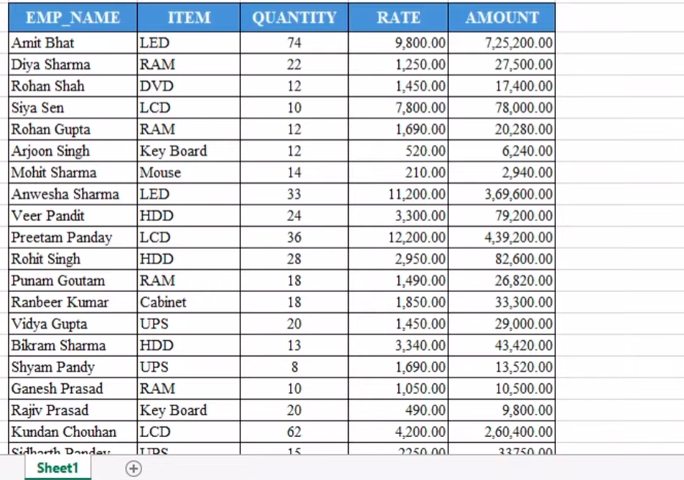

Creating PivotTable:

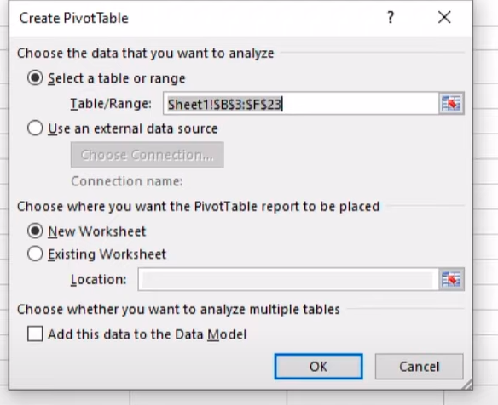

Select fields that you want :  
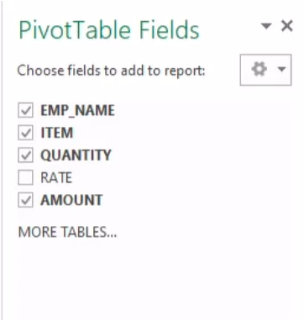

Final result:

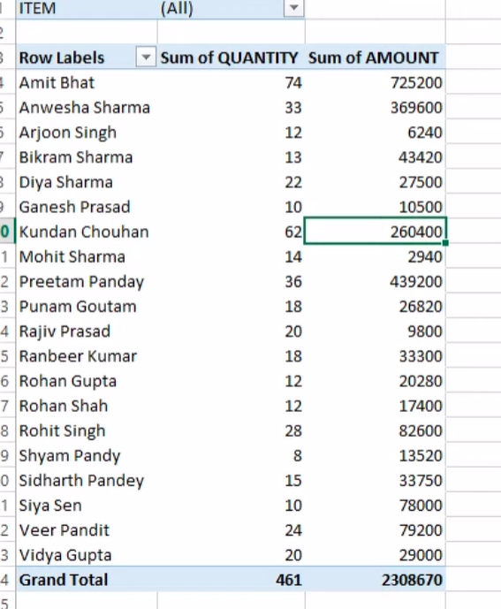

**Conclusion**

We learned to use PivotTable in Excel

**Trinity International College**

**Dillibazar Height, Kathmandu**

(Affiliated to TU)



**Lab Report**

Data Warehousing and Data Mining

Lab No: 3

**Submitted By: Submitted To:**

Abishkar Koirala Ashok Poudel

Semester: 7th  Lecturer

Roll No: 05

Theory  
  
NumPy is a library for the Python programming language, adding support for large, multi-dimensional arrays and matrices, along with a large collection of high-level mathematical functions to operate on these arrays.

NumPy Arithmetic Operations:

NumPy Add function  
This function is used to add two arrays. If we add arrays having dissimilar shapes we get “Value Error”.  
np.add(a, b)

NumPy Subtract function  
We use this function to output the difference of two arrays. If we subtract two arrays having dissimilar shapes we get “Value Error”.  
np.subtract(a, b)

NumPy Multiply function  
We use this function to output the multiplication of two arrays. We cannot work with dissimilar arrays.  
np.multiply(a, b)

NumPy Divide Function  
We use this function to output the division of two arrays. We cannot divide dissimilar arrays.  
np.divide(a,b)

NumPy Mod and Remainder function  
We use both the functions to output the remainder of the division of two arrays.  
np.remainder(a,b) , np.mod(a,b)

NumPy Power Function  
This Function treats the first array as base and raises it to the power of the elements of the second array.  
np.power(a,b)