FIELD GUIDE

Technical Work
Executive Decisions
  - A field guide to decision-ready briefs
Design, graphics, language, evidence, and workflow for strategy, business, and operations leaders
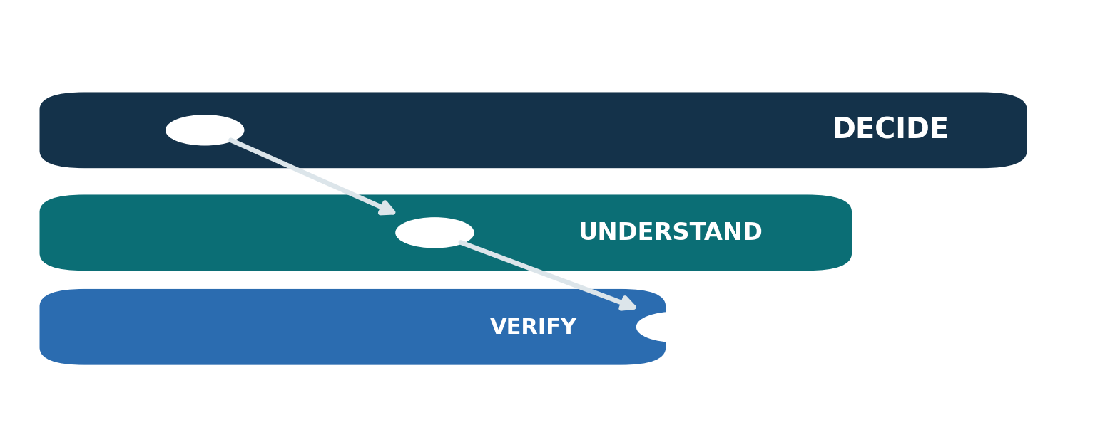
RESEARCH SYNTHESIS AND PRACTICAL HANDBOOK
September 2026

About this guide
Technical work rarely reaches executives in its native form. Architecture diagrams, model diagnostics, risk registers, process maps, simulations, and workforce analyses are built to support inquiry and verification. An executive brief has a different job: it must help a particular group make a particular decision without severing the evidence trail that makes the recommendation trustworthy.
This guide explains how to perform that translation. It is written for technical leaders, analysts, product and operations teams, strategy groups, and anyone who has to turn a dense body of work into an executive paper, pre-read, or decision deck. It treats wording and design as parts of the reasoning—not decoration added after the analysis.
The central standard is compression without distortion. A strong brief reduces what the reader must hold in mind while preserving the distinctions that could change the decision: observed versus modeled, correlation versus causation, committed versus proposed, a mapped control versus an effective control, workload versus headcount, and a role pattern versus an assessment of a person.
The methods are grounded in research on cognition, graphical perception, uncertainty communication, plain language, and board reporting; in a review of recent executive publications; and in a motivating real-world pattern: a third-generation analytical model becoming the first genuinely public-facing brief. That case is used only as a diagnostic lens. The recommendations are designed to travel.

How to use it
- Read pages 6–22 to reset a brief and rebuild its argument.
- Use pages 23–44 while shaping evidence and language.
- Use pages 45–57 while designing the reading experience.
- Use pages 58–74 for technical patterns, production, review, and rehearsal.
- Use the templates and 100-point rubric on pages 75–83 as repeatable working tools.

Executive summary
An executive brief is a decision interface, not a miniature technical report. Its visible layer should tell a skeptical reader what is happening, why it matters now, what the evidence supports, what remains uncertain, and what action is requested. Its underlying layer should let a reviewer trace those statements back to methods, data, assumptions, and ownership.
The most common failure is not lack of rigor. It is failure to control abstraction. Experts compress concrete operations into categories, models, and frameworks because those abstractions make complex work tractable. Executives who did not participate in that construction may see only conclusions floating above an unfamiliar mechanism. The cure is not indiscriminate simplification. It is to give the reader one concrete anchor, explain the mechanism, then climb to the portfolio or strategic implication.
Seven practices have disproportionate value:
1. Name the decision before drafting the document. Separate items for approval, discussion, awareness, and later work.
2. Lead with the answer and the ask. Do not make the reader excavate either from chronology or method.
3. Translate through operations. Connect technical mechanism → operational behavior → business consequence → decision.
4. Label evidence states. Distinguish observed, measured, estimated, modeled, assumed, inferred, and recommended claims.
5. Put caveats next to the claims they qualify. An appendix disclaimer cannot repair a confident headline.
6. Make graphics answer questions. Use position and length for comparison, diagrams for structure and sequence, and tables for exact lookup.
7. Design for multiple reading speeds. The ten-second scan, two-minute read, and fifteen-minute challenge should all work.
The best brief is not the brief with the fewest words. It is the one with the least avoidable work for the reader and the strongest path from claim to evidence.
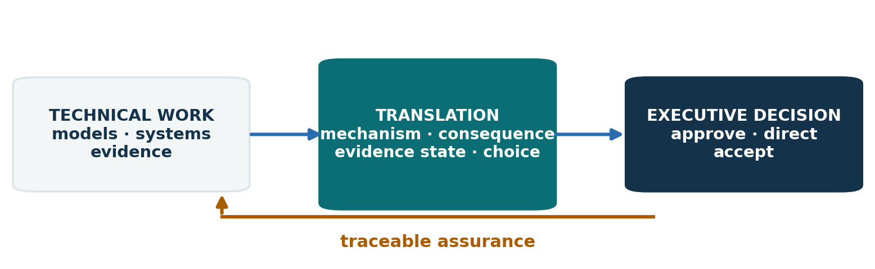
Figure 1 The executive brief converts technical evidence into a decision while preserving a route back to assurance.

Ten principles for durable executive briefs
Principle | Test
Decision before document | Can a reader state the decision in one sentence?
Concrete before abstract | Is there one real or representative operational example before the framework?
Conclusion before chronology | Does the first page say what the analysis means now?
Business consequence before mechanism | Does each technical claim connect to money, time, risk, capacity, quality, or strategic option value?
Evidence state before precision | Can the reader tell which numbers were observed, calculated, modeled, or assumed?
Comparator before magnitude | Does every important number have a baseline, target, prior period, or alternative?
Caveat at point of use | Is the important limitation visible where the claim is made?
One visual, one question | Can the chart’s purpose be said aloud in one sentence?
Layering instead of deletion | Can a skeptical reader reach the method without forcing everyone through it?
Ownership after decision | Are owner, timing, dependencies, and proof of completion explicit?

These principles work together. “Be concise” without evidence labels can create false certainty. “Show your work” without hierarchy can bury the decision. “Use plain language” without preserving technical distinctions can make the brief easier to read and less true.
The governing balance is legibility, fidelity, and consequence. Legibility lets the reader form an accurate mental model. Fidelity preserves material qualifications and provenance. Consequence links analysis to the choice in front of the organization. A brief that lacks any one of the three is incomplete.
Source notes: SEC Plain English Handbook [5]; BCG, The Art of Reporting [1]; Deloitte board communications [2]; UK Department for Education board-reporting guidance [4].

Contents
Part | Pages | Purpose
I · Reset the job | 6–13 | Reframe the brief as a decision interface and diagnose abstraction failure
II · Build the argument | 14–22 | Define the decision, motivation, page-one logic, options, and version identity
III · Build the evidence | 23–34 | Label evidence, communicate numbers and uncertainty, and report models honestly
IV · Write with precision | 35–44 | Control verbs, jargon, caveats, workforce claims, and sensitive language
V · Design the reading experience | 45–57 | Choose format, hierarchy, typography, color, charts, tables, and diagrams
VI · Apply the patterns | 58–66 | Adapt the method to architecture, AI, simulation, risk, operations, and workforce work
VII · Produce and govern | 67–74 | Author, review, release, rehearse, and use AI responsibly
VIII · Reusable tools | 75–83 | Templates, rewrite examples, checklist, and 100-point rubric
Research notes | 84–94 | Source review, bibliography, terms, and closing principle

The page references are intentionally stable in the designed edition. Each topic occupies a self-contained page or short sequence so teams can link directly to the tool they need.

SECTION

Part I

Reset the job
The first obligation is to decide what the brief is for. Until that is explicit, every fact looks potentially relevant and every abstraction competes for the opening.

A model version is not a publication edition
The motivating case began with a document labeled “version 3.” Analytically, that label was correct: two earlier generations of the model existed. Communicatively, it was misleading. This was the first version intended to cross from an internal technical workflow into an executive-facing meeting.
That mismatch changed the opening. Instead of orienting a first-time reader to the operational problem and the decision, the document began by comparing rate-setting methods across versions. The comparison answered a legitimate audit question—how did the assumptions change?—but it assumed context the public audience did not possess. The first screen became a defense of lineage rather than a guide to the decision.
Use three separate identity fields:
Axis | Example | What it controls
Analytical generation | Model M3 | Method, data, assumptions, reproducibility
Publication edition | Executive brief E1 | Audience-facing narrative and design
Release status | Wednesday meeting draft | Governance, approval, and permitted use

The cover might therefore read: Executive brief · first edition · based on model M3 · meeting draft. A small version table can preserve the analytical history. It should not demand the opening unless the decision itself concerns methodology.
This distinction prevents three errors: comparing a public brief to internal scaffolding as though the audience had seen both; treating inherited analytical language as approved executive language; and calling an externally consequential artifact “just another revision.” The transition to a new audience is a release event. It deserves its own content, design, and governance gate.
Source notes: motivating document review; Princeton Records Management version-control guidance [23]; HMRC naming and versioning guidance [35].

The brief is a decision interface
A technical report answers: What did we examine, how did we examine it, and what did we find? An executive brief answers: Given what we now know, what should this group understand, decide, fund, stop, accept, or monitor? The evidence still matters, but it is arranged around a decision rather than around the order in which the analysis was performed.
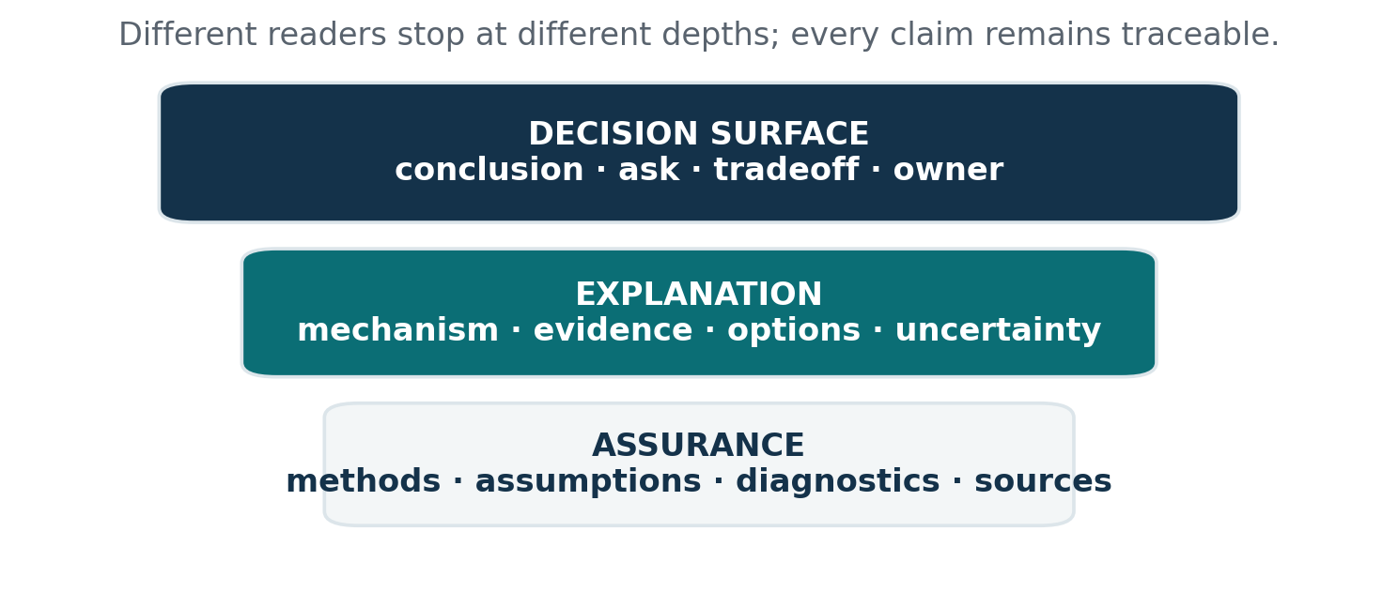
Figure 2 Three layers let different readers reach the depth they need.
The interface has three layers:
1. Decision surface. The conclusion, decision, recommendation, tradeoffs, owner, timing, and consequence of delay.
2. Explanation layer. The minimum mechanism and evidence required to understand why the recommendation follows.
3. Assurance layer. Methods, definitions, assumptions, detailed tables, diagnostics, sources, and reproducibility material.
The layers are not ranks of importance. They are routes for different reader needs. A CEO can act from the surface; a CFO can test the economics; an operations leader can interrogate feasibility; a risk leader can inspect the assumptions; a technical owner can reproduce the analysis.
This is why “cut 70 percent of the words” is usually bad editing advice. It treats all detail as excess. Better editing asks where each piece belongs, whether it changes the decision, and whether it must appear at the moment of the claim. Layering preserves rigor while reducing forced attention.
BCG’s reporting guidance describes reporting as part of a management system that should influence decisions rather than merely transmit data. Recent board guidance makes a similar distinction between material for information and material requiring approval or discussion. The practical implication is simple: begin the design with the decision and the meeting, not with the available content. [1][2][3][4]

Design for three reading speeds
Executives do not read a brief once, linearly, at a single level of attention. They scan, select, return, challenge, and sometimes hand the document to a specialist. The document must remain coherent at three speeds.
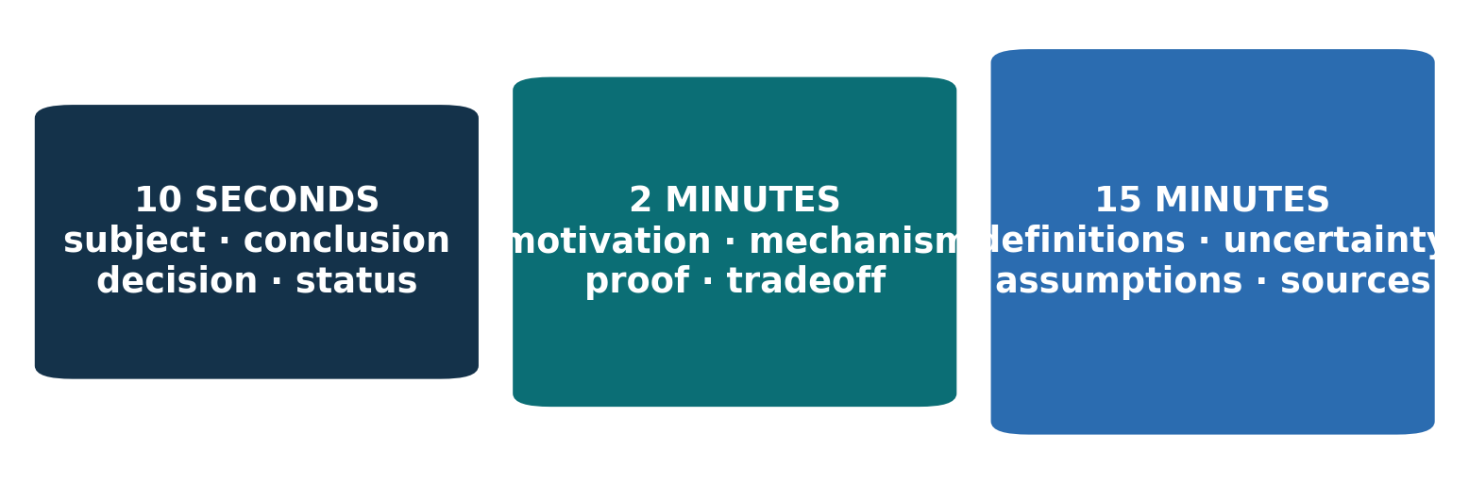
Figure 3 The same artifact must work as a scan, a selective read, and a challenge document.

Ten seconds
The reader should see the subject, the governing conclusion, the decision or requested action, the scale of consequence, and any status label that changes interpretation. A generic title such as “Risk Model Update” fails this test. A message title such as “Release controls reduce modeled exposure, but the closing decision remains unresolved” performs it.

Two minutes
The reader should understand why the issue matters now, the operating mechanism, the evidence class, the main options and tradeoffs, and the recommendation. A single concrete example often supplies the missing bridge.

Fifteen minutes
The skeptical reader should be able to inspect definitions, comparators, uncertainty, assumptions, sensitivities, implementation constraints, and sources without discovering that the headline meant something narrower than it appeared to mean.
Use the speeds as an editing test. Print only titles, leads, charts, and bold text: does the ten-second story hold? Read only the first paragraph of each section: does the two-minute logic hold? Then challenge every number and causal verb: does the fifteen-minute evidence survive?
Board-writing guidance explicitly assumes readers will skim first and read selectively. Cognitive research does not justify an arbitrary “four bullets maximum,” but it does reinforce a practical point: working attention is limited, and unfamiliar material imposes greater load than familiar schemas. Design should reduce search and reconstruction, not merely reduce word count. [3][8][9]

Why technically correct briefs still fail
Most weak executive briefs are not wrong in one dramatic way. They impose a sequence of small translation costs until the reader loses the thread or misclassifies the claim.
Failure | What the reader experiences | Repair
Chronology-first | “When will this get to the point?” | Lead with conclusion and decision; move history to context
Abstraction-first | “I cannot picture what is happening” | Start with one operational case, then name the pattern
Method-first | “Why do I need to know this?” | State consequence before method; layer assurance
Number without comparator | “Is that large, good, or actionable?” | Add baseline, target, prior period, or alternative
Model output as forecast | “Is this expected to happen?” | Label scenario, assumptions, range, and intended use
Control mapped as risk closed | “So the issue is gone?” | Separate coverage, effectiveness, adoption, and residual risk
Role analysis as people judgment | “Are individuals being evaluated?” | State unit of analysis and limits explicitly
Dense but decorative graphics | “Where do I look?” | Give each visual one question and one reading path
Caveat in appendix | “The headline overstates the evidence” | Attach qualification to the claim
Version narrative on page one | “Why am I reading an internal argument?” | Separate model lineage from publication identity

These failures share a root: the document reflects the structure of the work rather than the structure of the reader’s decision. The author’s sequence—discover, classify, model, validate, revise—may be essential to provenance. It is rarely the best narrative sequence.

Expertise creates an abstraction gap
Expertise is compression. An experienced analyst sees “control coverage,” “state invalidation,” or “model calibration” as compact handles for mechanisms, exceptions, and prior evidence. A new executive reader sees labels whose contents are not yet available.
Hinds, Patterson, and Pfeffer found that experts giving instructions tended to use more abstract and advanced statements and fewer concrete ones. Novices performed the immediate task better with beginner-authored instructions, while expert abstraction could help transfer to a different task. The lesson is not that abstraction is bad. It is that abstraction should follow orientation. [7]
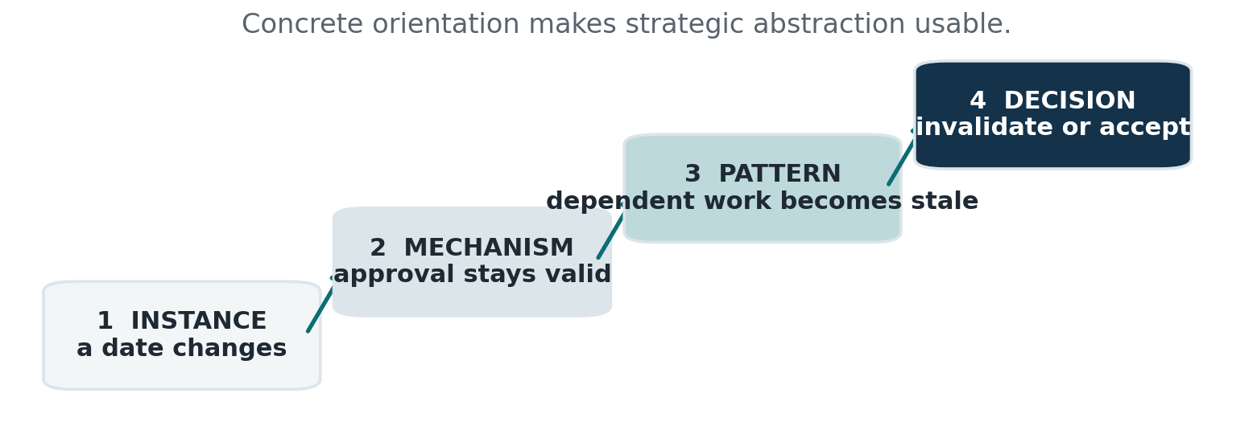
Figure 4 Climb from an instance to a mechanism, pattern, and decision.
Use a four-rung ladder:
1. Instance. “A closing date changes after the report is approved.”
2. Mechanism. “The approval remains attached to the record unless the change invalidates it.”
3. Pattern. “Date-dependent approvals can become stale without visible failure.”
4. Decision. “Require automatic invalidation before release, or accept the residual risk.”
This sequence respects both audiences. The instance makes the system visible. The mechanism protects rigor. The pattern permits strategic generalization. The decision explains why the reader is involved.
Experts often try to solve the gap by adding definitions. Definitions help, but a glossary does not create a mental model. If the reader cannot picture an event, defining the category name more precisely may only refine an abstraction that still floats. Put a concrete case in the body; use the glossary for repeat reference.

The concrete-first translation loop
For complex technical work, the most reliable explanatory unit is a short loop:
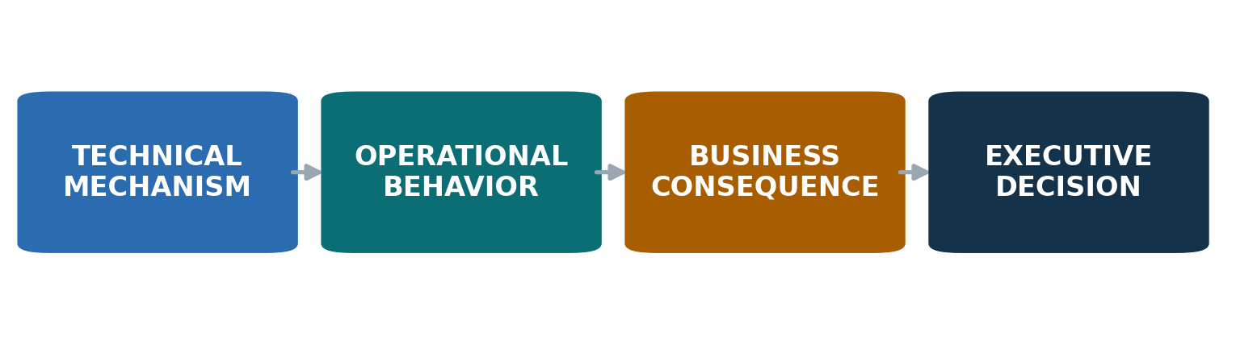
Figure 5 A complete translation chain connects mechanism to action.
Actual process. What is a person or system trying to do?
Potential failure. What specifically could happen—not a category, but an event?
Detection or control. What would reveal, prevent, or contain it, and at what point?
Business consequence. What changes in money, time, service, risk, capacity, compliance, or strategic option value?
Executive choice. What must this audience decide or authorize?
Example: “A team approves a work product. A later scope change does not invalidate that approval. The system can therefore release a stale decision without an obvious error. A state-change rule would force reapproval; without it, the organization relies on memory and review discipline. Decide whether the release gate must block automatically or whether the residual exposure is acceptable.”
The loop is short enough to fit on page one and rigorous enough to survive challenge. It also reveals missing reasoning. If the author cannot connect a control to an event or an event to a consequence, the problem is not prose—it is analysis.
Use one representative case before presenting a register of hundreds. Then show that the case is one member of a broader pattern. The case is not proof of prevalence; the portfolio evidence supplies that. Its job is to make the mechanism intelligible.
Diagram research helps explain why: effective diagrams can colocate related information, reduce search, and make relevant relationships explicit. The benefit depends on the task; a diagram is not automatically superior to prose. [11]

Give abstraction a budget
An abstraction is any label that asks the reader to retrieve a definition or infer a mechanism: “risk class,” “process dependency,” “priority index,” “maturity,” “capability,” “control level,” “agentic workflow.” Each may be valid. The problem is how many are introduced before the reader has an anchor.
Use an abstraction budget on the first two pages:
- Introduce no more than three essential named constructs.
- For each construct, give a plain-language meaning and one concrete instance.
- Delay taxonomies that do not change the immediate decision.
- Reuse the same term; do not alternate synonyms to sound varied.
- Remove internal field names, model variables, code names, and scoring labels unless the audience must act on them.
This is not a cognitive “law of three.” It is an editorial constraint that makes overload visible. Cowan’s review suggests a limited focus of attention averaging around four chunks under controlled conditions, but chunk size depends on knowledge and context. The appropriate conclusion is not “four boxes on every slide.” It is to reduce unfamiliar chunks and build stable schemas. [9]

The substitution test
Underline every abstract noun in a draft. Ask: could the sentence name an actor, action, object, or consequence instead?
Before: “Operationalization of the control architecture enables improved risk disposition.”
After: “The release gate stops the file until the required review is recorded.”
The second sentence is not simplistic. It carries more operational information with fewer interpretive steps.

SECTION

Part II

Build the argument
The argument should make the decision feel inevitable only to the extent that the evidence earns it. It should reveal tradeoffs, not perform certainty.

Write the decision question first
Before drafting, complete one sentence: At this meeting, we need [decision owner] to decide whether to [action] by [date], because [consequence]. If the sentence cannot be completed, the brief is not yet scoped.
Then classify every intended outcome:
Type | Reader action | Wording
Decide | Choose or approve | “Approve option B and its funding envelope”
Direct | Set a boundary or priority | “Direct the team to make release gating mandatory”
Discuss | Surface judgment before a later decision | “Discuss acceptable residual exposure”
Note | Acquire shared awareness | “Note the measured adoption gap”
Endorse | Signal support; formal authority lies elsewhere | “Endorse the implementation sequence”

Do not label an approval item “for discussion” to reduce friction. Do not ask for approval of a vague direction when the real choice is a resource commitment. Decision verbs allocate authority; use them precisely.
A sound question defines the decision object, authority, time horizon, and boundary. “Agree on what we are building” is directionally useful but incomplete. “Approve mandatory release and closing gates for the first launch, with the sixteen uncovered scenarios assigned to named owners before go-live” is testable.
Board guidance consistently asks authors to start with what the board must decide and why that body has authority. It also distinguishes strategic oversight from operational detail. [3][4]

Page one is a contract with the reader
Page one should establish what the document will and will not make the reader do. A durable sequence is:
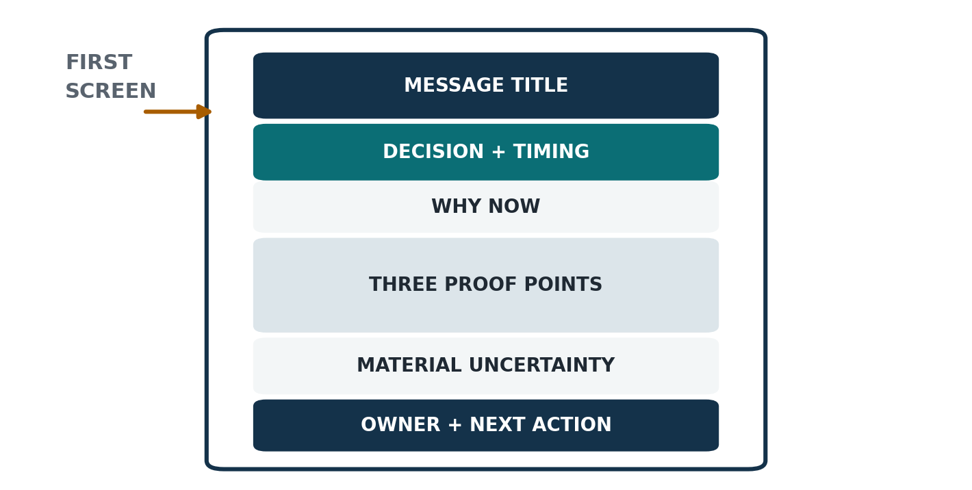
Figure 6 Page one moves from governing conclusion to accountable next action.
1. Message title. A sentence that states the governing conclusion.
2. Decision and timing. The exact action required, by whom, and when.
3. Why now. The event, deadline, threshold, or change that makes delay consequential.
4. Three proof points. The minimum evidence that supports the conclusion.
5. Material uncertainty. The limitation that could alter magnitude, ranking, or implementation.
6. Next action. Owner, milestone, and proof of completion.
Do not spend the first page proving how much work occurred. Counts of tables reviewed, interviews conducted, or scenarios simulated matter only when they establish coverage or credibility. “We analyzed 205 risks” is evidence of scope, not yet a conclusion. “Sixteen material scenarios have no software control and require an owner or explicit acceptance” is decision-relevant.
Likewise, “what changed since the last model” belongs on page one only when the reader saw the earlier model, the change affects the decision, or trust requires immediate disclosure. Otherwise, a version note or appendix preserves lineage without making internal history the executive’s entrance fee.
Deloitte’s board communication guidance recommends beginning with the conclusion, signaling whether material is for information or decision, and making pre-reads comprehensive but not exhaustive. [2]

Use message headlines to carry the logic
A topic heading names a subject: Control effectiveness. A message headline states what the reader should understand: The recommendation depends more on control effectiveness than on event frequency. The latter turns headings into a visible argument.
Sentence headlines improve three things:
- A scanning reader can reconstruct the logic without reading every paragraph.
- The author must choose the claim each page is making.
- Reviewers can challenge the assertion directly and ask whether the evidence below supports it.
Alley and colleagues found higher retention in a classroom comparison using assertion-evidence slides than with traditional topic-title slides. The treatment also changed the visual evidence and body design, so the study should not be reduced to “sentence titles cause a fixed improvement.” It does support a broader practice: make the assertion explicit and place evidence near it. [14]

Headline tests
- Does it contain a verb?
- Does it state one claim rather than a topic and a subtitle’s worth of qualifications?
- Is the evidence state honest? “The model indicates” is different from “Operations data show.”
- Does it avoid unsupported superlatives such as “transformational” or “best-in-class”?
- Would a skeptical executive know what to challenge?
Weak: “Simulation Results.”
Better: “Across tested scenarios, the release gate changes the direction of exposure; the size depends on unmeasured control effectiveness.”
The better version preserves both the strategic conclusion and the central limitation.

Give motivation its own section when it changes comprehension
Motivation is not throat-clearing. At its best, it answers three questions that a conclusion alone cannot: Why was this work necessary? Why is the current framing the right one? Why does action matter now? In complex or unfamiliar work, those answers can be the bridge that makes the rest of the brief legible.
A dedicated motivation section belongs in the main narrative when one or more conditions hold:
- The audience does not share the operational context that made the problem visible.
- The work challenges an established mental model, role boundary, or definition of success.
- The analysis exists because ordinary metrics hide the failure mode.
- The timing is driven by an irreversible event, launch, closing, regulatory window, or capacity threshold.
- The method is unusual enough that readers need to know why a simpler approach would corrupt the answer.
Keep motivation distinct from history. A useful motivation section has four moves:
1. Present state: what people currently see or believe.
2. Hidden tension: what that view misses.
3. Consequence: what becomes possible or dangerous because of the gap.
4. Purpose: what the analysis was designed to clarify.
Example: The organization can see completed work, but it cannot reliably see whether approvals became stale after a material change. That gap matters because a record can look complete while the underlying decision is no longer valid. This analysis maps the points where state can change without invalidating dependent work and tests which controls would surface the problem before release.
The motivation earns attention by sharpening the decision. If it mainly describes how long the team worked, how many artifacts it created, or which versions preceded the current one, move those facts to provenance. A good test: remove the section. If the reader can still understand why the decision exists and why now, motivation may be redundant. If the recommendation becomes arbitrary, the section is doing real work.

Sequence the story around consequence
Two familiar structures are useful but incomplete.
Pyramid: answer first, then supporting reasons, then evidence. This is excellent for scanability and logical grouping.
Situation–complication–question–answer: establish context, show what changed, pose the problem, then answer it. This is excellent when the audience needs a reason to care.
For technical executive briefs, combine them:
1. Answer and ask. What should happen?
2. Consequence. Why does it matter now?
3. Concrete mechanism. What actually happens in the operation or system?
4. Evidence. What was observed, measured, or modeled?
5. Options and tradeoffs. What else could be done?
6. Uncertainty and reversibility. What could change the choice?
7. Execution. Who does what next?
Do not manufacture drama. The “complication” may simply be a decision deadline, a missing control, a scale threshold, or a mismatch between planned capacity and required service. A narrative is a causal and decision sequence, not a theatrical arc.
Recent consulting publications frequently use WHY/WHAT/HOW structures, sentence-style titles, and summary pages. These are useful patterns, not proof of analytical quality. The best examples make the question visible and sources traceable; weaker examples use polished certainty while relegating qualifications to small notes. [26][27][28][29][30]

Show options as real choices
An executive does not need a false menu in which only one option is viable. Nor should a recommendation hide the tradeoffs that make alternatives attractive.
Use a decision table with consistent criteria:
Option | What changes | Value | Exposure | Cost and capacity | Reversibility | Recommendation
A · Defer | Continue current process | Preserves near-term capacity | Known issue remains | Lowest immediate cost | High | Not recommended
B · Stage | Implement highest-leverage control first | Reduces material exposure sooner | Residual gap remains | Moderate | High | Recommended
C · Full launch | Implement entire target state | Maximum intended coverage | Delivery risk increases | Highest | Medium | Consider if dependency is resolved

Criteria should reflect the actual decision: economics, risk, time to value, customer impact, legal constraints, technical feasibility, organizational capacity, and reversibility. Do not score every criterion simply because it exists. Weighting can clarify values, but a weighted score may conceal contested judgments; show the weights and test whether a small change flips the recommendation.
Include the cost of delay when it is material. Also include the cost of acting: migration disruption, review burden, false positives, operating friction, or capacity diverted from other commitments.
Board guidance commonly asks for two or three alternatives and brief reasons for not selecting them. The purpose is not ceremony; it demonstrates that the recommendation survived contact with plausible choices. [3]

Separate fact, interpretation, and recommendation
An executive sentence often compresses several epistemic moves. Make them visible.
Fact: “Twenty-nine event frequencies were measured in historical records.”
Method: “The remaining frequencies were derived by grouping risks with measured anchors.”
Result: “Under the stated control assumptions, modeled exposure declines in the release scenario.”
Interpretation: “The direction suggests release gating is a high-leverage control.”
Recommendation: “Implement the gate before launch and measure its actual effectiveness.”
When these are collapsed into “The new system eliminates most risk,” the sentence overstates causality, control effectiveness, and implementation status at once.
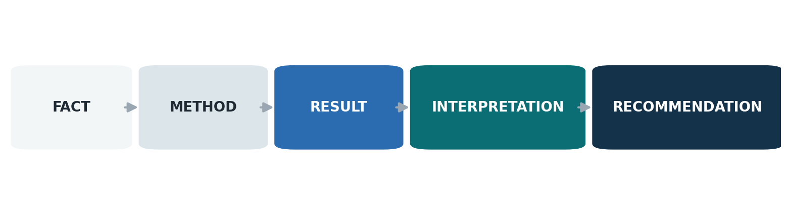
Figure 7 A recommendation is the end of a traceable claim chain.
Use a claim chain during review. For each headline, ask:
- What kind of statement is this?
- What evidence supports it?
- What inference connects evidence to meaning?
- What value judgment connects meaning to recommendation?
- What could falsify or reverse it?
Executives do not require a philosophy-of-science lecture. They do require enough separation to know whether they are accepting evidence, an interpretation, or a strategic preference.

Govern document identity and change
A reliable naming pattern separates content lineage from audience release:
[Subject] · [artifact type] · [publication edition] · based on [analysis generation] · [status] · [date]
Example: Workflow exposure · executive decision brief · E1.0 · based on model M3.2 · meeting draft · 2026-09-23.
Maintain a compact change table:
Field | Entry
Audience | Executive team
Decision date | 23 September 2026
Publication owner | Strategy lead
Analytical owner | Model owner
Evidence cutoff | 20 September 2026
Current status | Approved for meeting circulation
Material change | First public edition; model lineage retained in appendix

Avoid filenames such as `final_v3_revised_FINAL2`. A common vocabulary, sortable date, explicit owner, and revision status reduce ambiguity. Important documents should also carry a version table inside the file so identity survives download or renaming. [23][35]
Treat audience change as a major release. New readers, new claims, new permissions, or new business consequences require a content review even when the underlying model is unchanged. Conversely, a model refresh does not always require a new publication edition if the decision and conclusions are unaffected; it may require only an evidence note.

SECTION

Part III

Build the evidence
Evidence becomes executive-grade when its state, boundary, comparator, uncertainty, and intended use are visible without turning the brief into a methods paper.

Use an evidence-state vocabulary
Create a small controlled vocabulary and apply it consistently. The following is a practical synthesis, not a universal standard.
State | Meaning | Safe verbs
Observed | Directly seen in records, interviews, logs, or events | occurred, recorded, reported
Measured | Quantified from defined data and method | was, averaged, increased
Estimated | Calculated from incomplete information using a stated method | is estimated, likely falls
Modeled | Produced by a model under specified structure and inputs | model indicates, scenario yields
Assumed | Set for analysis without direct measurement | assumes, holds constant
Inferred | Reasoned from evidence but not directly observed | suggests, is consistent with
Recommended | A judgment about action | recommend, should, propose

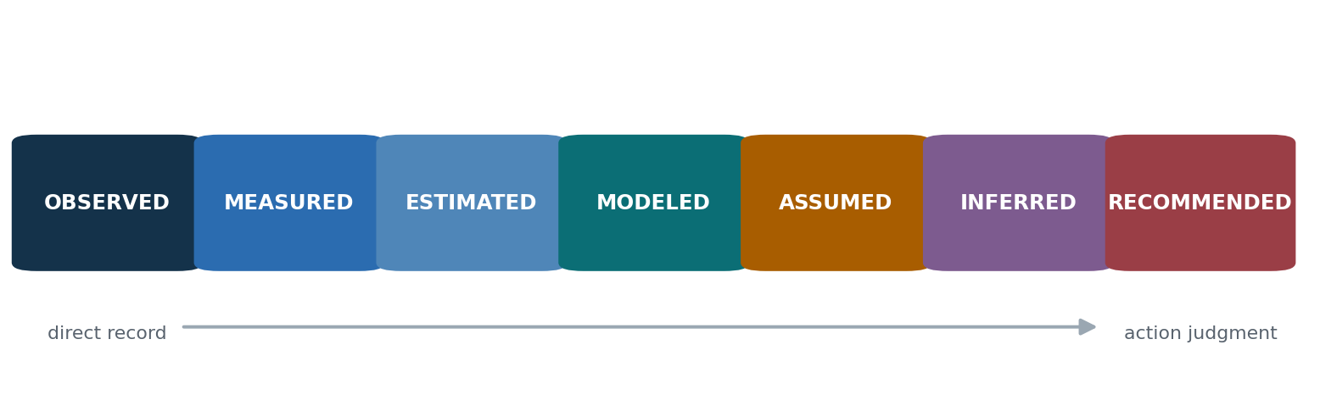
Figure 8 Evidence labels prevent unlike numbers from appearing equally factual.
These labels prevent a common slide-level distortion: formatting makes all numbers look equally factual. A historical rate, an analyst-set parameter, a simulated outcome, and a management target may all appear as bold percentages. Without labels, the reader supplies an evidentiary status—usually stronger than the author intended.
Put the label where the number appears: 14% measured, 6–18% derived estimate, 10% modeled outcome, 84% assumed control effectiveness. A global footnote stating “some figures are modeled” is inadequate.
The label should not become a decorative badge. It must correspond to a defined method in the assurance layer and remain stable across the document.

Give every important number a frame
A number is decision-ready only when the reader can answer six questions:
1. What is counted? Event, case, person, transaction, day, dollar, or model run.
2. Out of what? The denominator or eligible population.
3. Over what period? Snapshot, month, rolling year, or full history.
4. Compared with what? Baseline, target, prior period, peer, or alternative.
5. How was it produced? Measured, estimated, modeled, or assumed.
6. How uncertain is it? Sampling, parameter, measurement, or structural uncertainty.
Unframed: “Risk falls from 84% to 10%.”
Framed: “In the 500-deal scenario, the share of engaged synthetic deals released with at least one unresolved modeled problem falls from 84% in the baseline configuration to 10% in the on-release configuration; the result is directional and depends on assumed control effectiveness.”
The framed sentence is longer because it tells the truth. The executive surface can shorten it—Modeled unresolved-release exposure falls materially in the tested scenario—provided the chart subtitle and note preserve population, comparator, and assumption.
Use fixed denominators when comparing groups. If one row is “of all cases” and another is “of completed cases,” make that distinction visually unavoidable. Use absolute numbers alongside percentages when scale matters. A 50% improvement from two cases to one is not the same management problem as from 20,000 to 10,000.
Spiegelhalter emphasizes absolute risk, explicit reference classes, fixed denominators, comparators, and layered communication from gist to numbers to evidence. [15]

Baselines determine meaning
The comparator is part of the claim. “Faster,” “safer,” “higher,” and “reduced” are incomplete without a baseline. Choose the baseline that corresponds to the decision—not merely the one that produces the strongest contrast.
Decision | Useful baseline | Common trap
Replace a process | Current-state performance | Comparing only with an idealized no-control case
Fund a capability | Best feasible alternative | Comparing with doing nothing when a cheaper alternative exists
Launch a model | Human or existing-system benchmark | Comparing with a weak historical average
Add capacity | Demand and service target | Treating current headcount as the workload baseline
Accept risk | Risk tolerance and residual exposure | Showing gross risk only

State whether the baseline is observed or constructed. A simulation baseline is still modeled even if it represents the current configuration. “Today” can mislead when today’s real incident rate is not measured.
When rates are small, show natural frequencies: “3 in 1,000” alongside “0.3%.” When time horizons differ, normalize or display both. When groups have different exposure, compare rates with the relevant denominator rather than raw counts.
The baseline should remain consistent across headline, chart, and recommendation. Silent shifts—current state in one chart, prior model in another, target in a third—force the reader to reconstruct a moving reference frame.

Control causal language
Executives act differently on “causes,” “is associated with,” “contributes to,” and “is consistent with.” Treat causal verbs as evidence-bearing choices.
Evidence situation | Prefer | Avoid
Randomized or strong quasi-experimental design | caused, increased, reduced | —
Observational relationship with adjustment | was associated with, predicts within this sample | caused
Mechanistic evidence plus observational pattern | likely contributes to, is a plausible driver | proves
Scenario model | the model produces, under these assumptions | will deliver, prevents
Expert judgment | we assess, we recommend | the data show

Statistical significance does not establish practical importance, causation, or truth. The American Statistical Association’s statement warns against treating a threshold as a substitute for full scientific reasoning and disclosure. [19]
For operational work, a causal chain can be more useful than a single coefficient. Show the mechanism and mark which links are observed, assumed, or inferred. If a control is modeled as reducing delay, do not say the control “proved” it will reduce incidents. Say the scenario shows what would follow if the control operates at the assumed rate; then specify how post-launch measurement will test that assumption.
Qualification need not make language weak. “The experiment reduced median handling time by 18%” is stronger and more precise than “results seem promising.” Precision comes from matching the verb to the design.

Name the uncertainty that matters
“Uncertain” is not one condition. At least four forms matter in executive briefs:
Type | Source | Typical treatment
Variability | Random variation in events or populations | Distribution, percentile, range
Parameter uncertainty | Inputs are estimated imprecisely | Confidence or credible interval; sensitivity
Measurement uncertainty | Data or definitions imperfectly capture the construct | Quality note, validation, alternate measure
Structural uncertainty | Model omits or simplifies mechanisms | Competing models, scenarios, limitation statement

Spiegelhalter distinguishes stochastic variability from epistemic uncertainty and deeper uncertainty about problem structure. The UK intelligence framework separately communicates probability and analytical confidence. These distinctions are powerful because a narrow numerical interval can coexist with low confidence in the model form. [15][16]
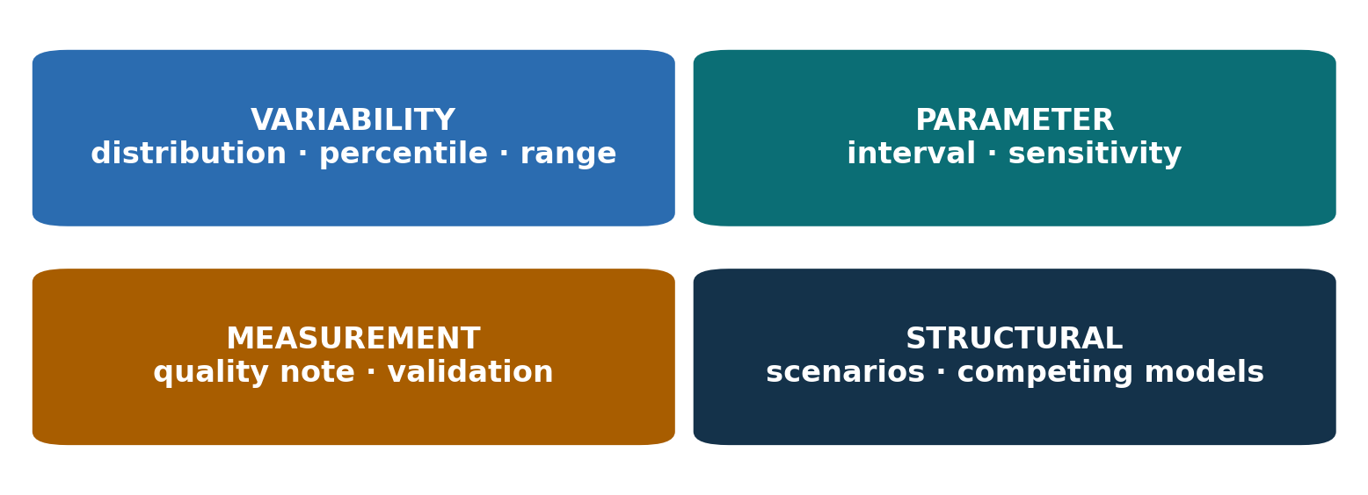
Figure 9 Different uncertainties require different treatments.
Do not place every uncertainty in the headline. Surface the one that could change the decision. If all plausible values lead to the same action, say the direction is robust and move detailed ranges to assurance. If plausible values reverse the recommendation, uncertainty is part of the decision and belongs on the executive surface.
Avoid false precision. “22%” derived from a sparse class may imply more resolution than the evidence supports; “approximately 20%, with a plausible range of 8–59%” communicates the center and width. Do not use decimal places that the method cannot defend.

Separate probability from confidence
Probability answers How likely is the proposition or event? Confidence answers How strong is the basis for that probability judgment? They are different axes.
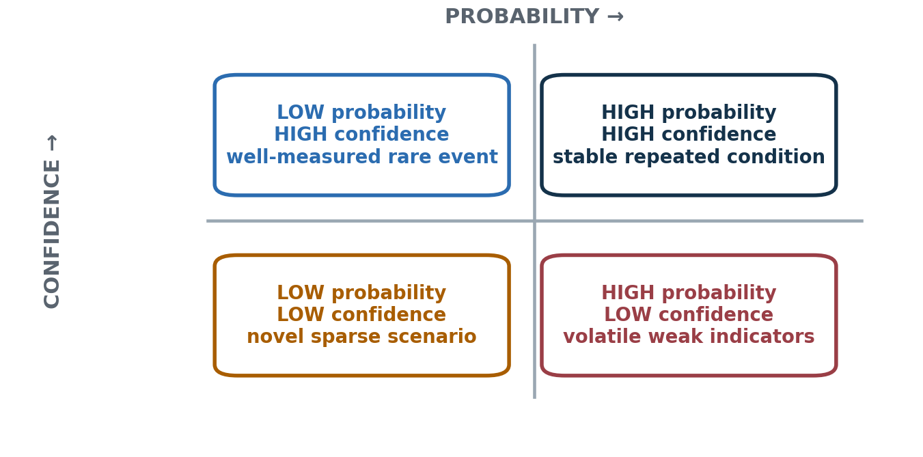
Figure 10 Probability and confidence are independent judgments.
Examples:
- High probability, low confidence: a volatile market event judged likely from sparse and conflicting indicators.
- Low probability, high confidence: a well-measured, rare mechanical failure.
- High probability, high confidence: a repeated operational condition supported by stable records.
- Low probability, low confidence: a novel scenario with little data and uncertain mechanism.
Use probability words only if the organization defines them. The UK probability yardstick maps phrases to approximate numeric ranges and pairs them with separate confidence statements. A company does not need to copy those exact ranges, but it should avoid allowing “likely” to mean 55% to one team and 90% to another. [16]
A useful confidence sentence explains the basis and the missing information: Moderate confidence: the direction is supported by process evidence and repeated scenarios, but control effectiveness has not been measured in production. Confidence would increase after three months of instrumentation and exception review.
This is more informative than a color-coded “amber” badge because it tells the reader why confidence is limited and what would change it.

Report models as conditional arguments
A model is an organized “if–then” statement. It is most useful when the brief shows the conditions under which its result should influence action.
For any simulation, forecast, optimization, or AI model, state:
- Purpose. Decision support, exploration, prioritization, prediction, or control.
- Unit and population. What entities, events, and period are represented.
- Inputs. Which are measured, estimated, derived, or assumed.
- Mechanism. The few rules that drive the result.
- Outputs. What the model produces and what it does not.
- Validation. Back-tests, holdouts, benchmarks, expert review, or none.
- Uncertainty. Sampling, parameter, and structural limits.
- Use boundary. Decisions the model can and cannot support.
- Monitoring. What will be measured after deployment.
Model cards proposed structured documentation around intended use, evaluation, and limitations; NIST’s AI Risk Management Framework likewise emphasizes governance, mapping, measurement, and management across the lifecycle. These materials are more detailed than an executive surface, but they provide a strong assurance pattern. [24][25]
Unsafe headline: “The model predicts a 90% reduction.”
Safer and more useful: “Under the tested control assumptions, the model indicates a large reduction; the magnitude will remain unverified until production effectiveness is measured.”

Use sensitivity to expose decision dependence
Sensitivity analysis is not a ritual appendix. Its executive purpose is to answer: Which uncertain inputs could change the decision?
Start with decision thresholds. If the recommendation remains preferred across the plausible range of every major assumption, report robustness. If one assumption flips the choice, elevate it as a dependency, measurement priority, or staged-release condition.
Finding | Executive interpretation | Action
Direction holds; magnitude varies | Choice is robust, benefits uncertain | Proceed with measurement plan
Ranking changes within range | Priorities are unstable | Avoid false ordering; group or stage
One input dominates | Decision depends on a specific unknown | Instrument or pilot that variable
Many interactions dominate | Model is structurally fragile | Use scenarios; reduce claim strength
Plausible range crosses tolerance | Risk acceptance is required | Escalate explicitly

Avoid the “tornado chart of everything.” Rank parameters by effect on the decision outcome and explain the top few. If many risks share the same derived rate, the model may not support a fine-grained rank. Present a tier or set rather than inventing order.
Hullman argues that uncertainty visualization should be evaluated against the task and decision, not by visual convention alone. A full distribution may add burden when a threshold comparison answers the actual question; conversely, a single point estimate can conceal a decision reversal. [18]

Coverage is not effectiveness
Risk and control briefs frequently collapse four different ideas:
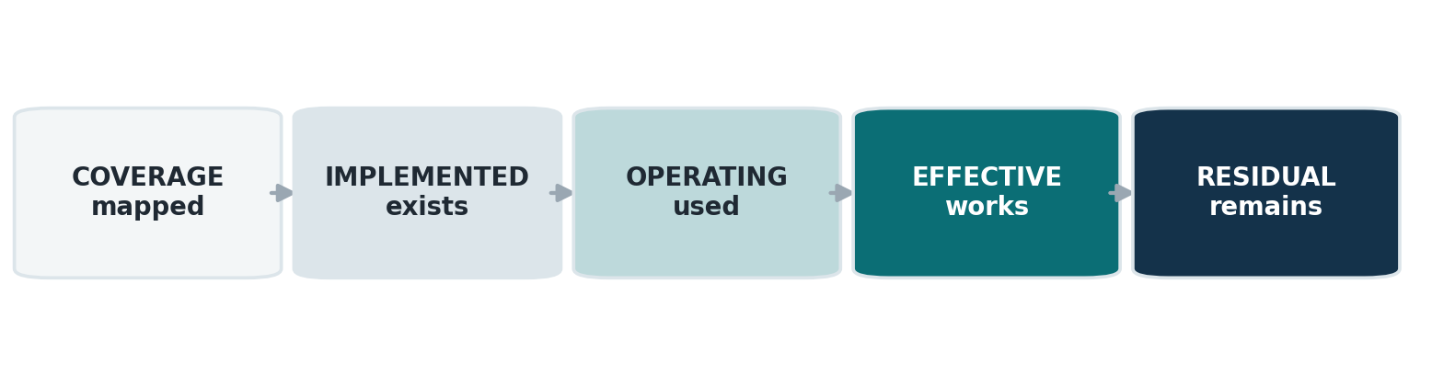
Figure 11 A mapped control becomes evidence of reduced risk only after it operates and proves effective.
1. Coverage. A control is mapped to a risk or failure mode.
2. Implementation. The control exists in the released process or system.
3. Operation. People and systems actually use it as intended.
4. Effectiveness. It prevents, detects, or contains the event at a measured rate.
5. Residual risk. Exposure that remains after control operation.
“189 of 205 risks have a mapped control” is a coverage claim. It does not mean 189 risks are closed. “Implemented” is not the same as adopted, and adopted is not the same as effective. A gate may exist but be bypassed; a review may occur without evidence; a notification may arrive too late; a human control may fail under peak load.
Use a control statement with all relevant qualifiers: A release gate is implemented and mapped to 22 failure modes. Its production effectiveness is not yet measured; scenario results assume 84% operation. Instrument bypasses, holds, overrides, and caught defects after launch.
This wording does not undermine the control. It turns uncertainty into a measurement plan.

Build a one-page model surface
When a model materially shapes a decision, include a compact model surface before the detailed method.
Element | One-line answer
Decision supported | Which control and staffing sequence to approve
What is represented | Synthetic cases moving through a defined workflow
What is observed | Selected historical event rates and conversion patterns
What is derived | Rates for unmeasured failure modes from measured anchors
What is assumed | Control effectiveness, delays, and severity weights
What is produced | Comparative scenario outcomes, not forecasts
What is robust | Direction of improvement across tested ranges
What is fragile | Exact magnitude and fine-grained ranking
What happens next | Instrument production controls and recalibrate

This surface lets an executive challenge the right thing. Without it, the reader may debate simulation counts when the dominant unknown is an assumed control effect, or treat a scenario comparison as a forecast.
Keep methodology available, but order it by decision leverage: assumptions that could reverse the decision first; implementation details and full diagnostics later. “We ran 5,000 simulations” sounds impressive but does not repair a misspecified model or unmeasured input. More runs reduce Monte Carlo noise; they do not remove structural uncertainty.

Make provenance visible but quiet
Credibility depends on traceability. Readability depends on not forcing every reader through the trace. Use a provenance ladder:
1. Inline label for evidence state and essential boundary.
2. Figure source line naming the dataset, analysis, and cutoff date.
3. Method note defining calculation, inclusion, and exclusion.
4. Appendix reference with diagnostics, assumptions, and tables.
5. Repository or record link for authorized reviewers.
Every important claim should have a route down the ladder. The executive should not have to follow it to understand the brief, but a reviewer should not encounter a dead end.
Specify “as of” dates for system state, organizational data, and implementation claims. “Already implemented” is perishable. Define it as of a named date and state whether it means coded, deployed, enabled, adopted, or verified.
For confidential data, cite the aggregate source and privacy treatment without revealing records. For AI-assisted analysis, disclose the role of AI, the human owner, and the checks performed. “AI assisted drafting and analysis; the named owner validated sources, calculations, and judgments” is more informative than either silence or a generic disclaimer.

SECTION

Part IV

Write with precision
Language controls what a reader believes happened, how certain it is, who owns it, and whether the proposed action is optional. Small wording choices can materially change governance.

Treat language as an operational control
In high-stakes technical work, prose is not a wrapper around analysis. It determines how the organization classifies the evidence and what it does next.
Consider four statements:
- “The control covers the risk.”
- “The control is mapped to the risk.”
- “The control is implemented for the risk.”
- “The control reduced observed failures associated with the risk.”
They may sound similar in conversation, but they assert different levels of evidence. The first is ambiguous; the second is a design claim; the third is a deployment claim; the fourth is an outcome claim that requires measurement and a defensible comparison.
Create a small claim lexicon for each project. Define the verbs attached to status, causality, evidence, and authority. Reviewers should be able to flag a word that exceeds its evidence without rewriting the entire paragraph.

Four tests for every consequential sentence
1. Actor: Who or what performs the action?
2. Action: What actually changes?
3. Evidence: What warrants the statement?
4. Boundary: Where, when, and for whom is it true?
Before: “Improved governance will enable optimization of the workflow.”
After: “A named process owner will review override patterns monthly and authorize changes to the release rule.”
The second sentence creates accountability and an observable completion condition. Plain language is not merely style; it makes the operating model testable.
The SEC’s plain-language guidance stresses that clear communication does not mean deleting complex information. It means organizing around audience needs, using concrete words and active construction, and designing the page to reveal hierarchy. [5]

Prefer actors and actions to nominalizations
Technical prose often turns verbs into nouns: implementation, operationalization, prioritization, reconciliation, determination. These nominalizations can hide the actor, timing, and standard of completion.
Before | After
“Completion of validation will occur prior to release.” | “The release service validates the record before it sends the file.”
“Ownership assignment is required.” | “The operations lead assigns an owner before launch.”
“A determination of materiality is made.” | “Legal decides whether the change is material.”
“There was an increase in exceptions.” | “Exceptions increased from 18 to 31 per week.”
“Review enablement is in progress.” | “The team has coded the review step; it has not deployed or tested it.”

Use passive voice when the actor is genuinely unknown, irrelevant, or intentionally withheld: “Three records were excluded because they lacked dates.” Do not use it to avoid ownership: “The deadline was missed” should become “The vendor delivered two days late” or “The team did not complete review by the deadline,” depending on the facts.
Noun strings are another warning: “enterprise workflow risk control effectiveness measurement plan.” Break the stack into a relationship: “a plan to measure whether enterprise workflow controls work.”
Shorter is not always clearer. “Gate works” is brief but underspecified. “The gate blocks release when clearance is absent or stale” is longer and far more precise.

Use modal verbs as governance signals
Modal verbs encode obligation and uncertainty. Inconsistent use can turn a recommendation into a requirement or a possibility into a promise.
Word | Recommended use | Risk
Must | Mandatory requirement or necessary condition | Sounds like policy if authority is absent
Will | Committed future action or well-supported forecast | Often overstates an aspiration or model output
Should | Recommendation or expected norm | Can obscure whether compliance is optional
May | Permission or genuine possibility | Ambiguous between the two meanings
Can | Capability | Often confused with likelihood
Could | Plausible scenario or option | Can become vague hedging
Is likely to | Probability judgment with defined basis | Readers assign different probabilities

Pair obligation with authority: The release gate must block missing clearance under the proposed launch policy is different from Engineering should consider a gate. Pair future tense with status: The team will deploy on 15 October should mean the commitment is owned and scheduled, not merely desired.
For model results, prefer conditional construction: If controls operate at the assumed rate, the scenario produces… For recommendations: We recommend… because… For uncertainty: The evidence suggests…; confidence is moderate because…
Do not sprinkle “may,” “might,” and “potentially” over weak reasoning. A useful hedge identifies the uncertainty source. “The ranking may change because fifteen items share the same derived input” is informative. “Results may vary” is not.

Control jargon by translation, not prohibition
Jargon is useful inside a community because it compresses shared knowledge. The executive test is whether the term saves more effort than it imposes.
Keep a technical term when it is the object of the decision, when no ordinary phrase is equally precise, or when readers must use it consistently after the meeting. Otherwise translate it.
Use a three-part introduction:
Term — plain meaning — operational example.
“State invalidation means a later change cancels an earlier approval; for example, a new amendment forces release clearance to be repeated.”
Avoid definitions that contain more jargon than the term. Avoid abbreviations used only two or three times. Avoid familiar words with private meanings unless the document makes the specialized meaning explicit. “Anchor,” “coverage,” “effective person,” “engaged,” and “control” can all be deceptively ordinary.
Defined terms can become shortcuts for the writer and obstacles for the reader, a problem the SEC handbook highlights. [5]

The replacement hierarchy
1. Use the ordinary word if precision is preserved.
2. Use the technical term with an inline translation if it will recur.
3. Use a compact glossary for later lookup.
4. Put field names, code labels, and taxonomies in the assurance layer.
A glossary is navigation, not absolution. If the main argument cannot be understood without repeated glossary trips, the body is still too abstract.

Place caveats where they change meaning
A caveat belongs next to a claim when it changes any of the following:
- whether the number is actual or conditional;
- whether the relationship is causal or associational;
- whether the result applies to the full population;
- whether the ranking is stable;
- whether implementation is complete;
- whether the recommendation depends on an unmeasured input.
Use a claim–qualification pair:
Claim: “The closing coordinator produces the largest modeled reduction under the current configuration.”
Qualification: “This is a paired simulation of role reliability, not a prediction of incidents or proof of a full-time staffing requirement.”
The qualification is close enough to prevent misclassification but does not interrupt the sentence with every methodological detail. The full method remains in assurance.
Avoid tiny-font absolution. A footnote cannot ethically repair a headline whose ordinary reading is stronger than the evidence. Nor should caveats swamp the result. Rank them by decision relevance: one material limitation on the surface; secondary limits in the method note; complete assumptions in the appendix.
An honest caveat often strengthens the recommendation because it reveals what management can control next: instrument the input, run a pilot, stage the decision, or set a review trigger.

Match precision to evidence
Precision has three dimensions: numeric, categorical, and rhetorical.
Numeric precision. Do not report decimals that exceed measurement quality. Use ranges, rounded values, or natural frequencies where they improve calibration. Keep exact values in the data table when reproducibility requires them.
Categorical precision. “Implemented” may need to split into coded, tested, deployed, enabled, adopted, and verified. “Human review” may mean judgment, checklist completion, approval, or evidence capture. Name the state that matters.
Rhetorical precision. “Most,” “material,” “significant,” “optimized,” and “best” need a threshold or comparator. Statistical significance and business significance are not interchangeable.
Imprecise | More precise
“The controls close most gaps.” | “Controls are mapped to 189 of 205 scenarios; effectiveness is not yet measured.”
“Every rate is evidence-based.” | “Twenty-nine rates are measured; 176 are derived from measured anchors.”
“Five hires are needed.” | “Five role patterns survived the defined tests; modeled workload estimates do not establish five full-time positions.”
“The ranking is stable.” | “The top tier persists across draws, but the order within it changes.”
“AI improved the analysis.” | “AI assisted extraction and drafting; the owner verified calculations, sources, and judgments.”

The goal is not defensive prose. It is a sentence that cannot be read more strongly than the evidence permits.

Write workforce findings without judging people
Workforce analysis is unusually easy to corrupt in summary because it sits near hiring, performance, privacy, and organizational politics.
Separate five questions:
1. Where does the process require human judgment or ownership?
2. Which role capabilities address those needs?
3. What workload exists, in what pattern and seasonality?
4. How much capacity is already available?
5. What staffing, sourcing, redesign, or automation choice follows?
A role simulation can answer the first two and perhaps estimate the third. It does not automatically answer headcount. Estimated hours divided by a standard work year ignores utilization, batching, peaks, skill scarcity, service levels, and adjacent duties. Logged rows measure recorded activity, not time or effort. A concentration measure shows dependence or diffusion, not performance.
State the unit of analysis: This analysis examines process steps, handoffs, and role classes. It does not score or rank individuals. Person-level identifiers were excluded from the decision artifact.
Use role language: “a credentialed second-signature capability,” not “the reviewer is failing.” Use process language: “81% of recorded activity is concentrated in one set of hands,” not “one person controls everything.” Use capacity language: “the pattern indicates a single-point dependency and an estimated 0.6 FTE of task load,” not “we need one new employee.”
Then show the decision alternatives: redesign, cross-train, assign, automate, outsource, combine roles, hire, or explicitly accept the gap.

Handle sensitive claims with symmetrical rigor
Claims involving legal exposure, customer harm, employee behavior, ethics, privacy, or executive accountability attract motivated reading. Apply the same evidence standard to statements that support and challenge the preferred narrative.
Use neutral construction:
- Describe behavior and conditions, not inferred motives.
- Distinguish a system permission from observed use of that permission.
- Distinguish missing evidence from evidence that an action did not occur.
- Distinguish a procedural gap from an incident.
- Distinguish anonymized aggregate patterns from individual records.
- State who reviewed legally or professionally sensitive interpretations.
Unsafe: “Approvals are routinely bypassed.”
Safer: “The current path permits release without a recorded approval; this analysis did not measure how often staff use that path.”
Unsafe: “Legal failed to review amendments.”
Safer: “The system has no structured amendment inventory, so the record cannot establish that every executed amendment reached Legal.”
Neutral language is not euphemism. It makes the claim auditable and reduces the chance that a challenge to wording derails attention from the actual control or decision.

Edit in passes, not all at once
Trying to fix logic, evidence, wording, and layout simultaneously produces local polish over structural weakness. Use separate passes.
Pass | Question | Typical deletion or repair
Decision | What must happen? | Remove content unrelated to the authority in the room
Logic | Does each conclusion follow? | Add missing bridge; reorder claim and proof
Evidence | What kind of claim is this? | Label state, comparator, uncertainty, source
Abstraction | Can the reader picture it? | Add one instance; replace category with mechanism
Language | Can it be misread? | Fix verbs, modals, actors, denominators
Visual | What should the eye see first? | Remove decoration; align hierarchy
Skeptic | What would a resistant reader attack? | Surface assumption, tradeoff, or alternative
Compression | What can move down a layer? | Shift method and inventory to assurance

Perform compression last. Otherwise, the writer may shorten an already missing causal bridge or delete a qualification because it looks secondary. The right target is not minimum words; it is minimum avoidable interpretive work.

SECTION

Part V

Design the reading experience
Design gives the argument sequence, relative weight, and navigability. A beautiful page that misstates hierarchy is a reasoning error rendered attractively.

Choose the artifact for the reading condition
The same analysis should not be poured unchanged into every format.
Format | Best use | Reader behavior | Design priority
One-page brief | Narrow decision; senior alignment | Scan and discuss | Exact ask, tradeoff, owner
Five-page paper | Moderate complexity; pre-read | Selective reading | Narrative continuity, evidence labels
Ten-slide deck | Facilitated meeting | Listen and glance | One assertion and visual per slide
Long-form report | Durable reference and assurance | Search and revisit | Navigation, definitions, provenance
Dashboard | Repeated monitoring | Compare over time | Stable measures, thresholds, exceptions

A deck is not a paginated report with larger type. A pre-read must stand alone; a live deck can rely on spoken transitions but should not rely on speech to correct misleading graphics. A dashboard does not explain a one-time strategic decision well unless the decision is about monitored state.
Create a content spine—decision, motivation, mechanism, evidence, options, uncertainty, next step—then adapt expression to the medium. This preserves meaning without forcing identical pages.
If the artifact will be circulated beyond the meeting, design for the absent presenter. Definitions, sources, qualifications, and status labels must survive forwarding and screenshotting.

One-page decision brief template
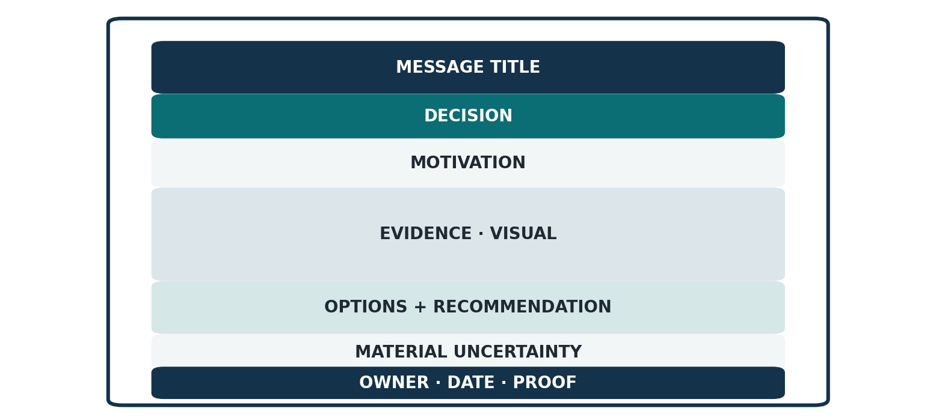
Figure 12 The one-page brief reserves visible space for decision, evidence, uncertainty, and ownership.

Header
Message title: the governing conclusion in one sentence. Add owner, date, status, and evidence cutoff in small type.

Decision
One sentence with decision maker, action, boundary, and timing. Separate approve, direct, discuss, and note.

Motivation
Two or three sentences: present state, hidden tension, consequence, purpose. Omit if shared context makes it redundant.

Evidence
Three proof points. Each should include evidence state and comparator. Use one chart or a compact table only if it makes the relationship faster to grasp.

Options and recommendation
Show two or three real choices with the tradeoff that matters. State the recommendation and why it dominates under the stated priorities.

Material uncertainty
Name the one assumption, dependency, or range that could change magnitude or choice. State how it will be tested or governed.

Next step
Owner, milestone, decision date, and proof of completion.
Place a short source line at the bottom. Link to the assurance material. Do not put a miniature methodology chapter in eight-point type.

Five-page executive paper architecture
Use five pages when the decision requires context, mechanism, and tradeoffs but the meeting should not become a methods review.
Page | Job | Typical visual
1 | Conclusion, decision, motivation, proof points | Decision summary
2 | Concrete operating mechanism and scale | Process or system diagram
3 | Evidence and uncertainty | Comparison chart with ranges
4 | Options, economics, risk, and reversibility | Decision table
5 | Recommendation, execution, measures, open issues | Roadmap or ownership table

Attach assurance rather than stretching the five-page paper until it becomes a report. The attachment can include methods, definitions, scenario inventory, sensitivity, source tables, model card, and control register.
Make each page answer one executive question. Use sentence headlines so the five headlines form a coherent argument. Repeat only the minimum status labels needed to prevent a page from being misread in isolation.
If motivation is essential, place it on page one or at the top of page two. Do not create a separate three-page history before the conclusion. Motivation should establish the hidden tension, not chronicle the project.

Ten-slide decision deck architecture
1. Decision and governing conclusion
2. Why this matters now
3. One concrete operational case
4. Pattern and scale across the system
5. Evidence and comparator
6. Uncertainty and sensitivity
7. Options and tradeoffs
8. Recommendation
9. Implementation, ownership, and measurement
10. Decision restated and discussion questions
This is a starting architecture, not a compulsory count. Combine slides when the story is simple. Split a slide when it asks the audience to decode two different relationships.
For live presentation, the headline states the assertion and the visual supplies evidence. Avoid paragraphs that compete with the speaker. Keep essential definitions on the slide, not only in notes, if the deck will circulate.
Reserve backup slides for methodology, full tables, alternative scenarios, data quality, and source detail. Number them and link from the main deck so challenge can be answered without derailing the core sequence.
The main deck should not pretend uncertainty vanished because it moved to backup. Surface any uncertainty that changes the recommendation or informs risk acceptance.

Create a visible hierarchy
A reader should identify page purpose, governing claim, evidence, and qualification before reading prose.
Use four consistent levels:
1. Page title or message headline
2. Lead sentence or decision statement
3. Evidence modules—paragraphs, chart, table, or diagram
4. Source and qualification notes
Alignment is a stronger organizer than decoration. Use a stable grid, consistent left edge, intentional column widths, and repeated spacing. Proximity should indicate relationship: the caveat sits near the claim, the label near the value, the source near the figure.
Whitespace is not unused space. It separates semantic groups and makes priority visible. Do not fill a page because room remains; add content only if it changes understanding or action.
Avoid a wall of equally weighted cards. Card grids can make every item look equivalent and force the reader to invent sequence. Use them only for genuinely parallel categories. For an argument, use a clear top-to-bottom path.
Recent executive publications often use strong message headers and modular pages effectively. Their weakness appears when brand devices, large decorative numbers, or compressed footnotes create confidence without comparable evidentiary clarity. Design should amplify the evidence state, not mask it. [26][27][28]

Use typography to reduce search
Typography should signal hierarchy with as few variables as possible.
- Use one highly legible family or a restrained two-family system.
- Use size, weight, and spacing before introducing many colors.
- Keep body text around 10–12 points in print, depending on typeface and measure.
- Use sentence case; reserve all caps for short labels.
- Keep line length moderate and left alignment consistent.
- Use tabular numerals in financial and comparison tables.
- Avoid underlining except for links.
- Make source notes readable; if a qualification matters, it cannot be microscopic.
The SEC handbook recommends consistent hierarchy, generous whitespace, limited fonts, and left-aligned text. [5]
Use bold to expose structure, not to create a second hidden document inside every paragraph. A page where half the text is bold has no hierarchy.
For tables, align text left and numbers right; align decimals when precision is meaningful. Use enough cell padding to separate rows. Repeat header rows across pages. Avoid vertical text and diagonal labels.
Test the exported PDF at normal zoom, not only in the authoring application. Fonts can substitute, lines can reflow, and footnotes can become unreadable after rendering.

Use color as a secondary channel
Color should encode status, category, or emphasis only when the same meaning is also available through label, position, pattern, or shape. WCAG 2.2 states that color should not be the sole means of conveying information and sets contrast requirements for text and non-text elements. [20]
Practical rules:
- Use a neutral foundation and one primary accent.
- Reserve alert colors for actual alert meaning.
- Do not use red and green alone for bad and good.
- Keep category colors stable across pages.
- Use direct labels so legends are not the only key.
- Check contrast in grayscale and under common color-vision simulations.
- Avoid saturated backgrounds behind long text.
For text, aim for at least 4.5:1 contrast; large text may use 3:1 under WCAG. For lines, icons, and graphical controls, maintain sufficient non-text contrast. [20]
Accessibility improves executive usability. Alt text forces the author to state the visual’s intended takeaway. Horizontal labels reduce decoding. Consistent navigation helps readers find assurance quickly. A chart that remains intelligible without hue is also more robust in print, projection, and screenshotting.

Choose a graphic by the question
Do not begin with “Which chart looks impressive?” Begin with the relationship the reader must see.
Question | Strong default | Use with care
Which is larger? | Sorted horizontal bar or dot plot | Pie, bubble, area
How did it change over time? | Line chart | Bars for many series
How far from target? | Dot or bar with reference line | Gauge
What is the distribution? | Histogram, box, strip, interval plot | Average alone
How do two measures relate? | Scatterplot | Dual-axis chart
What composes the whole? | Stacked bar; simple pie for few categories | Treemap for close comparison
Where does work or risk flow? | Process, Sankey when volume matters | Decorative arrows
What is exact? | Table | Chart with many value labels

Graphical perception research finds that judgments based on position along a common scale are generally more accurate than judgments of angle or area. Use bars and dots when exact comparison matters; do not ask executives to compare bubble areas for a funding decision. [12][13]
The Financial Times Visual Vocabulary and UK Government Analysis Function organize chart selection by statistical relationship, a better starting point than software menus. [21][22]

Give every chart a complete argument
A decision-grade chart needs more than marks on axes.
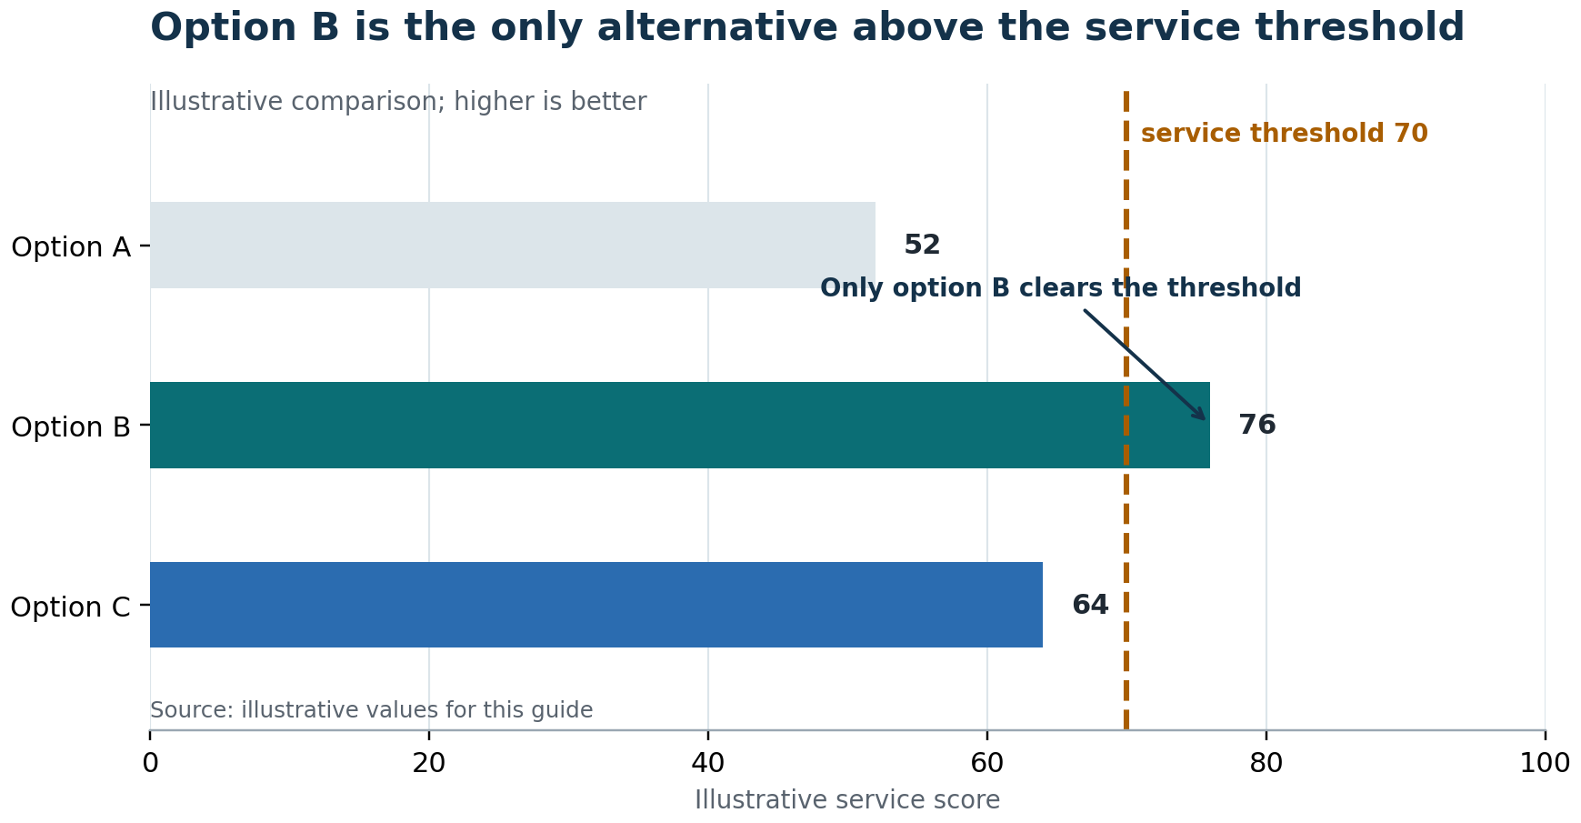
Figure 13 A chart should state the finding and expose the comparison needed to judge it.
Include:
- a message title stating the main pattern;
- a subtitle with measure, population, geography or scope, and time period;
- labeled axes and units;
- a meaningful comparator, target, or reference line when relevant;
- concise annotations placed near the data;
- evidence-state and uncertainty notes;
- a specific source and cutoff date;
- accessible description or underlying table.
Start quantitative axes at zero for bars unless a break is clearly signaled and justified. For lines, a nonzero range may be appropriate, but make the scale honest and visible. Avoid 3D, shadows, heavy gridlines, and needless markers. UK chart guidance recommends simple backgrounds, horizontal labels, light gridlines, direct context, and specific source information. [21]
Make titles describe the finding, not the topic. “Exceptions by month” becomes “Exceptions doubled after the policy change, then stabilized.” If the evidence cannot support that causal implication, write “Exceptions doubled after the policy change; the chart does not establish why.”

Show uncertainty only when it changes interpretation
Uncertainty can improve accuracy and still harm comprehension if it answers a question the reader is not asking. Choose the display based on the decision.
Decision need | Useful display
Compare estimates whose ranges overlap | Dot-and-interval plot
Show forecast or scenario path | Line with shaded range
Test a threshold | Estimate and interval against reference line
Show outcome distribution | Histogram or quantile plot
Show assumption influence | Ranked sensitivity bars
Show discrete futures | Small-multiple scenarios

The Office for National Statistics recommends showing uncertainty when it could fundamentally change interpretation and omitting it when consistently tiny and immaterial. It favors shaded bands or range plots over hard-to-read error-bar conventions and recommends plain-language explanations. [17]
Always define what the range is: across samples, seeds, parameter values, scenarios, or posterior uncertainty. Two ranges in one cell—such as seed variability and parameter bands—can be truthful and unreadable. Prefer a main visual for the decision-relevant range and a separate assurance table for the rest.
If uncertainty is so large that no comparison is meaningful, the honest graphic may be a scenario table or a statement that the evidence does not support ranking.

Use tables for exact lookup and multidimensional comparison
Tables are often the right executive visual when exact values, definitions, or several attributes matter simultaneously. Design them for a question.
- Put the comparison dimension in columns and the items in rows.
- Order rows by decision priority, magnitude, or natural sequence.
- Keep units in headers rather than repeating them in every cell.
- Align numbers right and text left.
- Use restrained row shading and visible but light borders.
- Highlight one or two decision-relevant cells; do not heat-map everything.
- Explain blanks, zeros, dashes, and “not applicable.”
- Do not mix denominators silently.
Replace a massive evidence table on the executive surface with a summary table plus a linked appendix. If the executive needs only direction and range, show that. If the exact values determine funding or risk tolerance, preserve them.
A useful hybrid is a chart-table: a small bar or dot for pattern plus an aligned value column for precision. Use it only if rendering remains sharp and accessible.
For risk registers, avoid presenting 200 rows as if senior attention should be uniform. Show the portfolio pattern, decision tiers, uncovered items, unstable rankings, and owner gaps; retain the complete register in assurance.

Use diagrams for structure, sequence, and dependency
Diagrams are strongest when they reduce search by placing related elements together. They are weakest when they decorate a simple list with boxes and arrows. [11]
Use:
- Process diagrams for sequence, handoffs, gates, and loops.
- System diagrams for boundaries, interfaces, and data movement.
- Decision trees for conditional policy or escalation.
- State diagrams for status changes and invalidation.
- Roadmaps for time, dependencies, and release stages.
- Swimlanes for ownership across functions.
Keep a diagram’s question in the title. Use a stable reading direction. Limit crossing lines. Label arrows with actions, not merely connections. Make the exception path visible when it is the source of risk. Distinguish current, committed, and proposed states through both style and label.
Do not use a large architecture diagram as a test of audience seriousness. Create an executive view with only the components needed to explain consequence; link to the engineering view. The two diagrams serve different tasks and can both be correct.
Mayer and Moreno’s multimedia-learning work supports relevant words and pictures, contiguity, and removal of extraneous material. Its experiments concern learning contexts, so apply the principle carefully rather than treating it as a universal slide law. [10]

SECTION

Part VI

Apply the patterns
Different technical genres fail in different ways. The decision interface remains stable, but the translation bridge and required caveats change.

Shift emphasis by executive lens
Audience | Primary question | Evidence they will test | Failure to avoid
CEO or board | Does this change strategic risk or option value? | Materiality, alternatives, ownership | Operational detail without strategic consequence
CFO | What are economics, sensitivity, and downside? | Baseline, cash timing, assumptions | Benefits without cost or range
COO | Can the operation execute reliably? | Flow, capacity, controls, service levels | System design without operating ownership
Strategy | What changes the portfolio choice? | Scenarios, competitive logic, reversibility | Trend summary without choice
Risk or legal | What is the claim boundary and residual exposure? | Definitions, provenance, controls, uncertainty | “Covered” presented as “closed”
CIO or CTO | What changes architecture, delivery, and reliability? | Dependencies, maturity, migration, observability | Executive simplification that erases constraints
People leader | What capabilities and capacity are required? | Workload, role design, privacy, alternatives | Role patterns turned into judgments of people

Do not create seven unrelated stories. Keep one governing conclusion and adjust the path into it. A decision meeting with multiple functions benefits from a shared page one followed by lens-specific evidence.
When audiences disagree, identify whether the conflict concerns facts, model assumptions, risk tolerance, or values. Better formatting cannot resolve a disagreement about acceptable exposure, but it can make the disagreement explicit.

Pattern for architecture and platform change
Executive question: Which business capability, risk, cost, or speed constraint changes if we alter the architecture?
Start with a concrete transaction or service journey. Show where the current architecture creates delay, fragility, duplicated control, or strategic lock-in. Then show the proposed boundary change and its consequence.
Required elements:
- current constraint and affected business process;
- target capability, not merely target technology;
- migration sequence and coexistence period;
- dependencies and irreversible choices;
- reliability, security, data, and operating-model implications;
- cost range and cost of delay;
- decision and guardrails.
Useful visual: two small system views—current and target—with only decision-relevant components, plus a migration roadmap.
Required caveat: architecture diagrams express intended structure, not proof of performance or adoption.
Language trap: “modernization enables scalability.” Replace with a measurable mechanism: “Separating the intake service lets the team scale document processing independently and reduces deployment coupling; the benefit depends on completing data-contract migration.”

Pattern for AI and data products
Executive question: For which decision or task does the system improve value, and under what governance boundary?
Show the user, task, input, output, human decision, and failure consequence. Separate model quality from product value and production reliability.
Required elements:
- intended users and prohibited uses;
- data provenance and representativeness;
- baseline and evaluation metric tied to the task;
- performance by material segment, not average alone;
- human oversight and override path;
- error costs, monitoring, drift, privacy, and security;
- deployment status and evidence cutoff;
- fallback when the model is unavailable or uncertain.
Useful visual: decision flow with human and model roles, followed by a threshold or segment-performance chart.
Required caveat: benchmark performance does not establish business impact; a pilot association does not establish durable causal value.
NIST’s AI RMF offers a useful lifecycle frame—govern, map, measure, manage—while model cards provide a documentation pattern for intended use, evaluation, and limitations. [24][25]

Pattern for simulation and scenario analysis
Executive question: Which decision remains preferred across plausible futures, and which assumptions could reverse it?
Do not lead with run count. Lead with the decision, modeled system, and comparison. Explain one simulated entity moving through the mechanism before presenting aggregate outcomes.
Required elements:
- purpose: exploration, prioritization, capacity, or prediction;
- synthetic versus observed populations;
- calibration targets and evidence states of inputs;
- scenario definitions and paired comparison design;
- output denominator and time horizon;
- stochastic, parameter, and structural uncertainty;
- validation and sensitivity;
- statements the model does not support.
Useful visual: small-multiple scenario comparison with an interval against a decision threshold.
Required caveat: repeated runs reduce simulation noise; they do not make hand-set assumptions measured or turn a scenario into a forecast.
If role effects are simulated, state whether the role changes event occurrence, detection, delay, impact, or all four. A modeled decrease in late discovery does not prove prevention.

Pattern for risk registers and controls
Executive question: Which exposures require a build decision, an owner and procedure, explicit acceptance, or further evidence?
Avoid starting with the full register. Begin with the process, one representative failure, the portfolio pattern, and the decision categories.
Required elements:
- risk event written as cause–event–consequence;
- severity distinct from likelihood;
- measured, estimated, or assumed likelihood;
- existing and proposed controls;
- coverage, implementation, operation, and effectiveness status;
- residual exposure and risk owner;
- review date and acceptance authority.
Useful visual: lifecycle or process heat strip showing where material risks concentrate, plus a disposition table for uncovered items.
Required caveat: a mapped control does not remove a risk. A risk register demonstrates enumerated coverage, not completeness of all possible failure modes.
Avoid multiplying ordinal scores as though the result were a physical quantity. A priority index can organize attention, but its weights are judgments and its fine ranking may be unstable. Show tiers and sensitivity when the distinction matters.

Pattern for workflows and operating models
Executive question: Where does work wait, fail, loop, or lose ownership—and which intervention changes the outcome?
Start with an end-to-end customer or transaction path. Mark work, wait, decision, handoff, rework, and gate. Then connect the pattern to service, revenue, risk, or capacity.
Required elements:
- unit of flow and start/end boundary;
- volume and demand pattern;
- elapsed time versus touch time;
- queue, handoff, and rework points;
- owner versus actual actor;
- exception path and escalation;
- technology and human control interaction;
- leading and lagging measures.
Useful visual: swimlane with wait and rework highlighted, followed by a before/after measure chart.
Required caveat: activity logs may not represent effort; absence of a logged action is not proof the action did not happen elsewhere.
Do not confuse automation with elimination of work. A gate can move effort earlier, expose latent demand, and create a queue. Show the operator and service level the automation requires.

Pattern for workforce and role design
Executive question: What capability and capacity does the process require, and what is the best way to supply it?
Organize the brief around capability gaps, not proposed job titles. A title is one implementation choice.
Required elements:
- process need and consequence if unowned;
- required judgment, credential, access, and service level;
- demand volume, variability, and peak pattern;
- work estimate with assumptions;
- current capacity and single-point dependencies;
- alternatives: redesign, automate, assign, cross-train, outsource, combine, hire;
- privacy boundary and unit of analysis;
- measures after implementation.
Useful visual: capability-to-process matrix plus a demand/capacity range—not a ranking of people.
Required caveat: modeled role impact does not equal headcount; estimated FTE does not establish a full-time hire; work rows are not hours; concentration is not performance.
When two partial role loads sum to roughly one FTE, do not combine them automatically. Test whether the credentials, timing peaks, segregation of duties, and service context are compatible. Conversely, do not split one coherent transaction lane merely because the taxonomy names two roles.

Technical pattern quick matrix
Work type | Concrete anchor | Executive visual | Must-label uncertainty | Decision form
Architecture | One transaction across systems | Current/target boundary | Migration and performance | Approve sequence and guardrails
AI or model | User task and failure | Human–model decision flow | Data, segments, drift | Pilot, deploy, restrict, or stop
Simulation | One synthetic case | Scenario interval comparison | Inputs and model form | Choose robust option or measure first
Risk | One cause–event–consequence | Process exposure and disposition | Likelihood and effectiveness | Build, assign, accept, or monitor
Operations | One case through handoffs | Swimlane and delay | Log completeness, demand | Redesign flow and ownership
Workforce | One unowned judgment | Capability and capacity | Workload and privacy | Assign, combine, source, or hire

The matrix is a navigation tool, not a substitute for judgment. Some projects span several patterns. A workflow simulation with a hiring recommendation needs both the simulation and workforce caveats. An AI-enabled operations redesign needs model evaluation, system architecture, process ownership, and change capacity.
When patterns overlap, preserve the claim boundary from each. The combined brief should not inherit the strongest-sounding conclusion from one method and apply it to another question.

SECTION

Part VII

Produce and govern
A strong artifact requires a workflow that separates analytical truth, executive translation, design, approval, and release. AI can accelerate each stage, but it cannot own the judgment.

Use a gated production workflow
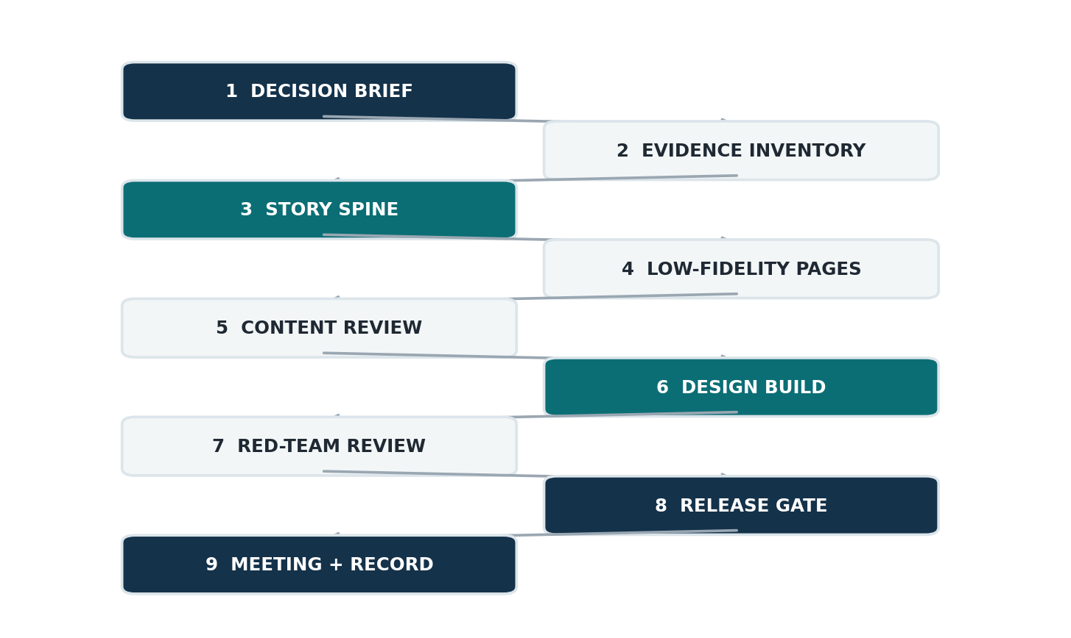
Figure 14 Nine gates separate analysis, translation, design, approval, and release.
1. Decision brief. Audience, authority, meeting outcome, timing, sensitivity.
2. Evidence inventory. Claims, states, sources, cutoff dates, assumptions, unresolved conflicts.
3. Story spine. Decision, motivation, concrete case, mechanism, evidence, options, uncertainty, execution.
4. Low-fidelity pages. Titles, page jobs, rough visuals, appendix routing.
5. Content review. Technical owner, business owner, risk/legal where applicable.
6. Design build. Grid, typography, charts, tables, accessibility, navigation.
7. Red-team review. Skeptical reader, numeric audit, claim-to-source audit, adverse interpretation.
8. Release gate. Correct identity, status, permissions, links, format, distribution list.
9. Meeting and record. Decision captured, conditions, owner, date, and follow-up measure.
Do not design the final pages before the story spine is stable, but do sketch visuals early. A visual often reveals that the analysis lacks a comparator, denominator, or mechanism.
Assign one publication owner. Multiple contributors can own analyses and sections; one person must own the coherence and release state of the artifact.

A 48-hour rescue workflow for a difficult meeting
When a dense technical document must be made executive-ready quickly, protect the highest-leverage moves.

First four hours
- Write the exact decision and meeting outcome.
- Correct document identity: publication edition, model generation, status, cutoff.
- Choose one concrete operational example.
- Draft the governing conclusion and material caveat.

Same day
- Build a six-to-ten-page story spine.
- Tag every headline number by evidence state.
- Remove internal comparison history from the opening unless the audience needs it.
- Create one options table and one uncertainty view.
- Move inventories and method detail to assurance.

Next morning
- Run technical, business, language, and design reviews separately.
- Challenge denominator, baseline, causality, implementation status, and role/headcount inference.
- Rehearse the two-minute opening and the five hardest questions.

Before circulation
- Export to PDF and inspect every page at normal size.
- Test links, page numbers, source notes, and confidentiality markings.
- Confirm that the decision owner can state what is being asked.
- Freeze the meeting edition and record any post-circulation corrections explicitly.
If time permits only one substantive change, repair page one. If two, add the concrete mechanism. If three, fix evidence labels and caveat placement. These changes often outperform cosmetic redesign.

Use AI as an accelerator with explicit controls
AI can help inventory sources, cluster risks, draft alternatives, propose structures, rewrite jargon, generate chart variants, and simulate skeptical questions. It can also invent evidence, flatten distinctions, overstate causality, and create polished inconsistency at scale.
Use a controlled loop:
AI task | Human control
Extract claims | Compare with source; record provenance
Summarize technical work | Check omitted constraints and evidence states
Generate narrative options | Choose the argument; reject invented motivation
Rewrite for executives | Verify meaning, authority, and modal verbs
Propose visuals | Validate data, scales, labels, and accessibility
Red-team the brief | Separate plausible challenge from fabricated fact
Format the artifact | Inspect every rendered page

Do not ask AI to “make it more confident.” Ask it to make claim strength consistent with evidence. Do not let it convert “modeled” to “expected,” “role” to “hire,” or “not observed” to “did not happen.”
The named human owner remains accountable for sources, calculations, judgments, privacy, and release. Disclose AI involvement proportionately when it materially assisted analysis or drafting.

Run four independent reviews

Technical truth
Can the technical owner reproduce every number and defend model boundaries? Are statuses current as of the stated cutoff? Do chart values match tables?

Executive usefulness
Can a reader identify decision, consequence, options, and owner in two minutes? Is motivation present where it is needed? Does the recommendation address the authority in the room?

Language integrity
Are evidence states, causal verbs, modals, denominators, time horizons, and units correct? Could any sentence be reasonably read more strongly than intended?

Design and accessibility
Does each page have one job? Are hierarchy, contrast, spacing, labels, sources, alt text, and navigation usable? Does the PDF render cleanly?
The reviewers can be the same people at different times, but the passes should remain distinct. A reviewer checking typography will often miss a denominator change; a technical reviewer immersed in the model may not notice an abstraction gap.
End with a claim ledger: headline, evidence state, source, owner, cutoff, material caveat, and approval. This turns final review from memory into a controlled process.

Review through a skeptical reader
Ask a reviewer to adopt five positions:
1. The busy executive: “What is the decision and why now?”
2. The methodological skeptic: “Which result depends on an assumption?”
3. The operational owner: “Who will do this and what breaks at peak?”
4. The political reader: “What does this imply about people, blame, or prior choices?”
5. The future auditor: “Can I reconstruct what was known, decided, and approved?”
For each, record the strongest reasonable misreading. Repair the artifact before arguing that the reader “should have known.”
High-value challenge questions include:
- What concrete event does this category describe?
- Is this number observed, derived, simulated, or targeted?
- What is the denominator and baseline?
- Does the method support causation?
- What uncertainty could reverse the recommendation?
- Is the control mapped, deployed, used, or measured?
- Is this role value, workload, capacity, or headcount?
- What alternative did we reject and why?
- What happens if we defer?
- What will prove the decision worked?

Design the meeting around the decision
The pre-read and meeting are one system. A good paper can still fail if the session becomes a narrated document review.
Open in two minutes:
1. decision and recommendation;
2. motivation and why now;
3. one concrete mechanism;
4. evidence and material uncertainty;
5. questions the group must resolve.
Use most of the meeting for challenge and choice. Deloitte suggests presenters speak for roughly one-third of the allotted time and preserve the rest for questions and discussion; the exact ratio can vary, but the principle is sound. [2]
Prepare direct answers to the hardest questions and know which appendix page supports each. If a question reveals a new assumption or decision condition, record it rather than improvising certainty.
End by restating the decision in the room: what was approved, rejected, deferred, or conditioned; who owns the next action; by when; and what evidence will return. A meeting that ends with “good discussion” but no decision record has not completed the interface.

Treat release as a governance event
Before distribution, verify:
- audience and permission boundary;
- publication edition, analytical generation, status, and date;
- evidence cutoff and implementation “as of” date;
- final decision language and approval authority;
- confidentiality, privacy, and legal-review requirements;
- source links and attachment completeness;
- accessible Word and fixed PDF editions;
- rendered page inspection;
- distribution list and record location;
- change procedure after circulation.
If a correction is material, do not silently replace the file. Increment the publication edition, describe the change, and notify recipients. If the analytical model changes but the executive conclusion does not, record the model update and explain why the decision remains stable.
A “meeting draft” can be polished and still remain a draft. Status is not a quality judgment; it communicates authority and permitted reliance.

SECTION

Part VIII

Reusable tools
The following templates turn the guide into a repeatable practice. Adapt the labels to the organization, but preserve the distinctions they enforce.

Rewrite example from model output to decision claim

Before
“Version 3 derives all unmeasured rates using the process score selected through leave-one-out testing. The model produces materially worse outcomes than version 2, but directionality holds across seeds and rate bands.”

Why it fails for a first public-facing brief
It begins with internal lineage, assumes the reader understands the scoring system, uses “worse” without defining the business consequence, and does not say what action follows. It also risks treating a model comparison as the meeting’s purpose.

After
The tested release controls reduce modeled exposure across the plausible input range, but the exact size is uncertain because control effectiveness has not been measured. Approve the release and closing gates, assign owners to the uncovered scenarios, and instrument bypasses and caught defects after launch.
The supporting method can then say: unmeasured event frequencies were derived from measured anchors; input and seed ranges were tested; the direction held; fine-grained ranking did not.

What changed
- publication decision replaced version history as the lead;
- technical method became assurance rather than motivation;
- modeled status and dominant uncertainty are visible;
- the action, owner category, and measurement plan are explicit;
- the analytical generation can still be identified in the document metadata.

Rewrite example from roles to capacity decision

Before
“The model supports five hires, ranked by measured impact. The closing coordinator reduces unsafe closings by 27.8 points and requires 0.7 FTE.”

Why it is corrupting
The analysis tests role patterns in a simulation; it does not directly measure hiring outcomes. “Measured impact” can be confused with observed production impact. The FTE is a workload estimate, not a headcount requirement. The sentence omits the assumption that role reliability is set by the model and the possibility of combining, assigning, sourcing, or redesigning work.

After
Five role capabilities survived the defined evidence and refutation tests. In the current-state scenario, dedicated closing ownership produces the largest modeled safety effect. The associated workload is estimated at roughly 0.7 FTE, so the executive choice is how to supply that capability—assignment, combination with legal operations, external support, process redesign, or hire. The simulation does not predict incidents or evaluate individuals.

What changed
- capability preceded title;
- modeled effect replaced “measured impact”;
- workload separated from staffing;
- alternatives became visible;
- the privacy and performance boundary moved into the main claim.

Fill-in template for an executive brief
Message title [Conclusion with an honest evidence verb]
Decision [Decision owner] to [approve/direct/discuss/note] [action and boundary] by [date].
Motivation Today, [current state]. The hidden tension is [mechanism or missing visibility]. It matters now because [consequence/deadline]. This analysis was designed to [purpose].
What the evidence says
1. [Observed/measured finding with comparator and scope]
2. [Modeled/estimated finding with assumption and range]
3. [Operational mechanism connecting finding to consequence]
Options
Option | Value | Exposure | Cost/capacity | Reversibility
A
B
C

Recommendation We recommend [option] because [decision criteria].
Material uncertainty [What could change magnitude or choice; how it will be tested]
Next action [Owner] by [date], complete when [observable condition].
Source and status [Evidence cutoff, publication edition, analysis generation, links]

Assurance appendix template

Claim ledger
Claim | State | Source | Cutoff | Owner | Material caveat

Model or analysis card
- Purpose and decision supported
- Unit, population, time horizon, exclusions
- Inputs by evidence state
- Core mechanism and outputs
- Validation and benchmarks
- Uncertainty and sensitivity
- Intended and prohibited uses
- Monitoring and recalibration

Definitions
Define terms whose ordinary meaning differs from project meaning. Keep each definition operational and add an example where useful.

Change and release record
Publication edition | Analysis generation | Date | Status | Material change | Approver

Decision record
Record approval, conditions, dissent, owner, due date, measurement plan, and review trigger.

Final release checklist

Decision and narrative
- The decision, authority, timing, and consequence are explicit.
- Motivation explains why the work and why now without becoming project history.
- One concrete example precedes the main abstraction.
- Options and the cost of delay are visible.
- The recommendation follows from stated criteria.

Evidence and language
- Important claims are labeled observed, measured, estimated, modeled, assumed, inferred, or recommended.
- Denominators, time periods, baselines, and units are clear.
- Causal verbs match the method.
- Probability and confidence are not conflated.
- Caveats sit next to the claims they change.
- Coverage, implementation, operation, effectiveness, and residual risk are distinct.
- Workforce claims distinguish role, workload, capacity, headcount, and individual performance.

Design and access
- Each page or slide has one job and a message title.
- Charts match the relationship and include source, scope, and uncertainty.
- Tables are ordered, aligned, and readable.
- Color is not the only signal; contrast and alt text are adequate.
- The document works at ten-second, two-minute, and fifteen-minute speeds.
- Every rendered page has been inspected.

Governance
- Publication edition, analysis generation, status, and evidence cutoff are correct.
- Named owners approved technical, business, and release content.
- Distribution and privacy boundaries are correct.
- The meeting decision and follow-up measure have a record location.

The 100-point executive-brief rubric
Score each criterion 0–5. A score of 3 means usable; 4 means strong; 5 means exemplary. Any zero in decision, evidence integrity, or material uncertainty is a release blocker regardless of total.
Domain | Criterion | Points
Decision | Exact action, authority, timing, and boundary | 5
Decision | Recommendation and real alternatives | 5
Decision | Consequence of action and delay | 5
Motivation | Why the work exists and why now | 5
Translation | Concrete mechanism before abstraction | 5
Translation | Technical → operational → business chain | 5
Structure | Answer-first, coherent page sequence | 5
Structure | Layered executive and assurance paths | 5
Evidence | Claim states and provenance | 5
Evidence | Baselines, denominators, scope, and time | 5

Subtotal: 50 points.

The 100-point rubric continued
Domain | Criterion | Points
Evidence | Causal and inferential discipline | 5
Uncertainty | Material uncertainty and sensitivity | 5
Language | Actors, verbs, modals, and definitions | 5
Language | Sensitive and workforce claims bounded | 5
Graphics | Correct form, honest scale, useful annotation | 5
Design | Hierarchy, density, typography, and consistency | 5
Access | Contrast, non-color cues, alt text, navigation | 5
Execution | Owner, dependencies, milestones, measures | 5
Governance | Version identity, status, approvals, privacy | 5
Resilience | Survives skeptical reading and forwarding | 5

Subtotal: 50 points. Total: 100.
Interpretation:
- 90–100: decision-ready and durable;
- 80–89: strong; repair the lowest domain before release;
- 70–79: usable only with an active presenter; revise;
- Below 70: not ready for executive reliance.
Do not optimize the score mechanically. A polished 92 with an incorrect denominator is worse than an honest 78 with a visible limitation. The blockers override the total.

Quick reference
When the brief is too technical, do not begin by deleting detail. Do this:
1. Write the decision.
2. Write the motivation in four sentences.
3. Choose one operational example.
4. Draw the translation chain.
5. Label every important claim by evidence state.
6. Add comparator, denominator, time, and uncertainty.
7. Build the options table.
8. Put the material caveat beside the conclusion.
9. Move method and inventory to assurance.
10. Rewrite headings as assertions.
11. Choose each visual by the question.
12. Separate control coverage from effectiveness.
13. Separate role value from headcount and people from process.
14. Give the artifact independent publication identity.
15. Inspect the rendered file and rehearse the decision.
The discipline can be summarized in one line:
Make the mechanism concrete, the evidence class visible, the choice explicit, and the path to verification intact.

SECTION

Research notes

Sources and practice review
The guide combines empirical research, official standards and guidance, and current executive-publication practice. No single source provides a complete method; recommendations are a synthesis, and limitations are noted where evidence comes from classroom, web, or specialized risk contexts.

What current executive publications do well
A review of recent McKinsey, BCG, PwC, Deloitte, EY, KPMG, and Accenture technology and CEO publications shows recurring strengths:
- strong opening summaries and message-oriented section titles;
- modular pages organized around a clear question;
- visible WHY/WHAT/HOW or trend/implication/action structures;
- direct annotations and source notes;
- repeated visual conventions that reduce navigation cost;
- methodology and respondent base disclosed in dedicated sections;
- practical prompts such as “your next move.”
McKinsey’s 2026 technology trends report makes its selection criteria and quantitative/qualitative methodology visible before the trend profiles. PwC’s CEO survey reports respondent base and, in places, distinguishes reported results from modeled associations. BCG’s executive perspectives use compact message headlines and question-led sections. [26][27][28]
The transferable lesson is not to imitate brand aesthetics. It is to make the page’s question and conclusion visible, establish a stable visual grammar, and provide a trace to method.

Where polished publications still require caution
Common weaknesses in executive publications are instructive:
- source notes and qualifications are sometimes too small for ordinary reading;
- branded rhetoric can sound more certain than the analysis warrants;
- one-idea-per-page design can fragment causal chains across several pages;
- large decorative statistics may omit denominator or evidence state;
- survey perceptions may be discussed beside modeled results without strong visual separation;
- recommendations may not show a genuine alternative or cost of action.
These are not indictments of particular firms. They show that visual polish and analytic integrity are separate variables. A report can be exceptionally navigable and still invite overinterpretation.
The right borrowing posture is critical: copy the discipline of message titles, modularity, source notes, and method disclosure; strengthen evidence-state labeling, caveat placement, and decision alternatives.

Research basis and boundaries
The guide draws on several evidence traditions:
- Cognition and expertise: working attention, schema, expert abstraction, multimedia coherence.
- Graphical perception: relative accuracy of position, length, angle, and area; task-dependent visualization.
- Risk and uncertainty: probability, confidence, reference classes, ranges, sensitivity, and model-form uncertainty.
- Plain language and accessibility: audience analysis, structure, typography, contrast, alternatives for non-text content.
- Governance and reporting: decision-first board papers, strategic versus operational content, and release discipline.
Important boundaries:
- Many cognition studies are conducted in learning or laboratory contexts; they inform design but do not dictate fixed executive-page rules.
- Consulting publications are practice examples, not independent proof that a format improves decisions.
- Risk-communication research often comes from health, intelligence, or public policy; transfer requires judgment.
- The recommended evidence-state vocabulary and 100-point rubric are syntheses created for this guide, not external standards.

References
[1] Boston Consulting Group. “The Art of Reporting: How to Take a Quantum Leap.” 2024. https://www.bcg.com/publications/2024/art-of-reporting-how-to-take-a-quantum-leap
[2] Deloitte. “Tips for Improving Board Communications and Effectiveness.” 2024. https://www.deloitte.com/us/en/services/audit-assurance/blogs/accounting-finance/effective-board-communications.html
[3] University of Saskatchewan. Author’s Guide for Board Document Preparation. 2026. https://governance.usask.ca/documents/board/authors-guide_board-march-2026.pdf
[4] UK Department for Education. “Producing Effective Board Reports for Strong Governance.” Updated 2025. https://www.gov.uk/government/publications/effective-governance-resources/producing-effective-board-reports-for-strong-governance-resources
[5] U.S. Securities and Exchange Commission. A Plain English Handbook. 1998. https://www.sec.gov/pdf/handbook.pdf
[6] GOV.UK Publishing Service. “Clear Structure.” https://guidance.publishing.service.gov.uk/writing-to-gov-uk-standards/writing-guidelines/clear-structure/
[7] Hinds, P. J., Patterson, M., and Pfeffer, J. “Bothered by Abstraction: The Effect of Expertise on Knowledge Transfer and Subsequent Novice Performance.” Journal of Applied Psychology 86(6), 2001. https://doi.org/10.1037/0021-9010.86.6.1232
[8] Sweller, J. “Cognitive Load During Problem Solving: Effects on Learning.” Cognitive Science 12(2), 1988. https://doi.org/10.1207/s15516709cog1202_4

References continued
[9] Cowan, N. “The Magical Number 4 in Short-Term Memory.” Behavioral and Brain Sciences 24, 2001. https://memory.psych.missouri.edu/assets/doc/articles/2001/cowan-bbs-2001.pdf
[10] Mayer, R. E., and Moreno, R. “Aids to Computer-Based Multimedia Learning.” Learning and Instruction 12, 2002. https://www.sfu.ca/~jcnesbit/EDUC220/ThinkPaper/MayerMoreno2002.pdf
[11] Larkin, J. H., and Simon, H. A. “Why a Diagram Is (Sometimes) Worth Ten Thousand Words.” Cognitive Science 11, 1987. https://doi.org/10.1111/j.1551-6708.1987.tb00863.x
[12] Cleveland, W. S., and McGill, R. “Graphical Perception: Theory, Experimentation, and Application to the Development of Graphical Methods.” Journal of the American Statistical Association 79, 1984. https://faculty.washington.edu/aragon/classes/hcde511/s12/readings/cleveland84.pdf
[13] Heer, J., and Bostock, M. “Crowdsourcing Graphical Perception.” CHI 2010. https://homes.cs.washington.edu/~jheer/files/2010-MTurk-CHI.pdf
[14] Alley, M., et al. “How the Design of Headlines in Presentation Slides Affects Audience Retention.” 2006. https://writing.engr.psu.edu/alley_et_al_2006.pdf
[15] Spiegelhalter, D. “Risk and Uncertainty Communication.” Annual Review of Statistics and Its Application 4, 2017. https://regulation.org.uk/library/2017-Spiegelhalter-Risk_and_Uncertainty_Communication.pdf
[16] UK Government. “Explaining Uncertainty in UK Intelligence Assessment.” 2025. https://www.gov.uk/government/publications/explaining-uncertainty-in-uk-intelligence-assessment/explaining-uncertainty-in-uk-intelligence-assessment

References continued
[17] Office for National Statistics. “Showing Uncertainty in Charts.” https://service-manual.ons.gov.uk/data-visualisation/guidance/showing-uncertainty-in-charts
[18] Hullman, J. “Why Evaluating Uncertainty Visualization Is Error Prone.” BELIV, 2016. https://users.eecs.northwestern.edu/~jhullman/paper_BELIV_evaluating_uncertainty_vis.pdf
[19] American Statistical Association. “Statement on Statistical Significance and P-Values.” 2016. https://www.amstat.org/docs/default-source/amstat-documents/p-valuestatement.pdf
[20] World Wide Web Consortium. Web Content Accessibility Guidelines 2.2. https://www.w3.org/TR/WCAG22/
[21] UK Government Analysis Function. “Data Visualisation: Charts.” 2022. https://analysisfunction.civilservice.gov.uk/policy-store/data-visualisation-charts/
[22] Financial Times. “Visual Vocabulary.” https://ig.ft.com/visual-vocabulary/
[23] Princeton University Records Management. “File Naming Conventions and Version Control.” https://records.princeton.edu/records-management-manual/file-naming-conventions-version-control
[24] National Institute of Standards and Technology. Artificial Intelligence Risk Management Framework 1.0. 2023. https://nvlpubs.nist.gov/nistpubs/ai/NIST.AI.100-1.pdf
[25] Mitchell, M., et al. “Model Cards for Model Reporting.” 2019. https://arxiv.org/pdf/1810.03993

References continued
[26] McKinsey & Company. Technology Trends Outlook 2026. 2026. https://www.mckinsey.com/~/media/mckinsey/business%20functions/mckinsey%20digital/our%20insights/the%20top%20trends%20in%20tech%202026/mckinsey%20technology%20trends%20outlook%202026.pdf
[27] Boston Consulting Group. AI and the Future of Software: Executive Perspectives. 2026. https://www.bcg.com/assets/2026/executive-perspectives-ai-and-the-future-of-software.pdf
[28] PwC. 29th Annual Global CEO Survey. 2026. https://assets.pwc.com/adobe/assets/urn:aaid:aem:65b637e7-a873-4ca3-b9ba-8df8354c337a/original/as/pwc-ceo-survey-2026.pdf
[29] EY. CEO Outlook. January 2025.
[30] Deloitte. Tech Trends 2026. https://www.deloitte.com/us/en/insights/topics/technology-management/tech-trends.html
[31] IPCC. Guidance Note for Lead Authors on Consistent Treatment of Uncertainties. https://www.ipcc.ch/site/assets/uploads/2017/08/AR5_Uncertainty_Guidance_Note.pdf
[32] UK Government Analysis Function. “Communicating Quality, Uncertainty and Change.” https://analysisfunction.civilservice.gov.uk/policy-store/communicating-quality-uncertainty-and-change/
[33] GOV.UK Brand Guidelines. “Charts.” https://brand.design-system.service.gov.uk/data/charts/
[34] Rozenblit, L., and Keil, F. “The Misunderstood Limits of Folk Science: An Illusion of Explanatory Depth.” Cognitive Science 26, 2002. https://cogdevlab.yale.edu/sites/default/files/files/rozenblit%20%26%20keil%20%202002.pdf
[35] HM Revenue & Customs. “Naming Convention Principles.” Updated 2026. https://www.gov.uk/hmrc-internal-manuals/specialist-investigations-operational-guidance/siog10345

Glossary
Abstraction budget — an editorial limit on unfamiliar constructs introduced before the reader has a concrete anchor.
Analytical generation — the version of a model, dataset, method, or calculation independent of the audience-facing publication.
Assurance layer — methods, diagnostics, assumptions, detailed tables, sources, and reproducibility material supporting the executive surface.
Baseline — the reference state against which a result is compared; it may be observed or modeled and should be labeled accordingly.
Confidence — strength of the analytical basis for a judgment, distinct from the probability assigned to the event.
Control coverage — mapping of a control to a risk; not proof that the control exists, operates, or works.
Decision interface — an artifact designed to connect evidence to a specific organizational choice while preserving traceability.
Evidence state — classification of a claim as observed, measured, estimated, modeled, assumed, inferred, or recommended.
Message headline — a sentence title that states the page’s governing assertion.

Glossary continued
Modeled outcome — a result generated under a defined model and inputs; not automatically a forecast.
Motivation — the present state, hidden tension, consequence, and purpose that explain why analysis and action are needed.
Publication edition — the version of the audience-facing artifact, separate from the analytical generation beneath it.
Residual risk — exposure remaining after controls, considering their operation and effectiveness.
Role pattern — a bundle of process ownership, judgment, credential, access, or service capabilities; not necessarily a job title or headcount unit.
Sensitivity analysis — testing how outputs or decisions change as assumptions or inputs vary.
Structural uncertainty — uncertainty about whether the model represents the right mechanisms or boundaries.
Translation chain — technical mechanism → operational behavior → business consequence → executive decision.
Version status — draft, meeting draft, approved, released, or superseded; communicates authority and permitted reliance.

Closing principle
The hardest executive briefs are not hard because the audience is incapable of understanding the work. They are hard because the work contains multiple kinds of truth at once: operational events, measured patterns, constructed classifications, modeled futures, unmeasured assumptions, implementation realities, human judgment, and strategic preference.
The writer’s responsibility is to preserve those distinctions while reducing the reader’s search burden.
A durable brief therefore does four things simultaneously:
- It makes the system concrete enough to picture.
- It makes the evidence honest enough to trust.
- It makes the choice explicit enough to decide.
- It makes the assurance path intact enough to challenge.
That is compression without distortion. It is also the difference between a technical artifact that happens to reach executives and an executive artifact worthy of technical work.

