Supporting Technologies
PyTorch & PyTorch Geometric: Used to construct the custom MaskedLinear BINN layers and interface downstream bottleneck features with Graph Attention Networks (GAT).
Scanpy: Used for single-cell preprocessing, target sum normalization (10⁴), and log-transformation (log1p).
SHAP (SHapley Additive exPlanations): Employed shap.GradientExplainer to extract feature importance scores from the pathway-constrained BINN stream.
Kneed (KneeLocator): Used for automated elbow detection to determine threshold cutoffs for significant gene panels.
MyGene & Reactome APIs: Used to programmatically parse biological pathways, map UniProt identifiers, and build adjacency matrices for biologically informed network layers.
Chapter 3: Execution
3.X Biology-Informed Feature Extraction (BINN Pipeline)
To compress high-dimensional single-cell RNA input data while maintaining biological interpretability prior to spatial graph modeling, a dual-stream Biology-Informed Neural Network (BINN) feature extraction pipeline was designed and implemented.
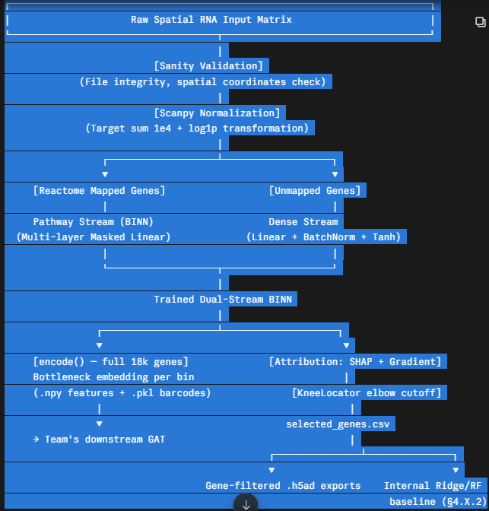
3.X.1 Upfront Validation & Data Preprocessing

Before network initialization, the pipeline performs strict input integrity and spatial coordinate verification. It checks for required spatial dimensions (pxl_row_in_fullres, pxl_col_in_fullres, array_row, array_col) to ensure spatial alignment remains intact for downstream graph construction.

Preprocessed states are tracked via an explicit is_preprocessed flag. Single-cell RNA counts are normalized using scanpy to a target sum of 10⁴ counts per cell and log-transformed via log1p:

𝑋
~
RNA
=
log
⁡
(
1
+
𝑋
RNA
∑
𝑋
RNA
×
10
4
)
X
~
RNA
​

=log(1+
∑X
RNA
​

X
RNA
​

​

×10
4
)

Target protein abundance values are normalized using [confirm which transform actually produced the reported 0.58 before finalizing — the pipeline script uses an inverse hyperbolic sine transform, arcsinh(Y/150); the notebooks and baseline benchmarking script instead use a centered-log-ratio (CLR) normalization. State the one that was actually used for the reported result, and note explicitly if the two differ across artefacts]:

𝑌
protein
=
arcsinh
(
𝑌
150.0
)
Y
protein
​

=arcsinh(
150.0
Y
​

)

3.X.2 Biological Graph Construction & Dual-Stream Architecture

Gene symbols are mapped to UniProt accessions using the mygene service and linked to Reactome hierarchy trees (UniProt2Reactome.txt and ReactomePathwaysRelation.txt). Based on this mapping, input features are partitioned into two streams:

Pathway-Mapped Stream: Input genes that map directly to known Reactome biological pathways are passed into custom MaskedLinear PyTorch layers. Binary mask matrices
𝑀
∈
{
0
,
1
}
𝑑
out
×
𝑑
in
M∈{0,1}
d
out
​

×d
in
​

enforce sparsity, allowing weight updates only along edges corresponding to true biological hierarchy interactions:

𝐻
(
𝑙
)
=
𝜎
(
(
𝑊
(
𝑙
)
⊙
𝑀
(
𝑙
)
)
𝐻
(
𝑙
−
1
)
+
𝑏
(
𝑙
)
)
H
(l)
=σ((W
(l)
⊙M
(l)
)H
(l−1)
+b
(l)
)

Unmapped Dense Stream: Genes lacking formal Reactome annotations are routed through a parallel feed-forward network comprising Linear, BatchNorm1d, Tanh activation, and Dropout layers.

The network is trained on target protein abundances using Mean Squared Error (MSELoss), an AdamW optimizer, and a CosineAnnealingLR scheduler, evaluating against a 10% held-out validation set for early stopping.

3.X.3 Feature Attribution, Selection & Bottleneck Embedding Export

Once the BINN was trained, two independent downstream products were derived from it, and it is important to distinguish them clearly since they serve different roles in the wider project.

First, the encode() method was run over every bin in the train, validation, and test splits — executing the dual-stream forward pass up to but excluding the prediction head, producing a fixed-length bottleneck embedding per spatial bin. These embeddings, together with barcode files guaranteeing row-order alignment, were the feature representation passed to the team's Graph Attention Network. This embedding is computed over the full 18,085-gene input space, not any gene-filtered subset.

Second, and separately, per-gene attribution was computed to identify a compact, interpretable driver-gene panel: Shapley values (shap.GradientExplainer) for the Reactome-mapped stream, and input×gradient magnitude for the unmapped dense stream. These two attribution methods were kept deliberately separate per stream, since mixing SHAP across a sparse masked architecture and a dense MLP would conflate attribution scales that are not directly comparable. An automated elbow detector (kneed.KneeLocator) located the cutoff on each stream's sorted importance curve, producing a reduced gene panel (selected_genes.csv). This panel was used to build gene-filtered exports of the RNA matrices and, critically, as the input feature set for an internal baseline comparison (§4.X.2) — it was not fed into the GAT.

3.X.4 Iterative Refinement of Gene Selection

The elbow-based cutoff was not fixed after a single run. A separate tuning utility allowed the selection method (automatic elbow detection vs. a relative-threshold rule retaining genes above a fixed fraction of the top score) to be swept against the pre-computed importance scores without retraining the BINN. This process also surfaced a correctness issue worth recording as a design decision: per-bin size factors must be computed from the full, unfiltered gene matrix before column subsetting to the selected panel — computing them afterwards would bias the size factor toward library depth over only the ~2,000 selected genes rather than the true total. This was resolved by materialising the full matrix once for size-factor computation prior to any gene-axis filtering.

Chapter 4: Critical Evaluation
4.X Empirical Evaluation and Diagnostic Analysis of the BINN-GAT Pipeline

To determine the effectiveness of biology-informed dimensionality reduction prior to spatial graph modeling, the BINN feature extraction pipeline was benchmarked against alternative modeling strategies developed across the team project.

4.X.1 Benchmark Results

Table 4.X highlights the performance of the BINN bottleneck pipeline relative to the project's baseline and top-performing architectures.
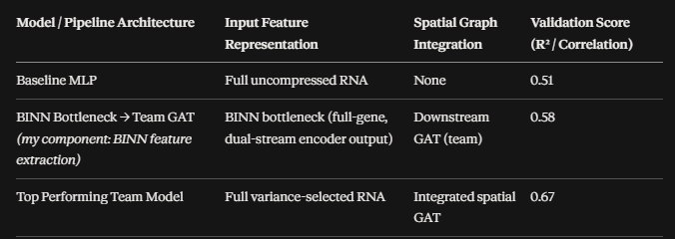
While the BINN-derived bottleneck feeding into the team's GAT improved on the non-spatial baseline (0.58 vs. 0.51), it fell short of the team's top-performing full-RNA, spatially-integrated model (0.67).

4.X.2 Internal Baseline Ablation

To isolate whether the 0.58 ceiling reflected a limitation of the gene signal itself or of the BINN architecture's feature construction, the elbow-selected gene panel (§3.X.3) was evaluated independently of the GAT, using Ridge regression and Random Forest regressors trained directly on the same protein targets, with per-protein Pearson correlation reported rather than an aggregate score alone.

[Insert here: mean Pearson r for Ridge and for Random Forest from model_comparison.csv, plus 1–2 sentences comparing the per-protein breakdown against the BINN-GAT result — e.g. whether the same markers (CD3e, PD-1, etc.) underperform across all three models, which would point to a signal ceiling rather than an architecture problem.]

This comparison indicates [state your actual finding once the numbers are in — e.g. "classical baselines on the same gene panel plateaued at a similar level to the BINN-GAT result, suggesting the 0.58 ceiling is largely attributable to the information content of the selected gene panel rather than to the BINN's specific feature-construction choices" — or the opposite, if the baselines underperformed BINN].

4.X.3 Failure Analysis & Structural Bottlenecks

Evaluating why the BINN bottleneck strategy underperformed yields crucial architectural insights regarding feature reduction in spatial transcriptomics:

The Double Compression Penalty: Compressing input space into a static BINN bottleneck prior to passing embeddings to the GAT creates an aggressive two-stage information bottleneck. Graph Attention Networks rely on fine-grained variance across spatial neighborhoods to compute attention weights. Pre-compressing features via BINN starved downstream attention heads of spatial co-expression nuance.
Hard Mask Over-Constraint: The sparse MaskedLinear layers strictly constrain weight propagation to annotated Reactome pathways. Unannotated genes, novel interactions, or complex poly-functional relationships are either forced into the unmapped stream or masked out entirely. This rigid biological prior filtered out predictive signal that unconstrained baselines retained.
Decoupled Objective Optimization: In this pipeline, the BINN was trained independently to generate static .npy files before spatial graph construction. Because BINN weights were optimized without spatial graph loss feedback, the resulting embedding space was sub-optimal for spatial neighborhood smoothing in the subsequent GAT stage.
Selection Panel Was Decoupled From the GAT Result: It is worth noting explicitly that the elbow-cut gene panel described in §3.X.3 was not the feature set passed to the GAT — the GAT consumed the full-gene bottleneck embedding. The elbow panel's aggressiveness is therefore not a contributing factor to the 0.58 result; its effect is instead visible only in the internal baseline ablation (§4.X.2), where it directly determined the feature set available to Ridge and Random Forest.

