DATABASE MANAGEMENT SYSTEMS
Review 3
Green Campus Carbon Footprint
& Energy Audit Tracker
Working Prototype and Final Report
Course | Database Management Systems (BACSE202)
Database | MySQL 8.0
Application | Python 3 + Flask, mysql-connector-python
Submission deadline | 26 October 2026
Project link | github.com/abitha7-glitch/green_campus_tracker
Submitted by
Abitha Laxmi P 25BCE0535
Vishnunarayan Praveen 25BCE0761
Daksh Bharath Singoor 25BDS0319
Department of Computer Science and Engineering

Contents

(Word asks to update this table when the file opens. Say Yes, or right-click it and choose Update Field.)

Where each Review 3 item is covered
Review 3 requirement | Section
Simple user interface | Section 3
Database connectivity | Section 4
CRUD operations | Section 5
Search / retrieval operations | Section 6
Important SQL queries through the application | Section 7
Input validation | Section 8
Test cases | Section 9
Final database | Section 10
Final project report | This document
Presentation / complete flow | Section 11 (demo flow)

1. Introduction
In Review 1 we designed the Green Campus Carbon Footprint & Energy Audit Tracker, and in Review 2 we turned the ER diagram into seven MySQL tables with keys, constraints, a trigger, sample data, queries and two views. The last thing missing was a way for somebody in the sustainability office to actually use the database without typing SQL.
Review 3 adds that. It is a small web application, written in Python with Flask, that connects to the same database. From the browser you can add, change and delete records in every table, log meter readings and watch the trigger work out their CO2e, search across the data, run all of our Review 2 queries, and print an audit report for any date range.
The tables from Review 2 did not need to change. We added one trigger, one stored procedure and a few rules in the application, all explained in Section 10. The sample data is also the same as Review 2, so every number in that report can be checked again here.

2. How the Application is Built
The application has three layers. The browser shows HTML pages. Flask receives each request, checks the input and decides which SQL to run. MySQL stores everything and enforces the constraints.
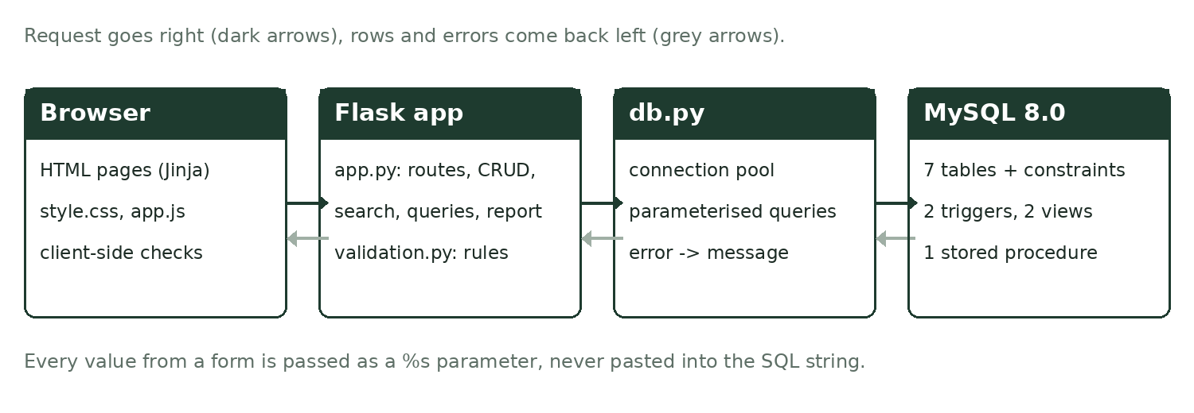
Figure 1: The three layers and the files that belong to each
File | What it does
app.py | All the pages: overview, CRUD for six tables, building details, carbon log, search, SQL queries, audit report
db.py | Connection pool and small helpers to run a query, a write, a stored procedure or a read-only query; turns MySQL error codes into readable messages
validation.py | Server-side checks for every form, matching the CHECK, ENUM and UNIQUE rules in the schema
config.py | Database host, user, password and name
init_db.py | Loads the two SQL files into MySQL (used by us and by the tests)
sql/ | 01_schema.sql, 02_seed.sql and 03_queries.sql
templates/, static/ | HTML templates, the stylesheet and a small JavaScript file
tests/test_app.py | The automated test cases from Section 9

We picked Flask because it is small enough that every line can be explained in the viva, and because the SQL stays visible in the code instead of being hidden behind an ORM. All queries in the application are plain SQL.

3. User Interface
The interface has a fixed menu on the left and the page content on the right. The menu is grouped into Records (the data people work with every day), Look things up (search, report, queries) and Setup (departments and emission factors, which rarely change). The yellow Log a reading button is the one action people will use most, so it is always on screen.
We wanted the screens to feel like they belong to an energy audit, so a few things are borrowed from real meters and labels:
- Meter counter. The campus total on the overview is shown like the rolling digits of an electricity meter, with the last digit in red for tenths.
- Building rating. Buildings are banded A to G by kg CO2e per square foot, drawn like the energy rating label on appliances. The bands are our own cut-offs (A under 0.05, then every 0.025). It reads the vw_building_carbon_summary view.
- Scope colours. Scope 1, 2 and 3 always use the same three colours on every page, so a reader can tell the source at a glance.
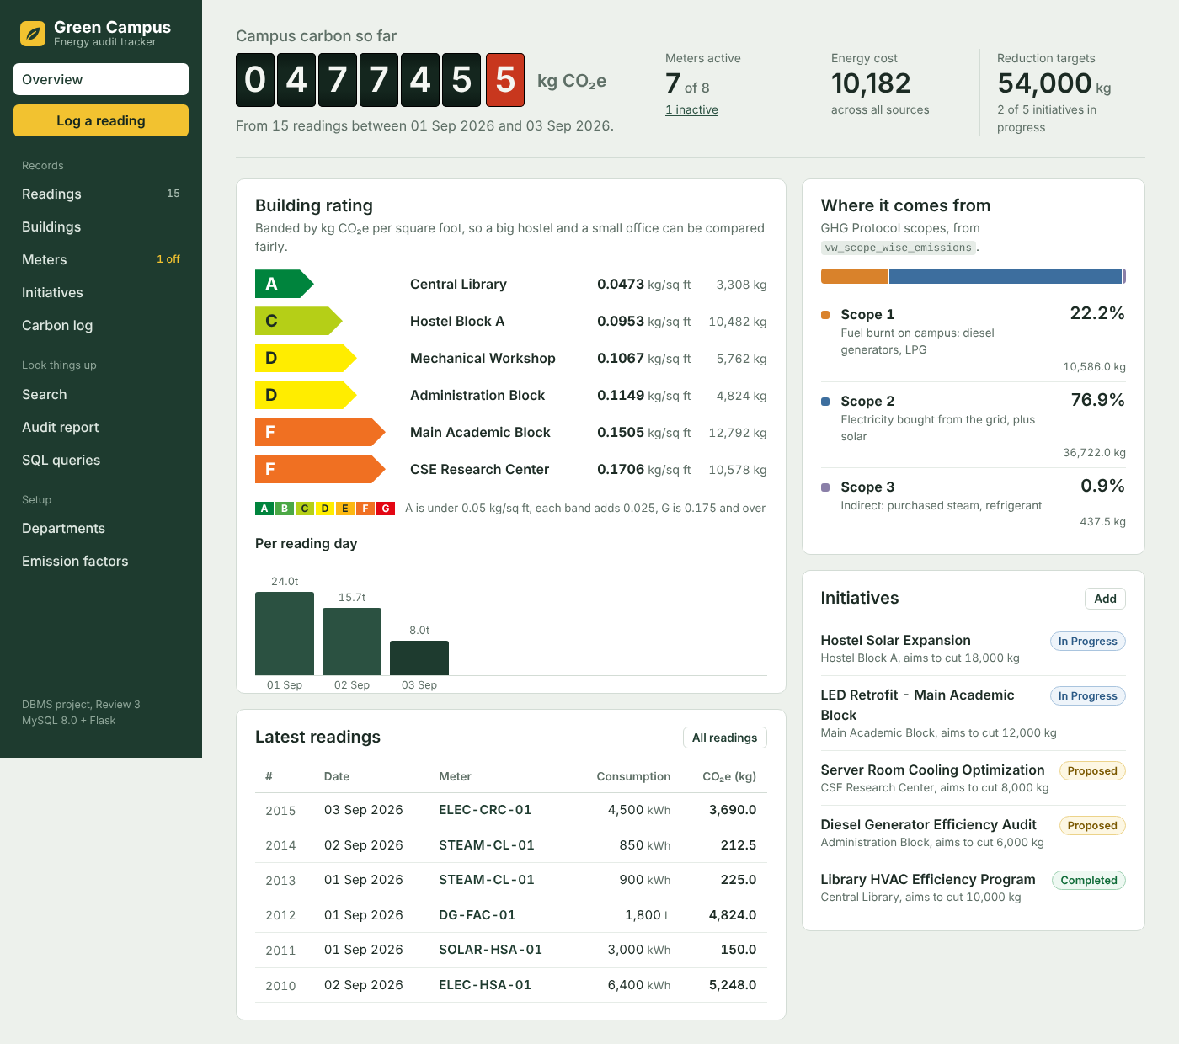
Figure 2: Overview page
Every list page has a filter box and sortable columns, and every record has Edit and Delete links. A building name opens a detail page that pulls together its meters, readings and initiatives (Figure 4).
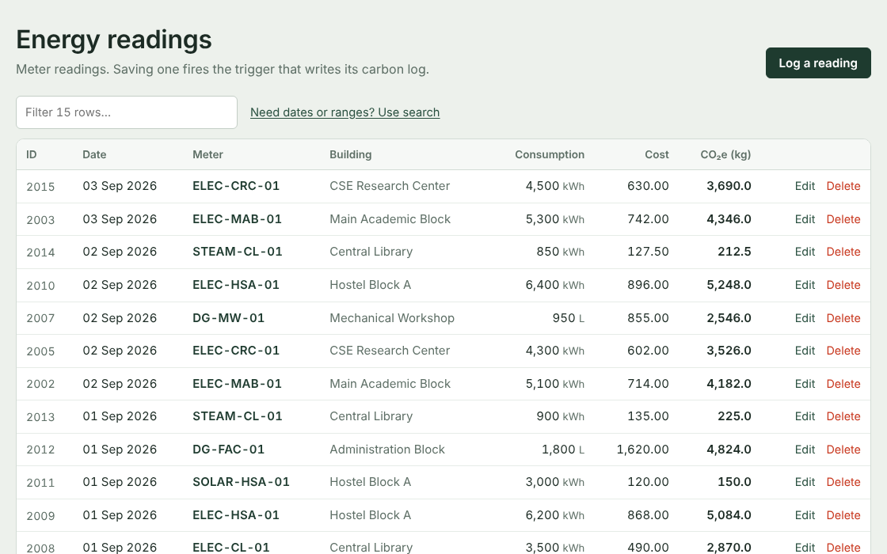
Figure 3: Energy readings list, newest first
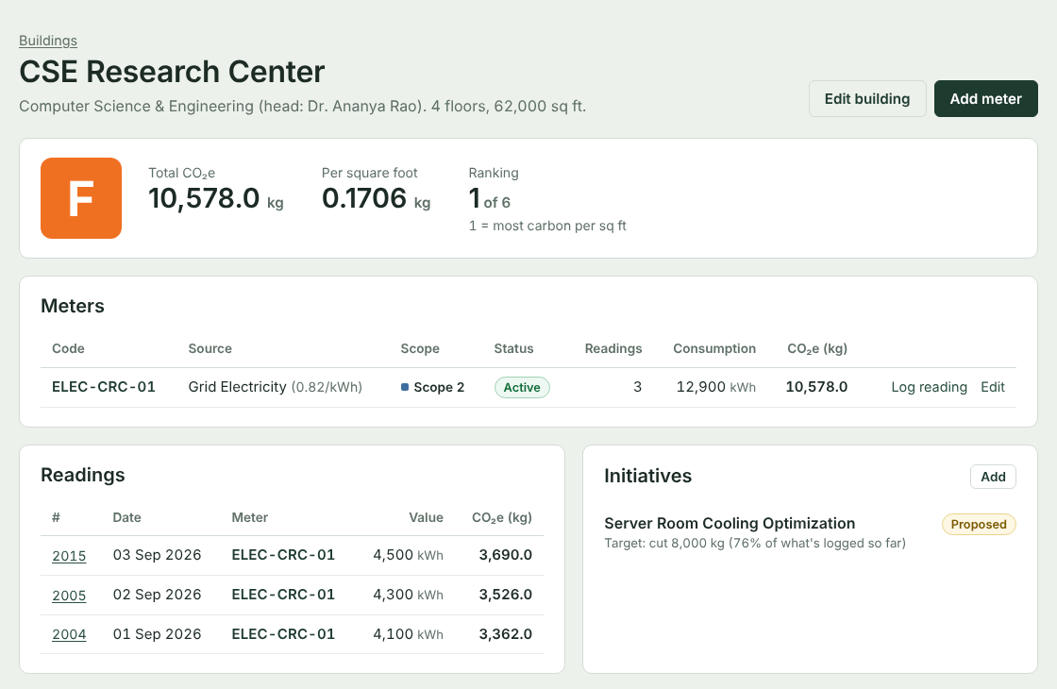
Figure 4: Building detail page for the CSE Research Center
The layout also works on a phone. The menu folds into a button and the tables scroll sideways, which is useful for someone reading a meter on the spot.
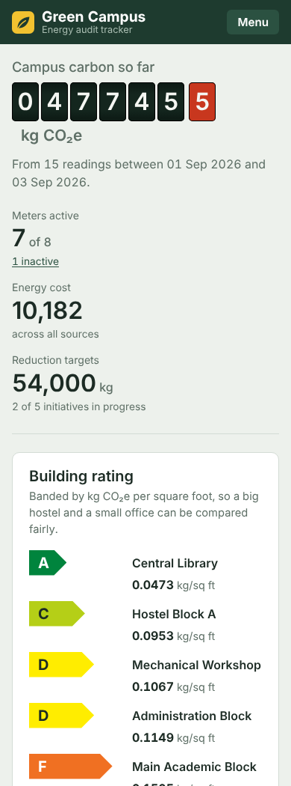
Figure 5: Overview on a phone-sized screen

4. Database Connectivity
The application connects with mysql-connector-python. The login details are kept in config.py and can be overridden with environment variables, so nobody's password has to be written into the code:
DB_HOST = os.environ.get("GC_DB_HOST", "localhost")
DB_USER = os.environ.get("GC_DB_USER", "root")
DB_PASSWORD = os.environ.get("GC_DB_PASSWORD", "")
DB_NAME = os.environ.get("GC_DB_NAME", "green_campus_db")
Opening a new MySQL connection for every page is slow, so db.py creates a pool of five connections when the first page is loaded and reuses them:
_pool = pooling.MySQLConnectionPool(
pool_name="greencampus", pool_size=5,
host=config.DB_HOST, port=config.DB_PORT,
user=config.DB_USER, password=config.DB_PASSWORD,
database=config.DB_NAME, autocommit=True)
Parameterised queries. Every value that comes from a form is sent as a %s parameter and never joined into the SQL string. For example, adding a reading runs:
INSERT INTO energy_readings
(reading_id, meter_id, reading_date, consumption_value, cost_incurred)
VALUES (%s, %s, %s, %s, %s)
MySQL receives the values separately from the statement, so text like ' OR 1=1 -- typed into a field is stored as text and cannot change the query. This protects against SQL injection.
Errors. If MySQL rejects a statement, db.friendly_error() turns the error code into a sentence for the user, for example 1062 (duplicate entry), 1451 (row still referenced), 1452 (parent missing), 3819 (CHECK failed) and 1265 (value not in the ENUM). If the database cannot be reached at all, the app shows a page telling the user to check config.py and that MySQL is running, instead of crashing.

5. CRUD Operations
Six of the seven tables can be created, read, updated and deleted from the app. carbon_logs is deliberately read-only: only the triggers write to it, which is the whole point of having them.
Table | Create | Read | Update | Delete
departments | Yes | Yes | Yes | Yes (buildings kept, SET NULL)
buildings | Yes | Yes + detail page | Yes | Yes (CASCADE)
emission_factors | Yes | Yes | Yes | Blocked while in use (RESTRICT)
meters | Yes | Yes | Yes | Yes (CASCADE)
energy_readings | Yes (fires trigger) | Yes | Yes (fires trigger) | Yes (CASCADE to log)
audit_initiatives | Yes | Yes | Yes | Yes
carbon_logs | Trigger only | Yes | Trigger only | Through CASCADE only

5.1 Create and the trigger
The ids follow the ranges from Review 2 (buildings from 101, meters from 1001, readings from 2001, initiatives from 3001). The form shows which id the new row will get, and the app assigns MAX(id) + 1 when it saves. Departments and carbon logs use AUTO_INCREMENT as before.
While a reading is being typed, a box beside the form estimates the CO2e from the meter's factor. The real value is still written by the trigger. After saving, the app reads the new carbon_logs row back and shows it in the confirmation message, so the trigger can be seen working during the demo.
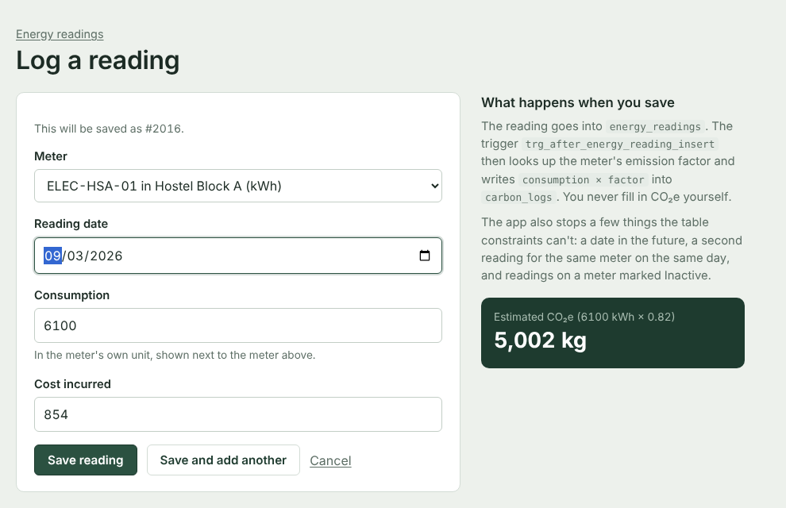
Figure 6: Logging a reading, with the live estimate
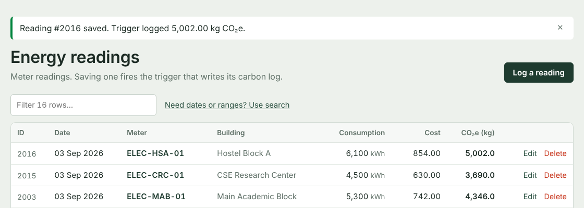
Figure 7: Confirmation after saving, showing the value the trigger logged

5.2 Update
The edit form is the same form with the current values filled in. Each table's update is one statement, for example UPDATE buildings SET building_name = %s, dept_id = %s, floors = %s, total_area_sqft = %s WHERE building_id = %s.
Editing a reading needed something new in the database. In Review 2 the trigger only ran on INSERT, so if the consumption was corrected later, the old CO2e would stay in carbon_logs. We added trg_after_energy_reading_update (Section 10.2).

5.3 Delete
Deleting never happens on a single click. A confirmation page first counts what else the delete will affect and says which foreign key rule causes it. This made the ON DELETE choices from Review 2 section 3 visible in the application:
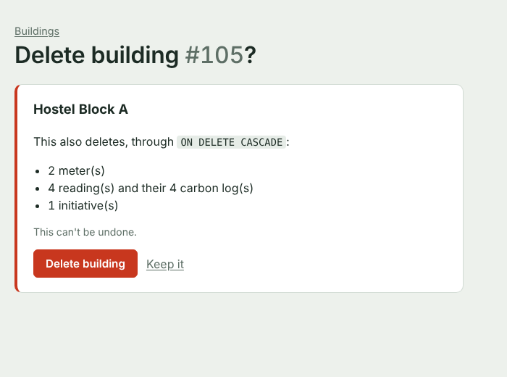
Figure 8: Deleting Hostel Block A lists everything ON DELETE CASCADE will remove
Trying to delete Grid Electricity, which four meters still use, is refused by MySQL because that foreign key is ON DELETE RESTRICT. The app shows the reason instead of an error code:
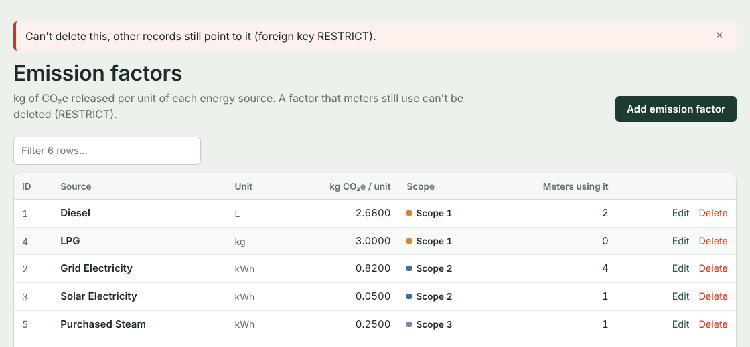
Figure 9: The RESTRICT rule stopping a delete

6. Search and Retrieval
The Search page looks through four tables at once. The text box matches meter codes, building names, department names, energy sources, initiative titles and reading numbers using LIKE. Filters narrow it down by building, energy source, scope, status, reading date range and consumption range. All filters are added to the WHERE clause as parameters, only when they are filled in.
Under the reading results the page adds up the consumption, cost and CO2e of what was found. Consumption is only added up when all the readings are in the same unit; otherwise it says mixed units, for the same reason we gave in Review 2 section 7.4.
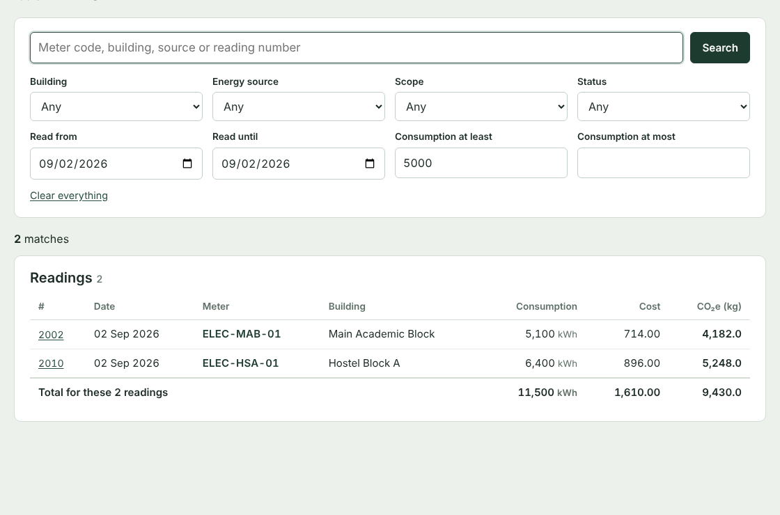
Figure 10: Readings on 2 September 2026 with consumption of 5,000 or more
Other ways of retrieving data in the app:
- The building detail page joins buildings, departments, meters, emission_factors, energy_readings, carbon_logs and audit_initiatives for one building, and ranks it against the others using the view.
- Every list page has a quick filter box and click-to-sort columns.
- The carbon log page recalculates each logged value from the current factor and marks whether it still matches.

7. Important SQL Queries Through the Application

7.1 The SQL queries page
All the queries from Review 2 (sections 7.1 to 8.2) run live on one page, each with a short note, the SQL behind a Show SQL toggle, and its result. The queries are read from sql/03_queries.sql, so the file we submit and what the page shows are always the same. Two new queries were added for Review 3: a check that every carbon_logs value equals consumption x factor, and a comparison of each initiative's target with what its building emits now (using a LEFT JOIN with the view).
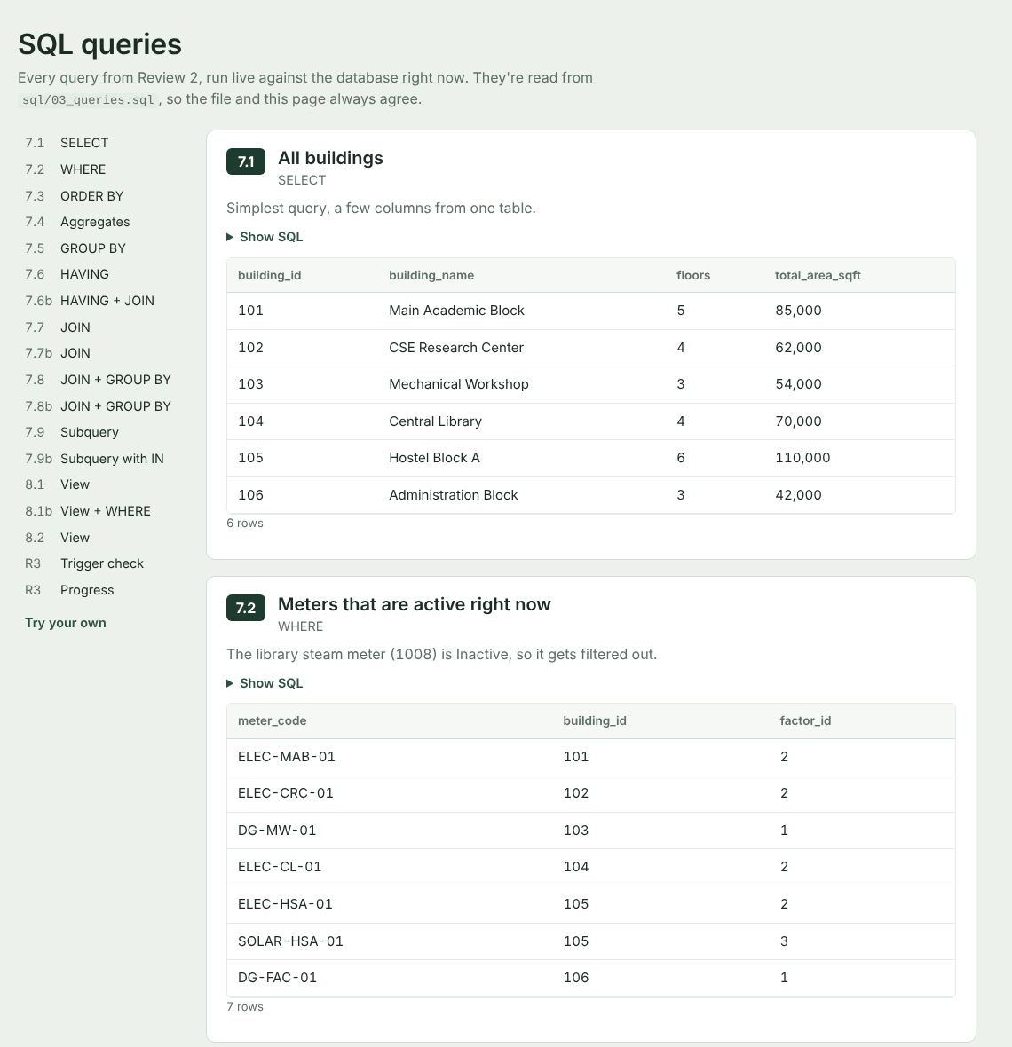
Figure 11: SQL queries page with a jump list for every clause

7.2 Read-only query console
At the bottom of that page anyone can type their own SELECT. We added it so that if an examiner asks a what-if question, we can answer it on the spot. To keep it safe it has two layers:
- The app only accepts one statement that starts with SELECT, SHOW, DESCRIBE, EXPLAIN or WITH, and refuses anything containing words like INSERT, UPDATE, DELETE, DROP or CALL.
- The query then runs inside START TRANSACTION READ ONLY, which is rolled back afterwards. Even if something got past the first check, MySQL itself would refuse to write.
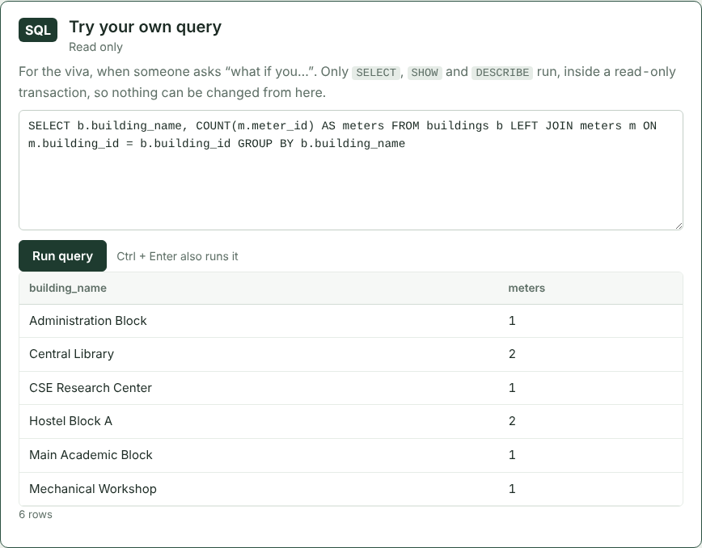
Figure 12: Running our own query from the console

7.3 Audit report with a stored procedure
The Review 1 slides showed a stored procedure for an audit report. For Review 3 we wrote it. It takes a start and end date and groups the readings in that period by building and energy source:
CREATE PROCEDURE sp_GetCampusAuditReport(IN p_from DATE, IN p_to DATE)
BEGIN
SELECT b.building_name, ef.scope_level, ef.source_type,
COUNT(er.reading_id) AS readings,
SUM(er.consumption_value) AS period_consumption, ef.unit,
ROUND(SUM(cl.calculated_co2e_kg), 2) AS period_co2e_kg,
SUM(er.cost_incurred) AS period_cost
FROM energy_readings er
JOIN meters m ON er.meter_id = m.meter_id
JOIN buildings b ON m.building_id = b.building_id
JOIN emission_factors ef ON m.factor_id = ef.factor_id
JOIN carbon_logs cl ON cl.reading_id = er.reading_id
WHERE er.reading_date BETWEEN p_from AND p_to
GROUP BY b.building_id, b.building_name, ef.scope_level, ef.source_type, ef.unit
ORDER BY period_co2e_kg DESC;
END
The Audit report page calls it with cursor.callproc() and adds the campus total, each row's share and the split by scope. The report can be printed (the menu and buttons are hidden when printing) or downloaded as a CSV file.
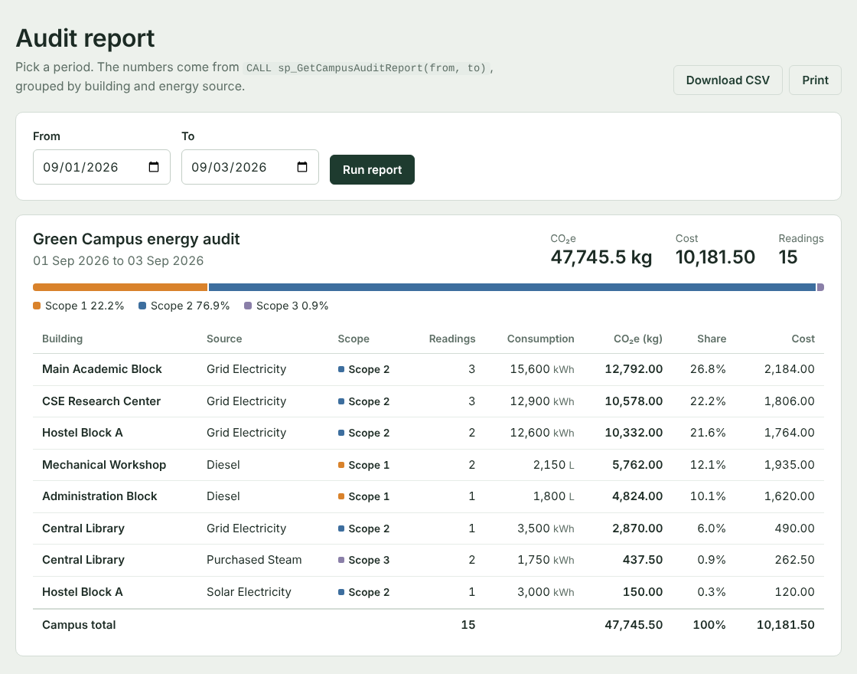
Figure 13: Audit report for 1 to 3 September 2026
For the full sample period the totals agree with Review 2: 47,745.50 kg CO2e, Scope 2 at 76.9%, Scope 1 at 22.2% and Scope 3 at 0.9%.

7.4 Views used by the pages
- vw_building_carbon_summary gives the building ratings on the overview, the CO2e column on the buildings list and the ranking on each building page.
- vw_scope_wise_emissions gives the scope split on the overview.

8. Input Validation
Input is checked in three places. Each one catches things the others cannot, and the database always has the last word.
Layer | Where | What it catches
1. Browser | HTML attributes and app.js | Empty required fields, negative numbers, non-numbers, wrong email format, bad meter code pattern, dates in the future, an end date before a start date. Errors appear under the field before anything is sent.
2. Server | validation.py | Everything above again (the browser checks can be switched off), plus checks that need the database: duplicate names and codes, the chosen department, building, meter or factor really exists, one reading per meter per day, no new readings on an Inactive meter.
3. Database | Constraints in 01_schema.sql | PRIMARY KEY, FOREIGN KEY, UNIQUE, CHECK, ENUM and NOT NULL, exactly as in Review 2 section 4.

The three rules below exist only in the application. They depend on other rows or on today's date, which a CHECK constraint cannot look at:
- No future dates. A meter can't be read tomorrow.
- One reading per meter per day. Two readings for the same meter on the same date would be counted twice in every total.
- No new readings on an Inactive meter. Meter 1008 (the library steam meter) is Inactive in the sample data. Old readings of a meter that was switched off later can still be edited.
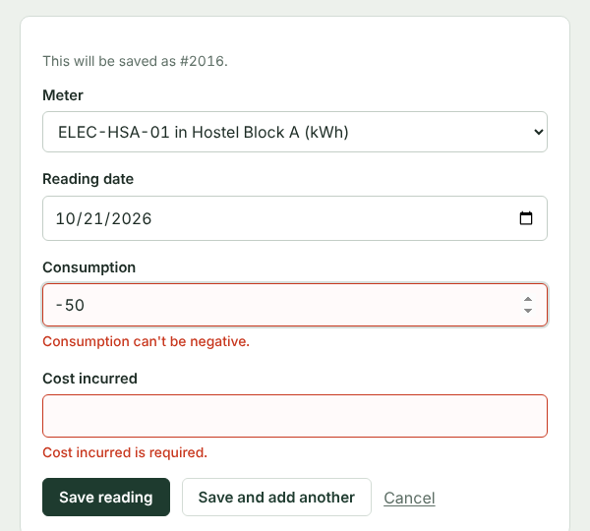
Figure 14: Browser-side checks: a negative value and an empty cost
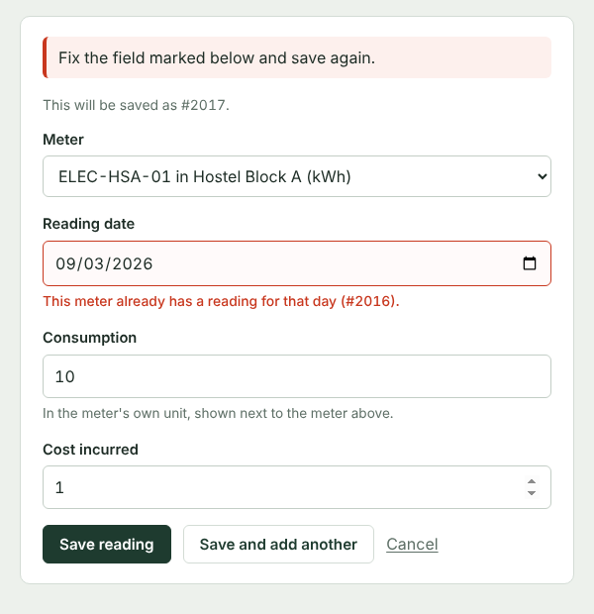
Figure 15: Server-side check: a second reading for the same meter and day

9. Test Cases
The test cases are written as automated tests in tests/test_app.py, using pytest and Flask's test client. Before every test the test database (green_campus_test) is rebuilt from the same two SQL files, so each test starts from the Review 2 data and the tests cannot affect each other or the real database.
TC25 repeats the six negative tests from Review 2 section 4.1 directly against MySQL, without the application, to show the constraints still hold on their own.
ID | Test | Input | Expected result | Result
TC01 | Open the overview | GET / | Page loads, total shows 47,745.5 kg CO2e | Pass
TC02 | Open every page | 11 page URLs | Every page returns 200 | Pass
TC03 | Create a department | Electrical Engineering, valid fields | Saved; departments has 4 rows | Pass
TC04 | Read the meters list | GET /meters/ | ELEC-MAB-01, SOLAR-HSA-01, STEAM-CL-01 listed | Pass
TC05 | Update a building | Administration Block floors 3 to 4 | Saved; floors = 4 | Pass
TC06 | Delete an initiative | Initiative 3005 | Deleted; 4 initiatives left | Pass
TC07 | Insert trigger | 5,000 kWh on ELEC-MAB-01 | Reading 2016 saved; carbon log = 4,100.000 kg | Pass
TC08 | Update trigger | Reading 2001 changed to 1,000 kWh | Carbon log changes from 4,264 to 820.000 kg | Pass
TC09 | Negative consumption | consumption = -50 | Rejected: can't be negative; still 15 readings | Pass
TC10 | Zero floors | floors = 0 | Rejected: must be at least 1 | Pass
TC11 | Future date | tomorrow's date | Rejected: can't be in the future | Pass
TC12 | Same meter, same day | meter 1001 on 01 Sep 2026 | Rejected: already has reading #2001 | Pass
TC13 | Inactive meter | reading for meter 1008 | Rejected: STEAM-CL-01 is Inactive | Pass
TC14 | Duplicate meter code | elec-mab-01 (lower case) | Rejected: ELEC-MAB-01 already used | Pass
TC15 | Bad email, bad status | civil-at-uni; status Cancelled | Both rejected with field messages | Pass
TC16 | Delete factor in use | Delete Grid Electricity | Refused by RESTRICT; factor still there | Pass
TC17 | Cascade delete | Delete Hostel Block A | 2 meters, 3 readings, 3 logs, 1 initiative gone | Pass
TC18 | SET NULL delete | Delete department 1 | Its 2 buildings stay with dept_id NULL | Pass
TC19 | Text search | q = DG | Both diesel meters found, no ELEC meters | Pass
TC20 | Date + value search | 2 Sep 2026, consumption >= 5000 | Exactly 2 matches (2002, 2010) | Pass
TC21 | Reversed dates | from 3 Sep to 1 Sep | Warning that the start is after the end | Pass
TC22 | Review 2 queries | GET /queries | 12,792 kg, 0.1706 and 36,722 kg appear as in Review 2 | Pass
TC23 | Stored procedure | Report for 1 Sep 2026; CSV | 8 readings; CSV file downloads | Pass
TC24 | Console blocks writes | DELETE ...; SELECT ...; DROP ... | Both refused; still 8 meters | Pass
TC25a | DB CHECK | Raw INSERT, consumption -50 | MySQL error 3819 (CHECK) | Pass
TC25b | DB CHECK | Raw INSERT, floors 0 | MySQL error 3819 (CHECK) | Pass
TC25c | DB FOREIGN KEY | Reading for meter 9999 | MySQL error 1452 | Pass
TC25d | DB UNIQUE | Second ELEC-MAB-01 | MySQL error 1062 | Pass
TC25e | DB ENUM | Status 'Cancelled' | MySQL error 1265 | Pass
TC25f | DB RESTRICT | Raw DELETE of factor 2 | MySQL error 1451 | Pass

Running python -m pytest -v gives:
tests/test_app.py::test_tc01_dashboard_loads_with_correct_total PASSED
tests/test_app.py::test_tc02_every_page_opens PASSED
... (26 more lines, all PASSED)
tests/test_app.py::test_tc25_constraints_reject_bad_sql[DELETE FROM ...] PASSED
============================== 30 passed in 1.86s ==============================
We also went through the whole demo flow by hand in Chrome, including on a narrow phone-sized window.

10. Final Database
The final database is created by sql/01_schema.sql and filled by sql/02_seed.sql. The script drops and recreates every object, so it can be run again to get back to a clean state after a demo.
Object | Count | Names
Tables | 7 | departments, buildings, emission_factors, meters, energy_readings, carbon_logs, audit_initiatives
Triggers | 2 | trg_after_energy_reading_insert (Review 2), trg_after_energy_reading_update (new)
Views | 2 | vw_building_carbon_summary, vw_scope_wise_emissions
Stored procedures | 1 | sp_GetCampusAuditReport (new)
Foreign keys | 6 | Same ON DELETE / ON UPDATE actions as Review 2 section 3
Sample rows | 58 | 3 + 6 + 6 + 8 + 15 + 15 (by trigger) + 5 - same as Review 2

10.1 Consistency with Reviews 1 and 2
The ER diagram, the relational schema and the actual tables are the same seven entities with the same keys and relationships. The table and column names from Review 2 are unchanged. The only additions are the trigger and the procedure below, which do not change any table.

10.2 New trigger: keeping carbon logs right after an edit
CREATE TRIGGER trg_after_energy_reading_update
AFTER UPDATE ON energy_readings
FOR EACH ROW
BEGIN
DECLARE factor_rate DECIMAL(10,4);
IF NEW.consumption_value <> OLD.consumption_value
OR NEW.meter_id <> OLD.meter_id THEN
SELECT ef.co2e_per_unit INTO factor_rate
FROM meters m
JOIN emission_factors ef ON m.factor_id = ef.factor_id
WHERE m.meter_id = NEW.meter_id;

UPDATE carbon_logs
SET calculated_co2e_kg = NEW.consumption_value * factor_rate,
logged_at = CURRENT_TIMESTAMP
WHERE reading_id = NEW.reading_id;
END IF;
END
It only recalculates when the reading itself changes. If only the date or cost is edited, the log stays as it was. Changing an emission factor does not touch any existing log either; that keeps the audit-record decision from Review 2 section 9, where logged figures must not silently change. The carbon log page marks any log written with an older factor (Figure 16).
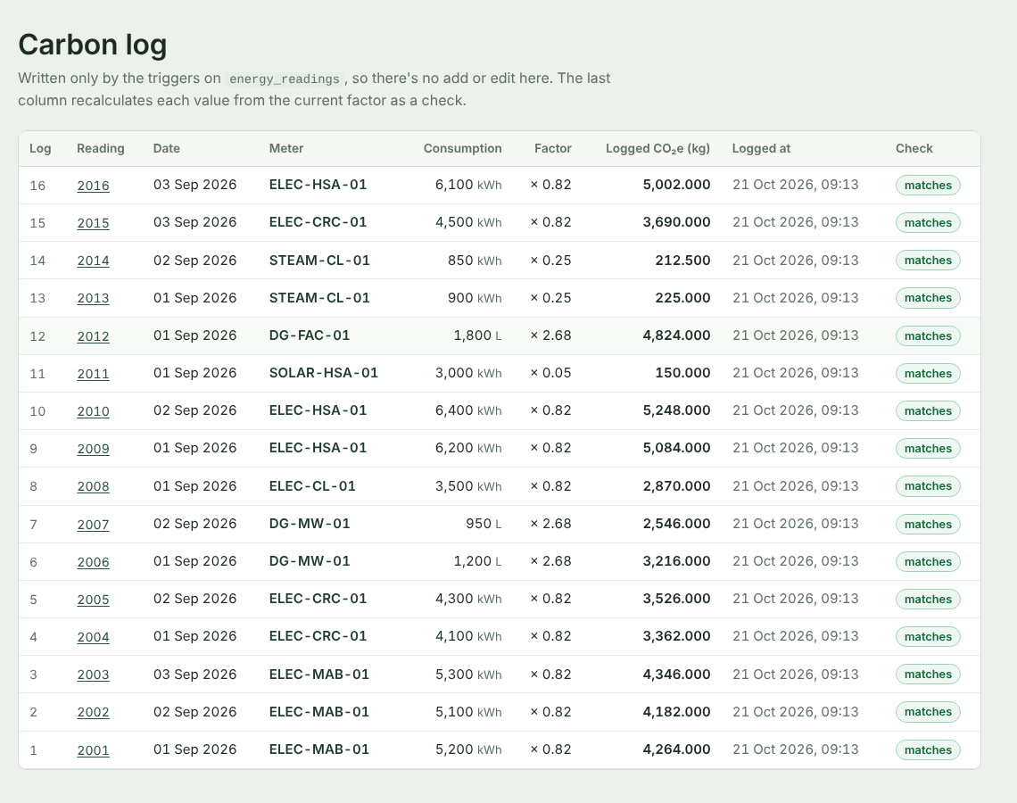
Figure 16: Carbon log page with the recalculation check

11. Running the Project and Demo Flow

11.1 Setup
All the code, SQL files and tests are on GitHub: https://github.com/abitha7-glitch/green_campus_tracker
- Download it with git clone https://github.com/abitha7-glitch/green_campus_tracker.git or the Code > Download ZIP button on that page.
- Install the packages: pip install -r requirements.txt
- Put the MySQL username and password in config.py.
- Create the database with python init_db.py, or run 01_schema.sql then 02_seed.sql in MySQL Workbench.
- Start the app with python app.py and open http://127.0.0.1:5000
- Run the tests with python -m pytest -v

11.2 Order of the final demonstration
Step | What we show | Requirement
1 | Overview: meter counter, building rating, scope split | User interface, views
2 | Log 6,100 kWh on ELEC-HSA-01 and show the logged CO2e | Create, trigger
3 | Try -50, tomorrow's date and a second reading for the same day | Input validation
4 | Edit that reading and open the carbon log | Update, new trigger
5 | Open the delete page of Hostel Block A, then try deleting Grid Electricity | Delete, CASCADE, RESTRICT
6 | Search readings on 2 Sep with consumption >= 5000 | Search / retrieval
7 | SQL queries page and one query typed in the console | Important SQL queries
8 | Audit report for 1 to 2 Sep, download the CSV | Stored procedure
9 | python -m pytest -v | Test cases

12. Conclusion
Over the three reviews the project went from a problem statement and ER diagram to a working application on top of a MySQL database. The final version keeps the seven-table design from Review 2, lets the database do the carbon calculation through triggers, enforces data rules at three levels, and makes every Review 2 query and view available from the browser. All 30 test cases pass on the sample data.
Some things we would add with more time:
- Logins, so that only the facilities team can delete records and departments can only log readings for their own buildings.
- Reading meters automatically through an API from smart meters, as mentioned in our Review 1 future scope, instead of typing values in.
- A department_emails table so a department can have several contact addresses (Review 2 section 2.3).
- Monthly trend charts once there are more than three days of readings.

