**Experiment 18:** Create a Simple Web Application using Java or Python and host it in any Public Cloud Service Provider (Azure/GCP/AWS) to demonstrate Platform as a Service (PaaS).

Step 1: Search For Static Web App and Click on Create Option.

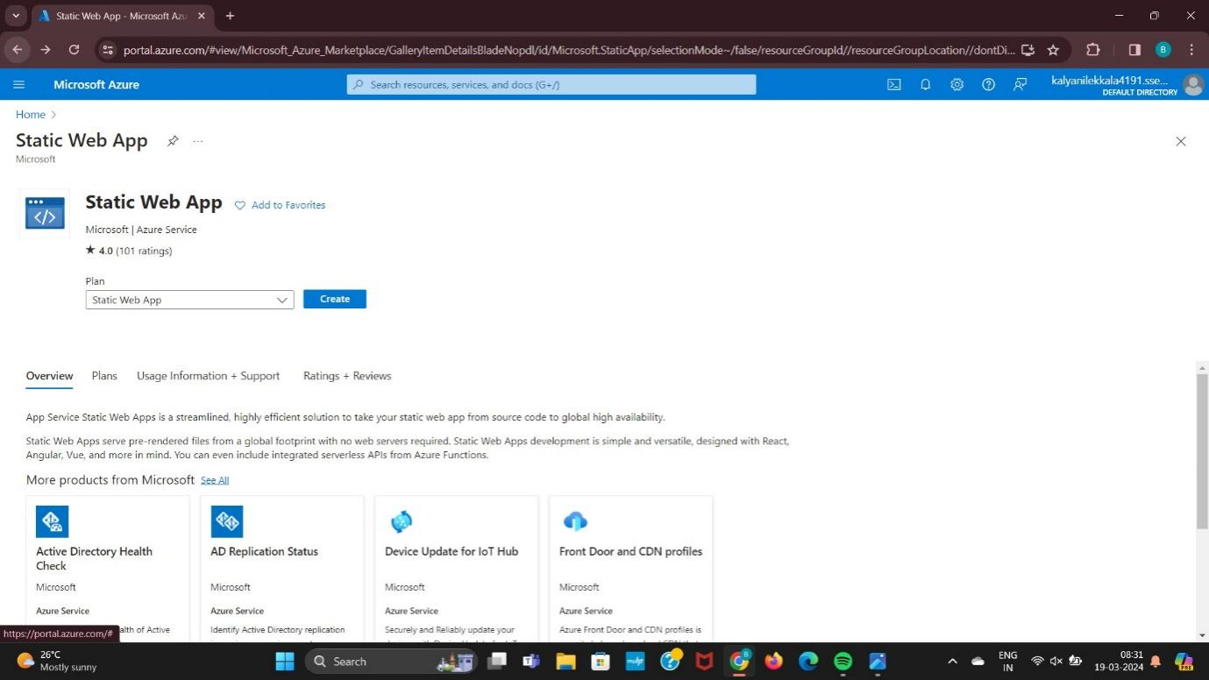

Step 2: Enter the resource group and Static web app details.

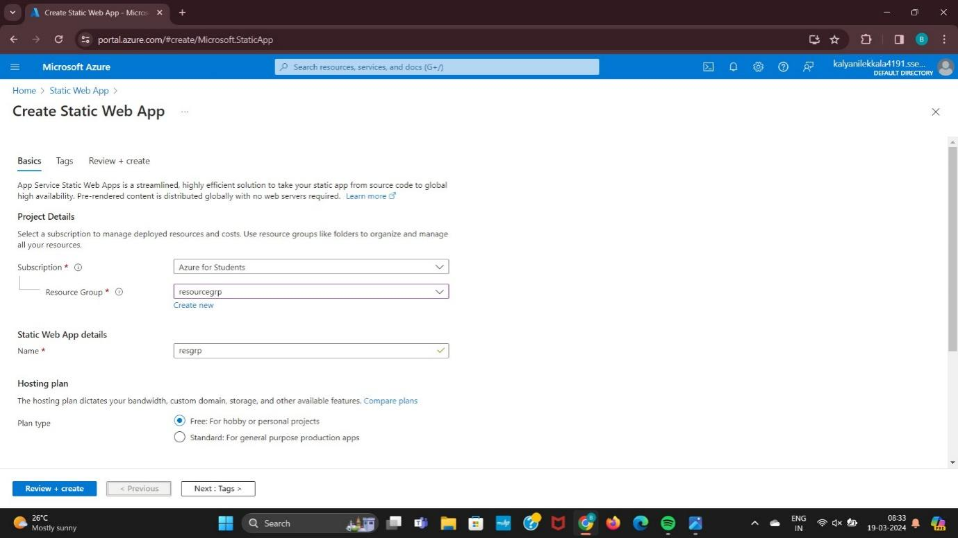

Step 3: Enter the Details Of the Tags.

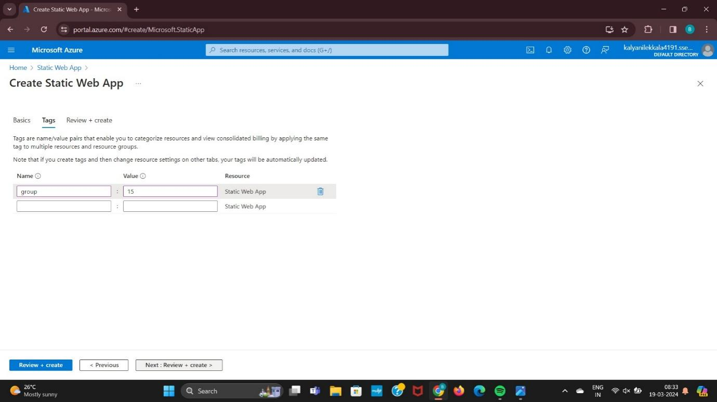

Step 4: Enter the Review + Create details there it will come Validation passed.

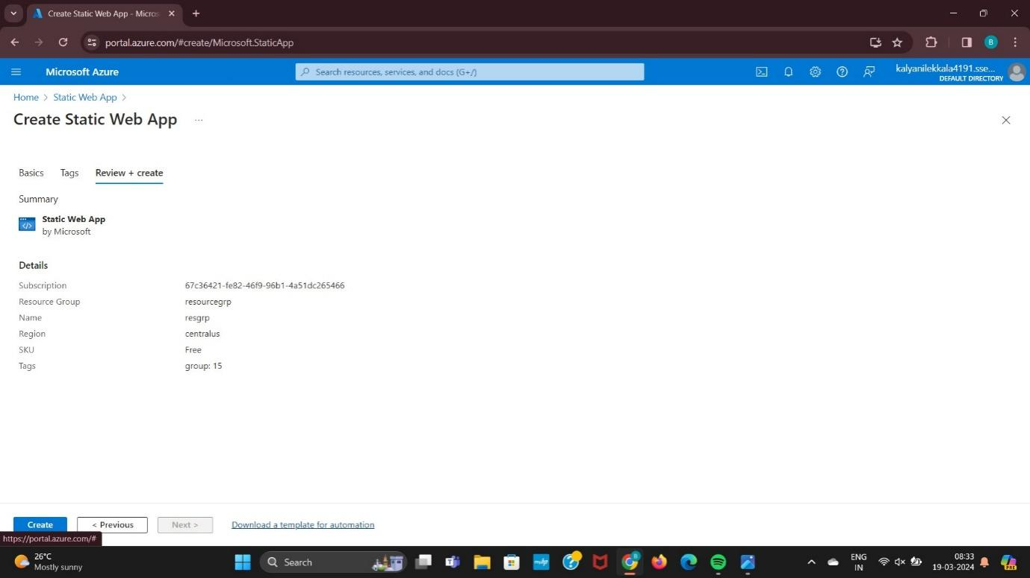

Step 5: There it will come Web Static App.

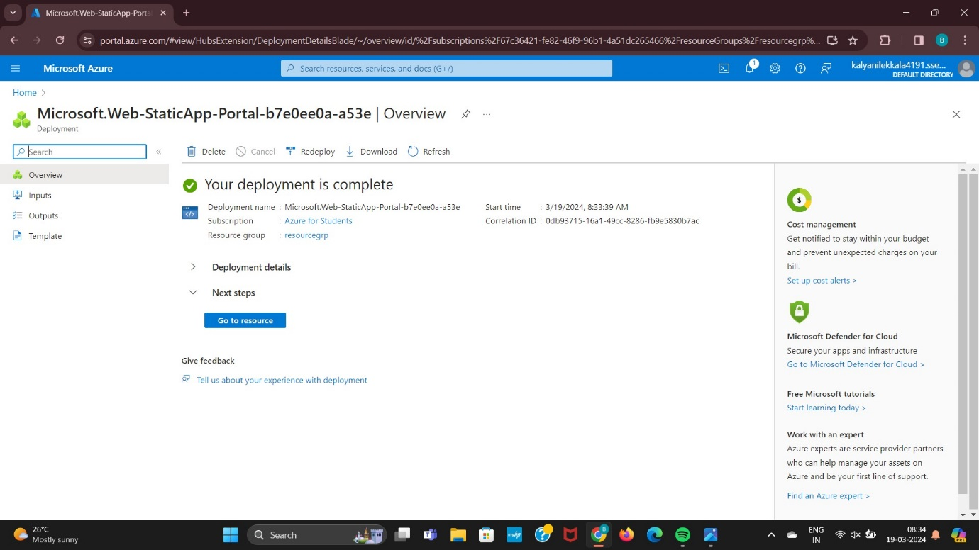

Step 6: Finally Web App Created.

