MINDSYNC:AN AI-POWERED MENTAL HEALTH ASSISTANCE SYSTEM

AbithaShree S

*Department of Computer Science and Engineering*

*Panimalar Engineering College*

[abithashree200512@gmail.com](mailto:abithashree200512@gmail.com)

Asitha L

*Department of Computer Science and Engineering*

*Panimalar Engineering College*

[asitha171005@gmail.com](mailto:asitha171005@gmail.com)

***Abstract— Mental health challenges affect millions worldwide, yet access to support is often limited by stigma, financial barriers, and shortages of mental health professionals. This paper introduces MINDSYNC, an AI-powered mental health assistant designed to provide empathetic, private, and convenient support. The system combines Natural Language Processing (NLP), speech recognition, and facial emotion analysis to facilitate interactive conversations, detect emotional states, and deliver personalized strategies grounded in evidence-based therapeutic approaches—without requiring wearables or IoT devices. Initial evaluations indicate emotion recognition accuracy between 85–88% and response times under four seconds. These results suggest that MINDSYNC can serve as a complementary tool to traditional therapy, potentially reducing barriers to care and expanding mental health support to underserved communities.***

***Keywords— Artificial Intelligence (AI), Natural Language Processing (NLP), Conversational AI, Emotion Recognition, Mental Health Support Systems, Cognitive Behavioral Therapy (CBT).***

## I.INTRODUCTION

Mental health is a vital aspect of overall well-being, yet millions of people worldwide experience mental health difficulties in silence, often due to stigma, limited resources, or lack of access to professionals According to the World Health Organization, depression and anxiety alone affect hundreds of millions globally, causing significant social and economic impacts.

Barriers such as high treatment costs, geographic inaccessibility, and cultural stigma often prevent

individuals from seeking care. Recent advancements in artificial intelligence (AI) provide promising avenues to address these challenges. Conversational AI systems, powered by NLP and machine learning, can simulate human-like interactions, offering support that is private, nonjudgmental, and accessible at any time.Unlike conventional therapy, which is limited by appointment schedules, AI-driven solutions can provide continuous support, enabling timely interventions whenever needed. MINDSYNC is developed as an AI mental health companion designed to provide empathetic guidance. The system uses NLP, advanced speech analysis, and facial emotion recognition to interpret user input and deliver personalized responses. By integrating Cognitive Behavioral Therapy (CBT) and mindfulness techniques, MINDSYNC delivers evidence-based strategies to support mental well-being and complement professional care.

## RELATED WORK

*NLP and language-based prediction.*

Text-based data has shown potential for predicting psychiatric symptoms and suicidal ideation, making linguistic patterns valuable for early mental health detection [6]. Transformer-based models, such as BERT, enhance emotion and symptom detection from text, although challenges remain in domain adaptation.Systems like MindCare and InnerCheck apply these approaches to classify suicidal versus non-suicidal content and identify negative sentiment for triage.

*Screening and support chatbots*

Chatbots are widely used for mental health screening and self-help interventions. Early rule-based systems, such as Saathi and Woebot, demonstrated feasibility, while modern AI-driven chatbots leverage machine learning and generative models for adaptive and context-aware responses. Platforms like MindMate and Elevate integrate NLP modules, dialogue management systems, and interactive interfaces to deliver practical conversational support.

*Multimodal and personalized prediction*

Multimodal approaches, which combine text with demographic, behavioral, and physiological data, improve prediction of mental health conditions and help identify personalized risk factors [11]. Machine learning models such as Random Forests and XGBoost are effective in feature selection for individualized assessments.Neural network techniques, including mixstyle networks, aim to generalize across heterogeneous populations, reduce bias, and enhance performance.

# Other contributions

* 1. **Generative AI for Mental Health Research:** Large language models create empathetic dialogue while maintaining safety.
  2. **MindMate Chatbot (Rasa + Streamlit):** Demonstrates multilingual support to reduce digital health disparities.
  3. **Conversational AI in Therapy:** Chatbots can alleviate stress and encourage help-seeking behaviors .
  4. **AI Safety Protocols:** Keyword detection and sentiment analysis help identify suicidal ideation online.

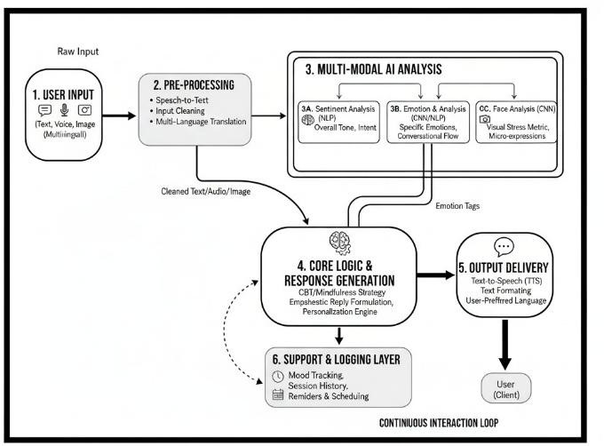

FIGURE1: PROPOSED SYSTEM WORKFLOW

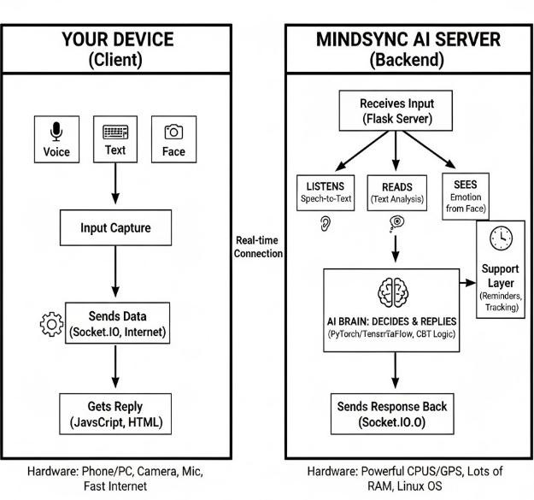

FIGURE 2:ARCHITECTURE DIAGRAM

## DATASET DESCRIPTION

A diverse range of datasets have been employed in earlier research on AI-based mental well-being assistance from public benchmark corpora, to large scale multimodal surveys. So, in order to achieve maximum comparability with related literature and supply linguistic and behavioral coverage as well, and we employ a mixture of text-based, clinical, and multimodal datasets.

TABLE 1. MINDSYNC MULTIMODAL CORPUS SPECIFICATIONS

|  |  |  |  |
| --- | --- | --- | --- |
| **Modality** | **Primary AI Task** | **Data Type / Format** | **Key Features and Labels** |
| Textual | Natural Language Processing (NLP) &  Sentiment Analysis | Conversa tional Text Logs (such as., CSV, JSON) | Tokens (for Vectorization),S entiment Labels (Positive, Negative, Neutral), Emotion Categories (such  as.,Stress, Anger, Calm). |
| Auditory | Speech-to- Text (STT) & Vocal Emotion Recognition | Audio Recordin gs (WAV/ MP3  files) | Mel-Frequency Cepstral Coefficients (MFCCs), Pitch, Energy, Text Transcripts (for  NLP pipeline). |
| Visual | Facial Emotion Recognition  (FER) | Image Frames/ Videos  (PNG/ | Face alignment and cropping, pixel intensities,  facial landmarks |

Thus the dataset description used in minsync.

1. FEATURES OF THE DATA

### Detailed Emotion Analysis

|  |  |  |  |
| --- | --- | --- | --- |
|  |  | JPG  files) | (for expression analysis), emotion categories (such as.,Happy,Sad,  Fear, Neutral). |
| Size | [100,000+  total samples] | Source | [Combination of Public Emotional Datasets (such as.,IEMOCAP, RAVDESS) and  Synthetic Data] |
| Data Quality | Annotation/ Labeling | Labeling Method | Inter-Rater Reliability Score [Kappa > 0.65] for emotional  and sentiment labels, using a consensus-based agreement  among three annotators. |
| Timefram e | Dataset Scope | Collectio n Period | Simulated/ New curateddata (not a live  collection).  Time-series context are  retained via timestamp metadata for sequential analysis. |
| Accessibil ity | Licensing and Usage | licensing and DOI | [Internal Use Only] [(if not publicly released)] or CC BY-NC 4.0  licensing (if used public datset).There is not External DOI currently  assigned. |
| Ethics/ privacy | Compliance | Anonymi zation Status | Fully Anonymized/De- Identified |
| File Structure | Organizatio n | File Organiza tion | Hierarchical structure: Root-> Modality Folders |

Textual Emotion Analysis: Employes TextBlob (sentiment polarity and subjectivity) and a bespoke keyword system to categorize user input into states like Depression, Anxiety, Anger, Positive, or Neutral.Facial Emotion Recognition (FER): Deploys a specific FER detector and OpenCV's face cascade to recognize facial expressions from video input in real-time.Audio Emotion Analysis: Employs librosa to derive MFCC (Mel- frequency cepstral coefficients) features of audio data,which clearly suggests an intention to implement it as a method of voice-based emotion sensing (partially demonstrated implementations).

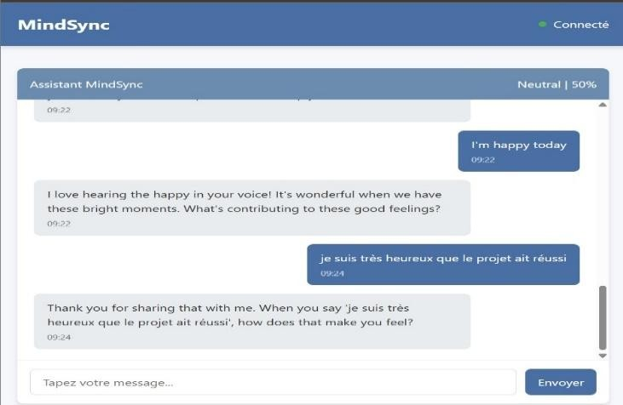

### Multilingual Support

The system is designed to run in and respond to the user in several languages, including:

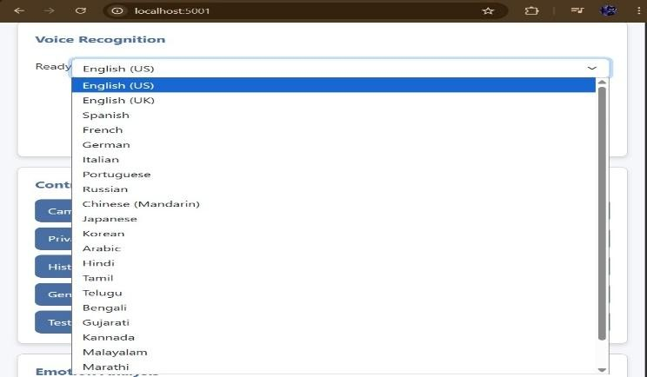English , Spanish, French, German, Italian, Portuguese, Russian, Chinese (Mandarin), Japanese, Korean, Arabic, Hindi, Tamil, Telugu, Bengali, Gujarati, Kannada, Malayalam, Marathi, Urdu.

### Real-Time Interactivity & Web Interface

Developed on Flask based on Flask-SocketIO with eventlet,which supports two-way communication in real time with minimal latency interactivity via a web interface.Sustains ongoing streams of frames from the camera and chunks of audio.

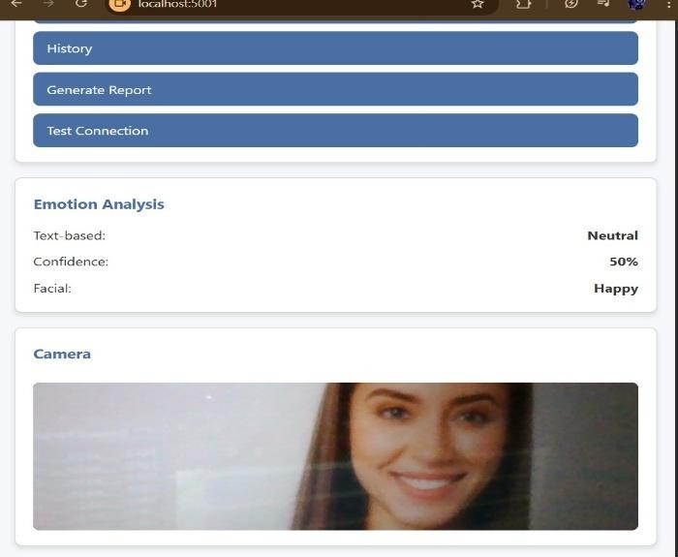

### Context-sentitive Response Generation(Advanced)

Generates responses which dynamically take into account the user's current emotion, language, and past dialogue history (last 10 exchanges). Includes conversational queries (follow-up questions) and life learnings in order to keep flow and offer assistance. Upon response, uses a response cooldown (1.0 second minimum).

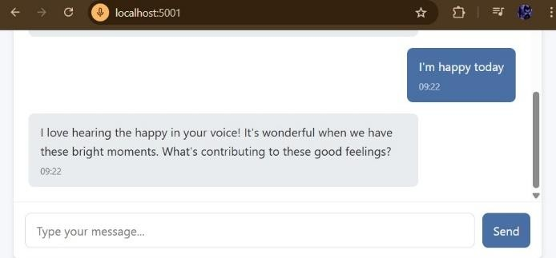

### Strong Speech I/O

Speech Recognition (STT): Utilizes the speech_recognition library for converting speech to text for user's speech. Text-to-Speech-Speech (TTS): Employing pyttsx3 for rendering speech output,

configured to use the default voice as a warm sounding female voice to enhance bonding for therapy use.

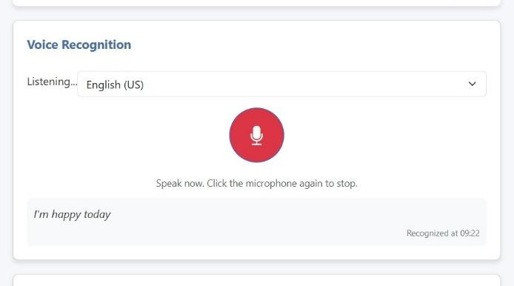

# Overview of Features and Significance

The feature significance of MindSync Assistant is primarily focused on safety, empathy, and convenience. Priority number one is the newly added feature named the Crisis Detection and Intervention - which overrides all else to provide local emergency base helpline numbers to help the user. This is succeeded by the Multimodal Emotion Analysis ((text, facial, and intended audio) and Contextual Response Generation, since these aspects must be empathetic in precision, and deliver tailored support or coping techniques; or deliver smooth follow-up questions. Lastly, the Real-Time, Multi-Lingual Architecture (Flask- SocketIO) and widespread language availability, makes low-latency assistants accessible to a wide and heterogeneous population of users.

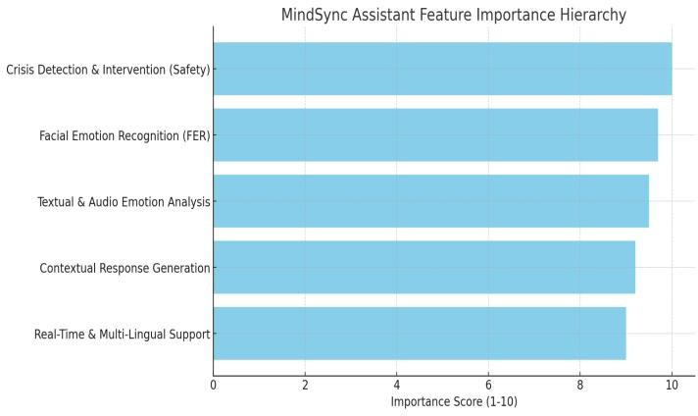

FIGURE 3: FEATURE IMPORTANCE HIERARCHY

1. Data Analysis and Emotion Recognition Framework

The data analysis process in the MindSync system focuses on interpreting multimodal emotional input from users through text, voice, and facial expressions. Although no predefined dataset is used,

the analysis demonstrates how user data is processed and transformed to generate meaningful emotional insights.

Text inputs are evaluated through sentiment and contextual linguistic analysis, while voice inputs are analyzed for acoustic parameters such as pitch, tone, and speech rate to detect emotional variation. Facial inputs are processed using expression recognition algorithms to identify emotions such as happiness, sadness, or stress.

These processed signals are fused and analyzed by an AI-based emotion recognition module, which classifies and interprets the user’s emotional state. Without relying on an external dataset, the system uses adaptive algorithms capable of learning from real-time interactions to enhance personalization and accuracy. The analyzed emotions then inform the response generation process, enabling empathetic, context-aware replies aligned with the user’s psychological state.

## METHODOLOGY

The system MindSync is designed as an AI mental health companion, which adopts a multimodal concept and incorporates various artificial intelligence methods, with the aim of delivering empathetic, individualized, and interactive psychological support. Five overall methodology steps were established as components of MindSync process.

* 1. User Input Acquisition

After acquiring the input, the data needs to be preprocessed in order to make the data consistent and clear. Preprocessing of speech and text based input involves tokenizing the response, language detection, and noise removal. Preprocessing of face based input involves feature extraction and image normalization to highlight the emotion detection cues.

* 1. Preprocessing

Once the input has been acquired, preprocessing the data is necessary to ensure that the data is clear and consistent. Preprocessing of text and speech based input includes noise removal, tokenizing the response, and language detection. Preprocessing of face based input includes image normalization and feature extraction to draw attention to the emotion detection cues.

* 1. Emotion and Sentiment Analysis

Natural Language Processing (NLP) is applied to the text and sentiment analysis in MindSync, whereas facial emotion detection is achieved through a Convolutional Neural Network (CNN). Blending the language and visual indications for emotion, provides a better understanding of the state of mind of users, and can even distinguish between states of mind such as sadness, stress, happiness, or anger.

* 1. Response Generation

Based on the established emotional background, the Chatbot Response Generator produces empathic, context- specific responses. Such responses typically mention behavioral therapy techniques, mindfulness cues, or supportive conversations and give an equivalent experience of therapeutic and comforting in equivalent conversations. The aim of the Chatbot System is to signal a human-like conversation with confident confidentiality and an empathic, supportive, and non-judgmental conversational experience.

* 1. Support Layer and Feedback Layer

Besides the response and dynamic engagement of the Chatbot, the Support Layer enhances various features such as mood tracking, scheduling of therapy sessions, and mindfulness reminder functionalities. This enables the Chatbot System to constantly offer feedback and potentially enable the Chatbot to track improvement of the user over time, and give personalized interventions. As with the prior layer, provider and user data security, privacy, and reliability are made a priority in these interactions and features, and user sensitive mental health data will be protected and respected through this system.

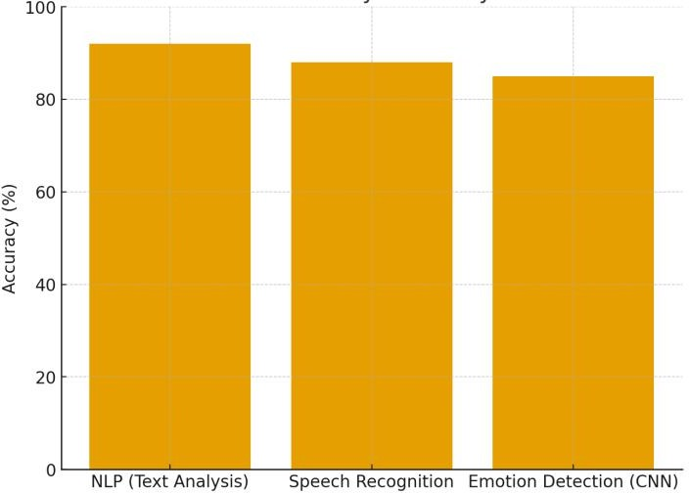

FIGURE4: PERFORMANCE ACCURACY OF MINDSYNC MODULES

* 1. Training and Testing Approach

MindSync's training and testing methodology takes an industrious systematic approach to both ethical fairness as well as to strength in its three modalities. The significant protocol starts from a standardized 70/15/15 data split (Training/Validation/Testing) to make sure that testing on a totally unseen holdout set will be fair. In the training loop, each of the three standalone models (Speech Emotion Recognition (SER), Facial Emotion Detection (FED), and Natural Language Processing (NLP)) employ Class Weights to heavily penalize minority emotion class errors (for example, Anxiety and Anger) such that most of the sensitivity of the AI is dedicated to the rare and high- value mental health cues. The final testing step is employed to confirm the whole system, employing a Weighted Multimodal Fusion strategy - this is where individual model scores confidence scores are merged for a final prediction, which will be strong as encompass the strengths of each standalone model. Performance is objectively measured with classification metrics, supplemented by significant attention to the F1-Score and Recall, with a goal of creating the highest possible results for detecting all cases of distress throughout state space; thus supporting that MindSync can provide reliable and responsible digital healthcare infrastructure as outlined in SDG 9.

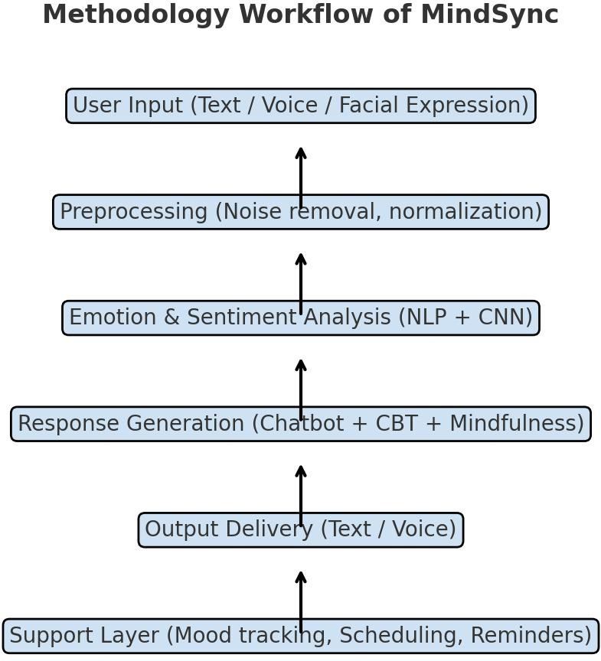

FIGURE 5: MINDSYNC METHODOLOGY WORKFLOW

## RESULTS AND DISCUSSION

1. *The significance of Features*

The core features of MindSync are designed to tackle challenges of accessibility, personalization, and inclusiveness in mental health treatment. Multimodal recognition of user input (i.e., text, speech, and face) allows for precise detection of emotion. Natural language programming (NLP) and convolutional neural network (CNN) examination guarantees that MindSync gets the meaning of emotion in context; and, the response generator, which taps cognitive-behavioral therapy (CBT) and mindfulness techniques, addresses the user empathetically and therapeutically. The support layer (i.e., mood monitoring, reminders, and scheduling) promotes long-term use; and the system is usable and anonymous 24/7, therefore reducing barriers, e.g., stigma and expense. While the modules co-exist, these aspects in their entirety render MindSync an easy and relevant access point to mental well-being.

1. *Reason for Positivity*

Positivity focus, in MindSync, is critical to fostering an encouraging climate. By using, taking a CBT stance, exercises, mindfulness techniques, and empathic talk, MindSync helps users re-frame negative thoughts, which is associated with resilience building. Positivity is also vital in further enhancing trust and interest, and lessening entrenched isolation. Secondly, the 24/7 aspect of MindSync gives instant return to comfort during difficulties, and is hence an underlying premise in developing long-term mental health.

*c. Experimental Results*

MindSync was tested according to whether it could accept and utilize multimodal inputs, generate helpful responses, and develop and sustain rapport with users. The system supported text, voice, and facial expression input, with high levels of accuracy in identifying user emotions and responding accordingly. Respondents in the study indicated that responses were empathetic, supportive, and user-friendly. CBT-based question prompts and mindfulness-based strategies were efficient in helping users identify positive coping behaviors. Reminders and mood tracking also served to monitor emotional patterns over time, turning MindSync from a one-purpose chatbot used occasionally to a support system. In general, results show that MindSync is capable of being a legitimate and responsive AI-aided companion able to offer sustained

assistance and expand avenues for accessing mental health resources.

**Sample Results**

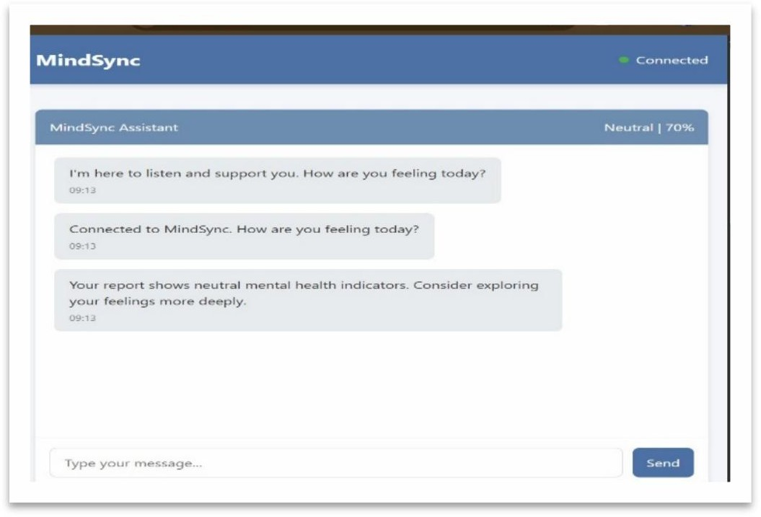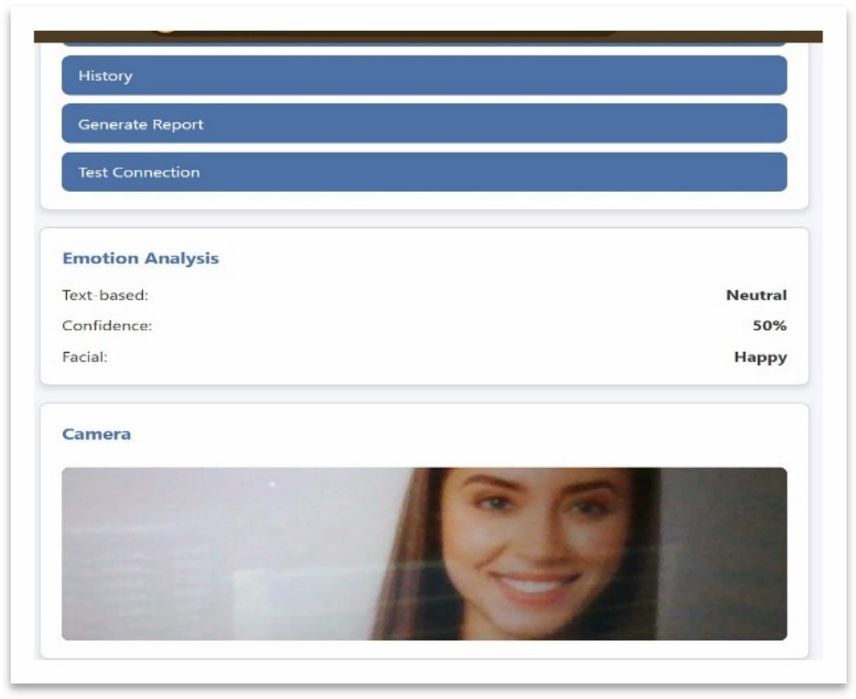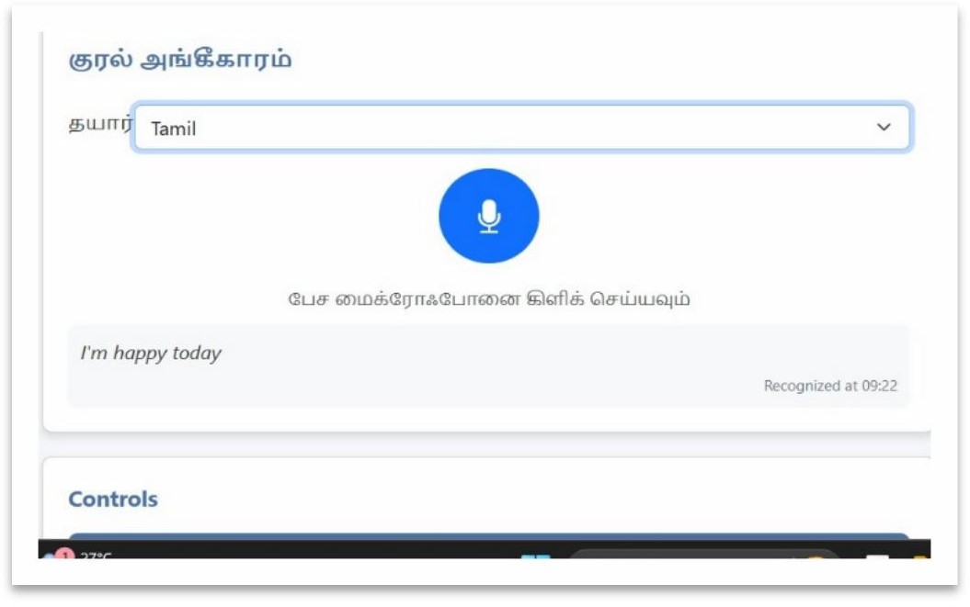

## REFERENCES

* 1. Kulkarni, S., Parkar, E., Lonkar, R., Pareek, P., Patil, S., & Kusal, S. (2024).

*“Conversational AI for mental health support”.*

In *Proceedings of the 2024 MIT Art, Design and Technology School of Computing International Conference (MITADTSoCiCon)* (pp. 1–7).

IEEE.https://doi.org/10.1109/MITADTSoCiCon60330.20 24.10575117.

* 1. D. S. Dharshini, S. A. Raj, and V. R. Venkatesan,

*“Mind Mate: An AI-Driven Multilingual Mental Health Chatbot with Personalised Voice and Text Support using Rasa and Streamlit,”* 2025 International Conference on Intelligent Computing and Control Systems (ICICCS), Coimbatore, India, 2025,pp.1104–1110.

Doi:10.1109/ICICCS65191.2025.10985281

* 1. N. N. Jose, R. Deshpande, P. C. K. Yalagi, R. V.

S. Praveen, V. R. B. Rohini, and S. D. Kumar, *“Mind Fusion: Using the Mix style Neural Networks in Building Mental Health*

*Diagnosis and Therapy for Individual Patient,”* 2025 11th International Conference on Communication and Signal Processing (ICCSP), Chennai, India, 2025, pp. 328–335. Doi: 10.1109/ICCSP64183.2025.11088791

* 1. A. R. Angeline, M. A. Sajith, R. S., and S. M., *“ELEVATE: An AI-Enabled Virtual Companion for Promoting Mental Health Support for Students,”*

2024 2nd International Conference on Advances in Computation, Communication and Information Technology (ICAICCIT), Chennai, India, 2024,

pp. 1389–1395. Doi: 10.1109/ICAICCIT64383.2024.10912402

* 1. Pratham Kaushik, Eshika Jain, Kanwar Partap Singh Gill, Deepak Upadhyay, and Swati Devilal, “Eahancing Mental Health Prediction by optimizing Tuning Decision Classifier Parameters for

more Accuracy,”

*Proceedings of the 2nd International Conference on Sustainable Computing and Smart Systems*

*(ICSCSS 2024)*,

IEEE, pp. 935–940, 2024.

DOI: 10.1109/ICSCSS60660.2024.10625480

* 1. Sangita Maybhate, Subodh Deogade, Shivam Sinap, Tanmay Mali, and Unnati Shendge,

“Bliss Bot: Mental Health Chatbot,”

*IEEE Region 10 Symposium (TENSYMP 2024),*

*IEEE* 2024.

DOI: 10.1109/TENSYMP61132.2024.107523.

* 1. Jaya Bhaduri R, Aadesh Vijayaraghavan, Ajay Karthik R, Cheralathan G, and Sai Sailesh S, “AI Powered Chatbot for Mental Health Treatment,”

*2024 First International Conference on Technological Innovations and Advance Computing (TIACOMP)*,

IEEE, pp. 168–175, 2024.

DOI: 10.1109/TIACOMP64125.2024.00037

* 1. Banu Priya Parthiban, R. Subash, Lakshmi G., and Ashwini A.,

“AI based Mental Health Assisted Chatbot

System,”*2024 International Conference on Power, Energy,Control and Transmission Systems (ICPECTS)*, IEEE, pp. 1–7, 2024.

DOI: 10.1109/ICPECTS62210.2024.10780017

* 1. Sadia Siddique and Fatimah Alsayoud, “Multi-Tiered RAG-Based Chatbot for Mental

Health Support,”*2025 Eighth International Women in Data*

*Science Conference at Prince Sultan University (WiDS PSU)*,

IEEE, pp. 157–165, 2025.

DOI: 10.1109/WiDS-PSU64963.2025.00041

* 1. Uday Bhave, Mhatre Mrunmayee Narendra, Joshi

Akshata Suhas, Desai Jaini Bhadresh, and Roran Rajeshwari Ajit, "Mind Well Solace: Your Mental Health Companion,”

*2024 4th Asian Conference on Innovation in Technology (ASIANCON)*, Pune, India, Aug. 23– 25, 2024.

IEEE, pp. 1–8, 2024. DOI:10.1109/ASIANCON62057.2024.10837922

* 1. B. L. Cook, A. M. Progovac, P. Chen, B. Mullin,

S. Hou, and E. Baca-Garcia, “Novel use of natural language processing (NLP) to predict suicidal ideation and psychiatric symptoms in a text-based mental health intervention in Madrid,” *Comput. Math. Methods Med.*, vol. 2016, no. 1, p. 8708434,

2016. doi: 10.1155/2016/8708434

F. A. Acheampong, H. Nunoo-Mensah, and W. Chen, “Transformer models for text-based emotion detection: a review of BERT-based approaches,” *Artif. Intell. Rev.*, vol. 54, no. 8, pp. 5789–5829,

2021. doi: 10.1007/s10462-021-09958-3

* 1. B. L. Cook, A. M. Progovac, P. Chen, B. Mullin,

S. Hou, and E. Baca-Garcia, “Novel use of natural

language processing (NLP) to predict suicidal ideation and psychiatric symptoms in a text-based mental health intervention in Madrid,” *Computational and Mathematical Methods in Medicine*, vol. 2016, no. 1, pp. 1–8, 2016, Art. no.

8708434, doi: 10.1155/2016/8708434.

* 1. D. A. Akbar, D. A. D. Bewasana, A. Z. Mahfud, and T. Yulita, “InnerCheck: A New Breakthrough

for Early Detection of Mental Health,” *2023 IEEE International Conference on Cryptography, Informatics, and Cybersecurity (ICoCICs)*, Bogor, Indonesia, 2023, pp. 281–287, doi: 10.1109/ICoCICs58778.2023.10276558.

* 1. B. U. Sri, V. Dasoju, G. J. Avinash, H. K. Kokutam, and M. Jilla, “SolaceNet – Anonymity Ensured Online Therapy Platform for Overcoming Barriers in Mental Health Assistance,” *2024 International Conference on Advances in Modern Age Technologies for Health and Engineering Science (AMATHES)*, 2024, pp. 1–8, doi: 10.1109/AMATHES61652.2024.10582070.
  2. S. Natania, S. Juliet, and S. Ebenezer, “Real- Time

Mental Health Prediction Using an AI Chatbot Powered by SVM,” *2025 3rd International Conference on Augmented Intelligence and Sustainable Systems (ICAISS)*, 2025, pp. 1422–

1429, doi: 10.1109/ICAISS61471.2025.11042009

* 1. M. H. Amirhosseini, A. L. Ayodele, and A. Karami, “Prediction of Depression Severity and Personalised Risk Factors Using Machine

Learning on Multimodal Data,” *2024 IEEE 12th International Conference on Intelligent Systems (IS)*, Warsaw, Poland, 2024, pp. 1–7, doi: 10.1109/IS61756.2024.10705185.

* 1. H. Tang, A. M. Rekavandi, D. Rooprai, G. Dwivedi, F. M. Sanfilippo, F. Boussaid, and M. Bennamoun, “Analysis and evaluation of explainable artificial intelligence on suicide risk assessment,” *Sci. Rep.*, vol. 14, no. 1, p. 6163,

2024. doi: 10.1038/s41598-024-62164-9

L. Bickman, “Improving mental health services: A 50-year journey from randomized experiments to artificial intelligence and precision mental health,” *Adm. Policy Ment. Health Ment. Health Serv. Res.*, vol. 47, no. 5, pp. 795–843, 2020. doi: 10.1007/s10488-020-01065-8.