Software Requirements Specification

Music Player application   
–

Document ID: SRS_Music_Player.doc

Author(s): Abitha T

Version:

Date: April 2, 2024

1. Objective and Scope 3

2. Project End Users 4

3. Features 4

3.1 Login to the system 7

3.2 Add/Edit User Details 7

3.3 Permission 7

3.4 Edit Playlist 8

3.5 View list of playlists and liked songs 9

3.6 View and manage Membership Details 10

3.7 Reports 11

# Objective and Scope

The objective of the Music Player Application is to provide users with a comprehensive and enjoyable music streaming experience, akin to popular platforms like Spotify. By offering a wide range of features such as personalized recommendations, seamless music streaming, social interaction capabilities, and offline playback, the application aims to cater to the diverse preferences of music enthusiasts while ensuring ease of use and accessibility across different devices.

The scope of the Music Player Application encompasses various functionalities and features aimed at delivering a rich and immersive music streaming experience. Key components within the scope of the application include:

1. User Management: Registration, login, and account management functionalities to enable users to access personalized features and settings.

2. Music Catalog: A comprehensive library of songs, albums, artists, and playlists, accessible through search and browsing functionalities.

3. Playlist Management: Tools for creating, editing, and organizing custom playlists, as well as access to pre-made playlists based on different criteria.

4. Music Streaming: Seamless playback of high-quality audio content over the internet, with options for controlling playback and adjusting audio settings.

5. Offline Playback: Ability to download and store music for offline listening, with features for managing downloaded content.

6. Recommendation System: Personalized suggestions for music content based on user preferences, listening history, and behavior.

7. Social Features: Interaction capabilities such as following friends, sharing music content, and viewing activity feeds to enhance social engagement.

8. Performance, Reliability, Security, Usability, and Compatibility: Ensuring that the application meets non-functional requirements related to performance, reliability, security, usability, and compatibility across different devices and platforms.

# Project End Users

End users interact with the application through various devices, including smartphones, tablets, desktop computers, and smart speakers. They utilize the features and functionalities provided by the application to access a vast library of songs, create personalized playlists, receive recommendations, and engage socially with friends and fellow music enthusiasts.

# Features

Start

Login Process

|

|---> Enter User Name and Password

| |

| |---> Validate User Name and Password

| |

| |---> Check if the User Name and Password are correct

| | |

| | |---> Grant access to the system

| |

| |---> If not valid,

| |

| |---> Prompt user to sign up or recover account

|

|---> Access Granted?

Main Menu

|

|---> Add/Edit User Details

| |

| |---> Sign Up User

| | |

| | |---> Check for duplicate entries

| | |

| | |---> Save user information

| |

| |---> Edit Details after login

| |

| |---> Edit draft user data

| |

| |---> Save updated information

|

|---> Permission

| |

| |---> Access to Content

| |---> Playback Control

| |---> Playlist Management

| |---> Personalization

| |---> Offline Playback

| |---> Social Interaction

| |---> Account Management

| |---> Privacy Settings

| |---> Notification Preferences

| |---> Membership

|

|---> Edit Playlist

| |

| |---> Locate Playlist

| | |

| | |---> Navigate to Playlist Management

| | |

| | |---> Search for the playlist

| | |

| | |---> Select Playlist

| | |

| | |---> Edit Playlist Details

| | | |

| | | |---> Modify playlist details

| | |

| | |---> Edit Playlist Content

| | |

| | |---> Add or remove songs

| | |

| | |---> Reorder tracks

| |

| | |---> Save Changes

|

|---> View list of playlists and liked songs

| |

| |---> Navigate to Playlist Section

| |

| |---> View Playlists

| | |

| | |---> Display list of created playlists

| |

| |---> Select a Playlist

| | |

| | |---> View playlist contents and details

| | |

| | |---> Play individual songs

| |

| |---> Access Liked Songs

| |

| |---> Dedicated section for liked songs

| |

| |---> Manage Liked Songs

| |

| |---> View list of liked songs

| |

| |---> Play songs individually or add them to playlists

|

|---> View and manage Membership Details

| |

| |---> Navigate to Account Settings

| |

| |---> View Membership Details

| | |

| | |---> Display current membership plan, subscription status, renewal date, and benefits

| |

| |---> Upgrade or Downgrade Membership

| |

| |---> Renew Membership

| |

| |---> Manage Payment Information

| |

| |---> Access Membership Benefits

| |

| |---> Cancel Membership

| |

| |---> Provide feedback or reasons for cancellation

|

|---> Reports

|

|---> Listening Habits

| |

| |---> Most played songs, top genres, total listening time

|

|---> Playlist Activity

| |

| |---> Frequently played or shared playlists

|

|---> Subscription Reports

|

|---> Membership status, upcoming renewals, benefits or discounts

End

**Class diagram**

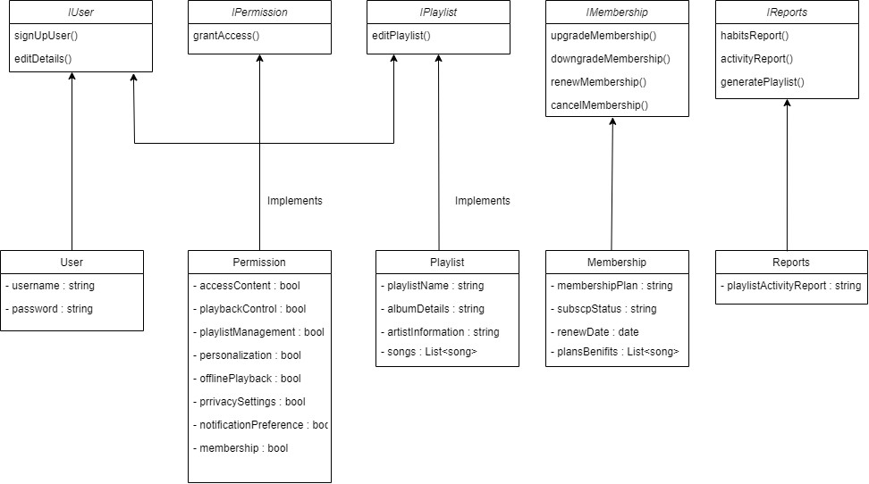

## Login to the system

Each and every user should be authenticated with a User Name and Password to login into the system. User can login if already has an account with unique user name and password , otherwise the user should signup with the required details.

Validations for User Name and Password.

User Name: It accepts only Alphabets, Numbers, Dot (.) symbol and Underscore (_) symbol.

Password: It can be anything of the users’ choice.

(Next release we have plan to integrate IDM for windows authentication)

## Add/Edit User Details

**Sign Up User:**

Users are added into the database through the Signup page. Before adding the user, it allows the user to check for any duplicates in the database.

**Edit Details after log in:**

Users who are added through sign up page are saved into the database as a draft, which can be edited by Edit details page after logging in into their account.

## Permission

Permissions granted to users of the Music Player Application:

1. Access to Content: Users can explore a vast library of songs, albums, playlists, and artists.

2. Playback Control: Users have the ability to play, pause, skip, and repeat songs as desired.

3. Playlist Management: Users can create, edit, and delete custom playlists, and add or remove songs from playlists.

4. Personalization: Users receive personalized recommendations based on their listening history and preferences.

5. Offline Playback: Users can download songs for offline listening, enabling access to music without an internet connection.

6. Social Interaction: Users can follow friends, share music content, and view activity feeds to enhance social engagement.

7. Account Management: Users can register, log in, and manage their accounts securely.

8. Privacy Settings: Users have control over their privacy settings, including profile visibility and data sharing preferences.

9. Notification Preferences: Users can customize notification settings for updates, recommendations, and social interactions.

10. Membership: Users can activate suitable membership plans

These permissions empower users to personalize their music streaming experience while ensuring control over their data and interactions within the platform.

And some features and functionalities will have access only for the administrator like whomever availed the membership subscription plans, what are the list of songs in the default playlist, etc…

## Edit Playlist

To edit a playlist in the Music Player Application, users can follow these steps:

1. Locate Playlist:

- Users can navigate to the "Playlist Management" section of the application.

- They have the option to search for the playlist by its name and movie or album name.

2. Select Playlist:

- Once the playlist is located, users can click on it to view its details and contents.

3. Edit Playlist Details:

- Users can modify various details of the playlist, such as its name, album details, and artist information.

4. Edit Playlist Content:

- Users can add or remove songs from the playlist as desired.

- They can reorder tracks within the playlist to customize the playback sequence.

5. Save Changes:

- After making the necessary modifications, users can save the changes to update the playlist.

By following these steps, users can easily edit playlists within the Music Player Application, ensuring that their music collections are tailored to their preferences and needs.

## View list of playlists and liked songs

To access the list of playlists and liked songs in the Music Player Application:

1. Navigate to Playlist Section:

- Users can access the "Playlist" section from the main menu or navigation bar within the application.

2. View Playlists:

- Upon entering the Playlist section, users will see a list of their created playlists.

- Each playlist is displayed with its name, thumbnail (if available), and additional information such as the number of songs included.

3. Select a Playlist:

- Users can click on a specific playlist to view its contents and details.

- They can see the individual songs within the playlist and play them directly.

4. Access Liked Songs:

- Alternatively, users may have a dedicated section labeled "Liked Songs" or "Favorites" within the application.

- This section aggregates all the songs that the user has liked or favorited while using the application.

5. Manage Liked Songs:

- In the Liked Songs section, users can view a list of all the songs they have liked.

- They can play these songs individually or add them to playlists as desired.

By following these steps, users can easily access and manage their playlists and liked songs within the Music Player Application, ensuring a personalized and enjoyable music listening experience.

## View and manage Membership Details

To view and manage membership details in the Music Player Application:

1. Navigate to Account Settings:

- Users can access the "Account" or "Profile" section from the main menu or user profile icon within the application.

2. View Membership Details:

- Within the Account Settings, users will find a section dedicated to membership details.

- This section displays information such as the current membership plan, subscription status, renewal date, and any applicable benefits.

3. Upgrade or Downgrade Membership:

- Users have the option to upgrade or downgrade their membership plan based on available options.

- They can select a different subscription tier or plan that better suits their needs.

4. Renew Membership:

- If the membership is nearing expiration or has expired, users can initiate the renewal process.

- They may be prompted to provide payment details to renew their subscription.

5. Manage Payment Information:

- Users can update or edit their payment information, such as credit card details or billing address, if necessary.

- This ensures seamless processing of membership fees and subscription renewals.

6. Access Membership Benefits:

- Users can explore any additional benefits or perks associated with their membership plan.

- This may include features like ad-free listening, access to exclusive content, or discounts on merchandise.

7. Cancel Membership:

- If desired, users have the option to cancel their membership altogether.

- They may be prompted to provide feedback or reasons for cancellation before confirming the action.

By following these steps, users can easily view and manage their membership details within the Music Player Application, ensuring a seamless and personalized experience tailored to their subscription preferences.

## Reports

Reports in the Music Player Application provide users with valuable insights and analytics regarding their listening habits, playlist activity, and account status. These reports offer a snapshot of user engagement, including metrics such as most played songs, top genres, and total listening time. Additionally, users can access reports detailing playlist popularity, showing which playlists are most frequently played or shared among friends. Furthermore, subscription reports provide users with information about their membership status, upcoming renewals, and any available benefits or discounts. Overall, these reports empower users to track their music consumption, optimize their playlists, and make informed decisions about their membership plans within the Music Player Application.