**Enterprise Resource Planning**

**ERP**

**Dr. Abdulelah Alekam**

Chapter 1

**Introduction to Enterprise Resource Planning**

* **CONTENTS**
* Objectives
* 1.1 Introduction
* 1.2 What is ERP?
* 1.3 Why ERP Required?
* 1.4 Definitions of ERP
* 1.5 Benefits of ERP
* **Objectives**
* After studying this chapter, you will be able to:
* Describe enterprise resource planning.
* Explain the growth reasons of ERP.
* Explain the ERP benefits.

1. **Introduction**

* Enterprise Resource Planning, or ERP, is a system that is used to combine all of the information or operations of a company into a single unit. The standard ERP system will utilize both computer hardware and software in order to achieve this. Perhaps one of the most important parts of the ERP system is the central database. This database will be used to store information from various modules. When the term ERP was originally coined, it was used to describe systems that were designed to use multiple resources. It was commonly connected to the manufacturing industry. The term is used today in a much broader context.
* The goal of ERP is to unify the various functions of an institution. However, the use of Enterprise Resource Planning is not simply limited to corporations. It is commonly used by non-profit organizations, government agencies, and other institutions. A typical system integrates all these functions by allowing it is modules to
* share and transfer information by freely centralising information in a single database accessible by all modules. (See Figure 1.1)

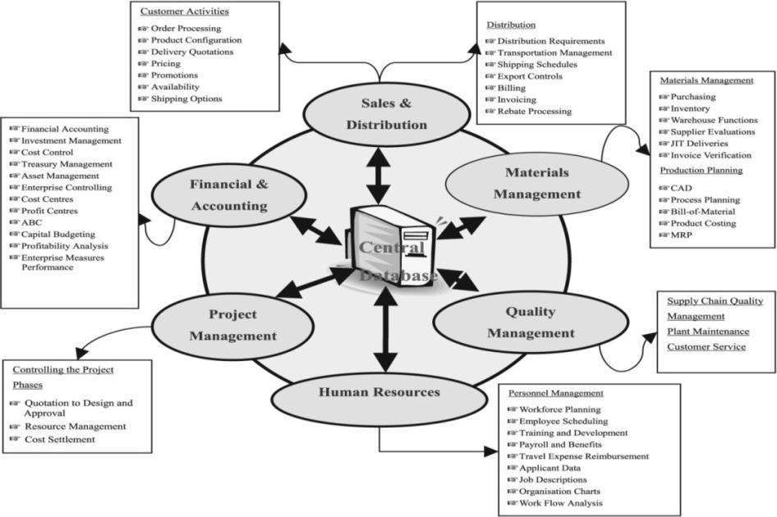

**Figure 1.1**: The ERP System Module

1. **What is ERP?**

* Enterprise Resource Planning (ERP) covers the techniques and concepts employed for the integrated management of businesses by the effective use of management resources, to improve the efficiency of an enterprise.ERP packages are integrated (covering all business functions) software packages that support the above ERP concepts.
* Originally ERP packages were targeted at the manufacturing industry, and consisted mainly of functions for planning and managing core businesses such as sales management, accounting and financial affairs, etc. However in the recent years, adaptation not only to the manufacturing industry, but also to diverse type of industry has become possible and the expansion of implementation and use has been progressing on the global level
* ERP (enterprise resource planning) is an industry term for the broad set of activities that helps a business manages the important parts of it is business

From the most basics to the more complete, this

documentation will be classified as follows:

* 1. *Control Issues*: Detail the controls to be made from the reception of the merchandise to the moment of manufacturing. These regulations are separated in three groups:
* 2. *Reception Rules:* With the objective to register all the controls made in the reception of materials and purchase products, these rules are generally created to be related through a register of the different versions and corresponding observations.
* 3. *Procedure Rules:* This involves making a group of controls responsible for all the operations needed for the manufacturing of a product. At this point, it should be taken into account the internal operations as well as the ones developed in the factory itself, as the external ones will be controlled with the same format as the reception ones.
* 4. *Final Control Rules:* This is the group of controls that are to be made once the whole process of product manufacturing is completed.
* 5. *Control Plan*: It make reference to all the controls identified for that purpose in the regulations.

**ERP Application Tools**

* Much of the software that is used with ERP is multi-module. This means that it will assist companies in properly integrating their various processes. The most important areas for ERP applications are finance, human resources, and manufacturing. When a vendor sells an ERP module to a company that is related to finance, it will be capable of combining a number of different tasks. For example, some modules may deal with charts related to accounts and balances, while it may also be used to maintain expenses that are connected to the organization.

1. **Why ERP Required**

* **A number of trends drove the growth of the enterprise software market.**
* **First, as discussed above, integrated information architecture improves business performance. Once a major company in an industry adopts enterprise software, competitors may be compelled to follow suit to stay competitive.**
* **Second, there has been a major shift towards the use of packaged applications. This is partly related to the “Y2K bug” and the European Union’s conversion to a single currency, which induced companies to replace their legacy systems with packaged software effectively “outsourcing” the solution to the ERP vendor.**
* **Third, many companies were abandoning legacy software due to the demands of electronic commerce and front office applications on the front end and linking to suppliers and business partners at the back end. Similarly, the emergence of ERP- based “vertical applications” that address the enterprise software needs of a specific industry have caused many companies to purchase ERP packages.**
* **Finally, rapid advances in computer and software technologies combined with the explosive growth of the Internet have led many companies to rethink their business practices, to put a greater emphasis on their use of IT, and to invest in more robust enterprise architecture.**
* ***Reasons for the Growth of the ERP Market***
* There is no doubt that the market for the Enterprise Resource Planning (ERP) systems is in great demand. Industry analysts are forecasting growth rates of more than 30 % for at least the next 3 years. Now why are so many companies replacing their key business systems?
* The answer is:

1. To enable improved business performance

* a) *Cycle time reduction*: the time required to contact other department is reduced.
* b) *Inventory reduction*: As the data is integrated there is no need to re enter the data and the paperless transaction is done using EDI (Electronic Data Interchange).
* c) *Order fulfillment improvement*: There are no conflicts between the departments like sales and production so order can be made on time.

1. To support business growth requirements

* a) *New Products and New Customers*: we can grow our organization by implementing new Products in the market and get the new customers for that product.
* b) *Globalize the product*: We can Globalize the product for International customers

1. To provide flexible, integrated, real-time decision support

* a) Managers get the integrated data of different departments at any time to analyze and to take important decisions at the right time.

1. To eliminate limitations in the legacy system:

* a) Integration of the isolated departments
* b) Decision support system
* c) Availability of the right data at right time
* d) Flexibility to change
* e) Supporting latest technologies

1. **Definition of ERP**

**The term ERP abbreviated from “Enterprise Resource Planning”, was introduced by the Gartner Group in the early 1990s and represent computer and software systems that combine and integrate all related processes of the enterprise, and serve users for the management of all functions within the enterprise.**

* Nah et al. (2001) defines ERP as “An enterprise resource planning (ERP) system is typically defined as a packaged business software system that facilitates a corporation to manage the efficient and effective use of resources (materials, human resources, finance, etc.) by providing a total integrated solution for the organization’s information- processing requests, through aprocess-oriented view consistent across the company.
* Botta-Genoulaz and Millet(2006) described ERP system as an integrated software packages comprising of set of functional modules (Production, Human resources, Sales, Finance etc.) and integrate all departmental functions across organizations into one single system fulfilling the needs of all departments.

1. **Benefits of ERP**

* Tangible benefits:
* Improves the productivity of process and personnel
* Lowering the cost of products and services purchased
* Paper and postage cost reductions
* Inventory reduction
* Lead time reduction
* Reduced stock obsolescence
* Faster product / service look-up and ordering saving time and money
* Automated ordering and payment, lowering payment processing and paper costs
* Intangible benefits:
* Increases organizational transparency and responsibility
* Accurate and faster access to data for timely decisions
* Can reach more vendors, producing more competitive bids
* Improved customer response
* Saves enormous time and effort in data entry ;
* More controls thereby lowering the risk of miss-utilization of resources
* Facilitates strategic planning
* Uniform reporting according to global standards

Installing an ERP system has many advantages both direct and indirect.

1. The direct advantages include improved efficiency, information integration for better decision making, faster response time to customer queries, etc.
2. The indirect benefits include better corporate image, improved customer goodwill, customer satisfaction, and so on.