# INTRODUCTION

* 1. Overview

The project aim is to provide real–time knowledge for all the students who have basic knowledge of salesforce and looking for a real-time project. This project will also help those professionals who are in cross-technology and want to switch to salesforce. With the help of this project they will gain knowledge and can include it into their resume as well.

* 1. Purpose

This project helps you to maintain and manage the schools related problems which further can be modified based on the requirements.

1. **Problem Definition & Design Thinking**
   1. Empathy Map

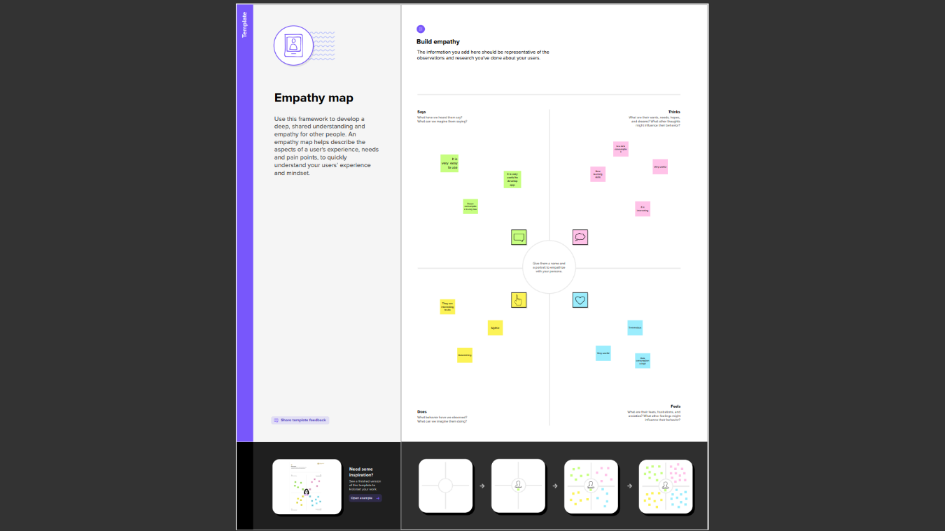

* 1. Ideation & Brainstorming Map

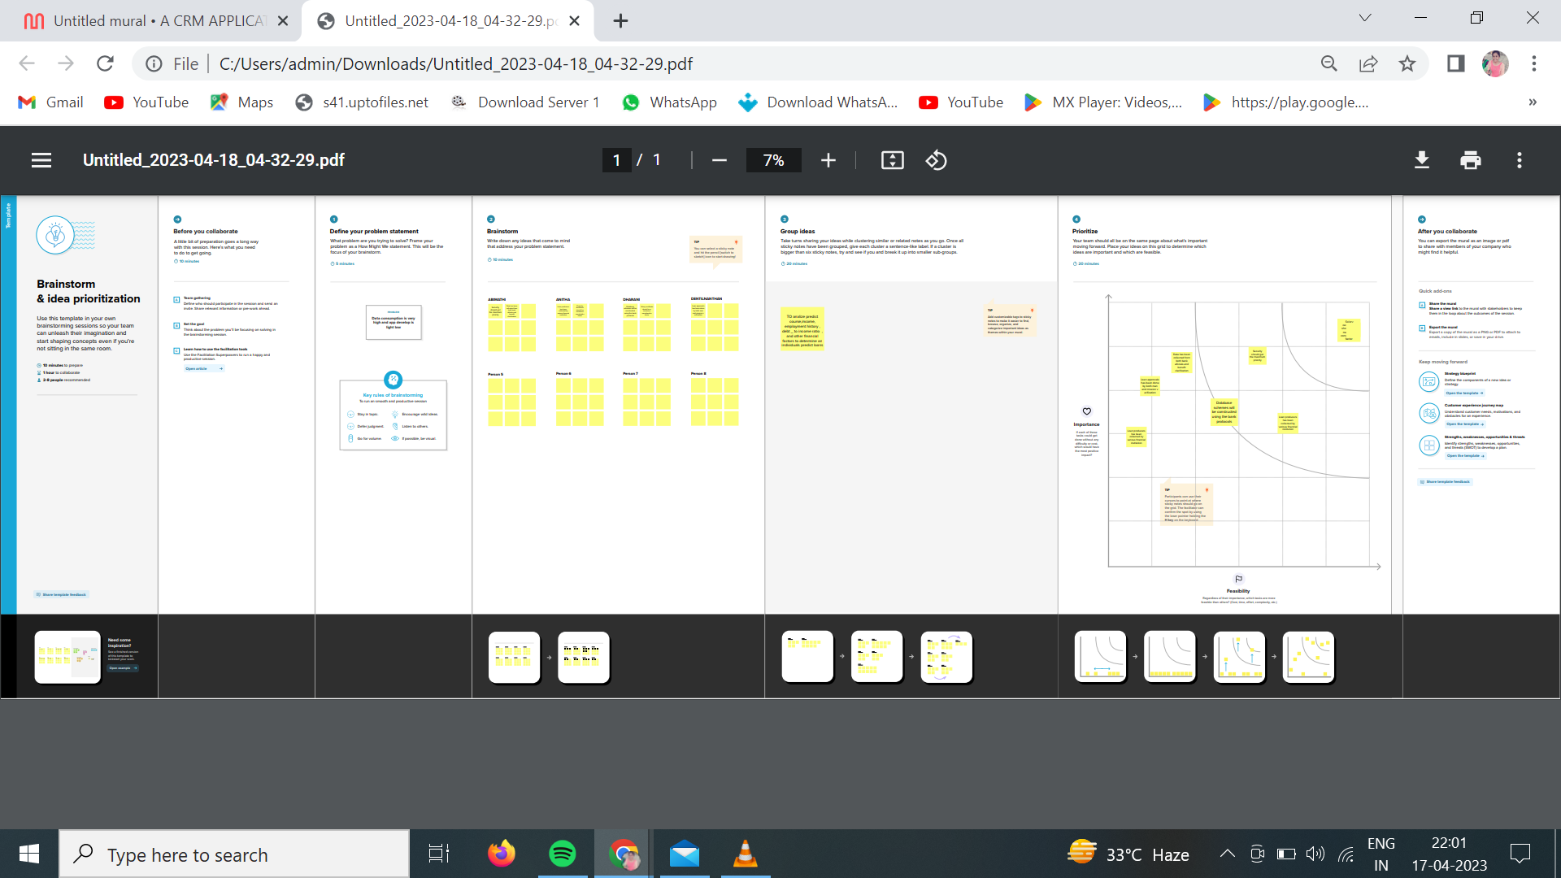

# RESULT

* 1. Data Model:

|  |  |
| --- | --- |
| **Object name** | **Fields in the Object** |
| School | |  |  | | --- | --- | | Field label | Data type | | Address | Text area | | District | Text area | | State | Text area | | School websites | Text area | | Phone number | Phone | | School | Master-Detail Relationship | |  |  | |
| Student | |  |  | | --- | --- | | Field label | Data type | | Result | Picklist | | Class | Number | | Marks | Number | | Parent address | Text area | | Parent number | Phone | |  |  | |

# Activity & Screenshot

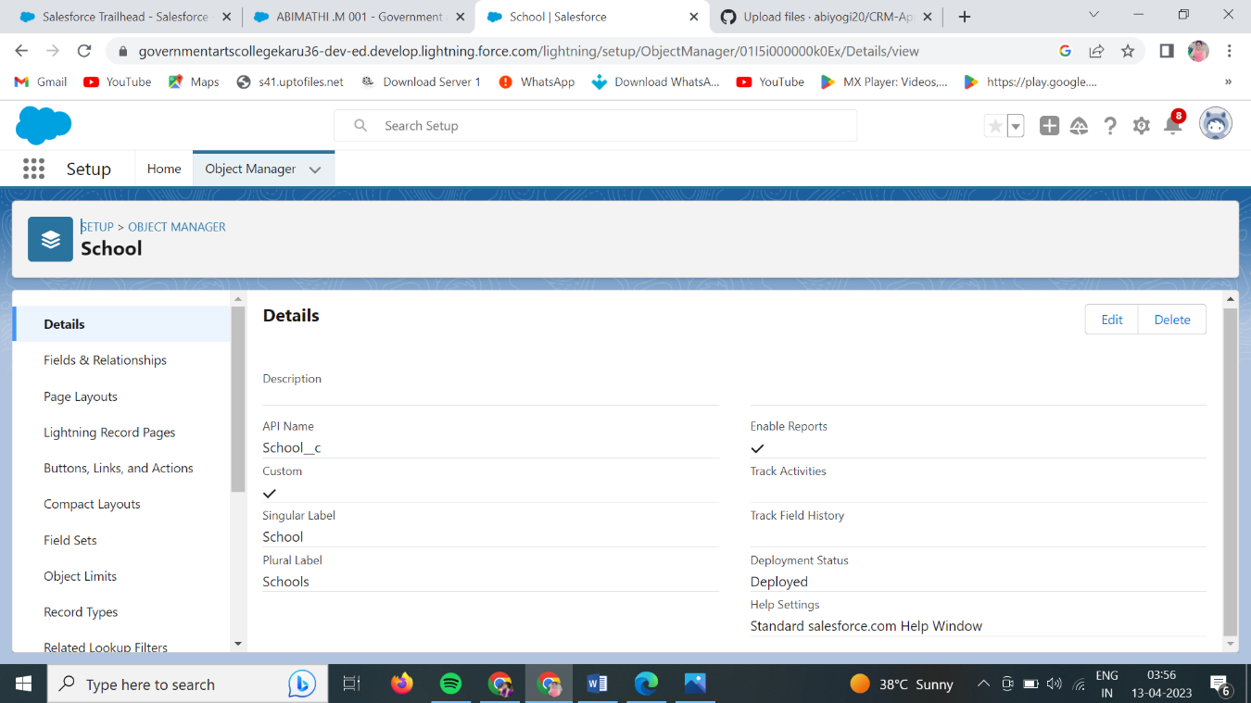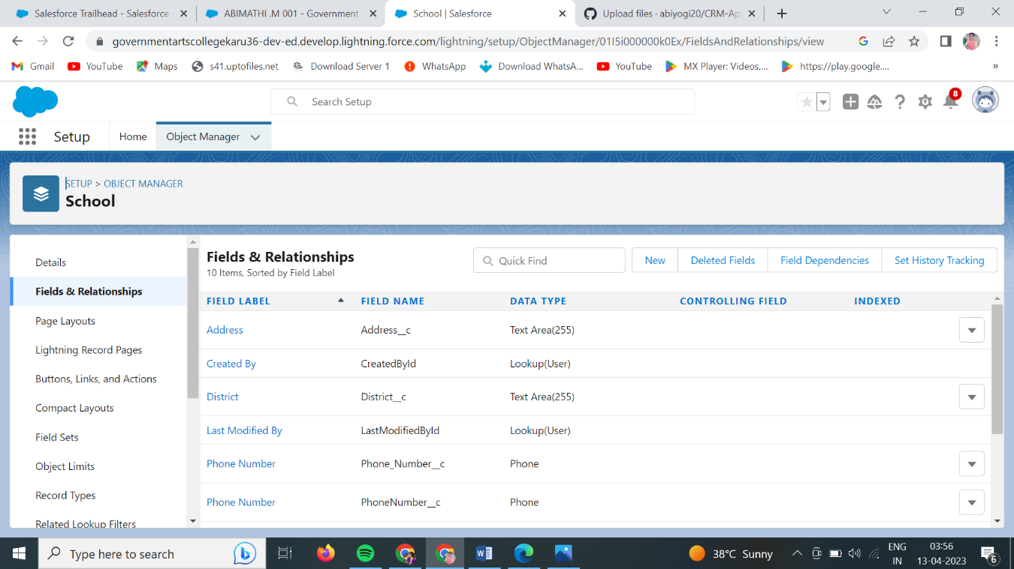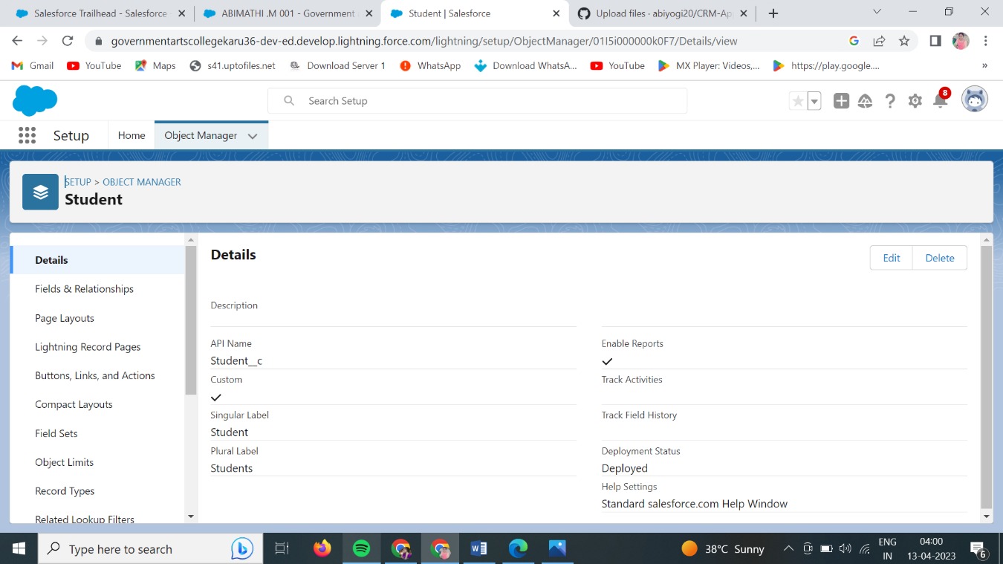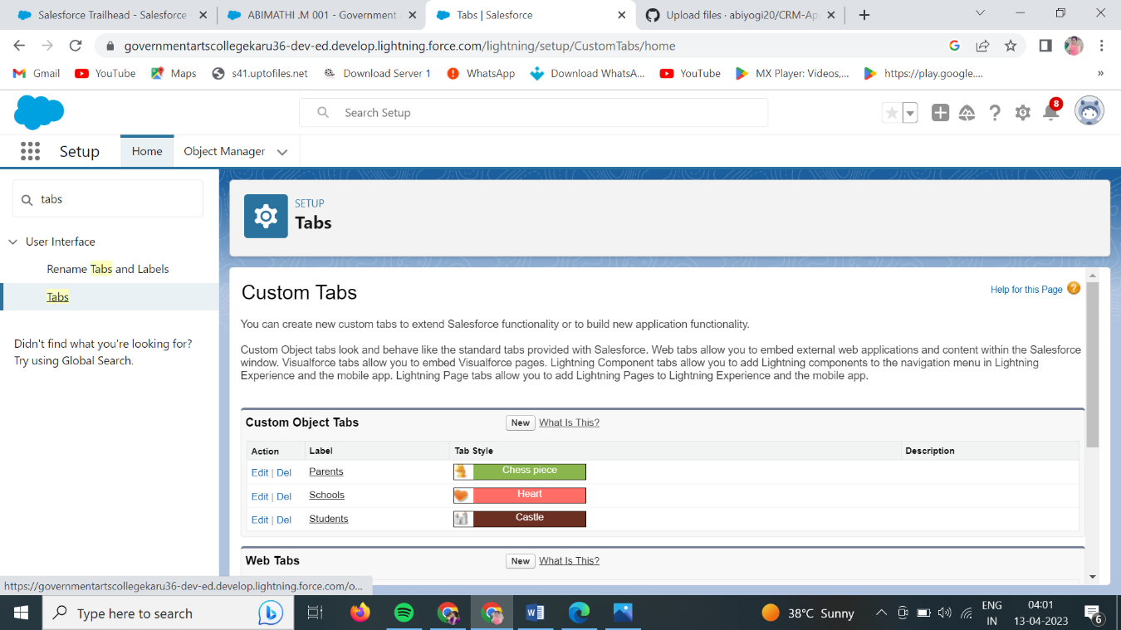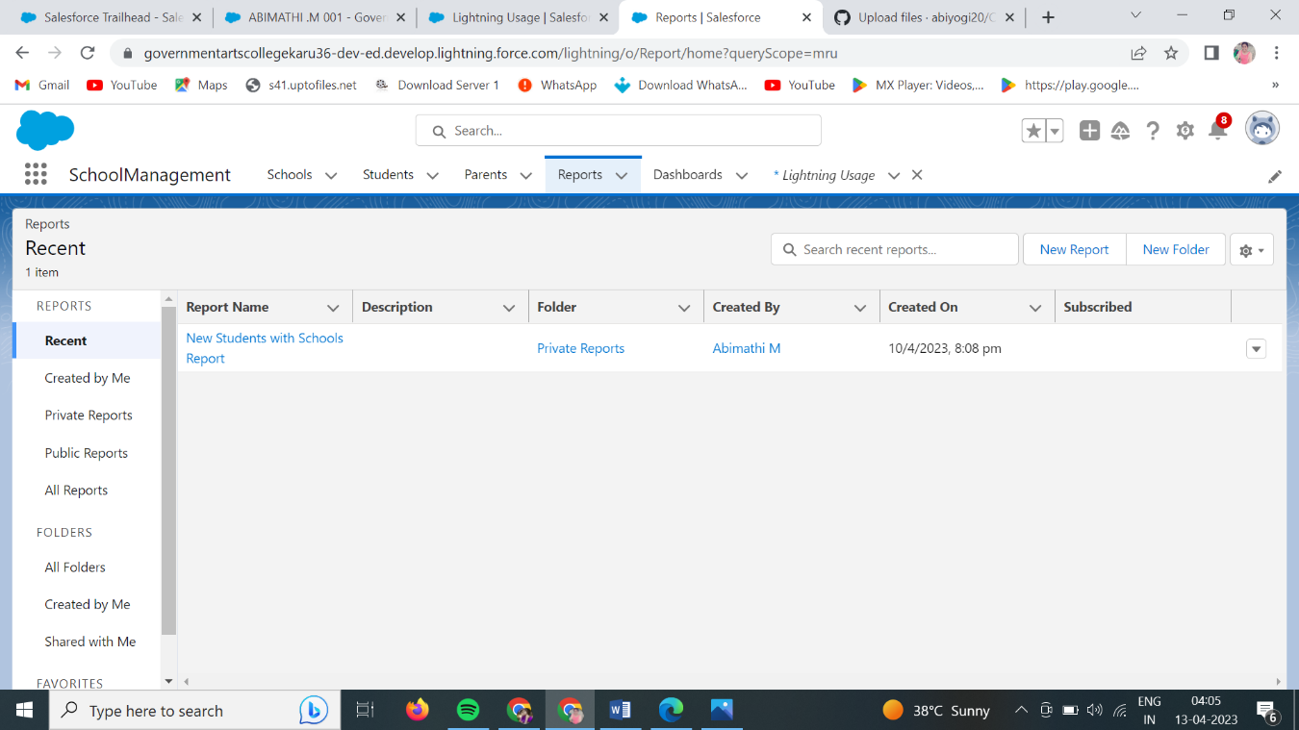

# Trailhead Profile Public URL

**Team Lead- https://trailblazer.me/id/am001 Team Member 1 - https://trailblazer.me/id/anitham13**

# Team Member 2-https://trailblazer.me/id/dentp

# Team Member 3 -https://trailblazer.me/id/dha05

1. **ADVANTAGES & DISADVANTAGE**
2. Reduction in the cost of expenses
3. Improving the quality of service
4. The excess initial time and productivity cost at the

Implementation

1. Requires a process driven sales

# APPLICATIONS

1.It speeds up the sales conversion process

2.It increases staff productivity

# CONCLUSION

CRM enables a company to align its strategy with the needs of the

Customer in order to best meet those needs and thus ensure long term customer loyalty.

# FUTURE SCOPE

Customer’s will become a company’s best sales reps through

Superior products and services as well as customer oriented

Messaging.