DATA ANALYST PORTFOLIO — CASE STUDY
Fleet Cycle-Time & Production Analysis
Prepared by: Abiyu Raihan
Dataset: Data Actual Cycle (165 hauling cycles, PC1250 / PC2000 / HD785) & Data Plan — shift window 12:54–16:45, 3 Nov 2023

1. Executive Summary
Across the recorded shift window, the fleet completed 165 truck-loading cycles and hauled 12,311 tons of material, using 22 excavators (8× PC1250, 14× PC2000) and 81 haul trucks (HD785) — matching the fleet size stated in the Plan sheet. Average payload per cycle was 74.6 tons against a 95-ton target, but almost all of that shortfall traces to a single issue: 19.4% of cycles (32 of 165) recorded zero tons. Loaded cycles alone actually average 92.6 tons, close to target. Cycle-time components are broadly in line with plan, with two consistent gaps worth acting on: spotting time runs above target for both excavator models, and haul distance (full-travel duration) — not loading speed — is what makes PC2000 cycles run 63% longer than PC1250 cycles.

2. Key Metrics
Total Cycles  165 | Total Tons Hauled  12,311 t | Avg Payload (all)  74.6 t | Zero-Ton Cycles  19.4% | Avg Cycle Time  27.7 min

3. Cycle Time — Actual vs Plan
PC1250 cycles average 20.8 minutes total; PC2000 cycles average 33.9 minutes — 63% longer. The gap is driven almost entirely by full-travel duration (16.8 min for PC2000 vs 9.9 min for PC1250), not by loading speed, which differs by only ~2.4 minutes. Spot time overshoots plan for both models: PC1250 runs 1.56 min against a 0.9 min target, and PC2000 runs 2.15 min against the same 0.9 min target.
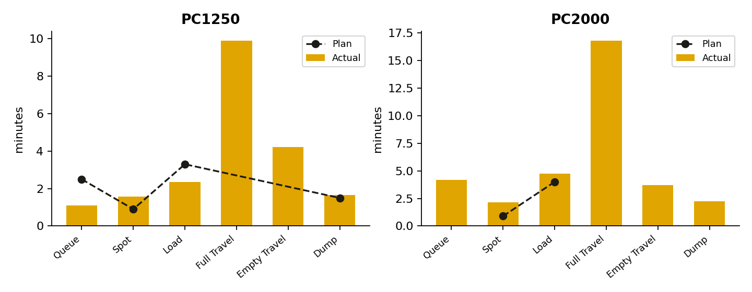

4. Payload Performance
The 95-ton payload target is being met on the cycles that actually load material — loaded-only averages are 87.3 t (PC1250) and 97.3 t (PC2000). The blended averages (70.5 t and 78.3 t) look like an underfilling problem but are actually a frequency problem: roughly 1 in 5 cycles carries no tonnage at all.
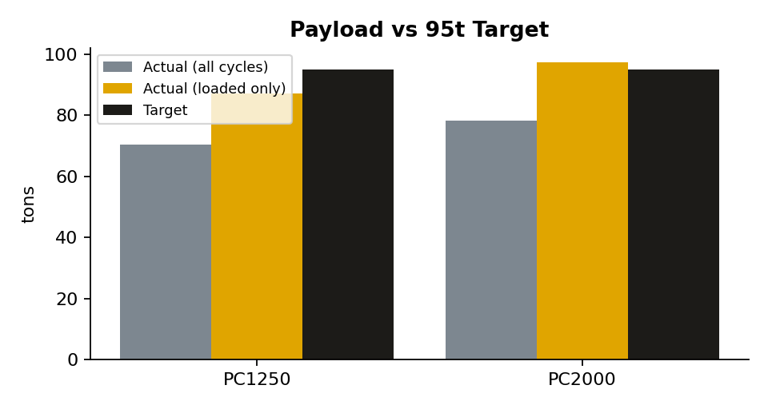
If the 32 zero-ton cycles had carried the average loaded payload instead, the shift would have hauled approximately 2,960 additional tons — about 24% more than the 12,311 tons actually recorded. This is the single largest recoverable-tonnage opportunity in the dataset, and is worth validating against the source dispatch/FMS log before assuming it reflects real operational idle time.

5. Production Trend by Hour
Production is heavily concentrated late in the shift: the 15:00 hour alone accounts for 82 of 165 cycles (50%) and 6,327 of 12,311 tons (51%). Average queue time also peaks in that hour at 4.1 minutes, versus 0.96 minutes the following hour — indicating that 15:00–16:00 is the operational bottleneck window where additional dispatch coordination would have the most impact.
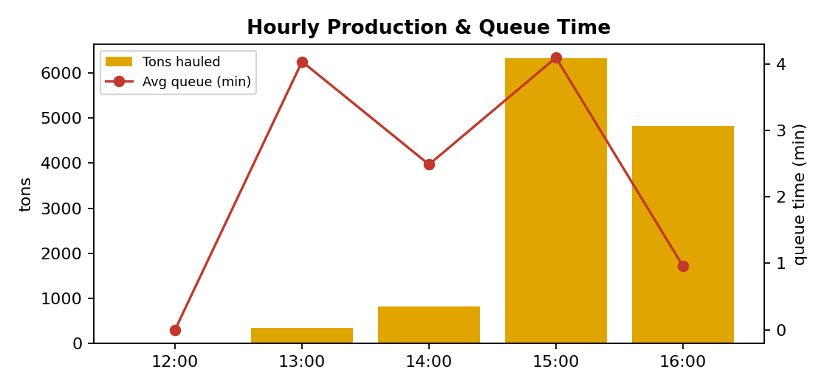

6. Material Mix & Haul Routes
OB B, OB E and ROM materials account for the largest tonnage shares. On routes, Load G → Dump G is both the highest-volume route (43 cycles) and one of the shortest (7.35 min average full-travel), while Load E → Dump E and Load F → Dump F combine high cycle counts with the longest full-travel durations (~20 and ~19.6 minutes respectively) — these are the routes where haul-distance, not process time, is the main driver of cycle length.

7. Excavator Utilization
Utilization across the 22 excavators is uneven: PC012 completed 18 cycles in the window versus 2 for PC028 and PC032 — a 9x spread. Some of this is explained by shorter local routes, but the spread is wide enough to warrant checking whether it reflects deliberate dispatch strategy, unplanned downtime on the low-cycle units, or a genuine assignment imbalance.
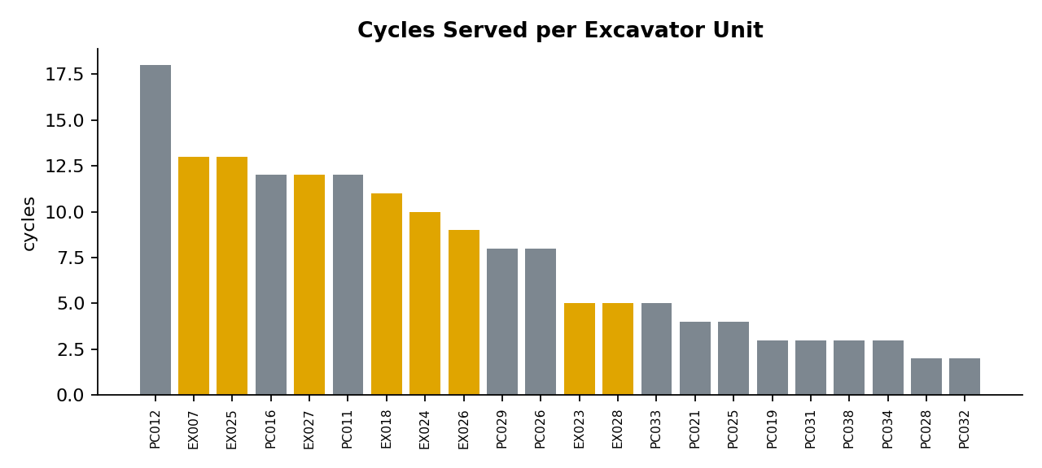

8. Recommendations
- Audit the zero-tonnage cycles first. Confirm with the FMS/dispatch team whether these 32 cycles are genuine empty runs or a payload-sensor / data-linking fault — this carries the largest potential tonnage upside in the dataset.
- Review spotting procedure at the highest-volume pits (Load F, G, H), since both excavator models run over the spot-time target.
- Re-balance excavator-to-route assignment: route short hauls (Load G/Dump G, Load A/Dump A) toward under-utilized units, and reserve long PC2000 hauls for units already running efficiently.
- Add dispatch capacity ahead of the 15:00 peak, where queue time nearly quadruples versus the following hour.

9. Notes & Data Caveats
- Duration fields (Queue, Spot, Loading, Full/Empty Travel, Dumping Time) are taken as provided by the source system, in seconds, converted to minutes for this analysis.
- The dataset covers a single shift window (12:54–16:45, 3 Nov 2023); conclusions on utilization and bottlenecks should be validated against a longer time horizon before being used for standing operational decisions.
- LoadFactorValue was constant (95) across all rows, consistent with the Plan sheet's 95-ton payload target.

