LEMBAR JAWABAN
UJIAN TENGAH SEMESTER
SEMESTER GENAP TAHUN AJARAN 2026/2027

Mata Kuliah : Pemrograman Web I
Kelas : IF201
Prodi : INFORMATIKA
Nama Mahasiswa: MUHAMMAD ABIYYU HAFIZH
NIM : 250401070209
Dosen : Dr. Fauziah , S.Kom., M.M.S.I.

SOURCE CODE WEB PORTOFOLIO

FILE index.html
<!DOCTYPE html>
<html lang="en">
<head>
<meta charset="UTF-8">
<meta name="viewport" content="width=device-width, initial-scale=1.0">
<title>Porto MA Hafizh</title>
<link rel="stylesheet" href="style.css">
<link rel="stylesheet" href="https://cdnjs.cloudflare.com/ajax/libs/font-awesome/7.0.1/css/all.min.css" integrity="sha512-2SwdPD6INVrV/lHTZbO2nodKhrnDdJK9/kg2XD1r9uGqPo1cUbujc+IYdlYdEErWNu69gVcYgdxlmVmzTWnetw==" crossorigin="anonymous" referrerpolicy="no-referrer" />
</head>
<body>
<!-- Navigation -->
<nav>
<div class="wrapper">
<div class="logo"><img src="images/internet-icon.png" alt="Logo"/></div>
<div class="menu">
<ul>
<li><a href="#profile">My Profile</a></li>
<li><a href="#achieve">Achievement</a></li>
<li><a href="#contact">Contact Me</a></li>
</ul>
</div>
</div>
</nav>

<!-- Hero / Jumbotron -->
<header>
<div class="header-opacity"></div>
<div class="header-jumbotron">
<img src="images/myPhoto-3x4.jpg" class="profile-image" alt="Muhammad Abiyyu Hafizh"/>
<h1>MUHAMMAD ABIYYU HAFIZH</h1>
<h2><i>IT Network Systems Administration</i></h2>
<a href="#profile" class="button">Explore My Work</a>
</div>
</header>

<!-- Profile Section -->
<section id="profile">
<div class="wrapper">
<h2>My Profile</h2>
<div class="desc">
<p>Perkenalkan saya Mahasiswa Informatika, saya memiliki keahlian dalam memanajemen jaringan dan server dengan sistem jaringan yakni Cisco, Mikrotik, Teltonika dan Server menggunakan Operating System Linux.</p>
</div>
<div class="desc2">
<p>Berikut Pengalaman Kerja Saya</p>
</div>
<div class="wrapper2">
<div class ="experience-card">
<h3>Server Administration</h3>
<small>PT ASTA BERKAH AUTONOMOUS - 6 Month</small>
</div>
<div class="experience-card">
<h3>Network Operation Access</h3>
<small>PT SUPRA PRIMATAMA NUSANTARA - 6 Month</small>
</div>
<div class="experience-card">
<h3>Network Security Engineer</h3>
<small>PT Visionary Solution Teknologi - 3 Month</small>
</div>
<div class="experience-card">
<h3>Network Engineer</h3>
<small>PT GRAHA KARYA INFORMASI - Now</small>
</div>
</div>
</div>
</section>

<!-- Achievement Section - DIPERBAIKI -->
<section id="achieve">
<div class="wrapper">
<h2>Achievement</h2>
<div class="achieve-grid">
<div class="achieve-card">
<a href="images/sertif-1.jpg" data-title="SERTIFIKAT BNSP">
<div class="achieve-image">
<img src="images/sertif-1.jpg" alt="Sertifikat BNSP"/>
</div>
<div class="achieve-title">
<h5>SERTIFIKAT BNSP</h5>
</div>
</a>
</div>
<div class="achieve-card">
<a href="images/sertif-2.jpg" data-title="SERTIFIKAT KABUPATEN">
<div class="achieve-image">
<img src="images/sertif-2.jpg" alt="Sertifikat Kabupaten"/>
</div>
<div class="achieve-title">
<h5>SERTIFIKAT KABUPATEN</h5>
</div>
</a>
</div>
<div class="achieve-card">
<a href="images/sertif-3.jpg" data-title="SERTIFIKAT PROVINSI">
<div class="achieve-image">
<img src="images/sertif-3.jpg" alt="Sertifikat Provinsi"/>
</div>
<div class="achieve-title">
<h5>SERTIFIKAT PROVINSI</h5>
</div>
</a>
</div>
</div>
</div>
</section>

<!-- Contact Section Placeholder -->
<!-- Contact Me Section -->
<section id="contact">
<div class="wrapper">
<h2>Contact <span>Me</span></h2>

<!-- Profile Photo & Info -->
<div class="contact-hero">
<div class="contact-photo">
<img src="images/fotoSeleknas.jpg" alt="Muhammad Abiyyu Hafizh"/>
</div>
<div class="contact-info">
<h3>MUHAMMAD ABIYYU HAFIZH</h3>
<div class="contact-details">
<div class="detail-item">
<i class="fa-solid fa-location-dot"></i>
<span>Pemalang, Jawa Tengah, Indonesia</span>
</div>
<div class="detail-item">
<i class="fa-solid fa-phone"></i>
<span>+62 818-0759-0824</span>
</div>
<div class="detail-item">
<i class="fa-solid fa-envelope"></i>
<span>muhabiyyuhafizh@gmail.com</span>
</div>
</div>
</div>
</div>

<!-- Social Media & Email -->
<!-- Social Media - 3 BOX SATU BARIS -->
<div class="contact-social">
<div class="social-grid">
<!-- Email -->
<a href="mailto:muhabiyyuhafizh@gmail.com" class="social-card email-card" target="_blank">
<div class="social-icon">
<i class="fa-solid fa-envelope"></i>
</div>
<div class="social-text">
<h6>Email Me</h6>
<p>Send Messages</p>
</div>
</a>

<!-- LinkedIn -->
<a href="https://linkedin.com/in/muhammad-abiyyu-hafizh" class="social-card linkedin-card" target="_blank">
<div class="social-icon">
<i class="fa-brands fa-linkedin-in"></i>
</div>
<div class="social-text">
<h6>LinkedIn</h6>
<p>Connect with me</p>
</div>
</a>

<!-- Instagram -->
<a href="https://instagram.com/siapiz" class="social-card instagram-card" target="_blank">
<div class="social-icon">
<i class="fa-brands fa-instagram"></i>
</div>
<div class="social-text">
<h6>Instagram</h6>
<p>Follow updates</p>
</div>
</a>
</div>
</div>

<!-- Download CV Button -->
<div class="cv-layer">
<a href="files/CV-Hafizh.pdf" class="button download-cv" download>
<i class="fa-solid fa-download"></i>
Download CV
</a>
</div>
</div>
</section>
<footer>
<div class="wrapper">&copy; 2026 Portofolio by Muhammad Abiyyu Hafizh</div>
</footer>
</body>

</html>

FILE style.css:
@import
url('https://fonts.googleapis.com/css2?family=Nunito:ital,wght@0,200..1000;1,200..1000&display=swap');
@import url('https://fonts.googleapis.com/css2?family=Josefin+Sans:ital,wght@0,100..700;1,100..700&display=swap');
@import url('https://fonts.googleapis.com/css2?family=Lexend+Deca:wght@100..900&display=swap');

/* Reset & Base */
* {
margin: 0;
padding: 0;
}

html, body {
font-size: 16px;
font-family: "Nunito", sans-serif;
scroll-padding-top: 70px;
scroll-behavior: smooth;
overflow-x: hidden;
}

.wrapper {
width: 1024px;
margin: auto;
padding: 20px 0px 20px 0px;
}

/* Navigation */
nav {
position: fixed;
top: 0;
width: 100%;
background-color: #0F2854;
color: #fff;
z-index: 10;
box-shadow: 0 2px 10px rgba(0,0,0,0.3);
}

nav .wrapper {
display: flex;
justify-content: space-between;
align-items: center;
font-size: 1.3rem;
}

.menu {
width: 50%;
}

.menu ul {
display: flex;
list-style-type: none;
justify-content: space-between;
}

.menu ul li a {
text-decoration: none;
color: #fff;
transition: color 0.3s ease;
}

.menu ul li a:hover {
color: #1bafe9f1;
}

.logo > img {
height: 45px;
border-radius: 10px;
}

/* Hero Section */
header {
height: 100vh;
background: url("../images/bgPorto.jpg") center/cover no-repeat;
position: relative;
display: flex;
align-items: center;
justify-content: center;
}

.header-opacity {
position: absolute;
top: 0;
left: 0;
width: 100%;
height: 100%;
background-color: rgba(15, 40, 84, 0.85);
z-index: 1;
}

.header-jumbotron {
position: relative;
z-index: 2;
text-align: center;
color: #fff;
font-family: "Josefin Sans", sans-serif;
}

.profile-image {
width: 22%;
height: 22%;
border-radius: 50%;
object-fit: cover;
box-shadow: 0 0 30px rgba(0,0,0,0.8);
margin-bottom: 10px;
border: 5px solid rgba(255,255,255,0.3);
}

.header-jumbotron h1 {
font-size: 3rem;
padding: 20px 0px 20px 0px;
text-shadow: 0 2px 10px rgba(0,0,0,0.8);
}

.header-jumbotron h2 {
font-size: 1.5rem;
margin-bottom: 30px;
opacity: 0.9;
}

.button {
display: inline-block;
background: linear-gradient(45deg, #73A5CA, #1C4D8D);
color: #fff;
padding: 15px 40px;
border-radius: 50px;
font-size: 1.2rem;
font-weight: 600;
transition: all 0.3s ease;
box-shadow: 0 5px 20px rgba(0,0,0,0.3);
text-decoration: none;
}

/* Profile Section */
#profile {
background: linear-gradient(135deg, #1C4D8D 0%, #0F2854 100%);
color: #fff;
padding: 70px 0px 80px 0px;
}

#profile h2 {
text-align: center;
font-size: 2.8rem;
margin-bottom: 40px;
font-family: "Lexend Deca", sans-serif;
text-shadow: 0 2px 10px rgba(0,0,0,0.5);
}

.desc {
background: rgba(255,255,255,0.95);
color: #333;
padding: 30px 40px;
margin-bottom: 50px;
border-radius: 20px;
box-shadow: 0 10px 40px rgba(0,0,0,0.3);
font-size: 1.3rem;
text-align: justify;
line-height: 1.7;
}

.desc2 {
background: rgba(255,255,255,0.95);
color: #333;
padding: 10px 20px;
margin-bottom: 20px;
border-radius: 20px;
box-shadow: 0 10px 40px rgba(0,0,0,0.3);
font-size: 1.3rem;
text-align: center;
line-height: 1.7;
}

.wrapper2 {
display: grid;
grid-template-columns: repeat(2, 1fr); /* 2 kolom */
grid-template-rows: repeat(2, 1fr); /* 2 baris */
gap: 30px;
max-width: 1000px;
margin: 0 auto;
}

.experience-card {
background: rgba(255,255,255,0.95);
color: #333;
padding: 30px;
border-radius: 20px;
text-align: center;
transition: all 0.3s ease;
box-shadow: 0 8px 30px rgba(0,0,0,0.2);
}

.experience-card h3 {
font-size: 1.7rem;
margin-bottom: 10px;
color: #0F2854;
}

.experience-card small {
font-size: 1rem;
opacity: 0.8;
}

/* ACHIEVEMENT SECTION */
#achieve {
background: linear-gradient(135deg, #2b2f38 0%, #1a1e24 100%);
padding: 70px 0 80px 0;
text-align: center;
}

#achieve h2 {
background: rgba(255,255,255,0.95);
color: #0F2854;
padding: 5px 20px;
border-radius: 20px;
font-size: 2.8rem;
margin-bottom: 60px;
display: inline-block;
box-shadow: 0 8px 30px rgba(0,0,0,0.3);
font-family: "Lexend Deca", sans-serif;
}

.achieve-grid {
display: grid;
grid-template-columns: repeat(3, 5fr);
gap: 100px;
margin: 10px auto;
}

.achieve-card {
background: rgba(255,255,255,0.05);
border-radius: 10px;
backdrop-filter: blur(10px);
border: 1px solid rgba(255,255,255,0.1);
box-shadow: 0 15px 50px rgba(0,0,0,0.4);
}

.achieve-card a {
display: block;
color: #fff;
text-decoration: solid;
position: relative;
}

.achieve-card:hover {
transform: translateY(-10px);
box-shadow: 10px 10px 10px rgba(255, 255, 255, 0.2);
}

.achieve-image {
border-top-right-radius: 10px;
border-top-left-radius: 10px;
width: 100%;
height: 200px;
overflow: hidden;
}

.achieve-image img {
width: 100%;
height: 100%;
object-fit: cover;
transition: transform 0.4s ease;
}

.achieve-title {
padding: 20px;
font-size: 1.4rem;
background: rgba(0,0,0,0.3);
backdrop-filter: blur(10px);
}

/* CONTACT SECTION */
#contact {
background: #16213e;
position: relative;
overflow: hidden;
padding-top: 70px;
}

#contact h2 {
background: linear-gradient(45deg, #73A5CA, #A3CDE3);
-webkit-background-clip: text;
-webkit-text-fill-color: transparent;
background-clip: text;
font-size: 2.8rem;
font-family: "Lexend Deca", sans-serif;
font-weight: 800;
display: inline-block;
text-align: center;
width: 100%;
}

#contact h2 span {
background: linear-gradient(45deg, #73A5CA, #ffffff);
-webkit-background-clip: text;
-webkit-text-fill-color: transparent;
background-clip: text;
}

/* Contact Hero */
.contact-hero {
display: grid;
grid-template-columns: 1fr 1fr;
gap: 60px;
align-items: center;
margin-bottom: 60px;
max-width: 1000px;
margin-left: auto;
margin-right: auto;
}

.contact-photo {
position: relative;
width: 220px;
height: 220px;
margin: 0 auto;
}

.contact-photo img {
width: 120%;
height: 120%;
border-radius: 50%;
object-fit: cover;
border: 5px solid rgba(255,255,255,0.2);
box-shadow: 0 20px 60px rgba(0,0,0,0.5);
}

.contact-info {
padding: 50px 50px 40px 50px;
width: 900px;
}

.contact-info h3 {
font-size: 2rem;
color: #fff;
margin-bottom: 30px;
font-family: "Josefin Sans", sans-serif;
font-weight: 600;
}

.contact-details {
display: flex;
flex-direction: column;
gap: 20px;
}

.detail-item {
display: flex;
align-items: center;
gap: 15px;
font-size: 1.2rem;
color: rgba(255,255,255,0.9);
}

/* Social Media Cards */
.contact-social {
margin: 60px;
}

/* Social Media - 3 BOX SATU BARIS */
.social-grid {
display: grid;
grid-template-columns: repeat(3, 1fr); /* 3 KOLOM SAMA */
gap: 25px;
margin: 0 auto;
justify-items: center;
}

.social-card {
display: flex;
align-items: center;
gap: 20px;
padding: 30px 25px; /* Lebih compact */
border-radius: 20px;
text-decoration: none;
color: #fff;
}

.social-card:hover {
transform: translateY(-10px);
background-color: #1C4D8D;
}

/* ICON SIZE */
.social-icon {
display: flex;
align-items: center;
justify-content: center;
font-size: 25px;
}

.social-text h6 {
font-size: 1.3rem;
font-weight: 700;
margin-bottom: 5px;
font-family: "Lexend Deca", sans-serif;
white-space: nowrap;
}

.social-text p {
font-size: 0.9rem;
opacity: 0.9;
margin: 0;
font-weight: 500;
}

/* Colors tetap sama */
.email-card { background: rgba(246, 26, 26, 0.2); }
.linkedin-card { background: rgba(0, 119, 181, 0.2); }
.instagram-card { background: rgba(225, 48, 108, 0.2); }

/* Download CV Button */
.cv-layer {
padding: 0px 0px 60px 0px;
text-align: center;
}

.download-cv {
background: linear-gradient(45deg, #73A5CA, #1C4D8D);
padding: 15px 30px;
font-size: 1.2rem;
display: inline-flex;
align-items: center;
gap: 5px;
}

.download-cv:hover {
transform: translateY(-8px);
}

/*
copyright
*/

footer {
background-color: #202940;
color: #fff;
text-align: center;
}

footer > .wrapper {
padding: 20px 0px 20px 0px;
font-size: 1rem;
}

SOURCE CODE WEB PORTOFOLIO

BERANDA:
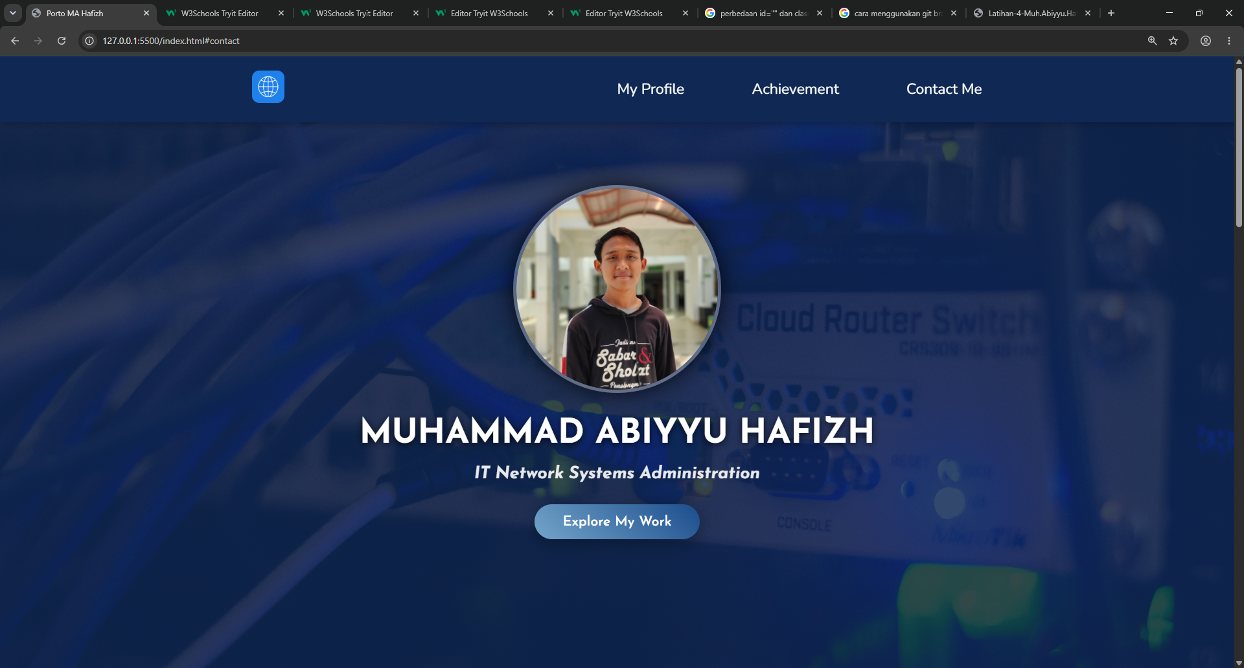

My Profile:
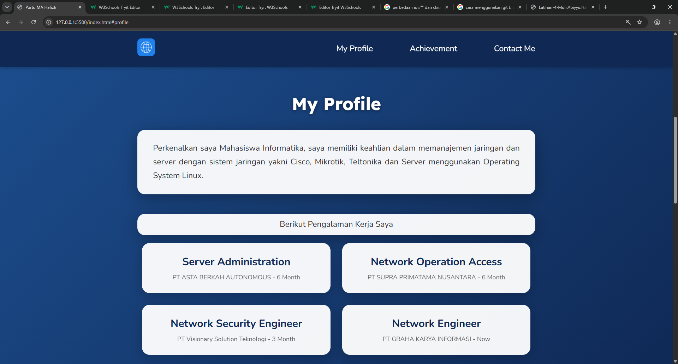

Achievement:
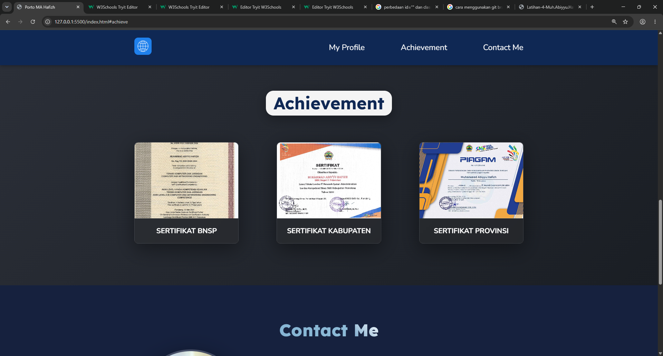

Contact:
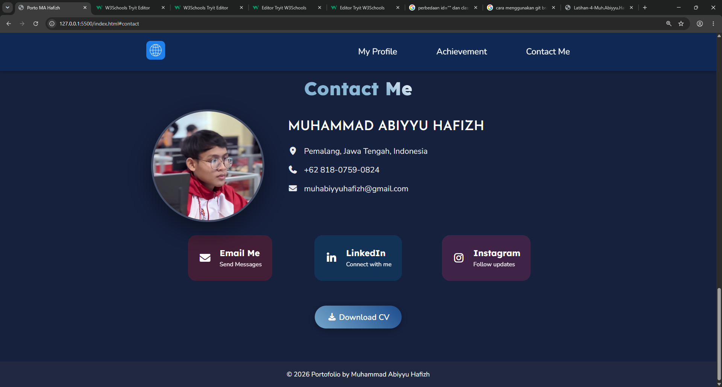

ANALISIS CODE

KODE HTML
- <!DOCTYPE html>: Untuk mengisiasi sebuah Document dengan tipe html.
- <html lang="en">: Tag untuk memulai html dengan lang/bahasa ‘en’ yang berarti english.
- <head>: Tag untuk mengedit bagian tab browser.
- <meta charset="UTF-8">: Tag ini berisikan atribut standar encoding untuk memberikan informasi terkait halaman web pada browser.
- <title>

- <link rel="stylesheet" href="style.css">
- <link rel="stylesheet"
- href="..."
- integrity="..."
- crossorigin="anonymous"
- referrerpolicy="no-referrer">

- </head>

- <body>

- <nav>

- <div class="wrapper">
- <div class="logo">
- <div class="menu">

- <ul>

- <li>

- <a href="#profile">
- <a href="#achieve">
- <a href="#contact">

- <a href="images/sertif-1.jpg" data-title="SERTIFIKAT BNSP">
- <a href="files/CV-Hafizh.pdf" class="button download-cv" download>
- <a href="mailto:muhabiyyuhafizh@gmail.com" class="social-card email-card" target="_blank">
- <a href="https://linkedin.com/in/muhammad-abiyyu-hafizh" class="social-card linkedin-card" target="_blank">
- <a href="https://instagram.com/siapiz" class="social-card instagram-card" target="_blank">

- </nav>

- <header>

- <div class="header-opacity">
- <div class="header-jumbotron">

- <img src="images/internet-icon.png" alt="Logo">
- <img src="images/myPhoto-3x4.jpg" class="profile-image" alt="Muhammad Abiyyu Hafizh">
- <img src="images/sertif-1.jpg" alt="Sertifikat BNSP">
- <img src="images/fotoSeleknas.jpg" alt="Muhammad Abiyyu Hafizh">

- </header>

- <section id="profile">
- <section id="achieve">
- <section id="contact">

- <h1>
- <h2>
- <h3>
- <h5>
- <h6>

- <p>

- <small>

- <span>

- <i>
- <i class="fa-solid fa-location-dot">
- <i class="fa-solid fa-phone">
- <i class="fa-solid fa-envelope">
- <i class="fa-brands fa-linkedin-in">
- <i class="fa-brands fa-instagram">
- <i class="fa-solid fa-download">

- <footer>

- </body>

- </html>

Nilai | Tanda Tangan Dosen Pengampu | Tanda Tangan  Mahasiswa
 | (Dr. Fauziah , S.Kom., M.M.S.I.) |   (Muhammad Abiyyu Hafizh)
Diserahkan pada Tanggal: |  | Tanggal Mengumpulkan:
 |  | DD/MM/YYYY

