PathologyLoss Figure Atlas
Every figure produced by the 50-epoch publication run on BraTS 2021 — twenty-two plates, in the order the argument needs them, each marked for whether it can go in the paper as it stands.
RUN  phasefinal_seed1 | SUBJECTS  100 | SPLIT  80 / 20 by patient
EPOCHS  50 | OBJECTIVES  5 + 2 anchors | WALL CLOCK  36 h 05 m
How to read the status marks
[CITE] usable as it stands
[CARE] usable with a caveat stated
[RETIRE] contradicts the current analysis — do not show
ACT 01

The problem
Rician noise at sigma = 0.08, applied in the image domain the way magnitude-reconstructed MRI actually carries it. Segmenting the corrupted input scores 0.3186 Dice on enhancing tumour; segmenting the clean image scores 0.6345. Everything in this study lives in that gap.
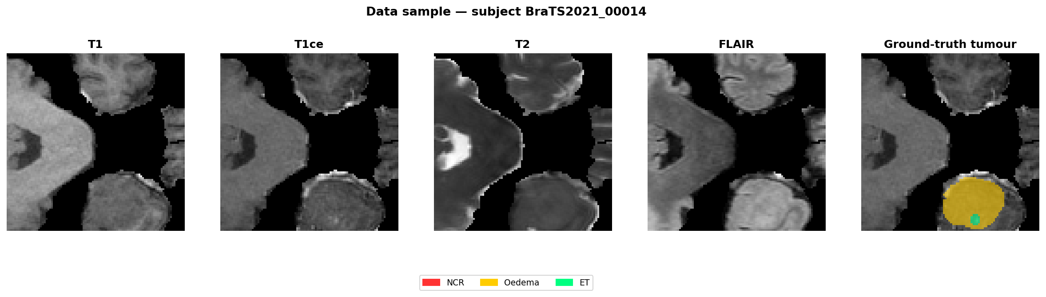
fig01 The input data [CITE]
One subject, four co-registered modalities — T1, T1ce, T2, FLAIR — with the expert label map. T1ce is where enhancing tumour shows, which is why every qualitative plate here uses it.
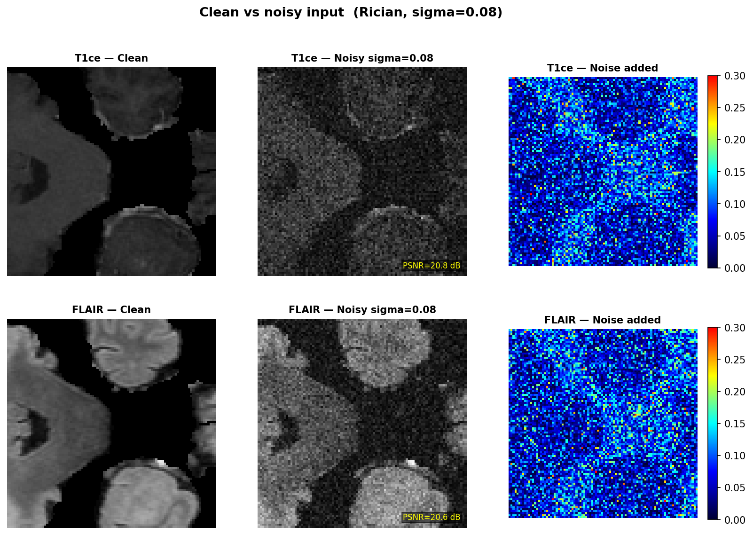
fig02 What the corruption does [CITE]
Clean against corrupted, same windowing. The damage is not uniform in consequence: fine enhancing-tumour margins disappear while bulk white matter survives looking acceptable.
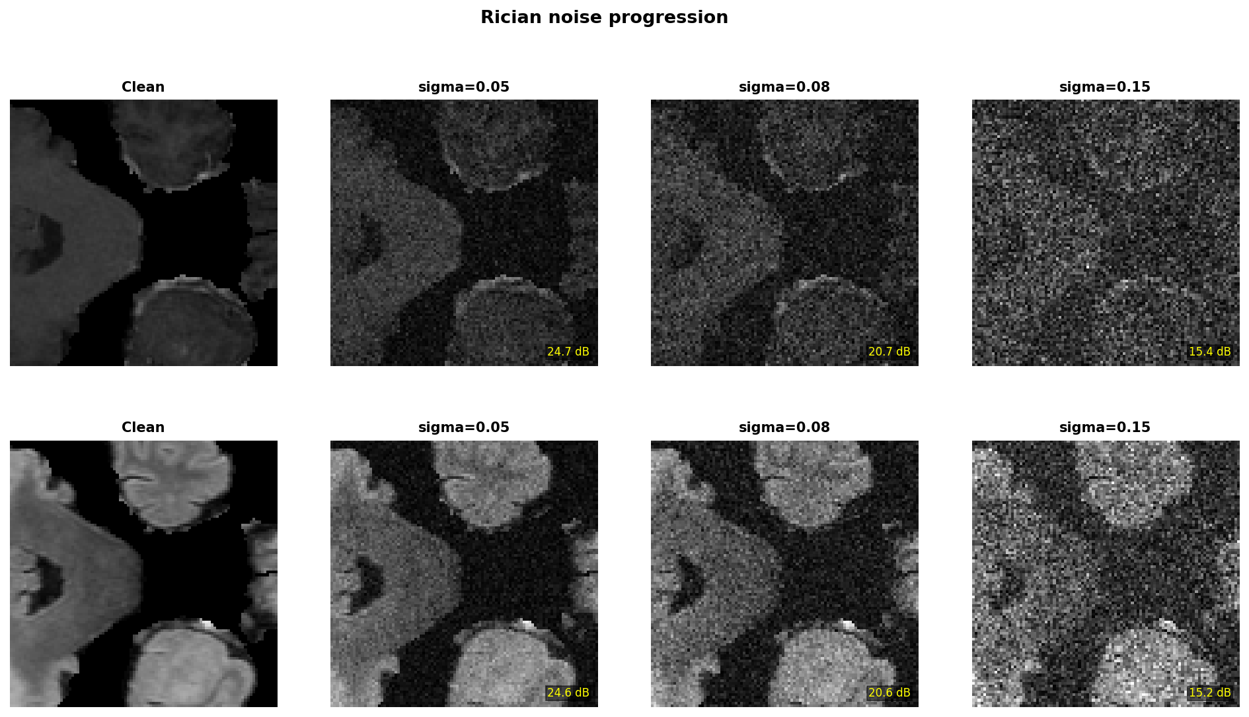
fig10 Noise progression [CITE]
The same slice across increasing sigma, showing where 0.08 sits. Useful for justifying the operating point — though the study only ever trains and tests at 0.08, so generalisation across this axis is untested.

ACT 02

The method
A restoration network trained with an extra term that weights reconstruction error inside the nested BraTS regions — whole tumour contains tumour core contains enhancing tumour — at 1:2:3, each normalised by its own area.
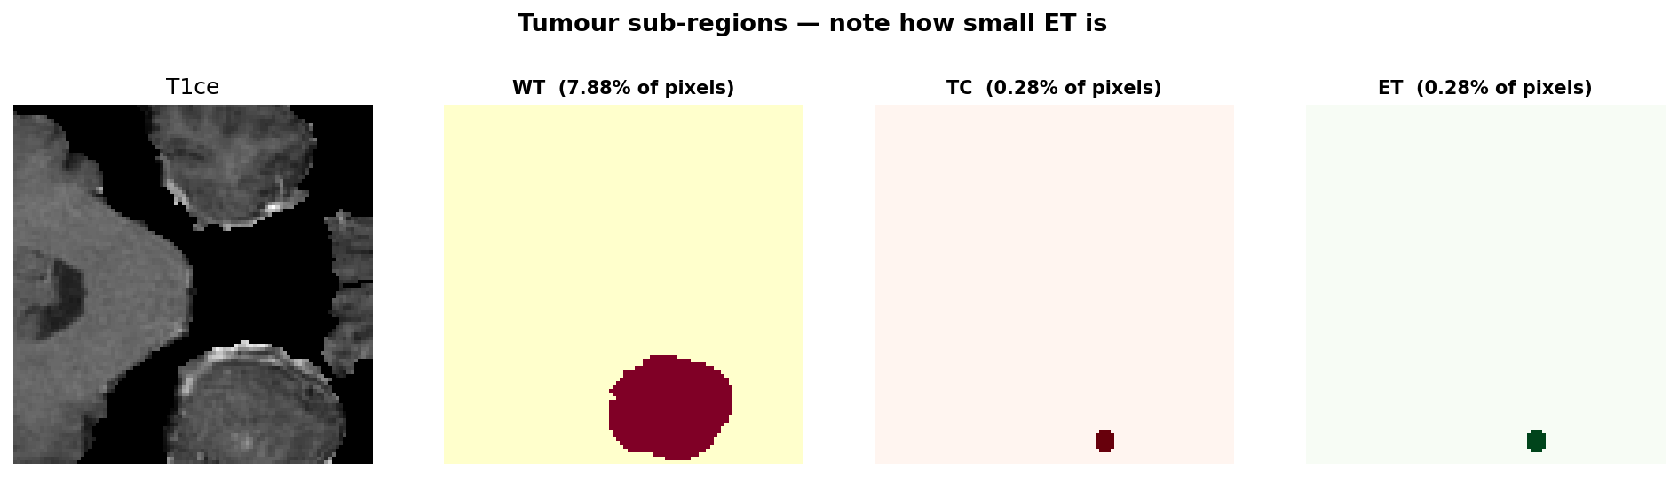
fig09 The nested regions [CITE]
WT, TC and ET on a real slice. The nesting is the structural claim: these are not three separate labels but three shells, so a voxel inside ET is also inside TC and WT and accumulates all three weights.
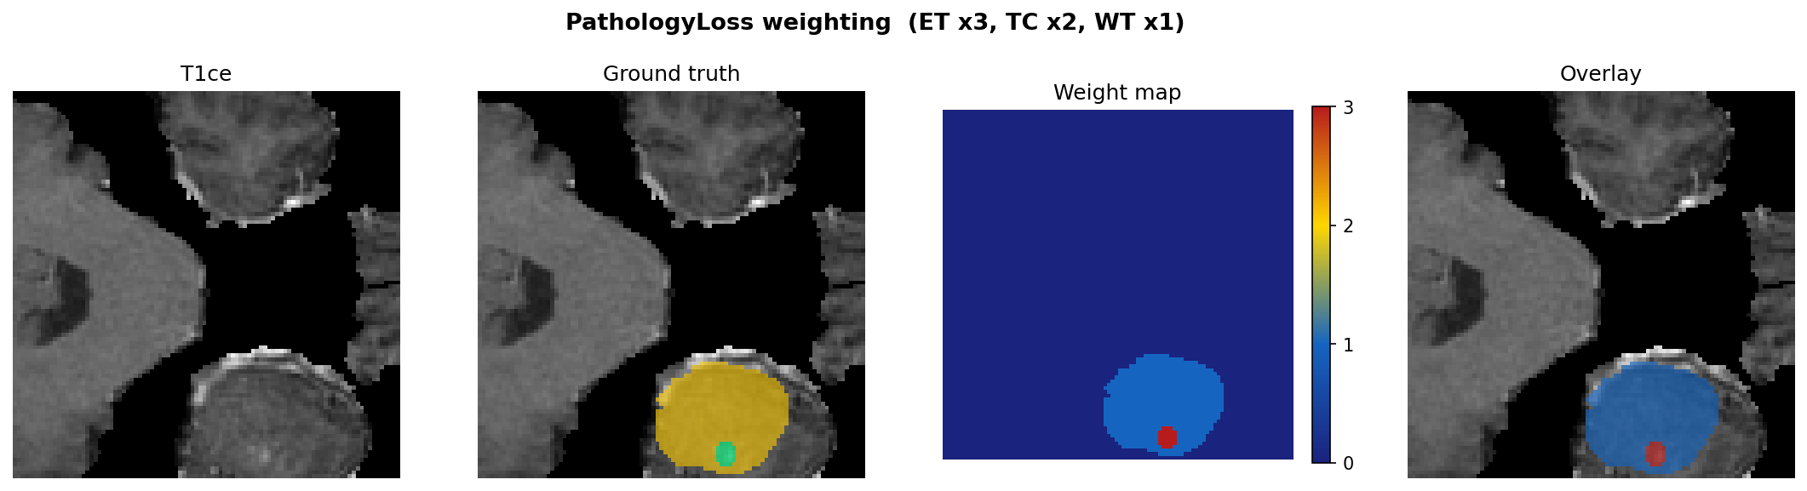
fig11 The weight map [CITE]
The coefficient each voxel actually receives. Because every region is normalised by its own area, the multiplier is size-dependent rather than a fixed 6x; measured on real data the effective ratio comes out 2.97 : 2.04 : 1.00, so the intended ordering survives.
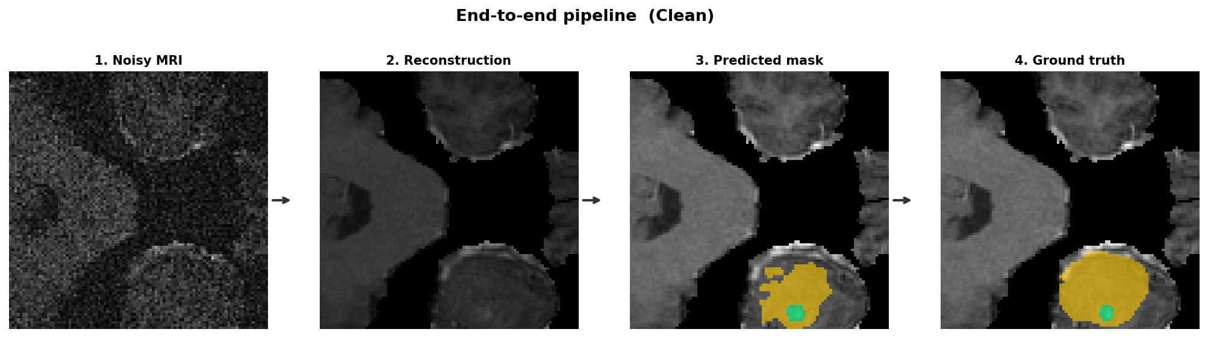
fig13 Evaluation pipeline [CITE]
Corrupt, restore, then segment with a segmentor trained on clean images and frozen. Every objective is judged by the identical frozen network, so a Dice difference can only come from the restoration.
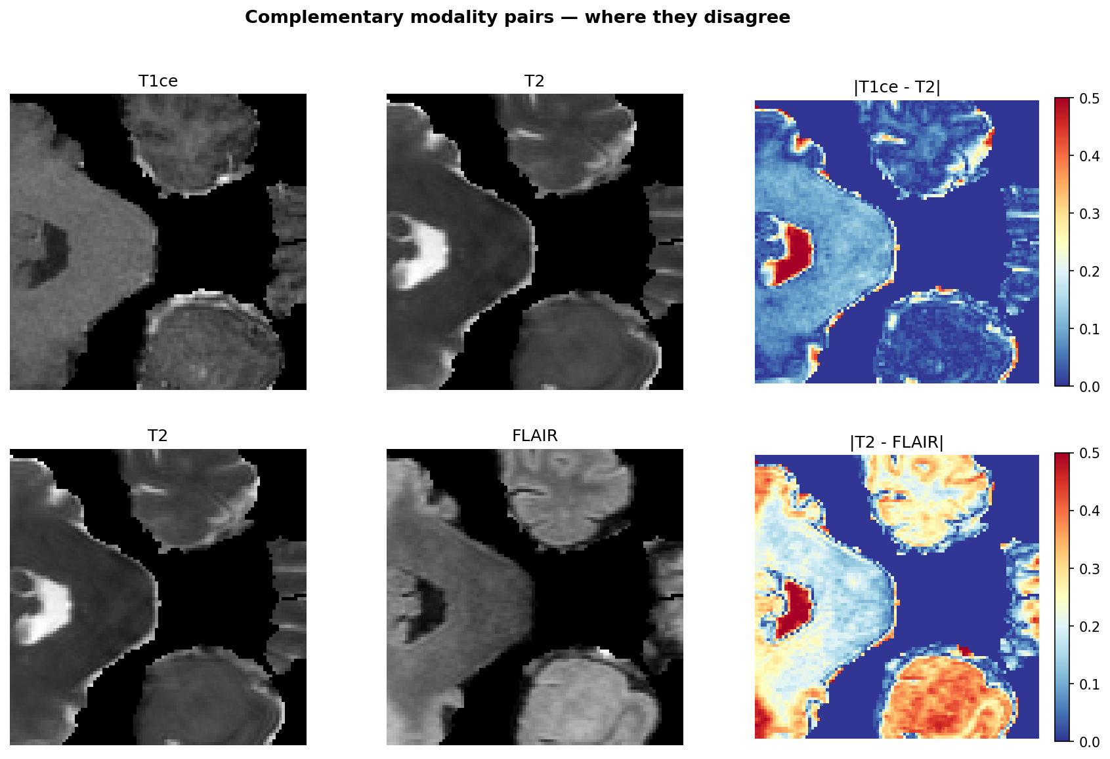
fig14 The cross-modal term [CITE]
The four modalities are co-registered, so structure should agree across them. This term is in the matched control too — and it turns out to be doing most of the work.
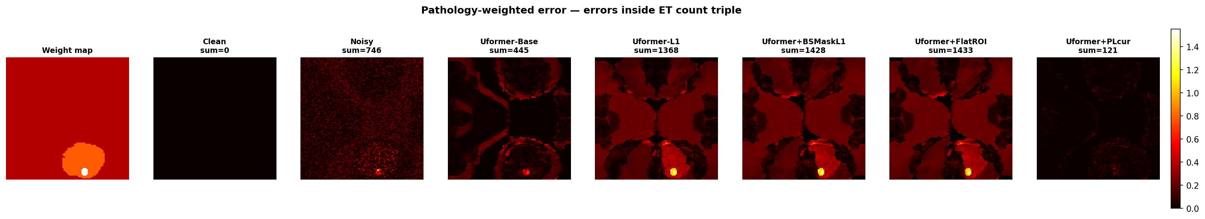
fig12 Where each objective looks [CITE]
Spatial distribution of loss for each objective on one slice. The clearest single picture of what distinguishes the arms before any metric is computed.

ACT 03

What came out
All seven arms on slice 95 of BraTS2021_00014, chosen automatically as the slice on which the arms disagree most — a slice they all handle identically demonstrates nothing.
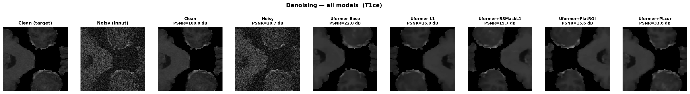
fig03 Restored output, all arms [CITE]
Identical windowing across arms, so brightness differences are real rather than a display artefact. To the eye these are nearly indistinguishable — the honest starting point for everything that follows.
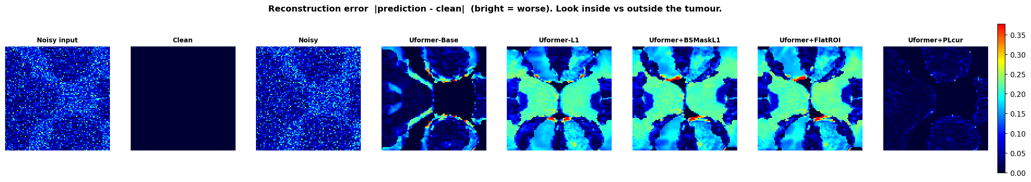
fig04 Reconstruction error [CITE]
Absolute error on one shared colour scale, so a brighter panel genuinely means worse. The differences the eye could not find in fig03 are visible here, concentrated exactly where each objective was told to care.
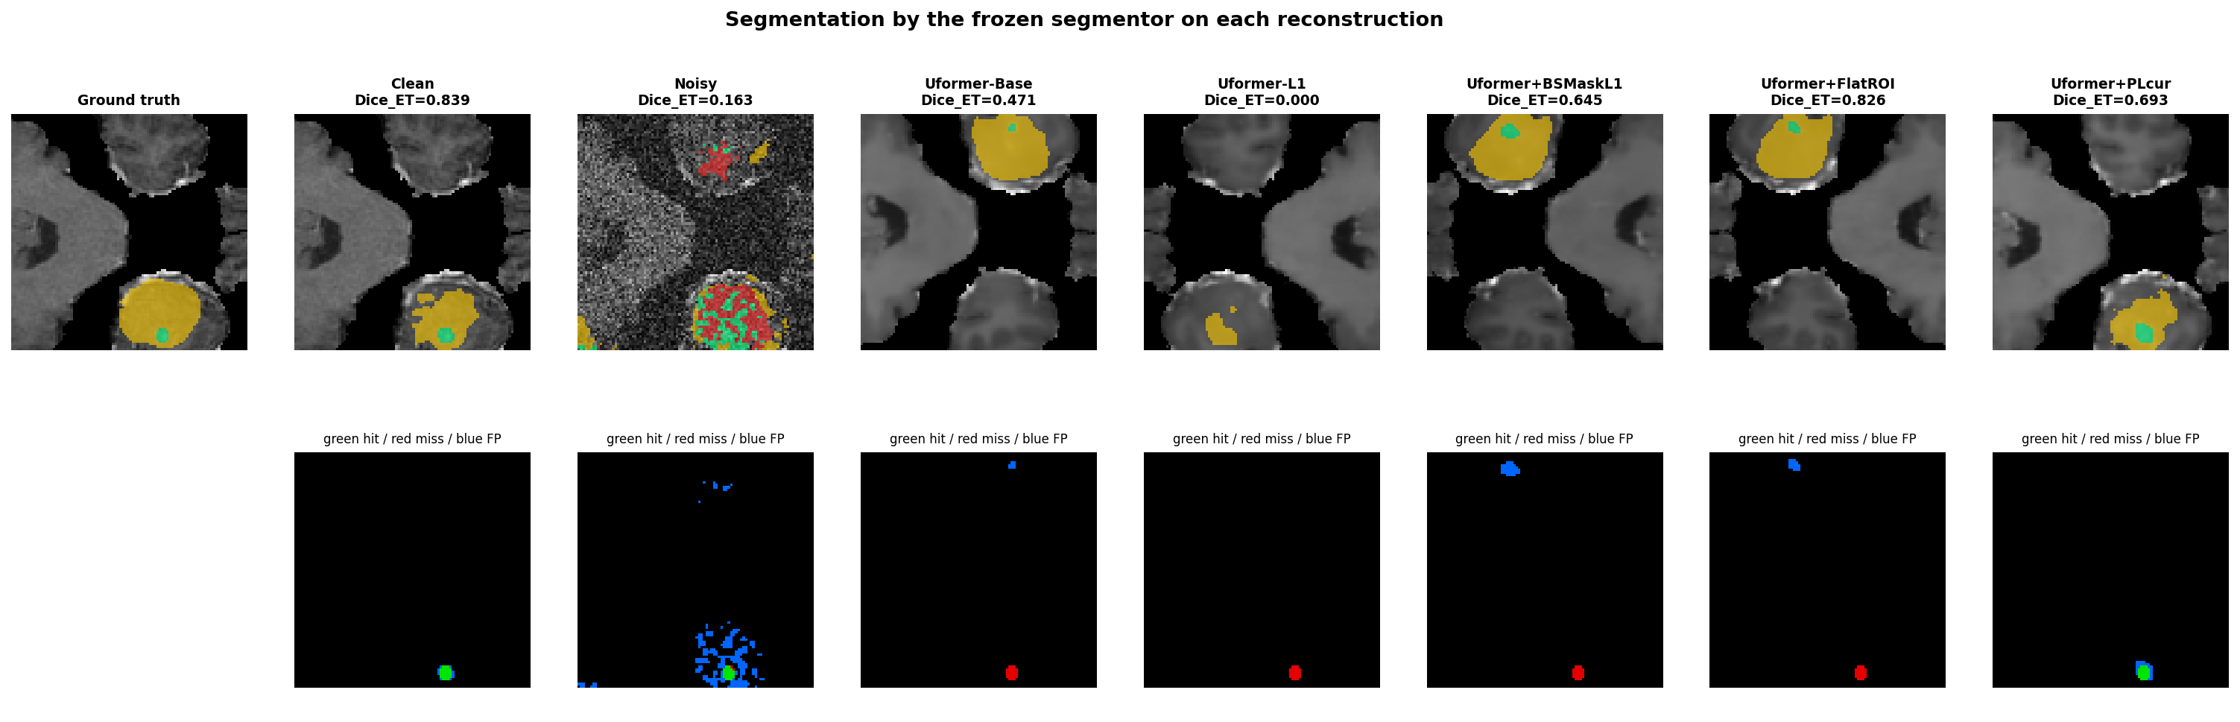
fig05 Segmentation agreement [CITE]
Green found real tumour, red missed it, blue invented it. The blue is the column to read: Dice rewards finding tumour and does not symmetrically punish inventing it.

ACT 04

Results
Twenty held-out patients, 1206 slices. Inference is at patient level throughout: 1206 slices from 20 people are not 1206 independent observations, and treating them as such inflates significance roughly tenfold.
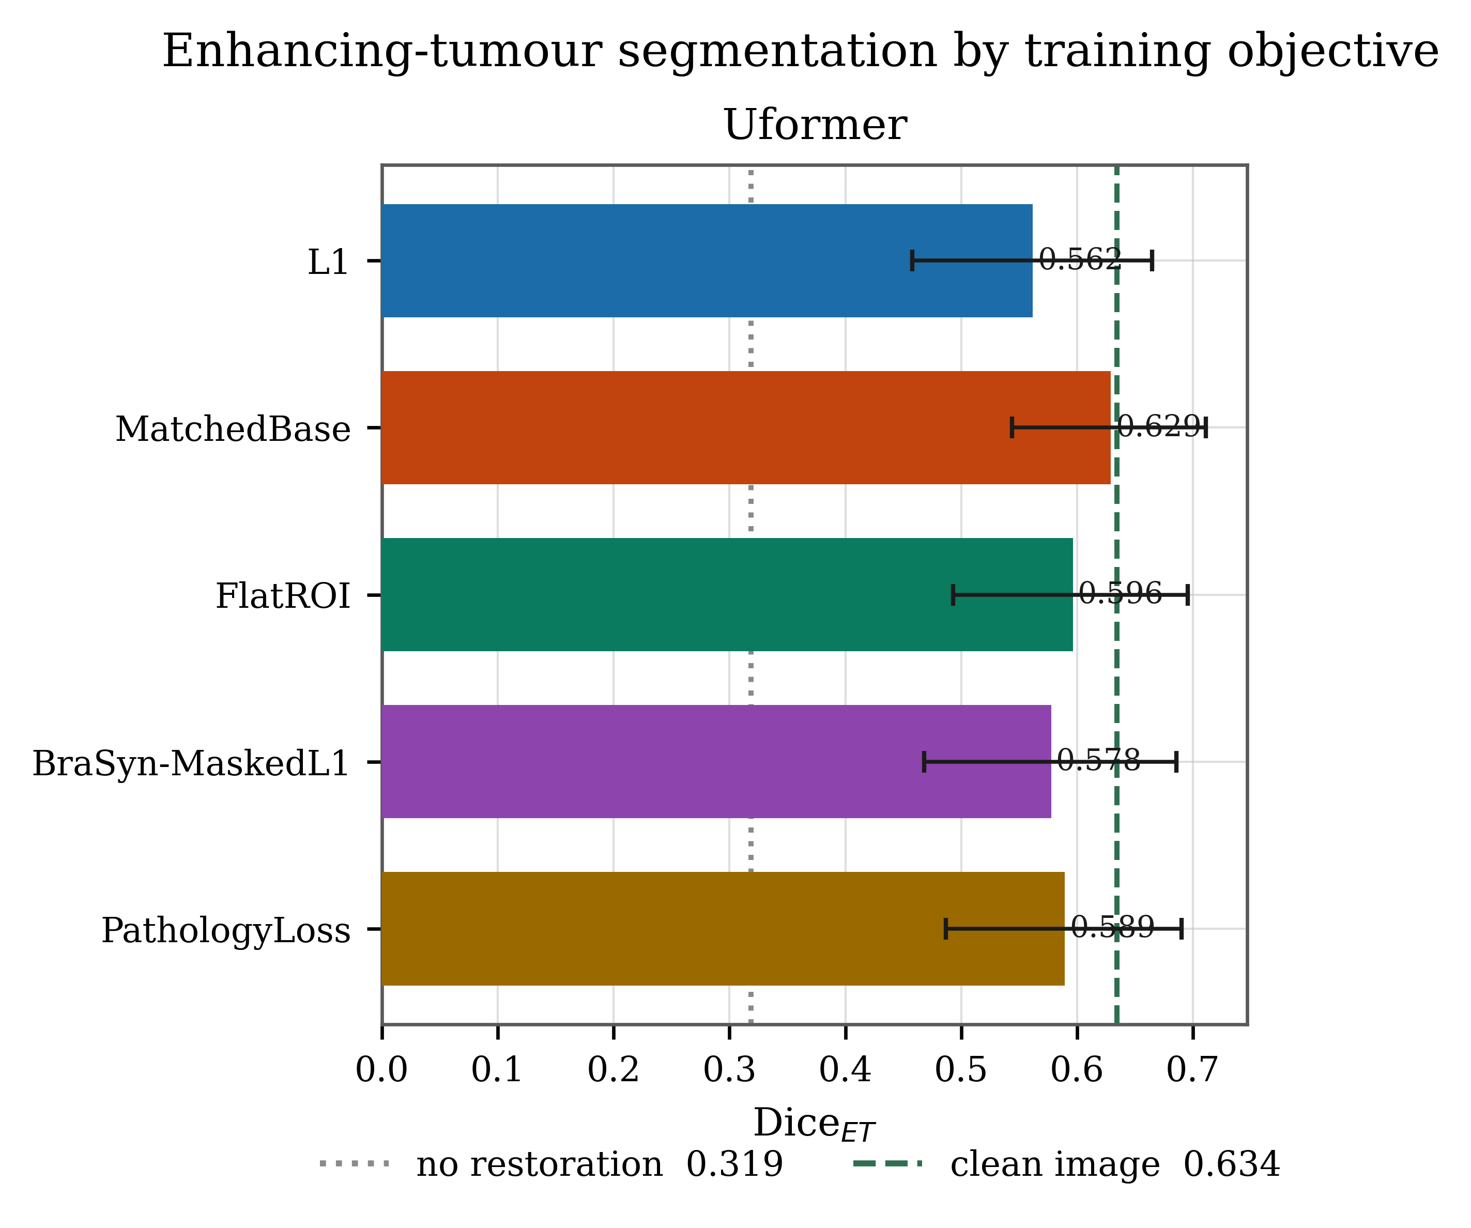
paper fig1 Accuracy by objective [CITE]
Dice on enhancing tumour per objective, bootstrap 95% intervals over patients, floor and ceiling marked. The matched control — which contains no pathology term at all — sits highest, essentially at the clean-image ceiling.
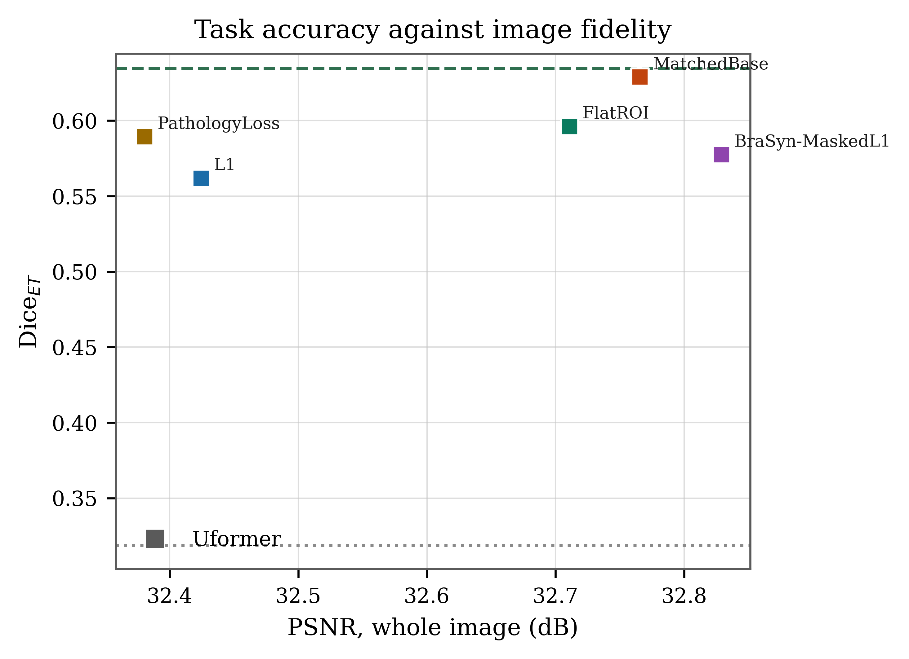
paper fig2 Accuracy against global fidelity [CITE]
The arm with the best picture is not the arm best for the tumour. PathologyLoss has the lowest global PSNR of the five trained arms, by design.
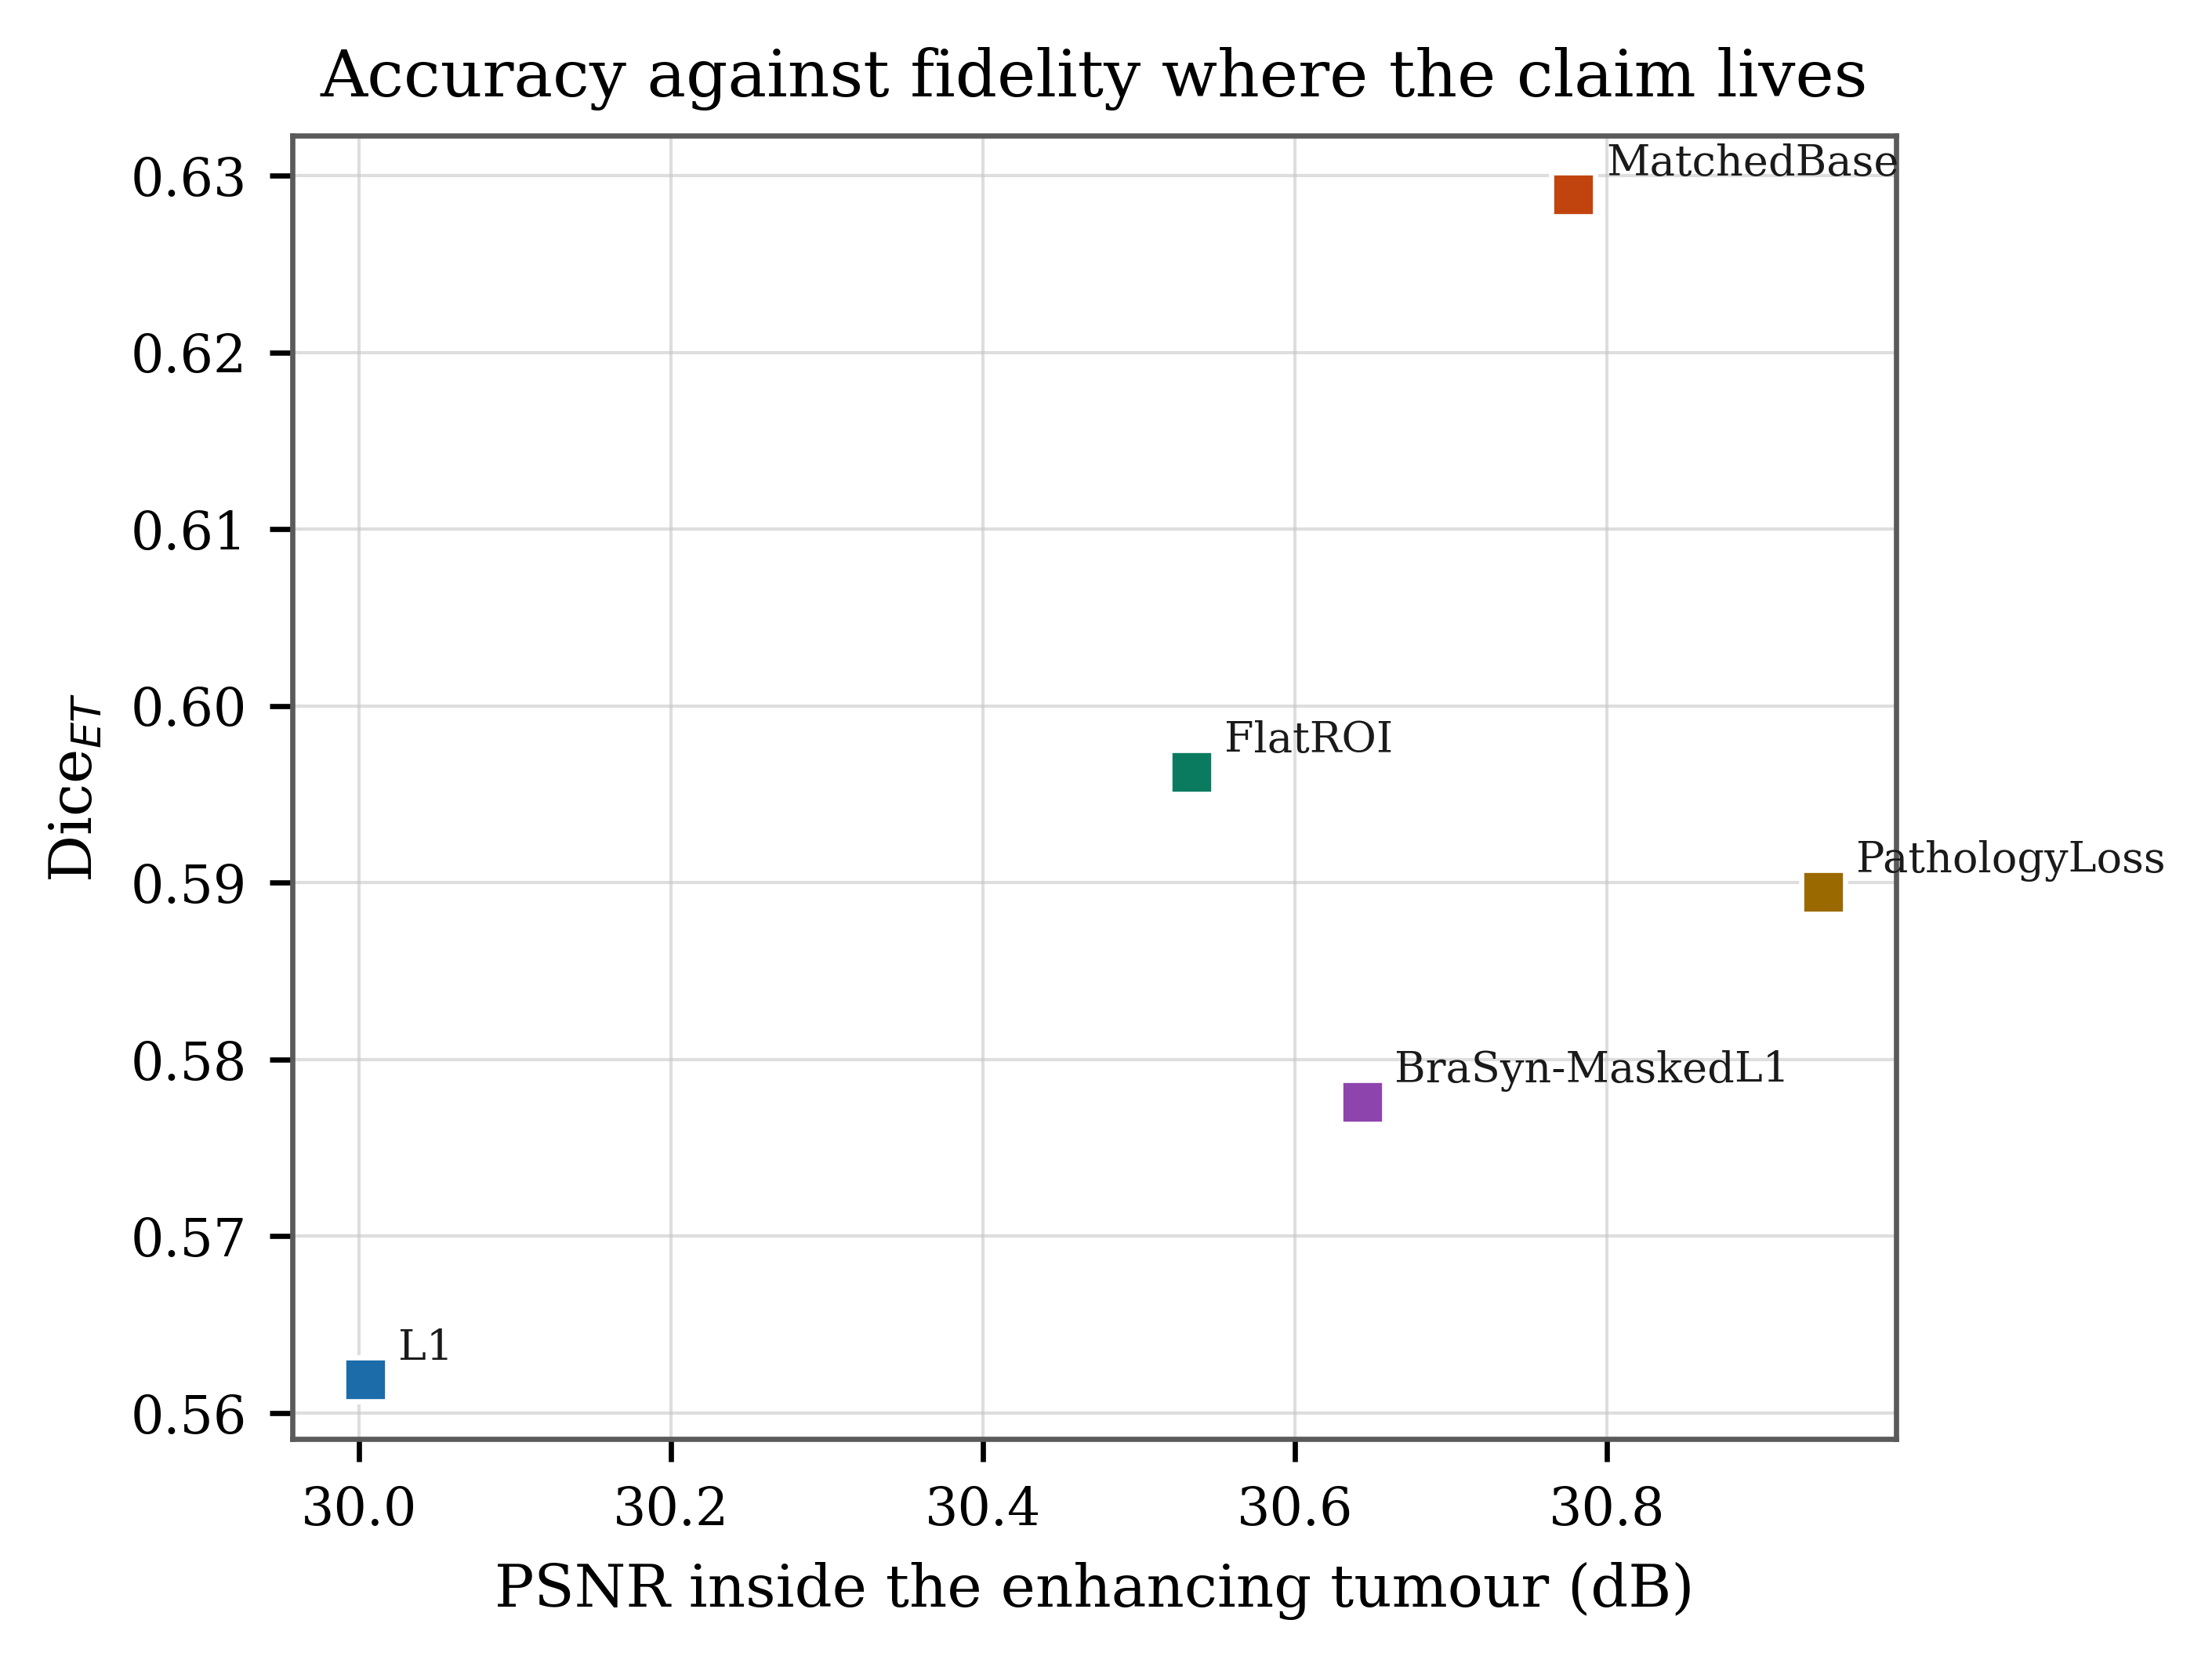
paper fig3 Accuracy against targeted fidelity [CITE]
The same plot against PSNR measured only inside enhancing tumour — where the claim actually lives. PathologyLoss is furthest right: +0.94 dB over L1 on 19 of 19 patients. This is the run's most robust positive result.
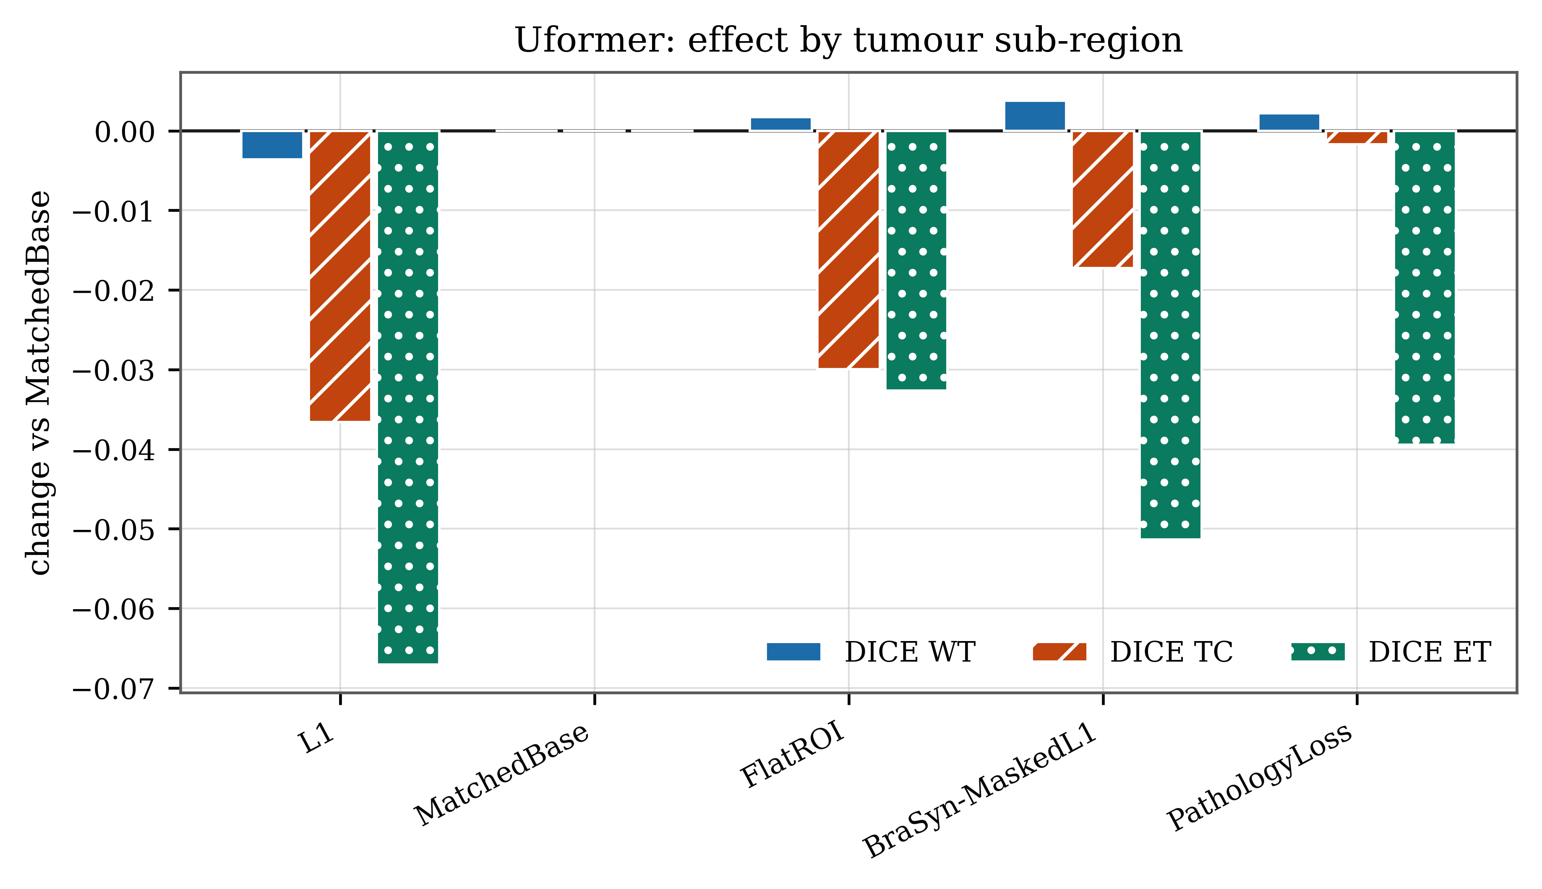
paper fig6 Per-region breakdown [CITE]
Every arm plotted as its change from the matched control, split by region. Read the sign carefully: the bars run downward, so each arm shown is worse than the control. The gaps are largest on enhancing tumour — the innermost, most heavily weighted shell — and near zero on whole tumour. PathologyLoss sits about 0.04 Dice below the control on ET, which is this plate's version of the central negative result.
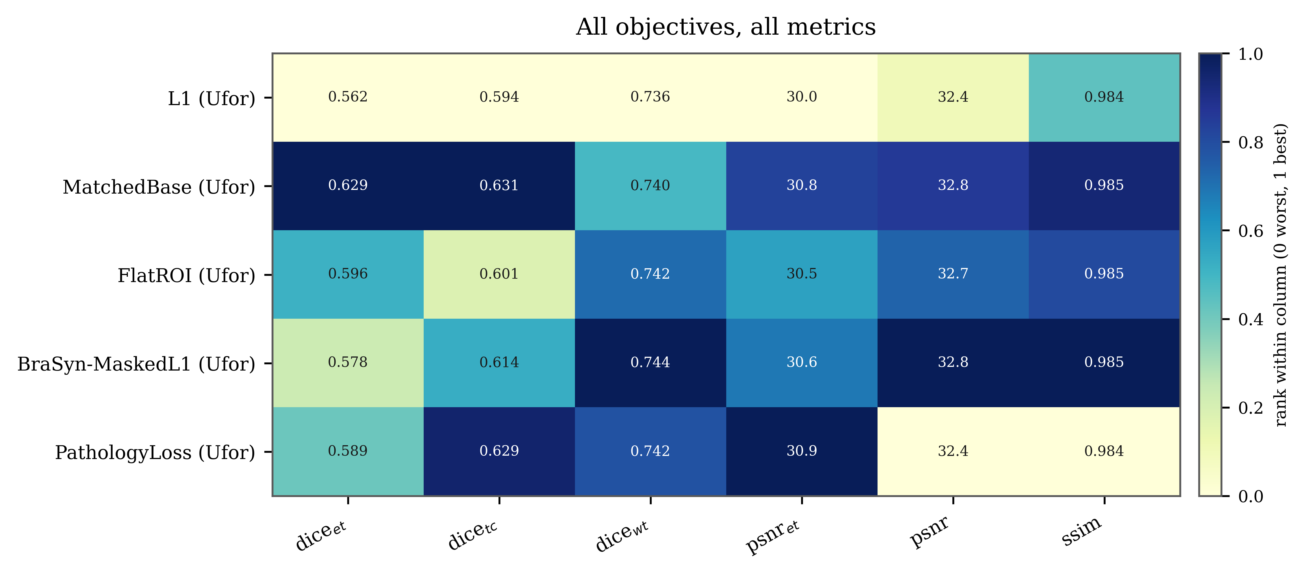
paper fig4 Every arm, every metric [CITE]
The whole result surface at once. The trade-off reads as a diagonal: arms that win on region-restricted fidelity lose on global fidelity, and no arm wins everywhere.
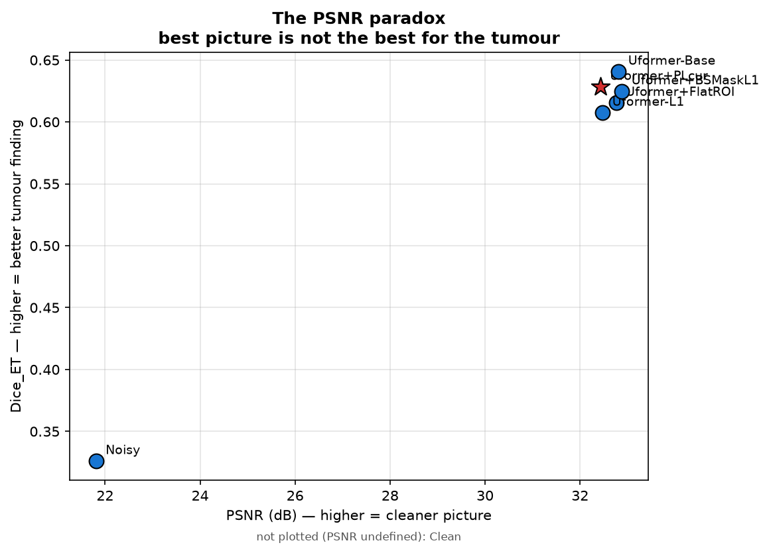
fig07 The fidelity paradox [CARE]
The run's own version of paper fig2, regenerated after the crash. The clean-image anchor has infinite PSNR and no position on this axis, so it is noted under the plot rather than drawn. Not submission-ready: the five trained arms land almost on top of one another and their labels overlap illegibly. Use paper fig2 instead.
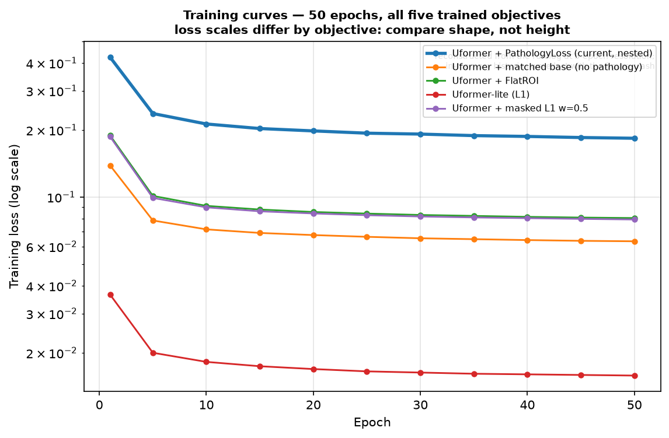
fig08 Training curves [CARE]
All five objectives, log scale. Loss heights are not comparable — each arm minimises a different functional — so read shape only. Two caveats: the per-epoch histories were held in memory and lost when the run crashed, so this is rebuilt from the log at 5-epoch resolution; and all five were still improving slightly at epoch 50.
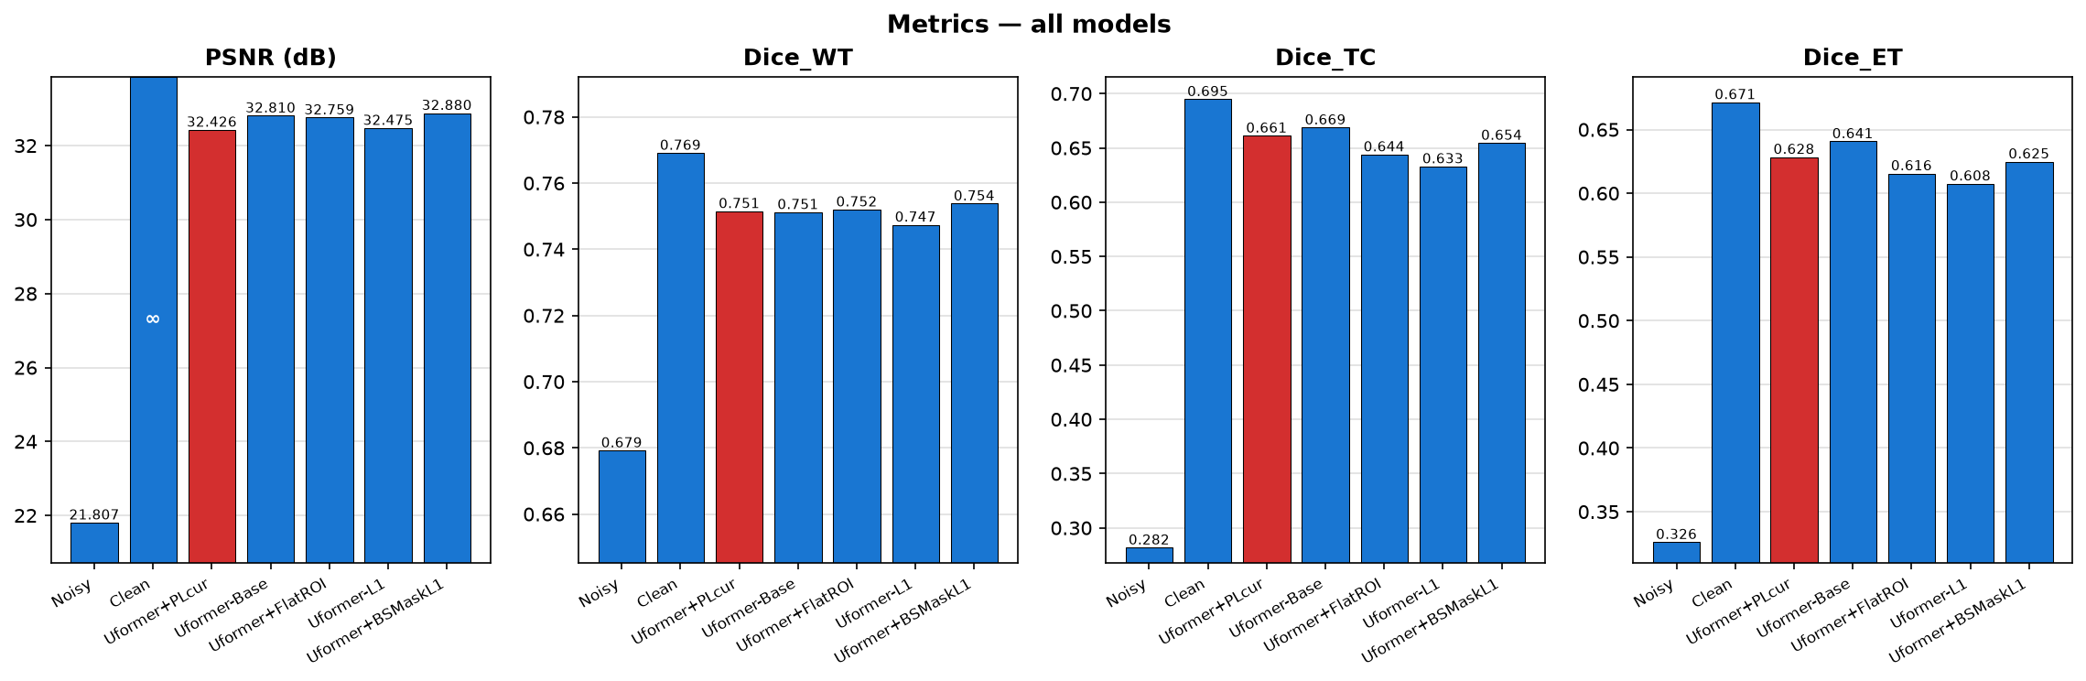
fig06 Metric bars [CARE]
The figure whose crash cost the run its exit code: the clean arm's PSNR is infinite and matplotlib refused the axis. Now drawn from the finite bars with the infinite one marked. Use with care — these are slice-level pooled means, which are descriptive only; paper fig1 is the version with valid intervals.
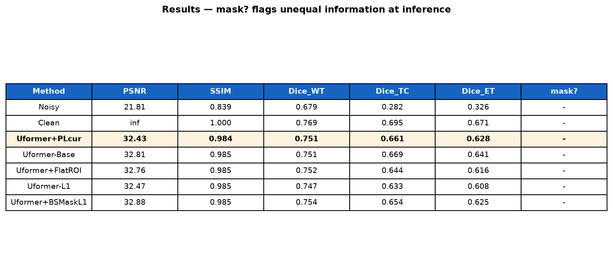
fig15 Results table [CARE]
Convenient for a slide, but slice-level like fig06. For the manuscript use table1_main_results.tex, which is patient-level and carries confidence intervals.
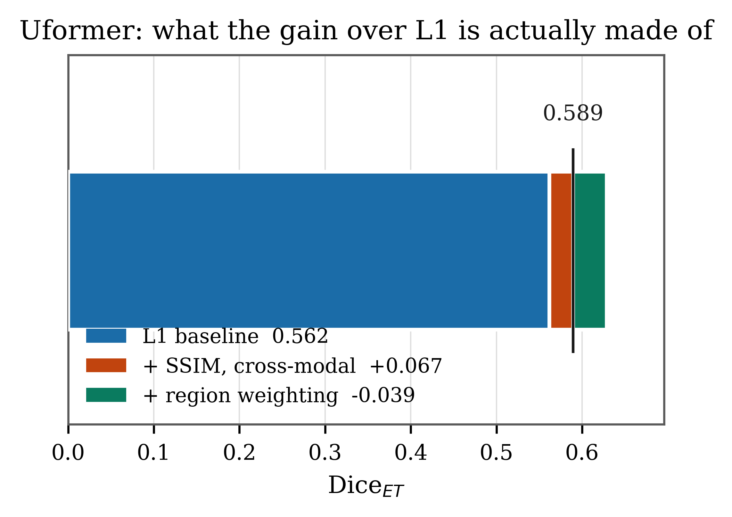
paper fig5 Gain decomposition [RETIRE]
This plate attributes the improvement 65% to the base terms and 35% to the pathology term. At 50 epochs that split is approximately 100 : 0 — the matched control beats plain L1 by MORE than PathologyLoss does. The figure now contradicts its own source data and should not be shown.

ACT 05

The decisive plate
The figure a reviewer looks at first, and the first one this project could build — earlier runs saved no slice dumps.
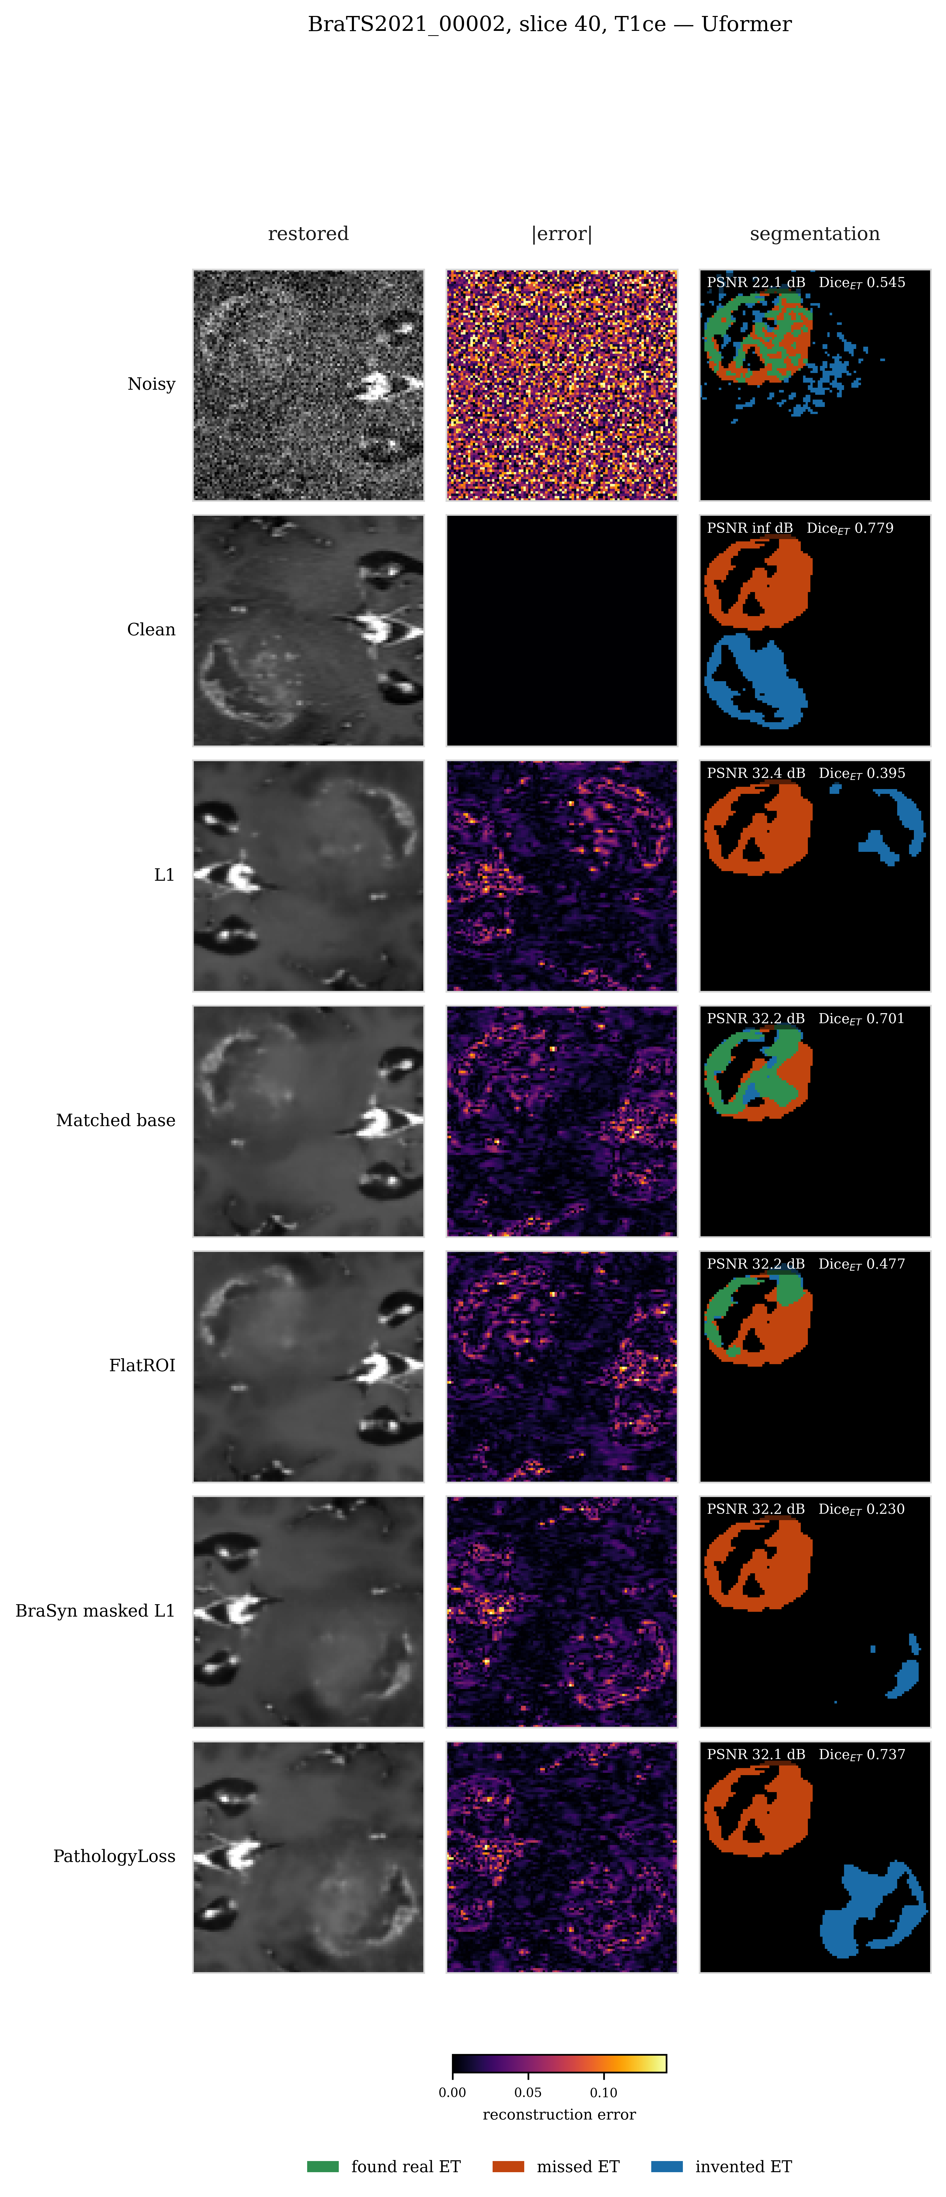
paper fig7 Qualitative comparison, all seven arms [CITE]
BraTS2021_00002, slice 40, T1ce. Three panels per objective: restored, absolute error, and segmentation — green found real enhancing tumour, red missed it, blue invented it.

Provenance
All twenty-two plates come from one run, phasefinal_seed1, on 100 BraTS 2021 subjects split 80/20 by patient with zero overlap. Source data is per_slice_metrics.csv — 8442 rows, 11 metrics x 1206 held-out slices x 7 arms. Nothing here is simulated or carried over from an earlier run.
One seed. A single-seed result is suggestive, not settled, and 20 patients with Dice standard deviations near 0.24 is thinly powered for the small differences at issue.
Read the blue in paper fig7. PathologyLoss carries the highest false-positive rate of any trained arm, 13.1% against 8.8% for plain L1, significantly worse than both L1 (p = 0.012) and BraSyn (p = 0.028). It finds more enhancing tumour and it invents more. No table in the paper shows that; that plate does.

