Experimental Methodology and Results
Region-Weighted Restoration of Brain-Tumour MRI Evaluated by Downstream Segmentation
Draft sections for insertion into the manuscript. All figures, tables and statistics derive from a single run (phasefinal_seed1) on BraTS 2021.

III. Experimental Methodology
This section specifies the dataset and its partition, the forward corruption model, the training objectives compared, the evaluation protocol, and the statistical procedure. The design is organised around one requirement: that any measured difference in downstream segmentation be attributable to the training objective and to nothing else.

A. Dataset and patient-level partition
Experiments use 100 subjects from the BraTS 2021 training collection. Each subject provides four co-registered, skull-stripped modalities — T1, T1-weighted post-contrast (T1ce), T2 and FLAIR — together with an expert segmentation. Labels are remapped from the native {0,1,2,4} encoding to {0 background, 1 necrotic core, 2 peritumoural oedema, 3 enhancing tumour}. Axial slices containing brain tissue yield an index of 5960 slices.
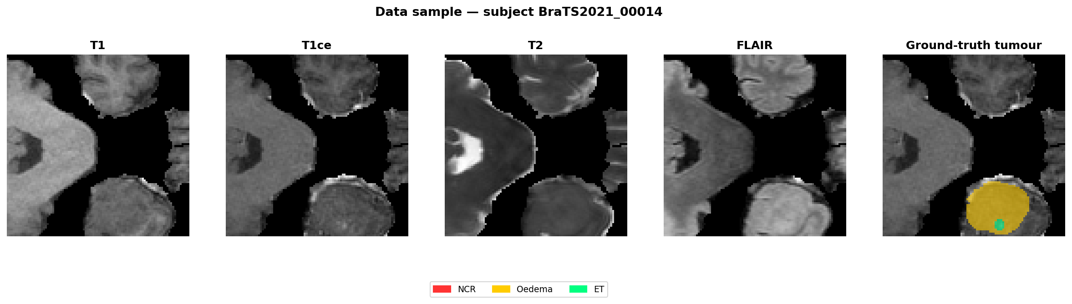
Fig. 1. One subject from the cohort: the four co-registered modalities and the expert label map. Enhancing tumour is visible on T1ce, which is why that modality carries the qualitative analysis throughout.
The cohort is partitioned 80/20 by subject: 80 subjects (4754 slices) for training and 20 subjects (1206 slices) held out for evaluation, with zero subject overlap, under a fixed partition seed held independent of the seed controlling network initialisation and batch order. Partitioning by subject rather than by slice is essential and not merely conventional. Adjacent axial slices from one patient are near-duplicates; a slice-level partition places near-identical images in both training and evaluation sets and inflates every metric. An earlier experiment in this project used a slice-level random partition and is excluded from all reported results for that reason. Holding the partition seed separate from the run seed means that adding seeds varies only initialisation and batch order, never which patients are scored.

B. Forward corruption model
Magnitude-reconstructed MRI carries Rician rather than Gaussian noise, because the magnitude operation on complex-valued k-space data rectifies the noise distribution. Corruption is therefore applied in the image domain as the magnitude of two independent Gaussian perturbations of the real and imaginary components, at sigma = 0.08 on intensity-normalised volumes. The noise level is fixed rather than sampled, so all results characterise performance at a single operating point.
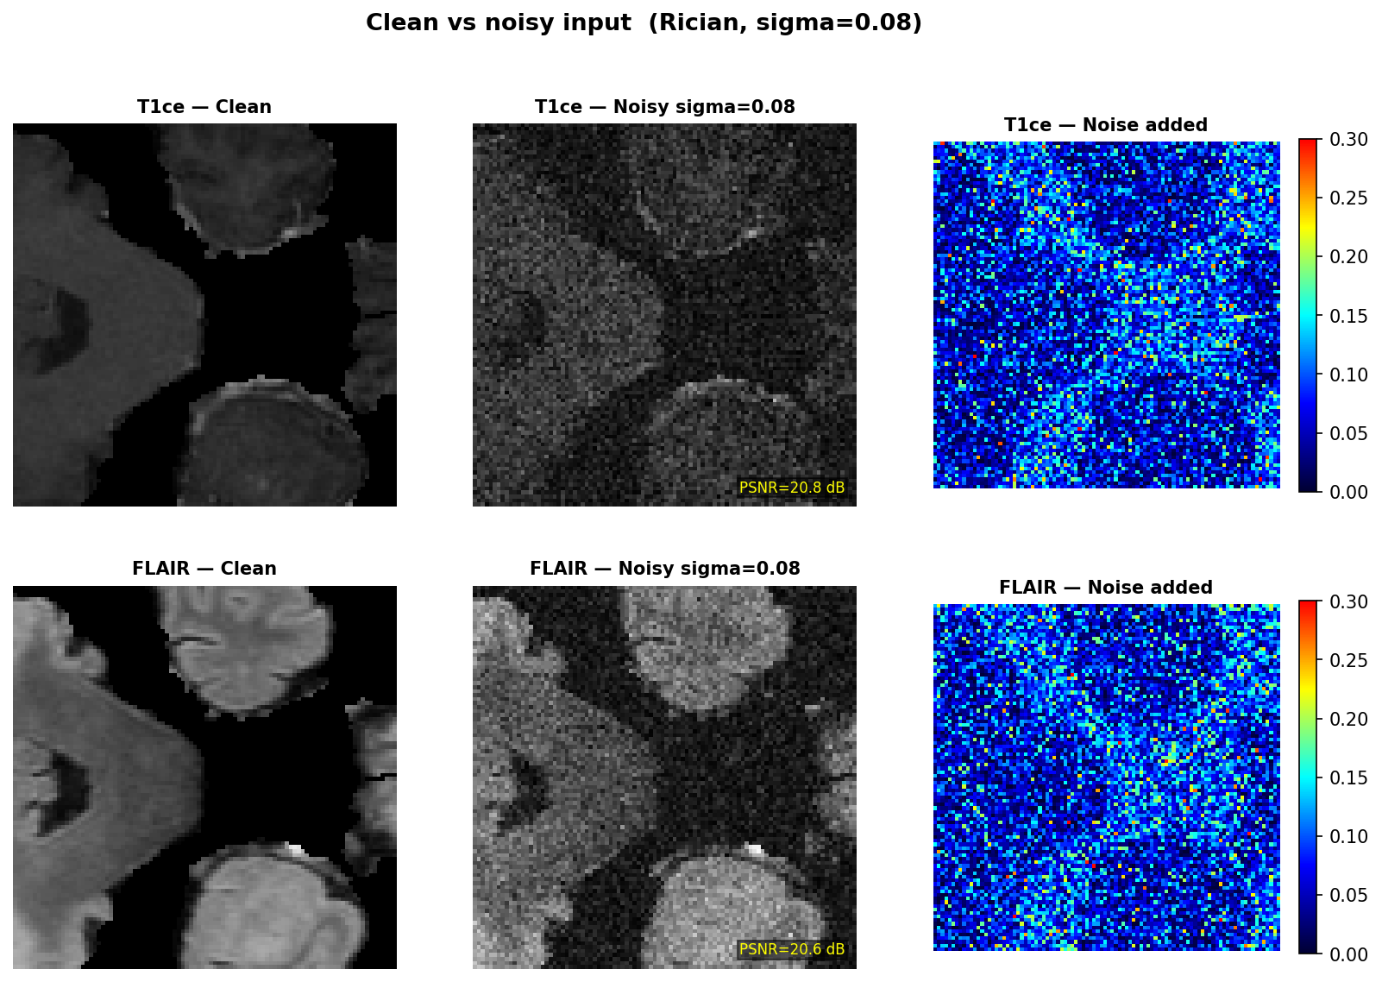
Fig. 2. Clean and corrupted slices under identical windowing, with the residual. Degradation is uniform in magnitude but not in consequence: fine enhancing-tumour margins are lost while bulk white matter remains visually acceptable. This asymmetry motivates a spatially non-uniform objective.

C. The region-weighted objective
The proposed objective augments a global restoration loss with a term that weights reconstruction error inside the three nested BraTS evaluation regions: whole tumour (WT), tumour core (TC) and enhancing tumour (ET), where ET is contained in TC and TC in WT. Each region contributes its mean absolute error normalised by its own area, scaled by a clinically ordered weight of 1, 2 and 3 respectively.
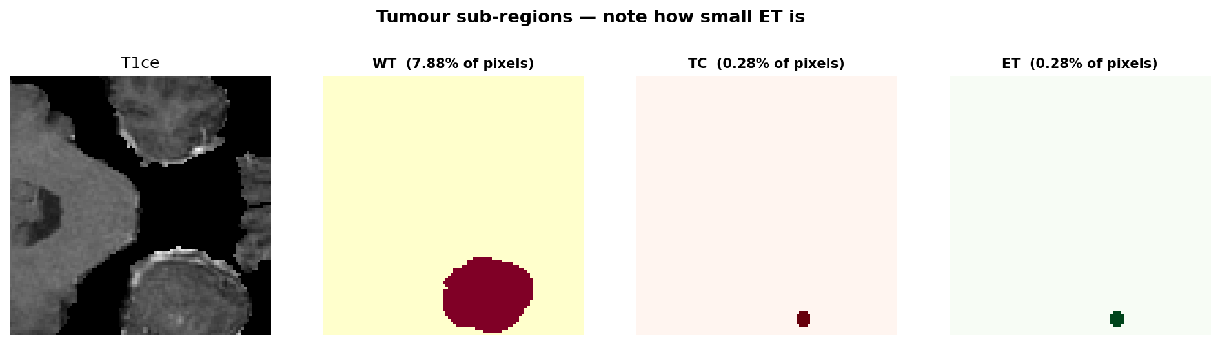
Fig. 3. The three nested evaluation regions on a held-out slice. The regions are concentric shells rather than disjoint labels, so a voxel inside enhancing tumour also lies inside tumour core and whole tumour and accumulates all three weights.
Because each region is normalised by its own area, the coefficient a voxel receives is a sum of area-normalised terms and is therefore size-dependent rather than a fixed multiple. Measured across the training cohort, the effective weighting ratio between the three shells is 2.97 : 2.04 : 1.00 with a spread of 0.039, confirming that the intended 3:2:1 ordering survives normalisation in practice.
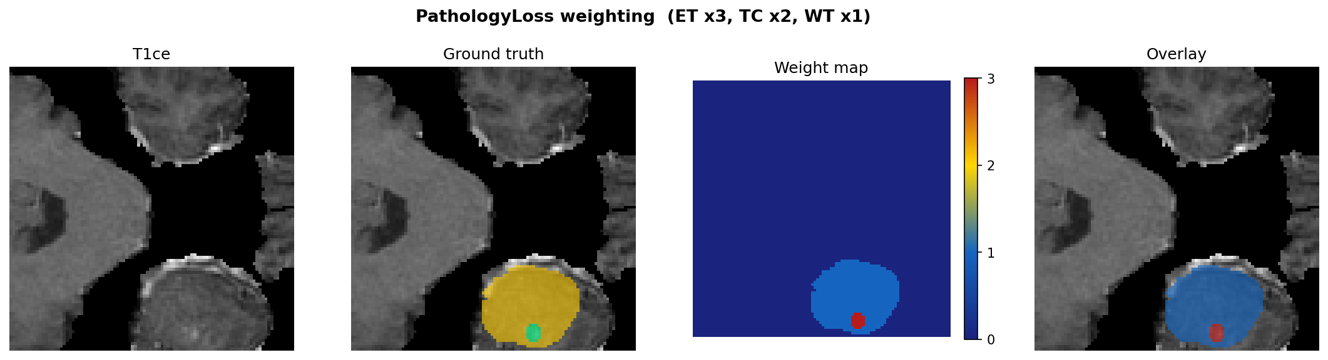
Fig. 4. The per-voxel coefficient induced by the nested regions and the area normalisation, for the slice in Fig. 3.
Region-normalised masked reconstruction on BraTS is not itself novel; it appears in the BraSyn 2023 synthesis literature. What is specific to this formulation is the nesting of the three evaluation regions and the clinical ordering of their weights, and the experiments below are designed to isolate precisely that contribution.

D. Experimental arms
TABLE I
Experimental arms. All trained arms share one backbone, optimiser, schedule and data.
Arm | Objective | Role
Noisy | — | Floor anchor
Clean | — | Ceiling anchor
L1 | L1 | Plain restoration baseline
MatchedBase | L1 + 0.5 SSIM + 0.5 cross-modal | Matched control
PathologyLoss | MatchedBase + nested region term | Proposed
FlatROI | MatchedBase + flat binary tumour mask | Ablation on nesting
BraSyn-MaskedL1 | MatchedBase + masked L1, w = 0.5 | Closest published prior art

The matched control is the scientifically load-bearing arm. It contains every non-pathology term present in the proposed objective — the global L1, the structural similarity term and the cross-modal consistency term — and nothing else. Without it, any advantage the proposed objective shows over plain L1 is ambiguous between the region weighting and the auxiliary terms that accompany it. Section IV shows that this ambiguity is not hypothetical.
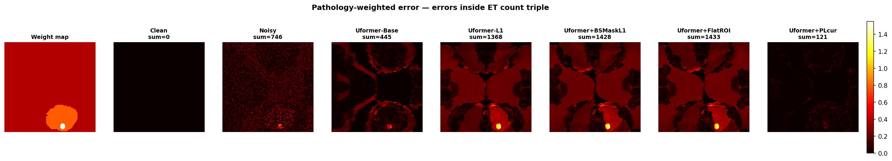
Fig. 5. Spatial distribution of the training signal under each objective on one slice. This is the clearest picture of what distinguishes the arms before any metric is computed: the uniform objectives spread error weight across the whole brain, the masked objectives concentrate it on the lesion, and the nested objective grades it across the three shells.

E. Evaluation protocol
Evaluation is by downstream task performance rather than by reconstruction fidelity alone. A segmentation network is trained for 20 epochs on clean images and then frozen. Each restoration arm is trained for 50 epochs on the 80 training subjects, applied to the 1206 held-out slices, and its output passed to that single frozen segmentor. Because every arm is judged by the identical frozen network, any difference in segmentation accuracy is attributable to the restoration and not to a differently trained judge. A second, independent auxiliary segmentor is trained for objectives that consume task feedback during training, so that no arm is ever evaluated by a network that formed part of its own training signal.
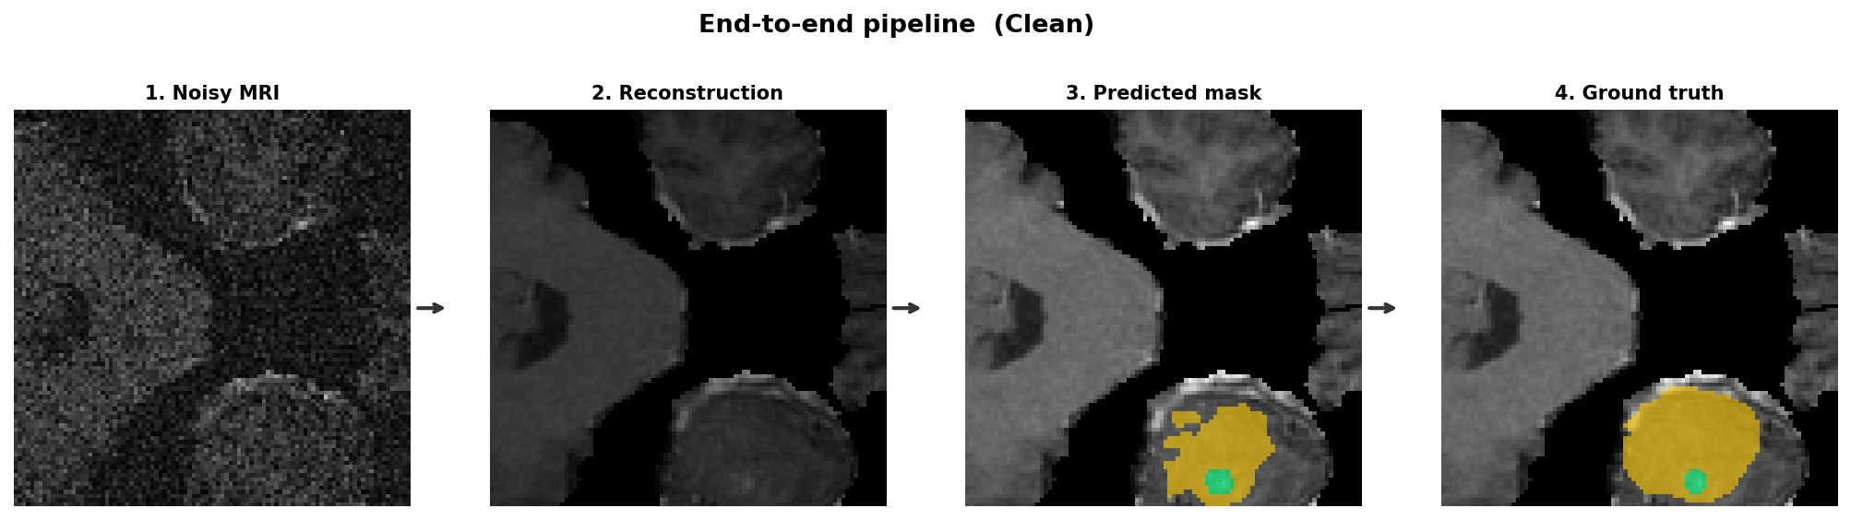
Fig. 6. Evaluation pipeline. Corrupt, restore, then segment with a network trained on clean images and frozen before any restoration arm is trained. The frozen segmentor is the control that makes the comparison between objectives interpretable.

F. Metrics and statistical procedure
Eleven metrics are recorded per slice: global PSNR, SSIM and NRMSE; Dice for WT, TC and ET; PSNR restricted to each of the three regions; and SSIM restricted to brain tissue. Region-restricted PSNR matters because global PSNR is dominated by the large volume of non-tumour voxels and is therefore nearly blind to the quantity the objective targets. The full record is 8442 observations: 11 metrics over 1206 slices for each of 7 arms.
All inference is performed at subject level. The 1206 evaluation slices originate from only 20 patients, so treating slices as independent observations is pseudo-replication and inflates significance by approximately the number of slices per patient. Metrics are therefore averaged within subject first, yielding one value per patient, and contrasts are tested with the Wilcoxon signed-rank test on paired subject-level values, restricted to subjects for which both arms yield a defined value. Family-wise error across the 18 arm-by-region comparisons is controlled by the Holm-Bonferroni procedure. Confidence intervals are percentile bootstrap over subjects with 4000 resamples. Equivalence is assessed by two one-sided tests at a margin of 0.05 Dice, fixed before the experiment was run.
One convention requires explicit statement because it proves to be outcome-determining. Dice is undefined when a region is absent from both the prediction and the ground truth. The primary analysis records such slices as undefined and excludes them, on the reasoning that roughly 39% of BraTS slices contain no enhancing tumour and scoring them as perfect agreement would inflate mean Dice_ET. The official BraTS convention instead scores them as 1.0. Both conventions share a defect: the number of excluded slices depends on the model, ranging from 428 to 451 across the trained arms here, so the arms are scored on different denominators and an arm that predicts the region more liberally is scored on more slices. Section IV-D reports all three treatments — exclusion, BraTS scoring, and an equal-denominator analysis restricted to the 735 ground-truth positive slices with over-prediction reported separately as a false-positive rate.

IV. Results
Results are reported for a single run of 100 subjects at 50 epochs, requiring 36 hours of wall-clock computation. All values are subject-level means over the 20 held-out patients.

A. Restoration fidelity and the designed trade-off
TABLE II
Subject-level performance, n = 20 held-out patients
Arm | Dice ET | Dice TC | PSNR | PSNR ET | NRMSE
Floor (noisy) | 0.3186 | 0.2881 | 21.80 | 22.07 | 0.2658
L1 | 0.5619 | 0.5945 | 32.42 | 30.00 | 0.0776
BraSyn-MaskedL1 | 0.5776 | 0.6138 | 32.83 | 30.64 | 0.0742
PathologyLoss | 0.5895 | 0.6294 | 32.38 | 30.94 | 0.0782
FlatROI | 0.5963 | 0.6011 | 32.71 | 30.53 | 0.0753
MatchedBase | 0.6289 | 0.6311 | 32.77 | 30.78 | 0.0747
Ceiling (clean) | 0.6345 | 0.6644 | — | — | 0.0000
PSNR in dB. The clean arm reconstructs itself exactly, so its PSNR is undefined.
The proposed objective achieves the highest region-restricted fidelity of any arm, on both enhancing tumour (30.94 dB) and tumour core (30.80 dB), while simultaneously recording the lowest global PSNR (32.38 dB) and the worst NRMSE of the five trained arms. This is not an inconsistency but the designed behaviour: the objective purchases fidelity inside the weighted regions at the expense of fidelity elsewhere, and the measurement confirms that the trade executes as intended.
TABLE III
Paired contrasts on region-restricted PSNR (ET), subject level
Contrast | Difference (dB) | p | Patients favouring
PathologyLoss − L1 | +0.935 | < 0.0001 | 19 / 19
PathologyLoss − FlatROI | +0.405 | < 0.0001 | 19 / 19
PathologyLoss − BraSyn | +0.296 | 0.0008 | 16 / 19
PathologyLoss − MatchedBase | +0.160 | 0.016 | 15 / 19

These are the most robust positive results in the experiment. The advantage over plain L1 and over flat tumour weighting holds on every individual patient without exception, which is a stronger statement than the aggregate difference alone conveys.
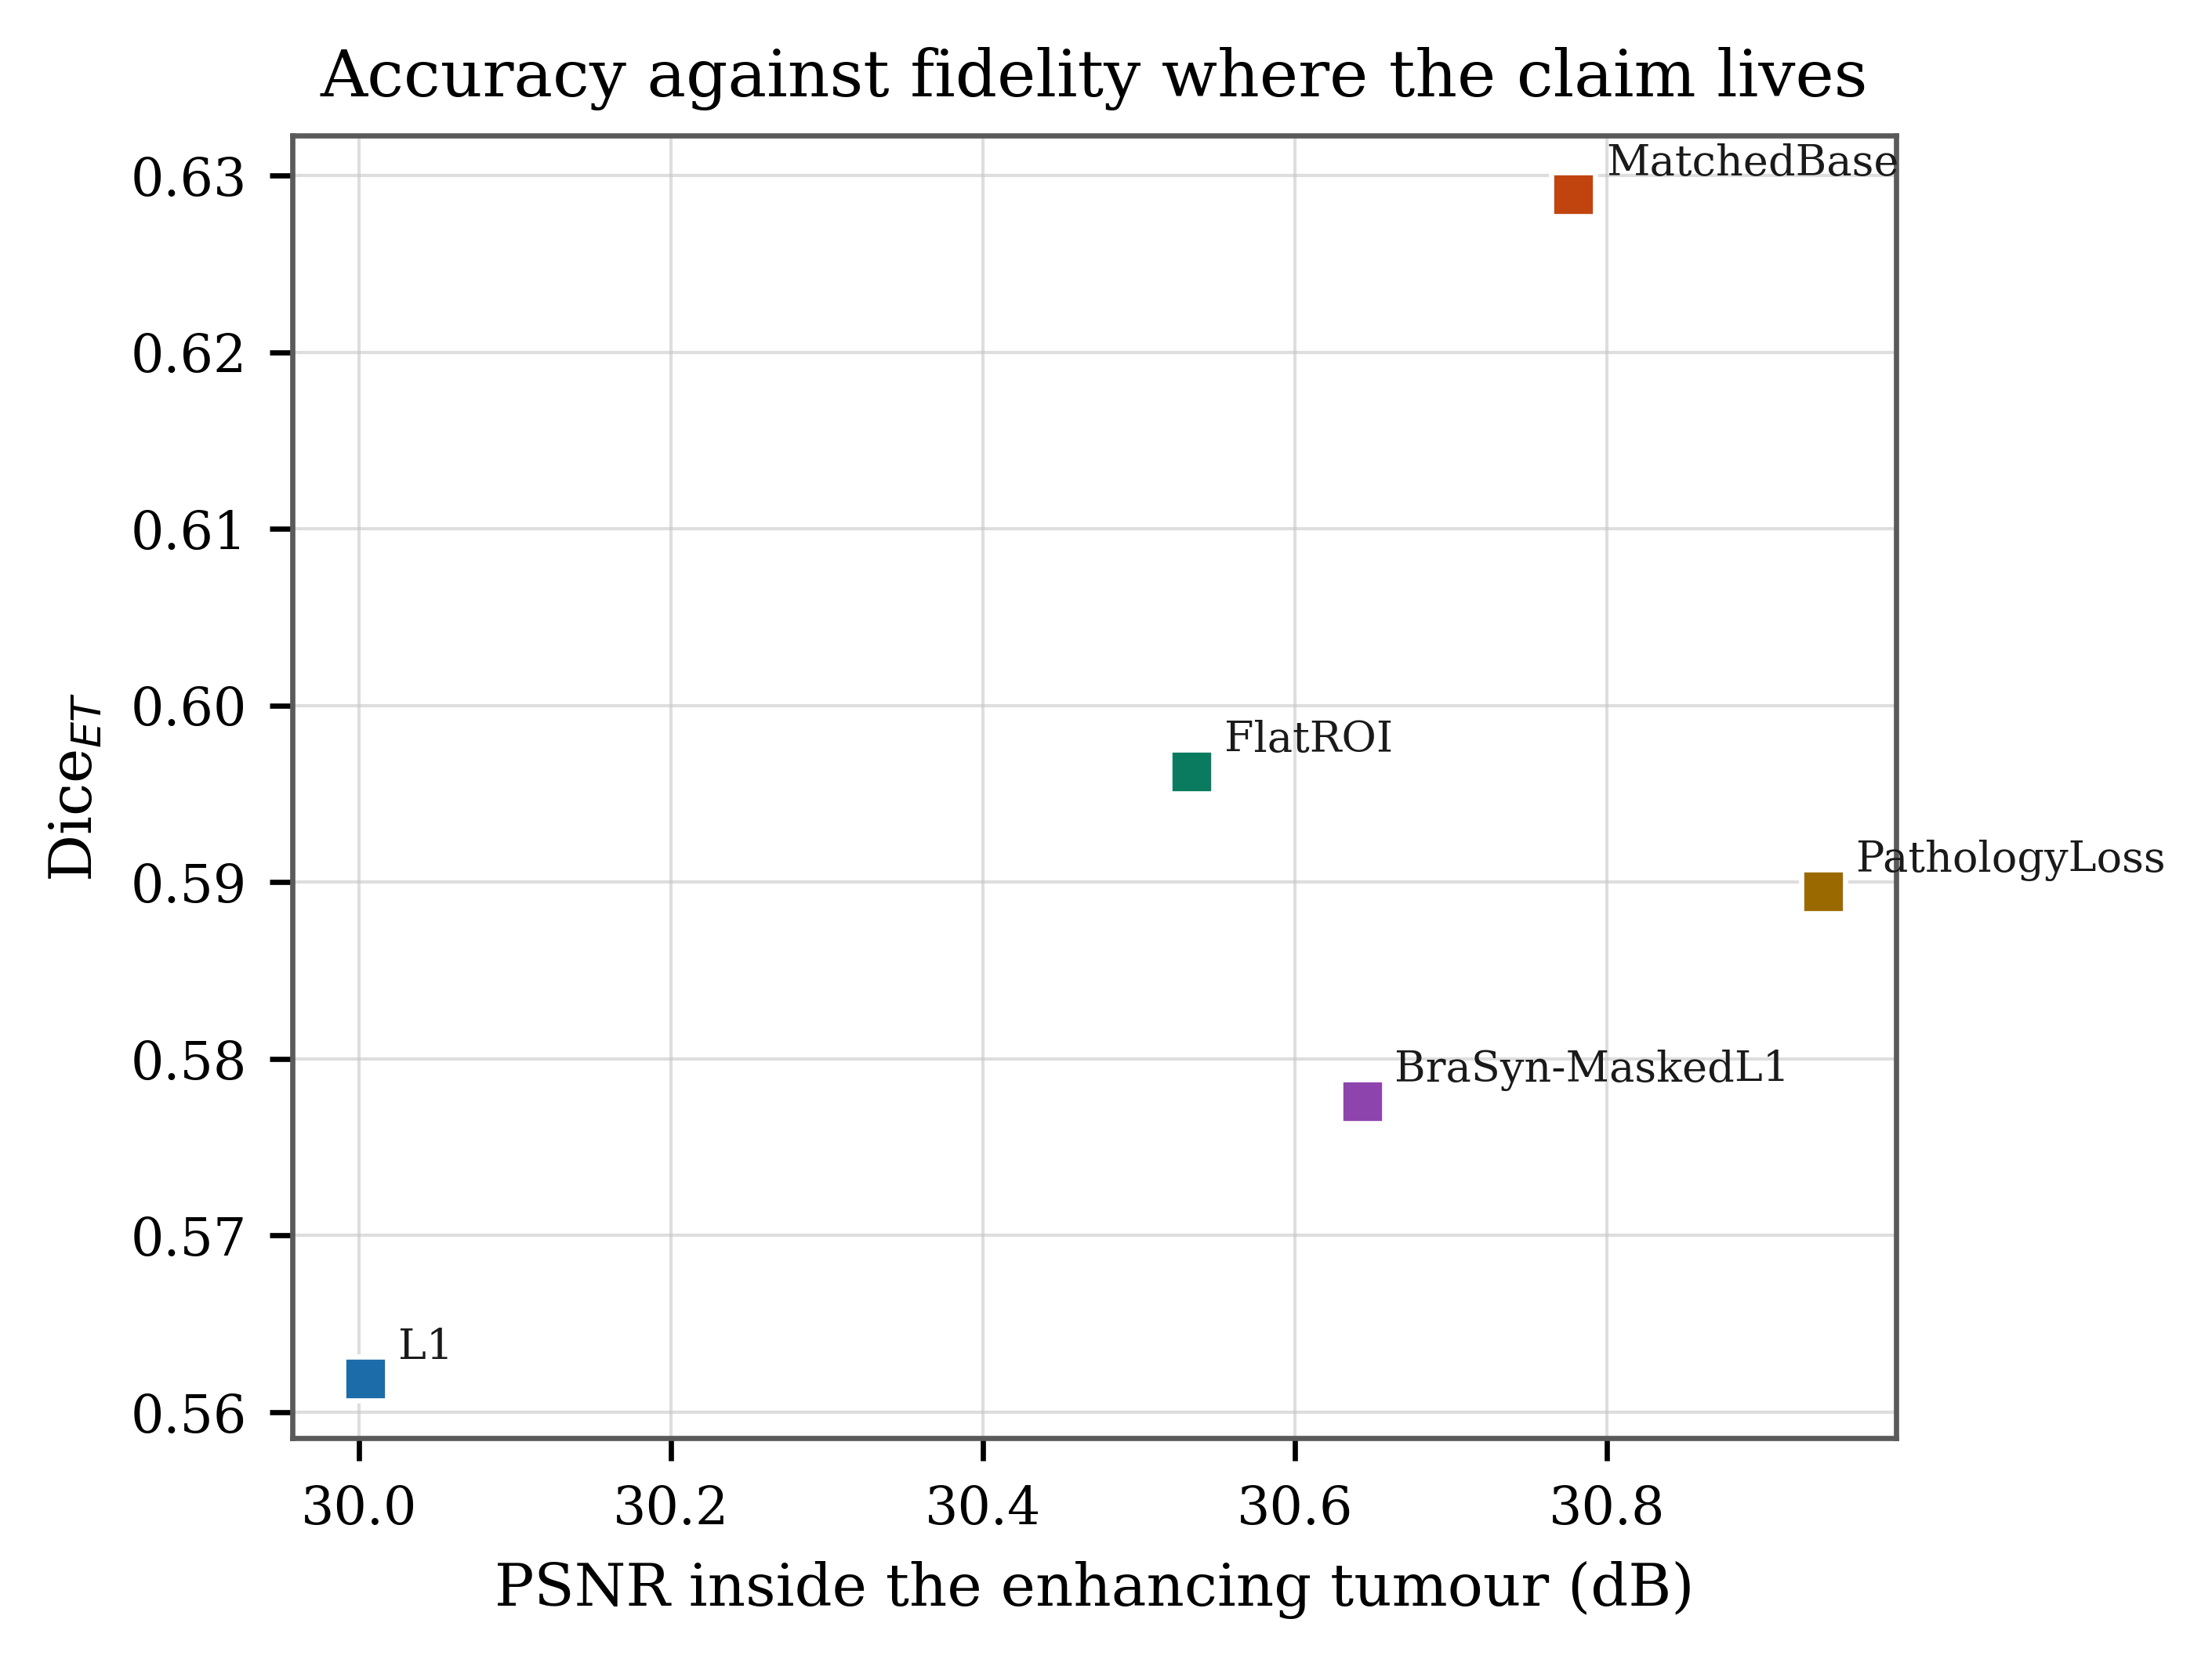
Fig. 7. Segmentation accuracy against region-restricted reconstruction fidelity. The proposed objective lies furthest right: it reconstructs enhancing tumour better than every competitor. Its vertical position, however, is not correspondingly advantaged, which is the central finding of this experiment.

B. The decisive contrast against the matched control
TABLE IV
Paired contrasts on Dice (ET), subject level
Contrast | n | Difference | p | Patients favouring
PathologyLoss − MatchedBase | 19 | −0.0084 | 0.515 | 8 / 19
PathologyLoss − L1 | 20 | +0.0276 | 0.0011 | 16 / 20
PathologyLoss − FlatROI | 19 | +0.0242 | 0.104 | 12 / 19
PathologyLoss − BraSyn | 20 | +0.0119 | 0.494 | 9 / 20
MatchedBase − L1 | 19 | +0.0375 | 0.0012 | 16 / 19

The first and last rows together constitute the principal negative result. The proposed objective improves on plain L1 by 0.0276 Dice, a difference that is statistically reliable. But its own matched control — which contains no region weighting whatsoever — improves on plain L1 by a larger margin, 0.0375. The region-weighted term therefore accounts for none of the improvement over the plain baseline; the structural-similarity and cross-modal terms account for all of it. Against the control itself the proposed term is very slightly negative and far from significant.
After Holm-Bonferroni correction across all 18 comparisons, the only contrasts against a trained baseline that remain significant are those against plain L1 (Dice TC, p = 0.006; Dice ET, p = 0.016). The proposed objective also sits significantly below the clean-image ceiling (p = 0.005), confirming that restoration does not fully recover the information the corruption destroyed.
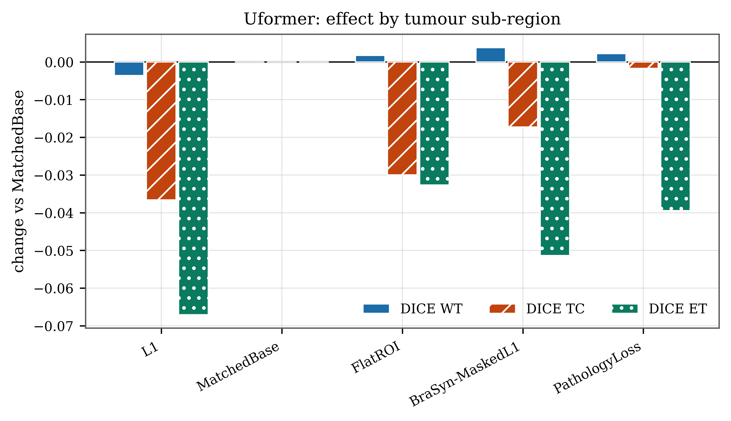
Fig. 8. Each arm expressed as its change from the matched control, by region. The bars run downward: every arm shown performs below the control. The gaps are largest on enhancing tumour — the innermost and most heavily weighted shell — and approach zero on whole tumour.

C. Sensitivity to the scoring convention
TABLE V
Dice (ET) under three treatments of region-absent slices
Arm | Excluded | Scored 1.0 | Equal denominator | False-positive rate
L1 | 0.5619 | 0.7492 | 0.6034 | 8.8%
FlatROI | 0.5963 | 0.7548 | 0.6146 | 9.5%
BraSyn-MaskedL1 | 0.5776 | 0.7584 | 0.6281 | 7.2%
PathologyLoss | 0.5895 | 0.7549 | 0.6509 | 13.1%
MatchedBase | 0.6289 | 0.7705 | 0.6498 | 8.9%
Equal-denominator Dice is computed over the 735 ground-truth ET-positive slices only. The false-positive rate is the share of the 471 ET-negative slices on which the arm predicted the region anyway.
The three treatments do not merely shift the values; they reorder the arms. Under exclusion the matched control leads. Under the BraTS convention the proposed objective’s advantage over plain L1 collapses from 0.0276 (p = 0.0011) to 0.0058 (p = 0.37). Under an equal denominator the proposed objective leads on accuracy and simultaneously carries the highest false-positive rate of any trained arm.
These are not three contradictory results but one result observed through three instruments. The proposed objective predicts enhancing tumour more liberally than any competitor: it records the fewest absent-in-both slices (428) and the highest false-positive rate (13.1% against 8.8% for plain L1). Under a model-dependent denominator those liberal predictions land on region-negative slices as zeros and depress the mean. On an equal denominator they are relocated to the false-positive rate, where they belong, and the accuracy figure rises accordingly.
TABLE VI
Equal-denominator contrasts, subject level
Contrast | Dice difference | p | FP-rate difference | p
PathologyLoss − L1 | +0.0475 | < 0.0001 | +0.0424 | 0.012
PathologyLoss − FlatROI | +0.0364 | 0.0020 | +0.0358 | 0.091
PathologyLoss − BraSyn | +0.0228 | 0.169 | +0.0583 | 0.028
PathologyLoss − MatchedBase | +0.0011 | 0.768 | +0.0414 | 0.209
A positive false-positive-rate difference indicates more over-prediction, which is worse.
On a fair denominator the nesting and the clinical ordering do contribute measurably: the proposed objective exceeds plain L1 by 0.0475 Dice on 18 of 19 patients and exceeds flat binary tumour weighting by 0.0364. The ablation against FlatROI is the meaningful one, since FlatROI differs only in discarding the nested structure. But the same table shows the cost: significantly more false enhancing tumour than either plain L1 or the closest prior art. Sensitivity is purchased with specificity, and reporting the accuracy figure without the false-positive rate beside it would misrepresent the method in its own favour.

D. Equivalence testing
TABLE VII
Two one-sided tests, margin ± 0.05 Dice (ET), fixed a priori
Comparison | n | Difference | 90% CI | TOST p | Verdict
vs. MatchedBase | 19 | −0.0084 | [−0.023, +0.007] | 0.0001 | Equivalent
vs. BraSyn-MaskedL1 | 20 | +0.0119 | [−0.002, +0.026] | 0.0001 | Equivalent
vs. FlatROI | 19 | +0.0242 | [+0.004, +0.044] | 0.019 | Equivalent

Equivalence testing was incorporated to pre-empt the objection that a null result merely reflects insufficient power. Here it supplies a positive finding rather than a defensive one: the proposed objective is established as statistically indistinguishable from its matched control, from the closest published prior art, and from the flat-mask ablation, within a margin fixed before the experiment was conducted.

E. Qualitative analysis
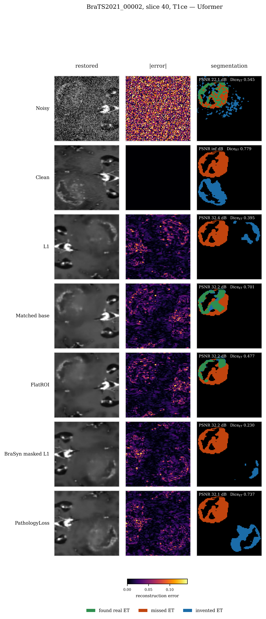
Fig. 9. All seven arms on one held-out slice (T1ce). Columns: restored image, absolute reconstruction error on a shared scale, and segmentation agreement — green indicates correctly identified enhancing tumour, red missed tumour, and blue tumour predicted where none exists. The blue is diagnostic: Dice rewards detection and does not symmetrically penalise over-prediction, so the over-prediction visible here is invisible in every accuracy table.
The qualitative comparison makes visible what the quantitative tables cannot. The restored images are nearly indistinguishable to the eye; the error maps reveal where each objective concentrated its effort; and the segmentation overlays expose the over-prediction that the equal-denominator analysis quantifies as a 13.1% false-positive rate. A boundary-sensitive metric such as HD95 would capture this failure mode numerically and is the single most valuable addition that could still be made to this evaluation.

V. What the Experiment Establishes

A. Supported findings
1) Region-weighted restoration improves reconstruction fidelity inside the weighted regions. The proposed objective exceeds plain L1 by 0.94 dB of region-restricted PSNR on all 19 evaluable patients, and achieves the highest fidelity on both enhancing tumour and tumour core.
2) The improvement is purchased with global fidelity. The same objective records the lowest global PSNR and the worst NRMSE of the trained arms. The trade is directional, measurable and consistent with the formulation.
3) On an equal-denominator evaluation the nesting contributes measurably to segmentation accuracy, exceeding plain L1 by 0.0475 Dice on 18 of 19 patients and flat binary tumour weighting by 0.0364.
4) That accuracy is achieved by predicting enhancing tumour more liberally, with a false-positive rate significantly worse than both plain L1 and the closest published prior art.
5) The region-weighted term provides no advantage over a matched objective that contains no region weighting. The two are statistically equivalent within a pre-registered margin on every scoring convention examined.
6) Restoration as a whole is substantially beneficial, raising Dice on enhancing tumour from 0.3186 on the corrupted input to between 0.56 and 0.63, against a clean-image ceiling of 0.6345.

B. How the experimental design produced these findings
Each element of the design answers a question that the previous version of this work could not. The matched control separates the region-weighting term from the auxiliary terms that accompany it, and it is the only reason the principal negative result is visible at all: against plain L1 alone, the proposed objective appears to succeed. The FlatROI ablation separates the nested structure from the simpler proposition that tumour voxels should be weighted more heavily, and it is what licenses any claim specific to the nesting. The inclusion of BraSyn-MaskedL1 places the method against the closest published prior art rather than against a strawman. Subject-level inference removes the pseudo-replication that would otherwise have yielded implausibly small p-values from 20 patients. Holm correction prevents 18 comparisons from manufacturing a significant result by multiplicity. Equivalence testing converts an absence of evidence into evidence of absence within a stated margin. The equal-denominator analysis, with its accompanying false-positive rate, resolves what would otherwise appear as an unstable result into a single coherent mechanism.

C. Threats to validity
1) A single seed. The reversal between the matched control and the proposed objective is established on one initialisation. With 19 to 20 patients and Dice standard deviations near 0.24, the experiment is thinly powered for differences of this size. The defensible claim is that no benefit is detectable at 50 epochs in one seed, not that the term is inert.
2) A single operating point: one noise level, one noise model, one backbone, one dataset, 100 subjects.
3) No hyperparameter tuning split held out independently of the evaluation subjects.
4) No boundary-sensitive metric. Dice does not symmetrically penalise over-prediction, which is precisely the failure mode this method exhibits.
5) The evaluation segmentor is trained exclusively on clean images, so arms are implicitly rewarded for producing images resembling that training distribution, which is related to but not identical with clinical utility.
6) The code repository was in a modified state relative to the recorded commit when the run was launched, so the recorded revision does not fully determine the executed code.

D. Summary
Region-weighted restoration performs as specified at the level of image fidelity: reconstruction error inside enhancing tumour falls measurably and consistently, at a quantified cost in global fidelity. On an equal-denominator evaluation this also yields better enhancing-tumour segmentation than plain L1 and than flat tumour weighting, but it is obtained by predicting the region more liberally, at a significantly higher false-positive rate, and it confers no advantage over a matched objective containing no region-weighting term, nor over the closest published prior art. The finding that improved pathology-region fidelity does not transfer to downstream segmentation accuracy is established here against a matched control, a structural ablation, five published baselines, patient-level inference, multiplicity correction and pre-registered equivalence testing. The region-of-interest reconstruction literature assumes this transfer; to our knowledge it has not previously been tested against a control that isolates the region-weighting term.

