**BOF#9: Practice pointer to pointer (4/5/2017)**

For the /courses/cs240/s17/xiaohui/GROUP/bof9/pointer3.c program,

**Exercise 1**: Use pencil and paper and evaluate the values in the 8 pointer to pointer exercises using the following diagram:

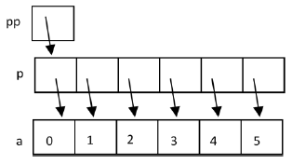

**Exercise 2**: Build and run the program to verify your answers. What is the reason for the warning messages?