Welcome

Stand

826 Hark, the Voice of Jesus Crying LSB 826
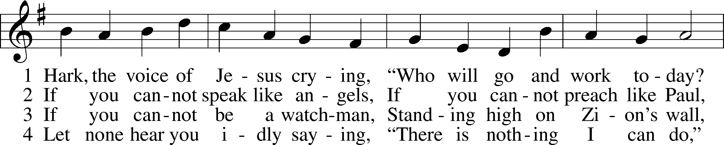
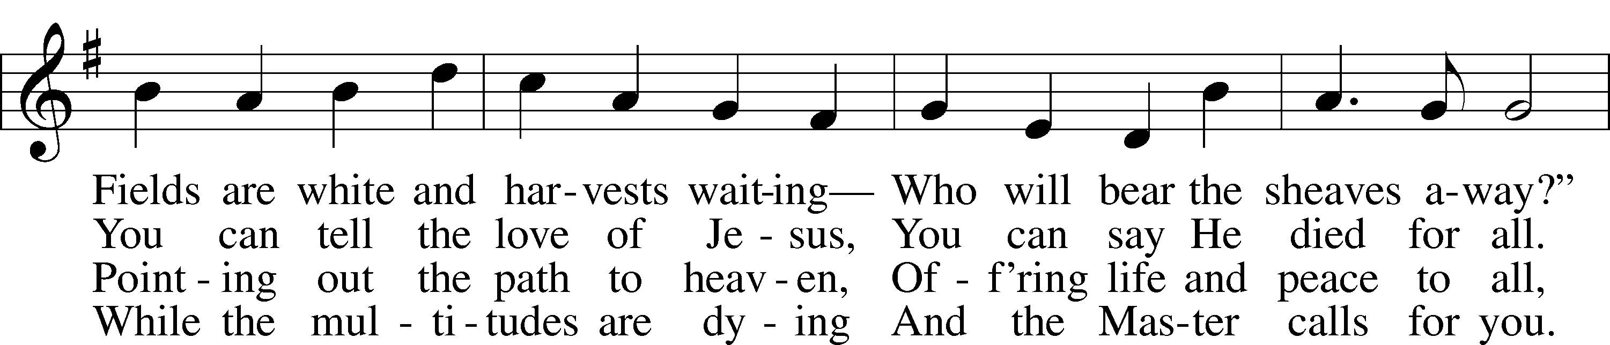
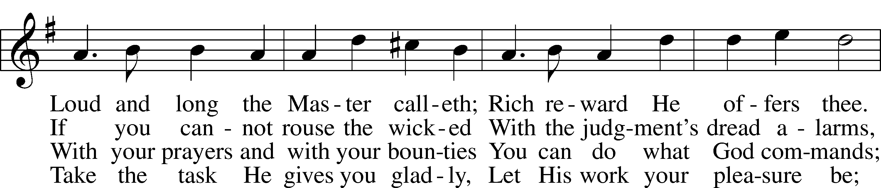
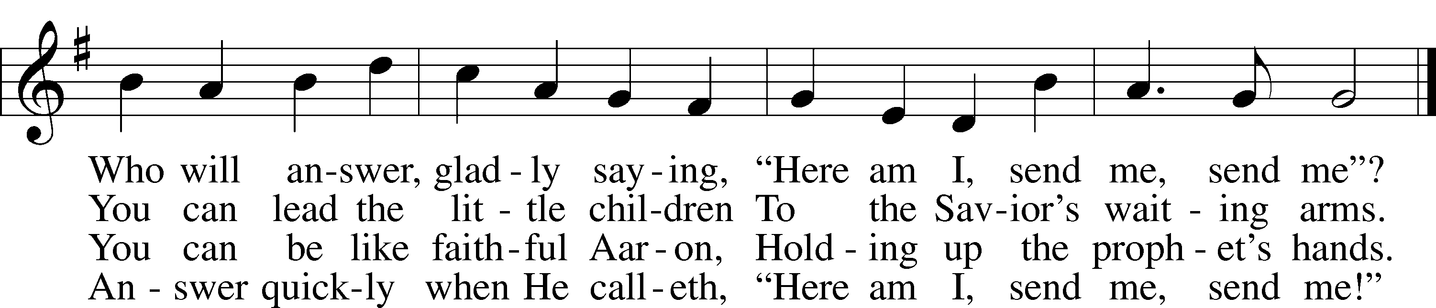
Text (sts. 1–2, 4): Daniel March, 1816–1909, alt.; (st. 3): unknown, alt.
Tune: Joseph Barnby, 1838–96
Text and tune: Public domain

Confession and Absolution

The sign of the cross may be made by all in remembrance of their Baptism.

P In the name of the Father and of the T Son and of the Holy Spirit.
C Amen.

P If we say we have no sin, we deceive ourselves, and the truth is not in us.
C But if we confess our sins, God, who is faithful and just, will forgive our sins and cleanse us from all unrighteousness.

Kneel/Stand

Silence for reflection on God’s Word and for self-examination.

P Let us then confess our sins to God our Father.
C Most merciful God, we confess that we are by nature sinful and unclean. We have sinned against You in thought, word, and deed, by what we have done and by what we have left undone. We have not loved You with our whole heart; we have not loved our neighbors as ourselves. We justly deserve Your present and eternal punishment. For the sake of Your Son, Jesus Christ, have mercy on us. Forgive us, renew us, and lead us, so that we may delight in Your will and walk in Your ways to the glory of Your holy name. Amen.

P Almighty God in His mercy has given His Son to die for you and for His sake forgives you all your sins. As a called and ordained servant of Christ, and by His authority, I therefore forgive you all your sins in the name of the Father and of the T Son and of the Holy Spirit.
C Amen.

Stand

Service of the Word

Psalm Psalm 100; antiphon: v. 5

A Together, we sing Psalm 100 responsively:
1Make a joyful noise to the Lord, | all the earth!*
2Serve the Lord with gladness!
Come into his presence with | singing!
3Know that the Lord, | he is God!*
It is he who made us, and we are his;
we are his people, and the sheep of his | pasture.
4Enter his gates with thanksgiving,
and his | courts with praise!*
Give thanks to him; | bless his name!
5For the Lord is good;
his steadfast love endures for- | ever,*
and his faithfulness to all gener- | ations.
C Glory be to the Father and | to the Son*
and to the Holy | Spirit;
as it was in the be- | ginning,*
is now, and will be forever. | Amen.

Kyrie LSB 152
A In peace let us pray to the Lord.
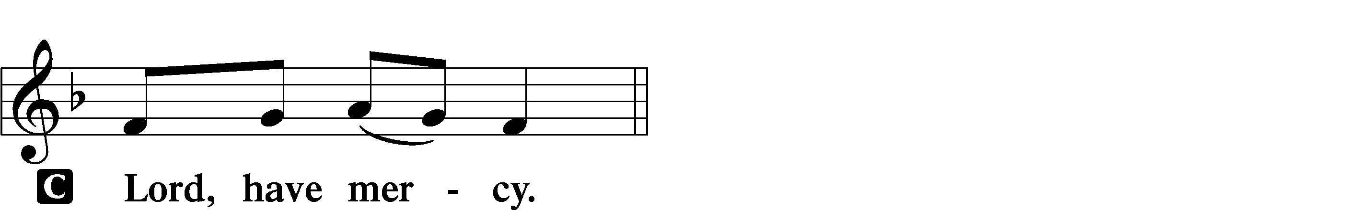

A For the peace from above and for our salvation let us pray to the Lord.
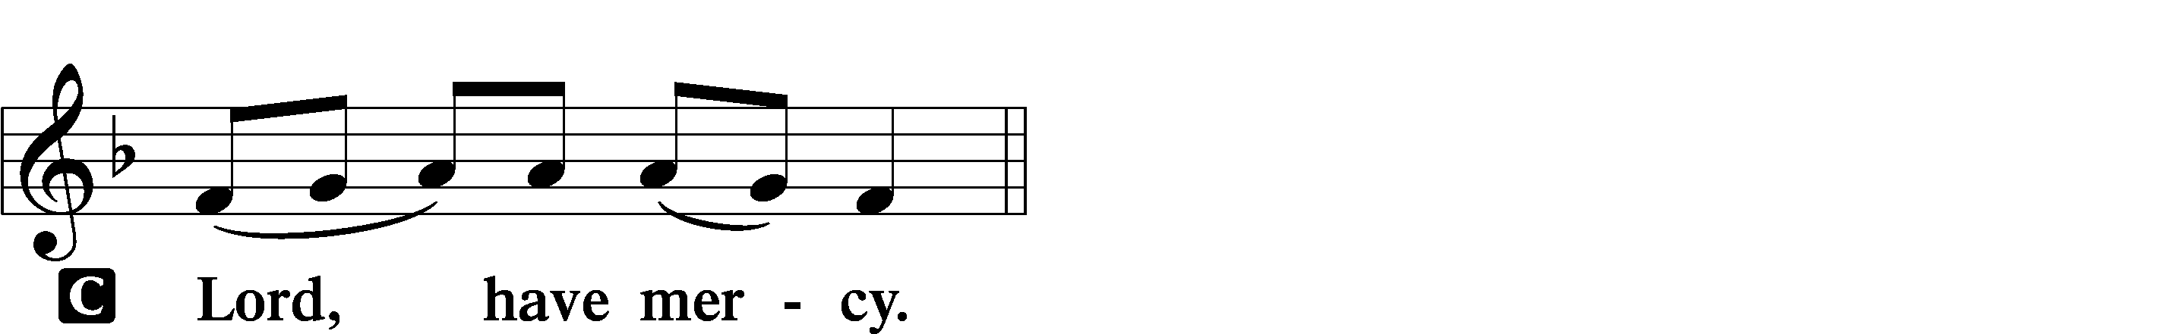

A For the peace of the whole world, for the well-being of the Church of God, and for the unity of all let us pray to the Lord.
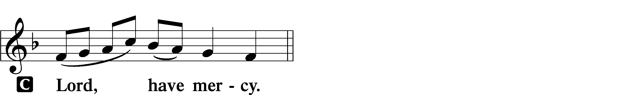

A For this holy house and for all who offer here their worship and praise let us pray to the Lord.
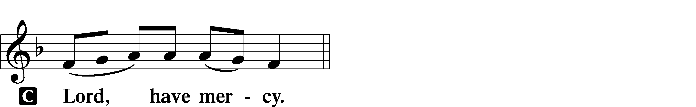

A Help, save, comfort, and defend us, gracious Lord.


This Is the Feast LSB 155
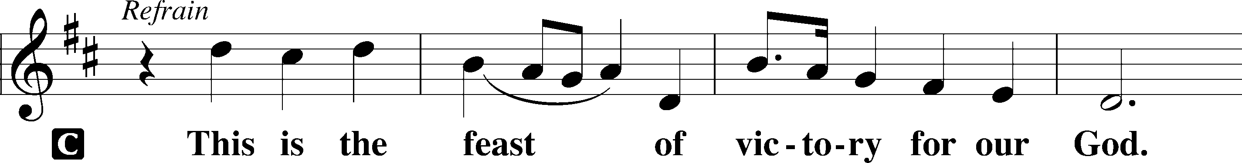
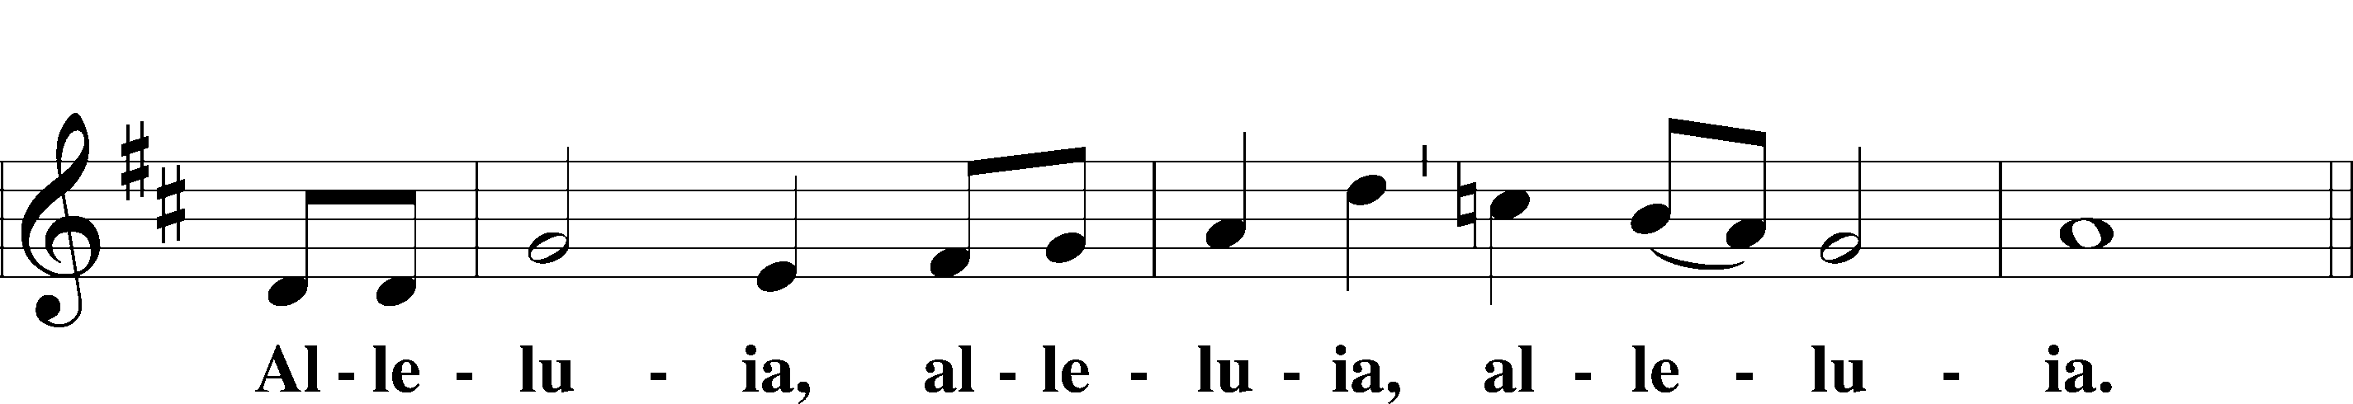
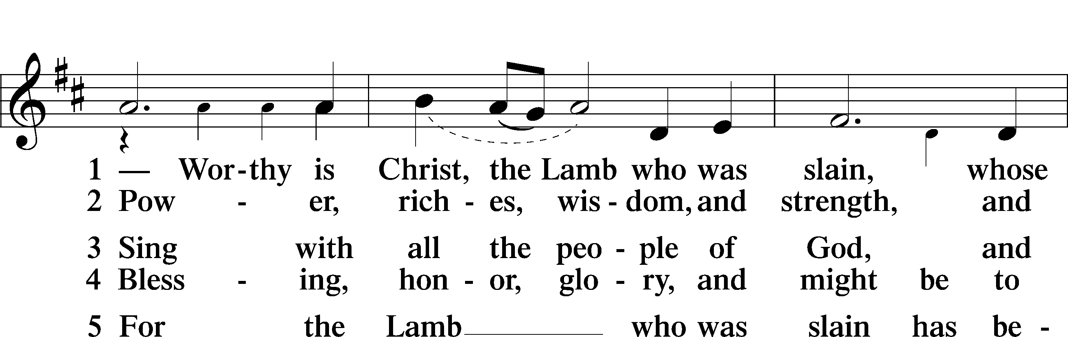
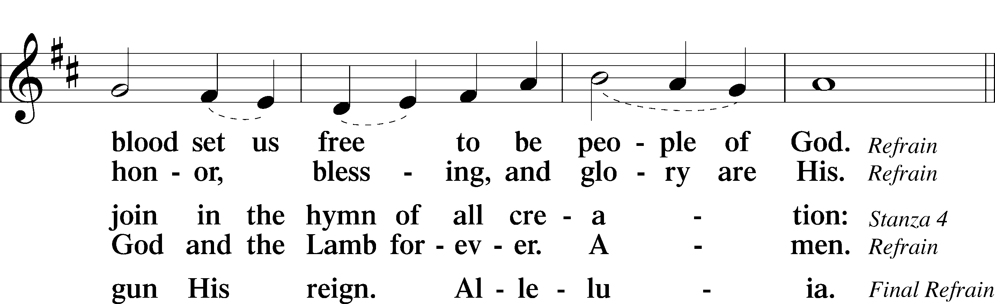
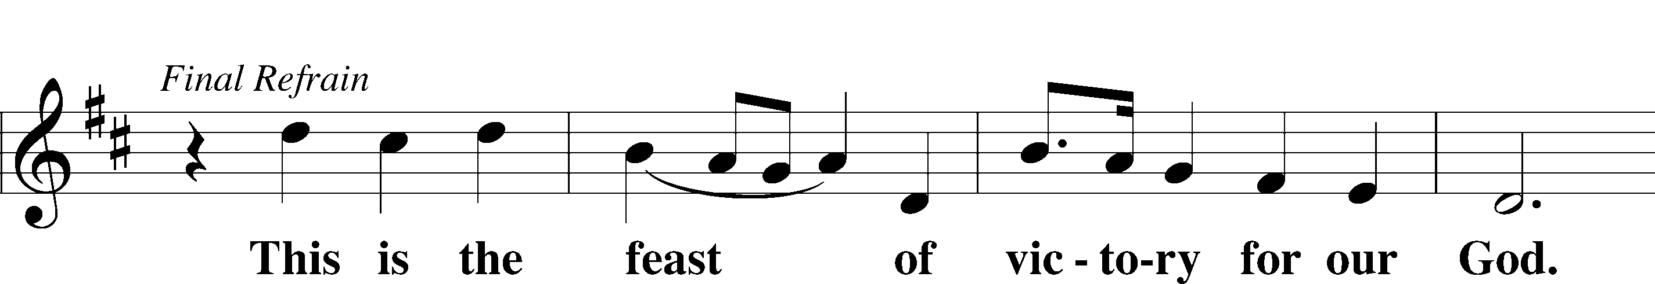
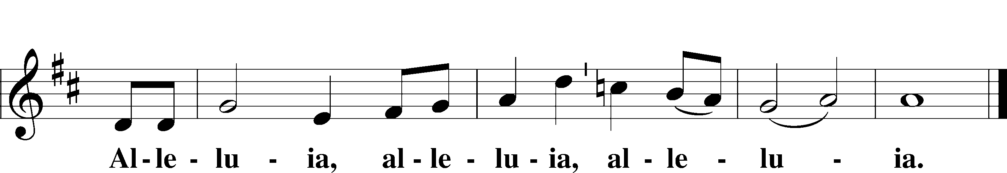

Salutation and Collect of the Day
P The Lord be with you.
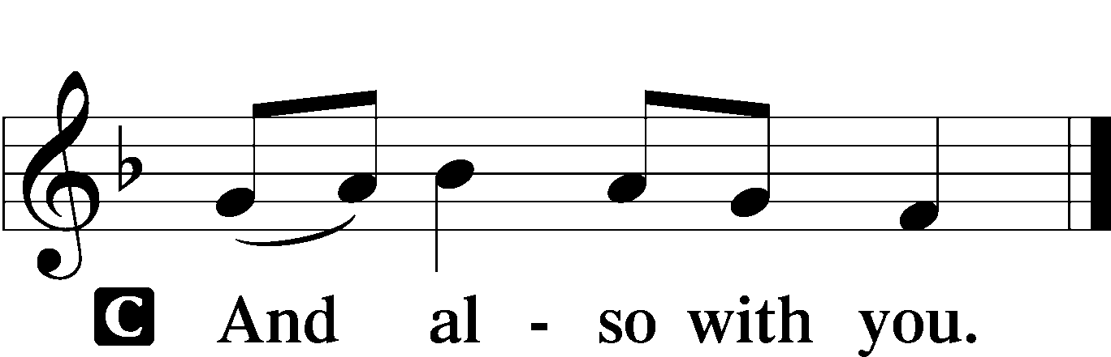

P Let us pray.
Almighty, eternal God, in the Word of Your apostles and prophets You have proclaimed to us Your saving will. Grant us faith to believe Your promises that we may receive eternal salvation; through Jesus Christ, our Lord, who lives and reigns with You and the Holy Spirit, one God, now and forever.

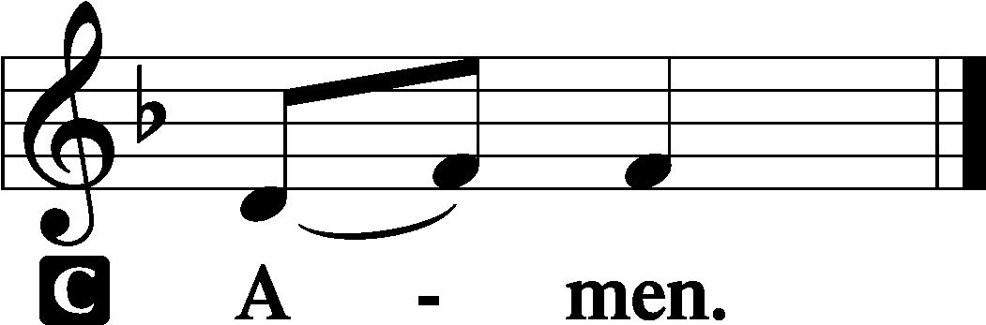

Sit

Old Testament Reading Exodus 19:2–8
2[The people of Israel] set out from Rephidim and came into the wilderness of Sinai, and they encamped in the wilderness. There Israel encamped before the mountain, 3while Moses went up to God. The Lord called to him out of the mountain, saying, “Thus you shall say to the house of Jacob, and tell the people of Israel: 4You yourselves have seen what I did to the Egyptians, and how I bore you on eagles’ wings and brought you to myself. 5Now therefore, if you will indeed obey my voice and keep my covenant, you shall be my treasured possession among all peoples, for all the earth is mine; 6and you shall be to me a kingdom of priests and a holy nation. These are the words that you shall speak to the people of Israel.”
7So Moses came and called the elders of the people and set before them all these words that the Lord had commanded him. 8All the people answered together and said, “All that the Lord has spoken we will do.” And Moses reported the words of the people to the Lord.

A This is the Word of the Lord.
C Thanks be to God.

Epistle Romans 5:6–15
6For while we were still weak, at the right time Christ died for the ungodly. 7For one will scarcely die for a righteous person—though perhaps for a good person one would dare even to die— 8but God shows his love for us in that while we were still sinners, Christ died for us. 9Since, therefore, we have now been justified by his blood, much more shall we be saved by him from the wrath of God. 10For if while we were enemies we were reconciled to God by the death of his Son, much more, now that we are reconciled, shall we be saved by his life. 11More than that, we also rejoice in God through our Lord Jesus Christ, through whom we have now received reconciliation.
12Therefore, just as sin came into the world through one man, and death through sin, and so death spread to all men because all sinned— 13for sin indeed was in the world before the law was given, but sin is not counted where there is no law. 14Yet death reigned from Adam to Moses, even over those whose sinning was not like the transgression of Adam, who was a type of the one who was to come.
15But the free gift is not like the trespass. For if many died through one man’s trespass, much more have the grace of God and the free gift by the grace of that one man Jesus Christ abounded for many.

A This is the Word of the Lord.
C Thanks be to God.

Stand

Alleluia and Verse LSB 156
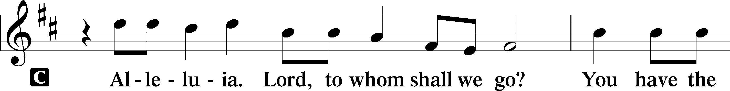
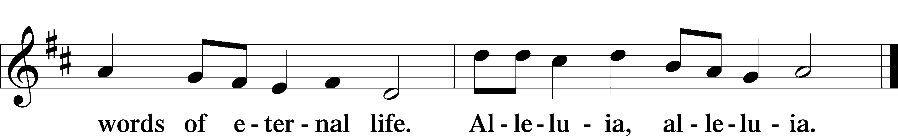

Holy Gospel Matthew 9:35—10:20
P The Holy Gospel according to St. Matthew, the ninth chapter.
C Glory to You, O Lord.

35Jesus went throughout all the cities and villages, teaching in their synagogues and proclaiming the gospel of the kingdom and healing every disease and every affliction. 36When he saw the crowds, he had compassion for them, because they were harassed and helpless, like sheep without a shepherd. 37Then he said to his disciples, “The harvest is plentiful, but the laborers are few; 38therefore pray earnestly to the Lord of the harvest to send out laborers into his harvest.”
1And he called to him his twelve disciples and gave them authority over unclean spirits, to cast them out, and to heal every disease and every affliction. 2The names of the twelve apostles are these: first, Simon, who is called Peter, and Andrew his brother; James the son of Zebedee, and John his brother; 3Philip and Bartholomew; Thomas and Matthew the tax collector; James the son of Alphaeus, and Thaddaeus; 4Simon the Cananaean, and Judas Iscariot, who betrayed him.
5These twelve Jesus sent out, instructing them, “Go nowhere among the Gentiles and enter no town of the Samaritans, 6but go rather to the lost sheep of the house of Israel. 7And proclaim as you go, saying, ‘The kingdom of heaven is at hand.’ 8Heal the sick, raise the dead, cleanse lepers, cast out demons. You received without paying; give without pay. 9Acquire no gold nor silver nor copper for your belts, 10no bag for your journey, nor two tunics nor sandals nor a staff, for the laborer deserves his food. 11And whatever town or village you enter, find out who is worthy in it and stay there until you depart. 12As you enter the house, greet it. 13And if the house is worthy, let your peace come upon it, but if it is not worthy, let your peace return to you. 14And if anyone will not receive you or listen to your words, shake off the dust from your feet when you leave that house or town. 15Truly, I say to you, it will be more bearable on the day of judgment for the land of Sodom and Gomorrah than for that town.
16“Behold, I am sending you out as sheep in the midst of wolves, so be wise as serpents and innocent as doves. 17Beware of men, for they will deliver you over to courts and flog you in their synagogues, 18and you will be dragged before governors and kings for my sake, to bear witness before them and the Gentiles. 19When they deliver you over, do not be anxious how you are to speak or what you are to say, for what you are to say will be given to you in that hour. 20For it is not you who speak, but the Spirit of your Father speaking through you.”

P This is the Gospel of the Lord.
C Praise to You, O Christ.

Nicene Creed
C I believe in one God,
the Father Almighty,
maker of heaven and earth
and of all things visible and invisible.

And in one Lord Jesus Christ,
the only-begotten Son of God,
begotten of His Father before all worlds,
God of God, Light of Light,
very God of very God,
begotten, not made,
being of one substance with the Father,
by whom all things were made;
who for us men and for our salvation came down from heaven
and was incarnate by the Holy Spirit of the virgin Mary
and was made man;
and was crucified also for us under Pontius Pilate.
He suffered and was buried.
And the third day He rose again according to the Scriptures
and ascended into heaven
and sits at the right hand of the Father.
And He will come again with glory to judge both the living and the dead,
whose kingdom will have no end.

And I believe in the Holy Spirit,
the Lord and giver of life,
who proceeds from the Father and the Son,
who with the Father and the Son together is worshiped and glorified,
who spoke by the prophets.
And I believe in one holy Christian and apostolic Church,
I acknowledge one Baptism for the remission of sins,
and I look for the resurrection of the dead
and the life T of the world to come. Amen.

Sit

571 God Loved the World So That He Gave LSB 571
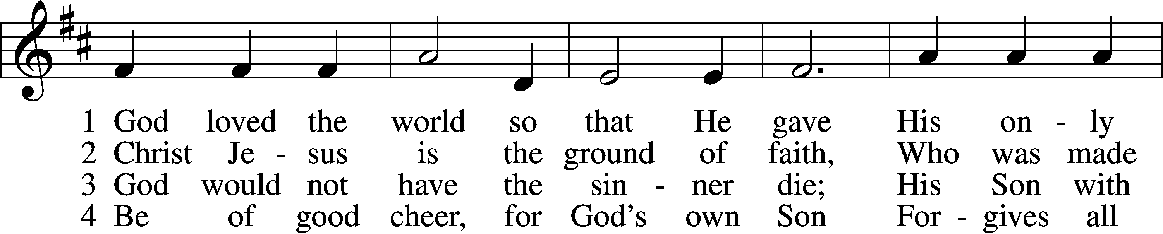
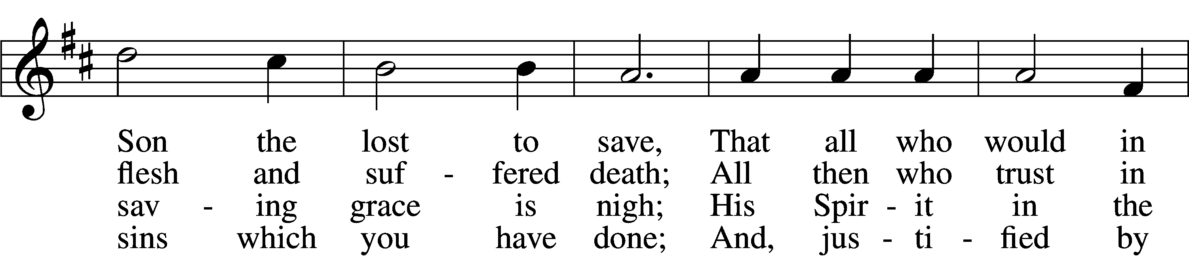
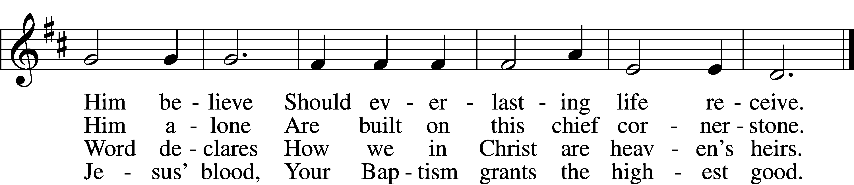

5 If you are sick, if death is near,
This truth your troubled heart can cheer:
Christ Jesus saves your soul from death;
That is the firmest ground of faith.

D 6 Glory to God the Father, Son,
And Holy Spirit, Three in One!
To You, O blessèd Trinity,
Be praise now and eternally!
Text: Heiliges Lippen- und Hertzens-Opffer, c. 1778, Stettin; tr. August Crull, 1845–1923, alt.
Tune: George J. Elvey, 1816–93
Text and tune: Public domain

Sermon

Stand

Prayer of the Church
L Let us pray for the whole Church of God in Christ Jesus and for all people according to their needs...

The response after each petition is as follows:
L Lord, in Your mercy:
C Hear our prayer.

Sit

594 God's Own Child, I Gladly Say It LSB 594
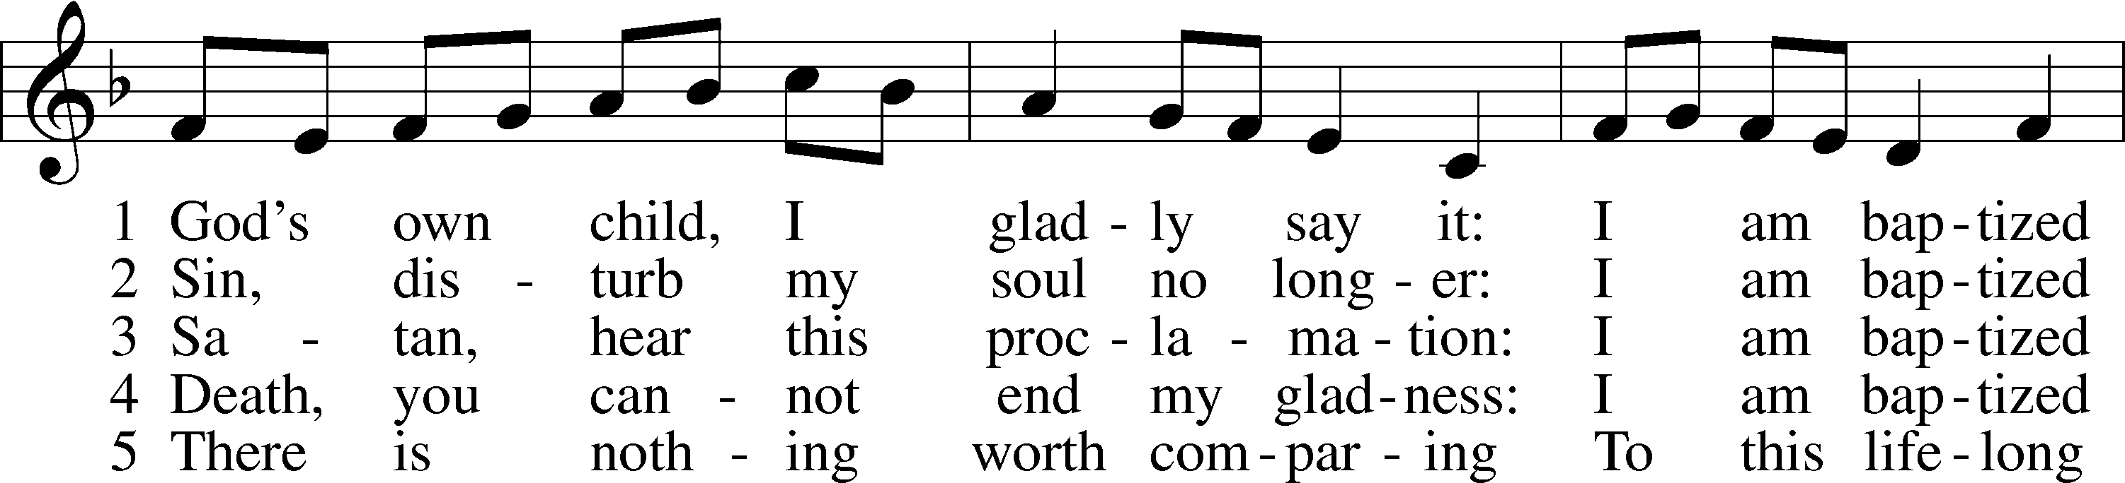
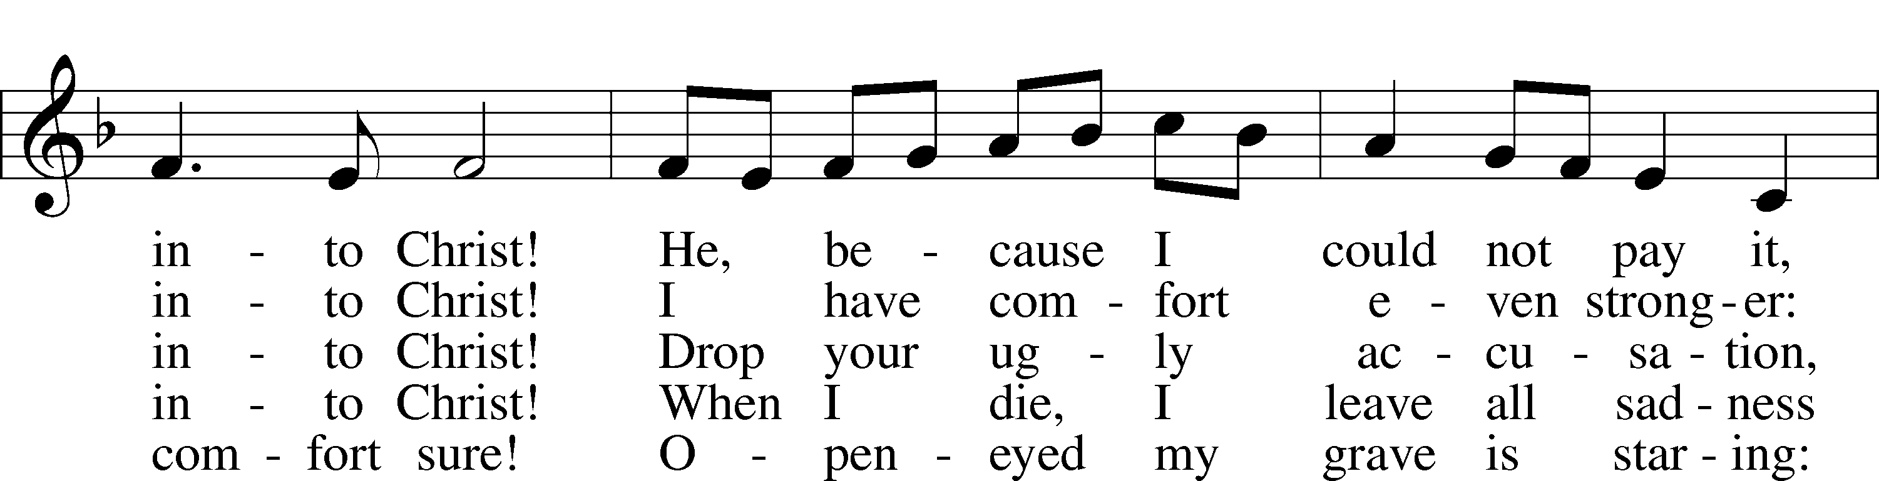
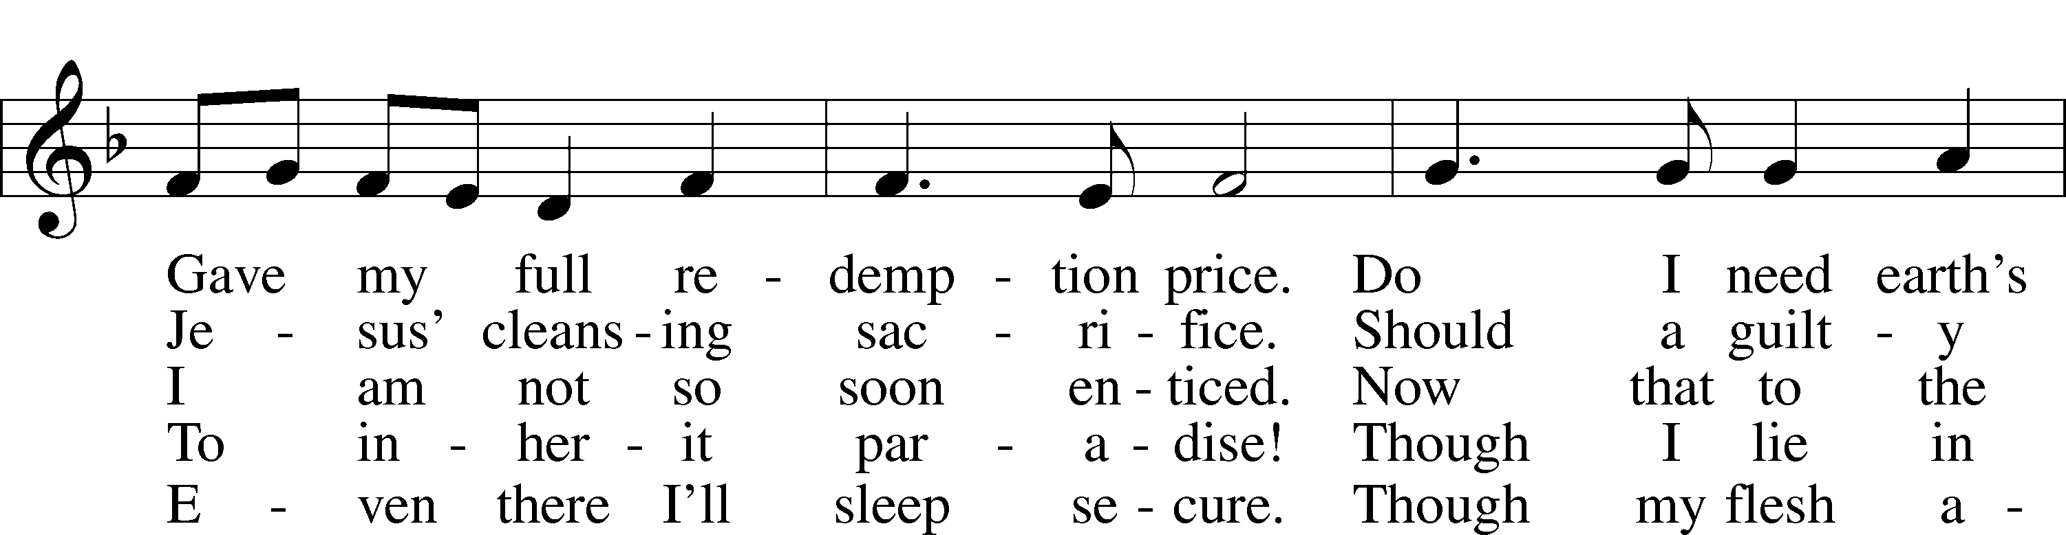
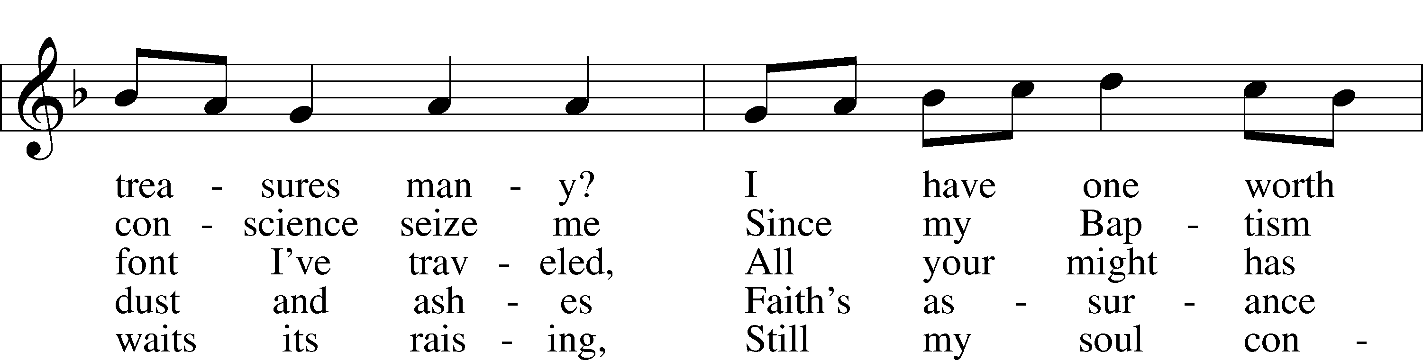
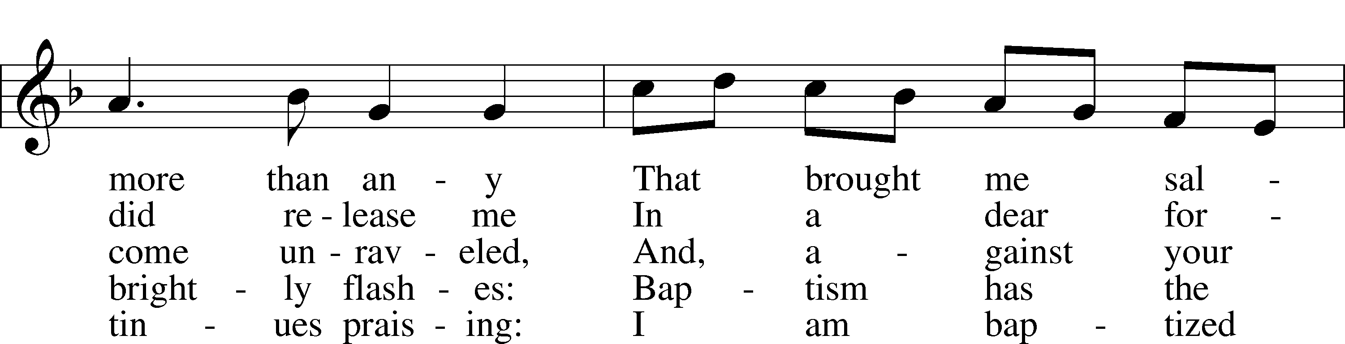
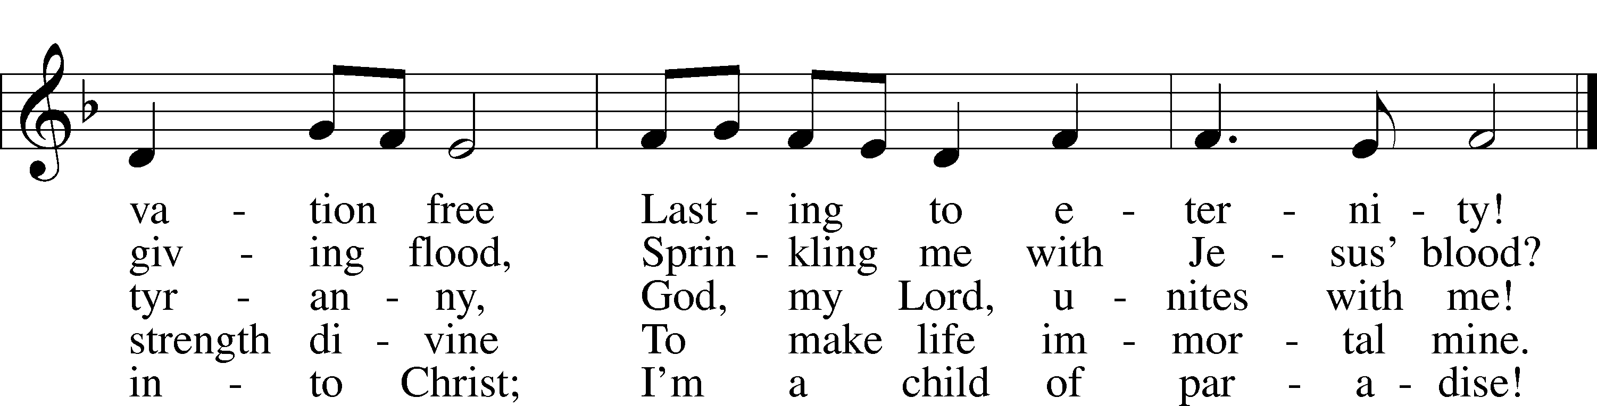
Text: Erdmann Neumeister, 1671–1756; tr. Robert E. Voelker, 1957
Tune: Johann Caspar Bachofen, 1695–1755, alt.
Text: © 1991 Robert E. Voelker. Used by permission: LSB Hymn License no. 110002371
Tune: Public domain

Stand

During the Offertory, the offerings from the offering box are brought forward to the altar.

Offertory LSB 159
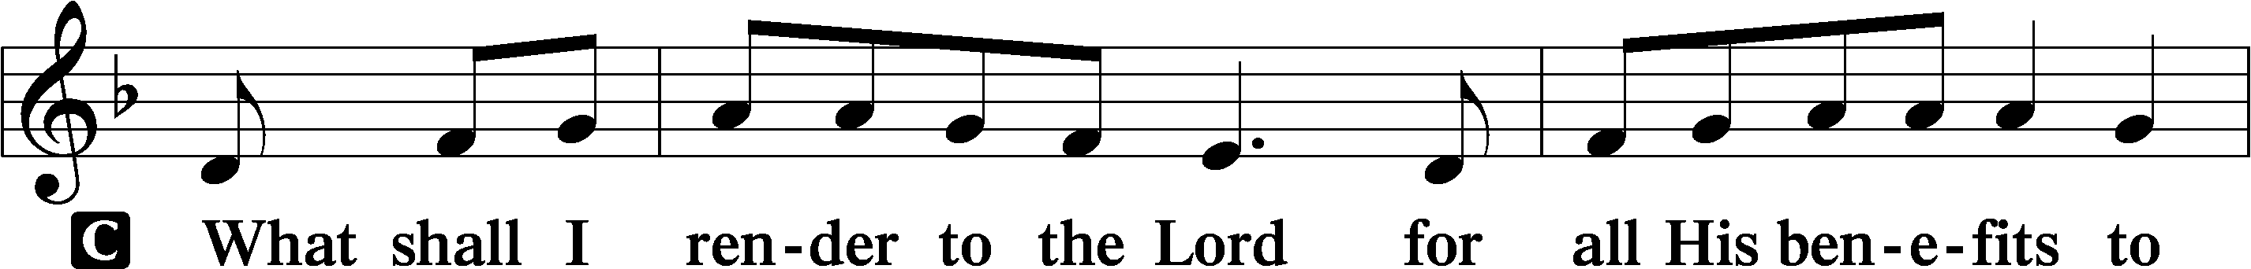
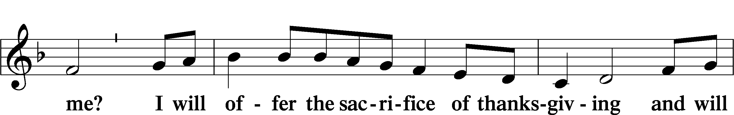
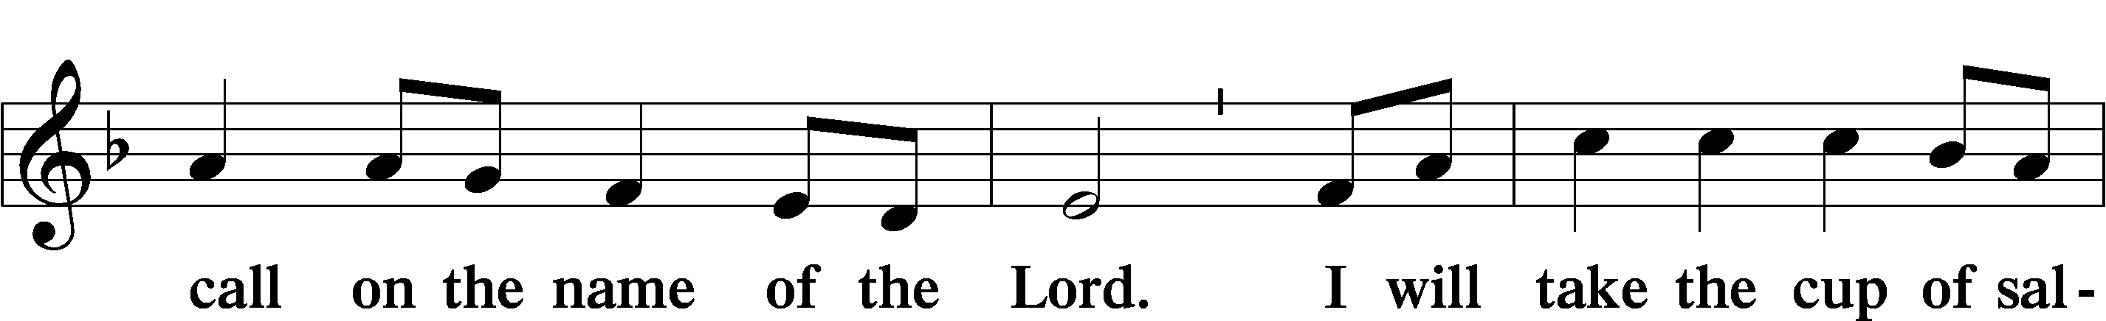
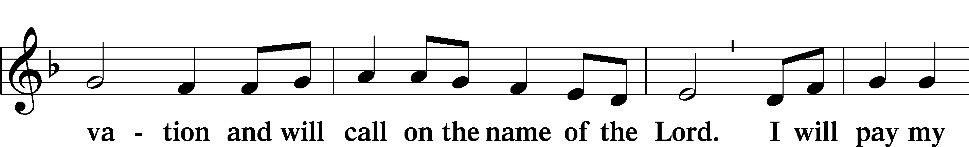
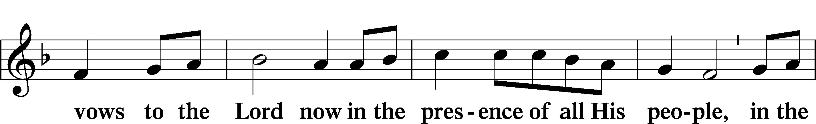
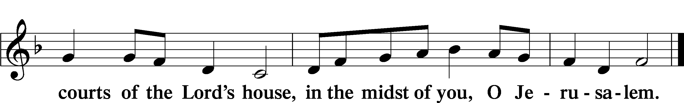

Service of the Sacrament

Preface LSB 160
P The Lord be with you.
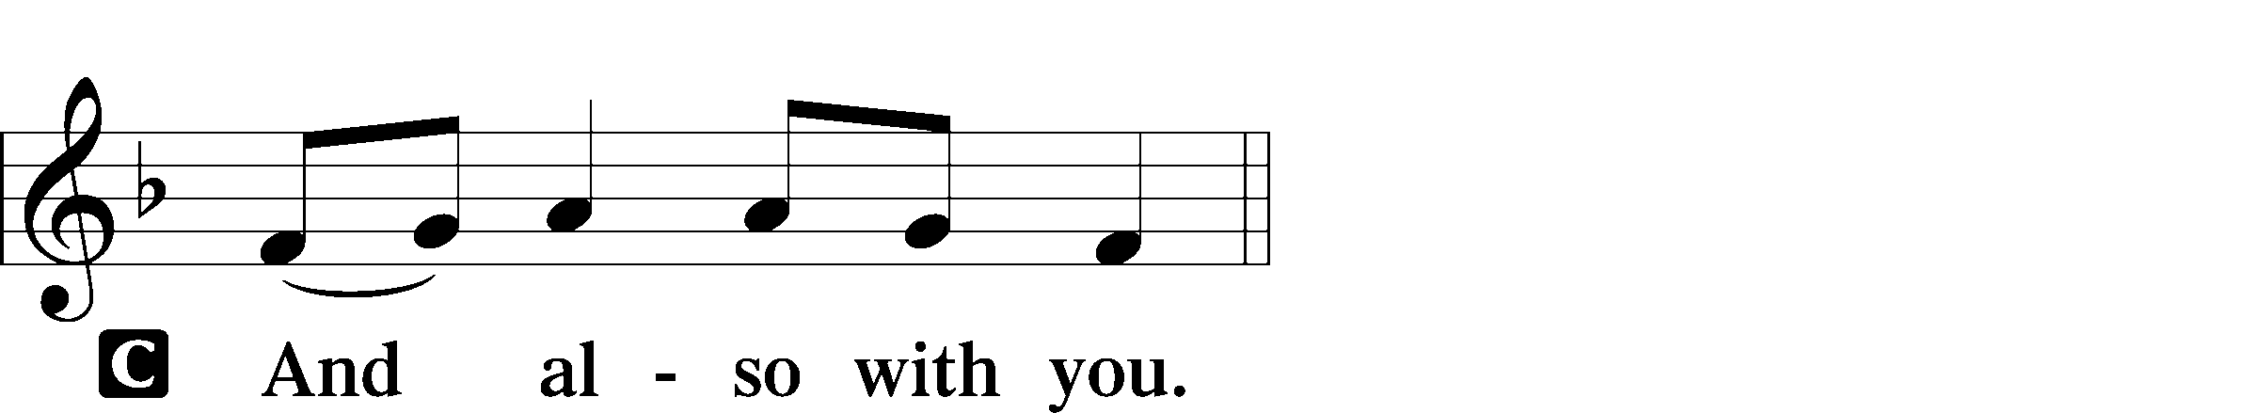

P Lift up your hearts.


P Let us give thanks to the Lord our God.
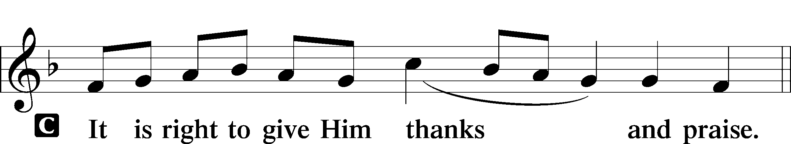

P It is truly good, right, and salutary that we should at all times and in all places give thanks to You, holy Lord, almighty Father, everlasting God, through Jesus Christ, our Lord, who on this day overcame death and the grave and by His glorious resurrection opened to us the way of everlasting life. Therefore with angels and archangels and with all the company of heaven we laud and magnify Your glorious name, evermore praising You and saying:

Sanctus LSB 161
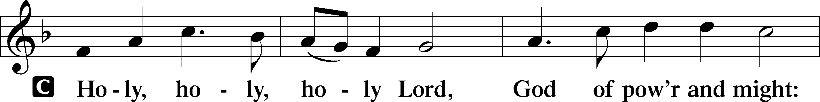
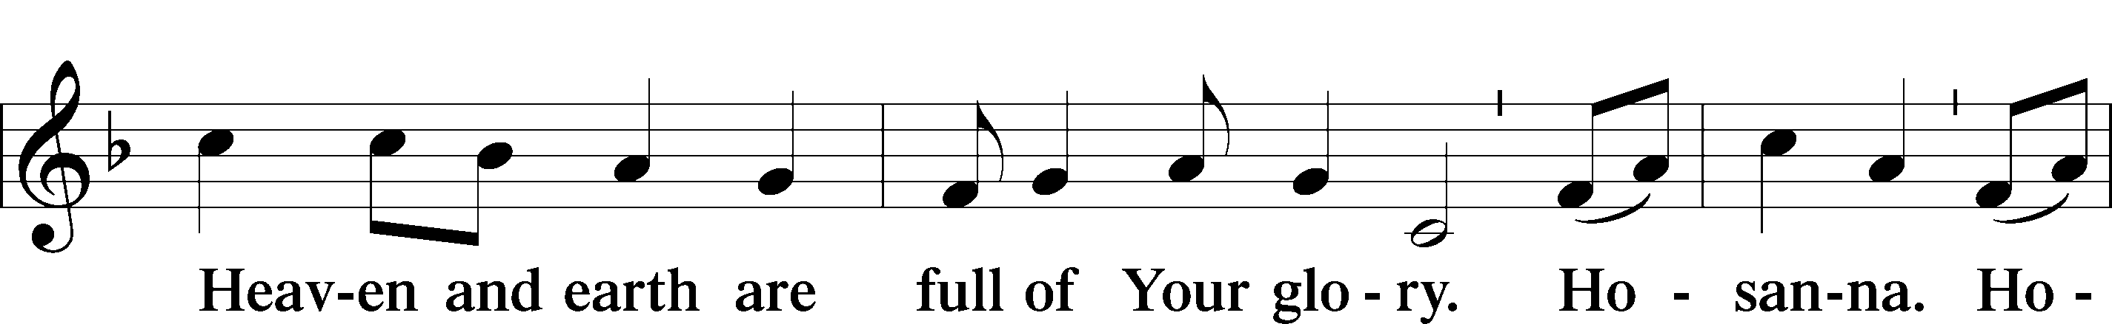
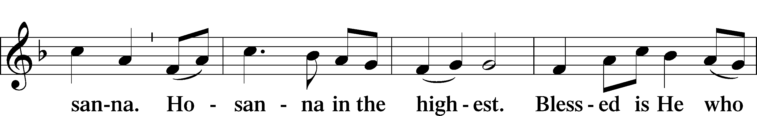
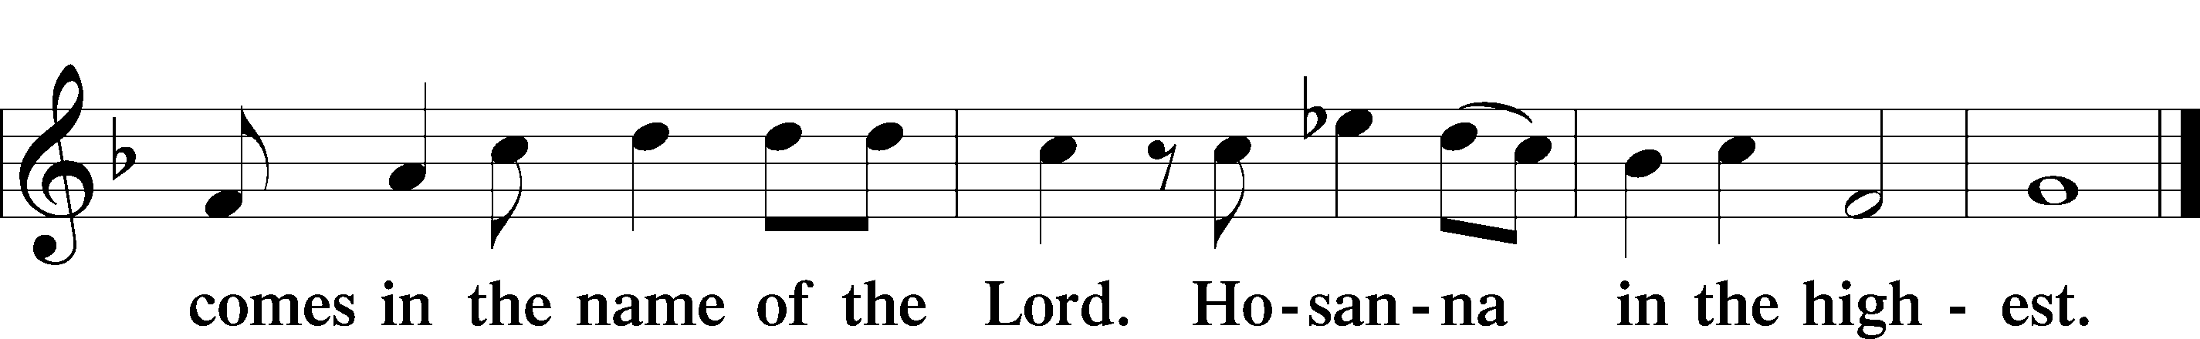

Prayer of Thanksgiving LSB 161
P Blessed are You, Lord of heaven and earth, for You have had mercy on those whom You created and sent Your only-begotten Son into our flesh to bear our sin and be our Savior. With repentant joy we receive the salvation accomplished for us by the all-availing sacrifice of His body and His blood on the cross.

Gathered in the name and the remembrance of Jesus, we beg You, O Lord, to forgive, renew, and strengthen us with Your Word and Spirit. Grant us faithfully to eat His body and drink His blood as He bids us do in His own testament. Gather us together, we pray, from the ends of the earth to celebrate with all the faithful the marriage feast of the Lamb in His kingdom, which has no end. Graciously receive our prayers; deliver and preserve us. To You alone, O Father, be all glory, honor, and worship, with the Son and the Holy Spirit, one God, now and forever.
C Amen.

Lord’s Prayer LSB 162
P Lord, remember us in Your kingdom and teach us to pray:
C Our Father who art in heaven,
hallowed be Thy name,
Thy kingdom come,
Thy will be done on earth
as it is in heaven;
give us this day our daily bread;
and forgive us our trespasses
as we forgive those
who trespass against us;
and lead us not into temptation,
but deliver us from evil.
For Thine is the kingdom
and the power and the glory
forever and ever. Amen.

The Words of Our Lord
P Our Lord Jesus Christ, on the night when He was betrayed, took bread, and when He had given thanks, He broke it and gave it to the disciples and said: “Take, eat; this is My T body, which is given for you. This do in remembrance of Me.”

In the same way also He took the cup after supper, and when He had given thanks, He gave it to them, saying: “Drink of it, all of you; this cup is the new testament in My T blood, which is shed for you for the forgiveness of sins. This do, as often as you drink it, in remembrance of Me.”

Pax Domini LSB 163
P The peace of the Lord be with you always.


Agnus Dei LSB 163
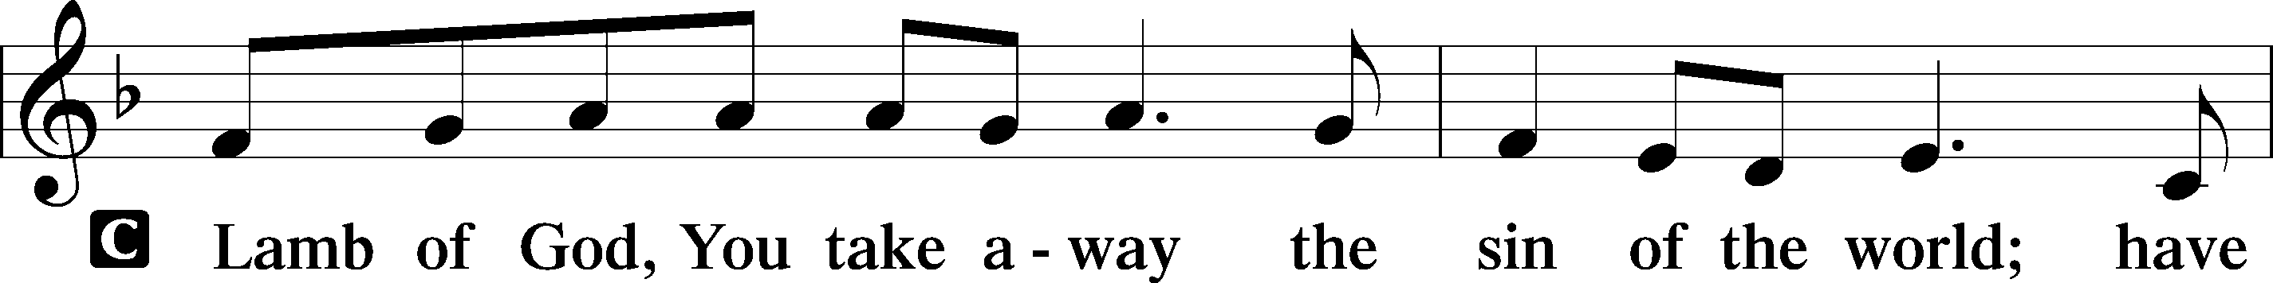
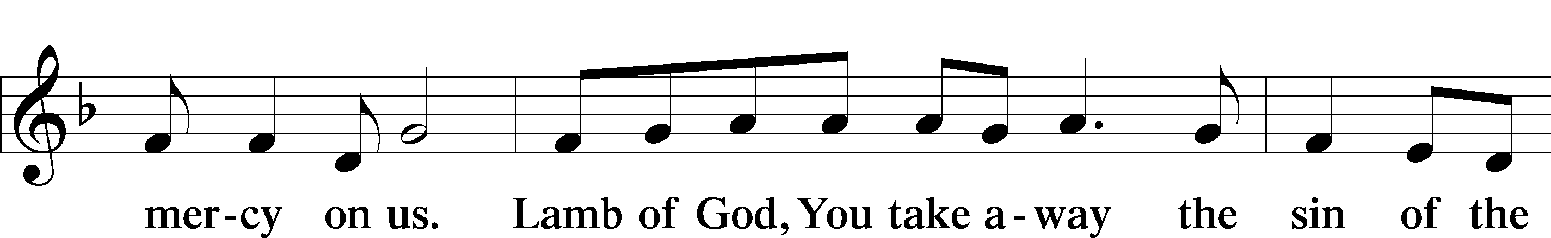
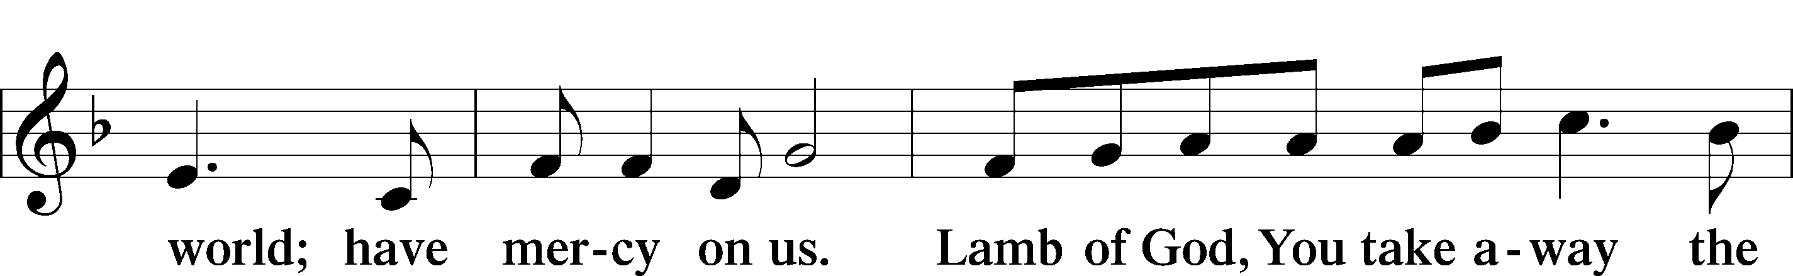
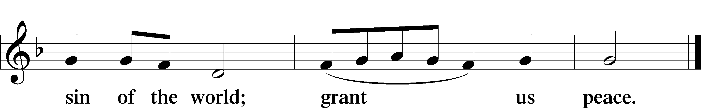

Sit

Distribution

In dismissing the communicants, the following is said:

P The body and blood of our Lord Jesus Christ strengthen and preserve you in body and soul to life everlasting. Depart T in peace.
C Amen.

Stand

Thank the Lord LSB 164
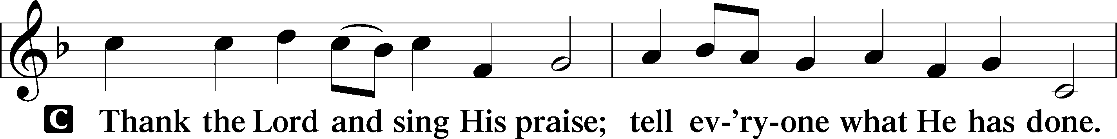
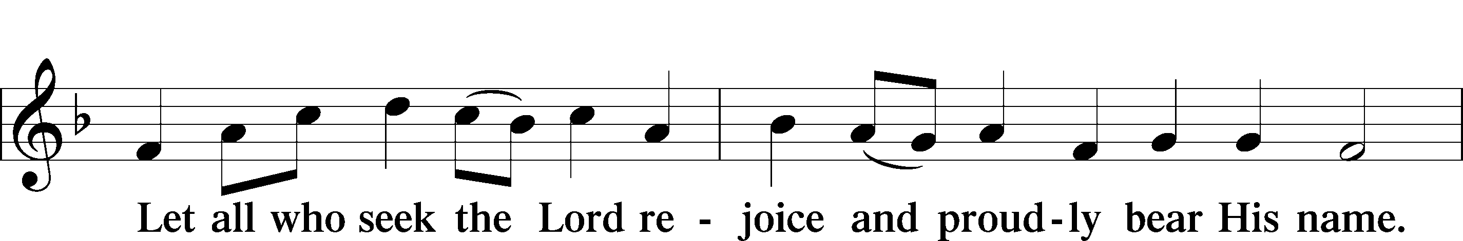
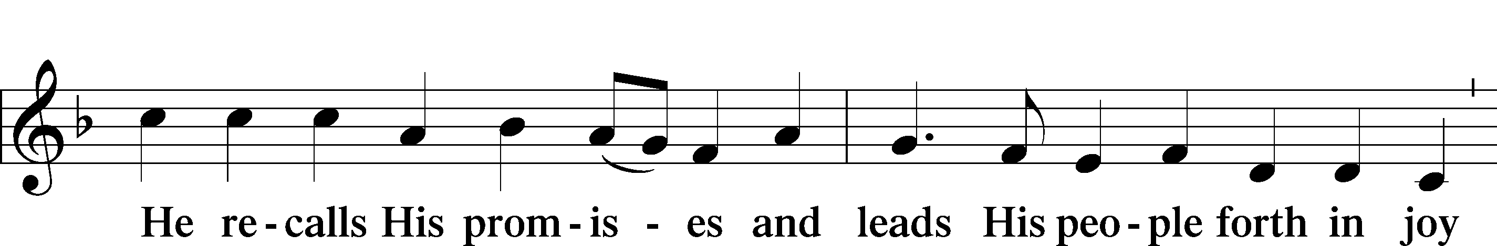
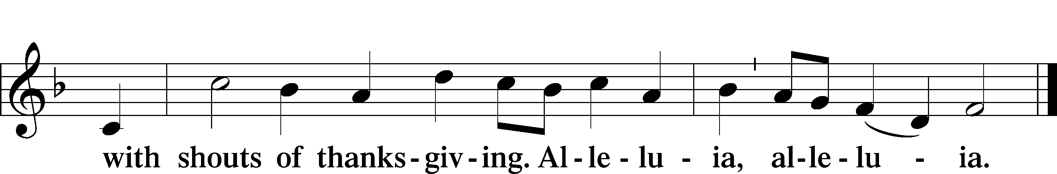

Post-Communion Collect
A Let us pray.
O God the Father, the fountain and source of all goodness, who in loving-kindness sent Your only-begotten Son into the flesh, we thank You that for His sake You have given us pardon and peace in this Sacrament, and we ask You not to forsake Your children but always to rule our hearts and minds by Your Holy Spirit that we may be enabled constantly to serve You; through Jesus Christ, Your Son, our Lord, who lives and reigns with You and the Holy Spirit, one God, now and forever.


Benediction LSB 166
P The Lord bless you and keep you.
The Lord make His face shine on you and be gracious to you.
The Lord look upon you with favor and T give you peace.


791 All People That on Earth Do Dwell LSB 791
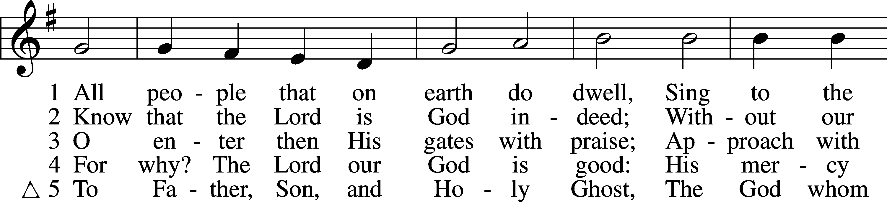
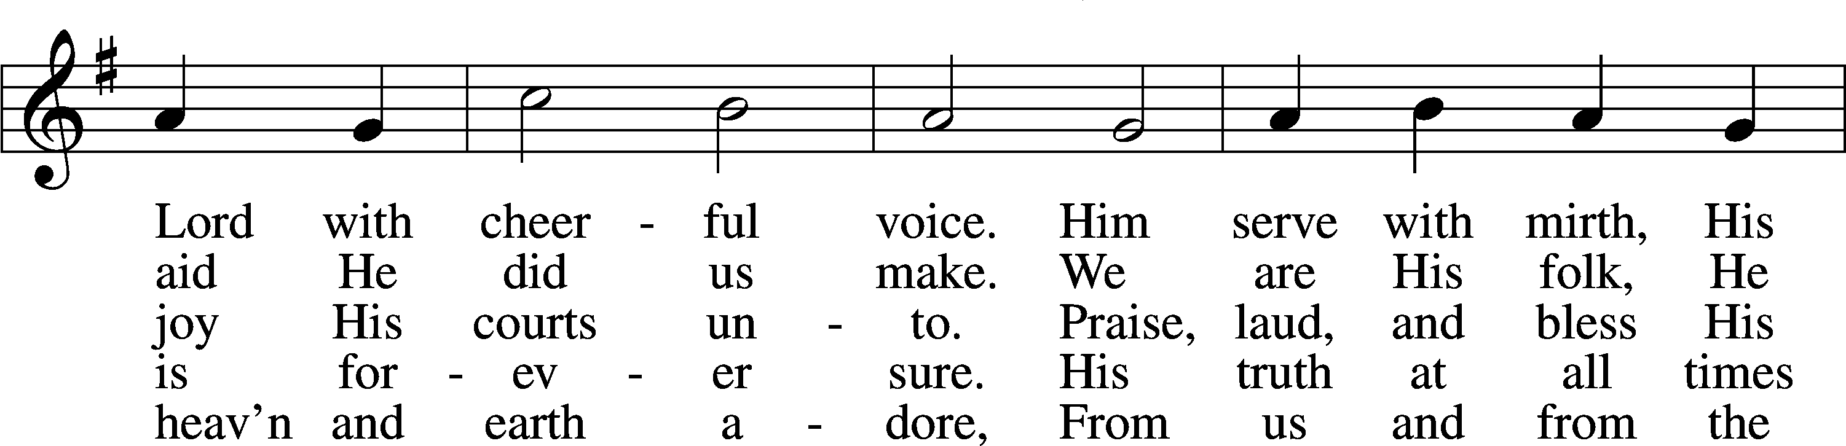
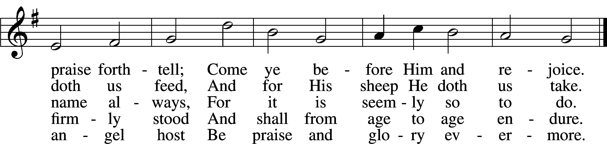
Text: William Kethe, d. c. 1593, alt.
Tune: Trente quatre Pseaumes de David, 1551, Geneva, ed. Louis Bourgeois
Text and tune: Public domain

Acknowledgments
Divine Service, Setting One from Lutheran Service Book
Unless otherwise indicated, Scripture quotations are from the ESV® Bible (The Holy Bible, English Standard Version®), copyright © 2001 by Crossway, a publishing ministry of Good News Publishers. Used by permission. All rights reserved.
Created by Lutheran Service Builder © 2026 Concordia Publishing House.

