July 13, 2014

To: My R friends

Re: Comparing methods of creating docx files

The usual report I create for my collaborators includes data tables, graphs, and short discussions. In this test documant, I've included some of each, formatted as closely as possble to my usual standards for document design.

# Creating a docx file using ReporteRs

I first created an R file to manipulate data and create a graph. With the analysis complete, I added in the ReporteRs functions.

In a separate step, I set up a docx template file, changed its styles, and added a logo in the header of the first page.

Some thoughts:

* No spellcheck for the R file. And for an unknown reason, Word spell check is not finding misspelled words in the docx created by ReporteRs.
* Many mouse clicks could be eliminated if the docx file could be overwritten while open. Or perhaps functions could be added to close an open file, overwrite it, and reopen it.
* I could not figure out how to easily create an em-dash.

# Data source

The *VADeaths* data are furnished in the base R install.

Learning to manage the table formatting for the first time was as about as involved as learning it in LaTeX for the first time---difficult, but once a design is known, the commands can be reused in the next document.

1. Death rate data (per 1000), Virginia 1940

| Age group | Rural male | Rural female | Urban male | Urban female |
| --- | --- | --- | --- | --- |
| 50-54 | 12 | 9 | 15 | 8 |
| 55-59 | 18 | 12 | 24 | 14 |
| 60-64 | 27 | 20 | 37 | 19 |
| 65-69 | 41 | 31 | 55 | 35 |
| 70-74 | 66 | 54 | 71 | 50 |

# Data display

The figure is drawn using the lattice package. The size of the figure is controlled using ResporteRs *addPlot()* function.

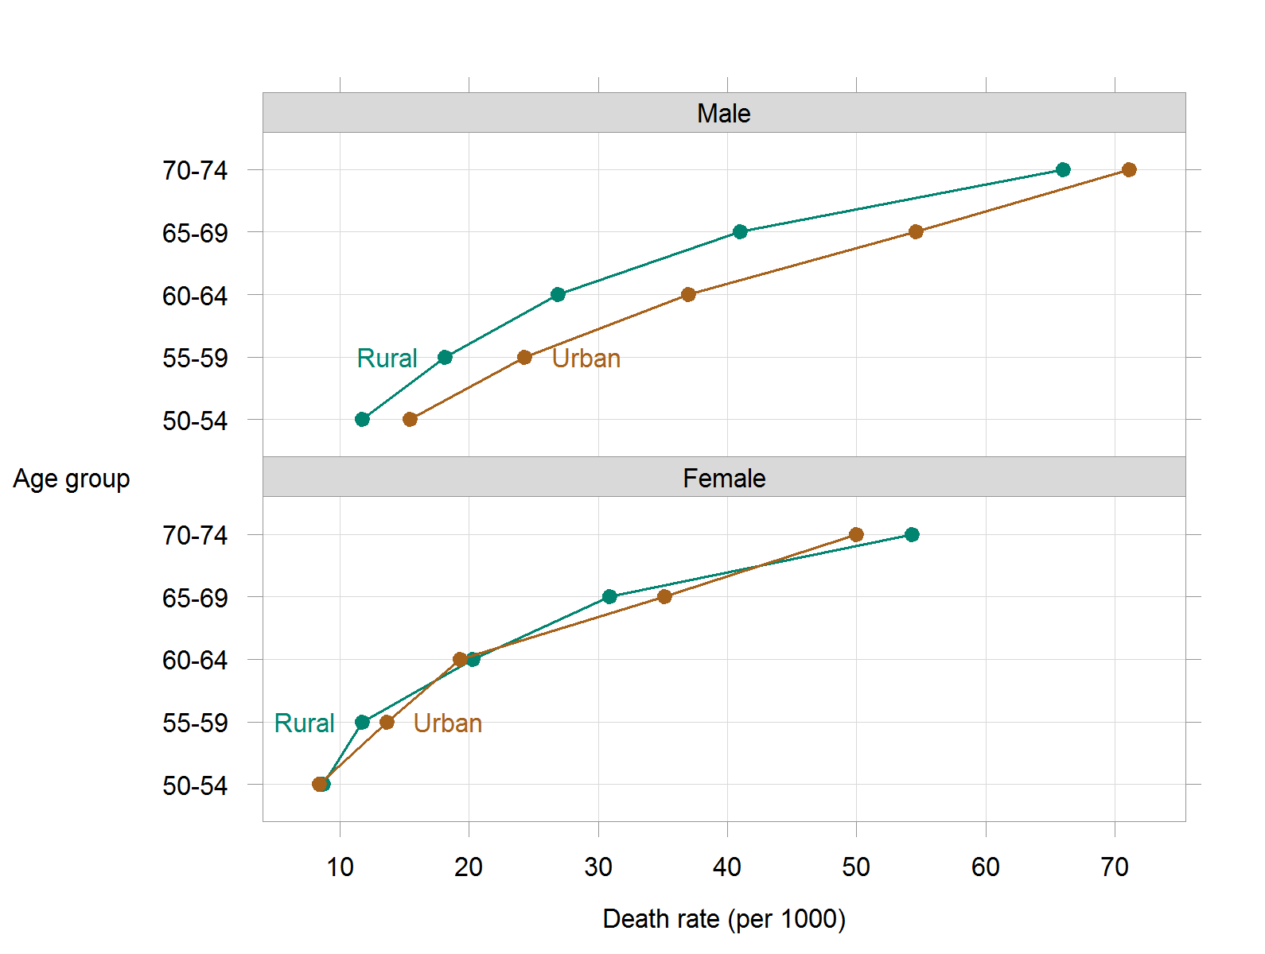

1. Comparing male and female death rates in rural and urban Virginia in 1940.

Rates are nearly identical for rural and urban females, with a systematic increase among rural males and a further increase for urban males.