Workflow for
Sensor → I2C → STM32L152→ DASH7 → MQTT → OpenHAB

Example workflow using the Magnetometer on the xtrinsic-sense board, but it’ll be analogous for any other sensor data retrieved on the STM32L152

MAG3110 The MAG3110 is a small, low-power, digital 3-axis magnetometer featuring a wide measurement range. It can measure magnetic fields (the overlapped fields consisting of the geomagnetic field and the fields created by components on PCB) on each of the 3 axes in the position where it is placed. The MAG3110 features an I2C serial interface, and is capable of measuring magnetic fields of up to 10 Gauss with an output data rate up to 80Hz. The output data rate can vary depending on the sampling intervals and may be adjusted from 12ms to several seconds.
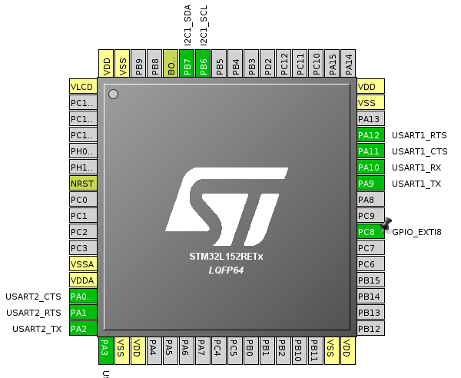
Int_U2 is the MAG3110 interrupt

cubemx
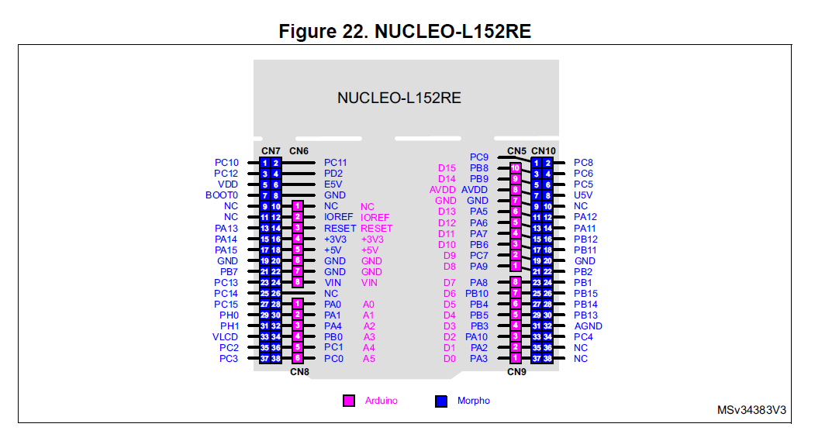

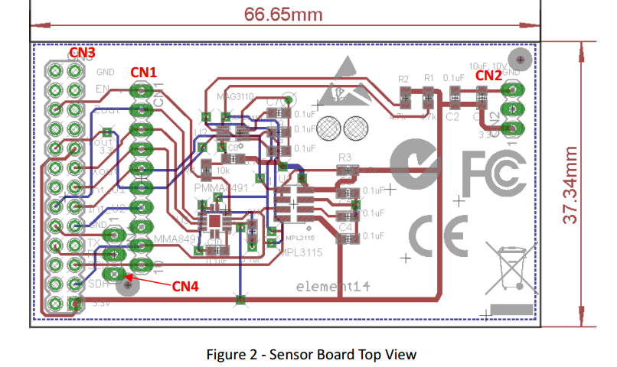
connecting the MAG sensor with the nucleo. Including interrupts

Name | Nucleo pin | MEMS board pin
SDA | PB7 | CN1 P9
SCL | PB6 | CN1 P10
GND | / | CN2 P3
3.3V | / | CN2 P1
Interrupt | PC8 | CN1 P6

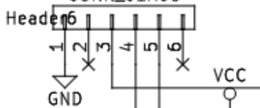
Connecting the dash7 868 dongle with the nucleo
FTDI pins on the D7 dongle:

[GND, CTS#, VCC, RX, TX RTS#]

Name | Nucleo pin | D7 868Hz dongle
GND | / | Header6_1
3.3V | / | Header6_3
TX/RX | USART1 TX : PA9 | RX : Header6_4
RX/TX | USART1 RX : PA10 | TX : Header6_5

New eclipse C project with vendor CMSIS name stm32l152xE

Generate code from cubemximporter, but make sure to enable the IRQ corresponding to EXTI_8 first. Probably EXTI9_5_IRQ

import the cubemx project into the newly created C project
./cubemximporter.py projects/MEMS_MAG3110_D7 cubemx-out/MEMS_MAG3110_D7/

Configure the sensor by settings its registers correctly through I2C. The MAG is configured to send data through DASH7 with the Action: “ReturnFileData” in order to send unsolicited data.

It’s possible to have these messages come in through MQTT, using a python mosquitto module

Acquisition through MQTT, Binding & Presentation in OpenHAB2

creating an STM32L162RD project in eclipse

STM32L162RD_mobile_node

